MPO & COG
Guidelines and Procedures
Manual

ACKNOWLEDGEMENTS

PREPARED FOR:

IN COLLABORATION WITH:

PREPARED BY:
1230 W. Washington Street, Suite 405
Tempe, AZ 85281

3440 N 16th St Suite 102B,
Phoenix, AZ 85016
Manual Content Update
Date . . . . . . . . . . . . . . . . December 2020
Content Updated . . . . . Ch. 1, Ch. 2, Ch. 3, Ch. 4, Ch. 5, Ch. 6, Ch. 7, Ch. 8, Ch. 10, Ch. 11, Ch. 12, Ch. 13, Ch. 14,
Ch. 15, Ch. 16, Ch. 17

This report was funded in part through grants from the Federal Highway or Federal Transit Administration, U.S. Department of Transportation. The contents of this report reflect the views of the authors, who are responsible for the facts and the accuracy of the data, and for the use or adaptation of previously published material, presented herein. The contents do not necessarily reflect the official views or policies of the Arizona Department of Transportation or the Federal Highway or Federal Transit Administration, U.S. Department of Transportation. This report does not constitute a standard, specification, or regulation. Trade or manufacturers’ names that may appear herein are cited only because they are considered essential to the objectives of the report. The U.S. government and the State of Arizona do not endorse products or manufacturers.
MANUAL TABLE OF CONTENTS
1 | Introduction 1-1
2 | Federal & State Planning Partners 2-1
3 | MPO Formation 3-1
4 | MPO Unified Planning Work Program AND Contract Activities 4-1
5 | COG Work Program 5-1
6 | Performance Measures 6-1
7 | Regional Transportation Plan 7-1
8 | Transportation Improvement Program 8-1
9 | Audit 9-1
10 | Financial Planning AND Programming 10-1
11 | Certification of the Metropolitan Transportation Planning Program 11-1
12 | Civil Rights 12-1
13 | Public Involvement 13-1
14 | Transit 14-1
15 | Freight 15-1
16 | Aeronautics 16-1
17 | Supporting Programs 17-1
17.1 | Air Quality 17-3
17.2 | Congestion Management Process 17-11
17.3 | Transportation Data and Functional Class 17-17
17.4 | Technology Applications for Planning: Modeling & GIS 17-26
17.5 | Safety 17-31
17.6 | Tribal Planning 17-36
17.7| Border Planning 17-45
17.8 | Public Private Partnerships 17-48
17.9 | Planning and Environmental Linkages 17-53
17.10 | State Land Department Planning 17-57
17.11 | Sustainability 17-61
17.12 | Bicycle and Pedestrian Planning 17-70
Appendix A | Common Acronyms

1 | INTRODUCTION
TABLE OF CONTENTS
1.1| PURPOSE
1.2| MANUAL STRUCTURE & ORGANIZATION
1.3| TRANSPORTATION PLANNING REQUIREMENTS
1.3.1| Federal Laws
1.3.2| Federal Regulations
1.3.3| Required Federal Products
1.3.4| Arizona Statutes
1.4| REGIONAL GOVERNANCE IN ARIZONA
1.5| TRANSPORTATION MANAGEMENT AREAS
1.5.1| Structure
1.5.2| Funding
1.5.3| Products
1.5.4| TMAs in Arizona
Maricopa Association of Governments (MAG)
Pima Association of Governments (PAG)
1.6 | METROPOLITAN PLANNING ORGANIZATIONS
1.6.1 | Structure
1.6.2 | Funding
1.6.3 | Products
1.6.4 | MPOs in Arizona (Non-TMA)
Central Yavapai Metropolitan Planning Organization (CYMPO)
Flagstaff Metropolitan Planning Organization (FMPO)
Lake Havasu Metropolitan Planning Organization (LHMPO)
Sun Corridor Metropolitan Planning Organization (SCMPO)
Sierra Vista Metropolitan Planning Organization (SVMPO)
Yuma Metropolitan Planning Organization (YMPO)
1.7 | COUNCILS OF GOVERNMENTS
1.7.1 | Structure
1.7.2 | Funding
1.7.3 | Products
1.7.4 | COGs in Arizona
Central Arizona Governments (CAG)
Northern Arizona Council of Governments (NACOG)
Southeastern Arizona Governments Organization (SEAGO)
Western Arizona Council of Governments (WACOG)
1.8 | REGIONAL TRANSPORTATION PLANNING ORGANIZATIONS
1.9 | CONTACT INFORMATION

| Introduction

1.1 | PURPOSE
This guidelines and procedures manual is intended to be used by the staff of the Arizona Department of Transportation (ADOT) and Arizona’s regional transportation planning agencies, which include Councils of Governments (COGs), Metropolitan Planning Organizations (MPOs), and Transportation Management Areas (TMAs). In addition to outlining the guidelines and procedures for regional transportation planning functions, this manual provides an overview of the programs administered by the ADOT Multimodal Planning Division (MPD). In every part of Arizona, the regional planning agencies, in cooperation with ADOT, have an important role in planning and coordinating transportation projects. ADOT’s planning partners often are responsible for facilitating the project process between local communities, public transit providers, and ADOT. Although they typically address multiple aspects of planning, this ADOT manual (Manual) will focus on planning activities and guidance for transportation.
ADOT prepared the ADOT MPO & COG Guidelines and Procedures Manual in cooperation with TMAs, MPOs, and COGs within Arizona. This manual describes the metropolitan transportation planning processes and administrative requirements that ADOT, TMAs, MPOs, and COGs must implement when working on transportation planning projects. Familiarity with the contents of this manual is vitally important because many transportation planning activities and transportation project/construction funding utilize federal resources. Federal and state processes and procedures must be followed accurately to ensure that funds continue to flow to Arizona and are maximized throughout the state. The goal of this manual is to clarify roles and responsibilities, improve efficiency among organizations, and reduce questions and potential conflicts.

1.2 | MANUAL STRUCTURE & ORGANIZATION
This manual includes numerous subjects organized into the following chapters:
CH | Title
1 | Introduction
2 | State & Federal Planning Partners
3 | MPO Formation & Modification
4 | MPO Unified Planning Work Program & Contract Activities
5 | COG Work Program
6 | Performance Measures
7 | Regional Transportation Plan (RTP)
8 | Transportation Improvement Program (TIP)
9 | Audit
10 | Financial Planning & Programming
11 | Certification of the Metropolitan Transportation Planning Program
12 | Civil Rights
13 | Public Involvement
14 | Transit
15 | Freight & Rail
16 | Aeronautics
17 | Supporting Programs

Strategically located throughout each chapter are colored text boxes that display the following symbols to indicate the type of information the boxes provide.
Schedule/Calendar Checklist Contact Tips & Tricks
Information
Additional Training State Federal
Resources Resource Resource

1.3 | TRANSPORTATION PLANNING REQUIREMENTS
Federal laws, federal regulations, and Arizona statutes govern transportation planning in Arizona. It is important to be familiar with the policies that are discussed briefly in this section and expanded upon throughout this Manual.

1.3.1 | Federal Laws
National transportation policy is set by the U.S. Congress in the form of laws, which establish specific planning requirements and/or delegate that responsibility to the U.S. Secretary of Transportation. Table 1-1 lists the major U.S. transportation laws since 1990, including the most recent law, Fixing America’s Surface Transportation Act (FAST Act), enacted on December 4, 2015.
Each new law can add, delete, or modify provisions in previous laws. A compilation of currently applicable laws, as amended, is found in the Code of Laws of the United States of America, often referred to as the U.S. Code. Transportation planning requirements are found in Title 23 (Highways) of the U.S. Code. Key sections with regard to transportation planning include the following, modified to address resiliency by the FAST Act:
Title 23 | Highways
Chapter 1 | Federal-Aid Highways
Sections 134 & 135:
- 23 U.S.C. § 134 | Metropolitan Transportation Planning
- 23 U.S.C. § 135 | Statewide and Non-metropolitan Transportation Planning
The FAST Act continued 23 U.S.C. § 201, Federal Lands and Tribal Transportation Programs (TTP), which mandates, “In consultation with the Secretary of each appropriate Federal land management agency, the Secretary shall implement transportation planning procedures for Federal lands and tribal transportation facilities that are consistent with the planning processes required under sections 134 and 135.” An approved tribal transportation program, federal lands transportation program, and federal lands access program, as well as transportation improvement programs (TIPs) are required to be included in appropriate state and MPO plans and programs (23 U.S.C. § 201(c)(4)).

Table 1-1 | Major U.S. Transportation Laws: 1998-Present
Year | Public Law # | Acronym | Full Name
1998 | 105-178 | TEA-21 | Transportation Equity Act for the 21st Century
2005 | 109-59 | SAFETEA-LU | Safe, Accountable, Flexible, Efficient Transportation Equity Act: A Legacy for Users
2012 | 112-141 | MAP-21 | Moving Ahead for Progress in the 21st Century Act
2016 | 114-94 | FAST Act | Fixing America’s Surface Transportation Act

1.3.2 | Federal Regulations
As noted above, Congress delegates to the U.S. Secretary of Transportation, in accord with the Administrative Procedure Act and pursuant to the surface transportation acts, the responsibility to issue regulations detailing how transportation laws are to be implemented. New regulations from all federal agencies are published on each non-holiday weekday in the Federal Register (FR). Each new regulation can add, delete, or modify provisions in previous regulations. A compilation of currently applicable regulations, as amended, is found in the Code of Federal Regulations (CFR). Transportation planning requirements are found in Title 23 (Highways).
Title 23 | Highways
Chapter 1 | Federal Highway Administration, Department of Transportation
Subchapter E | Planning and Research
Part 450 | Planning Assistance and Standards
Subpart A, B & C:
- A | 23 C.F.R. § 450.100 et seq. | Planning Definitions
- B | 23 C.F.R. § 450.200 et seq. | Statewide Transportation Planning
- C | 23 C.F.R. § 450.300 et seq. | Metropolitan Transportation Planning and Programming
* “Et seq.” is an abbreviation for the Latin et sequences, which means “and the following.” It indicates that relevant information continues in the sections that follow the section cited.
Corresponding, nearly identical requirements are found in Title 49 (Transportation), addressing planning for federal transit projects, which are under the jurisdiction of the Federal Transit Administration (FTA).
Title 49 | Transportation
Subtitle III | General and Intermodal Programs
Chapter 53 | Public Transportation
Sections 5303 & 5304:
- 49 U.S.C. § 5303 | Metropolitan Transportation Planning
- 49 U.S.C. § 5304 | Statewide and Non-metropolitan Transportation Planning
The regulations in 23 C.F.R. § 450 specify the federal transportation planning requirements that are addressed in this manual. Regulations implementing the December 2015 Performance Management requirements (23 U.S.C. § 150) were issued by the U.S. Department of Transportation (USDOT) in April 2016 and communicated through ADOT MPD to the COGs and MPOs throughout the state.
Transportation planners should be aware that it takes time to incorporate provisions of a new law into the U.S. Code, time for the U.S. secretary of transportation to promulgate new regulations in response to a new law, and additional time to incorporate new regulations into the Code of Federal Regulations. Therefore, check with the ADOT MPD for clarification regarding the current applicable requirements, especially if a new federal transportation law has recently been enacted and state action is required.

1.3.3 | Required Federal Products
There are various required federal documents that must be developed by MPOs (including MPOs that have TMA status) and COGs. Table 1-2 summarizes the required federal documents, the time period that each product covers, general contents and how often the document needs to be updated. More specific detail on each of the products is contained in this manual in the following chapters.

Table 1-2 | Schedule of Required Federal Products
Product/ Document | Horizon | Contents | Updates | Agency
 |  |  |  | TMA | MPO | COG
M/RTP  (Metropolitan/Regional Transportation Plan) | 20 years  (min.) | Policies, goals, and strategies | Every 5 years  (4 years for non-attainment and maintenance areas) | ✓ | ✓
UPWP  (Unified Planning Work Program) | 2 years | Planning studies and tasks | Biennially | ✓ | ✓
WP  (Work Program) | 2 years | Planning studies and tasks | Biennially |  |  | ✓
TIP  (Transportation Improvement Program) | 4-5 years | Transportation investments by fund type and funding year | At least every 4 years  (period may occur  more frequently) | ✓ | ✓ | ✓
Public Participation Plan | N/A | Details of the MPO public involvement process | As needed  (to stay in compliance with federal regulations) | ✓ | ✓ | ✓
Title VI Plan | N/A | Actions taken to meet antidiscrimination laws | Annually | ✓ | ✓ | ✓
Regional Coordination Plan | N/A | Transportation services for people with disabilities, low incomes, and older adults | Based on TIP and MTP  (4 years for non-attainment and maintenance areas) | ✓ | ✓ | ✓
Air Quality Regional Conformity | Based on TIP and MTP | Conformity links air quality and transportation planning to ensure transportation activities in non-attainment and maintenance areas are consistent with air quality goals | Based on TIP and MTP  (4 years for non-attainment and maintenance areas) | ✓ | ✓
Congestion Management Plan | Ongoing | Provides demand reduction and operational management strategies | As needed | ✓

1.3.4 | Arizona Statutes
Similar to the federal process, the Arizona State Legislature passes laws (approved by the governor) which are incorporated into the Arizona Revised Statutes (A.R.S.). Arizona’s laws on transportation planning are found in several articles of Title 28, Transportation:
Chapter 2 | Administration
Article 7 | Transportation Planning
Section 501, 503, & 504:
- A.R.S. § 28-501 et seq. | Transportation Planning
- A.R.S. § 28-503 | Performance Based Planning & Programming
- A.R.S. § 28-504 | Transportation system performance measures; data collection and reporting; methodologies
Chapter 17 | Transportation Excise Tax Distribution
Article 1 | Transportation Excise Tax Distribution in Highly Populated Counties
Section 6308:
- A.R.S. § 28-6308 | Regional planning agency transportation policy committee; regional transportation plan; plan review process
Chapter 20 | State Highways and Routes
Article 3 | Five Year Transportation Facilities Construction Program
Sections 6951, 6952, 6953, 6954, & 6955:
- A.R.S. § 28-6951 et seq. | Five Year Transportation Facilities Construction Program
Arizona’s statutory requirements focus largely on development of the statewide transportation plan and the statewide Five-Year Transportation Facilities Construction Program. The statewide plan and five-year program are developed including the regional and metropolitan project priorities resulting from federally mandated transportation planning processes. All plans and programs developed by COGs and MPOs, including TMAs, must be consistent with Arizona statutes and ADOT planning documents.

1.4 | REGIONAL GOVERNANCE IN ARIZONA
Arizona has three types of regional transportation planning agencies to conduct and coordinate transportation planning activities:
- TMAs
- MPOs
- COGs
Every community within Arizona is represented by at least one of these planning agencies, as illustrated in Figure 1-1 on the next page. Table 1-3 lists the various planning entities that are indicated in Figure 1-1. There are two MPOs classified as TMAs, MAG and Pima Association of Governments (PAG). MAG has the most population of the state’s regional agencies, including all of Maricopa County and the northern portion of Pinal County. PAG represents all of Pima County, the second most populated county in Arizona. Central Yavapai Metropolitan Planning Organization (CYMPO), Flagstaff Metropolitan Planning Organization (FMPO), and Yuma Metropolitan Planning Organization (YMPO) are represented within the urbanized areas of the Northern Arizona Council of Governments (NACOG) and the Western Arizona Council of Governments (WACOG).
The three newest entities listed in Table 1-3 were formed in 2013, after the 2010 U.S. Census indicated that a representative population had reached the threshold of 50,000 residents, triggering a regulatory requirement for MPO formation. They are Lake Havasu Metropolitan Planning Organization (LHMPO) based in Lake Havasu City, Sun Corridor Metropolitan Planning Organization (SCMPO) based in Casa Grande, and Sierra Vista Metropolitan Planning Organization (SVMPO) based in Sierra Vista. They are also encompassed within WACOG, Central Arizona Governments (CAG), and Southeast Arizona Governments Organization (SEAGO), respectively. The following sections further describe these entities roles and responsibilities.

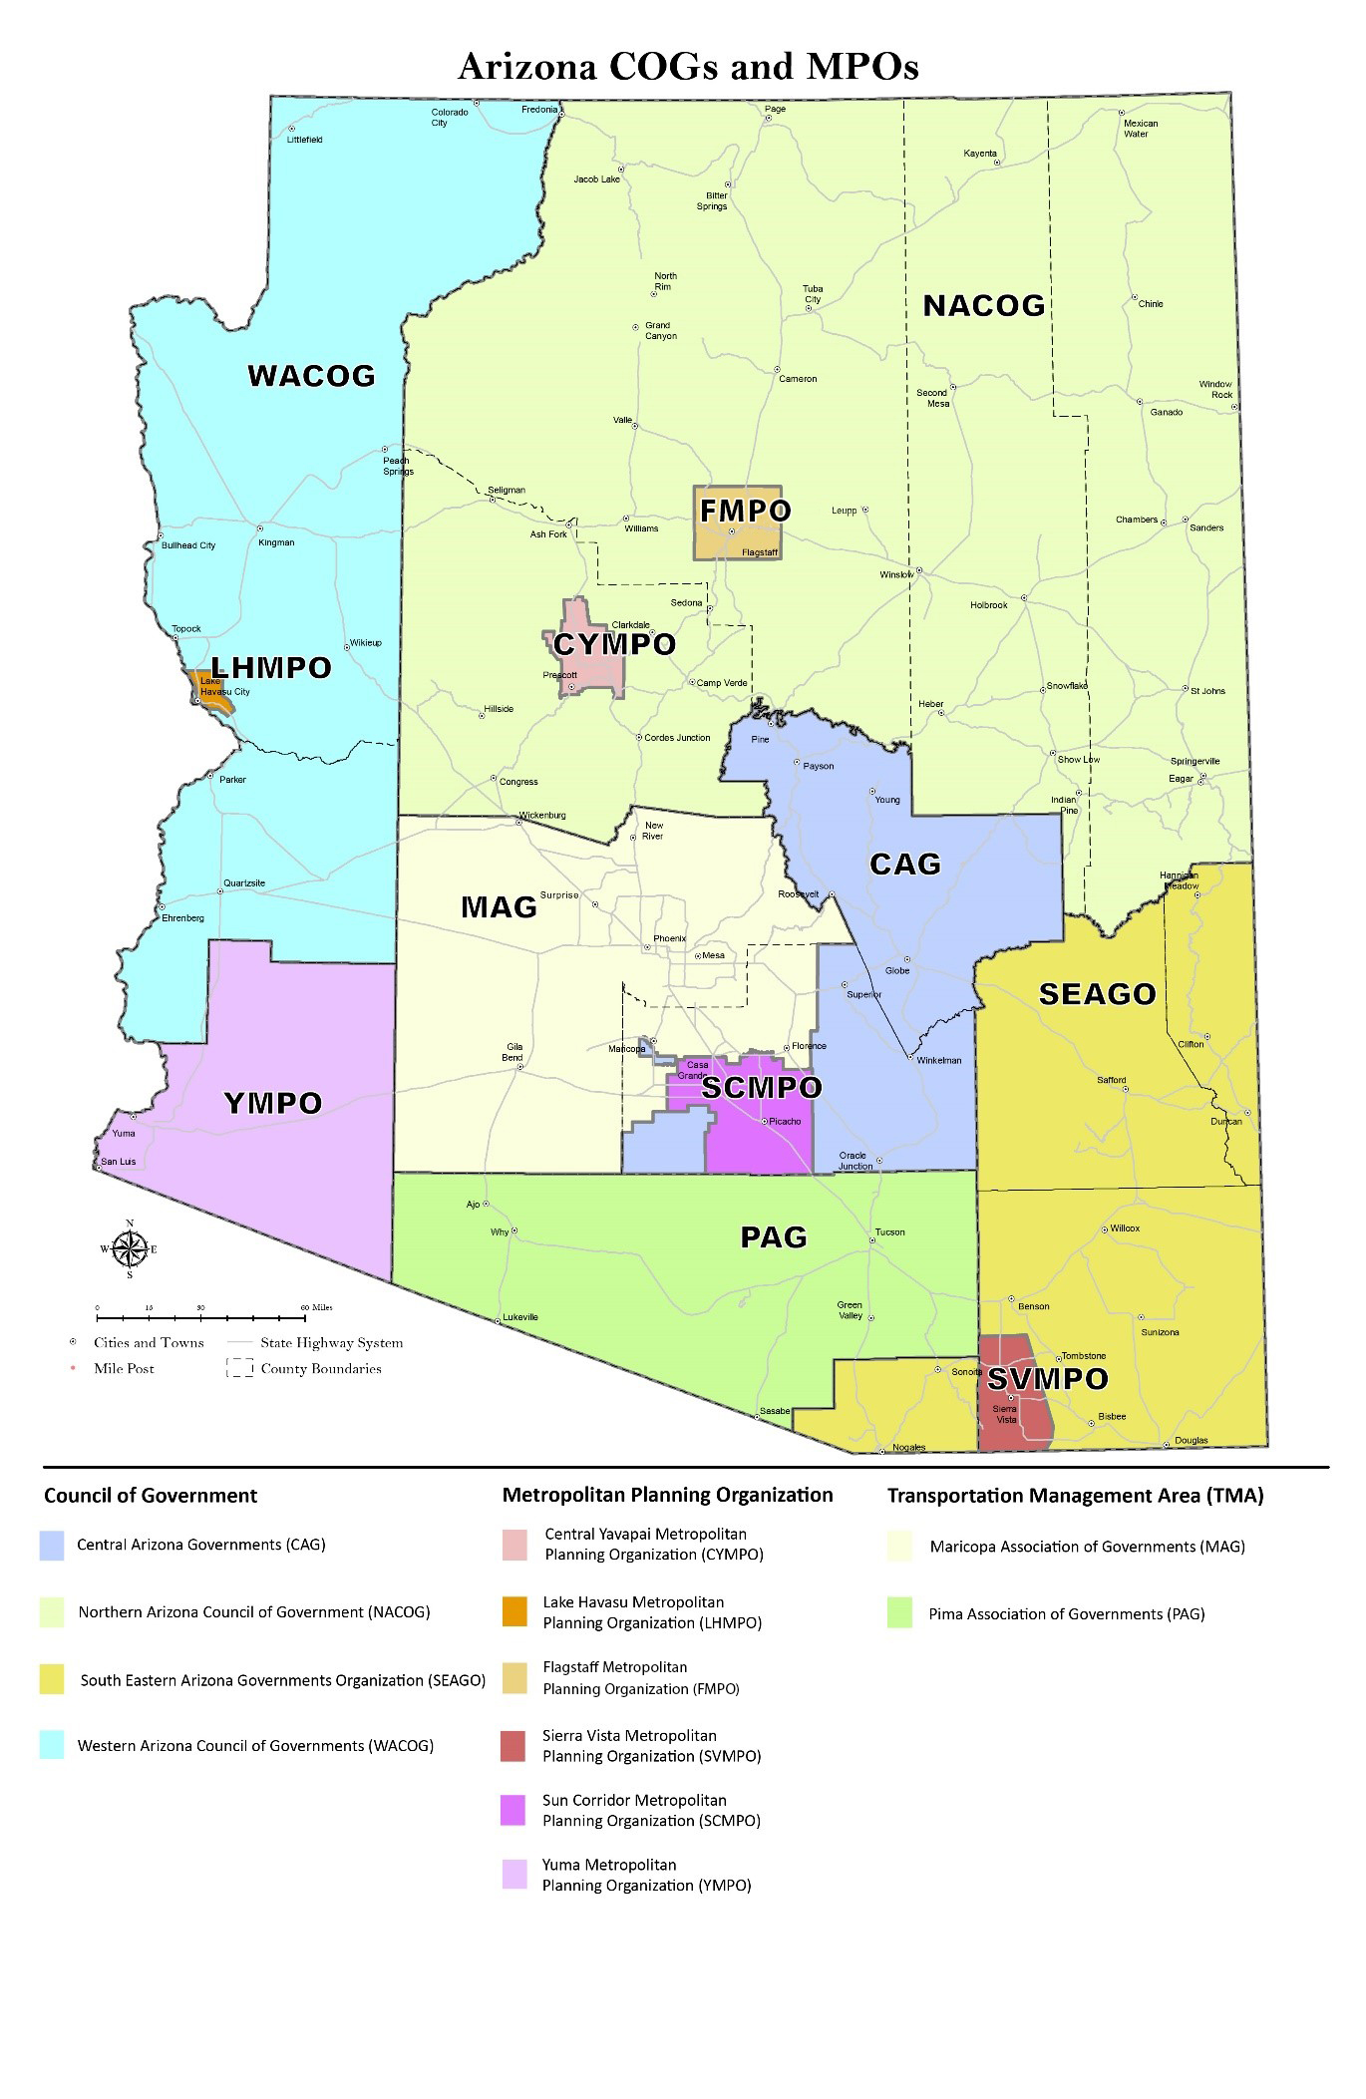
Figure 1-1 | Regional Governance in Arizona

Table 1-3 | Arizona TMAs, MPOs, and COGs
Acronym | Entity Name | Location | Year Est. | TMA ¹ | MPO ² | COG ³
MAG | Maricopa Association of  Governments | Phoenix | 1967 | ✓ | ✓ | ✓
PAG | Pima Association of Governments | Tucson | 1972 | ✓ | ✓ | ✓
CYMPO | Central Yavapai Metropolitan Planning Organization | Prescott | 2003 |  | ✓
FMPO | Flagstaff Metropolitan Planning Organization | Flagstaff | 1996 |  | ✓
LHMPO | Lake Havasu Metropolitan Planning Organization | Lake Havasu City | 2013 |  | ✓
SCMPO | Sun Corridor Metropolitan Planning Organization | Casa Grande | 2013 |  | ✓
SVMPO | Sierra Vista Metropolitan Planning Organization | Sierra Vista | 2013 |  | ✓
YMPO | Yuma Metropolitan Planning Organization | Yuma | 1983 |  | ✓
CAG | Central Arizona Governments | Apache Junction | 1970 |  |  | ✓
NACOG | Northern Arizona Council of Government | Flagstaff | 1975 |  |  | ✓
SEAGO | Southeastern Arizona Governments Organization | Bisbee | 1972 |  |  | ✓
WACOG | Western Arizona Council of Governments | Kingman | 1971 |  |  | ✓
1 TMAs have 200,000 or more population; mandated under the Intermodal Surface Transportation Efficiency Act of 1991.
2 MPOs have 50,000 or more population; mandated under the Federal-Aid Highway Act of 1962.
3 Executive Order 70-2 from Governor Jack Williams in 1970 provided the initial framework for the current COG jurisdictions.

1.5 | TRANSPORTATION MANAGEMENT AREAS
A TMA is designated by the U.S. Secretary of Transportation for an urbanized area with a population of at least 200,000. Congress provided for this greater role by MPOs through a certification review aimed at formalizing the continuing oversight and day-to-day evaluation of the planning process. MPOs attaining certification enjoy certain benefits, but they also incur additional requirements beyond those of smaller urbanized areas for congestion management, project selection, and certification. For more information about the certification process, please see chapter 11 of this manual. The Federal Highway Administration (FHWA) and FTA jointly review and evaluate the transportation planning process every four years. In air quality nonattainment or maintenance areas, the FHWA and FTA review to ensure that TMAs follow air quality conformity regulations.

TMA

1.5.1 | Structure
TMAs are created after reaching the population threshold of 200,000 through an agreement between Arizona’s governor and the cities and towns within the metropolitan area. Following TMA designation, They are governed by boards that serve as policy committees with representatives from state and local governments, tribal members, regional planning agencies, business groups, and public transit providers as defined in the TMA organization’s bylaws. TMAs typically have advisory committees and have a professional staff to provide committee support and prepare required products.

1.5.2 | Funding
TMAs typically receive their funding either from the federal government or through ADOT that includes State Planning and Research (SPR) and Surface Transportation Block Grant (STBG) program funds. Some programs may not require a TMA to go through ADOT for funding, in which case the TMA may apply directly to the federal government. Each MPO, including TMAs, signs a Grant Agreement (GRT) with ADOT that outlines annual responsibilities. Those responsibilities are further outlined in the Unified Planning Work Program (UPWP) detailed in chapter 4. Funding for MPO programs and projects are described in chapter 10.

1.5.3 | Products
Each TMA is required to produce the following:
- Metropolitan Transportation Plan (MTP)
- Unified Planning Work Program (UPWP)
- Transportation Improvement Program (TIP)
- Public Participation Plan
- Title VI Plan
- Regional Coordination Plan
- Air Quality Plan (only for non-attainment)
- Congestion Management Process
These documents are further described in the following chapters in this manual.

1.5.4 | TMAs in Arizona
There are two TMAs in Arizona, Maricopa Association of Governments (MAG) and Pima Association of Governments (PAG). MAG operates in the Phoenix metropolitan region and PAG operates in the Tucson metropolitan region.
Maricopa Association of Governments (MAG)
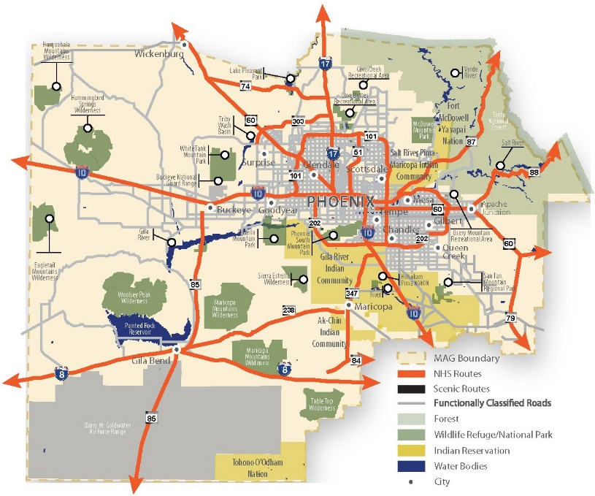
Maricopa Association of Governments is the regional planning agency for Maricopa County and the northern portion of Pinal County, which includes the metropolitan Phoenix area, as shown in Figure 1-2. The MAG membership currently consists of the 27 incorporated cities and towns within Maricopa County and the contiguous urbanized area, the Gila River Indian Community, the Salt River Pima Maricopa Indian Community, Fort McDowell Yavapai Nation, Maricopa County, and Pinal County. Additionally, ADOT serves as an ex-officio member for transportation-related issues. The MAG region, which is Maricopa County and includes portions of Pinal County, comprises 10,655 square miles and had a 2018 Census population estimate of 4,857,962 residents.

Figure 1-2 | MAG Regional Area
In 1967, MAG was the first regional planning agency formed in the state of Arizona when local elected officials recognized the need for long-range planning and policy development on a regional scale. The governor designated MAG to serve as the principal planning agency for issues such as air quality, water quality, and solid waste management.

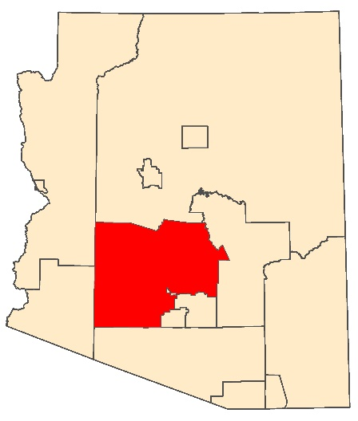
Table 1-4 | MAG Statistics
MAG
302 N. 1st Ave., Ste. 300 Phoenix, AZ 85003
#: 602-254-6300

https://www.azmag.gov/
Maricopa Association of Governments – MAG
Year Established | 1967
Hosted/Independent MPO | Independent
2018 Population | 4,857,962
Counties | 2 | Maricopa, Pinal
Number of Municipalities | 27
Tribal Partner Agencies | 3 | Fort McDowell Yavapai Nation, Gila River Indian Community, Salt River Pima-Maricopa Indian Community
Primary Travel Corridors | 9| Interstate: I-8, I-10, I-17. US Routes: US 60. State Routes: SR 85, SR 101, SR 202, SR 303, SR 347.
Transit | Yes
Airport | Yes
Air Quality Nonattainment or Maintenance | Carbon monoxide (CO), Ozone (1 hr), Ozone (8 hr), PM10, PM2.5

Pima Association of Governments (PAG)
Pima Association of Governments is the MPO that serves Pima County, including the Tucson metropolitan area in southern Arizona. PAG’s boundary is shown in Figure 1-3. PAG’s nine-member regional council has representatives from the county, five municipalities, the Pascua Yaqui and Tohono O’odham tribal governments, and the Arizona State Transportation Board (ASTB). The PAG region, which is Pima County, comprises 9,188 square miles and had a 2018 Census population of 1,047,279 residents.
PAG’s programs focus on cross-jurisdictional planning issues, such as air quality, water quality, energy, transportation, and population growth. PAG’s activities and services include traffic data collection, mapping, population projections, carpool matching, sustainability planning, public meetings, and publications. The governor has designated PAG to serve as the principal planning agency for issues such as, air quality, water quality, and solid waste management.

Figure 1-3 | PAG Regional Area
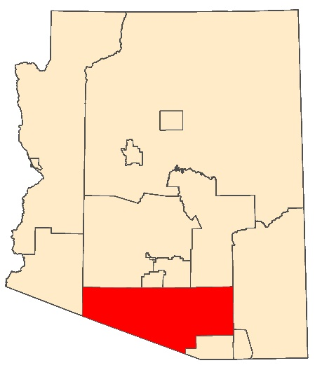
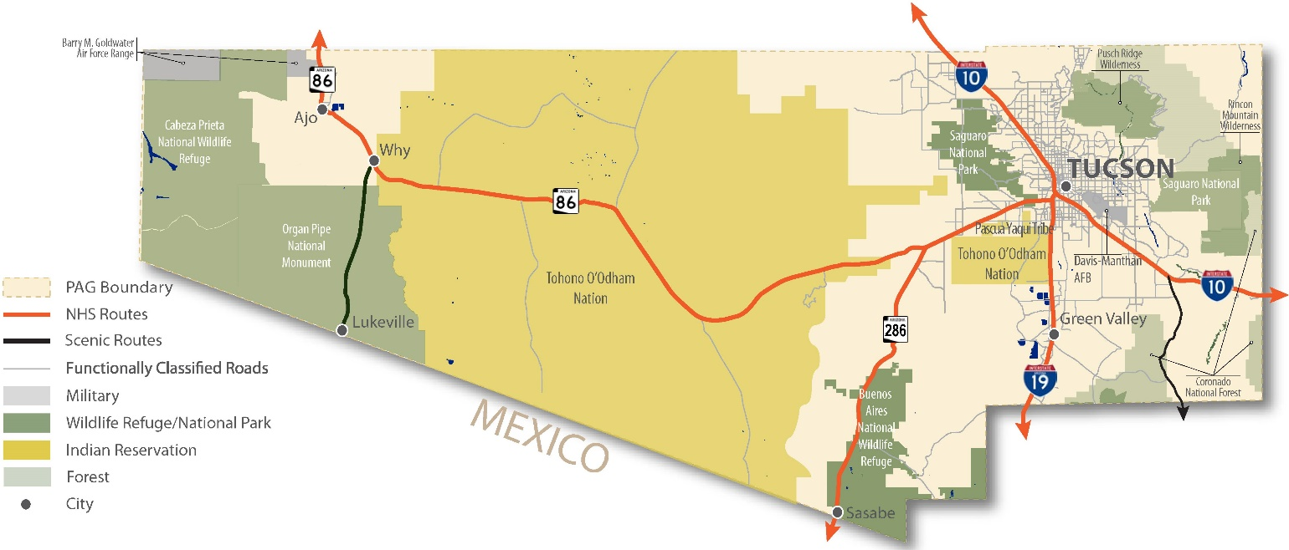
Pima Association of Governments – PAG
Year Established | 1972
Hosted/Independent MPO | Independent
Land Area (sq. mi.) | 9,188
2018 Population | 1,047,279
Counties | 1 | Pima
Number of Municipalities | 5
Tribal Partner Agencies | 2 | Pascau Yaqui Tribe, Tohono O’odham Nation
Primary Travel Corridors | 3 | Interstates: 1-10, 1-19. State Routes: SR 86
Transit | Yes
Airport | Yes
Air Quality Nonattainment or Maintenance | PM 10

Table 1-5 | PAG Statistics

1.6 | METROPOLITAN PLANNING ORGANIZATIONS
PAG
1 E Broadway Blvd., Ste. 401
Tucson, AZ 85701
#: 520-792-1093

https://pagregion.com/
An MPO is a governmental entity required in urban areas with a population of 50,000 persons or more. The MPO is charged with providing a comprehensive regional transportation planning process for the designated planning area. MPOs work with ADOT and other partner agencies to develop federal- and state-required transportation plans and programs for their regions. An MPO ensures federal spending on transportation occurs through a comprehensive, continuous, and cooperative (3-C) planning process.

MPO

1.6.1 | Structure
MPOs are created through an agreement between Arizona’s governor and the cities and towns within a metropolitan area. They are governed by boards that serve as policy committees with representatives from state and local governments, tribal members, regional planning agencies, business groups, and public transit providers as defined in the MPO bylaws. MPOs typically have several topic-based advisory committees and have a professional staff to facilitate committee discussions and conduct the work outlined in the UPWP.

1.6.2 | Funding
MPOs typically receive their funding both from the federal government and through ADOT that include SPR and STBG. Several factors determine the amount of funding granted, including formula funds, transit activities, air quality conformity planning, and other agreed-upon planning work outlined in the GRT and UPWP.
Funding for MPO programs and projects are described in chapter 10.

1.6.3 | Products
Each MPO is responsible for at a minimum producing the following:
- MTP/RTP
- UPWP
- TIP
- Public Participation Plan
- Title VI Plan
- Regional Coordination Plan
- Air Quality Plan (only for non-attainment)

1.6.4 | MPOs in Arizona (Non-TMA)
Beyond the two MPOs certified as TMAs, Arizona has six other MPOs: Central Yavapai Metropolitan Planning Organization (CYMPO), Flagstaff Metropolitan Planning Organization (FMPO), Lake Havasu Metropolitan Planning Organization (LHMPO), Sun Corridor Metropolitan Planning Organization (SCMPO), Sierra Vista Metropolitan Planning Organization (SVMPO), and Yuma Metropolitan Planning Organization (YMPO). Each of these MPOs is described on the following pages.
Federal law detailing metropolitan planning requirements is codified in 23 U.S.C. § 134
Central Yavapai Metropolitan Planning Organization (CYMPO)

Figure 1-4 | CYMPO Regional Area
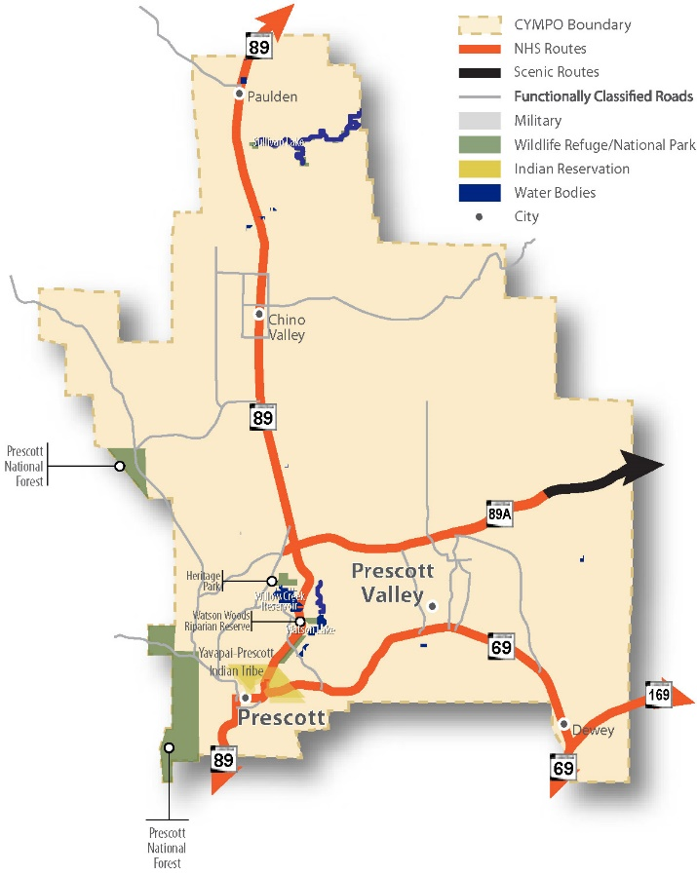
The Central Yavapai MPO is a partnership of the jurisdictions that are within its planning area, which includes: the city of Prescott, town of Chino Valley, town of Dewey-Humboldt, town of Prescott Valley, Yavapai County, and ADOT. CYMPO’s purpose is to cooperatively plan the transportation future of the Central Yavapai region that falls within the 401 square miles of the MPO planning boundary. CYMPO’s boundary is shown in Figure 1-4.

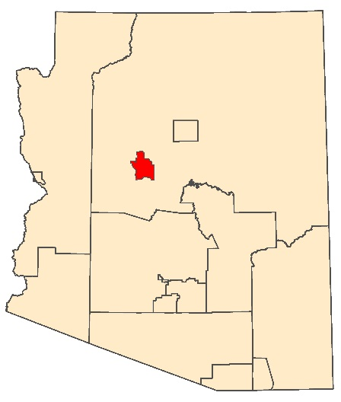
Table 1-6 | CYMPO Statistics
CYMPO
1971 Commerce Center Circle, Ste. E
Prescott, AZ 86301
#: 928-759-5516

https://www.cympo.org/
Central Yavapai Metropolitan Planning Organization – CYMPO
Year Established | 2003
Hosted/Independent MPO | Hosted by Yavapai County
Land Area (sq. mi.) | 401
2018 Population | 139,600
Counties | 1 | Yavapai
Number of Municipalities | 4
Tribal Partner Agencies | 1 | Yavapai-Prescott Indian Tribe
Primary Travel Corridors | 4 | State Routes: SR 69, SR 89, SR 89A, SR 169
Transit | Yes
Airport | Yes
Air Quality Nonattainment or Maintenance | None

Flagstaff Metropolitan Planning Organization (FMPO)

Figure 1-5 | FMPO Regional Area
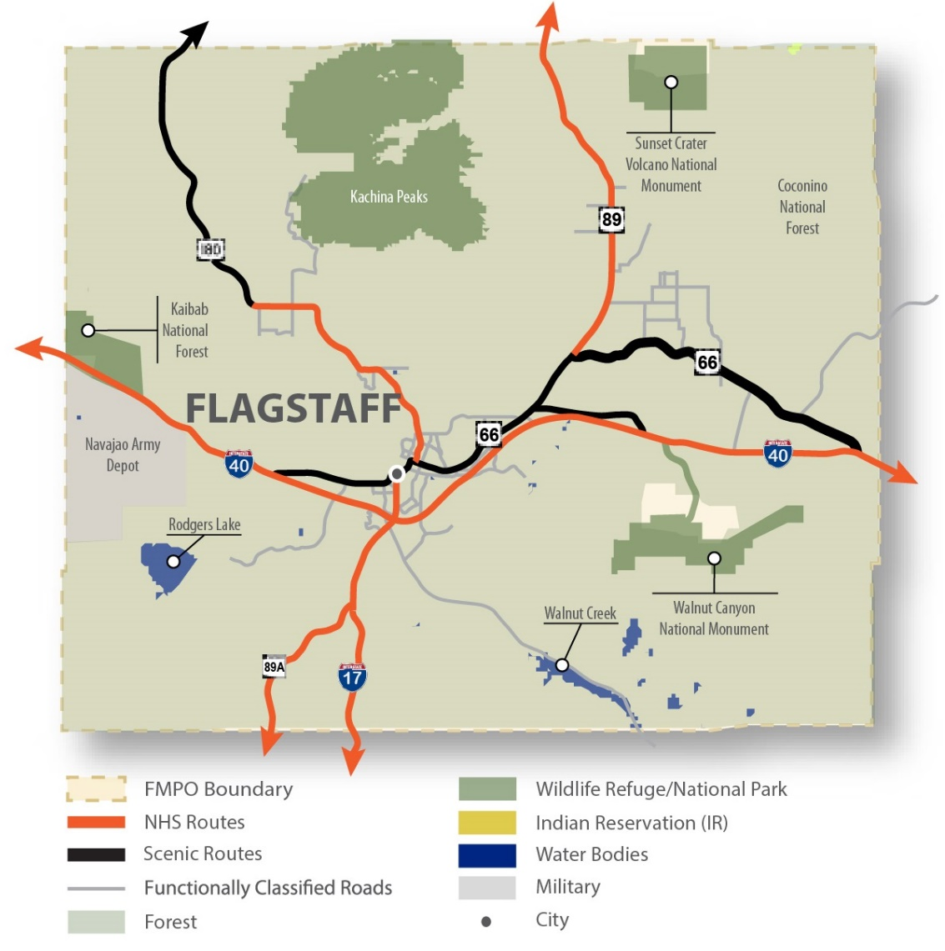
The Flagstaff Metropolitan Planning Organization is responsible for the planning, coordination, and integration of activities necessary to maintain a 3-C multiagency transportation planning program. Jurisdictions that make up FMPO include the city of Flagstaff, Coconino County, and ADOT. The FMPO boundary is shown in Figure 1-5. FMPO receives funding from federal, state, and local governments, and all these governmental agencies work closely together to oversee the expenditure of federal transit funds. Each year, the MPO evaluates and approves proposed surface transportation improvement projects. It also provides a forum for interagency cooperation and public input into how transportation funding is spent through a collaborative decision making processes. FMPO does business under the agency title MetroPlan.

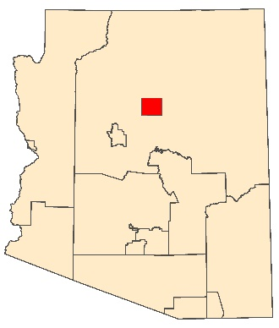
Table 1-7 | FMPO Statistics
FMPO
6 E. Aspen Ave., Ste. 200
Flagstaff, AZ 86001
#: 928-266-1293

www.metroplanflg.org
Flagstaff Metropolitan Planning Organization – FMPO
Year Established | 1996
Hosted/Independent MPO | Independent
Land Area (sq. mi.) | 525
2018 Population | 92,000
Counties | 1 | Coconino
Number of Municipalities | 1
Tribal Partner Agencies | N/A
Primary Travel Corridors | 6 | Interstate: I-17, I-40. US Routes: US 66, US 180. State Routes: SR 89, SR 89A.
Transit | Yes
Airport | Yes
Air Quality Nonattainment or Maintenance | None

Lake Havasu Metropolitan Planning Organization (LHMPO)

Figure 1-6 | LHMPO Regional Area
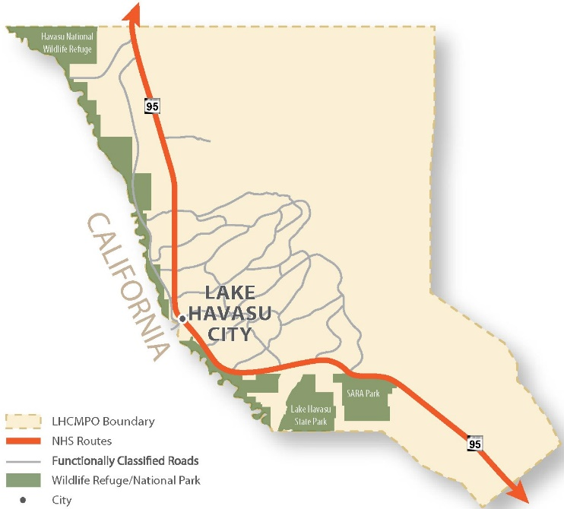
The Lake Havasu MPO is one of three new MPOs in Arizona. It is located in Mohave County in western Arizona, accessed by SR-95. The LHMPO boundary is shown in Figure 1-6. Located along the Colorado River between Yuma and Bullhead City, Lake Havasu City attracts recreationalists, retirees, and vacationers. Throughout the year, the population fluctuates, much like many of the Arizona destinations during the fall, winter, and spring months.

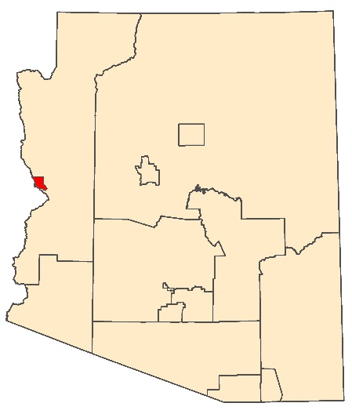
Table 1-8 | LHMPO Statistics
LHMPO
900 London Bridge Rd.
Lake Havasu City, AZ 86404 #: 928-854-0750

http://www.lhmpo.org/
Lake Havasu Metropolitan Planning Organization – LHMPO
Year Established | 2013
Hosted/Independent MPO | Hosted by Lake Havasu City
Land Area (sq. mi.) | 101
2010 Population | 58,400
Counties | 1 | Mohave
Number of Municipalities | 1
Tribal Partner Agencies | N/A
Primary Travel Corridors | 1 | State Routes: SR 95
Transit | Yes
Airport | Yes
Air Quality Nonattainment or Maintenance | None

Sun Corridor Metropolitan Planning Organization (SCMPO)

Figure 1-7 | SCMPO Regional Area
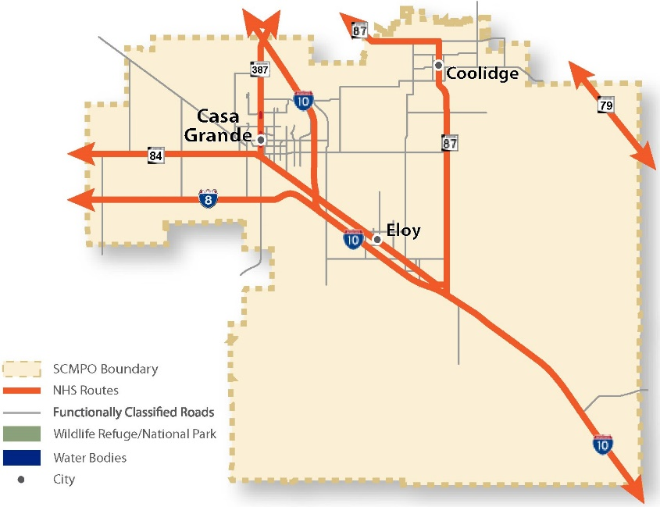
The Sun Corridor MPO is located in Pinal County, between the Phoenix and Tucson metropolitan areas. The SCMPO boundary is shown in Figure 1-7. Casa Grande and some of the neighboring communities formed the Sun Corridor MPO to conduct transportation planning for this region south of MAG in a rapidly developing area of Pinal County. Future planning efforts for I-10, I-8, the CANAMEX corridor, and the future North-South Freeway will play a critical role for the SCMPO.

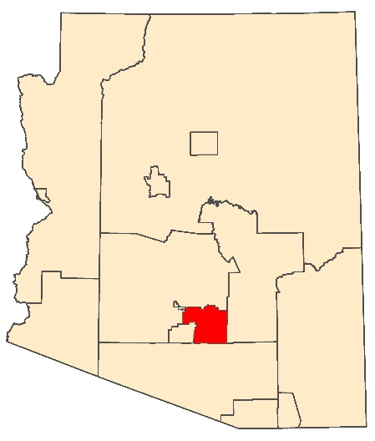
Table 1-9 | SCMPO Statistics
SCMPO
211 N. Florence St, Ste. 103
Casa Grande, AZ 85122
#: 520-705-5143

https://scmpo.org/
Sun Corridor Metropolitan Planning Organization – SCMPO
Year Established | 2013
Hosted/Independent MPO | Hosted by City of Casa Grande
Land Area (sq. mi.) | 1,155
2018 Population | 127,960
Counties | 1 | Pinal
Number of Municipalities | 3
Tribal Partner Agencies | N/A
Primary Travel Corridors | 4 | Interstates: 1-8, 1-10. State Routes: SR 79, SR 84, SR 87, SR 387.
Transit | Yes
Airport | Yes
Air Quality Nonattainment or Maintenance | PM10

Sierra Vista Metropolitan Planning Organization (SVMPO)

Figure 1-8 | SVMPO Regional Area
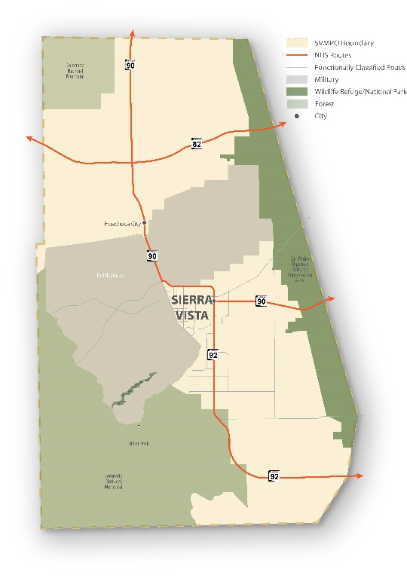
The Sierra Vista MPO is one of three new MPOs in Arizona. Sierra Vista is located in Cochise County, from the Arizona/Mexico border in the south to 8 miles north of the SR 82/90 intersection. The SVMPO boundary is shown in Figure 1-8. It is approximately 30 miles east of the Nogales Port of Entry and 30 miles west from the Douglas Port of Entry. State Route 90 provides access to Interstate 10 to the north, State Route 92 to the south provides access to Douglas, and State Route 82 provides access southwest to the Nogales Port of Entry. The MPO includes the Fort Huachuca Army Base. The lands east and west of Sierra Vista include the San Pedro Riparian National Conservation Area and the Coronado National Forest, respectively.

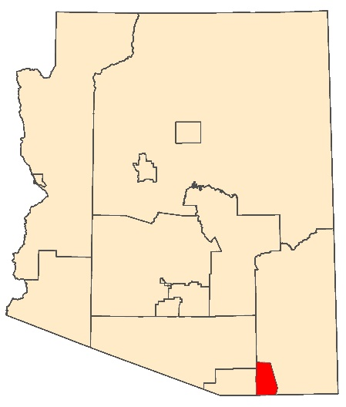
Table 1-10 | SVMPO Statistics
Sierra Vista Metropolitan Planning Organization – SVMPO
Year Established | 2013
Hosted/Independent MPO | Hosted
Land Area (sq. mi.) | 614
2018 Population Estimate | 70,446
Counties | 1 | Cochise
Number of Municipalities | 2
Tribal Partner Agencies | N/A
Primary Travel Corridors | 3 | State Routes: SR 82, SR 90, SR 92
Transit | Yes
Airport | Yes
Air Quality Nonattainment or Maintenance | None
SVMPO
410 Giulio Cesare Ave.
Sierra Vista, AZ 85635
#: 520-515-8525

https://www.sierravistaaz.gov/department/index.php?structureid=318
Yuma Metropolitan Planning Organization (YMPO)

Figure 1-9 | YMPO Regional Area
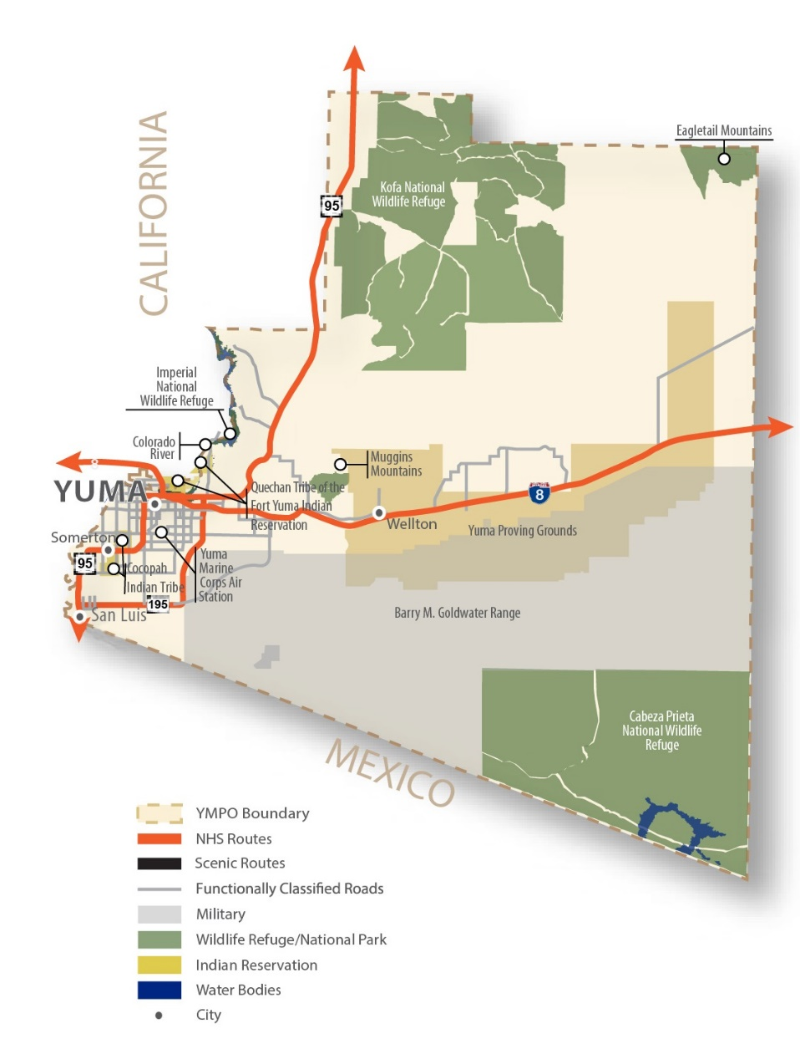
The Yuma MPO is the leader for coordinating regional transportation and land-use planning with innovative communication and solutions in Yuma County. The jurisdictions that compose the YMPO are: the cities of Yuma, Somerton, and San Luis; Yuma County; the town of Wellton; Cocopah Indian Tribe; and ADOT. The YMPO planning area also includes the Winterhaven community in Imperial County, California, across the Colorado River from the city of Yuma. Although Winterhaven and the Fort Yuma Indian Reservation (Quechan Tribe) are within the YMPO planning boundaries, they are not members of YMPO’s Technical Advisory Committee (TAC) or the Executive Board. YMPO’s boundary is shown in Figure 1-9.
The YMPO area experiences a major influx of part-time residents each year including, migrant workers, winter visitors, and military officials. Additionally, YMPO experiences border traffic including migrant workers, day laborers, freight traffic, visitors, and those crossing the border on bicycle or on foot. These factors create unique challenges for the planning, operation, and maintenance of the transportation system.

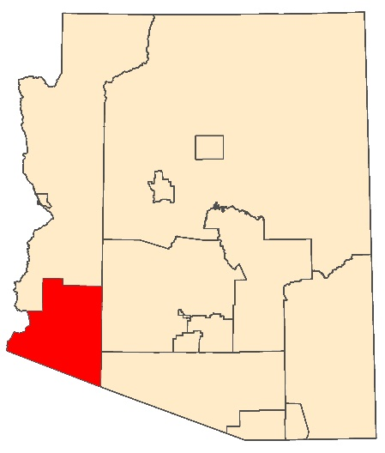
Table 1-11 | YMPO Statistics
YMPO
502 S. Orange Ave.
Yuma, AZ 85364
#: 928-783-8911

https://ympo.org/
Yuma Metropolitan Planning Organization – YMPO
Year Established | 1983
Hosted/Independent MPO | Independent
Land Area (sq. mi.) | 5,519
2018 Population | 211,612
Counties | 1 | Yuma
Number of Municipalities | 4
Tribal Partner Agencies | 2 | Cocopah Indian Tribe, Quechan Tribe of the Fort Yuma Indian Reservation
Primary Travel Corridors | 3 | Interstate: I-8. US Highway: US 95. State Route: SR 195
Transit | Yes
Airport | Yes
Air Quality Nonattainment of Maintenance | Ozone (8 hr), PM10

1.7 | COUNCILS OF GOVERNMENTS
Funding for COG programs and projects are described in chapter 10.
A COG is a regional body with voluntary membership that provides a forum for regional transportation planning, collaboration, and decision making in regions comprising several counties with a total contiguously urbanized population of less than 50,000. COGs work with ADOT and other partners to facilitate cross-agency regional transportation discussions and develop transportation plans and programs for their regions as outlined in the GRT and the Work Program (WP). Arizona has four COGs. The COGs are the primary communications channel between ADOT and the rural local governments.

COG

1.7.1 | Structure
Through Executive Order 70-2, planning boundaries were established by Governor Jack Williams in 1970 in response to federal planning requirements and to achieve uniformity in various planning areas. Arizona’s four COGs formed within these planning boundaries as voluntary associations. In rural areas of Arizona, the COGs perform transportation planning services and also provide direct service functions, such as operating the Area Agency on Aging, Head Start programs, and employment programs.

1.7.2 | Funding
Funding for COGs typically comes from federal, state, and local governments. ADOT discretionary funds, including SPR and STBG funds are distributed to COGs and can be used for operating expenses and transportation projects based upon ADOT approval, and included in the WP.

1.7.3 | Products
Each COG is responsible for producing and completing the following:
- Work Program (WP)
- Transportation Improvement Program (TIP)
- Public Participation Plan
- Title VI Plan
- Regional Coordination Plan

1.7.4 | COGs in Arizona
Outside of MPO and TMA boundaries, COGs serve rural sections of the state. There are four COGs in Arizona outside of the TMAs and MPOs including Central Arizona Governments (CAG), Northern Arizona Council of Governments (NACOG), South Eastern Arizona Governments Organization (SEAGO), and Western Arizona Council of Governments (WACOG).

Central Arizona Governments (CAG)

Figure 1-10 | CAG Regional Area
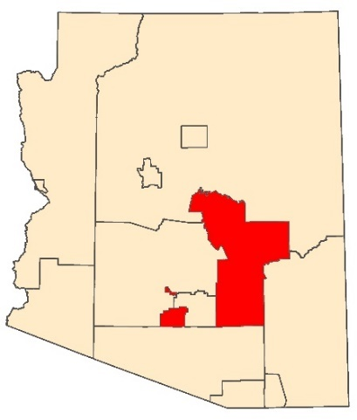
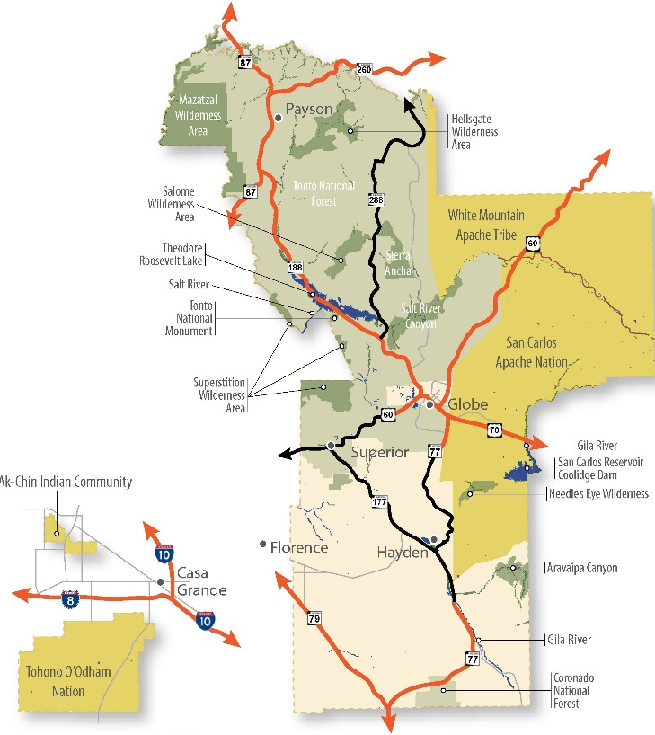
Central Arizona Governments is a COG that serves as the regional planning agency for the rural portions of Pinal and Gila counties, which together comprise approximately 10,170 square miles in southern central Arizona. CAG’s member agencies include the two counties, 17 municipalities, and five Native American nations: the Ak-Chin Indian Community, the Gila River Indian Community, the San Carlos Apache Nation, the Tohono O’odham Nation, and the White Mountain Apache Tribe. CAG’s boundary is shown in Figure 1-10.
CAG
2540 Apache Trail
Apache Junction, AZ 85120
#: 480-474-9300

http://www.cagaz.org/

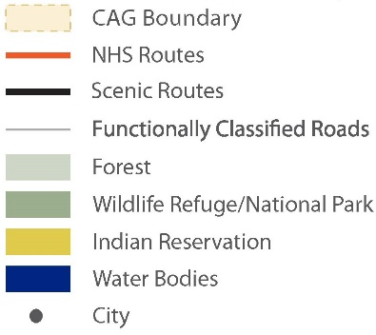

Table 1-12 | CAG Statistics
Central Arizona Governments – CAG
Year Established | 1970
Hosted/Independent COG | Independent
Land Area (sq. mi.) | 7,586
2018 Population Estimate | 187,442
Counties | 2 | Pinal, Gila
Number of Municipalities | 17
Tribal Partner Agencies | 5 | Ak-Chin Indian Community, Gila River Indian Community, San Carlos Apache Nation, Tohono O’odham Nation, and White Mountain Apache Tribe
Primary Travel Corridors | 8 | US Routes: US 60, US70. State Routes: SR 77, SR 79, SR 87, SR 177, SR 188, SR 260.
Transit | Yes
Airport | Yes
Air Quality Nonattainment or Maintenance | Lead, PM10, Sulfur Dioxide

Northern Arizona Council of Governments (NACOG)

Figure 1-11 | NACOG Regional Area
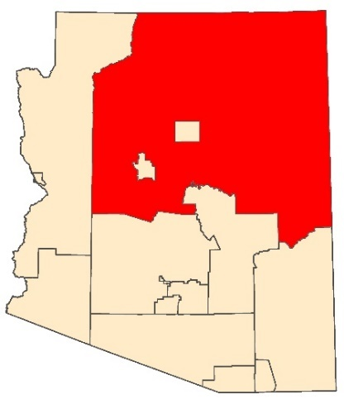
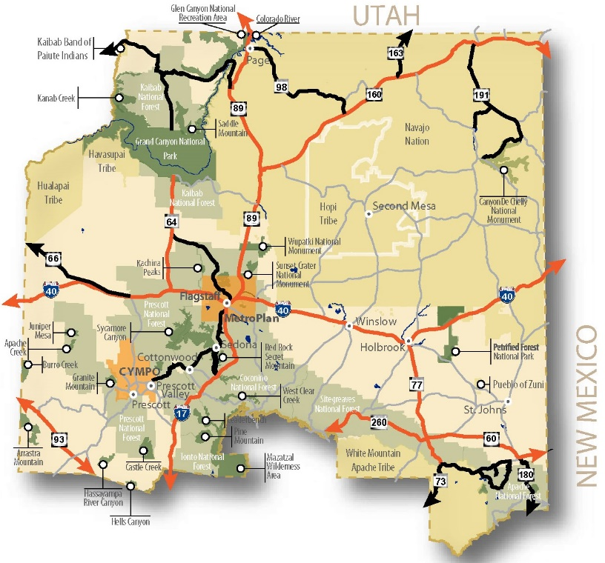
Northern Arizona Council of Governments is a nonprofit membership corporation that represents rural local governments within the four Arizona counties of Apache, Coconino, Navajo, and Yavapai. This vast four-county region covers approximately 48,000 square miles and had a combined population of 318,375 in the 2010 Census. Thus, it encompasses about 42 percent of Arizona’s area but accounts for only 8 percent of the state’s population. NACOG’s boundary is shown in Figure 1-11. NACOG’s member jurisdictions include the four counties, 22 municipalities, and seven Native American tribes.
NACOG
119 E. Aspen Ave.
Flagstaff, AZ 86001
#: 928-774-1895

https://www.nacog.org/

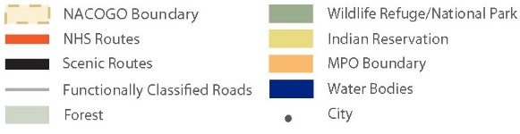

Table 1-13 | NACOG Statistics
Northern Arizona Council of Governments – NACOG
Year Established | 1975
Hosted/Independent COG | Independent
Land Area (sq. mi.) | 47,046
2018 Population | 329,786
Counties | 4 | Apache, Coconino, Navajo, Yavapai
Number of Municipalities | 22
Tribal Partner Agencies | 7 | Navajo Nation, Hopi Tribe, Havasupai Tribe, Hualapai Tribe, Kaibab Band of Paiute Indians, White Mountain Apache Tribe, Pueblo of Zuni
Primary Travel Corridors | 10 | Interstates: I-40, I-17. US Routes: US 60, US 163, US 180. State Routes: SR 64, SR 73, SR 77, SR 98, SR 260.
Transit | Yes
Airport | Yes
Air Quality Nonattainment or Maintenance | None

Southeastern Arizona Governments Organization (SEAGO)

Figure 1-12 | SEAGO Regional Area
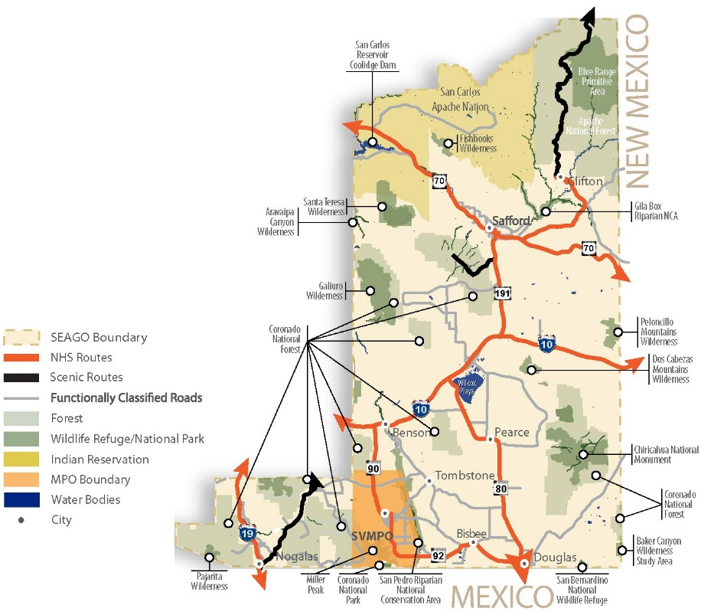
South Eastern Arizona Governments Organization is a rural regional planning agency for the area consisting of Cochise, Graham, Greenlee, and Santa Cruz counties. Its 19-member jurisdictions include the four counties, 14 municipalities, and the San Carlos Apache Tribe. The SEAGO region, as shown in Figure 1-12, has a combined area of 13,946 square miles.

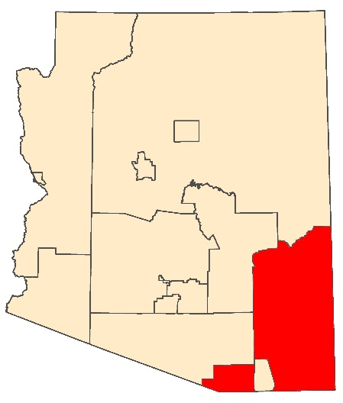
Table 1-14 | SEAGO Statistics
SEAGO
1403 W. Hwy. 92
Bisbee, AZ 85603
#: 520-432-5301

https://www.seago.org/
Southeastern Arizona Governments Organization – SEAGO
Year Established | 1972
Hosted/Independent MPO | Hosted by City of Bisbee
Land Area (sq. mi.) | 13,346
2018 Population | 150,309
Counties | 4 | Cochise, Graham, Greenlee, Santa Cruz
Number of Municipalities | 14
Tribal Partner Agencies | 1 | San Carlos Apache Nation
Primary Travel Corridors | 13 | Interstates: I-10, I-19. US Routes: US 70. State Routes: SR 90, SR 92, SR 80, SR 191
Transit | Yes
Airport | Yes
Air Quality Nonattainment or Maintenance | PM10, PM2.5, Sulfur Dioxide

Western Arizona Council of Governments (WACOG)

Figure 1-13 | WACOG Regional Area
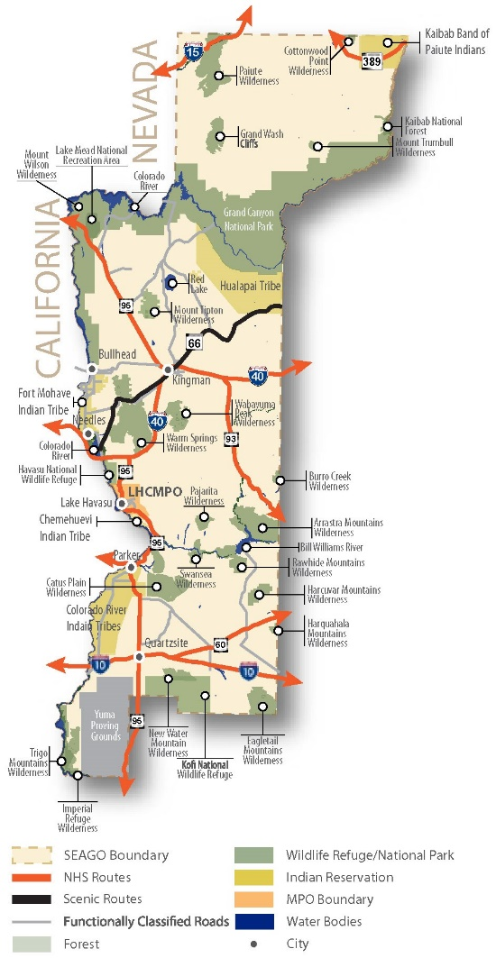
Western Arizona Council of Governments is a voluntary association of rural local governments serving La Paz, Mohave, and Yuma counties, which total about 23,500 square miles, or 20 percent of the state’s total area, whereas the region’s population of 165,172 residents in 2010 represented only 6.5 percent of Arizona’s population. WACOG’s member entities include three counties and 10 municipalities. WACOG’s boundary is shown in figure 1-13.
The WACOG planning area is bordered by the Colorado River, California, and Nevada to the west, by Utah to the north, and by Mexico to the south. Some cities along the Mexican border and other YMPO member cities have experienced significant growth. Additionally, the winter visitor population adds over 100,000 additional temporary residents to Yuma County.

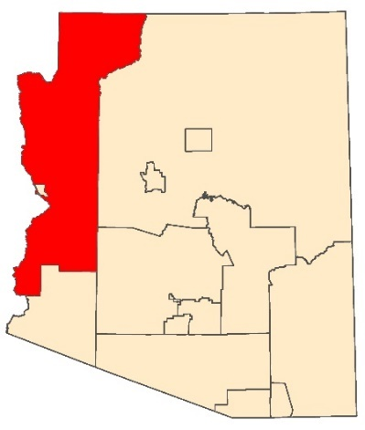
Table 1-15 | WACOG Statistics
WACOG
208 N. 4th St.
Kingman, AZ 86401
#: 928-753-6247

https://www.wacog.com/
Western Arizona Council of Governments – WACOG
Year Established | 1971
Hosted/Independent MPO | Independent
Land Area (sq. mi.) | 17,893
2018 Population | 180,670
Counties | 2 | La Paz, Mohave
Number of Municipalities | 7
Tribal Partner Agencies | 5 | Kaibab Band of Paiute Indians, Hualapai Tribe, Fort Mohave Indian Tribe, Chemehuevi Indian Tribe, Colorado River Indian Tribes
Primary Travel Corridors | 10 | Interstate: I-10, I-15, I-40. US Highways: US 60, US 93, US 95. State Routes: SR 389, SR 66, SR 68, SR 72.
Transit | Yes
Airport | Yes
Air Quality Nonattainment or Maintenance | None

1.8 | REGIONAL TRANSPORTATION PLANNING ORGANIZATIONS
The December 4, 2015 FAST Act legislation recognizes a planning entity category called a Regional Transportation Planning Organization (RTPO). The state of Arizona is not designating COGs as RTPOs. Based on the federal definition of an RPTO, COGs in Arizona perform similar functions with the exception of the requirement to develop an RTP. Prior to making any changes in the current COG structure, ADOT must determine the financial ramifications and feasibility of changing this designation.

1.9 | CONTACT INFORMATION
Table 1-16 provides the primary contact information for the TMAs, MPOs, and COGs in Arizona.

Table 1-16 | Arizona COGs, MPOs, and TMAs
Organization |  | Contact Information | Organization |  | Contact Information
TMA | MAG | 302 N. 1st Ave., Ste. 300  Phoenix, AZ 85003  #: 602-254-6300  https://www.azmag.gov/ | MPO | CYMPO | 1971 Commerce Center Circle, Ste. E  Prescott, AZ 86301  #: 928-442-5730  https://www.cympo.org/
 | PAG | 1 E. Broadway Blvd., Ste. 401  Tucson, AZ 85701  #: 520-792-1093  http://www.pagregion.com/ |  | FMPO | 6 E. Aspen Ave., Ste. 200  Flagstaff, AZ 86001  #: 928-266-1293  https://www.metroplanflg.org/
COG | CAG | 2540 Apache Trail  Apache Junction, AZ 85120  #:480-474-9300  http://www.cagaz.org/ |  | LHMPO | 900 London Bridge Rd.  Lake Havasu City, AZ 86404  #: 928-453-2823  http://www.lhmpo.org/
 | NACOG | 119 E. Aspen Ave.  Flagstaff, AZ 86001  #: 928-774-1895  https://www.nacog.org/ |  | SCMPO | 211 N. Florence St., Ste. 103  Casa Grande, AZ 85122  #: 520-705-5143  https://scmpo.org/
 | SEAGO | 1403 W. Hwy. 92  Bisbee, AZ 85603  #: 520-432-5301  https://www.seago.org/ |  | SVMPO | 410 Giulio Cesare Ave.  Sierra Vista, AZ 85635  #: 520-515-8525  https://www.svmpo.org/
 | WACOG | 208 N. 4th Street  Kingman, AZ 86401  #: 928-753-6247  https://www.wacog.com/ |  | YMPO | 502 S. Orange Ave.  Yuma, AZ 85364  #: 928-783-8911  https://ympo.org/

2 | FEDERAL AND STATE PLANNING PARTNERS
TABLE OF CONTENTS
2.1 | ADOT MULTI-MODAL PLANNING DIVISION
2.1.1 | Systems & Regional Planning
Studies, Plans, & Programs
2.1.2 | Transportation Programming
ADOT Five-Year Transportation Facilities Construction Program
State Transportation Improvement Program
State Implementation Plan
2.1.3 | Transportation Plans
Long-Range Transportation Plan
Arizona State Rail Plan
Arizona State Airports System Plan
2.1.4 | Transit Programs & Grants
Rail Transit State Safety Oversight Program
2.1.5 | Data Management & Analysis
Data Collection & Analysis
Geographic Information Systems
Travel Demand Modeling
2.1.6 | Planning & Environmental Linkages
2.1.7 | Corridor Planning Studies
2.1.8 | Sustainability
2.1.9 | Aeronautics
2.1.10 | Finance & Contract Administration
2.1.11 | Transportation Research Center
2.2 | FEDERAL PARTNER AGENCIES
2.2.1 | Federal Highway Administration
Central Federal Lands Highway Division
FHWA Arizona Division
2.2.2 | Federal Transit Administration
FTA Region 9
2.2.3 | Federal Railroad Administration
FRA Region 7
2.2.4 | Federal Aviation Administration
FAA Western-Pacific Region
2.2.5 | Department of Housing & Urban Development
2.2.6 | Environmental Protection Agency
EPA Region 9
2.2.7 | Bureau of Indian Affairs
BIA Western Region
2.3 | CONTACT INFORMATION

| Federal and State Planning Partners
ADOT MPD maintains a comprehensive website that houses extensive information regarding the functions of division staff, procedural items, directives, organizational descriptions, and contact information for all programs. Various website topics are referenced throughout this manual.

There are numerous state and federal planning partners that provide assistance, guidance and oversight for various funding, operating and decision-making processes that Arizona’s MPOs and Arizona’s COGs facilitate. Most of these programs involve coordinating with the ADOT regional planners or a specific section of ADOT MPD. This collaborative effort is the core purpose for this manual by providing a broader perspective and understanding of common practices.
Throughout this manual, there are examples of best practices on relevant topics. These examples provide a contact for each topic so the other MPOs and COGs can directly work with those practitioners for guidance or insight. This chapter focuses on the primary planning partners from the state and federal levels that routinely interact with our Arizona MPOs and COGs.
Figure 2-1 is a simplified illustration of the interrelationships of how ADOT and Arizona’s planning partners must coordinate with each other. In most cases, federal and state funding used by MPOs and COGs must be administered by ADOT; however, there are several instances when the MPO or a tribal agency coordinates directly with the federal funding partner.

2.1 | ADOT MULTI-MODAL PLANNING DIVISION
ADOT MPD is committed to providing the highest quality transportation research, plans, and programs to the public. This commitment instills excellence in practice internally, and excellence in coordination and communication externally. Much of this external communication is with our MPOs and COGs as they are a critical component to provide local agency coordination. The central objective of ADOT MPD is to help identify current significant transportation issues in Arizona as well as improve existing systems. ADOT MPD is also committed to researching and planning the development of supporting strategies necessary to optimize investment to preserve and expand the state’s transportation infrastructure. The state relies heavily on using federal funding to make these infrastructure investments, so many of our programs mirror the federal funding program administration processes. Figure 2-2 provides an organization chart of the ADOT MPD sections.

Figure 2.1 | Federal Agency Coordination
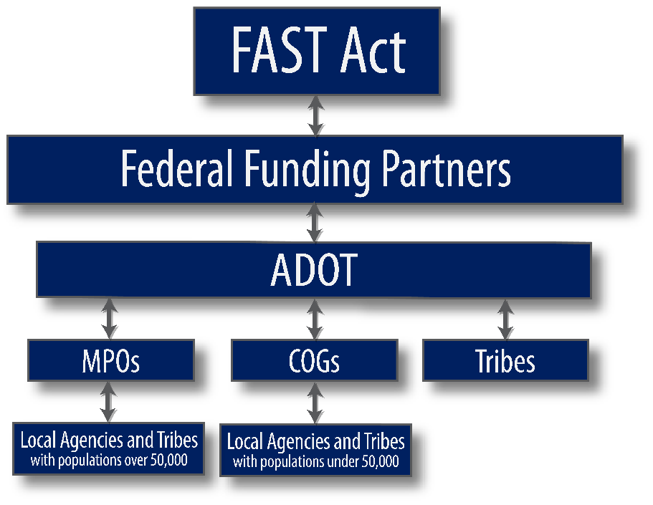

2.1.1 | Systems & Regional Planning
The Systems and Regional Planning Section works with its planning partners to facilitate multi-modal planning activities. In addition to managing transportation studies for the state highway system, the section actively participates in planning activities with our regional planning partners. These partners include Arizona’s MPOs, COGs, federal agencies, Indian tribes, counties, cities, transit providers, the public, and other stakeholders. ADOT MPD maintains a staff of approximately 70 professionals to manage and support the programs identified below.
Cross reference chapter 7, “Metropolitan/Regional Transportation Plan” for further information.

Figure 2.2 | ADOT MPD Organization Chart
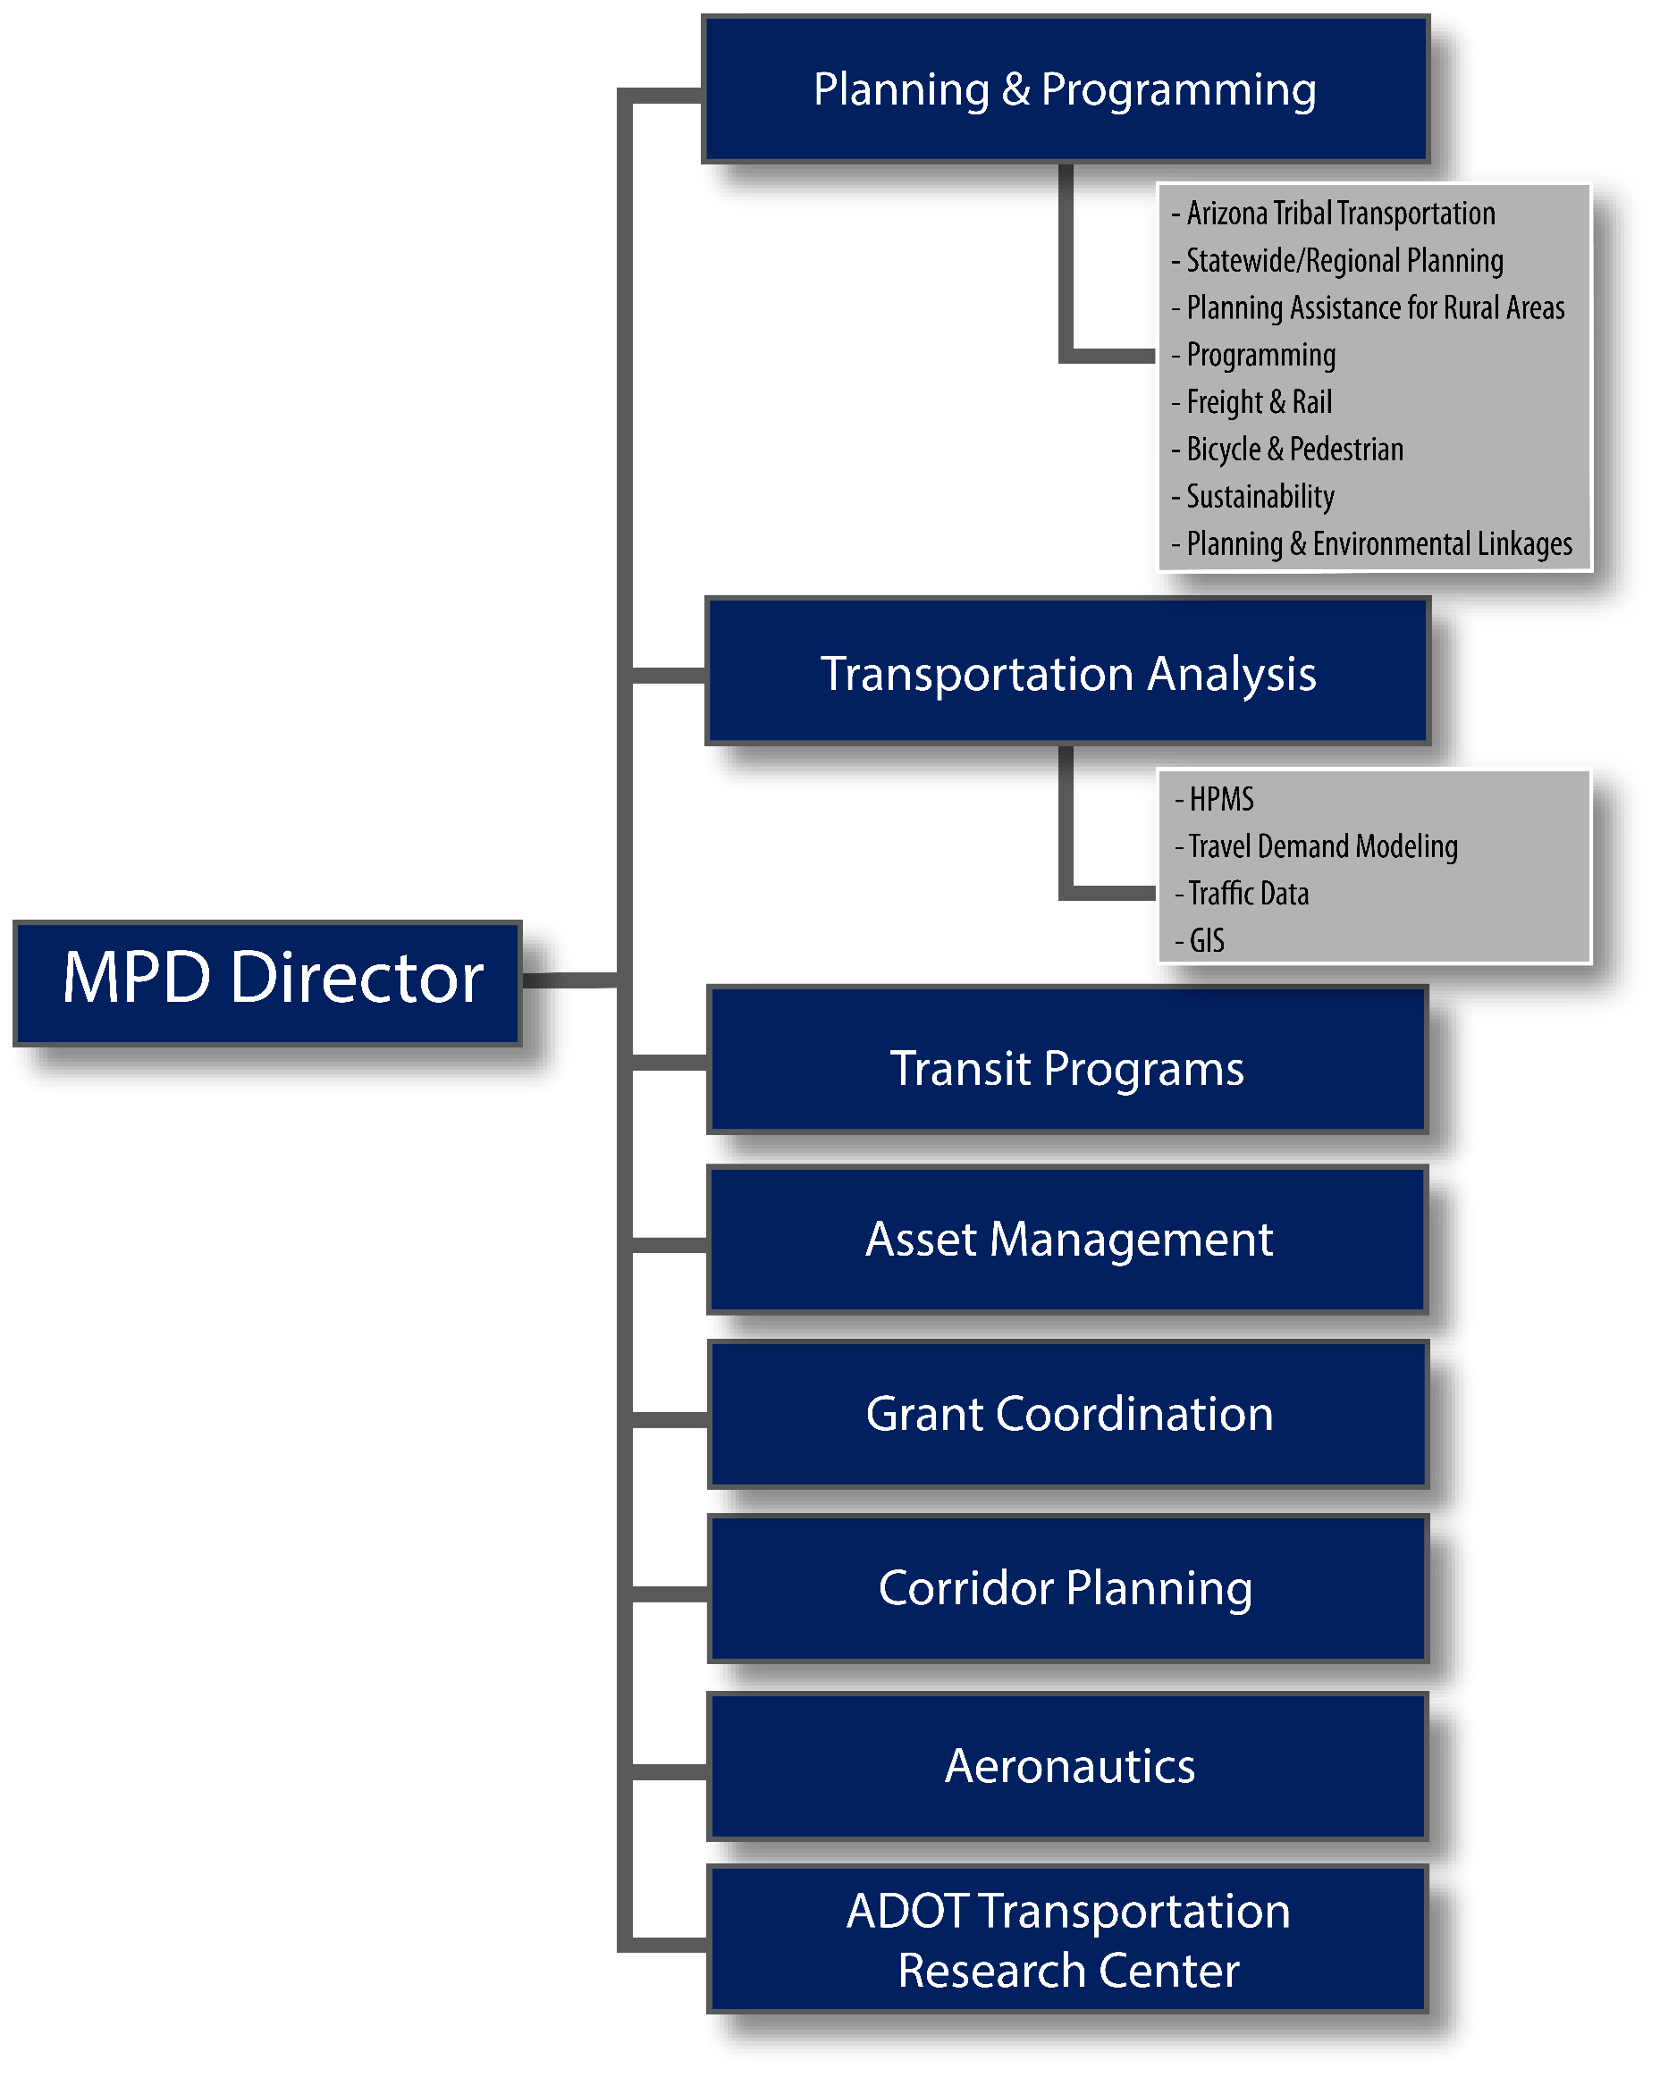

Studies, Plans, & Programs
Arizona Tribal Transportation
Native nations and tribal governments have sovereign status and jurisdiction over lands within reservation boundaries as defined by federal law 18 U.S.C. § 1151, but ADOT has exclusive control and jurisdiction over state highways within reservation boundaries, as defined in A.R.S. § 28-332(A). Approximately 1,219 miles or 19.8 percent of Arizona’s state highway system crosses tribal lands. To facilitate needed state-tribal discussion, coordination, and consultation, ADOT’s Tribal Transportation Program focuses on transportation-related partnerships, projects, and activities. ADOT has tribal planning coordinators assigned to work with each Arizona tribal entity.
Just as transportation issues and problems do not end at a city boundary, they also are not confined by reservation boundaries; often they are regional in nature. Accordingly, tribes are eligible and welcome (but not required) to participate in regional transportation planning processes as members of COGs or MPOs. Tribal membership in Arizona’s COGs and MPOs is discussed on the Arizona Tribal Transportation website in the Frequently Asked Questions section.
ADOT Transportation Planning and Programming Guidebook for Tribal Governments:
http://www.aztribaltransportation.org/PDF/Transportation_Planning_Programming_Gdbk_Tribal_Govts.pdf
Arizona Tribal Transportation:

http://www.aztribaltransportation.org/
Federal laws and regulations have a number of provisions pertaining to transportation on tribal lands. The regulations for these programs state that a participating tribe must inform the state DOT, and as appropriate, any MPO on its transportation planning process to ensure any programs and projects adjacent to tribal lands are consistent and appropriate with tribal needs and interests.
Bicycle & Pedestrian Program
The Bicycle and Pedestrian Program is designed to provide a wide variety of resources pertaining to biking and walking in Arizona, including information about places to bike and walk, how to integrate biking and walking into your commute, important laws and policies, safety issues, maps, and organizations.
ADOT has a bicycle and pedestrian program coordinator who monitors all state statutes, federal requirements, and recommended practices for the design and inclusion of bicycle facilities. ADOT maintains a bicycle and pedestrian website that provides information on:
ADOT Bicycle and Pedestrian Program:
http://www.azbikeped.org/
- bicycling;
- walking;
- maps;
- state and federal laws and policies;
- Arizona Statewide Bicycle and Pedestrian Plan;
- educational materials; and
- contact information.
FHWA funding for bicycle and pedestrian planning and construction activities is administered under a Surface Transportation Block Grant (STBG) program. The FAST Act converted the long-standing Surface Transportation Program into STBG. This is described in chapter 10, “Financial Planning and Programming.”
Freight Program
The freight program is designed to assist in facilitating safe and efficient freight movement in Arizona. The ADOT Freight & Rail Planner provides technical assistance, coordination and oversight for freight- and rail-related activities in the state. Freight and railroad activity have a direct correlation to economic development and the state’s ability to facilitate commerce.
ADOT Railroad Planning:
https://azdot.gov/planning/transportation-programs/state-rail-plan
Planning Assistance for Rural Areas
On an annual basis, ADOT MPD assesses its priorities and funding capability to conduct studies under the Planning Assistance for Rural Areas (PARA) program. The PARA program is sponsored by ADOT MPD and provides federal State Planning and Research (SPR) funds to non-metropolitan communities for the purpose of conducting transportation planning studies. Eligible applicants include all counties, cities, towns, and tribes located outside of TMA planning boundaries. The PARA program was placed on hiatus after fiscal year 2018.
PARA funds are limited to planning applications and may not be used for the design or construction of transportation facilities. PARA funds may be applied to address a broad range of planning issues related to roadway and non-motorized transportation modes. Funds may also be applied to studies dedicated to the planning solely of public transportation services and the development of new programs and processes. COGs and MPOs typically provide letters of support for jurisdictions applying for PARA funds and serve as Technical Advisory Committee members.
ADOT Planning Assistance for Rural Areas (PARA):
https://azdot.gov/planning/transportation-programs/planning-assistance-rural-areas-para-program
The PARA program coordinator facilitates the PARA process annually. The application process and common questions and answers regarding the PARA program can be found on the ADOT MPD website on the PARA program page. All completed and in-progress PARAs are also located on the PARA program website.
Transportation Consultation with Rural Officials Policy
ADOT is the primary decision maker for federal-aid transportation plans and investments in non-metropolitan areas with populations less than 50,000 (COG areas). However, ADOT understands the importance of consulting with local governments before, during, and after the decision-making process to ensure that participation results in improved transportation system planning, performance and project development decisions.
The Rural Officials Policy outlines a cooperative process between ADOT and the COGs and MPOs to consult with public officials on a yearly basis.
The primary guidelines for state consultation with non-metropolitan local officials are contained in the FHWA and FTA joint rule making, “Statewide and Metropolitan Planning: Part 450 Planning Assistance and Standards” (Federal Register February 14, 2007). According to 23 C.F.R. § 450.210(b), “at least once every five years (as of February 24, 2006), the State shall review and solicit comments from non-metropolitan local officials and other interested parties for a period of not less than 60 calendar days regarding the effectiveness of the consultation process and any proposed changes. A specific request for comments shall be directed to the State association of counties, State municipal league, regional planning agencies, or directly to non-metropolitan local officials.”
ADOT Transportation Consultation with Rural Officials Policy:
https://azdot.gov/planning/transportation-planning/transportation-consultation-rural-officials-tcro
This consultation policy is subject to review and revision by ADOT every five years. It may be immediately revised in the event that Congress enacts new transportation language. This is typically contained in the current transportation legislation (FAST Act).

2.1.2 | Transportation Programming
State law mandates ADOT to be responsible for planning, constructing, and maintaining all interstate and state highways in Arizona and providing financial assistance to public airports for airport development projects. Fulfilling this responsibility requires extensive public participation and a sophisticated technical evaluation referred to as the Priority Programming Process. The process culminates in the ADOT Five-Year Transportation Facilities Construction Program for Highways and Airports.
ADOT Five-Year Transportation Facilities Construction Program
The ADOT Five-Year Transportation Facilities Construction Program for Highways and Airports identifies projects on the state highway system and at airports during the next five years. All projects in the first two years of the program are to be fully funded and ready to advertise within the year programmed or sooner as determined by the ASTB. The last three years of the program are to be illustrative in nature and used to establish an implementation plan for projects moving through the project development phases needed prior to construction. This process is generally outlined in the ADOT Local Public Agency Projects Manual.
The Priority Planning Advisory Committee (PPAC)is a statutory public body appointed by the director of ADOT and subject to A.R.S. Title 38: Open Meeting Laws of Arizona. The committee is responsible for updating and preparing the Five-Year Transportation Facilities Construction Program. The PPAC is an internal ADOT committee composed largely of high-level department managers.
State Transportation Improvement Program
All highway and transit projects in the state, funded under Title 23 (Highway) and Title 49 (Transit) must be included in a federally approved State Transportation Improvement Program (STIP). Projects in the STIP must be consistent with the statewide Long-Range Transportation Plan (LRTP) and all metropolitan TIPs. The program must reflect reasonably expected funding and priorities for programming, including transportation alternatives (TA). The STIP is typically a four-year program but may include up to 10 years when updated yearly. MPOs and COGs must submit their approved TIPs to ADOT by August 1 annually. The STIP includes the ADOT Five-Year Transportation Facilities Construction Program, The COG TIPs and the Metropolitan TIPs.
Cross reference chapter 8, “Transportation Improvement Program” for further information on TIPs.
State Implementation Plan
The State Implementation Plan (SIP) is the cumulative record of all air pollution strategies, state statutes, state rules, and local ordinances implemented under Title I of the Clean Air Act by governmental agencies within Arizona. Revisions to Arizona’s SIP must be submitted to the U.S. Environmental Protection Agency (EPA) by the director of the Arizona Department of Environmental Quality (ADEQ) on behalf of the governor. Once approved by the EPA and published in the Federal Register, the provisions contained in the SIP revision become enforceable by the federal government as well as by the appropriate governmental entities of Arizona. The cumulative and complete record of SIP revisions that have been approved by the EPA and are federally enforceable in Arizona is referred to as the “applicable Arizona SIP.”
The Clean Air Act Amendments (CAAA) requires MPOs within nonattainment areas to perform conformity determinations prior to the approval of their Regional Transportation Plans (RTPs) and TIPs. These conformity determinations show that the STIP, as a product of all the regional TIPs, is consistent with the air quality goals in the applicable Arizona State Implementation Plans (SIPs).
In addition to ADEQ, there are local air planning organizations that share in the responsibility of completing SIP requirements. MAG and PAG are MPOs that are responsible for completing SIP revisions for their respective county areas. The SIP requirements relate directly with programmed projects in the Five-Year Transportation Facilities Construction Program and qualifying events on key local roadways. Chapter 17 outlines key aspects of the air quality processes.

2.1.3 | Transportation Plans
Arizona has several key transportation plans that all COGs and MPOs should reference as they develop their localized transportation plans. They include the What Moves You Arizona 2040 and the Arizona State Rail Plan (SRP). These two documents outline the investment choices for Arizona for a 25-year period. In addition, ADOT has a Border Master Plan from 2031 that outlines mobility investment choices for the Arizona-Mexico border. In 2019, ADOT is updated the Strategic Traffic Safety Plan (STSP) that outlines the way safety funds are to be prioritized for future programming.
Long-Range Transportation Plan
What Moves You Arizona 2040 is the ADOT LRTP. It defines the visionary, yet pragmatic, investment choices Arizona intends to make over a 25-year period to maintain and improve its multi-modal transportation system. The plan is not rigid or fixed. It is part of a continual process of planning, implementation, operation, and preservation that evolves over time to reflect and be responsive to future changes in needs, resources, and priorities. The plan advances the BqAZ vision by defining a preferred investment strategy. The plan also:
- provides strategic direction to guide future investments for all transportation modes, but does not identify a specific list of projects for implementation;
- documents existing conditions with an eye toward future trends that could influence both system performance and investment needs;
- defines state transportation system goals, objectives, and performance measures that reflect input from Arizona’s stakeholders and transportation planning partners;
- incorporates the comprehensive land use and 2050 vision developed in BQAZ as a framework for the state’s desired future;
- recognizes that ADOT’s role is evolving from a traditional highway agency toward a more multi-modal transportation department;
- assesses future needs and anticipated revenues for the state’s multi-modal transportation network;
- considers an array of outcome-based programmatic investment choices to illustrate likely future system performance under different investment mixes;
- establishes ADOT’S Recommended Investment Choice (RIC), which provides the department with a capital investment strategy through 2040 and meets federal and state requirements for long-range statewide transportation planning;
- is fiscally constrained— that is, the RIC at baseline includes no new taxes and applies realistic, conservative revenue growth rates coupled with modest assumptions about inflation; and
- focuses on implementation not only through developing the RIC but also by acknowledging necessary changes to mid- and long-range policies, planning and programming linkages, and interagency partnerships.
Arizona State Rail Plan
The Arizona SRP is the first comprehensive assessment of the state’s rail needs and was initiated in response to the increasing involvement by ADOT in freight and passenger rail issues. The SRP assesses the current rail system, determines infrastructure needs, and includes rail projects in the state’s long-range planning processes to improve regional and statewide safety and mobility. The principal purpose is to convey the magnitude of rail needs in the state and set forth a policy framework through which strategic actions can be taken to realize the full potential of passenger and freight rail transportation.
Cross reference chapter 15, “Freight & Rail” for further information on the ASRP.
Arizona State Airports System Plan
ADOT Public Transportation
State Management Plan

https://azdot.gov/sites/default/files/2019/05/2018-adot-state-management-plan.pdf
Within ADOT MPD, the ADOT Aeronautics Group (Aeronautics) has long recognized the importance of planning as a proactive approach to ensuring aviation continues its role in the statewide transportation system. The Arizona State Aviation System Plan (SASP) for Arizona was first developed in 1978. Since then, Aeronautics has diligently updated various components of the system plan, conducting various elements of a Continuous Airport System Planning Process (CASPP). These components include the State Aviation Needs Study (SANS), economic impact studies, the Arizona Rural Air Service Study, the Navigational Aids and Aviation Services Study, recreational airport studies, and other special studies.
The 2008 Arizona SASP is a comprehensive update to the 1978 study. The purpose of this plan is to provide a framework for the integrated planning, operation, and development of Arizona’s aviation assets. This plan enables Aeronautics to remain current with industry trends and to determine how Arizona’s airports can be optimally positioned to respond to future aviating needs and challenges.
Cross reference chapter 16, “Aeronautics” for further information on the SASP.

2.1.4 | Transit Programs Grants
The role of the Transit Programs & Grants section within the ADOT MPD is to ensure a multi-modal approach to mobility, congestion, and air quality issues throughout the state. Transit Programs & Grants staff administers several FTA grant programs, provides technical assistance and expertise to local transit agencies and decision makers, coordinates and funds state transit and rail planning efforts, and sets and monitors light rail system safety standards. The Transit Programs & Grants section staff is responsible for producing the Public Transportation State Management Plan. Through these efforts, the Transit Programs & Grants staff is dedicated to working with their partners to create better communities by identifying and providing options for safe and reliable public transportation. Chapter 14 has detailed information regarding the transit programs in Arizona that are coordinated through ADOT, the MPOs and COGs.
Cross reference chapter 14, “Transit” for more information on Section 5310, 5311 and other FTA grant programs.
Rail Transit State Safety Oversight Program
ADOT is the designated state safety oversight agency in Arizona and is required to perform several distinct functions. The core activities mandated by FTA’s State Safety Oversight Rule include but are not limited to the following:
- develop a System Safety Program Standard;
- develop a System Safety Program Plan (SSPP);
- develop accident and unacceptable hazardous notification, investigation, and reporting;
- require the rail transit system to implement a Corrective Action Plan (CAP);
- conduct a Three-Year On-Site Safety and Security Review;
- develop Internal Safety and Security Audit Program; and
- develop annual submission/annual certification.

2.1.5 | Data Management & Analysis
Data Collection & Analysis
The ADOT MPD Roadway Inventory Management Section (RIMS) is responsible for collecting, producing, and maintaining a wide array of highway extent, use, and performance information regarding Arizona’s public road and street network. Primarily focusing on the centerline miles of the state highway system, the principal charges of RIMS are to collect and disseminate traffic volume data, maintain related traffic monitoring equipment, perform photo highway inventories, collect global positioning system (GPS) data, and maintain an annual log of length and geometric information on each state highway as a result of completed construction projects. In order to accomplish these tasks, the RIMS section relies heavily on support from MPOs, COGs, tribal, county and municipal agencies.
The section is also responsible for administering the FHWA’s Highway Performance Monitoring System (HPMS), a comprehensive source of information about vehicle mileage and travel estimates for all of Arizona’s public roads and streets. Data collected extensively by all COGs and MPOs is maintained in the HPMS database. Information collected by RIMS is used extensively in and out of the department to develop policies and support decisions related to public highway funding issues and private investment options. Products from the RIMS section include:
Cross reference chapter 17.3, “Transportation Data & Functional Classifications” for further information on Data Management & Analysis.
- HPMS,
- highway log,
- traffic counts, and
- Transportation Data Management System (TDMS.)
Geographic Information Systems
ADOT GIS for Transportation Section (GIS-T)
GIS-T maintains the statewide street centerline GIS database and coordinates GIS issues for ADOT. The GIS database (also referred to as the Arizona Transportation Information System, or ATIS Roads) is the foundation for numerous state, MPO, COG and locally sponsored planning studies and programs.
GIS is rapidly becoming a necessary technology tool for planning, analyzing, modeling, and managing information. Most notably, GIS provides a visual array of information that enables the user to easily understand complex environmental, economic, and social issues. GIS can also be an effective tool for collaboration and coordination of programs, policies, and activities. The GIS team is committed to providing support to ADOT for the many projects that contain a GIS component.
ADOT Geographic Information Systems for Transportation (GIS-T):

https://azdot.gov/maps
Travel Demand Modeling
The ADOT Travel Demand Modeling & Analysis (TDM&A) Group is available to assist MPOs in resolving modeling questions and in conducting travel demand model applications. ADOT maintains a statewide TransCAD-based Arizona Travel Demand Model (AZTDM) to complement regional model analyses by providing external to Arizona and interregional travel and goods movement estimates.

2.1.6 | Planning & Environmental Linkages
The Planning and Environmental Linkages (PEL) program, a specific approach for implementing the FAST Act, seeks to develop subarea and corridor studies that can be used more directly to inform the National Environmental Policy Act of 1969 (NEPA) process. Effective, conceptual-level transportation studies that follow the PEL process provide opportunities both to identify important issues of concern early and to build the agency, stakeholder, and public understanding necessary to successfully address them.
Cross reference chapter 17.9, “Planning & Environmental Linkages” for further information.

2.1.7 | Corridor Planning Studies
The Roadway Pre-design Section is a new section within ADOT MPD. This group oversees the Project Scoping Phase of the ADOT Project Development Process. Information from the scoping phase is used by the MPD in the Priority Programming Process (PPP) for inclusion of projects in the ADOT Five-Year Transportation Construction Program. Scoping defines consensus of a preferred alternative as well as the major features and cost estimate of a project.

2.1.8 | Sustainability
The ADOT Sustainability Program is a new aspect of ADOT MPD that assists communities understanding and integrating sustainability issues and opportunities in agency plans and directives. This effort focuses on broadening stakeholder knowledge-base capacity through sharing available tools, policies and practices that help balance sound decision making processes that consider capital investments with social and environmental protection considerations. This, in-turn, allows communities to advance local planning and project development activities that are more livable, resilient, accessible, viable, and sustainable for future generations.
Cross reference chapter 17.11, “Sustainability” for further information.

2.1.9 | Aeronautics
The ADOT Aeronautics Group within ADOT MPD is responsible for encouraging and advancing the safe and orderly development of aviation in Arizona. The division assembles and distributes information related to aviation to the public and provides funding to public airports for planning, land acquisition, and construction projects. The division’s deliverables include the five-year Airport Capital Improvement Program (ACIP), statewide planning projects, the Airport Loan Program, and the Arizona Pavement Management System (APMS).
Cross reference chapter 16, “Aeronautics” for further information.

2.1.10 | Finance & Contract Administration
The MPD Finance & MPD Contracts Sections work directly with MPOs and COGs to execute all ADOT contracts related to the work program, including GRTs. One GRT example is the standard contract agreement between ADOT and every MPO to undertake the activities outlined in the UPWP. The Finance & Contracts Sections manage all audit, budget, federal match, and financial management activities relative to ADOT MPD. MPD Contracts also assists with compliance review for COG/MPO procurement and contracting activities.

2.1.11 | Transportation Research Center
The ADOT Research Center administers ADOT research activity and the publication of the results of those activities. In addition, it houses the ADOT Research Program and the Product Evaluation Program which coordinates the evaluation of new products for use by ADOT and maintains the Approved Products List.
ADOT Research Center policies and procedures:

https://azdot.gov/planning/research-center

2.2 | FEDERAL PARTNER AGENCIES
Most of the funds spent on infrastructure improvements in Arizona come from the state’s federal partners. Therefore, recipients of federal funding (ADOT, MPOs, and COGs) must meet federal criteria, requirements, and expectations in order to use the funding on Arizona’s transportation systems.

2.2.1 | Federal Highway Administration
The FHWA is an agency within the USDOT that supports state and local governments in the design, construction, and maintenance of the nation’s highway system under the Federal-Aid Highway Program (FAHP) and various other activities directed toward federal and tribal owned lands (e.g., Federal Lands Transportation Program (FLTP)). Through financial and technical assistance to state and local governments, the FHWA ensures that America’s roads and highways continue to be among the safest and most technologically sound in the world. Table 2.1 summarizes the planning program approval chart.
Central Federal Lands Highway Division
The Central Federal Lands Highway Division (CFLHD) operates as part of the FLTHP, serving the needs of all central states. CFLHD roads serve recreational travel and tourism, protect and enhance natural resources, provide sustained economic development in rural areas, and provide needed transportation access for Native Americans. Figure 2-3 Shows the Federal Lands Highway Divisions.
Figure 2-3 | Federal Lands Transportation Divisions
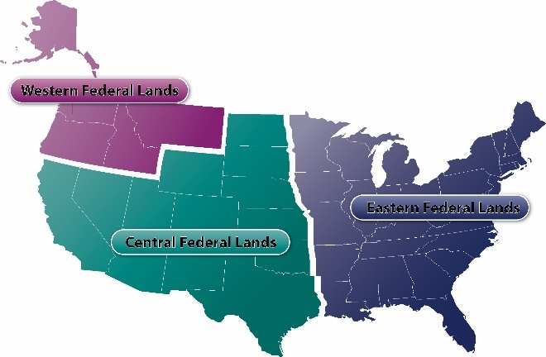

Table 2-1 | Planning Approval Chart
Program Activities |  | Agency Responsible
Approval Action | Reference | Review | Approve | Remarks
State Planning and Research (SP&R) Work Program | 23 C.F.R. § 420.111 | FHWA | FHWA | ADOT develops a work program every two years.
MPO Unified Planning Work Programs (UPWPs) | 23 C.F.R. § 450.308 | ADOT & FHWA | FHWA | MPOs develop a UPWP every two years.
Long-Range Statewide Transportation Plan | 23 C.F.R. § 450 | FHWA | ADOT | FHWA reviews and comments on LRTP to determine compliance with federal requirements. No official approval action is taken.
Statewide Transportation Improvement Program (STIP) | 23 C.F.R. § 450.218 | FHWA | FHWA & FTA | Minimum 4-year period; update required every 4 years, but ADOT traditionally updates annually. FHWA also reviews the STIP to determine whether it contains projects consistent with a compliant long-range statewide plan.
Metropolitan 20-Year Long-Range Transportation Plan (LRTP) | 23 C.F.R. § 450.324 | ADOT & FHWA | MPO | FHWA/FTA & ADOT review and comment on metropolitan LRTPs but do not approve them. However, FHWA/FTA must make an air quality conformity determination.
Metropolitan Transportation Improvement Program (MTIP) | 23 C.F.R. § 450.326 | FHWA &  ADOT (and any affected public transportation operators | FHWA & FTA | Minimum 4-year period; update required every 4 years but may be updated more frequently. FHWA also reviews the TIP to determine whether it contains projects consistent with a compliant metropolitan long-range transportation plan (LRTP).
Traffic Volume Monthly Automated Traffic Recorder (ATR) Data | 23 C.F.R. § 420.105 | FHWA HQ | NONE | ADOT submits required ATR data reports directly to FHWA HQ.
Annual Truck Weight Characteristics Data | 23 C.F.R. § 420.105 | FHWA HQ | NONE | ADOT annually submits required data directly to FHWA HQ.
Highway Performance Monitoring System (HPMS) Annual Data Submittal from State and Field Verification Review and Report | 23 C.F.R. § 420.105 | FHWA | NONE | FHWA annually conducts field verification review. Based on this review, FHWA recommends to FHWA HQ accepting this HPMS data for funding apportionment and allocation purposes.
Highway Statistics: 500 Series Report | 23 C.F.R. § 420.105 | FHWA | NONE | FHWA annually conducts field verification review. Based on this review, FHWA recommends to FHWA HQ accepting this HPMS data for funding apportionment and allocation purposes.
Certification of Public Road Mileage | 23 C.F.R. § 460 | FHWA | FHWA HQ | Due by June 1 of each year. The governor has delegated the certification authority to the ADOT director.

FHWA Division for Arizona
The FHWA division offices are local field offices that provide leadership, guidance, and direction to the state department of transportation in the planning, construction, and maintenance of transportation projects. Working collaboratively with state partners, FHWA division offices ensure that the nation’s roads, bridges, and tunnels are safe and continue to support economic growth and environmental sustainability. Additionally, to ensure accountability, the FHWA division offices work with the state to develop, track, and analyze activities and recommend innovative techniques and strategies to improve the performance of the transportation system. FHWA and its division offices are responsible for working with state departments of transportation to ensure that the nation’s strategic investments preserve and modernize the U.S. highway system—and ultimately save lives. There are two FHWA planning regions in Arizona. The planning regions listed below also list the corresponding MPOs and COGs that they coordinate with:
Planning Region 1
Ed Stillings
Senior Transportation Planner T: 602-382-8966

Planning Region 2
Romare Truely
Community Planner
T: 602-382-8978
FHWA STAFF DIRECTORY
4000 N. Central Ave., Ste. 1500 Phoenix, Arizona 85012-3500 T: 602-379-3646
F: 602-382-8998 http://fhwa.dot.gov/azdiv/staff. cfm
- Planning Region 1: CAG, FMPO, MAG, SCMPO, SVMPO
- Planning Region 2: CYMPO, LHMPO, NACOG, PAG, SEAGO, WACOG, YMPO

2.2.2 | Federal Transit Administration
The FTA is an agency within the USDOT. The FTA provides financial and technical assistance to local public transit systems. The FTA is headquartered in Washington, DC, and has 10 regional headquarters.
FTA Region 9
The FTA regional offices work with local transit officials in developing and processing grants applications. FTA Region 9 is headquartered in San Francisco, California, and governs Arizona, California, Hawaii, Nevada, and the territories of Guam, American Samoa, and the Northern Mariana Islands. FTA Region 9 serves 141 grantees and oversees a total portfolio of $12 billion in federal funding distributed among 832 active grants for transit projects and initiatives. (4 Contact Graphics)

2.2.3 | Federal Railroad Administration
The Federal Railroad Administration (FRA) was created by the Department of Transportation Act of 1966 (49 U.S.C. § 103, Section 3(e)(1)). The purpose of FRA is to promulgate and enforce rail safety regulations, administer railroad assistance programs, conduct research and development in support of improved railroad safety and national rail transportation policy, provide for the rehabilitation of the Northeast Corridor rail passenger service, and consolidate government support of rail transportation activities. Today, the FRA is 1 of 10 agencies within USDOT concerned with intermodal transportation. It operates through seven divisions under the offices of the administrator and deputy administrator.
FRA Region 7
801 I St., Ste. 466
Sacramento, CA 95814
T: 916-498-6540
F: 916-498-6546

https://railroads.dot.gov/
FRA Region 7
FRA Region 7 is headquartered in Sacramento, California, and governs Arizona, California, Nevada, and Utah.

2.2.4 | Federal Aviation Administration
The Federal Aviation Administration (FAA) is responsible for providing a safe and efficient aerospace system; it is accountable to the American public and the FAA’s stakeholders. The FAA has nine regional offices, an aeronautical center, and the FAA headquarters located in Washington, DC.
FAA Phoenix Field Office William Withycombe
2800 N. 48th St., Ste. 510
Phoenix, AZ 85008
T:602-379-4350
F: 602-379-3034
FAA Western-Pacific Region
The Western-Pacific Region comprises four states (Arizona, California, Hawaii, and Nevada) and three U.S. territories (American Samoa, Guam, and the Commonwealth of the Northern Mariana Islands). Arizona has a field office for the Western-Pacific Region.

2.2.5 | Department of Housing & Urban Development
The FAST Act streamlined regulatory requirements affecting the Department of Housing and Urban Development (HUD). According to the HUD website, their mission is to generate strong, sustainable, inclusive communities and quality affordable homes for all. HUD is working to strengthen the housing market to bolster the economy and protect consumers; meet the need for quality affordable rental homes: utilize housing as a platform for improving quality of life; build inclusive and sustainable communities free from discrimination; and transform the way HUD does business. HUD does not have a regional structure but operates two Arizona field offices, which are located in Phoenix and Tucson. The Phoenix office operates in areas north of Casa Grande, and the Tucson office operates in areas south of Casa Grande.
HUD Phoenix Field Office Tony Ramirez
One North Central Ave., Ste.
600 Phoenix, AZ 85004
T: 602-379-7100
F: 602-379-3985
TTY: 602-379-7181

HUD Tucson Field Office Tony Ramirez
6245 East Broadway, Ste.
350 Tucson, AZ 85711
T: 520-308-3007
F: 520-670-6207

2.2.6 | Environmental Protection Agency
According to the EPA website, their mission is to protect human health and the environment. Air quality and water quality, in particular, are two aspects of the environment that interface directly with the planning, delivery, and operation of transportation facilities and services. The EPA has offices headquartered in Washington, DC, and 10 regional offices located throughout the United States.
EPA Region 9
EPA’s Region 9, located in San Francisco, covers the Pacific Southwest Region including Arizona, California, Hawaii, Nevada, the Pacific Islands, and 148 tribal nations. The region’s key issues include: cleanup sites, watershed priorities, air quality, agriculture, Environmental Justice, compliance and enforcement, climate change, tribes, Pacific Islands, and the U.S.-Mexico border.
EPA Region 9
Jared Blumenfeld
75 Hawthorne St.
San Francisco, CA 94105
T: 415-947-8000

2.2.7 | Bureau of Indian Affairs
The Bureau of Indian Affairs (BIA) is part of the U.S. Department of the Interior (DOI) and provides services directly or through contracts, grants, or compacts to 566 federally recognized tribes with a service population of about 1.9 million American Indian and Alaska Natives. Delivery of BIA program services to the federally recognized tribes and individual Indians and Alaska Natives, whether directly or through contracts, grants, or compacts, is administered by the 12 regional offices and 83 agencies that report to the BIA deputy director-field operations, located in Washington, DC.
BIA Western Region
Bryan Bowker
2600 N. Central Ave., 4th Floor Mailroom
Phoenix, AZ 85004-3050
T: 602-379-6600
F: 602-379-4413

https://www.bia.gov/regional-offices/western
BIA has its own Division of Transportation (BIADOT) whose mission is to assist tribes to develop their capacity to plan, construct, and maintain safe and efficient transportation networks and to promote tribal tourism. BIADOT oversees road maintenance and road construction for the Tribal Transportation Program (TTP)in BIA land through the following efforts:
- operating and maintaining BIA roads;
- administering the TTP Program; and
- administrating other FHWA programs that are specifically related to TTP.
Federal transportation funds available to tribal governments may be used for tribal transportation planning activities, as specified in 25 C.F.R. § 170.403. Transportation planning funds are only available upon request to a tribal government and with the approval of the BIA regional office. A tribe may develop an LRTP itself, in accordance with the Indian Self-Determination and Education Assistance Act of 1975 (ISDEAA), as amended, or may ask BIA to develop the plan on the tribe’s behalf. Similarly, federal funding may be used to prepare a Tribal Transportation Improvement Program (TTIP), in accordance with 25 C.F.R. § 170.421. The basic goals of these tribal planning efforts are the same as the goals of the metropolitan planning process: to identify foreseeable transportation needs and prioritize use of available funds to meet those needs.
BIA Western Region
BIA’s Western Region office located in Phoenix, Arizona, serves a population of approximately 143,000 American Indian people enrolled in 42 tribes. The BIA states that it is responsible for 12,950,000 acres primarily in the states of Arizona (excluding the Navajo Region), Nevada, and Utah. Portions are also in California, Oregon, and Idaho. Thirteen Indian Agencies and an Irrigation Project are Western Regional Office partners. Currently, three Arizona tribes have intergovernmental charters in place with the BIA, FHWA, ADOT, counties in which they border or coordinate with, and other entities as appropriate to commit to ongoing, cooperative transportation planning efforts. These are the Navajo Nation, Hopi Tribe, and San Carlos Apache Tribe.

2.3 | CONTACT INFORMATION
Table 2-2 provides the primary contact information for ADOT as well as FHWA, FTA, FRA, FAA, HUD, BIA, and EPA.

Table 2-2 | Contact Information
Organization |  | Contact Information | Organization |  | Contact Information
ADOT | Multi-modal Planning Division (MPD) | 206 S. 17th Ave.  Phoenix, AZ 85007  Mail Drop: 310B  T: 602-712-7333  https://azdot.gov/planning | FAA | Western-Pacific Region | 15000 Aviation Blvd.  Lawndale, CA 90261  T: 310-725-3550  https://www.faa.gov/about/office_org/headquarters_offices/arc/ro_center/?file_name=contact_us_western_pacific
FHWA | Arizona Division | 4000 N. Central Ave., Ste. 1500  Phoenix, AZ 85012-3500  T: 602-379-3646  https://www.fhwa.dot.gov/azdiv/ | HUD | Arizona Field Office | One North Central Ave., Ste. 600  Phoenix, AZ 85004  T: 602-379-7100  https://www.hud.gov/states/arizona/offices
FTA | Region 9 | 201 Mission St., Ste. 1650  San Francisco, CA 94105-1839  T: 415-744-3133  https://www.transit.dot.gov/region9 | EPA | Region 9 | 75 Hawthorne St.  San Francisco, CA 94105  T: 415-947-8000  https://www.epa.gov/aboutepa/epa-region-9-pacific-southwest
FRA | Region 7 | 801 I St., Ste. 466  Sacramento, CA 95814  T: 916498-6540  https://railroads.dot.gov/divisions/regional-offices/region-7-sacramento-ca | BIA | Western Region | 2600 N. Central Ave., 4th Floor Mailroom  Phoenix, AZ 85004-3050  T: 602-379-6600  https://www.bia.gov/regional-offices/western

3 | MPO FORMATION
TABLE OF CONTENTS
3.1 | PURPOSE
3.2 | AUTHORITY
3.3 | CENSUS DESIGNATION OF URBANIZED AREAS
3.4 | METROPOLITAN PLANNING AREA
3.5 | DESIGNATION OF AN MPO
3.6 | MEMBERSHIP
3.6.1 | Voting Membership
3.6.2 | Nonvoting Membership
3.6.3 | Agreements & Contracts
3.7 | MPO ORGANIZATIONAL STRUCTURE
3.7.1 | Policy Board
3.7.2 | Executive/Management Committee
3.7.3 | Advisory Committees
3.7.4 | MPO Director & Staff
3.8 | INSTITUTIONAL STRUCTURE
3.8.1 | Hosted MPOs
All-In-One Agency
Dual Purpose MPO
Component MPO
3.8.2 | Independent MPOs
Leaning Independent MPO
Freestanding Independent MPO
3.9 | RESPONSIBILITIES OF AN MPO
3.9.1 | Policy Board
3.9.2 | Regional Planning
Fiscally Constrained Planning
Annual Element (AE)
3.9.3 | Special Technical Responsibilities

| MPO Formation

3.1 | PURPOSE
This chapter explains the framework for the formation of an MPO. It describes the way an urbanized area (UZA) is defined, the way relevant transportation planning boundaries are created, the way MPOs designations are established, and the way an MPO is structured to serve its member governments. (Resource Graphic)

3.2 | AUTHORITY
This section discusses the historical basis for the establishment of MPOs and cites the authority that mandates their establishment. The authority supporting establishment, organization, operation, and administration of an MPO lies in various Federal and Arizona State laws and regulations. The laws are described in table 3-1 below.

3.3 | CENSUS DESIGNATION OF URBANIZED AREAS
Federal law requires the formation of an MPO to coordinate transportation planning in a UZA, defined in 23 U.S.C. § 134 (b) (7) as “a geographic area with a population of 50,000 or more, as determined by the Bureau of the Census.” A UZA may consist of one or more municipalities as well as unincorporated areas between municipalities as long as the UZA includes a central core and adjacent densely settled territory that together contain at least 50,000 residents.
Census defined UZAs are statistically based on results of each decennial Census and any special censuses that may be taken by request of a recognized governing jurisdiction (e.g., the city, county, state, etc.). The Census Bureau follows a delineation process that is applied consistently across the country and results are not subject to review.

Table 3-1 | Authority
Code |  | Description
Federal | 23 U.S.C. § 134(e) | These laws outline the requirements and process for the establishment of transportation planning boundaries of an MPO.
 | 49 U.S.C. § 5303(e)
 | 23 C.F.R. § 450.312
 | 23 U.S.C. § 134(d) (e) | These laws describe the requirements for the designation and redesignation of MPOs.
 | 49 U.S.C. § 5303(d) (e)
 | 23 C.F.R. § 450.310
 | 23 U.S.C. § 134(d) (2) | These laws describe voting membership and membership apportionment of the MPO.
 | 23 C.F.R. § 450.310(d)
 | 49 U.S.C. § 5303(d) (2)
 | 23 C.F.R. § 450.314 | This law describes the types of agreements necessary to implement the metropolitan transportation planning process.
 | 27 C.F.R. Parts 40-46 | Final Urban Area Criteria for the 2010 Census.
State | Executive Order 70-2 -  Intergovernmental Cooperation Act of 1968 | In 1970, Arizona Governor Jack Williams signed Executive Order 70-2 relating to the Intergovernmental Cooperation Act of 1968 and the establishment of planning districts within the state of Arizona.
 | A.R.S. §§ 49-406 and 408 | A.R.S. § 49-406 and 408 stipulate that the MPO is responsible for development of a Non-attainment Plan or Maintenance Area Plan, and it inhibits any state agency, the MPO, or local transportation agency from taking actions more stringent than required under federal air quality laws.

Federal transportation legislation provides state and local officials with the ability to cooperatively expand or extend the Census defined UZA boundaries. However, adjustments, typically undertaken to smooth irregular UZA boundaries, are subject to approval by the FHWA in accordance with 23 U.S.C. § 101(a) (36, 37) and 49 U.S.C. § 5302(a) (16, 17). ADOT submits the proposed UZA boundary adjustment to the FHWA. This submittal must include maps indicating the proposed adjustments to UZA boundaries as well as approval letters from the MPO(s) and Governor(s). The Arizona FHWA Division Planners determine the best method for submitting the revised boundary map.
Census Urbanized Areas and MPO/TMA Designation details can be found at:

https://www.fhwa.dot.gov/planning/census_issues/urbanized_areas_and_mpo_tma/

3.4 | METROPOLITAN PLANNING AREA
A Metropolitan Planning Area (MPA) is a geographic area in which the 3-C transportation planning process required by 23 U.S.C. § 134 and Section 8 of the Federal Transit Act (49 U.S.C. app. 1607) must be accomplished in accordance with 23 C.F.R. § 420. AS stated in 23 § 450.312, an MPA must encompass the UZA, as this is the formal geographic area within which planning actions are implemented by an MPO. An MPA must encompass the UZA and contiguous geographic area(s) expected to become urbanized within the following 20 years.
The MPO, in cooperation with the State and any affected public transportation operator, shall review the MPA boundaries after each decennial Census to determine if existing MPA boundaries meet the minimum statutory requirements for new and updated UZAs. If an MPO’s UZA has been changed by the U.S. Census Bureau and has affected jurisdictional boundaries, the MPA is then determined by the governor in cooperation with the existing MPO’s policy board. For example, continuing rapid population growth in Arizona may cause an existing UZA area served by an MPO to expand outward and reach other nearby municipalities that in the previous Census were separated by undeveloped land. As a result of the growth over 10 years, the Census Bureau newly designates that the two previously separate urban areas now together constitute joined a single urban area. Accordingly, a new MPA boundary is established, and the existing MPO adjusts its membership and voting allocations to incorporate the new member jurisdictions.
The MPA may encompass the entire Metropolitan Statistical Area (MSA) or Consolidated Metropolitan Statistical Area (CMSA), as defined by the U.S. Office of Management and Budget (OMB) for the purpose of tabulating statistical data relative to the metropolitan areas (23 C.F.R. § 450.104). Both the MSA and CMSA are simply geographical regions with a relatively high population density at its core and close economic ties throughout the area.

3.5 | DESIGNATION OF AN MPO
An MPO is a local decision-making body responsible for carrying out the 3-C transportation planning process within a defined MPA. The USDOT recognizes the UZAs published in the Federal Register for purposes of disseminating federal transportation funds for highways, public transit, and other travel and freight modes. Every UZA must be represented by an MPO in accordance with 23 U.S.C. § 134(b) and 49 U.S.C. § 5303(c). Federal laws and regulations (23 U.S.C. § 134(d) and 23 C.F.R. § 450.310(b)) require that the governor of each state in cooperation with local officials establish an MPO within 12 months of a place being designated a UZA by the Census Bureau.

https://www.nado.org/metropolitan-and-rural-transportation-planning-case-studies-and-checklists-for-regional-collaboration/
provides guidance in improving collaboration, communication, and partnerships among MPOs, rural transportation planning organizations, state departments of transportation, and other entities.
Once ADOT is informed of the designated UZAs, ADOT MPD and FHWA Arizona Division are contacted and provided with relevant information, including the Census defined UZA boundary and population data. ADOT MPD and FHWA then provide information to existing MPOs and local jurisdictions to help with MPO redesignation or formation, respectively. If a new UZA is not contiguous to an existing MPO, ADOT MPD provides all relevant information to affected local governments in that area as well as to transportation mode operators, local and regional planning agencies, and tribal governments. This group then meets to discuss the new MPO formation. An existing MPO must review the Census data to assess potential changes in its boundaries or governing board membership.
Designation of a new UZA does not necessarily require that a new MPO be formed. The newly designated UZA may be combined with or integrated into an existing MPO. To the extent possible, only one MPO ideally is designated for each UZA or group of contiguous UZAs. More than one MPO may be designated in a UZA when the governor and any existing MPOs determine that the size and complexity of a combined planning area makes designation of the new MPO appropriate (see 23 U.S.C. § 134 (d) (6) and 23 C.F.R. § 450.310(e)).
If it is determined that the MPA for an existing MPO’s boundaries has changed or that formation of a new MPO is justified, ADOT MPD must schedule all meetings in accordance with federal and state requirements, to discuss the following aspects and attributes of the UZA:
- the Census population;
- the legal agreements for formation, organization, transportation planning, and funding;
- the establishment of bylaws and procedures;
- the delineation of the MPO MPA;
- funds available to an MPO;
- federal regulations regarding the formation and responsibilities of an MPO;
- state laws and rules for the organization, operation, and responsibilities of an MPO;
- all ADOT procedures, handbooks, and manuals to assist in meeting the requirements of federal and state funding and the requirements for transportation planning in a defined MPA;
- all ADOT procedures, software, and manuals for travel demand forecasting models;
- the overall role of ADOT and ADOT contact persons; and
- the role of the MPO and its intergovernmental relationships with state and local governments, regional planning agencies, and other land or transportation agencies.
The MPO and its MPA are established and designated by agreement between the governor and local governments that together represent at least 75 percent of the affected population (including the incorporated city with the largest population) designated for inclusion in the MPA. The agreement includes formation and identification of the MPO and adoption of bylaws that identify membership and voting rights. Figure 3-1 illustrates a generalized process for MPO designation and formation.

Figure 3-1 | |MPO Process Flow Chart
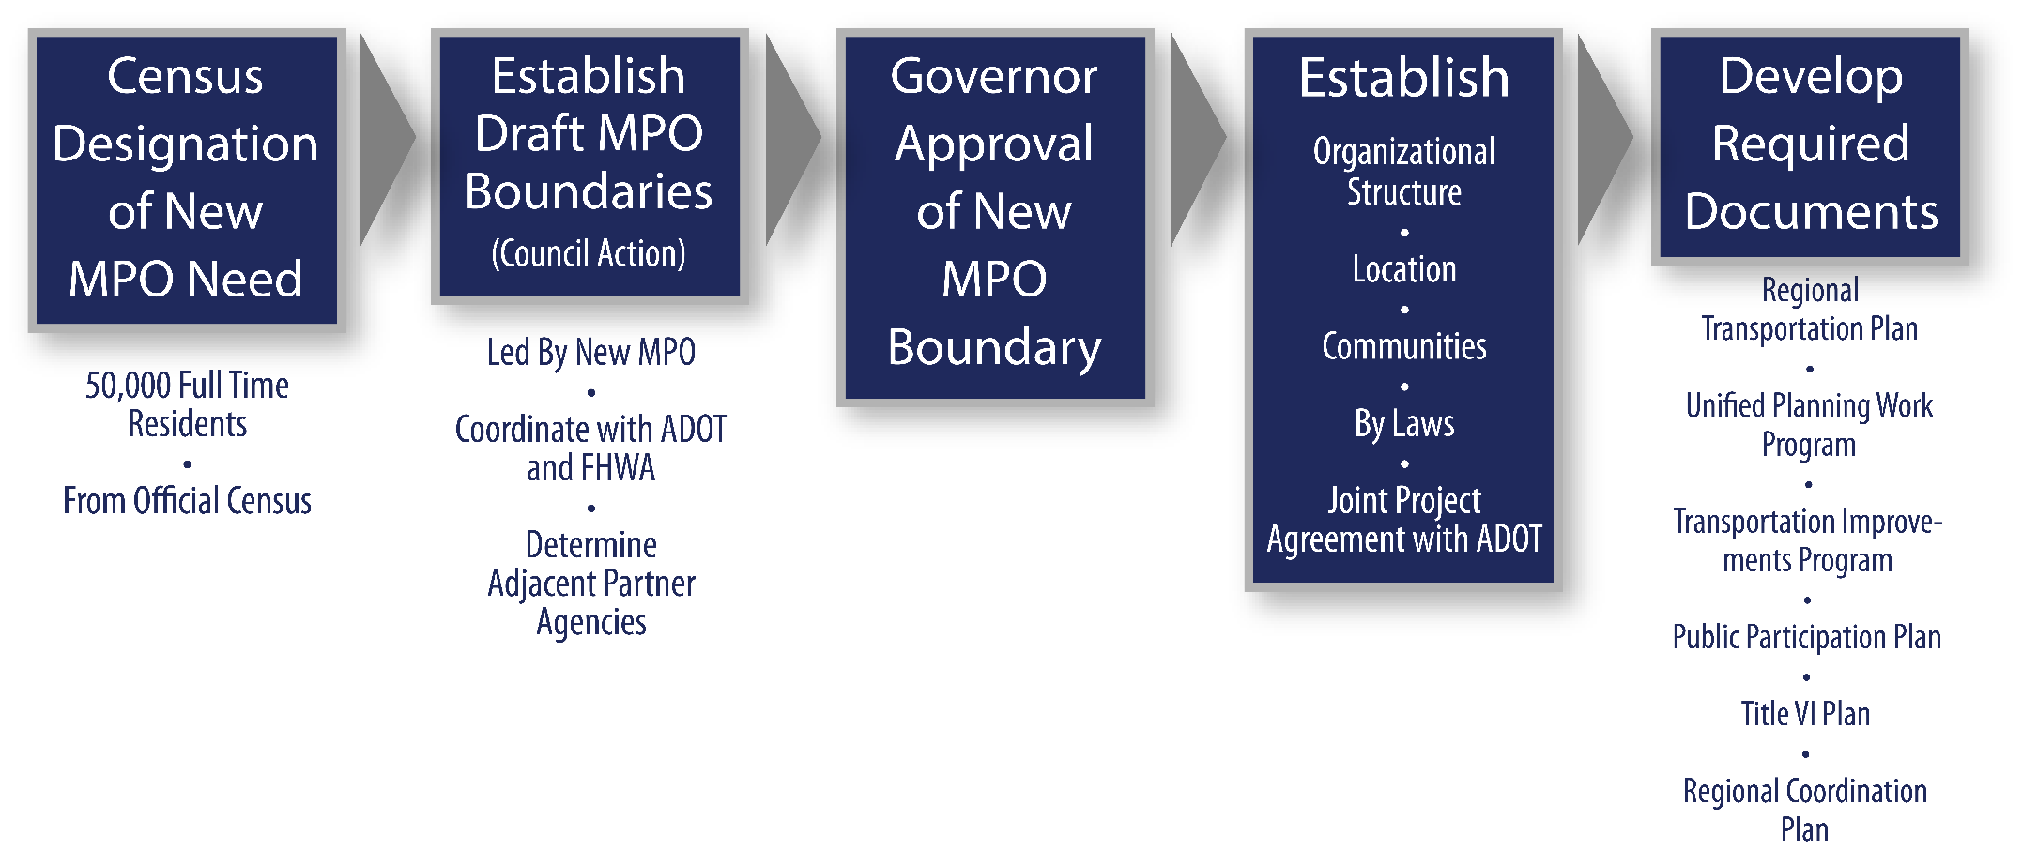

3.6 | MEMBERSHIP
An MPO is defined by its membership, which varies from region to region, depending on the size of the region and its transportation issues. Membership composition is not established by federal law or regulation nor does the state of Arizona have any statute or regulation pertaining to this matter. Nevertheless, FAST Act specifically requires MPOs for regions with a population of 200,000 and more to have representatives of public transit operators and member tribal agencies. The governor and local governments determine membership when the MPO is formed. Memoranda of Agreement (MOA) are developed stipulating the relationship of each member to the MPO.
A core function of MPO membership is to establish and manage a fair and impartial setting for effective transportation decision making in an MPA. Therefore, membership generally is representative of key municipal jurisdictions, important agencies, and major interests present in the MPA. Voting members and nonvoting members are identified, as appropriate to meet the needs and issues of the MPO and MPA.

3.6.1 | Voting Membership
The voting membership of an MPO consists of elected officials of affected local governments and is apportioned on an equitable geographic population basis. The voting membership can include representatives of statutorily authorized planning boards, an official of an agency/operator of a major mode of transportation, and any authority or agency created by law to perform transportation functions (e.g., an aviation authority, a school board).
For an MPO that is additionally designated as a TMA (population of 200,000 or more residents) federal law (23 U.S.C. § 134(d)(2) and 23 C.F.R. § 450.310(d)) specifically requires that its voting membership include:
- local elected officials;
- officials of agencies administering major transportation systems; and
- appropriate state officials (e.g., ADOT).

3.6.2 | Nonvoting Membership
The MPO may identify and designate nonvoting members among agencies, organizations, and institutions within the MPA. FHWA and FTA are nonvoting ex officio members. Other nonvoting members may include major military installations and state, federal, and tribal agencies with land and transportation interests.

3.6.3 | Agreements & Contracts
Recognition of MPO status and acceptance for funding assistance follows execution of certain required agreements and contracts, as prescribed in:
- 23 U.S.C. § 134 (c), (d), (f), (i), (j);
- 49 U.S.C. § 5303(c), (d), (f), (i), (j);
- 49 U.S.C. § 5304;
- 23 C.F.R. § 450.314; and
- 49 C.F.R. § 613.100.
Primarily, the MPO, ADOT, and public transportation agencies (as may be applicable) must cooperatively determine their mutual responsibilities, which must be identified in written agreements. To the extent possible, a single written agreement should be developed including all member agencies or groups. Written agreement(s) must include specific provisions for cooperatively developing and sharing information related to the development of financial plans that support regional transportation planning activities. Essentially, the membership must agree to cooperate in the 3-C transportation planning process.
MPOs must follow the 3-C process to be certified and eligible to receive federal funds. Completing and maintaining the documentation requirements cited in the previous chapter fulfills the 3-C planning process. In addition, the MPO must define and ratify agreements between the organization and ADOT through the annual GRT contract, between the organization and the area public transportation operator (as may be applicable), and, if in an air quality non-attainment area, between the organization and the designated air quality agency (or agencies). Should there be more than one MPO in a metropolitan area, these agreements must be inclusive of all affected agencies and organizations.
Execution of required agreements and contracts provides the basis for attaining certification of the MPO as the regional planning body. The agreements must reflect the most recent legislation/regulations and correspond fully to the 3-C planning process. Additionally, adopted planning procedures must reflect the content of agreements and contracts ratified by the MPO’s policy board.
Contracts and agreements are discussed in detail in chapter 4, “MPO Unified Planning Work Program & Contract Activities.”

3.7 | MPO ORGANIZATIONAL STRUCTURE
The organizational structure of an MPO is determined by agreement between its members during the designation process and documented in the MPO bylaws. It is customary for an MPO to have a governing board charged with setting policy for the transportation planning process in the designated MPA.
The governing board generally is assisted in its activities by an executive director, a professional staff, and advisory committees, as may be deemed necessary or appropriate. This section presents a generalized structure and composition of MPO governance and outlines the principal characteristics of the organizational elements of an MPO. An organizational chart for a typical MPO is shown in Figure 3-2.

Figure 3-2 | MPO Organizational Structure
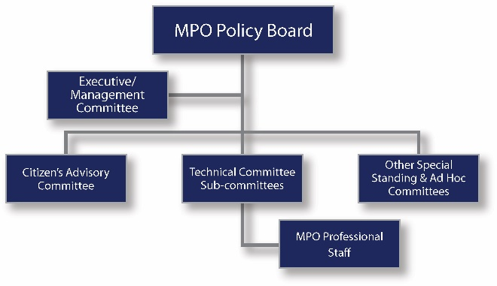

3.7.1 | Policy Board
The policy board serves as the decision-making body of the MPO as well as the primary forum for stakeholder input into the MPO decision-making process. The policy board is the key element of an MPO’s composition and function. Each policy board member has the legal authority to speak and act in the MPO setting on behalf of the jurisdiction that he or she represents. The policy board debates issues, proposals, and projects and makes decisions regarding key MPO actions relating to the federal transportation planning process. It plays an active role in key decisions or at important milestones associated with MPO plans and studies, as well as conducts public hearings and meetings. The policy board makes specific prioritization recommendations regarding future projects in the region after formally reviewing, discussing, and adopting plans developed through regional collaboration.
Federal law provides authority to states and their local governments to determine the composition of an MPO, as prescribed in 23 U.S.C. § 134(d)(2), 49 U.S.C. § 5303(d), 23 C.F.R. § 450.310, and 49 C.F.R. § 613.100. There is wide variation in policy board size, which is dependent on a number of factors that vary by locality and size of the MPA.
Most boards generally have 9 to 18 members. Board membership and the number of seats are cooperatively designated by the governor and local jurisdictions representing at least 75 percent of the UZA population. It is important to note that federal law does not require the MPO policy board members to be representative of the planning area’s population in regard to racial, ethnic, gender, or other socioeconomic criteria; that is, the socioeconomic mix of the MPA does not need to be reflected in the policy board membership.
Adopted bylaws regulate policy board composition and voting rights, nonvoting membership, as well as the composition of any advisory committees. Intergovernmental politics and demographics may lead some board seats to be treated differently than others (e.g., a dominant county may have more voting power). Also, an imbalance among member populations is often addressed through seat rotation, allocation of seats, and, although more exception than rule, weighted voting. A dominant member is a permanent position on the board and therefore may not be involved in the seat rotation.

3.7.2 | Executive/Management Committee
As shown in Figure 3-1, an executive/management committee may be created, which becomes a top-level body providing guidance and oversight for the policy board. The members of this committee typically are elected or appointed officials of one or more of the MPO’s constituent local jurisdictions.

3.7.3 | Advisory Committees
The policy board may establish advisory committees as it deems necessary or desirable to carry out its functions and responsibilities. Typical committees and subcommittees may be mode-oriented (e.g., roadway and transit), issue-oriented (e.g., sustainability), or focused on special needs (e.g., Environmental Justice matters, socioeconomic projections, bicycle and pedestrian facilities, and travel demand forecasts). Examples of the different committees currently available within the MPOs and COGs are shown in table 3-2.

Table 3-2 | MPO Advisory Committees
Agency | Committees Link
MAG | https://www.azmag.gov/Committees
PAG | https://mk0pagrtahost21swg12.kinstacdn.com/wp-content/docs/2020/07/2020PAGCommitteeFactSheets070220FINAL.pdf
CYMPO | https://www.cympo.org/technical-advisory-committee/
FMPO | https://www.metroplanflg.org/who-we-are
LHMPO | http://www.lhmpo.org/committees
SCMPO | https://scmpo.org/tac/
SVMPO | https://www.svmpo.org/boards-and-committees/
YMPO | https://ympo.org/about-us/technical-advisory-committee/
CAG | http://www.cagaz.org/committees.html
NACOG | https://www.nacog.org/menus/councils-committees.html
SEAGO | https://www.seago.org/board-councils-and-committees
WACOG | https://www.wacog.com/transportation-advisory-committee/

3.7.4 | MPO Director & Staff
The MPO director and professional staff generally manage day-to-day functions of the organization and provide direct support to the policy board as it meets its responsibilities in carrying out the 3-C planning process. These personnel also may prepare (in-house or with outside assistance) technical assessments and evaluations of proposed transportation initiatives, which may be provided to the board, committees, or subcommittees, as may be appropriate.

3.8 | INSTITUTIONAL STRUCTURE
MPOs vary greatly in terms of capacity and responsibilities, depending on the needs of the member agencies. MPOs are usually housed within and operate through a regional planning council or a city or county government agency, but also may operate as an independent agency.
MPO organizational structures span a continuum that ranges from MPOs that are fully independent and freestanding to MPOs that are so integrated with their host agency that together they form a single, indistinguishable all-in-one agency.

3.8.1 | Hosted MPOs
According to the report “Administrative Structure and Hosting of Metropolitan Planning Organizations” (Transportation Research Journal, Bond, Alexander, Kramer, Jeffrey, Volume 2244, December 2011), in a hosted MPO, another organization acts as the fiscal agent and holds the power to hire and fire MPO employees. Several variations of hosted MPOs are discussed below, as well as a list of advantages and disadvantages of being hosted.
All-In-One Agency
An all-in-one agency does not differentiate between MPO functions, non-MPO transportation functions, and all other functions of the broader agency.
Dual Purpose MPO
Dual purpose MPOs leverage planning funds to maintain transportation planning staff that performs both MPO planning and host agency transportation planning functions.

Component MPO
A component MPO’s functions are separated from most functions of the host, but the MPO remains a division of the umbrella agency.

Table 3-3 | Hosted MPO Advantages & Disadvantages
Advantages | Disadvantages
Reduced cost of operations  Financial assistance from the host agency— “capital float”  Shared expertise, greater employee diversification | Blurred responsibilities, identities, and boundaries  MPO is subject to host agency’s rules, budget, and oversight  Potential for host to interfere with MPO policies  Potential for host to misunderstand MPO mission

3.8.2 | Independent MPOs
According to the report “Administrative Structure and Hosting of Metropolitan Planning Organizations” (Transportation Research Journal, Bond, Alexander, Kramer, Jeffrey, Volume 2244, December 2011), an independent MPO acts as its own fiscal agent, and the director can only be hired or fired by the MPO board.
Leaning Independent MPO
A Leaning Independent MPO receives some services from one of its member agencies under a severable contract.
Freestanding Independent MPO
A Freestanding Independent MPO meets all of its own operating needs.
Figure 3-2 depicts the variants of an MPO structure as a continuum that spans from fully independent to fully hosted.

Table 3-4 | Independent MPO Advantages & Disadvantages
Advantages | Disadvantages
Political and administrative autonomy  Clarity of chain of command, reduced staff confusion  Distinct identity with unique and focused mission  Cleaner finances, eliminates administrative entanglements | Trouble with cash flow for operating requirements  Trouble meeting funding match  High operation costs, no economies of scale  Greater dependence on versatile staff and outside contractors

3.9 | RESPONSIBILITIES OF AN MPO

3.9.1 | Policy Board
MPOs have been mandated by Congress as a vehicle to establish and manage a fair and impartial setting for effective regional decision making. This responsibility requires the MPO policy board to formulate and evaluate transportation improvement alternatives sensitive to the context of regional interest and, therefore, scaled to the size and complexity of the region. All MPOs have the same basic planning requirements.

Figure 3-3 | ADOT MPD Structure
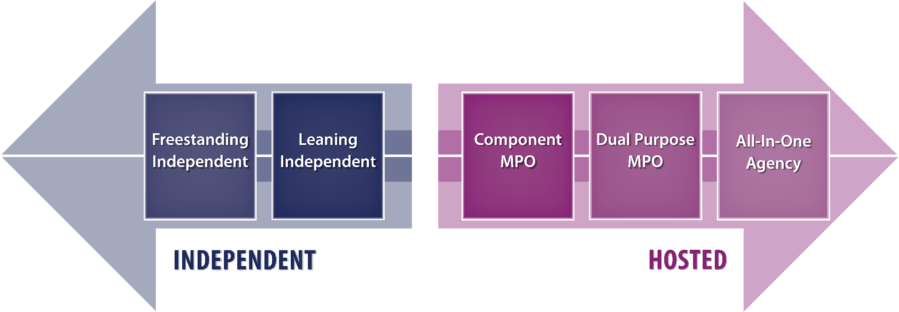

Thus, by its focus and actions, the policy board establishes a forum to discuss regional issues and manages effective regional decision making for transportation improvement projects within the MPA. It accomplishes this through comprehensive evaluations of transportation needs and issues with public involvement. The policy board, generally through its staff or an advisory committee assisted by its staff, develops, and updates a fiscally constrained 20 year (minimum) LRTP, which is translated into a fiscally constrained 4-year TIP with an Annual Element (AE).
Each MPO is required to produce the following plans and programs:
UPWP
20-year LRTP
Short-range (4-year) TIP
Public Participation Plan
Title VI Plan

3.9.2 | Regional Planning
Two vital aspects of the regional planning process that must be followed to ensure eligibility for federal transportation funding are fiscally constrained planning and adoption of an AE. These two products of the MPO planning process are instrumental to the development of the RTP and TIP. The process followed by the policy board also must ensure active involvement of the general public and all significantly affected subgroups.
Fiscally Constrained Planning
Fiscally constrained planning is a statutory requirement established by Congress with the passage of Intermodal Surface Transportation Efficiency Act (ISTEA). Fiscal constraint means that revenues identified for transportation planning and programming (federal, state, local, and private) “are reasonably expected to be available to implement the State Long-Range Transportation Plan (LRTP) and the State Transportation Improvement Program (STIP)/Transportation Improvement Program (TIP), while providing for the operation and maintenance of the existing highway and transit systems.” The intent of this requirement is to ensure that plans and programs reflect realistic assumptions regarding future revenues. Thus, requests for federally funded highway and transit projects must be accompanied by an analysis of revenues and costs that fully supports proposed plans and program implementation. This statutory requirement is clarified in federal regulations relating to statewide and metropolitan transportation planning regulations (23 C.F.R. Part 450 and 49 C.F.R. Part 613). Key points related to this requirement are:
- Costs to implement adopted plans and programs cannot exceed funding/revenues reasonably expected or projected to be available through the planning horizon.
- An understanding and full accounting of funding/revenue streams must be provided.
- Prioritization of investment needs is required.
- The assessment of revenues and cost must encompass all travel modes (i.e., decisions and priorities for a multimodal transportation system).
Annual Element (AE)
A TIP establishes a schedule for obligating federal funds to identified capital and operation costs of highway, transit, and other transportation-related projects. A TIP must include all federally funded projects; furthermore, in non-attainment areas the TIP must include all regionally significant projects, regardless of the funding source. It is updated each year to reflect changes in priorities as well as revenues. Thus, a TIP documents an agency’s intent to construct or implement specific projects based on a fiscally constrained revenue/cost forecast, which is based on the estimated receipt of all federal, state, and local funds, including private and Transportation Authority funds. The current year of the TIP is called the AE. Projects contained in the AE are programmed for and, are therefore eligible to receive federal funding to obligate in that initial fiscal year of the TIP. Key points related to this requirement are that the AE:
- includes transportation improvement projects proposed for implementation in the current fiscal year;
- represents projects for which funding is expected to be secured and disbursed; and
- constitutes a mandatory part of the federal planning process to qualify for federal funds.
Note that individual transportation projects or programs that are federally funded or require federal approval are subject to requirements for environmental review under NEPA. Before programming federal projects in the AE, the MPO must ensure that NEPA requirements have been satisfied or can be expected to be completed in a timely manner. NEPA applies to all federal decisions. Additionally, the improvement project must have a functional classification of rural major collector or higher to qualify for federal funding. Its applicability is unrelated to and not limited to air quality nonattainment areas.
Local Public Agency Projects Manual

https://azdot.gov/business/programs-and-partnerships/local-public-agency

3.9.3 | Special Technical Responsibilities
Additional requirements associated with MPO regional planning factors are spelled out in the FAST Act. The MPO policy board must consider projects and strategies to:
- protect and enhance the environment;
- promote energy conservation;
- improve quality of life; and
- promote consistency between transportation improvements and state and local planned growth and development patterns.
The MPO, through its staff or special advisory committees, must develop and maintain a regional travel demand model to support analysis of the performance of the transportation network of services. This modeling requirement is necessary if the area has been designated as air quality non-attainment
4 | MPO Unified Planning Work Program AND Contract Activities
TABLE OF CONTENTS
4.1 | PURPOSE
4.2 | AUTHORITY
4.3 | SCOPE
4.4 | DEVELOPMENT
4.5 | FUNDING
4.5.1 | Requesting & Authorizing PL Funds
4.5.2 | Financial Management of Metropolitan PL Funds
Close-Out of Pl Funds
4.5.3 | In-Kind Contributions
4.6 | MPO & THIRD-PARTY AGREEMENTS
4.6.1 | Grant Agreement
4.6.2 | GRT Amendment
4.6.3 | Third-Party Agreement
4.7 | TWO-YEAR REVIEW
4.7.1 | Early Coordination
4.7.2 | Draft Review
4.7.3 | ADOT Review
4.7.4 | Adoption & Submittal
4.7.5 | FHWA/FTA Approval
4.8 | MODIFICATIONS
4.8.1 | Approval of Modifications
4.9 | PROGRESS REPORTS
4.10 | INVOICING
4.10.1 | Submitting Invoices
4.10.2 | Processing Payment

| MPO Unified Planning Work Program and Contract Activities

4.1 | PURPOSE
This chapter provides information regarding the development, implementation, and financial management of funds of the UPWP. The UPWP is a two-year planning work program that identifies activities and the transportation planning budget for a metropolitan area. This chapter is intended for use by ADOT and MPOs as a guideline in the development, review, and administration of the UPWP. The UPWP is synonymous with the “Work Program” referenced in the GRT contract between ADOT and the MPO.

4.2 | AUTHORITY
Table 4-1 below describes the federal and state laws that provide the authority for MPO Unified Planning Work Program & contract activities.

4.3 | SCOPE
The Code of Federal Regulations defines a UPWP as “a statement of work identifying the planning priorities and activities to be carried out within a metropolitan planning area. At a minimum, a UPWP includes a description of the planning work and resulting products, who will perform the work, time frames for completing the work, the cost of the work, and the source(s) of funds” (23 C.F.R. § 450.104).

Table 4-1 | Authority
Code |  | Description
Federal | 23 C.F.R. § 420 | Planning and Research Program Administration
 | 23 C.F.R. § 450.308 | Unified Planning Work Programs
 | 23 U.S.C. § 134 | Metropolitan Transportation Planning
 | 23 U.S.C. § 135 | Statewide Planning
 | 23 U.S.C. § 139 | Efficient Environmental Reviews for Policy Decision Making
 | 31 U.S.C. § 3101-3907 | Financial Management
 | 2 C.F.R. 200 | Uniform Administrative Requirements, Cost Principles, and Audit Requirements for Federal Awards
 | 49 C.F.R. Part 18 | Uniform Administrative Requirements for Grants and Cooperative Agreements to States and Local Governments
 | 49 C.F.R. Part 29 | Government-wide Debarment and Suspension (Non-procurement) and Government-wide Requirements for Drug-free Workplace (Grants)
 | FTA Circular 8100.1C | Program Guidance for Metropolitan Planning and State Planning and Research Program Grants

4.4 | DEVELOPMENT
Every two years in late summer, each MPO begins a new tentative UPWP cycle in order to program funds for the state fiscal year that begins the following July 1. Available federal funds are determined by apportionments from the FHWA. These funds are distributed according to approved distribution formulas. Available state funds are distributed by agreement to each MPO. The GRT establishes the contract for the MPO to utilize funds to develop and administer the UPWP. This is different from the COG WP, which is developed by ADOT to define the work elements the COGs must perform. At a minimum, the UPWP must include:
- an introduction;
- organization and management;
- funding description and budget summary;
- fiscal year work elements; and
- work program task sheets.
The UPWP is the listing of planning work items that the MPO intends to undertake during the grant award period (currently two years). Examples of these work items include:
- TIP development;
- RTP development;
- HPMS data collection;
- Public Participation Plan;
- Title VI Plan;
- multimodal mobility planning;
- manage planning studies or participate as a member of the study TAC; and
- all other transportation planning functions to meet state and federal requirements.
Once drafted, the UPWP works through a critique process in which ADOT and the federal funding partners provide comments on the document before it is ultimately submitted to an MPO governing board for approval. The grant award period for UPWPs can be approved for one or two years.
Example UPWPs from Arizona’s MPOs are provided in table 4-2.

Table 4-2 | MPO Unified Planning Work Programs
MPO | UPWP Resource
MAG | https://www.azmag.gov/Documents/FY_2020-21_UPWP_FINAL.pdf
PAG | https://mk0pagrtahost21swg12.kinstacdn.com/wp-content/docs/pag/2020/09/PAG_OWP_FY2020_and_FY2021_WEB__061419.pdf
CYMPO | https://www.cympo.org/FY-2020-21-Work-Program.pdf
FMPO | https://flagstaff.az.gov/MetroPlan-UPWP-2019
LHMPO | http://www.lhmpo.org/fy20-fy21-upwp.pdf
SCMPO | https://scmpo.org/FY2020_2021-SCMPO-UPWP.pdf
SVMPO | http://svmpo.org/about/work-program-andbudget/FY20-Work-Program.pdf
YMPO | https://ympo.org/FY-2019-21-YMPO-UPWP.pdf

4.5 | FUNDING
Funding for the UPWP comes primarily from the Metropolitan Planning (PL) program; however, MPOs may use funds from a number of other sources as long as the guidelines for the use of those funds are met. Further detail on the funds available for use in UPWPs, including match requirements and project eligibility, is provided in chapter 10. The following are some of the most common funds used for administering the UPWP:
- PL funds which require a 5.7 percent local match;
- SPR funds which require a 20 percent local match;
- STBG Program funds which require a 5.7 percent local match;
- Transportation Alternatives (TA) funds which require a 5.7 percent local match;
- Congestion Mitigation and Air Quality (CMAQ) funds which require a 5.7 percent local match; and
- FTA Section 5303 funds which require a 20 percent local match.

4.5.1 | Requesting & Authorizing PL Funds
Individual MPOs are required to send a letter to the Multimodal Planning Division Regional Planner requesting Metropolitan Planning (PL) Funds. The letter should include the name of the requesting MPO, the ADOT Project Number, federal aid number, and contract number. In addition to this information, the requesting MPO must detail the amount of funding requested, how much PL apportionment money is currently available, PL obligation authority amount, and match amount.

4.5.2 | Financial Management of Metropolitan PL Funds
Close-Out of PL Funds
In accordance with 49 C.F.R. § 18.50, PL funds obligated in a prior year UPWP must be closed out within 45 days of the termination of the grant award period. The grant is based on the two-year WP period (i.e., July 1, 2021 to June 30, 2023).
After the de-obligation request has been approved, the ADOT Finance and Contract Administration section finalizes the balance sheet and closes out the funds.

4.5.3 | In-Kind Contributions
In-kind contributions make up a substantial proportion of local matching funds that COGs and MPOs use for federal funding. The in-kind contributions come from non-Federal sources of donated time, services, or goods. In-kind contributions need not be tracked and quantified by work element and by task but instead may be used generally across the UPWP. The UPWP must identify the anticipated in-kind contributions, including narrative descriptions of the services provided and the organizations that provide the in-kind services.

Figure 4-1 | Key Dates & Actions
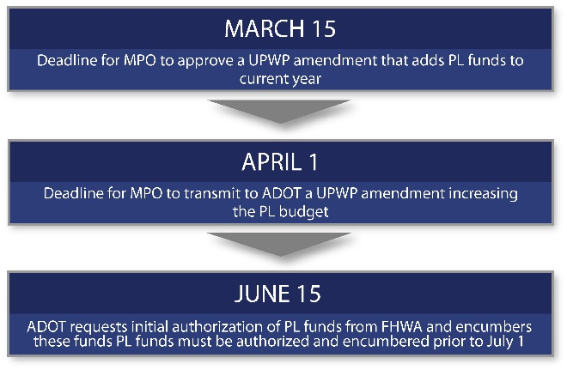
Federal transportation funding programs, whether for actual road or transit facilities and services or MPO planning activities, generally require some amount of local matching funds, which may vary by program. For example, planning activities with a total budget of one million dollars might receive $800,000 in federal funds with an 80/20 match requirement, which means that the FHWA’s $800,000 payment is contingent upon $200,000 in local matching or in-kind contributions. The local match may consist of in-kind contributions of goods and services that are necessary to the planning activity and that are credited at fair market value or non-federal cash donations collected by the MPO.
As there have been different FHWA interpretations and guidance over time in response to various inquiries, FHWA issued an informational memorandum in December 2009 to consolidate and clarify non-federal matching requirements. The ten-page attachment titled “Non-Federal Matching Requirements” is followed by five pages of tables illustrating examples of programs funded with an 80/20 match requirement.
The informational memorandum is contained in an attachment to the May 15, 2019, one-page memorandum from FHWA Chief Financial Officer Brian Bezio, available online at:

https://www.fhwa.dot.gov/legsregs/directives/policy/memonfmr_tapered20190515.htm
The key federal statute applicable to this matter is 23 U.S.C. § 323(c), which states:
Credit for Donations of Funds, Materials, or Services. —Nothing in this title or any other law shall prevent a person from offering to donate funds, materials, or services, or a local government from offering to donate funds, materials, or services performed by local government employees, in connection with a project eligible for assistance under this title. In the case of such a project with respect to which the Federal Government and the State share in paying the cost, any donated funds, or the fair market value of any donated materials or services, that are accepted and incorporated into the project by the State transportation department shall be credited against the State share.
Under the heading of “Special Provisions,” the December 2009 FHWA memorandum includes the following additional important details:
Planning Activities: Requirements for in-kind donations related to the Planning and Research Programs (23 C.F.R. 420) may be applied on either a total planning work program basis or for specific line items or projects. Work performed by a third party must be an eligible transportation planning related activity that benefits the Federal element of the work program, during the grant award period (i.e., planning or research work program period). In-kind contributions must be identified in the original planning work program/scope of work and the grant/subgrant agreement or amendment(s) thereto.”
For more details visit the FTA frequently asked questions page, “Local Matching Funds,” available at:

https://www.transit.dot.gov/funding/procurement/third-party-procurement/local-matching-funds
Although the December 2009 FHWA memorandum preceded the FAST Act, the 2015 federal transportation re-authorization law, it remains almost entirely applicable. The term “in-kind” is mentioned only five times in the FAST Act. All of those references involve only amendments to 23 U.S.C. § 49 (Transportation, but not Highways) .
In-kind match either occurs locally, or through a third party valued at fair market value. To successfully use in-kind contributions for transportation planning activities, it is critical to:
- carefully estimate the value of proposed in-kind contributions in advance;
- obtain federal agency approval for the in-kind contribution in advance; and
- track and document the actual contributions of in-kind goods and services in a timely manner as they are received or applied.
In addition to in-kind contributions generated within an MPO or COG via its staff or facilities, local matches used to fund regional planning activities also might include the fair market value of the time spent by local government employees who participate on MPO or COG committees or who develop local transportation data for input into the regional planning process. In-kind contributions used to fund roadway improvements or other transportation projects typically involve donations of land, whereas local match for federally funded transit projects might include locally funded services and/or administration provided by a local transit agency.
Additional information about FTA in-kind requirements is provided in FTA Circular 8100.1C, “Program Guidance for Metropolitan Planning and State Planning and Research Program Grants”
On its website, the FTA urges funding applicants to always check in advance with their regional FTA office to determine what is applicable in this manner.

4.6 | MPO & THIRD-PARTY AGREEMENTS
Each MPO has several possible funding sources and is required to identify how these funds will be spent in the UPWP.

4.6.1 | Grant Agreement
A GRT is the standard contract between the MPO and ADOT to perform and be reimbursed for activities in the UPWP. The GRT contract is developed with the ADOT Finance and Contract Administration section. The GRT may be up to a five-year contract that is amended bi-annually. It is active from July 1 of the first year through June 30 of the second year.

4.6.2 | GRT Amendment
GRT amendments are handled in a manner similar to the original. The scope of services in the UPWP determines whether more funds are needed.

4.6.3 | Third-Party Agreement
Third-party agreements are used when an MPO enters into an agreement with a party other than ADOT to perform UPWP work activities. Consultant contracts must be in accordance with the applicable requirements of federal and state of Arizona laws as defined in all GRT contracts. An example of a third-party agreement is the collection of HPMS data using a portion of the UPWP PL or SPR funds to fund the data collection efforts completed by others.

4.7 | TWO-YEAR REVIEW
FHWA/FTA initiates and schedules a UPWP meeting in March/April at each of the MPO offices, during which the MPO provides a summary of the prior Work Plan’s accomplishment as well as an overview of the work efforts contained in the proposed UPWP. There is no standard agenda for this meeting. A draft UPWP is provided by the MPO to FHWA and FTA prior to the meeting. FHWA and FTA typically comment on the UPWP at the meeting, and the MPO addresses the comments afterward. Once comments are addressed, the MPO begins the approval process, sending the UPWP to various reviewers, including the Transportation Technical Advisory Committee (TTAC) and the executive board. Additionally, the meeting serves as a platform to discuss issues with the TIP, RTP, Public Participation Plan, Title VI Plan, and other UPWP elements.

4.7.1 | Early Coordination
ADOT regional planners start early coordination with MPOs and provide technical assistance for the preparation of the UPWP. This early coordination includes outlining new tasks and the most recent estimates of FHWA and FTA metropolitan planning funds available to the MPO. If issues require additional discussion, the MPO is advised to consult the FHWA and/or FTA early in the UPWP development process. The MPO should initiate a kick-off meeting and invite ADOT, FHWA, FTA, and other transportation partners to attend. All UPWPs must be in accordance with the approved Public Participation Plan (23 C.F.R. § 450.316; see chapter 13, “Public Involvement,” in this manual).

4.7.2 | Draft Review
The MPO must submit the draft UPWP to all reviewing agencies no later than two weeks prior to the review meeting. ADOT reviews the draft UPWP for format and content and distributes copies of the draft UPWP to the appropriate agencies afterward. In order to avoid confusion and reduce timing constraints for FHWA and FTA, there are no preliminary or final drafts.

4.7.3 | ADOT Review
After comments received during the draft review process have been addressed, the MPO produces the final UPWP, which must be reviewed by ADOT within 10 working days of receipt. The MPO addresses any additional concerns raised during ADOT’s review and determine ways to resolve those comments. ADOT submits the MPO’s responses to comments to the FHWA, FTA, and ADOT MPD.

4.7.4 | Adoption & Submittal
The MPO must address all comments, have its board adopt the final UPWP, and transmit the approved UPWP by May 15 to the ADOT MPD director. The ADOT regional planner (not the MPO) distributes the final UPWP to FHWA and FTA, along with a transmittal letter from ADOT recommending approval, conditional approval, or disapproval.

4.7.5 | FHWA/FTA Approval
Although UPWPs may include tasks funded by FTA, FHWA approves the UPWP on behalf of FTA (23 C.F.R. § 420.115(a)). In order for FHWA to approve the UPWP prior to the beginning of the state fiscal year on July 1, it is critical to allow FHWA adequate time to review it. FHWA sends its approval letter to ADOT; ADOT must notify the MPO within 10 business days including providing the MPO a copy of the approval letter. FHWA and FTA may disapprove or withhold approval of certain tasks in the UPWP. Should that occur, an MPO cannot receive reimbursement of PL funds for these tasks until FHWA and FTA grant approval.

4.8 | MODIFICATIONS
ADOT and the MPO monitor all invoices to ensure consistency between task expenditure amounts and programmed task amounts. When an FHWA line item requires modification, the MPO must prepare and submit a request for an amendment to ADOT. Amendments also are necessary when scope or task items are added, removed, or modified. Modifications of UPWP fall into two categories: revisions and amendments.

4.8.1 | Approval of Modifications
Approval for a revision is not required; however, MPOs must notify ADOT and FHWA/FTA of any revision to the UPWP within the consultative process prior to the revision’s execution. Amendments must be approved by the FHWA. Amendment requests must indicate the total amount of the funds being increased, decreased, or de-obligated within the body of the amendment request. The MPO must copy the ADOT regional planner on the amendment request. ADOT must review the MPO’s amendment request and transmits a letter of concurrence or comments within 10 working days of receipt from the MPO along with copies of the request and supporting material to FHWA for approval. ADOT must notify the MPO of FHWA’s response within 10 working days of receipt. The consultative process should be used at all stages of an amendment in order to facilitate communication and coordination among all parties involved. The MPO must provide copies of the FHWA approved amendment to the ADOT regional planner.

4.9 | PROGRESS REPORTS
Progress reports are used to monitor the implementation of the UPWP, consistent with 23 C.F.R. § 420.117 for FHWA subrecipients and FTA Circular 8100.1C (September 1, 2008) for FTA subrecipients. Although, federal regulations require MPOs to submit quarterly progress reports to be due within 30 days after the end of the reporting period; Arizona typically requires monthly progress reports. All invoices and progress reports are sent to the ADOT Finance and Contract Administration section. Final invoices and progress reports are due 45 days after the end of the end of the Arizona fiscal year.
A progress report must accompany each invoice an MPO submits to ADOT. If ADOT believes that the MPO’s documentation is inadequate, ADOT withholds MPO funding until the MPO submits proper documentation to the ADOT Finance and Contract Administration section. The ADOT regional planner notifies FHWA/FTA if charges have been determined to be ineligible.
The MPO must report to ADOT any events that have a significant impact on the UPWP, including problems, delays, or adverse conditions that materially affect the MPO’s ability to attain the UPWP’s objectives, as soon as they become known. A description of the action taken or contemplated and any federal or state assistance needed to resolve the situation must accompany the MPO’s disclosure (23 C.F.R. § 420.117(d)). The ADOT regional planner will forward a copy of the MPO’s progress report, with a cover letter/memorandum and accompanying invoice(s) to the FHWA Arizona Division.
At a minimum, invoices must include the following nine items:
Authorized amount by fund
Total expenditures
Total reimbursement for the current invoice
Percentage of project complete
Funds remaining in project
Breakdown of expenditures by UPWP task
Progress reports
The period of time covered by the invoice
Federal-aid project number
Receipts for eligible expenses
In-kind worksheet
Detailed expense ledge

Information related to receipts for eligible expenses (e.g. meeting supplies) can be found in

https://www.govinfo.gov/app/details/CFR-2014-title2-vol1/CFR-2014-title2-vol1-part200
Travel receipts should be submitted with invoices. Receipts for travel typically can include food, lodging and commercial transportation. The ADOA provides Travel Policy and Guidance at:

https://gao.az.gov/travel/welcome-gao-travel
Progress reports must contain the following five items:
Each authorized FHWA (PL funded) and FTA funded task separately
A comparison of actual performance with established goals
A description of progress in meeting schedules and milestones
A comparison of approved budget amounts and actual costs incurred
Revisions and any other supporting data

4.10 | INVOICING
All invoices are paid as reimbursements for expenses. All work performed by a third party must be paid before a reimbursement is made.

DID YOU KNOW

4.10.1 | Submitting Invoices
MPOs must use ADOT’s E-GRANTS platform to submit invoices no more frequently than monthly, but no less than quarterly. Standard GRT language requires MPOs to submit invoices to the ADOT Finance and Contract Administration section monthly. The various MPO accounting offices in consultation with ADOT determine invoice detail requirements. The invoice must provide enough detail to accurately document all charges. It’s assumed that supply or material expenses may require a receipt to confirm eligibility of expenses. ADOT has the right to request these records or receipts. Supporting documents for invoices should include receipts for eligible expenses, progress reports, in-kind worksheets, and a detailed expense ledger.
Submit invoices to ADOT Finance and Contract Administration.

mpdinvoice@azdot.gov
You will receive an automatic reply from ADOT confirming the email has been received.

4.10.2 | Processing Payment
Upon approval by Project Manager and MPO Finance section at ADOT, Arizona reimburses expenses within 30 days of receipt of the request for reimbursement from the MPO relating to Section 134 (23 U.S.C. § 104). Should ADOT later determine those charges were unallowable, ADOT deducts those charges from any future claim for reimbursement. ADOT may request additional information before approving and processing the invoice.
ADOT uses a centralized financial information system. VendorPay allows for vendors and customers to effectively monitor status of payment. For vendor payment or to sign up for automated payment, instructions and forms are located under “Payment Options” at

https://gao.az.gov/afis/vendor-information
The State of Arizona has tools for vendors and customers to check if an invoice or reimbursement has been paid. Additionally, vendors and customers have the opportunity to sign up for automated payment; this option will allow the State to send payment electronically through a bank institution. This automatic payment is processed as a direct deposit and reduces the amount of time it takes for the vendor or customer to receive payment from the State.

5 | COG WORK PROGRAM
TABLE OF CONTENTS
5.1 | PURPOSE
5.2 | AUTHORITY
5.3 | SCOPE
5.4 | FUNDING
5.5 | DEVELOPMENT, REVIEW, & APPROVAL
5.5.1 | Early Coordination
5.5.2 | Draft Review
5.5.3 | ADOT Review
5.5.4 | Adoption & Submittal
5.6 | MODIFICATIONS
5.7 | BUDGET APPROVAL
5.8 | WORK ELEMENT DESCRIPTIONS
5.8.1 | Public Involvement Plan
5.8.2 | Website
5.8.3 | HPMS Data Collection
5.8.4 | Functional Classification
5.8.5 | Air Quality Standards
5.8.6 | Population Projections & Estimates
5.8.7 | Transportation Improvement Program
5.8.8 | Transportation Technical Advisory Committee
5.8.9 | ADOT Five-Year Facilities Construction Program
5.8.10 | Surface Transportation Block Grant (STBG) Program
5.9 | INVOICING
5.9.1 | Submitting Invoices
5.9.2 | Processing Payment

| COG Work Program

5.1 | PURPOSE
The role of a COG is multifaceted; in the transportation planning process, it functions as an arm of ADOT and provides a local direct linkage between ADOT and local government transportation decision making. The WP outlines the COG responsibilities to fulfill ADOT’s requirements to create a 3-C decision-making environment.
Every two years, ADOT MPD prepares a draft WP that includes goals, objectives, and required elements to be executed with federal funds that are distributed by ADOT to the COG. The WP requires each COG to comply with all applicable federal and state requirements and describes required transportation planning activities that are to be conducted by the COG during the July 1–June 30 fiscal year.

5.2 | AUTHORITY
Table 5-1 lists the authority provided by the State of Arizona for the COG Work Program.

Table 5-1 | Authority
Code |  | Description
State | Executive Order 70-2 | Executive Order 70-2 established planning boundaries in 1970 in response to federal planning requirements in an effort to achieve uniformity in various planning areas.
 | C.F.R. § 200 | Uniform Administrative Requirements, Cost Principles, and Audit Requirements for Federal Awards.

5.3 | SCOPE
WP work elements are developed to meet the ten planning factors of FAST Act and the goals of ADOT. The WP establishes the scope that is referred to in the GRT for work to be completed throughout the fiscal year, primarily focused on coordination, facilitation, and data development and management to accomplish transportation planning throughout the state. This chapter provides guidance on how to accomplish the tasks outlined in the WP. Other chapters in this manual provide significant detail and guidance on specific WP tasks.

5.4 | FUNDING
Each year in December, ADOT begins to draft new WPs in cooperation with the COGs in order to program planning funds to the COGs for the state fiscal year, which begins the following July 1. The following are some of the most common funds used for administering the COG Work Program:
- SPR funds which require a 20 percent local match;
- FTA Section 5311 state administrative funds which require no match.
Funding for the WPs comes primarily from the federal SPR funds that are allocated to ADOT to conduct transportation planning activities. The SPR funding that is allocated to Arizona is a discretionary distribution to all COGs. For COGs that also perform transit-related activities, additional FTA planning funds are available. COGs perform data collection activities for the HPMS work element. Because COGs may take on other roles, human services functions in particular, they may use funds from a number of other federal or state funding sources as long as they meet the guidelines for the use of those funds.
Chapter 10, “Financial Planning & Programming,” provides detailed information on the available funding programs.

5.5 | DEVELOPMENT, REVIEW, & APPROVAL
CAG is a COG that has developed an agreement with the local member agencies
to provide GIS-related services for a fee.

DID YOU KNOW

5.5.1 | Early Coordination
Beginning in December, the ADOT regional planners coordinate with the COGs to develop the first draft of the two-year WP. Preliminary steps include reviewing previous work items and outlining new WP tasks.
The WP generally covers activities in the following seven primary functional areas that COGs facilitate and manage:
- Public involvement (chapter 13 of this manual)
- HPMS (chapter 17.3 of this manual)
- Data collection (chapter 17.3 of this manual)
- TIP development and programming (chapter 8 of this manual)
- Regional planning coordination
- Coordinated mobility programs (chapter 14 of this manual)
- Rural public transportation (chapter 14 of this manual)
Additional work tasks that are unique to a specific COG, such as developing an RTP for a region, also may be defined and described in the WP.

5.5.2 | Draft Review
The ADOT regional planner must submit the draft WP to the COG no later than March 15. The COG then reviews the draft WP for format and content and submits its edits and comments to the ADOT regional planner by April 15. During the 30-day review period, ADOT and the COG work together to ensure concerns are properly addressed.

5.5.3 | ADOT Review
After comments received during the draft review process have been addressed, ADOT produces the final WP, which the COG must review within 10 working days of receipt. ADOT addresses any additional concerns raised during the COG’s review and determines ways to resolve those issues.

5.5.4 | Adoption & Submittal
The final WP must be signed by the COG director and the regional council chair. The COG may decide to take the draft WP before the TAC and the regional council prior to submitting it to ADOT. This demonstrates transparency in the process to the member agencies while providing an overview of the work activities expected to be undertaken in the upcoming fiscal year. The final WP must be transmitted to the ADOT regional planner by May 15. The timeline for activities is described in figure 5-1.

5.6 | MODIFICATIONS
ADOT and the COG monitor all invoices to ensure consistency between task expenditure amounts and WP budget amounts. When a budget line item requires modification, the COG must prepare and submit a request for a modification to the ADOT regional planner. Amendments are also necessary when WP scope or task items are added, removed, or modified.
Progress reports are used to monitor the implementation of the WP. A progress report must be included with each invoice that is submitted to ADOT and must reflect the work agreed to in the WP.
The COG should report to the ADOT regional planner any events that have a significant impact on the WP, including delays, staffing issues, and any adverse conditions that materially affect the COG’s ability to conduct the work items outlined in the WP, as soon as they become known. The COG must send a description of the action taken or considered and any related federal and state assistance needed to resolve the situation to the ADOT regional planner to ensure that ADOT MPD is aware of the COG’s desired direction.

Figure 5.1 | COG Work Timeline
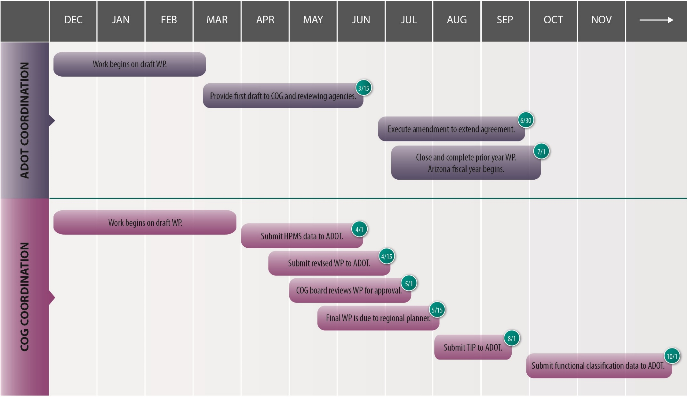

5.7 | BUDGET APPROVAL
The COG must submit the approved WP and budget to the ADOT regional planner by May 15. The COG may not incur any expenses when the WP begins on July 1 until the FHWA has approved the WP and the agreement is executed.

5.8 | WORK ELEMENT DESCRIPTIONS

5.8.1 | Public Involvement Plan
The COG must develop a public involvement plan to guide outreach activities to stakeholders, including agency staff, elected officials, the public, and other interested parties. The public involvement plan addresses outreach for COG activities that occur throughout the fiscal year, in compliance with federal and state regulations. These include the development and amendment of the COG TIP and ADOT STIP, standing meetings, committee meetings, and participation in ADOT planning studies such as the statewide long-range plan.
Key aspects of the public involvement plan include the following:
- Outreach activities must include consultation with non-metropolitan elected officials and appointed officials with responsibility for transportation, public meetings, appropriate notification, and other elements.
- COGs must conduct public involvement activities, as defined by the public involvement plan, as appropriate and feasible based on the development of the plan.
A COGs website must include:
organizational chart
name, title, and contact information for each staff member
Public Involvement Plan
Title VI Plan
approved WP
schedule of activities
membership lists (for the TAC, regional council/executive board, and any other COG committees that include the name, title, and contact information for each member)
dates, locations, agendas, and minutes for the reoccurring meetings of each committee (Agendas must be posted a minimum of 24 hours before the scheduled meeting. Minutes must be posted within 5 days of approval)
dates, locations, agendas, and minutes for non-reoccurring meetings that support tasks outlined in the WP, including air quality interagency consultation
contact person for key responsibilities of the COG
TIP to include all subsequent amendments; complete TIP amendments in compliance with federal regulations (23 C.F.R. 450) and conformity (40 C.F.R. 93)
public involvement opportunities and activities
files of or links to relevant planning studies conducted by the COG, ADOT, or member agencies
approvals for fund expenditures

- COGs must demonstrate compliance with public involvement activities, such as the required minimum 45-day review period for the TIP.
COGs must follow guidelines set forth in ADOT policy document Transportation Consultation with Rural Officials, which can be found at:

https://azdot.gov/sites/default/files/2019/05/tcro-policy-update.pdf
- COGs must post the Title VI poster at all locations where COG-related activities, regional council meetings, committee meetings, and public meetings are held (chapter 12).
Details on public involvement activities and civil rights can be found in chapter 12, “Civil Rights.”
Further details on public involvement activities and civil rights can be found in chapter 13, “Public Involvement.”
- In nonattainment areas, interagency consultation for conformity is recommended.

5.8.2 | Website
The COG must develop and maintain a website with current and accurate information relating to the COG organizational structure, activities, data, and plans. The website must include, at a minimum, the items shown in the following chart.

5.8.3 | HPMS Data Collection
The HPMS data collection is completed through the HPMS web-based application that provides a method to upload and monitor the HPMS data for any roadway classified as a “major collector” or higher. Note that HPMS data for minor collector roads in urban areas is also collected since these are included in the definition of Federal-Aid Highways. Many COGs and MPOs hire contractors to collect the HPMS data.
Detailed information on HPMS and associated HPMS data collection is provided in chapter 17.3, “Transportation Data & Functional Classifications,” of this manual.
Additional detail on air quality is available in chapter 17.1, “Air Quality,” of this manual.

5.8.4 | Functional Classification
Monitoring and maintaining a current inventory of the COG region’s functional classification of roadways and urban boundaries is critical to understanding project eligibility for federal transportation funding and accurate TIP development. Key aspects of a COG’s role regarding functional classification include:
Detailed information on functional classification is provided in chapter 17.3, “Transportation Data & Functional Classifications, “of this manual.
- maintaining an inventory of basic centerline data for federally functionally classified roads (collector and above classifications);
- processing proposed changes in classification with approvals through the ADOT regional planner and ADOT Geographic Information Systems for Transportation (GIS-T) Section; and
- verifying that projects identified for the TIP are eligible for federal funding (minor collector in urban area and higher).

5.8.5 | Air Quality Standards
There are several areas within the state that do not meet the National Ambient Air Quality Standards (NAAQS). These geographic areas must coordinate closely with the ADOT Transportation Analysis/Air Quality teams to comply with requirements regarding nonattainment areas. Specifically, the COG staff must notify the Air Quality staff and copy the ADOT regional planner of the notification when there is a change to a qualifying improvement project in the TIP, or if a new qualifying improvement project is added to the TIP in any of the areas identified as not meeting the NAAQS.
Nonattainment areas is available on ADOT’s website: https://azdot.gov/business/environmental-planning/air-quality
When a qualifying project is within a nonattainment or air quality maintenance area, the ADOT staff provides guidance on the appropriate methodology and processes for projects in the TIP, other transportation control measures, and interagency consultation that may be required.

5.8.6 | Population Projections & Estimates
Population projections are developed and maintained by each of the COGs and MPOs to feed into local and regional planning processes. This task requires extensive coordination with the local agencies to calculate the number of building permits and certificates of occupancy that are issued. This ensures that population data from the COG region is collected according to requirements of the Arizona Department of Administration, including:
- actively participating in the Department of Administration Council for Technical Solutions; and
- working with local jurisdictions to ensure that data required for the preparation of population estimates and projections are collected and submitted to the Department of Administration by the prescribed due date. The building permit and certificate of occupancy information must be consistent with the estimates and projections to be submitted to the Department of Administration.

5.8.7 | Transportation Improvement Program
Chapter 8, “Transportation Improvement Program,” in this manual describes the TIP process.
COGs must identify and prioritize transportation improvement projects that are to be completed over a four- to five-year period on local and regional roads, using regionally accepted policies and plans.

5.8.8 | Transportation Technical Advisory Committee
COGs must maintain a TAC comprising representatives of local jurisdictions and tribal nations for the purpose of carrying out regional planning activities. The TAC meets regularly to discuss all aspects of transportation planning as it relates to local, regional, state, and public transportation coordination, public participation, plan development, programming of funds (TIP), and data submittals to ADOT. TAC representation includes all member agencies, ADOT, and transit providers.

5.8.9 | ADOT Five-Year Facilities Construction Program
COGs work with the ADOT regional planner, ADOT district staff, and the TAC to prioritize and recommend improvements to roadways on the state highway system to be considered for inclusion in the ADOT Five-Year Transportation Facilities Construction Program. All recommendations that result in the prioritized project listing from the COG must be recommended by the TAC and approved by the regional council before they are submitted to ADOT.
Submit invoices to ADOT Finance and Contract Administration. mpdinvoice@azdot.gov
You will receive an automatic reply from ADOT confirming the email has been received.

5.8.10 | Surface Transportation Block Grant (STBG) Program
The FAST Act eliminates the MAP-21 Transportation Alternatives Program (TAP) and replaces it with a set-aside of Surface Transportation Block Grant Program (STBGP) funding for transportation alternatives (TA). These set-aside funds include all projects and activities that were previously eligible under TAP, encompassing a variety of smaller-scale transportation projects such as pedestrian and bicycle facilities, recreational trails, safe routes to school projects, community improvements such as historic preservation and vegetation management, and environmental mitigation related to stormwater and habitat connectivity.

5.8.11 | Public Transportation/Transit
The WP defines extensive COG staff responsibilities relating to transit requirements, reporting, and facilitation. Chapter 14 in this manual describes the transit programs and processes.

5.9 | INVOICING

5.9.1 | Submitting Invoices
COGs must use ADOT’s E-GRANTS platform to submit invoices no more frequently than monthly, but no less than quarterly. The various COG accounting offices in consultation with ADOT determine invoice detail requirements. The invoice must provide enough detail to accurately document all charges. It’s assumed that supply or material expenses may require a receipt to confirm eligibility of expenses. ADOT has the right to request these records or receipts. Supporting documents for invoices should include receipts for eligible expenses, progress reports, in-kind worksheets, and a detailed expense ledger.
At a minimum, invoices must include the following nine items:
Authorized amount by fund
Total expenditures
Total reimbursement for the current invoice
Percentage of project complete
Funds remaining in project
Breakdown of expenditures by UPWP task
Progress reports
The period of time covered by the invoice
Federal-aid project number
Receipts for eligible expenses
In-kind worksheet
Detailed expense ledger

All invoices are paid as reimbursements for expenses. All work performed by a third party must be paid before a reimbursement is made.

DID YOU KNOW
Travel receipts should be submitted with invoices. Receipts for travel typically can include food, lodging and commercial transportation. The ADOA provides Travel Policy and Guidance at: https://gao.az.gov/travel/welcome-gao-travel
Information related to receipts for eligible expenses (e.g. meeting supplies) can be found in

https://www.govinfo.gov/app/details/CFR-2014-title2-vol1/CFR-2014-title2-vol1-part200

5.9.2 | Processing Payment
Upon approval by Project Manager and COG Finance section at ADOT, Arizona reimburses expenses within 30 days of receipt of the request for reimbursement from the COG relating to Section 134 (23 U.S.C. § 104). Should ADOT later determine those charges were unallowable, ADOT deducts those charges from any future claim for reimbursement. ADOT may request additional information before approving and processing the invoice.
ADOT uses a centralized financial information system. VendorPay allows for vendors and customers to effectively monitor status of payment. For vendor payment or to sign up for automated payment, instructions and forms are located under “ Payment Options” at

https://gao.az.gov/afis/vendor-information
The State of Arizona has tools for vendors and customers to check if an invoice or reimbursement has been paid. Additionally, vendors and customers have the opportunity to sign up for automated payment; this option will allow the State to send payment electronically through a bank institution. This automatic payment is processed as a direct deposit and reduces the amount of time it takes for the vendor or customer to receive payment from the State.
6 | PERFORMANCE MEASURES
TABLE OF CONTENTS
6.1 | PURPOSE
6.2 | AUTHORITY
6.3 | NATIONAL PERFORMANCE GOALS
6.4 | P2P LINK
6.4.1 | Initial P2P Performance Measures

| Performance Measures

6.1 | PURPOSE
Establishing a meaningful strategic direction to drive system investment decisions is a critical part of the statewide transportation planning process. Plan goals and objectives define investment priorities and describe how ADOT plans to work with its transportation planning partners to achieve a shared transportation vision. Plan-level performance measures establish a means of determining how different investment strategies contribute to achieving the plan’s goals and objectives and provide a basis to establish program-level and project-level measures to guide plan implementation.

6.2 | AUTHORITY
The USDOT establishes performance measures for: pavement conditions and performance for the Interstate and National Highway System (NHS); bridge performance and conditions; highway injuries and fatalities; traffic congestion and on road mobile source emissions, as these relate to CMAQ; freight movement on the Interstate system; and safety and state of good repair (SGR) relating to transit services. Once established, ADOT adopts specific performance measures, including rural transit-related measures, within one year. MPOs, in coordination with the State and transit operators, where applicable, have 180 days to set regional targets once statewide or transit performance targets are set. State and metropolitan transportation plans must describe how program and project selection help achieve the targets (23 U.S.C. § 134).
The LRTP must describe the performance measures and targets used to assess system performance and demonstrate progress in achieving the performance targets—progress expected to be achieved by planned decisions and investments. LRTPs must
include system performance reports that evaluate conditions and performance with respect to the targets. The TIP also must be developed to make progress toward established performance targets and include a description of the anticipated achievements (23 U.S.C. § 134 and 135; 23 C.F.R. § 450.326(d)). Performance targets are established in coordination with the state and public transportation providers. Thus, the planning process integrates public transportation and relevant public transportation performance measures.

Table 6-1 | Authority
Code |  | Description
Federal | 23 C.F.R. § 450.334: Self-certifications and federal certifications | The FHWA and FTA jointly review and evaluate the metropolitan transportation planning process.
 | 23 U.S.C. § 134 | The TIP must be developed to make progress toward established performance targets and include a description of the anticipated achievements.
 | 23 U.S.C. § 135 | Statewide and nonmetropolitan transportation plans must describe how program and project selection help achieve the targets.
State | A.R.S. § 28-503 | The state statute covers performance-based planning and programming.
 | A.R.S. § 28-504 | This state statute covers transportation system performance measures, data collection and reporting, and methodologies.
 | A.R.S. § 28-505 | This state statute covers transportation system performance factors and weights.

6.3 | NATIONAL PERFORMANCE GOALS
- The FAST Act continues allowing states to set their own targets for reaching national performance goals for Federal highway programs:
- Safety—Achieve a significant reduction in traffic fatalities and serious injuries on all public roads.
- Infrastructure Condition—Maintain the highway infrastructure asset system in a state of good repair.
- Congestion Reduction—Achieve a significant reduction in congestion on the NHS.
- System Reliability—Improve the efficiency of the surface transportation system.
- Freight Movement and Economic Vitality—Improve the national freight network, strengthen the ability of rural communities to access national and international trade markets, and support regional economic development.
- Environmental Sustainability—Enhance the performance of the transportation system while protecting and enhancing the natural environment.
- Reduced Project Delivery Delays—Reduce project costs, promote jobs and the economy, and expedite the movement of people and goods by accelerating project completion through the elimination of delays in the project development and delivery process, including reduction of regulatory burdens and improvement of agencies’ work practices.
The FAST Act did reduce the timeframe for states and MPOs to meet their self-determined performance targets for the national performance goal areas from two years to one year. The FAST Act also set new definite timeframes for states to meet their self-determined performance targets for the specific national performance goal areas of freight movement and pavement condition. In the first instance, if a state fails to meet or make significant progress toward its freight performance target goal within two years after setting the goals, that state must describe in its next performance report to USDOT the actions it will take to achieve these targets. In the second case, the FAST Act adjusts the federal review timeframe down from two years to one year for when a fiscal penalty can be triggered for failing to meet condition target on a state’s interstate pavement. The penalty requires the state to dedicate certain funds to interstate maintenance until pavement condition targets have been satisfied.

6.4 | P2P LINK
ADOT has developed a planning to programming linkage called P2P Link. It establishes a well-documented, understandable, logical, and defensible means of selecting and prioritizing projects in the STIP that will allow the Arizona state transportation system to meet the objectives identified in the LRTP.

Table 6-2: National Programs, Goals & Performance Measures
FAST Act Program Area | National Goal Area | National Performance Measure Area
Highway Safety Improvement Program | Safety | Number of Fatalities
 |  | Rate of Fatalities per 100 million Vehicle Miles Traveled (VMT)
 |  | Number of Serious Injuries
 |  | Rate of Serious Injuries per 100 million VMT
 |  | Number of Non-motorized Fatalities and Non-motorized Serious Injuries
National Highway Performance Program | Infrastructure Condition | Bridge Condition on the NHS
 |  | Pavement Condition of the Interstate System
 |  | Pavement Condition of the NHS
 | System Reliability | Performance of the Interstate System
 |  | Performance of the NHS Excluding the Interstate System
Congestion, Mitigation, and Air Quality | Congestion Reduction | Traffic Congestion
 | Environmental Sustainability | On-road Mobile Source Emissions
National Highway Freight Program | Freight Movement & Economic Vitality | Efficient Freight Movement on the Interstate System
The approach preferred by the leadership of ADOT, and required by FAST Act legislation, demands that the system be evaluated from a variety of critical perspectives and that decisions be made on the basis of system performance. ADOT is in the process of developing clear objectives for how the system elements will be expected to perform so they can help identify system priorities and strategically select projects for a capital program that meets ADOT’s policy objectives. P2P Link is designed to implement a “best-in-class” performance-based planning process, which will include recommendations about what ADOT should consider under performance categories to comply with the FAST Act. Implementation of a revised process will require a more strategic allocation of resources based on priorities set in accordance with performance. These changes will allow the resulting program to address Arizona transportation policy, and transportation needs as a whole.

6.4.1 | Initial P2P Performance Measures
The P2P Link team developed metrics for system performance that address the FAST Act and can be used as a starting point for ADOT, including:
- System Preservation - Roadway;
- System Preservation - Bridge;
- Modernization; and
- Expansion.

7 | REGIONAL TRANSPORTATION PLAN
TABLE OF CONTENTS
7.1 | PURPOSE
7.2 | AUTHORITY
7.3 | SCOPE
7.4 | PUBLIC INVOLVEMENT
7.5 | PLAN DEVELOPMENT METHODS
7.5.1 | RTP Standard Periodic Updates
7.5.2 | RTP Updates due to Major Projects
7.6 | FISCALLY CONSTRAINED RTP
7.7 | RELATIONSHIP TO THE TIP/STIP
7.8 | AREAS TO BE ADDRESSED IN THE RTP
7.8.1 | Additional Topics to be Covered in the RTP
7.8.2 | Environmental Mitigation
7.9 | RTP REVISIONS
7.10 | PUBLICATION & DISTRIBUTION

| Regional Transportation Plan

7.1 | PURPOSE
This chapter provides guidance to ADOT and MPOs in creating, implementing, and managing the MPO RTP required by federal laws and regulations. Arizona’s COGs are not required to develop RTPs, but they are encouraged to work with ADOT if an RTP is desired and warranted. An RTP is also commonly referred to as a Metropolitan Transportation Plan (MTP) in federal publications.

7.2 | AUTHORITY
Table 7-1 describes the Federal and State statutes, codes, and regulations regarding MPO RTPs.

Table 7-1 | Authority
Code |  | Description
Federal | 23 U.S.C. § 134(h) (i) | These laws describe the structure and requirements of MPOs as well as the scope of the metropolitan planning process.
 | 49 U.S.C. § 5303
 | 23 C.F.R. § 450.316 | These laws discuss planning assistance standards for metropolitan planning agreements, congestion management, and the development and content of the metropolitan transportation plan.
 | 23 C.F.R. § 450.320
 | 23 C.F.R. § 450.322
 | 23 C.F.R. § 500.109 | Defines the requirements, strategies, and performance measures that must be integrated into a Congestion Management System (CMS), Public Transportation Management System (PTMS), and Intermodal Management System (IMS.)
 | 23 C.F.R. § 500.110
 | 23 C.F.R. § 500.111
State | A.R.S. 28-501 | These laws, under article 7 of chapter 2, define many different aspects of transportation planning. The practices and requirements are defined as well as the standard performance measures, methodologies, and data collection/reporting. The later sections then describe the transportation system database, divisions, and long-range plan that the division must develop in cooperation with local, regional, and tribal agencies.
 | A.R.S. 28-502
 | A.R.S. 28-503
 | A.R.S. 28-504
 | A.R.S. 28-505
 | A.R.S. 28-506
 | A.R.S. 28-507
 | A.R.S. 28-6951 | These laws, listed under article 3 of chapter 20, discuss the description and requirements of the Five-Year Transportation Facilities Construction Program.
 | A.R.S. 28-6952
 | A.R.S. 28-6953
 | A.R.S. 28-6954
 | A.R.S. 28-6955
 | A.R.S. 28-6308 | Describes the requirements of the regional planning agency transportation policy committee, regional transportation plan, and plan review process.

7.3 | SCOPE
MPOs are responsible for developing an RTP that addresses at least a 20-year planning horizon from the date of the plan adoption (in air quality attainment areas) or the date of its federal agency approval of conformity (for air quality nonattainment areas (23 CFR. § 450.322(a)).
An RTP is intended to promote a safe and efficient intermodal transportation system that serves the mobility needs of people and freight in a regional or metropolitan area. The RTP focuses on the management, operation, and development of this transportation system while minimizing fuel consumption and air pollution. The RTP must include short- and long-range strategies consistent with the goals and objectives of state and local governments.
At a minimum, an RTP should include:
the identification of transportation facilities
performance measures and targets
a system performance report
mitigation activities
a financial plan
operational and management strategies
capital investment and other strategies
transportation and transit enhancement activities

The RTP provides for the development and integrated management and operation of transportation systems and facilities (including accessible pedestrian walkways and bicycle transportation facilities) that function as a multimodal transportation system for the MPA (Pub. L. 112-141 § 1201; 23 U.S.C. § 134(c)(2). The RTP is prepared and updated every four to five years unless the MPO elects to update more frequently for any area designated as nonattainment and any area that was nonattainment designated to be attainment and required to have a Maintenance Plan (Pub. L. 112-141 § 1201; 23 U.S.C. § 134(i)(1)). The RTP quantifies transportation facilities (including major roadways, transit, multimodal and intermodal facilities, nonmotorized transportation facilities, and intermodal connectors) that should function as an integrated metropolitan transportation system, giving emphasis to those facilities that serve important national and regional transportation functions (Pub. L. 112-141 § 1201; 23 U.S.C. § 134(i) (2)).
The RTP considers system-level investments as they relate to a minimum 20-year forecast period:
- Support the economic vitality of the metropolitan area, especially by enabling global competitiveness, productivity, and efficiency;
- Increase the safety of the transportation system for motorized and nonmotorized users;
- Increase the security of the transportation system for motorized and nonmotorized users;
- Increase the accessibility and mobility of people and for freight;
- Protect and enhance the environment, promote energy conservation, improve the quality of life, and promote consistency between transportation improvements and state and local planned growth and economic development patterns;
- Enhance the integration and connectivity of the transportation system, across and between modes, for people and freight;
- Promote efficient system management and operation; and
- Emphasize the preservation of the existing transportation system. (Pub. L. 112-141 § 1201; 23 U.S.C. § 134(i)(2) and 23 U.S.C. § 134(h)(1)).

7.4 | PUBLIC INVOLVEMENT
A.R.S. § 28-6308 applies only in the case of counties with a population of 1.2 million residents or more. Based on the 2010 Census, this only applies to Maricopa County, which is served by MAG. For this region, paragraph C of the statute mandates that the RTP:
- Shall include the following transportation mode classifications with a revenue allocation to each classification consistent with section 42-6105, subsection D:
- Freeways and other routes in the state highway system.
- Major arterial streets and intersection improvements.
- Public transportation systems.
- Shall provide a suggested construction schedule for the transportation projects contained in the plan.
- May be annually updated to introduce new controlled access highways, related grade separations and transportation projects or to modify the existing plan.
- Shall be developed to meet federal air quality requirements established for the region in which it is located.
Federal law requires that the MPO develop and use a documented Public Participation Plan (23 U.S.C. § 134(i)(5)(B); 23 C.F.R. § 450.316(a)). The participation plan defines the process for public input to the RTP and the TIP. Detailed information on the public involvement process can be found in chapter 13, “Public Involvement.”
MPOs must provide a reasonable opportunity to comment on the transportation plan using the documented Public Participation Plan methodologies and processes outlined by the MPO. To accommodate public review and comment, the plan must be published or otherwise made readily available by the MPO, including (to the maximum extent practicable) in electronically accessible formats and means on the Internet (23 C.F.R. § 450.322(j)).

7.5 | PLAN DEVELOPMENT METHODS
The RTP addresses the unique goals and objectives of the region or metropolitan area. For this reason, there is no single methodology used to develop an RTP. At the beginning of the RTP process, the local communities work through a public process to identify transportation needs that are important for their local citizens. The plan includes both long-range and short-range strategies and actions that lead to the development of an integrated multimodal transportation system that facilitates the efficient movement of people and goods and addresses current and future transportation demand (23 C.F.R. § 450.322(b)). All MPOs must include an estimate of needs, which shall be within the body of the RTP. In addition, revenue and cost estimates supporting the plans must use an inflation rate or rates to reflect the year of expenditure (YOE) amounts (23 C.F.R. § 450.322(f)(10)(iv)).
Arizona’s statutory requirements focus largely on development of the statewide transportation plan, and the statewide Five-Year Transportation Facilities Construction Program. The statewide plan and five-year program are developed in coordination with the regional and metropolitan project priorities resulting from federally mandated transportation planning processes.
Table 7-2 includes a listing of the current MPO RTPs, and the links to access each plan.

Table 7-2 | MPO Regional Transportation Plans
MPO | RTP Document
MAG | 2031 Regional Transportation Plan Update
PAG | 2045 Regional Mobility and Accessibility Plan
SCMPO | 2040 Regional Transportation Plan
CYMPO | 2040 Regional Transportation Plan Update
FMPO | 2040 Regional Transportation Plan
LHMPO | 2040 Regional Transportation Plan
SVMPO | 2040 Regional Transportation Plan
YMPO | 2018-2041 Regional Transportation Plan

7.5.1 | RTP Standard Periodic Updates
An RTP is not a one-time effort; instead it undergoes periodic updates to ensure that it reflects the ever-changing conditions and needs of the community. Accordingly, the FAST Act requires that MPOs review and update the RTP at least every five years in air quality attainment areas or every four years in a nonattainment or maintenance areas (23 C.F.R. 450.322(b)). During these updates, MPOs confirm the plan’s validity and consistency with current and forecasted transportation and land use conditions and trends. The MPO also extends the planning horizon outward to at least 20 years (23 C.F.R. 450.322(c)). For example, if a plan adopted in 2010 has a planning horizon year of 2030, then its update five years later must address transportation needs at least through the year 2035.
The schedule for the required periodic update of the RTP is determined cooperatively by the MPO, ADOT, FHWA, and FTA, but the RTP must be updated no later than five years to the day when the MPO last adopted it.

7.5.2 | RTP Updates due to Major Projects
For individual projects estimated to cost $500 million or more, ADOT is required to submit a Project Management Plan and an Annual Financial Plan to FHWA (23 U.S.C. § 106(h)). The FTA also has requirements for Major Capital Investment Projects (49 U.S.C. Part 611). The update of the Annual Financial Plan may necessitate an update to the RTP if revenue assumptions are not consistent with the Annual Financial Plan.
It is important for the MPO’s RTP to identify any Major Capital Investment Projects. FHWA guidance directs that the cost estimates reported for a Major Capital Investment Project in the first five years of the RTP are to be based on more precise cost estimate information than a project reflected in the latter years of the RTP. Typically, preliminary engineering (PE) would occur five years prior to construction activities, unless an aggressive schedule is undertaken. In most cases, the more precise cost estimate can be developed for that first five-year period of the RTP.

7.6 | FISCALLY CONSTRAINED RTP
FHWA, Lessons Learned in Fiscal Constraint:

https://www.fhwa.dot.gov/planning/lsnlrndatchmt.cfm
FHWA, Financial Planning and Fiscal Constraint for Transportation Plans and Programs, Questions & Answers:

https://www.fhwa.dot.gov/planning/fsclcntrntques.cfm
MPOs are required to include a fiscally constrained element in their RTP. Fiscal constraint is defined by the FHWA as “A demonstration of sufficient funds (Federal, State, local, and private) to implement proposed transportation system improvements, as well as to operate and maintain the entire system, through the comparison of revenues and costs.” (FHWA, Fiscal Constraint Definitions).
FHWA has published two informative reports including a “Lessons Learned” and a “Q&A” report regarding Fiscal Constraint. Identified below is a set of questions to be posed as an initial test of financial plans/fiscal constraints for State and MPO plans:
- Are operations and maintenance costs accounted for in the financial plans?
- Are capital costs accounted for in the financial plan?
- Are underlying assumptions for revenue forecasts reflected in the financial plan?
- Are costs in RTPs, TIPs, and STIPs shown as “year of expenditure” dollars?
- Is the MPO designated as an air quality nonattainment or maintenance area?

Based upon input gathered from FHWA Division Offices, a series of key issues are to be considered when discussing fiscal constraint, including:
Cross reference chapter 6, “Perfomance Measures” for additional detail on performance measures.
- Awareness of State Transportation Funding Levels is Important;
- Awareness of Funding Issue Deliberations in State Legislatures is Valuable;
- Discretionary Funding Levels Can Play a Significant Role in Fiscal Constraint;
- Accurate Transit Operations and Maintenance Costs are an Important Variable in Fiscal Constraint; and
- Program/Process Reviews on Fiscal Constraint Can Be a Valuable Stewardship and Oversight Tool.

7.7 | RELATIONSHIP TO THE TIP/STIP
The RTP is used as the basis upon which TIPs are developed. Accordingly, there must be an approved RTP or a properly amended RTP in place when the MPO submits its TIP to ADOT for approval. The TIP must be incorporated into the STIP to ensure continued federal funding for the metropolitan area. A TIP (for inclusion in the STIP) that is not representative of a currently approved or amended RTP cannot be approved.

7.8 | AREAS TO BE ADDRESSED IN THE RTP
The fiscal constraint requirements are more stringent in air quality nonattainment and maintenance areas. Nonattainment and maintenance areas may not rely upon proposed new revenue sources (i.e. taxes, bonding, or major funding increase still under consideration) to support projects listed in the first two years of the TIP and STIP.

DID YOU KNOW
Since 2005, federal law has identified ten planning factors and 3 emphasis areas to be considered in the MPO planning process, including in the RTP planning process (23 U.S.C. § 134(h)(1) and 23 § C.F.R. 450.306).
FEDERAL PLANNING FACTORS
1. Support the economic vitality of the metropolitan area, especially by enabling global competitiveness, productivity, and efficiency.
2. Increase the safety of the transportation system for motorized and non-motorized users.
3. Increase the security of the transportation system for motorized and non-motorized users.
4. Increase accessibility and mobility of people and freight.
5. Protect and enhance the environment, promote energy conservation, improve the quality of life, and promote consistency between transportation improvements and state and local planned growth and economic development patterns.
6. Enhance the integration and connectivity of the transportation system, across and between modes, for people and freight.
7. Promote efficient system management and operation.
8. Emphasize the preservation of the existing transportation system.
9. Improve the resiliency and reliability of the transportation system and reduce or mitigate stormwater impacts of surface transportation.
10. Enhance travel and tourism.
EMPHASIS AREAS
11. Transition to performance-based planning and programming (MAP-21 [currently the FAST Act] Implementation).
12. Ensure a regional approach to transportation planning by promoting cooperation and coordination across transit agency, MPO and state boundaries (Regional Models of Cooperation).
13. Provide access to essential services (Ladders of Opportunity).
The FAST Act continued the requirement for MPOs to establish performance measures addressing seven national goals of the Federal-Aid Highway Program (23 U.S.C. § 150):
- Safety
- Infrastructure condition
- Congestion reduction
- System reliability
- Freight movement and economic vitality
- Environmental sustainability
- Reduced project delivery delays
This action by MPOs was required within 180 days after the state establishes its own performance measures, which in turn, is required within one year after the secretary of the U.S. Department of Transportation does the same (23 U.S.C. 134(h)(2)(C)).
Because there is extensive overlap between the previously established planning factors and the new federal transportation goals, establishing performance measures does not necessarily alter recent or ongoing planning priorities. However, MPOs do need to track how transportation investments in their five-year TIPs address the new national performance measurement goals. Performance metric emphasis areas data and trends should be utilized to the extent feasible to inform future TIP development and programming decisions.

7.8.1 | Additional Topics to be Covered in the RTP
In addition to the ten planning factors and 3 emphasis areas and the FAST Act performance measures discussed above, federal laws and regulations specify other topics required to be addressed in a Regional Transportation Plan. At a minimum, the RTP is required to include the following 12 elements (23 C.F.R. § 450.324(f)):
- projected 20-year travel demand;
- documented multimodal transportation facilities and systems;
- description of performance measures and performance targets of the transportation system;
- a report of the system performance and subsequent updates evaluating the condition and performance of the transportation system;
- documented operational and management strategies for system preservation
- Consideration of the results of the congestion management process in TMAs;
- assessment of capital investment and other strategies to preserve the existing and projected future metropolitan transportation infrastructure, provide for multimodal capacity increases based on regional priorities and needs, and reduce the vulnerability of the existing transportation infrastructure to natural disasters;
- transportation and transit enhancements;
- design concept and design scope descriptions of all existing and proposed transportation facilities in sufficient detail, regardless of funding source, in nonattainment and maintenance areas for conformity determinations);
- a discussion of types of potential environmental mitigation activities and potential areas to carry out these activities;
- a financial plan that demonstrates how the adopted transportation plan can be implemented;
- Pedestrian walkway and bicycle transportation facilities in accordance with 23 U.S.C. 217(g).
Table 7-3 provides a list of the federal codes and regulations that define the requirements of RTP contents.
Table 7-3 | RTP Relevant Codes & Regulations

1| | The Plan Considers:  - Economic Vitality;  - Improves Safety;  - Improves Transportation Systems Security;  - Improves Person Mobility’  - Improves Flight Mobility;  - Protects/Enhances the Environment;  - Enhances Connectivity between Modes;  - Promotes System Management and Operational Efficiencies; and  - Emphasizes System Preservation.
2| | The Plan Accounts for:  - Completed State Mobility Plans;  - BqAZ  - What Moves You Arizona  - Arizona State Rail Plan  - Arizona State Airport System Plan  - Local Agency Plans;  - County Plans/General Plan  - Municipal Plans/General Plans  - Tribal Plans; and  - State Land Department Plans.
3| | The Plan’s socioeconomic growth control totals match the Arizona Department of Administration Office of Employment and Population Statistics
4| | The Plan was adopted following the procedures outlined in the Public Involvement Plan.

RTP CHECKLIST
Code/Regulation | Relevance
23 U.S.C. § 134 (i) (2) (A) | transportation facilities

23 C.F.R. § 450.322 (f) (2)
23 U.S.C. § 134 (i) (2) (D) (i) | environmental mitigation activities

23 C.F.R. § 450.322 (f) (7)
23 U.S.C. § 134 (i) (2) (E) | financial plan

23 C.F.R. § 450.322 (f) (10)
23 U.S.C. § 134 (i) (2) (F) | operational and management strategies

23 C.F.R. § 450.322 (f) (3)
23 U.S.C. § 134 (i) (2) (G) | capital investment and other strategies

23 C.F.R. § 450.322 (f) (5)
23 U.S.C. § 134 (i) (2) (H) | transportation and transit enhancement activities

23 C.F.R. § 450.322 (f) (9)
23 C.F.R. § 450.322 (f) (1) | projected transportation demand
23 U.S.C. § 217 (g) | pedestrian walkway and bicycle transportation facilities

23 C.F.R. § 450.322 (f) (8)
23 C.F.R. § 450.322 (f) (6) | proposed improvements in sufficient detail to develop cost estimates
23 C.F.R. § 450.322 (h) | safety element
23 C.F.R. § 450.322 (e) | updating the plan
23 C.F.R. § 450.322 (b) | long-range and short-range strategies/actions
23 U.S.C. § 134 (k) (3) (A) | address congestion management

23 C.F.R. § 450.322 (f) (4)

7.8.2 | Environmental Mitigation
The RTP process must include a discussion on environmental mitigation in which a general approach to mitigation activities, in accordance with federal, state, regional, and local regulations, are considered. This discussion must occur on a regional system-wide level rather than on project-specific issues. Areas of consideration include mitigation policies, strategies, and activities derived from regional resources, conservation, and mitigation plans. The discussion needs to include, among other issues, wetlands, water resources, protected species, cultural resources, wildlife corridors, Title VI/Environmental Justice, and impacts to the human environment. Areas designated for future mitigation, conservation, or preservation must be mapped in both its existing area as well as its future area.
Several federal requirements already discussed in this chapter have mentioned the need to address environmental considerations in the RTP. FHWA encourages closer coordination between the processes to help streamline the process of project-level environmental clearances. ADOT has established the PEL process to facilitate these discussions.
FHWA’s Planning and Environmental Linkages:

https://www.environment.fhwa.dot.gov/env_initiatives/PEL.aspx

7.9 | RTP REVISIONS
Besides the five-year update cycle, there are times when an MPO may find it necessary to revise the RTP. Federal regulations define two types of RTP revisions: administrative modifications and amendments.
An administrative modification is a minor revision to the RTP. Administrative modifications include minor changes to project/phase costs, funding sources, or project/phase initiation dates. They do not require public review and comment or demonstrating fiscal constraint (23 C.F.R. § 450.104).
An amendment is a major revision to the RTP (or TIP). This may include adding or deleting projects from the plan as well as making major changes to project costs, initiation dates, or design concepts and scopes for existing projects. An amendment requires public review and comment in accordance with the RTP amendment and public involvement processes and demonstrating fiscal constraint. Changes to projects that are included only for illustrative purposes do not require an amendment (23 C.F.R. § 450.104). An amendment requires revenue and cost estimates supporting the plan to use an inflation rate(s) to reflect year of expenditure dollars, based on reasonable financial principles and information (23 C.F.R. § 450.322(f) (10) (iv)).
The RTP can be revised at any time. The MPO does not have to extend the planning horizon of the RTP out another 20 years for administrative modifications and amendments. That is only required for the periodic (e.g., five-year) updates.

7.10 |PUBLICATION & DISTRIBUTION
Although the RTP does not require approval by ADOT, FHWA or FTA, these agencies should be involved during the development of the plan and be provided an opportunity to comment on the draft plan. The plan is reviewed by FHWA and FTA during the quadrennial TMA certification. Copies of any new and/or revised plans must be provided to each agency as well as to ADOT (23 C.F.R. § 450.322(c)). New or revised plans should be provided to the FHWA, FTA, and appropriate ADOT offices prior to the MPO annual self-certification.
Federal law requires that the MPO publish its RTP and make it available to the public for review including, to the maximum extent practicable, in electronically accessible format (23 U.S.C. § 134(i)(7); 23 C.F.R. § 450.316(a)(1)(iv)).

8 | TRANSPORTATION IMPROVEMENT PLAN
TABLE OF CONTENTS
8.1 | PURPOSE
8.2 | AUTHORITY
8.3 | SCOPE
8.4 | TIP LEGAL REQUIREMENTS
8.4.1 | TIP Schedule
8.4.2 | Public Involvement
8.4.3 | Financial Constraints
8.4.4 | Project Selection Process
8.4.5 | Projects to be Included in the TIP
8.5 | YEARS TO BE COVERED
8.6 | RELATIONSHIP OF THE RTP
8.7 | FORMAT & CONTENT
8.7.1 | Introductory Materials
8.7.2 | Narrative
8.7.3 | Detailed Project Listings for Five Fiscal Years
8.8 | REVIEW PROCESS
8.8.1 | Review by Federal Agencies
8.8.2 | TIP Approval
8.9 | AMENDMENTS
8.9.1 | TIP Amendment Procedure
8.10 | DETERMINING IF A TIP/STIP AMENDMENT IS REQUIRED
8.10.1 | Determining Amendment or Modification
8.10.2 | Change Adds a New Individual Project
8.10.3 | Change Adversely Impacts Financial Constraint
8.10.4 | Change Results in Major Scope Changes
8.10.5 | Change Deletes an Individually Listed Project
8.10.6 | Change Results in a Cost Increase Greater Than 25 percent
8.10.7 | Contents of TIP/STIP Amendment Package
8.11 | STANDARD WORK IN ESTIP

| Transportation Improvement Program

8.1 | PURPOSE
This chapter provides guidance to MPOs/COGs on reviewing, processing, and amending TIPs.

8.2 | AUTHORITY
Table 8-1 displays the laws and regulations that specify the requirements of a TIP.

8.3 | SCOPE
This chapter facilitates department planning, program development and environmental management in ADOT and may be used by MPO/COG staff as a guideline for the requirements of developing a TIP and entering all projects and TIP action into the electronic STIP (ESTIP). Standard work that includes instructions for the most common actions in ESTIP can be found in the links on the website for the ADOT, MPO, and COG Guidelines and Procedures Manual .

ADOT, MPO, and COG Guidelines and Procedures Manual Website

8.4 | TIP LEGAL REQUIREMENTS
The MPO is required by 23 U.S.C. § 134(j) to develop a TIP. The TIP is the primary document to communicate to the public the ways that public (and private) dollars are allocated and spent. This listing of projects must be displayed in a manner that is understandable by the public, as the public is the intended audience of the TIP. The C.F.R. defines the TIP as a “prioritized listing/program of transportation projects covering a period of four years that is developed and formally adopted by an MPO as part of the metropolitan transportation planning process, consistent with the metropolitan transportation plan, and required for projects to be eligible for funding under title 23 U.S.C. and title 49 U.S.C. Chapter 53” (23 C.F.R. § 450.104). The MPO, in cooperation with the State and any affected public transportation operator(s), shall develop a TIP for the metropolitan planning area (23 C.F.R. § 450.326(a)).
COGs in Arizona are required to produce a TIP because they use and manage federal funds, much like an MPO does. The GRT that the COGs sign establishes the agreement and requirement for COGs to develop and manage a TIP.

8.4.1 | TIP Schedule
The schedule for the development of the TIP must be compatible with the schedule for the development of ADOT’s STIP because the TIP is incorporated into the STIP (23 U.S.C. § 135(g)(5)(D)(i); 23 C.F.R. § 450.216(b)). FHWA and FTA make a joint finding that each TIP is consistent with the RTP. FHWA and FTA base their findings on the self-certification statement submitted by the State and the MPO, their review of the RTP, and other reviews that they deem necessary (23 C.F.R. § 450.328(a)). COGs are not required to submit a self-certification statement as they do not certify themselves.

Table 8-1 | Authority
Code |  | Description
Federal | 23 U.S.C. § 134 (h) (j) and (k) (3) and (4) | Metropolitan Transportation Planning
 | 23 U.S.C. § 135 | Statewide Transportation Planning
 | 23 U.S.C. § 139 | Efficient Environmental Reviews for Project Decision making
 | 23 U.S.C. § 204 | Federal Lands Highways Program
 | 49 U.S.C. § 5304 | Statewide Transportation Planning
 | 23 C.F.R. Part 450 §§ 320, 324, 326, 328, 330, and 332 | Congestion Management Process in Transportation Management Areas, Development and Content of the TIP, TIP Revisions and Relationship to the STIP, TIP Action by the FHWA and the FTA, Project Selection From the TIP, and Annual Listing of Obligated Projects, respectively
 | 23 C.F.R. Part 500 §§ 109, 110, and 111 | Congestion Management System, Public Transportation Management System, and Intermodal Management System, respectively
State | A.R.S. 28-6538 | Arizona Highway User Revenue Fund Distribution; Remaining Monies; Highway Fund Distribution; Contract Authorization; Regional Transportation Plan Requirements
 | Arizona State Transportation Board Policies (revised November 15, 2019) | Section 20: Programming Policy and Section 21: Program Development Policy
Chapter 13 provides information regarding developing a public participation plan

8.4.2 | Public Involvement
The FAST Act requires that the MPO develop and use a documented Public Participation Plan (23 U.S.C. § 134(i)(6)(B); 23 C.F.R. § 450.316(a)). In Arizona, COGs are also required to develop and use a Public Participation Plan.
In addition, the MPO/COG must periodically review the effectiveness of the procedures and strategies contained in the Public Participation Plan (23 C.F.R. § 450.316(a)(1)(x)). These requirements are necessary because the Public Participation Plan must define the process for public input into the TIP.
The MPO/COG must provide all interested parties opportunity to comment on the TIP. In addition, in nonattainment TMAs, at least one public meeting during the TIP development process must be provided, which is documented in the Public Participation Plan (23 C.F.R. § 450.326(b)). The Public Participation Plan outlines the interested parties that may want to comment on the TIP. The interested parties may include citizens; affected public agencies; representatives of public transportation employees; freight shippers; providers of freight transportation services; private providers of transportation; representatives of users of public transportation, pedestrian walkways, bicycle transportation facilities; and representatives of people with disabilities (23 C.F.R. § 450.316(a)). If the MPO/COG includes tribal lands that are not included on the regional council and TAC, the MPO/COG must involve the tribal governments that are located within their planning boundaries throughout the process using the consultation process outlined in chapter 17, section 17.6. In addition, if the MPA includes federal public lands, the MPO/COG must involve federal land management agencies in the process.

8.4.3 | Financial Constraints
The TIP is always fiscally constrained, meaning that all projects in the TIP must identify the funding source that is paying for the improvements. The funds used to pay for the improvements cannot exceed the amount of available funding per funding source that can be programmed in the TIP. For federal funding, The Financial Management Services (FMS) and the MPO/COG ledger provide the apportionments and obligation authority to guide TIP development and fiscal constraint. The MPO/COG must demonstrate that the TIP is financially constrained by year and maintain that financial constraint (23 C.F.R. § 450.326(k)). It is highly recommended that the TIP include a table(s) that compares the funding sources and amounts by year with the total project costs by year. The TIP must include a financial plan that demonstrates how the approved TIP can be implemented, indicates resources from public and private sources that are reasonably expected to be made available to carry out the TIP, and recommends any additional financing strategies for needed projects and programs (23 C.F.R. § 450.326(j)). In developing the TIP, the MPO/COG, State, and public transportation operator(s) shall cooperatively develop estimates of funds that are reasonably expected to be available to support TIP implementation (23 C.F.R. § 450.326(j)).
The TIP must include a project or phase of a project only if full funding can reasonably be anticipated for the time period contemplated to complete the project (23 C.F.R. § 450.326(k)). The TIP may include projects that are not fully funded in the four federally recognized years of the TIP so long as those projects or project phases are fully funded within the 20-year time horizon of the MTP/ RTP. However, once federal funds are spent on a project, right-of-way acquisition or construction must be started within a 10-year period starting from the date of when the federal funding is obligated. Specifically, for ADOT sponsored-projects, the term “project” refers to the event when an ADOT project number is developed. This rule does not apply to TIP projects not sponsored by ADOT.

8.4.4 | Project Selection Process
There is no set methodology to determine which projects are selected for inclusion in the TIP. Typically, the process involves an evaluation that determines how the proposed project meets the goals and objectives of the RTP and other regional and state plans. All TIP projects in MPO areas must be included in the RTP. Because COGs are not mandated to have an RTP, this is not a requirement of COG TIPs.
The TIP project selection evaluations are typically conducted by the MPO/COG staff, and the results are then shared with the MPO/COG TAC for review and input prior to regional council MPO/COG approval.

8.4.5 | Projects to be Included in the TIP
The TIP must include the following projects:
- The TIP shall include, to the maximum extent practicable, a description of the anticipated effect of the TIP toward achieving the performance targets identified in the metropolitan transportation plan, linking investment priorities to those performance targets (23 C.F.R. § 450.326(d))
- Capital and non-capital surface transportation projects proposed for funding under Title 23 and Title 49 Chapter 53 (including transportation alternatives, Federal Lands Transportation projects, safety projects included in the Strategic Highway Safety Plan, trail projects, pedestrian walkways, and bicycle facilities) (23 C.F.R. § 450.326(e))
- All regionally significant projects requiring an action by FHWA or FTA regardless of funding source. For information purposes, all regionally significant projects proposed to be funded with federal funds other than those administered by the FHWA or FTA, as well as all regionally significant projects to be funded with non-federal funds (23 C.F.R. § 450.326(f))
- In areas with Americans with Disabilities Act (ADA) required paratransit and key station plans, identification of those projects that will implement these plans (23 C.F.R. § 450.326(g)(7))
- Only projects consistent with the RTP (23 C.F.R. § 450.326(i))
- According to 23 C.F.R. § 450.326(e), the following types of projects may be included in the TIP.
- Safety projects funded under 23 U.S.C. § 402 and 49 U.S.C. § 31102
- Metropolitan planning projects funded under 23 U.S.C. § 104(d), 49 U.S.C. § 5305(d)
- State planning and research projects funded under 23 U.S.C. § 505 and 49 U.S.C. § 5305(e)
- State planning and research projects funded with NHS, STBGP, and/or Equity Bonus funds
- Emergency relief projects (except those involving substantial functional, location, or capacity changes)
- National planning and research projects funded under 49 U.S.C. § 5314
- Project management oversight projects funded under 49 U.S.C. § 5327
- Furthermore, the MPO/COG may group projects that are not considered to be of appropriate scale for individual identification in a given program year (23 C.F.R. § 450.326(h)).

A transportation project (other than an exempt project) that is on a facility which serves regional transportation needs (such as access to and from the area outside of the region, major activity centers in the region, major planned developments such as new retail malls, sports complexes, etc., or transportation terminals as well as most terminals themselves) and would normally be included in the modeling of a metropolitan area’s transportation network, including at a minimum all principal arterial highways and all fixed guide-way transit facilities that offer an alternative to regional highway travel.
https://ops.fhwa.dot.gov/Freight/infrastructure/nat_reg_sig/index.htm

REGIONALLY SIGNIFICANT PROJECT

8.5 | YEARS TO BE COVERED
Under federal law, the TIP must cover a four-year period (23 U.S.C. § 134 (i)(1)(B)). Federal regulations allow a TIP to cover more than the required four years. FHWA and FTA consider the fifth year of a TIP as informational (23 C.F.R. § 450.326(a)). The consolidation of both federal and state requirements into a single project listing satisfy the federal requirement that regionally significant transportation projects be listed in the TIP even if no federal funding is involved.

8.6 | RELATIONSHIP OF THE RTP
There must be an approved RTP or a properly amended RTP at the time the MPO submits the annual TIP to ADOT for the director’s approval. The TIP must be incorporated into the STIP to ensure continued federal funding for the metropolitan area. The director cannot approve a TIP for inclusion in the STIP that does not come from a currently approved RTP or a TIP that includes projects that have not been properly amended into the RTP and approved by the MPO. Because COGs are not required to have an RTP, the COG TIP must be consistent with goals set forth in the statewide LRTP.
Chapter 7 provides information regarding RTP.

8.7 | FORMAT & CONTENT
Although no format for the TIP is specified in federal or state laws or rules, the following format meets legal requirements and is acceptable to the FHWA and the FTA.
What Moves You Arizona LRTP 2016-2040 https://azdot.gov/planning/transportation-programs/state-long-range-transportation-plan

8.7.1 | Introductory Materials
- On the cover or title page, include the official MPO/COG name, state fiscal years covered, and list the MPO/COG board approval date and/or subsequent revision dates.
- In the table of contents, list the title of each section and its beginning page number.
Each TIP must include an endorsement stating the date of official MPO/COG approval and that the TIP has been developed consistent with federal and state requirements. The endorsement may be a copy of the MPO/COG resolution approving the TIP or a signature block on the document cover page signed by the MPO/COG chairperson. In maintenance or nonattainment areas, an air quality conformity determination must be approved prior to the TIP approval by the MPO/COG.
Include a list of definitions, abbreviations, funding and phase codes, and acronyms used within the text.

8.7.2 | Narrative
The MPO’s/COG’s TIP typically includes the following sections:
- Introduction
  - Mission
  - Vision
  - Regional Profile
  - Funding and Budget Summary
- TIP Process and Public Involvement
  - Schedule
  - Project Submittal
  - Fiscal Constraints
  - Technical Committee Review
  - Public Review and Public Comment Period
  - Final Approval
- Transit Projects
  - Table with Costs for State and Federal Funded Projects
  - Table with Costs for Operations and Maintenance
  - Table with Costs for Transit Projects
  - Table with Costs for Locally Funded Projects
  - Table with Costs for STBGP Projects
In the narrative, include a description of the following subjects:
- Purpose
- Begin the narrative with a statement that the purpose of the TIP is to provide a prioritized listing of transportation projects covering a period of four years that is consistent with the regional transportation plan. Indicate that the TIP contains all transportation projects within the designated metropolitan area to be funded by Title 23 and Title 49 funds and all regionally significant projects regardless of funding source.
- Financial plan: In the narrative, discuss the TIP’s financial plan.
- Explain that the TIP is financially constrained for each year.
- Provide a financial plan that demonstrates how the TIP how it will be implemented. The plan needs to indicate the public and private financial resources that are reasonably expected to be available to accomplish the program. For example, in order for ADOT to initiate a non-federally funded project, a GRT must be established to arrive at a financial plan. All GRTs and IGAs are on a per project basis. Identify any innovative financing techniques that may be used to fund needed projects and programs. Additional projects that would be included in the approved TIP if reasonable additional resources beyond those identified in the financial plan were available may be identified.
- State that the TIP is developed by the MPO/COG in cooperation with the State and any affected transit operator(s) who will provide the MPO/COG with estimates of available federal and state funds in order for the MPO/COG to develop the financial plan (23 C.F.R. § 450.326(a)).
- Project Selection: Describe the project selection process and state that it is consistent with the federal requirements in 23 C.F.R. § 450.332(b) for non-TMA MPOs/COGs or 23 C.F.R. § 450.332(c) for TMA MPOs.
- Consistency with Other Plans: Describe how projects are consistent with the MPO RTP and, to the maximum extent feasible, with transit development plans and the approved local government comprehensive plans for those local governments located within the metropolitan area. When possible, the TIP should cross-reference projects with the corresponding RTP project. Additionally, in nonattainment areas, TIPs and RTPs must be in line with State Implementation plan. In other areas, all of the TIPs and RTPs have to conform with the Clean Air Act at a minimum.
- Project Priority Statement: Identify the MPO’s/COG’s criteria and process for prioritizing implementation of the transportation plan elements for inclusion in the TIP and explain any changes in priorities from the previous TIP (23 C.F.R. § 450.326(l)(1)). The MPO’s/COG’s TIP project priorities must be consistent with the MTP/RTP.
- Public Involvement: This section documents the MPO’s/COG’s activities to seek public comment and how the draft TIP was made available for public review (23 CFR C.F.R. § 450.316(a)). The MPO/COG must document the techniques used to reach citizens, such as Internet access to documents, flyers, meeting notices, billboards, media outreach, and other means it uses to seek the involvement of citizens and groups.
- Certification: This section includes the date the current annual ADOT and MPO joint certification was completed. MPOs within TMAs should also include the date of the last FHWA/FTA certification and, if known, the anticipated date of the next FHWA/FTA certification.
- Congestion Management Process (CMP): TMAs are required by 23 U.S.C. § 134 (k)(3) to have a CMP that provides for the effective management and operation of new and existing facilities through the use of travel demand reduction and operational management strategies. This section of the TIP includes a discussion of the CMP that is in place at the TMA.

8.7.3 | Detailed Project Listings for Five Fiscal Years
Per (23 C.F.R. § 450.326(g), for each project or phase the TIP must include:
- sufficient descriptive material (i.e., type of work, termini, and length) to identify the project or phase.
- estimated total project cost, which may extend beyond the four years of the TIP.
- the amount of federal funds proposed to be obligated during each program year for the project or phase (for the first year, this includes the proposed category of federal funds and source(s) of nonfederal funds. For the second, third, and fourth years, this includes the likely category or possible categories of federal funds and sources of nonfederal funds).
- identification of the agencies responsible for carrying out the project or phase.
- in nonattainment and maintenance areas, identification of those projects that are identified as Transportation Control Measures (TCMs) in the applicable SIP.
- in nonattainment and maintenance areas, sufficient detail (design concept and scope) for air quality analysis in accordance with the EPA transportation conformity regulation (40 C.F.R. part 93).
- in areas with ADA-required paratransit and key station plans, identification of those projects that will implement these plans.
Please note that for FTA funded projects, the FTA has provided guidance stating that projects in the TIP or STIP need to be described in a level of detail that delineates between minor projects (bus shelters, signs, facility rehabilitation, preventative maintenance, operating assistance) and major projects (rolling stock, new facilities) activities. Major projects must be listed in an approved Transit Development Plan (TDP). Minor activities that are not considered to be of an appropriate scale for individual identification may be grouped by function.
The MPO/COG should identify and document all projects that have been rescheduled in the proposed TIP that had advanced to the design stage of preliminary engineering and have been removed from a previous TIP.

8.8 | REVIEW PROCESS

8.8.1 | Review by Federal Agencies
ADOT provides a copy of each TIP document to FHWA for review and comment. If the FHWA or the FTA finds any TIP to be deficient or incomplete, FHWA produces a “Letter of Findings” that identifies all TIP-related issues if any exist. ADOT coordinates with the MPO/COG to resolve the identified issues as soon as possible and, upon resolution of deficiencies, the MPO/COG resubmits the corrected TIP to ADOT. ADOT resubmits the TIP submittal package to the FHWA Arizona Division Office through the ESTIP and upon confirmation that issues have been resolved to the satisfaction of the FHWA and the FTA, the TIP can then be incorporated into the STIP.

8.8.2 | TIP Approval
TIPs require some sort of executive approval. This includes the State Transportation Board approval of ADOT’s Five Year Facilities Construction Program and MPO/COG executive approval of the regional TIPs. A project must be included in the approved TIP and STIP in order for the FHWA and the FTA to participate in the cost of any federally funded transportation project and issue a federal project authorization. Federal authorization requests are prepared by ADOT. The request is reviewed for compliance with the required criteria and transmitted electronically to the FHWA for approval.
Address ADOT letters to FTA to:
REGIONAL ADMINISTRATOR Federal Transit Administration 201 Mission St., Suite 1650 San Francisco, CA 94105-1839
Generally, a properly filed federal authorization request is approved by the FHWA within two weeks of the submission by the Federal-Aid Highway Program. However, if the project is not properly listed in the TIP/STIP, then a TIP amendment requiring MPO/COG board action may be required to obtain the federal authorization. This may delay commencement of work by weeks if not months. A STIP amendment request generally needs to accompany the TIP amendment.
Address ADOT letters to FHWA to:
DIVISION ADMINISTRATOR
Federal Highway Administration 4000 N. Central Ave., Suite 1500 Phoenix, AZ 85012-1906

8.9 | AMENDMENTS
At times, the MPO/COG TIPs and the STIP may require changes. ADOT MPD should identify the need for amending the TIP and STIP and work with the MPO/COG to prepare and approve the TIP amendment in accordance with 23 C.F.R. §§ 450.326 and 328 in advance of the authorization request to FHWA. Internal production schedules may need to be modified to allow time for MPO/COG board action and FHWA or FTA approvals through ESTIP.

8.9.1 | TIP Amendment Procedure
A request to amend the TIP may be received as an email or a letter (preferred) from an MPO/COG or a federal or state agency. The requesting entity should compile supporting documentation, including:
- a signed letter from the MPO/COG or federal or state agency requesting the attached TIP be included in the current STIP,
- the page of the TIP being amended, and
- other supporting documents related to the request.
The TIP amendment is created in ESTIP along with making the applicable project changes and attaching any support documentation. The regional planner reviews the amendment request and supporting documentation in ESTIP and forwards the request to the ADOT MPD Director for signature. Once approved, the STIP change is submitted through ESTIP to FHWA/FTA for approval and inclusion in the STIP.
Following receipt of the update approval, the ADOT STIP Manager attaches and sends electronic copies through ESTIP to:
- the recipients on the original letter’s cc list,
- the local FHWA and FTA offices that represent the COG/MPO, and the ADOT amendments administrator (for the Amendments file).

8.10 | DETERMINING IF A TIP/STIP AMENDMENT IS REQUIRED
This section defines the changes to the federally mandated MPO/COG TIPs and statewide STIP that require state review and federal approval before the included federally funded projects can be authorized for federal participation. These guidelines do not affect any other provisions of state or federal law or departmental procedure governing the way projects are initially incorporated into the MPO/COG TIPs or the statewide STIP.
The WP amendment process must not be confused with the TIP/STIP amendment process described herein. Although administered concurrently, the two processes are not the same, and one cannot be substituted for the other. Different criteria apply to each process, and the reporting, notification, and approval provisions for WP amendments are very different from those governing TIP/STIP amendments.

8.10.1 | Determining Formal Amendment or Administrative Modification
Not all changes to the TIP/STIP require state review and federal approval. Changes requiring formal state review and federal approval are referred to as “TIP/STIP amendments” and are based upon criteria established under federal law.
An administrative modification approved by the state is a minor revision to a TIP or STIP that includes minor changes to project/project phase costs, minor changes to funding sources of previously included projects, and minor changes to project/project phase initiation dates. An administrative modification does not require public review and comment, demonstration of fiscal constraint, or a conformity determination (23 C.F.R. § 450.104).
An amendment is a revision to a TIP or STIP that involves a major change to a project in a TIP or STIP, including the addition or deletion of a project; a major change in project cost, project/project phase initiation dates; or a major change in design concept or design scope (e.g., changing project termini or the number of through traffic lanes) (23 C.F.R. § 450.104). An amendment requires public review and comment, demonstration of fiscal constraint, or a conformity determination, if applicable.
A TIP/STIP requires formal amendments when one or more of the following criteria are met:
- Change to federally funded project or source of federal funds.
- Additions or deletions of projects which will require air quality analysis.
- Major change in project description, limits, scope, or project phase.
- Change in project schedule over one year.
- The change results in a cost increase of greater than 25 percent.
- Adding a new federally funded project (in attainment areas).

8.10.2 | Change Adds a New Individual Project
A new project added one of the first four years of the TIP/STIP requires a formal TIP/STIP amendment. The TIP/STIP must cover a minimum period of at least five years according to state law. Only the first four are recognized by the federal government. The federal government regards the fifth year as illustrative. Any federally funded project listed in any of the first four years of the TIP/STIP may be advanced or deferred within those four years without requiring a formal TIP/STIP amendment if the change in project schedule is not greater than one year. If a project is listed in the first four years of the TIP but without federal funding, and the funding is subsequently changed to add federal funds, a formal TIP/STIP amendment is required.
A new project that is “regionally significant” as defined by 23 C.F.R. § 450.104 or that requires FHWA or FTA approval must have a TIP/STIP amendment regardless of the funding source.

8.10.3 | Change Adversely Impacts Financial Constraint
Federal law requires that the TIP/STIP must be financially constrained to the amount of funds that have been projected to be available by year over the four-year period of the approved TIPs/STIP. This means that the cost of new projects and cost increases on existing projects must be offset by decreases in other areas of the TIP/STIP to maintain the financial constraints upon which the TIP/STIP was originally developed, unless new sources of funds are identified.
TIP/STIP Amendment Recommendation Guidelines

https://azdot.gov/sites/default/files/media/2020/08/TIP-Amendment-Guidelines.pdf
When new projects are added to the TIP/STIP, the TIP/STIP amendment transmittal letter must identify the source of funds for the new project. Examples include the following:
- When the funds come from an item within a contingency source already included in the appropriate year of the WP, the TIP/STIP amendment shows the reduction in the contingency source item as well as the cost of the new project addition.
- When the funds come from the deletion or deferral of another individual project in the appropriate year of the TIP/STIP, the TIP/STIP amendment identifies the specific project being deleted or deferred as well as the new project addition.
- When the funds come from reductions of cost estimates to other projects already included in the appropriate year of the TIP/STIP, the TIP/STIP amendment identifies the specific projects where estimated costs are being reduced.
- When the funds come from new appropriations or allocations of federal funds that were not available, or reasonably expected to be available, when the TIP/STIP was originally developed, the TIP/STIP amendment identifies the source and amount of the new funds.
- For cost increases on existing projects, a TIP/STIP amendment is not required as long as all of the following statements are true:
  - The funds financing the cost increase do not come from the deletion of another project already included in the TIP/STIP (or deferral of another project beyond the four years of the TIP/STIP).
  - The TIP/STIP remains financially constrained after the cost adjustment.
  - The cost increase is not a result of a major scope change to the project, as defined below.

8.10.4 | Change Results in Major Scope Changes
A TIP/STIP amendment is required when there are major changes to the scope of a project. In this context a major scope change is defined to be one that changes or significantly expands the basic attributes or nature of a project (design concept). Examples include:
- Any material changes to project limits,
- Any material changes to capacity (e.g., adding additional lanes),
- Any material changes to type of work (e.g., adding bridge repairs to resurfacing job, or changing modes from highway to transit), and
- Any scope change that is significant enough to affect the priority order of projects in the TIP/STIP or to affect consistency with the MPO’s/COG’s RTP.

8.10.5 | Change Deletes an Individually Listed Project
The deletion of any individually listed project in the four years of the TIP/STIP requires a TIP/STIP amendment and may also require an amendment to the RTP. When a project is listed in the first four years of the TIP with federal funding and that funding is subsequently deleted, a TIP/STIP amendment is required.

8.10.6 | Change Results in a Cost Increase Greater Than 25 percent
This TIP/STIP amendment criterion was added in 2006 because of the frequent occurrence of cost increases on projects. The threshold of 25 percent has been adopted by ADOT, FTA, and FHWA as the guideline to determine when an amendment is required.

8.10.7 | Contents of TIP/STIP Amendment Package
TIP amendment packages must include specific documents and information regarding project changes to be considered complete. The accompanying STIP amendment (prepared by the Federal Aid Office) will draw upon the contents of individual TIP amendments as the basis for its preparation. TIP amendments must contain the following information:
For new projects, include the following 11 items
- Project name, limits, length, detailed description, and type of work
- Estimated cost
- Phase of work
- State fiscal year in which work is to commence
- Reason for the proposed change
- Effect of the change to financial constraints
- RTP page number
- TIP page number
- Indication whether a formal STIP amendment or administrative modification is required
- Signature of MPO/COG chair or designee (if approval authority has been delegated to MPO/COG staff and documented)
- Statement that the TIP amendment was developed and approved in compliance with applicable laws and procedures
For existing projects, include the items outlined for new projects above plus the following, for a total of 12 items:
- ESTIP project ID to locate existing project
The ADOT STIP Manager notifies all interested parties after the TIP/STIP amendment(s) are approved by FHWA.

8.11 | STANDARD WORK IN ESTIP
ESTIP is the current platform used to show all pending and approved TIPs and the ADOT STIP. ESTIP can be accessed via the following link: ADOT ESTIP.
ADOT MPD has published on its website step-by-step instructions for standard work flows of common procedures for MPOs and COGs to use for ESTIP. Table 8-2 is a list of the links to these standard work instruction pages.

Table 8-2 | Standard Work ESTIP
Links for Instructions of Standard Work for ESTIP, E-Grants, and Work Programs
Creating a TIP Amendment in ESTIP | TIP Amendment Guidelines
Adding Projects to a New TIP Cycle Adoption in ESTIP | Submitting a Reimbursement Request in E-Grants
Un-submitting and Deleting the Latest Project Version or Deleting a TIP Action No Longer Required in ESTIP | COG, MPO, and TMA Two-Year Work Program Approval Process

Creating new TIP cycle numbers in ESTIP

9 | AUDIT
TABLE OF CONTENTS
9.1 | PURPOSE
9.2 | AUTHORITY
9.3 | FEDERAL REQUIREMENTS
9.4 | STATE REQUIREMENTS
9.5 | AUDIT FINDINGS
9.6 | REPORT SUBMISSION
9.7 | RECORD RETENTION
9.8 | REGIONAL TRANSPORTATION PLAN AUDIT
9.9 | SUFFICIENCY OF FEDERAL AUDITS

| Audit

9.1 | PURPOSE
This chapter explains the state and federal single audit requirements for MPOs and COGs and provides guidance for the ADOT regional planners who are involved in the single audit compliance process.

9.2 | AUTHORITY
The federal and state authorities listed in Table 9-1 apply to the audit process. The Federal requirements for Audit are provided in 2 C.F.R. § 200.

Table 9-1 | Authority
Code |  | Description
Federal | Intermodal Surface Transportation Efficiency Act of 1991 (ISTEA) | These five federal policies specifically impact all federal, statewide and tribal transportation project development processes.
 | Transportation Efficiency Act for the 21st Century (TEA-21)
 | Safe, Accountable, Flexible, Efficient Transportation Equity Act: A Legacy for Users (SAFETEA-LU)
 | Moving Ahead for Progress in the 21st Century (MAP-21)
 | Fixing America’s Surface Transportation Act (FAST Act)
 | United States Office of Management and Budget;  OMB Circular A-133 | Includes guidance and regulations for audits of states, local governments, and non-profit organizations
 | 2 C.F.R. § 200 | Uniform Administrative Requirements, Cost Principles, and Audit Requirements for Federal Awards
State | A.R.S. 28-6305 | Transportation Excise Tax Distribution
 | A.R.S. 28-6313
 | A.R.S. 28-6353
 | A.R.S. 28-6392
 | A.R.S. 28-6533 | Distribution of Highway User Revenues
 | A.R.S. 28-7675 | State Highway Financing and Bonding
 | A.R.S. 28-9142 | Intergovernmental Public Transportation Authorities - Public Transportation Authority Fund
 | A.R.S. 41-1278 | Joint Legislative Audit Committee and Auditor General (Definitions)
 | A.R.S. 42-6105 | Local Excise Taxes
 | A.R.S. 42-6106

9.3 | FEDERAL REQUIREMENTS
Any MPO and COG that expends $750,000 or more of federal financial assistance in a fiscal year is required to have a single audit conducted by an independent CPA for that year in accordance with 2 C.F.R. § 200.
In determining the federal awards expended in its fiscal year, the MPO and subrecipient shall consider all sources of federal awards, including federal resources received from ADOT. The determination of amounts of federal awards expended should be in accordance with the guidelines established by 2 C.F.R. § 200 .502. An audit of the MPO conducted by the Arizona auditor general or an independent auditor in accordance with the provisions in 2 C.F.R. § 200, will meet the requirements of this part.
ADOT
Audit & Analysis:

https://azdot.gov/about/audit-and-analysis
The MPO shall fulfill the requirements relative to auditee responsibilities as provided in 2 C.F.R. § 200.508. If the MPO expends less than $750,000 in federal awards in its fiscal year, an audit conducted in accordance with the provisions of 2 C.F.R. § 200 is not required. However, if the MPO elects to have an audit conducted in accordance with the provisions of 2 C.F.R. § 200, the cost of the audit must be paid from non-federal resources (i.e., the cost of such an audit must be paid from MPO resources obtained from other than federal entities).
Federal awards are to be identified using the Catalog of Federal Domestic Assistance (CFDA) title and number, award number and year, and name of the awarding federal agency.
In compliance with 2 C.F.R. § 200.512, the audit must be completed and the report must be submitted “within the earlier of 30 days after receipt of the auditor’s report(s), or nine months after the end of the audit period.”

9.4 | STATE REQUIREMENTS
In addition to reviews of audits in accordance with 2 C.F.R. § 200.512(b), monitoring procedures may include, but are not limited to, on-site visits by ADOT staff or designees; limited in scope audits as defined by 2 C.F.R. § 200.425, as revised; and/or other procedures. Relating to federal financial assistance from ADOT, the MPO agrees to comply and cooperate fully with any monitoring procedures and processes deemed appropriate by ADOT. In the event ADOT determines that a limited scope audit of the MPO is appropriate, the MPO agrees to comply with any additional instructions provided by ADOT staff to the MPO regarding such audit. The MPO further agrees to comply and cooperate with any inspections, reviews, investigations, or audits deemed necessary by the ADOT Office of Audit and Analysis, ADOT Office of the Inspector General (OIG), and ADOT FMS. ADOT will allow the MPO the right to inspect ADOT records applicable to an agreement associated with federal financial assistance.
FEDERAL AUDIT CLEARINGHOUSE Bureau of the Census
1201 East 10th St. Jeffersonville, IN 47132

https://facweb.census.gov/

It is the responsibility of the MPO to monitor its subrecipients.

9.5 | AUDIT FINDINGS
The MPO shall follow up and take corrective action on audit findings. A summary schedule of prior year audit findings, including corrective action, a timetable for resolution, and current status of the audit findings must be submitted to ADOT. Current year audit findings requiring corrective action, a timetable for resolution, and status of findings will also be reported to ADOT.
If the MPO fails to take corrective action, ADOT will make a determination to make financial adjustments to the allocated federal funding as determined appropriate, up to and including repayment by the MPO of disallowed costs, or ADOT may take other action as determined appropriate. If the MPO has not completed corrective action, a timetable for follow-up should be provided.

9.6 | REPORT SUBMISSION
Copies of reporting packages for audits conducted in accordance with 2 C.F.R. § 200.512 must be submitted when required by 2 C.F.R. § 200.512 directly to each of the following agencies at the addresses provided in Table 9-2.
The audit must be completed and the data collection form and reporting package described in 2 C.F.R. § 200.512 must be submitted within the earlier of 30 calendar days after receipt of the auditor’s report(s), or nine months after the end of the audit period. If the due date falls on a Saturday, Sunday, or Federal holiday, the reporting package is due the next business day.
Copies of written communication between the MPO and the independent auditor in compliance with the Statement on Auditing Standards No. 114 must be submitted by or on behalf of the MPO directly to the ADOT. Any written communication required to be submitted to ADOT shall be submitted timely in accordance with 2 C.F.R. § 200.
When submitting financial reporting packages to ADOT for audits, MPOs should include correspondence that indicates the delivery date of the reporting package.

9.7 | RECORD RETENTION
The MPO, along with its subrecipients, shall retain sufficient records for a period of at least five years from the date the audit report is issued and shall allow ADOT, FHWA, and the FTA access to such records upon request. The MPO shall ensure that audit working papers are made available to ADOT, FHWA, and the FTA upon request for a period of at least five years from the date the audit report is issued, unless extended in writing by ADOT.

Table 9-2 | Audit Contact Information
Organization |  |  | Contact Information | Website
State | ADOT | Arizona Department of Transportation | 206 S. 17th Ave., MD310BPhoenix, AZ 85007 | https://azdot.gov/about/audit-and-analysis
Federal | FAC | Federal Audit Clearinghouse  Bureau of the Census | 1201 East 10th St.Jeffersonville, IN 47132 | https://facweb.census.gov/
 | FHWA | Federal Highway Administration, Arizona Division | 4000 North Central Ave., Suite 1500Phoenix, AZ 85012-1906 | https://www.fhwa.dot.gov/azdiv/
 | BIA | Bureau of Indian Affairs | 2600 N. Central Ave., 4th Floor MailroomPhoenix, AZ 85004-3050 | https://www.bia.gov/knowledge-base/audit-financial
 | EPA | Environmental Protection Agency | 75 Hawthorne St.San Francisco, CA 94105 | https://www.epa.gov/compliance/epas-audit-policy
 | HUD | Department of Housing and Urban Development | One North Central Ave., Ste. 600Phoenix, AZ 85004 | https://www.aicpa.org/interestareas/governmentalauditquality/resources/hudinformation/hudinformationhudconsolidatedauditguide.html
 | FAA | Federal Aviation Administration | 801 I St., Ste. 466Sacramento, CA 95814 | https://www.faa.gov/about/office_org/headquarters_offices/aae/
 | FTA | Federal Transit Administration | 801 I St., Ste. 466Sacramento, CA 95814 | https://www.transit.dot.gov/region9/about
 | FRA | Federal Railroad Administration | 801 I St., Ste. 466Sacramento, CA 95814 | https://railroads.dot.gov/

Figure 9-1 | Regional Transportation Plan Audits
A. Beginning in 2010 and every fifth year thereafter, the auditor general shall contract with a nationally recognized independent auditor with expertise in evaluating multimodal transportation systems and in regional transportation planning to conduct a performance audit, as defined in A.R.S. § 41-1278, of the regional transportation plan and projects scheduled for funding during the next five years.
B. With respect to light rail systems, the audit shall consider the criteria used by the federal transit administration pursuant to 49 United States Code section 5309(e)(1)(B) and the interrelationship among the criteria to provide federal funding for light rail systems. For light rail systems, the audit shall also consider:
1. Service levels.
2. Capital costs.
3. Operation and maintenance costs.
4. Transit ridership.
5. Farebox revenues.
C. The audit shall:
1. Examine the regional transportation plan and projects scheduled for funding within each transportation mode based on the performance factors established in Section 28-505, Subsection A, in the context of the transportation system.
2. Review past expenditures of the regional transportation plan and examine the performance of the system in relieving congestion and improving mobility.
3. Make recommendations regarding whether further implementation of a project or transportation system is warranted, warranted with modifications, or not warranted.
D. The auditor general or the auditors contracted to conduct the audit shall periodically update the transportation policy committee regarding the progress of the audit.
E. Within 45 days after the release of the audit, the regional public transportation authority, the citizens transportation oversight committee, the state transportation board, and the county board of supervisors, by a majority vote of each entity, shall submit written recommendations to the transportation policy committee that the findings are agreed to or disagreed with and the recommendations should be implemented, implemented with modification, or not be implemented.
F. Within 45 days after the audit’s release, the regional planning agency shall hold a public hearing on the audit findings and recommendations.
G. The auditor general shall distribute copies of the audit to:
1. The regional planning agency.
2. The transportation policy committee.
3. The citizen’s transportation oversight committee.
4. The regional public transportation authority in the county.
5. The county board of supervisors.
6. The state transportation board.
7. The governor, secretary of state, president of the Senate, and speaker of the House of Representatives.
8. The Arizona state library, archives and public records.
9. Any other person who requests a copy pursuant to Title 39, Article 2.
H. The state transportation board, regional planning agency, regional public transportation authority, and county board of supervisors shall cooperate with and submit to the auditor general and the auditors contracted to conduct the audit information necessary to conduct the audits under this section.
I. The cost incurred by the auditor general in contracting with independent auditors for conducting performance audits under Subsection A of this section shall be paid from revenues of the county transportation excise tax under Section 42-6105. When due, the payments have priority over any other distribution authorized by Section 42-6105. The auditor general shall deposit the payments in the audit services revolving fund established by Section 41-1279.06.

9.8 | REGIONAL TRANSPORTATION PLAN AUDIT
Regional transportation plan (RTP) audits in accordance with A.R.S. § 28-6313 are shown in Figure 9-1.
Determine whether the MPO’s or COG’s financial statements are presented fairly in all material respects in conformity with generally accepted accounting principles.
Determine whether state financial assistance shown on the Schedule of Expenditures of Federal Awards and State Financial Assistance and/or the Schedule of Expenditures of Federal Awards are presented fairly in all material respects in relation to the MPO’s or COG’s financial statements taken as a whole.
Obtain an understanding of the MPO’s or COG’s internal financial controls by assessing risk and performing tests of control.
Determine whether the MPO or COG has complied with applicable state and/or federal laws, rules, regulations, and contracts and/or agreements.
Determine whether the MPO or COG has internal controls in place to provide reasonable assurance of compliance with the provisions of laws and rules pertaining to financial assistance.

SINGLE AUDIT REQUIREMENTS

9.9 | SUFFICIENCY OF FEDERAL AUDITS
The audit required by Arizona law is in addition to any single audit of federal requirements mandated by 2 C.F.R. § 200 and other federal laws and regulations. However, to the extent that the federal single audit provides ADOT with information it needs to carry out its responsibilities under Arizona law, ADOT shall rely upon and use that information.
Federal and state governments require that the single audit be performed by an independent auditor in accordance with generally accepted government auditing standards (2 C.F.R. § 200; A.R.S. § 28-6313). Each federal and state single audit of an MPO or COG shall meet the requirements listed on the right.
The federal single audit must cover the operations of the entire nonfederal entity, (e.g., if an MPO or COG is under a county government or regional planning council) or at the discretion of the nonfederal entity, be a series of audits of those specific departments and/or units that expended federal funds during the fiscal year.

10 | FINANCIAL PLANNING AND PROGRAMMING
TABLE OF CONTENTS
10.1 | PURPOSE
10.2 | AUTHORITY
10.3 | SCOPE
10.4 | FUNDING PROGRAMS
10.4.1 | Transportation Planning Funds
Metropolitan Planning
State Planning and Research
In-Kind Match
10.4.2 | Federal Capital Improvement Funds
Cooperative Agreements
Funding for MPO/COG Areas
National Highway System Funding
Surface Transportation Block Grant Program Funding
Federal Transit Funds
FTA Section 5303 Funding: Metropolitan Transportation Planning Program
FTA Section 5307 Funding: Urbanized Area Formula Program—Designated Recipient
10.5 | INNOVATIVE FUNDING – FEDERAL ASSISTANCE
10.5.1 | Federal Debt Financing Tools
10.5.2 | Federal Credit Assistance Tools
10.6 | INNOVATIVE STATE AND LOCAL FUNDING
10.6.1 | Current Local Revenue Sources
10.6.2 | Potential Funding Sources Already Allowed by Statutes
10.6.3 | New Legislation for Local Option Revenue Sources
10.6.4 | New Shared Revenue Sources
10.6.5 | Road-Use-Based Revenue Sources

| Financial Planning and Programming

10.1 | PURPOSE
This chapter provides information on the available funding programs for regional planning activities. The chapter is intended to be used by MPO/COG staff as well as ADOT officials to understand appropriate guidelines for using various federal and local funding programs.

10.2 | AUTHORITY
This section provides the historical basis and authority for financial planning and programming. The authority lies in various Federal laws and regulations. The laws are described in table 10-1.

10.3 | SCOPE
It is the policy of ADOT to distribute and allocate federal-aid funds between ADOT and local governments in a fair and equitable manner consistent with federal laws, guidelines, and regulations. Funding sources available to local jurisdictions, as well as anticipated project costs to local jurisdictions, are detailed in the following sections.
MPO/COG internal distributions are consistent with federal directives and guidelines. The COGs/MPOs are responsible for management of both the federal funding apportionments and the funding obligation authority in the execution of their approved TIP. Distribution of apportionments and obligation authority within each region is determined by ADOT and shared annually with the MPOs/COGs based on current legislation, formulas, and other funds that ADOT chooses to distribute.
ADOT may transfer apportionments among program categories if shown to be beneficial to the state in meeting the objectives of the state or local transportation plans. However, there are limitations that ADOT must follow in transferring funds based on the federal guidelines established by FHWA.
FHWA’s policy for the eligibility, use and transfer of funds is outlined in the Guide to Federal Aid Programs and Projects.

https://www.fhwa.dot.gov/federalaid/projects.cfm

Table 10-1 | Authority
Code |  | Description
Federal | 23 U.S.C. § 101 | Declaration of Policy
 | 23 U.S.C. § 102 | Program Efficiencies
 | 23 U.S.C. § 104 | Calculation of State Amounts; (d): Metropolitan Planning; (f)(1) (Transfer of Highway and Transit Funds; and (f)(3)(c) Funds Suballocated to Urbanized Areas
 | 23 U.S.C. § 120 | Federal share payable
 | 23 U.S.C. §§ 134, 135, and 139 | Metropolitan Transportation Planning, Statewide and Nonmetropolitan Transportation Planning, and Efficient Environmental Reviews for Project Decision Making, respectively
 | 23 U.S.C. § 150 | National goals and performance management measures
 | 23 U.S.C. § 168 | Integration of planning and environment
 | 23 U.S.C. § 201 | Roads on federal lands to be included in the TIP (where applicable)
 | 49 U.S.C § 5304 (g) | Statewide Transportation Improvement Program
 | 23 C.F.R. Part 450 §§ 320, 324, 326, 328, 330, and 332 | Transportation Improvement Program
 | 23 C.F.R. §§ 500.109, 500.110, and 500.111 | CMS (Congestion Management System), PTMS (Public Transportation Management System), and IMS (Intermodal Management System), respectively

10.4 | FUNDING PROGRAMS
As indicated in 23 C.F.R. Part 450 § 308, funds provided under 23 U.S.C. § 104(f), 49 U.S.C. § 5305(d), 49 U.S.C. § 5307, and 49 U.S.C. § 5339 are available to MPOs to accomplish metropolitan transportation planning activities. At ADOT’s discretion, funds provided under 23 U.S.C. §§ 104(b)(1) and (b)(3) and 23 U.S.C. § 105 may also be provided to MPOs for metropolitan transportation planning. In addition, an MPO serving a UZA with a population over 200,000, as designated by the Census Bureau, may at its discretion use funds suballocated under 23 U.S.C. § 133(d)(3)(E) for metropolitan transportation planning activities.

10.4.1 | Transportation Planning Funds
Transportation planning funds are provided for in each surface transportation act, the most recent being the FAST Act. Transportation programs that the MPOs and COGs are responsible for tracking are generally funded by the FHWA, FTA, and ADOT.
Metropolitan Planning
PL funds are apportioned to states on the basis of population in UZAs and relative to the amount of highway construction funds the state receives. The Census Bureau population estimates for UZAs are used for all PL funding formulas. The ADOT GRTs establish the contract with the MPOs to conduct transportation-related planning activities using PL funds within their region; COGs do not use PL funds for planning activities.
As outlined by FHWA, “the PL funding distribution formula is based on a ratio of UZA population in individual States to the total nationwide UZA population. The minimum apportionment per State is 0.5 percent of the total nationwide PL funding apportionment.” Arizona receives 1.8 percent of the total PL apportionments made by FHWA. PL funds require a 5.7 percent local match, which is provided by the local governments other non-federal sources. PL funds can only be used for metropolitan planning activities that are outlined in the approved UPWP.
State Planning and Research
SPR funds are discretionary and typically administered by the state to carry out specific technical activities. ADOT receives SPR funds from FHWA and chooses to distribute some of these funds to Arizona’s MPOs and COGs to conduct transportation planning activities outlined in the WP. SPR funds require a 20 percent local match, which is provided by the local governments or other non-federal sources. SPR funds can be used only for planning or research. Construction, environmental clearance, design, and other non-planning activities are not allowed uses for these funds.
The funding breakdown with match percentages is shown in Table 10-2.

Table 10-2 | Funding Breakdown
Funding Program | Match Percentage
PL | 5.7 percent local match
SPR | 20 percent local match
STBGP | 5.7 percent local match
TA | 5.7 percent local match
CMAQ | 5.7 percent local match
FTA section 5303 | 20 percent local match
Examples of these matching funds formulas for Arizona are shown below.
Funding apportionments can be found on FHWA’s website:

https://www.fhwa.dot.gov/map21/funding.cfm

SPR formula: $100,000 divided by .80 | =$125,000
Match amount: $125,000 multiplied by .20 | =$25,000
PL formula: $100,000 divided by .943 | =$106,044.54
Match amount: $106,044.54 multiplied by .057 | =$6,044.54

Based on $100,000 in Federal Funds
49 U.S.C. § 5303 transit funds are used for transit panning purposes. Use of these Section 5303 funds is earmarked for planning and technical studies related to urban mass transportation. They are distributed by the FTA through ADOT to the MPOs and COGs within the state. The funds require a 20 percent local match, which is provided by the local governments.
Federal funding matches vary by fund type:

https://www.fhwa.dot.gov/policy/olsp/financingfederalaid/apph.cfm#9b
In-Kind Match
The following clarifies which types of third parties may contribute towards in-kind match for FHWA Federal Aid-funded (PL, SPR, STBG) projects and programs.
The below definitions are taken from the 2019 FHWA Federal-Aid Guidance Non-Federal Matching Memo:
Third party – A third party is an entity (other than a recipient, subrecipient, or Federal agency) that is not party to a Federal-aid project agreement, but who may derive a benefit associated with the completion of the project. As a recipient, a State cannot be considered a third party.
Third Party In-kind Contribution - The value of non-cash contributions (i.e., property or services) that—(a) Benefits a federally assisted project or program; and (b) Are contributed by non-Federal third parties, without charge, to a non-Federal entity under a Federal award (2 C.F.R. 200.96).
ADOT and the FHWA Arizona Division, after collaboration with other FHWA Division offices, offer the following clarification regarding which third parties are allowed to be counted towards FHWA in-kind match.
Eligible Third-Party In-Kind Match Contributors:
- Tribal Government Representatives
- Local Public Agency Representatives (including elected officials)
- Guest Speakers (such as a University Professor)
Eligible third-party contribution could only count towards in-kind match when it is necessary and eligible, meaning such participation:
- Benefits a federally assisted project or program; and
- Are contributed by non-Federal third parties, without charge, to a non-Federal entity under a Federal award (2 C.F.R. 200.96).
Ineligible Third-Party In-Kind Match Participants:
- Public Participants
- Rural Transportation Advocacy Council (RTAC) Participants
- ADOT or FHWA Participants
- COG, MPO, or TMA Staff Participants
- ¹Consultant Participants (if under federal aid contract or not directly contributing)
¹Consultant Participants: If a consultant is hired as a contract employee to represent an eligible third party, such participation could count towards in-kind match. If a consultant is requested to present on a topic that directly relates to Work Program activities and is not under an active federal aid contract, specific to the topic being presented, such participation could count towards in-kind match. Under all other circumstances, consultant participation would be ineligible to count towards in-kind match.
It should be noted that participants on the above ineligible list are still encouraged to participate in COG and MPO activities, but such participation cannot be counted towards in-kind match. The above guidance should be applied to all FHWA Federal Aid reimbursement requests (or invoices).
For additional guidance, refer to 2 C.F.R. § 200.306 – Cost sharing or matching (subparts e-f).
Funding Eligibility
The following lists identify eligible funding activities by FHWA funding activities by FHWA funding program. For more information regarding PL funding eligibility, please review 23 U.S.C. 104 and 134 and 23 C.F.R. 420 and 450. For SPR eligibility, refer to 23 U.S.C. 505. For STBG eligibility, refer to 23 U.S.C. 133.
Metropolitan Planning (PL) Eligibility
- Activities associated with carrying out the metropolitan transportation planning process required by 23 U.S.C. 134
- Activities associated with the development of metropolitan area transportation plans and transportation improvement programs
- Conducting inventories of existing routes to determine physical condition and capacity
- Determining the types and volumes of vehicles using these routes
- Predicting the level and location of future population, and economic growth, and using such information to determine current and future transportation needs
- Predicting the level and location of future employment
- Developing, in cooperation with the State and affected transit operators, a long-range transportation plan (*LRTP) and transportation improvement program (**TIP) for the area
- *Both the LRTP and TIP must be fiscally constrained.
- **The TIP also must be prioritized, and consistent with the transportation plan, and must include all projects in the metropolitan area that are proposed for funding with either Title 23 or Federal Transit Act (Title 49, U.S.C., Chapter 53) money.
State Planning and Research (SPR Eligibility outlined in Title 23, U.S.C. 505(a))
- Engineering and economic surveys and investigations
- The conduct of activities relating to the planning of real-time monitoring elements
- Studies of the economy, safety, and convenience of surface transportation systems and the desirable regulation and equitable taxation of such systems
- Development and implementation of management systems under section 303
- The planning of future highway programs and local public transportation systems and the planning of the financing of such programs and systems, including metropolitan and statewide planning under sections 134 and 135
- Studies of the economy, safety, and convenience of surface transportation systems and the desirable regulation and equitable taxation of such systems
- Research, development, and technology transfer activities necessary in connection with the planning, design, construction, management, and maintenance of highway, public transportation, and intermodal transportation systems
- Study, research, and training on the engineering standards and construction materials for transportation systems described in paragraph (5), including the evaluation and accreditation of inspection and testing and the regulation and taxation of their use
Surface Transportation Block Grant (STBG) Eligibility
- Construction of highways, bridges and tunnels and transit capital projects eligible under Chapter 53 of title 49, U.S.C.
- Infrastructure based Intelligent Transportation Systems (ITS) capital improvements, including the installation of vehicle-to-infrastructure communication equipment;
- Truck parking facilities eligible under Section 1401 of MAP-21 (23 U.S.C. 137);
- Border infrastructure projects eligible under Section 1303 of SAFETEA-LU
- Operational improvements and capital and operating costs for traffic monitoring, management, and control facilities and programs.
- Environmental measures eligible under 23 U.S.C. 119(g), 328, and 329, and transportation control measures listed in Section 108(f)(1)(A) of the Clean Air Act (42 U.S.C. 7408(f)(1)(A)).
- Highway and transit safety infrastructure improvements and programs, including railway-highway grade crossings.
- Fringe and corridor parking facilities and programs in accordance with 23 U.S.C. 137 and carpool projects in accordance with 23 U.S.C. 146.
- Recreational trails projects eligible under 23 U.S.C. 206, pedestrian and bicycle projects in accordance with 23 U.S.C. 217, and the Safe Routes to School Program under Section 1404 of SAFETEA-LU (23 U.S.C. 402).
- Planning, design, or construction of boulevards and other roadways largely in the right-of-way (ROW) of former Interstate System routes or other divided highways
- Development and implementation of a State asset management plan for the National Highway System (NHS) and a performance-based management program for other public roads
- Protection (including painting, scour countermeasures, seismic retrofits, impact protection measures, security countermeasures, and protection against extreme events) for bridges (including approaches to bridges and other elevated structures) and tunnels on public roads, and inspection and evaluation of bridges and tunnels and other highway assets.
- Surface transportation planning programs, highway and transit research and development and technology transfer programs, and workforce development, training, and education under Title 23, U.S.C. Chapter 5.
- Surface transportation infrastructure modifications to facilitate direct intermodal interchange, transfer, and access into and out of a port terminal.
- Projects and strategies designed to support congestion pricing, including electronic toll collection and travel demand management strategies and programs
- Upon request of a State and subject to the approval of the Secretary, if Transportation Infrastructure Finance and Innovation Act (TIFIA) credit assistance is approved for an STBG-eligible project, then the State may use Page 8 of 13 STBG funds to pay the subsidy and administrative costs associated with providing Federal credit assistance for the projects.
- The creation and operation by a State of an office to assist in the design, implementation, and oversight of public-private partnerships eligible to receive funding under title 23 and chapter 53 of title 49, United States Code, and the payment of a stipend to unsuccessful private bidders to offset their proposal development costs, if necessary to encourage robust competition in public private partnership procurements.
- Any type of project eligible under 23 U.S.C. 133 as in effect on the day before the FAST Act was enacted. Location of Projects.—A surface transportation block grant project may not be undertaken on a road functionally classified as a local road or a rural minor collector unless the road was on a Federal-aid highway system on January 1, 1991, except—
- for a bridge or tunnel project (other than the construction of a new bridge or tunnel at a new location);
- for a project described in paragraphs (4) through (11) of subsection (b);
- for a project described in section 101(a) (29), as in effect on the day before the date of enactment of the FAST Act; and as approved by the Secretary.
- Any type of project eligible under 23 U.S.C. 133 as in effect on the day before the FAST Act was enacted.

10.4.2 | Federal Capital Improvement Funds
The FAHP is a primary source of funding for construction of Arizona highways, roads, and streets. Most of the funding falls into several core programs, including:
- National Highway Performance Program (NHPP);
- STBG Program;
- Highway Safety Improvement program (HSIP);
- CMAQ
The FAHP is financed from the transportation user-related revenues deposited in the federal Highway Trust Fund (HTF), and the primary sources of those revenues are federal excise taxes on motor fuels, along with truck use taxes and excise taxes on tires, trucks, and trailers. Many of the projects identified in a TIP are funded by these core programs. (TIP processes are outlined in chapter 8 of this manual.)
The FAHP is a reimbursement program. Once projects are approved in advance by the FHWA and federal funds are obligated, the federal government reimburses states for costs as they are incurred. With few exceptions, federal reimbursements must be matched with state and/or local funds. For most projects in Arizona, the federal share is 94.3 percent and the state/local share is 5.7 percent. The match ratio is based on the amount of public land within the state. Most states need to match the full 20 percent.
Cooperative Agreements
FHWA and ADOT maintain a stewardship agreement that outlines the responsibilities in carrying out the FAHP. The agreement includes matrices that outline deliverables outlined in this document and the approval responsibilities. The agreement outlines program and project level oversight that is intended to facilitate proper FAHP fund use and expenditure.
The FHWA and ADOT Stewardship and Oversight Agreement for Arizona:

https://www.fhwa.dot.gov/azdiv/stewtoc.cfm
Funding for MPO/COG Areas
MPOs and COGs receive FHWA funding for capital transportation projects. STBG Program funds are provided directly to the MPOs and additional federal funds are indirectly distributed from ADOT to the MPOs. The STBG promotes flexibility in State and local transportation decisions and provides flexible funding that may be used by States and localities for projects to preserve and improve the conditions and performance on any Federal-aid highway, bridge and tunnel projects on any public road, pedestrian and bicycle infrastructure, and transit capital projects, including intercity bus terminals. The FAST Act’s STBG Program continues all prior STP eligibilities (see in particular 23 U.S.C. 133(b)(15), as amended). It also adds the following new eligibilities:
- A State may use STBG funds to create and operate a State office to help design, implement, and oversee public-private partnerships (P3) eligible to receive Federal highway or transit funding, and to pay a stipend to unsuccessful P3 bidders in certain circumstances (23 U.S.C. 133(b)(14)); and
- At a State’s request, the U.S. DOT may use the State’s STBG funding to pay the subsidy and administrative costs for TIFIA credit assistance for an eligible STBG project or group of projects (23 U.S.C. 133(b)(13)).
The FAST Act also adds specific mention of the eligibility of installation of vehicle-to-infrastructure communication equipment (FAST Act § 1407, 23 U.S.C. 133(b)(1)(D)).
National Highway System Funding
The NHS consists of roadways important to the nation’s economy, defense, and mobility. The NHS includes the Interstate system, principal arterials, Strategic Highway Network (STRAHNET), major STRAHNET connectors and intermodal connectors.
FHWA National Highway System:

https://www.fhwa.dot.gov/planning/national_highway_system/

Surface Transportation Block Grant Program Funding
The STBGP provides flexible funding that may be used by States and localities for projects to preserve and improve the conditions and performance on any Federal-aid highway, bridge, and tunnel projects on any road classifications higher than rural minor collector, pedestrian and bicycle infrastructure, and transit capital projects, including intercity bus terminals.
ADOT’s FMS prepares ledgers for the federal Surface Transportation Block Group (STBG) Program funding, as well as other funding sources, allocated to Arizona’s MPOs and COGs. The monthly ledgers reflect actual and estimated activity in the current federal fiscal year (FFY).
Federal Transit Funds
ADOT produces a Public Transportation State Management Plan (PTSMP) that includes information on public transportation funding sources and programs. As indicated in the PTSMP, each of the MPOs is eligible for 49 U.S.C. § 5303 planning assistance and is responsible for coordination of FTA programs within its area. Requests for FTA funding from within a UZA are submitted to the MPO for inclusion in the MPO’s UPWP. The MPO staff reviews each application for coordination, conformity, and fiscal constraint in relation to TIP goals and objectives.
For rural areas, ADOT MPD works with the COGs to complete transportation planning functions using SPR funds. ADOT may choose to utilize the SPR funds for transit feasibility studies, short-range transit development plans, capital project assessments, and special studies that include a statewide rural transit needs study and statewide rail inventory and assessment. The COG’s primary role is to assist MPD in coordination and outreach with local agencies and transit providers. MPD takes the lead on coordinating the completion of transit development plans with the COGs and local agencies, and these plans are integrated into the STIP.
ADOT, Public Transportation Division, State Management Plan, Parts I and II:

https://azdot.gov/sites/default/files/2019/05/2018-adot-state-management-plan.pdf
FTA Section 5303 Funding: Metropolitan Transportation Planning Program
49 U.S.C. § 5303 provides funding and financial assistance to states and local public bodies to support various types of planning. In order to qualify for metropolitan planning funding, an agency must meet MPO eligibility.
FTA apportions 80 percent of the assistance to the states based on a UZA population formula continued by FAST Act. The state then allocates its funding assistance to the MPOs based on an FTA-approved formula developed by the state in cooperation with MPOs that considers population and provides an appropriate distribution. The MPOs must match pro rata the remaining 20 percent.
FTA Section 5307 Funding: Urbanized Area Formula Program—Designated Recipient
The FTA Section 5307 funding program (49 U.S.C. § 5307) makes federal funding available to UZAs and to governors for transit capital and operating assistance in UZAs and for transportation-related planning. A UZA is an incorporated area with a population of 50,000 or more that is designated as such by the U.S. Department of Commerce, Bureau of the Census.
Funding is made available to designated recipients that must be public bodies with the legal authority to receive and dispense federal funds. Governors, responsible local officials, and publicly owned operators of transit services are to designate a recipient to apply for, receive, and dispense funds for TMAs pursuant to 49 U.S.C. § 5307(a)(2). The governor or governor’s designee is the designated recipient for UZAs with populations between 50,000 and 200,000.
Eligible activities include planning, engineering design, and evaluation of transit projects and other technical transportation-related studies; capital investments in bus and bus-related activities such as replacement of buses, overhaul of buses, rebuilding of buses, crime prevention and security equipment, and construction of maintenance and passenger facilities; and capital investments in new and existing fixed guideway systems including rolling stock, overhaul and rebuilding of vehicles, track, signals, communications, and computer hardware and software. All preventive maintenance and some ADA complementary paratransit service costs are considered capital costs. Funds are available the year appropriated plus three years (a total of four years). Administration costs are not eligible to use Section 5307 funds.
For UZAs with populations less than 200,000, operating assistance is an eligible expense. In these areas, at least 1 percent of the funding apportioned to each area must be used for transit enhancement activities such as historic preservation, landscaping, public art, pedestrian access, bicycle access, and enhanced access for persons with disabilities.
For TMAs, funds are apportioned and flow directly to a designated recipient selected locally to apply for and receive federal funds. For UZAs under 200,000 in population, the funds are apportioned to the governor of each state for distribution based on legislative formulas based on population and population density. For areas with populations of 200,000 and more, the formula is based on a combination of bus revenue vehicle miles, bus passenger miles, fixed guideway revenue vehicle miles, and fixed guideway route miles, as well as population and population density.
The federal share is not to exceed 80 percent of the net project cost. The federal share may be 90 percent for the cost of vehicle-related equipment attributable to compliance with the ADA and the Clean Air Act (CAA). The federal share may also be 90 percent for projects or portions of projects related to bicycles. The federal share may not exceed 50 percent of the net project cost of operating assistance.

10.5 | INNOVATIVE FUNDING – FEDERAL ASSISTANCE
USDOT defines innovative finance to include “a combination of techniques and specially designed mechanisms to supplement traditional financing sources and methods.” https://www.fhwa.dot.gov/ipd/finance/default.aspx These include:
- new or nontraditional sources of revenue designed to leverage resources,
- new funds management techniques, and
- new institutional arrangements.
Innovative financing must be considered, because state and local governments, faced with competing demands on scarce public resources, are challenged by inadequate funding sources to meet growing transportation needs. New sources/mechanisms for generating revenue need to be implemented, or critical projects may face years of delay before funding is available. Nevertheless, innovative financing, in and of itself, does not guarantee resolution of the problem of inadequate funding. Rather, innovative financing requires a close look at a group of tools that can increase the efficiency and flexibility in employing existing resources and managing the timing of their use. The essence of innovative financing is to find ways to leverage existing sources to be able to utilize projected revenues sooner.
The FHWA has defined three categories of tools to assist local entities and project sponsors in securing adequate financing for future projects. Federal debt financing tools, federal credit assistance tools, and federal-aid fund matching tools are described below.

10.5.1 | Federal Debt Financing Tools
Federal debt financing tools allow state and local entities to borrow against future expected revenue, particularly federal aid, to better manage and accelerate project delivery. The most common method employed is the securing of future revenue through the issuance of municipal bonds. Proceeds from the bond issuance yield the immediate influx of cash necessary to implement a project or series of projects. The state or local agency retires bond obligations by making principal and interest payments to the investors over time with the stream of revenue coming from grant funding and tax receipts.
Although municipal bonds impose interest charges and other debt related costs on the issuers, there also are costs associated with delaying projects, including inflation, lost travel time, freight delays, wasted fuel, and forgone or deferred economic development. Bringing a project to construction more quickly than would otherwise be possible based on the current flow of funds sometimes can offset these costs. FHWA and USDOT have identified, can approve, and will administer three innovative debt instrument tools that can provide additional opportunities to issue debt supported by a future revenue stream. The usage and issuance of these types of debt tools is administered by ADOT FMS.
- Grant Anticipation Revenue Vehicles (GARVEEs)—GARVEEs are debt financing instruments, (e.g., bond, note, certificate, mortgage, lease, or other debt financing techniques) pledged on the basis of future Title 23 federal aid funding.
- Private Activity Bonds (PABs)—PABs permit private involvement in the benefits accruing to tax-exempt municipal bonds. PABs are issued by a public entity that serves as a conduit of funding on behalf of a private entity for highway and freight transfer projects. This tool allows the sponsor of a private project to benefit from the lower financing costs of tax-exempt municipal bonds.
- Other Bonding and Debt Instruments—USDOT and FHWA participate in several other types of bonding and debt instrument tools administered at the state and local levels.
Source: https://www.fhwa.dot.gov/ipd/finance/tools_programs/federal_debt_financing/default.aspx

10.5.2 | Federal Credit Assistance Tools
USDOT has developed a number of financing tools to enable project sponsors to access federal credit assistance. The assistance takes one of two forms:
- Loans—Project sponsors borrow federal highway funds directly from a state DOT or the federal government.
- Credit Enhancements—A state DOT or the federal government makes federal funds available on a contingent (or standby) basis.
These loan and credit enhancement tools allow project sponsors to better manage the funding requirements of a project and accelerate project delivery. Federal or state DOT loans provide immediate necessary capital funding for a project, carry lower interest rates, and reduce investor risk. Credit enhancement helps reduce investor risks and, thereby, lowers interest rates to the borrower. The loan mechanism also can serve to provide credit enhancement, as investor risk is lower. USDOT identifies three programs that aid it in moving transportation improvement projects forward at the local level:
- Transportation Infrastructure Finance and Innovation Act (TIFIA)—TIFIA provides direct loans, loan guarantees, and standby lines of credit to finance surface transportation projects of national and regional significance.
- State Infrastructure Banks (SIBs)—SIBs are state-run revolving funds supporting surface transportation projects through loans, credit enhancements, and other forms of non-grant assistance.
- Section 129 Loans—This financing tool, authorized through Section 129 (a)(7) of Title 23, Highways, allows states to lend apportioned Federal Aid Highway funds to support projects that will generate a dedicated revenue stream, which can include toll and non-toll projects. This is a variant of the revenue bond, which is supported by revenue generated by the project.

10.6 | INNOVATIVE STATE AND LOCAL FUNDING
Complications involving revenue streams from the tax sources identified in the previous section make forecasting of local revenues very problematic.
There are other options available for the funding of transportation system improvements under year 2013 statutes, such as a county property tax for roads and the use of general funds. These options are rarely used but may become more attractive should the established sources become further restricted.
Regarding state and local innovative funding approaches, there are four general categories: (1) expansion of current local revenue sources, (2) adopting new funding sources already allowed by statutes, (3) new legislation for local options revenue sources, and (4) new shared revenue sources.

10.6.1 | Current Local Revenue Sources
Current local revenue sources include property taxes, general sales taxes, construction sales taxes, and development impact fees. Property taxes and sales taxes are part of the general fund and compete with non-transportation services. Roadway impact fees must be earmarked for road capacity projects. Other choices include Improvement Districts (IDs) formed for specific projects and Community Facility Districts (CFDs) formed with new land development. (A.R.S. § 48-510 et seq. for municipal IDs, A.R.S. § 48-901 et seq. for county IDs, and A.R.S. § 48-701 for CFDs)

10.6.2 | Potential Funding Sources Already Allowed by Statutes
Potential funding sources already allowed by year 2013 statutes include a countywide property tax dedicated for county roads and a county general excise tax to be used to support and enhance countywide services. (A.R.S. § 28-6712 for the county property tax and A.R.S. § 42-6103 for the county general excise tax.) These sources require approval by the governing entity (i.e., a county board of supervisors) without a vote by the electorate. Local toll roads are made possible by leveraging ADOT’s public-private partnership (P3) powers to work jointly with other jurisdictions to implement privatized routes. (A.R.S. § 28-7701 et seq.)

10.6.3 | New Legislation for Local Option Revenue Sources
New legislation for local option revenue sources includes measure to enact a sales tax on gasoline purchases, a local per-gallon gas tax, local registration fees, and numerous other options. All of these are used in various parts of the country, and all are currently precluded by Arizona statute. These sources are identified here with a brief summary of the key elements.
Local Option for Levying and Indexing Fuel Taxes—As of October 2020 in Arizona, only the federal government and the state are authorized to impose fuel taxes on gallons sold. Other states authorize a local option to levy and index fuel taxes on fuels sold in local jurisdictions. This option may include either (1) allowing each incorporated jurisdiction and county to impose the tax or (2) enabling the county to levy and index the tax with distribution of revenues among the local jurisdictions.
Local Option for Levying a Sales Tax on Fuel Sales—As of September 2013, fuel sales are exempt from the state and local sales tax under A.R.S. § 42-5159-A-5. Statutes in other states permit local jurisdictions to include fuel sales in the structure of local sales tax collections. This tax is levied against the price of the fuel sales rather than the gallons sold, which automatically indexes the tax to inflation. Again, the sales tax on fuels may be an individual local option of each jurisdiction or a county tax with local distribution.
Local Option for Vehicle License Taxes and Registration Fees—Other states have enabled local jurisdictions to levy vehicle license taxes (VLTs) and/or registration fees. This option also may be levied at the county level with distribution to local jurisdictions.
Approval of local options may not be subject to the supermajority requirements of the Arizona Constitution.

10.6.4 | New Shared Revenue Sources
New shared revenue sources include an expansion of any of the Highway User Revenue Fund (HURF) components (e.g., state gas tax, VLT, use fuel tax, registration fees, etc.). An increase in any of the taxes or fees would likely be allocated by HURF formula, which allocates about half to the state and shares the other half among counties and municipalities. Any increases by the state require a supermajority vote of the legislature (highly unlikely) or a simple majority of the electorate through referral or initiative (very difficult).

10.6.5 | Road-Use-Based Revenue Sources
Many transportation finance experts predict a switch in the future to greater reliance on road-use-based revenue sources in place of fuel-based sources. Among the possible schemes discussed are mileage-based fees, toll roads, and congestion pricing. The latter two methods of collecting revenue for roadway use already have been implemented in a number of communities within the country. As of September 2013, these revenue sources are not used in Arizona, but they are under consideration by ADOT and the larger metropolitan areas. Jurisdictions are well advised to follow developments relative to these funding sources and be prepared to utilize them should they become available

11 | Certification of the Metropolitan Transportation Planning Program
TABLE OF CONTENTS
11.1 | PURPOSE
11.2 | AUTHORITY
11.3 | SCOPE
11.4 | FEDERAL REVIEW PROCESS
11.4.1 | Certification Review Tasks
11.4.2 | Components of the Review
Document Review
Site Visit to the TMA
Written Report
Closeout Meeting
11.5 | REVIEW TOPICS
11.6 | FEDERAL ACTIONS
11.6.1 | TMA Meets Requirements
11.6.2 | TMA Does Not Meet Requirements
11.7 | GUIDELINES FOR PUBLIC INVOLVEMENT

| Certification of the Metropolitan Transportation Planning Program

11.1 | PURPOSE
This chapter provides guidance to ADOT and the TMAs on the certification of the metropolitan transportation planning process conducted by the FHWA, and FTA. It is intended for use by ADOT and TMA staff to assist them in carrying out the federal certification requirements.

11.2 | AUTHORITY
According to 23 U.S.C. § 134(k)(5), TMAs must have their planning process certified by the federal government every four years. 23 C.F.R. § 450.334 requires that the state and TMA annually certify the TMA’s planning process, including non-TMA regions within jurisdiction. The purpose of certification is to make sure that the metropolitan planning process of a particular area addresses the major transportation issues and is conducted in accordance with the codes, regulations, and statutes outlined in table 11-1.

11.3 | SCOPE
Federal law and regulation require ADOT and the TMAs to jointly certify the transportation planning process for the metropolitan area on an annual basis, concurrent with the submittal of the TIP to FHWA. Additionally, federal law and regulation require that FHWA review and evaluate the transportation planning process for MPOs in TMAs (i.e., UZAs with Census populations greater than 200,000) no less than once every four years.

11.4 | FEDERAL REVIEW PROCESS
Federal law requires that the FHWA and the FTA certify that the metropolitan transportation planning process in TMAs is carried out in accordance with applicable provisions of federal law at least once every four years (23 U.S.C. § 134(k)(5) and 49 U.S.C. § 5305(e)). The schedule for federal TMA certification reviews is published annually in the Federal Register and announced in writing to the TMAs by the Arizona Division of the FHWA. The FHWA and the FTA conduct these certifications on a multiyear cycle, thereby ensuring that the TMAs in this category are federally certified at least every four years.

11.4.1 | Certification Review Tasks
In general, the federal certification review process is continuous and includes five major tasks:
- Certification reviews of TMA’s at least once every four years;
- Review and approval of the UPWPs;
- Review of adopted metropolitan RTPs;
- Review of metropolitan TIPs and the 3-C planning process; and
- Issuance of a planning finding before the approval of the STIP.

11.4.2 | Components of the Review
The FHWA must contact the TMA and the district to schedule the certification review of the metropolitan planning process two months prior to the certification review. The certification review consists of four parts: Document Review, Site Visit, Written Report, and Closeout Meeting.
Document Review
A thorough examination of ADOT’s joint certification questions. FHWA reviews the TMA’s planning documents and work products, such as the RTP, Congestion Management Process, TIP, and UPWP. The federal review team consists of FHWA and FTA representatives. In nonattainment or maintenance areas, the EPA may also examine these items prior to a site visit to the TMA

Table 11-1 | Authority
Code |  | Description
Federal | Pub. L. 109-59 § 1101(b) | Section 1101(b) of SAFETEA-LU (Pub. L. 109-59) and 49 C.F.R. § 26 regarding the involvement of Disadvantaged Business Enterprises in USDOT funded projects.
 | 49 C.F.R. Part 26
 | Pub. L. 105-178 112 Stat. 107 | Section 1101(b) of the TEA-21 (Pub. L. 105-178 112 Stat. 107) regarding the involvement of Disadvantaged Business Enterprises in the FHWA and FTA funded projects (FR Vol. 64 No. 21, 49 C.F.R. § 26)
 | 23 U.S.C. § 134(h)(3) | 23 U.S.C. §§ 134(h)(3) and 135(d)(3), as revised by MAP-21 §§ 1201 and 1202. FHWA, a state, or an MPO cannot be sued specifically on matters relating to the eight transportation planning factors, or the performance-based approach to transportation planning as it relates to a statewide or metropolitan transportation plan, a STIP or TIP, a project or strategy, and/or certification of the planning process. FTA has similar provisions in 49 U.S.C. §§ 5303(h)(3) and 5304(d)(3), as revised by MAP-21 Section 20005 and 20006.
 | 23 U.S.C. § 135(d)(3)
 | 23 C.F.R. Part 230 | Regarding the implementation of an equal employment opportunity program on federal and Federal-Aid Highway construction contracts.
 | 23 C.F.R. § 450.334 | Requires that the state and TMA annually certify the TMA’s planning process. The planning process must be done in accordance with 10 areas of law listed in 23 C.F.R. § 450.334 (a).
 | 23 U.S.C. § 134 | TMAs must have their planning process certified by the federal government every four years.
 | 23 U.S.C. § 135
 | 23 U.S.C. § 324 | Regarding the prohibition of discrimination on the basis of gender.
 | 29 U.S.C. § 794 | Section 504 of the Rehabilitation Act of 1973 regarding discrimination against individuals with disabilities.
 | 40 C.F.R. Part 93 | Determining Conformity of Federal Actions to State or Federal Implementation Plans
 | 42 U.S.C. § 2000d-1 | Title VI of the Civil Rights Act of 1964, as amended.
 | 42 U.S.C. § 6101 | The Older Americans Act, as amended (42 U.S.C. § 6101) prohibiting discrimination on the basis of age in programs or activities receiving Federal financial assistance.
 | 42 U.S.C. § 7504 | Sections 174 and 176 (c) and (d) of the Clean Air Act, as amended. Only for MPOs in non-attainment or maintenance areas.
 | 42 U.S.C. § 7506 (c)(d)
 | 42 U.S.C. § 12101 et seq. | The provisions of the Americans with Disabilities Act of 1990. (Pub. L. 101-336, 104 Stat 327, as amended)
 | 49 C.F.R. Part 21 | Title VI of the Civil Rights Act of 1964, as amended.
 | 49 C.F.R. Part 27 | The U.S. DOT implementation regulations found in ”Transportation for Individuals with Disabilities”.
 | 49 C.F.R. Part 37
 | 49 C.F.R. Part 38
 | 49 U.S.C. § 5303 | Metropolitan Planning as apart of MAP-21 section 20005
 | 49 U.S.C. § 5305(e) | Federal law requiring the FHWA and FTA to certify the metropolitan transportation planning process in TMAs in accordance with federal law at least once every four years.
 | 23 U.S.C. § 134 (k)(5)
 | 49 U.S.C. § 5306 | Private enterprise participation in metropolitan planning and transportation improvements programs
 | 49 U.S.C. § 5323 | Financial assistance may be used to acquire an interest in, or to buy property of a private company engaged in public transportation, for a capital project for a private company engaged in public transportation, or to operate a public transportation facility or equipment in competition with, or in addition to, transportation service provided by an existing public transportation company
 | 49 U.S.C. § 5332 | Prohibiting discrimination on the basis of race, color, creed, national origin, sex, or age in employment or business opportunity.

Site Visit to the TMA
Consists of federal team meetings with participants to discuss findings from the Document Review and areas critical to the planning process, such as those listed at 23 C.F.R. § 450.334(a). The site visit includes the opportunity for information-sharing sessions in which best practices may be discussed.
The FHWA, in cooperation with the FTA, TMA, and ADOT district, is responsible for preparing the site visit agenda. The TMA is responsible for scheduling, advertising the meeting, and distributing the agenda.
Public involvement is required during TMA certification reviews (23 U.S.C. § 134(k)(5)(D)). Accordingly, the site visit includes public involvement activities. The Arizona division of the FHWA may provide guidelines used for scheduling and administering the public involvement component of the certification process. Public involvement activities may include a public meeting and, if feasible, individual meetings with members of the TMA board and/or committees. The TMA must provide documentation of its public involvement efforts.
Written Report
The written report includes document review and site visit findings as well as comments from the public involvement activities. A draft preliminary report is distributed to the TMA and the district for review and commentary prior to finalizing the report.
Closeout Meeting
A presentation at a TMA board meeting can be led by the federal review team on the report findings and a discussion on the certification options.

11.5 | REVIEW TOPICS
- The purpose of certification review is to gather facts and best practices regarding the quality of the planning process. Following is a list of some topics that may be covered during certification review.
- TMA structure
- UPWP
- Public involvement
- Title VI and related federal requirements
- Intelligent Transportation System (ITS)
- Congestion Management Process (CMP)
- Multimodal activities
- LRTP
- TIP
- Intermodal/freight activities
- Alternatives analysis on regionally significant projects
- National programs/initiatives
- Air quality

11.6 | FEDERAL ACTIONS
The following section describes the federal actions taken when a TMA either meets or does not meet the requirements of certification.

11.6.1 | TMA Meets Requirements
Upon review and evaluation of the metropolitan area, the FHWA and FTA have various options for issuing a certification action; the action is determined by both agencies. If a TMA’s transportation planning process meets, or substantially meets, the requirements of federal law and regulations, the FHWA and FTA take one of three actions.
- Certify the TMA’s transportation planning process.*
- Certify the TMA’s transportation planning process subject to certain specified corrective actions.*
- Certify the TMA’s transportation planning process as the basis for approval of program categories or projects that FHWA and FTA subject to specified corrective actions. The certification is valid for four years unless a new certification determination is made (23 C.F.R. § 450.334(e))

11.6.2 | TMA Does Not Meet Requirements
If FHWA and FTA determine that the transportation planning process does not meet, or substantially meet, the requirements of federal law and regulations, the TMA’s transportation planning process is not certified. If a metropolitan area is not certified, the FHWA and FTA may withhold up to 20 percent of the apportioned funds attributable to the TMA under Title 23 and Chapter 53 of Title 49 (23 U.S.C. § 134(i)(5)(C)). Upon full certification by the FHWA and FTA, all funds are restored to the metropolitan area.

11.7 | GUIDELINES FOR PUBLIC INVOLVEMENT
Public involvement during the federal certification review is designed to:
Cross reference chapter 13, “Public Involvement” for further information.
- provide citizens an opportunity to comment on the transportation planning process;
- inform the public about federal transportation planning requirements;
- discuss public concerns;
- provide follow-up action to demonstrate that public concerns are being addressed; and
- help the federal team better understand community issues.

12 | CIVIL RIGHTS
TABLE OF CONTENTS
12.1 | PURPOSE
12.2 | AUTHORITY
12.2.1 | Related Nondiscrimination Authorities
12.3 | SCOPE
12.4 | COMPLIANCE WITH TITLE VI OF THE CIVIL RIGHTS ACT OF 1964 & ENVIRONMENTAL JUSTICE
12.4.1 | Self-Certification
12.4.2| Federal Certification
12.4.3 | Title VI Nondiscrimination Implementation Plan
12.5 | LIMITED ENGLISH PROFICIENCY
12.5.1 | Background
12.5.2 | LEP Plan
12.6 | PUBLIC INVOLVEMENT, TITLE VI, & ENVIRONMENTAL JUSTICE
12.6.1 | Public Involvement During Planning
12.6.2 | Public Involvement During Federal Certification
12.7 | TITLE VI AND ENVIRONMENTAL JUSTICE PLAN FORMAT AND CONTENT
12.8 | TITLE VI AND ENVIRONMENTAL JUSTICE COMPONENTS OF MPO TRANSPORTATION PLANNING DOCUMENTS
12.9 | Disadvantaged Business Enterprise
DBE Plan
DBE Contract Assurances

| Civil Rights

12.1 | PURPOSE
All recipients of Federal financial assistance are obligated to comply with various civil rights requirements. This chapter provides the basis for the requirements and descriptions of the programs.
The overarching law that provides the basis of all civil rights programs is Title VI of the Civil Rights Act of 1964. It states:
“No person in the United States shall, on the grounds of race, color, or national origin, be excluded from participation in, be denied the benefits of, or be subjected to discrimination under any program or activity receiving Federal financial assistance.”
USDOT and its modal agencies have established and implemented Title VI/ Nondiscrimination programs; to ensure fair treatment and meaningful involvement of all people during the planning, development, evaluation, and implementation of Federal-aid programs and activities. Recipients of federal assistance for transportation and other programs are required to submit assurances of compliance (Pub. L. 88 352) and to comply with established laws, regulations, and policies. Figure 12-1 illustrates the nondiscrimination programs.

12.2 | AUTHORITY

12.2.1 | Related Nondiscrimination Authorities
In addition to regulations cited in the section above, the following authority listed in table 12-1 applies to the MPO certification process:
- Title VI of the Civil Rights Action of 1964 (42 U.S.C. § 2000(d) et seq., 78 stat.252), (prohibits discrimination on the basis of race, color, national origin);
- Federal-Aid Highway Act of 1973, (23 U.S.C. 324 § 324 et seq.)(prohibits discrimination on the basis of sex);
- Section 504 of the Rehabilitation Action of 1973, as amended, (29 U.S.C. § 794 et seq.), as amended, (prohibits discrimination on the basis of disability);
- The Age Discrimination Act of 1975, as amended, (42 U.S.C. § 6101 et seq.), (prohibits discrimination on the basis of age)

Figure 12-1 | Nondiscrimination Programs
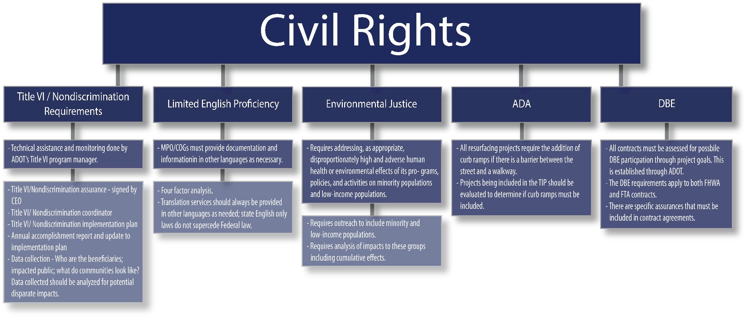

- The Civil Rights Restoration Act of 1987, (PL 100-209), (broadened the score, coverage and applicability of Title VI of the Civil Rights Act of 1964, The Age Discrimination Act of 1975, and Section 504 of the Rehabilitation Act of 1973, by expanding the definition of the terms “programs or activities: to include all of the programs or activities of Federal-aid recipients and contractors, whether such programs or activities are Federally funded or not);
- Americans with Disabilities Act of 1990, as amended, (42 U.S.C. § 12101 et seq.), (prohibits discrimination on the basis of disability);
- 49 C.F.R. Part 21 (entitled Nondiscrimination In Federally-Assisted Programs Of The Department of Transportation – Effectuation of Title VI of the Civil Rights Act of 1964);
- 49 C.F.R. Part 27 (entitled Nondiscrimination On The Basis of Disability In Programs Or Activities Receiving Federal Financial Assistance);
- 49 C.F.R. Part 28 (entitled Enforcement Of Nondiscrimination On The Basis Of Handicap In Programs Or Activities Conducted By The Department of Transportation);
- 49 C.F.R. Part 37 (entitled Transportation Services For Individuals With Disabilities (ADA);
- 23 C.F.R. Part 200 (FHWA’s Title VI/Nondiscrimination Regulation);
- 28 C.F.R. Part 35 (entitled Discrimination On The Basis Of Disability In State And Local Government Services);
- 28 C.F.R. § 50.3 (DOJ Guidelines for Enforcements of Title VI of the Civil Rights Act of 1964);

Table 12-1 | Authority
Code |  | Description
Federal | 42 U.S.C. § 2000d | Addresses discrimination based on race, color, and national origin in any program or activities financed by Federal aid.
 | 49 C.F.R. Part 21 | Addresses nondiscrimination in federally assisted programs of the USDOT—effectuation of the provisions of title vi of the Civil Rights Act of 1964.
 | 23 C.F.R. Part 200
 | 49 U.S.C. § 5332 | Prohibits discrimination on the basis of race, color, creed, national origin, sex, or age in employment or business opportunity.
 | 42 U.S.C. § 6101 | Prohibits discrimination on the basis of age in programs or activities receiving federal financial assistance.
 | 23 C.F.R. Part 230 | Addresses implementation of an Equal Employment Opportunity (EEO) program on federal and federal-aid highway construction contracts.
 | 29 U.S.C § 794 | Addresses discrimination against individuals with disabilities.
 | 42 U.S.C § 4601 | Addresses nondiscrimination with respect to persons displaced and property acquired.
 | 23 U.S.C. § 324 | Adds gender to the list of Title VI protections.
 | 42 U.S.C. § 12101 | Adds disability to the list of Title VI protections.
 | 65 F.R. 50121 | Improves access to services for persons with limited English proficiency.
 | 49 C.F.R. Part 26 | Addresses the involvement of Disadvantaged Business Enterprises (DBEs) in USD-funded projects.

- Executive Order 12898, Federal Actions to Address Environmental Justice in Minority Populations and Low-Income Populations, which ensures non-discrimination against minority and low-income populations by discouraging programs, policies, and activities with disproportionately high and adverse human health or environmental effects on minority and low-income populations;
- Executive Order 13161, Improving Access to Services for Persons with Limited English Proficiency, and resulting agency guidance, national origin discrimination includes discrimination because of limited English proficiency (LEP).
Identify the presence of Environmental Justice populations.
Evaluate policy and project options considering the complex mix of the metropolitan area.
Determine benefits to and potential negative impacts on Environmental Justice populations relative to proposed investments or actions.
Quantitatively and qualitatively define potential effects.
Identify an appropriate course of action, whether avoidance, minimization, or mitigation.

ENVIRONMENTAL JUSTICE EARLY IDENTIFICATION PROCEDURES

12.3 | SCOPE
This chapter provides guidance for reviewing the metropolitan planning process compliance with Title VI of the Civil Rights Act of 1964 (as amended) and related statutes; NEPA; 23 U.S.C. § 109(h); 49 C.F.R. Part 26; other federal environmental laws; and directives of the USDOT and all federal modes including, FHWA and FTA.
DID YOU KNOW
ADOT and all local public agencies that use funding through Federal and ADOT funding resources must comply with all federal Title VI and Environmental Justice requirements.

Title VI/Nondiscrimination and its subprogram, Environmental Justice, have been determined to be an essential part of the planning process conducted by MPOs and COGs. Environmental Justice must be considered in all phases of transportation planning, including the development and implementation of RTPs, TIPs, WPs, and UPWPs. As the primary forum for addressing a metropolitan area’s transportation needs and plans for improvement, MPOs and COGs facilitate the integration of needs and plans with Environmental Justice concerns. A truly integrated and effective planning process ensures active consideration and promotion of Environmental Justice within plans, projects, and groups of projects. Ultimately, successful plans and policy decisions rely on comprehensive public involvement efforts, engaging ADOT, transit providers (as may be applicable), local agencies, stakeholders, the public, and targeted engagement of Environmental Justice populations in the 3-C planning process.
Advance planning relating to Environmental Justice, allows MPO and COG officials and staff to focus on relevant issues early in the planning development process and use data and other information related to the early identification of Environmental Justice populations and engagement.
USDOT planning regulations (23 C.F.R. §§ 450.210 and 450.316) require MPOs and states to seek and consider “the needs of those traditionally underserved by existing transportation systems, such as low-income and minority households, who may face challenges accessing employment and other services.” In addition, Title 23 C.F.R. § 450.334 specifies that “the State and MPO shall certify at least every four years that the metropolitan transportation planning process is being carried out in accordance with all applicable requirements.” Title 23 C.F.R. § 450.334(a)(3) requires the FHWA and FTA to certify that the “planning process … is being conducted in accordance with all applicable requirements of … Title VI of the Civil Rights Act of 1964 and the Title VI assurance executed by each State under 23 U.S.C 324 and 29 U.S.C. 794.” This certification of compliance must be submitted concurrently with the MPO’s entire proposed TIP to the FHWA and FTA, as part of the STIP approval process.
Almost every project that involves ADOT uses federal funds. As an ambassador of taxpayer funds, all projects must comply with

https://www.epa.gov/ocr

It is important that these matters be addressed early and continuously in the planning stage, as conflicts with Environmental Justice principles may arise during project development or later, when mitigation may be more difficult and project implementation delayed.

12.4 | COMPLIANCE WITH TITLE VI OF THE CIVIL RIGHTS ACT OF 1964 & ENVIRONMENTAL JUSTICE
Compliance with Title VI and Environmental Justice provisions of federal law is accomplished within the framework of the MPO program. The certification process is a check to ensure that compliance is occurring. There are two forms of MPO certification: self-certification and federal certification. COGs do not self-certify for work through federal certification; however, as an extension of ADOT, COGs are required to comply with all Title VI and Environmental Justice provisions.

12.4.1 | Self-Certification
Self-certification is a process by which ADOT and MPOs with UZAs having a population of less than 200,000 residents verify and document their compliance with the requirements of 23 U.S.C. § 134, 49 U.S.C. § 5303, and other applicable statutes and regulations. The ADOT and MPO jointly certify and submit to FHWA and FTA (as may be applicable) that the planning process fully addresses major transportation issues facing the area. Certification is required at least every three years as part of the approval process of the STIP. To certify compliance with Title VI and adequately address Environmental Justice, MPOs need to:
- establish analytical capabilities to ensure that the LRTP and the TIP comply with Title VI and related federal nondiscrimination requirements;
- identify residential, employment, and transportation patterns of Environmental Justice populations in such a manner to permit identifying and addressing whether the benefits and burdens of transportation investments area fairly distributed and demonstrating the extent to which members of Environmental Justice populations are beneficiaries of programs and projects and not disproportionately impacted; and
- evaluate and improve where necessary their public involvement process to eliminate participation barriers and engage Environmental Justice populations in the transportation decision-making activities within the MPA.
In addition, 23 C.F.R. § 200.9 requires assurances that state program officials and Title VI specialists conduct annual reviews to determine compliance with Title VI, which includes Environmental Justice matters. Section 200.9(b)(7) stipulates that the state “conduct Title VI reviews of cities, counties, consultant contractors, suppliers, universities, colleges, planning agencies [e.g., MPOs], and other recipients of Federal-Aid Highway funds.” ADOT also is charged in Section 200.9(b)(14) with establishing “procedures to identify and eliminate discrimination when found to exist.” Thus, compliance documentation maintained by an MPO provides the appropriate vehicle for the state’s compliance with this requirement.
Self-certification is conducted as part of the UPWP development process and supports compliance with Title VI and Environmental Justice guidance through citations of policies relating to equal employment opportunity, affirmative action, sexual harassment, and other related policies and actions aimed at implementing the various nondiscrimination requirements associated with the authorities listed in Section 10.2.3. During regional planning documentation is also provided to demonstrate that the MPO has considered the effects its policies and plans have on the travel times, accessibility, and socioeconomic impacts of Environmental Justice populations. Section 10.6 provides guidance for developing a Title VI/Environmental Justice Plan to address these aspects of the MPO’s operations. The head of the MPO board or executive director, if present, and the ADOT district engineer sign the self-certification, which they forward to FHWA for review and approval.

12.4.2| Federal Certification
Self-certification by ADOT and the state’s MPOs was the process in place prior to passage of ISTEA in 1991. ISTEA instituted the requirement that the federal government certify the transportation planning processes of TMAs, which are those MPOs a population of 200,000 or more residents. The federal certification assesses how well a TMA is working with transportation-related organizations, local governments, and the public, as well as with ADOT to meet the many statutory requirements applicable to the planning process. Certifications must be renewed every three years by joint action of the FHWA and FTA for TMAs to maintain full eligibility for federal highway and transit funding. An essential part of the certification process is evidence of compliance with applicable provisions of Title VI of the Civil Right Act and related Environmental Justice guidance.
COG | Not Required
MPO | Self-certification
TMA | Federal Certification

CERTIFICATION
REQUIREMENTS
Certification with respect to Title VI and Environmental Justice compliance involves satisfaction of a number of stipulations outlined in the USDOT Order 5610.2(a). Specifically, in addition to satisfying the requirements cited for the self-certification, the MPO must demonstrate early in the development of programs, policies, and projects (activities) that it is proactive in obtaining, where relevant, appropriate, and practical, information pertinent to and including:
- Environmental Justice populations served and/or affected;
- optional steps to guard against and avoid discrimination and disproportionately high and adverse effects on Environmental Justice populations;
- potential alternatives and measures to avoid, minimize, and/or mitigate disproportionately high and adverse environmental and public health effects and interrelated social and economic effects;
- offsetting benefits and opportunities to enhance communities, neighborhoods, and individuals affected; and
- public involvement opportunities and consideration of the results thereof, including soliciting input from Environmental Justice populations during consideration of alternatives.
- As guidance for completing and ensuring satisfaction of the federal certification process, items of relevance to Title VI and Environmental Justice compliance should be addressed.
The federal certification process is carried out to ensure the MPO’s 3 C planning process meets the requirements of applicable provisions of federal laws and regulations. It is much more detailed and comprehensive than the self-certification process. The federal certification review consists of four parts: a document review, site visit, written report, and closeout meeting. Title VI and Environmental Justice is one of the specific topics addressed during this review. Even so, in each of these areas of activity, the issues and concerns of Title VI and Environmental Justice typically vary in their degrees of relevance and importance.

12.4.3 | Title VI Nondiscrimination Implementation Plan
ADOT is required to have a Title VI Nondiscrimination Plan, which includes FHWA Title VI Assurances. ADOT also is required to maintain an effective program to monitor subrecipients’ efforts to effectively implement Title VI, Environmental Justice, and related nondiscrimination requirements. As a subrecipient of federal assistance through ADOT, MPOs must have a nondiscrimination plan with the state to ensure compliance with Title VI, Environmental Justice, and related statutes.
The Title VI Nondiscrimination Implementation Plan acts as the MPO’s Title VI Plan pursuant to 49 C.F.R. Part 21 and the Title VI requirements for FHWA and FTA. The Title VI Nondiscrimination Implementation Plan must include all Title VI requirements that an MPO agrees to take on in return for receiving federally assisted planning funding from the state, including: Title VI assurances; a nondiscrimination policy statement; a discrimination complaint procedure; and mandatory Title VI nondiscrimination language in all MPO bids, contracts, and agreements. The signed Title VI Nondiscrimination Implementation Plan also must include assurances that programs will be conducted and facilities operated in compliance with Title VI and Environmental Justice requirements (49 C.F.R. § 21.7). In addition, the MPO must include Title VI assurances in all contracts and bids (USDOT Order 1050.2A).
The Title VI Nondiscrimination Implementation Plan must be reviewed by the ADOT Civil Rights Office and signed annually by the MPO’s signature authority. The ADOT Civil Rights Office is required to review regional MPO Title VI agreements submitted with the UPWP that are required to be updated bi-annually in compliance with the ADOT Title VI Nondiscrimination Plan and related federal statutes. State COGs must have a Title VI plan.
The ADOT Title VI/: Nondiscrimination Plan can be found at:

https://azdot.gov/business/civil-rights/title-vi-nondiscrimination-program

12.5 | LIMITED ENGLISH PROFICIENCY
Persons with a limited ability to read, write, speak, or understand English are designated the status LEP within the construct of Title VI and implementing regulations. The LEP population includes “persons for whom English is not their primary language and who have a limited ability to speak, understand, read, or write English” (FTA 2012).

12.5.1 | Background
The U.S. Supreme Court, in Lau v. Nichols (414 U.S. 563 [1974]), ruled that Title VI regulations promulgated by the former Department of Health, Education, and Welfare (HEW) prohibit federal actions that have a disproportionate effect on LEP persons, because such conduct constitutes discrimination with respect to national origin. In response, Executive Order 13166, “Improving Access to Services for Persons with Limited English Proficiency” both established that differing treatment based upon a person’s inability to speak, read, write or understand English is a type of national origin discrimination and directed each federal agency to publish guidance clarifying the obligation of recipients of federal assistance to ensure such discrimination does not occur. Subsequently, USDOT issued “Policy Guidance Concerning Recipients’ Responsibilities to Limited English Proficient Persons,” dated December 14, 2005 (70 FR 74087). Additional guidance is provided in Implementing the Department of Transportation’s Policy Guidance Concerning Recipients’ Responsibilities to Limited English Proficient (LEP) Persons: A Handbook for Public Transportation Providers, issued by the FTA Office of Civil Rights, April 13, 2007.
Identify LEP individuals and populations that need language assistance
Identify the methods and means by which language assistance will be provided under varying circumstances.
Establish appropriate orientation and training practices to ensure employees (management and staff) in public contact positions have a full understanding of the importance of the LEP Plan and its implementation.
Identify and create appropriate methods and means for informing LEP populations that language services are available.
Establish a process to monitor the accessibility of agency documents, programs, services, and activities as well as update both the LEP Plan and employees regarding any changes in services.

LEP PLAN PROCEDURES

12.5.2 | LEP Plan
USDOT LEP guidance specifies that recipients of federal assistance are required to take reasonable steps to ensure LEP persons are afforded meaningful access to their programs and activities. This requires development of a plan that is fact dependent, yet flexible, and balances the four critical factors defined by the U.S. Department of Justice (DOJ):
- Number or proportion of LEP persons eligible to be served or likely to be encountered by a program, activity, or service of the recipient or grantee;
- Frequency with which LEP individuals come in contact with the program;
- Nature and importance of the program, activity, or service provided by the recipient to people’s lives; and
- Resources available to the recipient and costs.
The results of this analysis provide a reasonable basis for identifying different language assistance measures necessary to ensure meaningful access for LEP persons to the different types of programs or activities in which the recipient engages. The following steps are recommended for MPOs that determine an LEP Plan is useful and beneficial to the conduct of its Title VI/Environmental Justice Program and in meeting compliance requirements.
The LEP Plan establishes a framework for consistently determining the types of documents and activities (e.g., public meetings, workshops) critical to ensuring meaningful access for LEP person and full participation in federally assisted systems and services. The LEP Plan should serve to document compliance as well as establish a process for providing timely and reasonable language assistance. The plan should incorporate procedures and guidance for training, administration, planning, and budgeting to aid agency managers and staff.

12.6 | PUBLIC INVOLVEMENT, TITLE VI, & ENVIRONMENTAL JUSTICE
Public involvement is an integral part of transportation planning and project development decision making and Title VI and Environmental Justice should be considered in this, and all, aspects of the process.

12.6.1 | Public Involvement During Planning
The USDOT Order 5610.2(a) directs that access to information relating to federally assisted policies, programs, and activities must be made available to all those impacted by an agency’s actions and specifically to identified Environmental Justice populations within a study area. In addition, to Environmental Justice populations all those impacted must be afforded opportunities to participate in policy and planning matters that may impact human health and the environment in compliance with Title VI. The FAST Act also emphasizes the meaningful involvement by all the public in transportation decision making. The USDOT order specifies these as two guiding principles, for integrating Environmental Justice into the operations of organizations receiving federal assistance.
USDOT Order 5610.2(a) further stipulates that “DOT managers and staff must administer their programs in a manner to assure that no person is excluded from participating in, denied the benefits of, or subjected to discrimination by any program or activity” (USDOT 2012a, 27535). Because recipients of federal assistance are subject to administration by DOT, they are expected to comply with this order. To actively administer and monitor to identify the risk of discrimination and disproportionate effects, USDOT requires organizations receiving federal assistance to identify:
Each MPO and COG should identify and post a specific Title VI contact Person.
Arizona Department of Transportation Civil Rights Office 1135 N. 22nd Ave., 2nd Floor Phoenix, AZ 85009 #: 602-712-7761
- the population served and/or affected by race, color or national origin, and income level;
- proposed steps to guard against disproportionately high and adverse effects on persons on the basis of race, color or national origin, and income level; and
- present and proposed membership, by race, color, or national origin, in any planning or advisory body that is part of policies, programs, and activities.
The stipulations above have a direct effect on the makeup of the MPO membership. Although, as indicated in chapter 3, “MPO Formation & Modification,” there are no specific federal laws or regulations guiding the composition of MPO membership, the gathering and referencing of such information by USDOT indicates that MPO composition can be a factor in evaluating the risk of discrimination and disproportionate effects.
Federal guidance clearly directs MPOs to engage in early and continuous public involvement during the planning and project development process. This is encouraged to ensure state and local agencies are alert to Title VI and Environmental Justice concerns, so there are no surprises during the project implementation stage. Efforts must be made to demonstrate that all relevant federal, state, regional, local, and tribal agencies are afforded the opportunity to be engaged in MPO public involvement procedures to ensure full consideration of Title VI and Environmental Justice matters. The procedures provide for an inclusive, representative, and equal opportunity for meaningful two-way communication resulting in appropriate actions that reflect public involvement. Continuous interaction between community members and transportation professionals is critical to successfully identify and resolve potential Title VI and Environmental Justice issues and concerns. Thus, “concern for Environmental Justice should be integrated into every transportation decision—from the first thought about a transportation plan to post construction operations and maintenance.”
GUIDING PRINCIPLES
Environmental Justice procedures must ensure early involvement by protected populations during planning and programming activities, formulation of policies, and identification and evaluation of potential impacts to avoid disproportionately high and adverse effects.
GUIDING PRINCIPLES
Steps must be taken to provide protected populations access to information concerning potential human health or environmental concerns associated with proposed actions. (LEP Plan is an example.)
The Title VI Notice to the Public must be posted in all locations where coordination meetings are held for any MPO/COG public/committee meeting, event, or discussion. The Title VI Notice notifies the public of their right to file a discrimination complaint based on race, color, or national origin.
It is important that the initial and routine activities of the MPO are open to public discussion, review, and evaluation. Alternatives are formulated and examined to determine how they affect the planning area, and specific attention is given to potential disproportionate and adverse effects on Environmental Justice populations and potential Title VI disparate impacts. The results of the public involvement processes must be recorded and documented. The ADOT Public Involvement Plan developed in support of the Arizona LRTP specifically references Environmental Justice and calls for documentation of efforts to be included in documents developed in support of the LRTP. The plan also calls for the development of a list of organizations, e.g., nonprofit groups which may provide services for low-income and minority groups for targeted outreach. ADOT Communications has many contact lists that can be useful in identifying targeted audiences.

12.6.2 | Public Involvement During Federal Certification
Federal certification is required for TMAs, which represent an area with a population of 200,000 or more residents. Public involvement during the federal certification review has five key points of focus designed to fully and adequately examine the MPOs activities. These points include:
- providing the public an opportunity to comment on the transportation planning process (specific projects and improvements are not the subject of the federal certification review);
- informing the public about federal transportation planning requirements;
- discussing public concerns regarding the manner in which decisions are made, the equity of those decisions, and the resultant effects;
- providing follow-up action to demonstrate that public concerns are being addressed; and
Public involvement associated with the federal certification process focuses not on the programs, products, projects, and activities of the MPO but rather on ensuring public involvement in the review of processes, practices, and procedures followed by the MPO during the course of its planning activities.
- helping the federal team better understand community issues.

12.7 | TITLE VI AND ENVIRONMENTAL JUSTICE PLAN FORMAT AND CONTENT
MPOs are required to submit a Title VI Nondiscrimination Implementation Plan annually to the ADOT Civil Rights Office. Table 12-2 references some existing Title VI Plans that are available on the web. In the circumstances when an MPO needs to go beyond what is included in the ADOT Title VI Nondiscrimination Plan, it must at minimum include the required sections that meet the Title VI requirements of FHWA and FTA.
As FTA and FHWA have different requirements, the MPO/COG should work with ADOT’s Title VI program manager to ensure the plan meets the minimum Title VI requirements for both federal modes.

Table 12-2 | Available Title VI Plans
Agency | Title VI Plan Location
ADOT | https://azdot.gov/business/civil-rights/title-vi-nondiscrimination-program/title-vi-implementation
MAG | https://azmag.gov/Title-VI
PAG | https://pagregion.com/title-vi/
CYMPO | https://www.cympo.org/federally-required-documents/h
FMPO | https://www.flagstaff.az.gov/DocumentCenter/View/13093/MetroPlan-Title-VI-and-Environmental-Justice-Plan?bidId=
YMPO | http://ympo.org/studies-reports/title-vi-report/

12.8 | TITLE VI AND ENVIRONMENTAL JUSTICE COMPONENTS OF MPO TRANSPORTATION PLANNING DOCUMENTS
In addition to the Title VI Nondiscrimination Implementation Plan, the general planning documents of the MPO need to include certain components directed toward establishing compliance with federal laws and regulations. These documents or reports are directed to ADOT or to the FTA, if the MPO is a direct recipient of FTA assistance. The table below highlights key requirements associated with the UPWP, LRTP, TIP, and Public Involvement Plan.

Table 12-3 | Key MPO Reports and Requirements for Title VI & Environmental Justice Documentation
Document Name | Required Components | Details
Unified Planning Work Program (UPWP) | Certification of DBE and EEO  Assurance of Title VI compliance | Tasks and funds for outreach to low-income, minority populations, limited English Proficient persons, and other populations afforded Title VI protection as well as necessary data.  Tasks related to LEP populations.
Long-Range Transportation Plan (LRTP) | Identify and provide information to interested parties about the LRTP  Assurance of Title VI compliance | Information regarding low income and minority populations, limited English Proficient persons, and other populations afforded protection against discriminatory actions or policies, as identified with respect to Title VI compliance:  Data collection and processing  Analysis of locations/concentrations  Goals and objectives for serving these groups  Process and criteria for  Selecting cost-feasible projects that minimize or avoid disproportionately high and adverse effects  Defining a cost-feasible plan accounting for potential infrastructure impacts and benefits  Execution and documentation of public involvement efforts  Data collection, impact assessment, and project selection criteria for cultural resources  Discussion of mitigation efforts  Preparation of a Coordinated Public Transit-Human Services Transportation Plan
Transportation Improvement Program (TIP) | Identify and provide “interested parties” information about the TIP and its projects  Compliance with previously adopted nondiscrimination statement | Information regarding low income and minority populations:  Criteria for selecting cost-feasible projects that account for infrastructure impacts and benefits  Public involvement efforts
Public Involvement Plan | Compliance with previously adopted nondiscrimination statement | A notice that the agency complies with Title VI and procedures the public may follow to file a discrimination complaint.

12.9 | Disadvantaged Business Enterprise
Federal guidelines for participation of Disadvantaged Business Enterprises (DBEs) in USDOT-funded contracts are set forth in 49 C.F.R. Part 26. Since DBEs are one of the five core areas of MPO certifications, MPOs, as recipients of federal planning funds, are impacted by the federal requirements (49 C.F.R. § 26).
ADOT has established its DBE Program in accordance with regulations promulgated by USDOT (49 C.F.R. Part 26). As a condition of receipt of federal funding, ADOT has signed an assurance that it will comply with 49 C.F.R. Part 26. It is ADOT’s policy to ensure that DBEs, as defined in Part 26.5, have an equal opportunity to receive and participate in USDOT-assisted contracts. It is also the policy of the department:
- to ensure nondiscrimination in the award and administration of USDOT-assisted contracts;
- to create a level playing field on which DBEs can compete fairly for USDOT-assisted contracts;
- to ensure the DBE Program is narrowly tailored in accordance with applicable law;
- to ensure only firms that fully meet 49 C.F.R. Part 26 eligibility standards qualify as DBEs;
- to help remove barriers to participation of DBEs in USDOT-assisted contracts; and
- to assist in the development of firms that can compete successfully in the marketplace outside the DBE Program.
MPOs and COGs are not responsible for determining the eligibility of any company to be certified as a DBE. However, they do have several responsibilities when it comes to participation of DBEs in the consultant contracts that they put out to bid. ADOT has developed and implemented an Arizona Unified Transportation Registration and Certification System (AZUTRACS) that all recipients of USDOT dollars must use as their DBE directory. The Arizona AZUTRACS has been established to facilitate statewide DBE certification. The AZUTRACS eliminates the need for DBE applicant businesses to obtain certification from multiple agencies and provides reciprocity within Arizona. ADOT, the city of Phoenix, and the city of Tucson are members of the Arizona AZUTRACS. The official AZUTRACS DBE database includes certified DBE firms as stated below.
AZUTRACS DBE database:

https://adotdoors.dbesystem.com/
DBE Plan
MPOs must follow everything that is in the approved ADOT DBE Plan. A direct recipient may adopt the ADOT Plan or develop their own plan and get approval by the USDOT. On the other hand, sub recipient’s must follow the ADOT Plan. Plans must be updated every 4 years. An MPO may adopt the ADOT DBE Plan as its own. Though a city or county DBE Plan may have already been approved by another federal agency, the MPO still must receive the approval of USDOT, as there are specific federal requirements for transportation contracts that may not be addressed in other parts of the Code of Federal Regulations (CFR).
DBE Contract Assurances
Under 49 C.F.R. § 26.13, MPOs are required to have a signed policy statement expressing their commitment to DBE participation. The same federal regulation requires that each contract that an MPO signs with contractors and subcontractors, consultants and subconsultants include the following assurance:
“The contractor or subcontractor shall not discriminate on the basis of race, color, national origin, or sex in the performance of this contract. The contractor shall carry out applicable requirements of 49 C.F.R. Part 26 in the award and administration of USDOT assisted contracts. Failure by the contractor to carry out these requirements is a material breach of this contract, which may result in the termination of this contract or such other remedy as the recipient deems appropriate” (49 C.F.R. § 26.13(b)).

13 | PUBLIC INVOLVEMENT
TABLE OF CONTENTS
13.1 | PURPOSE
13.2 | AUTHORITY
13.3 | SCOPE
13.4 | MINIMUM REQUIREMENTS
13.5 | PUBLIC INVOLVEMENT PROCESS DOCUMENTATION
13.6 | PUBLIC INVOLVEMENT PLAN FORMAT & CONTENT
13.7 | TOOLKIT FOR PUBLIC INVOLVEMENT

| Public Involvement

13.1 | PURPOSE
This chapter provides guidance to ADOT, MPOs, and COGs for creating, implementing, and managing the public involvement process mandated by federal and state laws and regulations. Each MPO and COG is required to develop a Public Participation Plan.

13.2 | AUTHORITY
The FAST Act follows public participation requirements and guidelines set forth in the previous federal transportation legislation, MAP-21 (23 U.S.C. § 134(i)(5)(B); 23 C.F.R. § 450.316(a)). MPOs and COGs are required to develop a public participation plan, in consultation with interested parties, that provides reasonable opportunities for all parties to participate in and comment on transportation plans. The detailed requirements and guidelines for the public participation plan are provided in section 13.6.
The ADA requires the public participation process to provide equal access to people with disabilities. Title VI of the 1964 Civil Rights Act, and its implementing regulations prohibits discrimination and requires that federal funding recipients take responsible steps to ensure meaningful access to the benefits, services, information, and other important portions of their program and activities for LEP individuals (USDOT 2005).
A.R.S. § 38-431 describes the Arizona open meeting law requirements, including meeting notification and posting of proceedings.
The federal and state laws which provide the authority to conduct public involvement activities are shown in table 13-1.

13.3 | SCOPE
Each MPO and COG must develop and use a documented participation plan that defines a process for providing citizens, affected public agencies, representatives of public transportation employers, freight shippers, providers of freight transportation services, private providers of transportation, representatives of users of public transportation, representatives of users of pedestrian walkways and bicycle transportation facilities, people with disabilities, and other interested parties with reasonable opportunities to be involved in the transportation planning process. The Public Participation Plan defines the process for public input to the RTP and the TIP.
When developing an RTP, MPOs and COGs must consult with a wide variety of state and local agencies and afford the opportunity to comment on the plan to a wide variety of groups. These agencies include, as appropriate, those that are responsible for land use management, natural resources, environmental protection, conservation, and historic preservation
When regional planning jurisdictional boundaries include Native American tribal lands, the MPO and COG shall appropriately involve tribal governments in the process. When the MPA includes federal public lands, the MPO and COG shall appropriately involve federal land management agencies in the process. In nonattainment areas the MPO and COG shall appropriately consult with federal, state, and local transportation and air agencies.
For projects that ADOT or an ADOT consultant administers on behalf of an MPO or COG, a project-specific public involvement plan must align with the ADOT Public Involvement Plan. The ADOT Civil Rights Office will review to ensure the public involvement plan that outlines strategies and processes for populations protected under ADA, Title VI, Limited English Proficiency, and Environmental Justice laws that mirror that of the ADOT Public Involvement Plan.

Table 13-1 | Authority
Code |  | Description
Federal | 23 U.S.C. § 134(i)(5)(B) | These laws state that MPOs and COGs are required to develop a public participation plan, in consultation with interested parties, that provides reasonable opportunities for all parties to participate in and comment on transportation plans.
 | 23 C.F.R. § 450.316 (a)
 | Title VI of the 1964 Civil Rights Act | This act prohibits discrimination on the basis of race, color, or national origin in programs and activities receiving federal financial assistance.
 | Title VI and implementing regulations | This ensures meaningful access to the benefits, services, and information of their program and activities for LEP individuals.
State | A.R.S. § 38-431 et seq. | This statute describes the Arizona open meeting law requirements, including meeting notification and posting of proceedings

13.4 | MINIMUM REQUIREMENTS
Besides consulting with these agencies and groups in their public participation processes, the MPO and COG shall, at a minimum:
- include a public involvement plan that aligns with ADOT’s Public Involvement Plan
- provide reasonable public access to technical and policy information used in the development of the RTP and TIP and conformity determination (if applicable);
- provide adequate public notice of public involvement activities and time for public review and comment at key decisions, such as the approval of the RTP and TIP, conformity analysis;
- hold all public meetings at convenient and accessible locations and times;
- employ appropriate visualization techniques to describe the RTP and TIP;
- make public information (technical information and meeting notices) available in electronically accessible formats and means, such as on the internet;
- demonstrate explicit consideration and response to public input received during plan development processes;
- seek out and consider the needs of those traditionally underserved by existing transportation systems, including but not limited to, low-income and minority households, who may face challenges accessing employment and other services;
- coordinate with the statewide transportation planning public involvement and consultation processes developed by ADOT;
- periodically review the effectiveness of the procedures and strategies contained in the participation plan;
- make a summary, analysis, and report on the disposition of comments that are part of the final RTP and TIP when significant written and oral comments are received on a draft RTP (including the financial plan) because of public involvement;
- provide an additional opportunity for public comment if the final RTP differs significantly from the one made available previously for public comment or raises new material issues;
- publish a proposed program of projects (POP) in a way that affected individuals, private transportation providers, and local elected officials can examine the proposed program and submit comments on the proposed program; and
- provide an opportunity for a public hearing in which to obtain the views of individuals on the proposed program of projects.

13.5 | PUBLIC INVOLVEMENT PROCESS DOCUMENTATION
Public involvement process records are reviewed as a part of the annual MPO and COG joint certification. Documentation of MPO and COG public involvement processes may include:
- copies of published public notices of meetings designed to receive public input on the draft plan;
- minutes, attendance sheets, comment cards, or other media that document public participation in RTP and TIP development;
- documentation (date, time, message) of media used to communicate with the community (e.g., internet resources, local radio, and television announcements);
- identification of major transportation providers (such as aeronautics, freight, seaports, and transit) who participated in the process;
- outreach efforts to minority, transportation disadvantaged, elderly, and other groups that have been traditionally underserved by the transportation system;
- newsletters, mailings, or other methods used for public outreach; and
- a summary and an analysis that identifies the significant written and oral comments received on the draft RTP and TIP and how the MPO and COG considered these comments.

13.6 | PUBLIC INVOLVEMENT PLAN FORMAT & CONTENT
Although no format for the Public Involvement Plan is specified in federal or state laws or rules, the following format is recommended by ADOT:
- Introduction
  - Goals of Public Involvement
- Public Involvement Process
- Underserved
- Guidelines
    - Techniques
    - Meeting Schedules and Locations
    - Notification
    - Presentation of Information
    - Written and Personal Communication
    - Ongoing Communication
    - Other Entities
    - Transportation Interests
    - Opportunities for Input
    - Use of Public Comments
    - Decision Making
- Evaluating Public Involvement Activities
- Development, Adoption, and Revision of the Public Participation Plan
- Plan Stages
- Plan Revisions
- MPO and COG Commitment
- Contact Information
- Statement on Accessing Information in Spanish
- Toolkit of Public Involvement Techniques
- Compliance Information
Not all Arizona MPOs & COGs list their public participation plans online. Table 13-2 lists the existing MPO and COG public participation plans available online.

Table 13-2 | MPO & COG Public Participation Plans
MPO/COG | Resource
MAG | https://www.azmag.gov/Portals/0/MAG-Public-Participation-Plan_English_1.pdf
PAG | https://mk0pagrtahost21swg12.kinstacdn.com/wp-content/docs/pag/2020/08/PIP2018.pdf
SCMPO | https://scmpo.org/wp-content/uploads/2018/09/Final-DRAFT-SCMPO-PPP-2019-073118.pdf
CYMPO | http://www.cympo.org/pdf/products/Final_PPP_2011.pdf
FMPO | https://www.flagstaff.az.gov/DocumentCenter/View/6802/MetroPlan-PPP?bidId=
LHMPO | http://www.lhmpo.org/docs/default-source/federal-required-documents/lhmpo_pip_final_amended_10302017.pdf?sfvrsn=fadef9f0_6
SVMPO | https://18b4wg1zsjp31kslx82j41oc-wpengine.netdna-ssl.com/wp-content/uploads/2019/01/2019-Public-Participation-Plan-APPROVED.pdf
YMPO | http://ympo.org/plans/ympo-public-participation-plan/
CAG | http://www.cagaz.org/Departments/tpt/programs/tptprograms.html
NACOG | https://nacog.org/fileLibrary/TPAC%20Title%20VI%20Plan.pdfN
SEAGO | https://www.seago.org/?q=title-iv-implementation-and-public-participation-plan-2012-update
WACOG | https://www.wacog.com/title-vi/

13.7 | TOOLKIT FOR PUBLIC INVOLVEMENT
Developing an effective public involvement program is a strategic effort that requires assembling a selection of techniques to meet the needs of a given transportation plan, program, or project. “Public Involvement Techniques for Transportation Decision-Making,” prepared by the USDOT FHWA/FTA (2005), provides proven guidelines and techniques for public involvement success. The training document lists various techniques that can be used to engage the public.

14 | TRANSIT
TABLE OF CONTENTS
14.1 | PURPOSE & AUTHORITY
14.2 | ROLES & RESPONSIBILITIES
14.2.1 | Federal Transit Administration (FTA)
14.2.2 | The Arizona Department of Transportation (ADOT)
14.2.3 | Metropolitan Planning Agencies (MPO) and Councils of Governments (COG)
14.3 | STATEWIDE & METROPOLITAN TRANSIT PLANNING REQUIREMENTS
14.3.1 | ADOT’s Role in Public Transportation Planning
LRTP/STIP
Tribal Transit Planning
14.3.2 | MPO/COG Role in Public Transportation Planning
Regional Transportation Plan
Performance Monitoring & Asset Management
Transportation Improvement Program
Planning Work Program
14.3.3 | ADOT Planning and Support to Subrecipients
14.4 | TRANSIT FUNDING
14.4.1 | Transit Planning Funding
Section 5303: Metropolitan Transportation Planning
Section 5304: Statewide & Nonmetropolitan Transportation Planning
14.4.2 | Transportation Providers
14.4.3 | Federal Transit Funding Programs Administered by ADOT
14.5 | MOBILITY MANAGEMENT PROGRAM
14.5.1 | Regional Coordination Plan
14.5.2 | Tribal Coordination
14.6 | GRANT MANAGEMENT AND GRANTEE RESPONSIBILITIES
14.6.1 | ADOT’s Grant Application & Management Responsibilities
14.6.2 | MPO/COG Role in the Grant Process
14.6.3 | Grantee Requirements
14.6.4 | Site Visits & Compliance Reviews
14.6.5 | Grantee Guidance Documents and Agreements
Master Agreement
Grant Agreement
Certifications & Assurances
Guidance Circulars and Other Services

| Transit

14.1 | PURPOSE & AUTHORITY
This chapter contains guidance to assist Arizona COGs and MPOs in their mission to fulfill their respective public transportation planning and grant-making responsibilities in Title 49 U.S.C. Chapter 53 under the FAST Act.

14.2 | ROLES & RESPONSIBILITIES
This section discusses the roles and responsibilities of ADOT and other agencies in providing administration and technical assistance for transit programs throughout Arizona.

14.2.1 | Federal Transit Administration (FTA)
The FTA provides overall policy and program guidance. The FTA is responsible for apportioning funds annually to the State; developing and implementing financial management procedures; initiating and managing program support activities; and conducting national program review and evaluation. The FTA regional offices have day-to-day responsibility for interface with state transit program managers.
Availability of grants occurs when FTA issues a Notice of Funding Availability (NOFA) in the Federal Register. Applications are typically submitted via Grants.gov. For further information see:

https://www.grants.gov/web/grants/home.html
FTA will issue new and revised guidance to grant recipients. Updated February 27, 2020:

https://www.transit.dot.gov/regulations-and-guidance/fta-circulars/full-funding-grant-agreements-guidance

14.2.2 | The Arizona Department of Transportation (ADOT)
ADOT is the State agency designated by the Governor to administer FTA’s grant programs. The Transit Group of ADOT MPD administers and provides oversight for these FTA programs. ADOT receives formula funding allocations annually, a portion of which is used to administer the programs. MPD provides information, oversight, and technical assistance to Arizona communities, transportation planning agencies, transit agencies, and intercity carriers.
As the direct recipient of FTA funds for statewide and regional planning activities, ADOT is responsible for coordinating transit planning activities around the state and certifying to the federal government that all legal and regulatory requirements are met.
MPD staff coordinates closely with other ADOT divisions to oversee and provide the financial, managerial, and civil rights compliance oversight that FTA requires. Key staff functions include administering FTA grants, providing technical assistance and expertise to COGs, MPOs, local transit agencies, and decision makers.
Chapter 1 provides a map referencing the locations of MPOs and COGs in Arizona.

14.2.3 | Metropolitan Planning Agencies (MPO) and Councils of Governments (COG)
To review FTA Circular 9040.1F: Non-urbanized Area Formula Program Guidance and Grant Application Instructions follow:

https://www.transit.dot.gov/sites/fta.dot.gov/files/docs/FTA_C_9040.1F.pdf
In Arizona, the responsibilities of Transportation Planning Agencies are assumed by the established MPOs and COGs. The Governor designates an MPO for each UZA with 50,000 or more residents by agreement with general purpose local governments representing at least 75 percent of the population.
For rural areas, MPD works with the COGs to complete transportation planning functions.
Both MPOs and COGs assist MPD in coordination and outreach with local agencies and transit providers and develop Regional Coordination Plans

14.3 | STATEWIDE & METROPOLITAN TRANSIT PLANNING REQUIREMENTS
Public transportation planning and grant-making responsibilities are often shared by the state and the MPOs and COGs and are defined in FAST Act and Chapter 53 of the United States Code.

14.3.1 | ADOT’s Role in Public Transportation Planning
LRTP/STIP
ADOT is required to prepare the statewide LRTP and five-year statewide STIP in cooperation with Arizona’s MPOs and COGs. The state documents are compilations of regional plans and TIPs developed in an environment of transparency and active public participation.
Tribal Transit Planning
Statewide transportation plans must be developed in coordination with tribal governments and the U.S. Secretary of the Interior.

14.3.2 | MPO/COG Role in Public Transportation Planning
Federal Transit Planning Requirements emphasize regional participation in the planning process. The organizational structure of Arizona MPOs and COGs must reflect broad participation among elected officials, public agencies including public transportation providers, and ADOT.
Transit planning requirements now include a performance-driven, outcome-based approach to planning. MPOs and COGs must develop a regional performance-based planning process that includes goals and objectives, performance measures and targets, and a monitoring process or use ADOT’s performance-based planning process (49 CFR § 625.55).
Regional Transportation Plan
Arizona MPOs are required to prepare a 20-year LRTP covering all transportation modes, including public transportation.
The RTP plans and TIPs must provide for the development, integrated management, and operation of transportation systems and facilities (including accessible pedestrian walkways and bicycle transportation facilities) that function as an intermodal transportation system for the planning area and as an integral part of an intermodal transportation system.
Performance Monitoring & Asset Management
ADOT shares the responsibility with MPOs and COGs to establish and apply a performance-based approach to transportation decision making, and to implement Transportation Asset Management Plans (TAMs).
Transportation Improvement Program
Arizona’s MPOs and COGs are required to develop a rolling five-year list of transportation projects. The TIP must include a description of implementation progress anticipated and attained relative to established performance targets for all included projects. Requests for FTA funding from within an urbanized area are submitted to the MPO for inclusion in the MPO’s TIP. The MPO staff reviews each application for coordination, air quality conformity and fiscal constraint in relation to TIP goals and objectives. As funding becomes available, the awards are incorporated into the MPO and COG TIP, which are then integrated into the STIP.
Cross reference chapter 7, “Regional Transportation Plan (RTP)” for further information on RTPs.
Planning Work Program
Arizona’s MPOs and COGs enter an agreement with ADOT to conduct planning activities for their respective areas. MPOs develop a Unified Planning Work Program (UPWP) and the COGs develop a Work Program (WP) defining all activities (including transit). ADOT and these Planning agencies have moved to a two-year work program beginning July 1 and ending June 30 the second year.
Cross reference chapter 4, “MPO Unified Planning Work Program & Contract Activities” and chapter 5, “COG Work Program” for further information on Planning Work Programs.

14.3.3 | ADOT Planning and Support to Subrecipients
Transit systems change as communities change. As a result, MPD requires subrecipients to conduct planning activities. Existing subrecipients are expected to do routine planning as part of the management of their systems. These plans are designed to evaluate and plan for new transit services in a community, to update and re-assess the direction of an existing transit program, to address changing conditions (such as community growth or new or changing employment locations), or to address the need for new regional service connections. The ADOT Transit Section coordinates with subrecipients relative to specific planning needs. MPOs and COGs can administer studies on behalf of these transit agencies or the agency can lead these studies with the support of ADOT and the Regional Planning Agency. These planning efforts include transit feasibility studies, short-range transit development plans, capital project assessments, and other special studies.

14.4 | TRANSIT FUNDING

14.4.1 | Transit Planning Funding
Transit planning is most often funded using Transit Planning Section 5303 and Section 5304 as described below.
Section 5303: Metropolitan Transportation Planning
The FTA apportions 80 percent of the Metropolitan Planning Program (PL) assistance 5303 to the states based on a UZA population formula established by statute. The eight urbanized areas with designated MPO status in Arizona are eligible recipients of Section 5303 planning assistance and are responsible for coordination of FTA programs within their respective areas. Funds apportioned to Arizona are distributed by MPD to the eight MPOs. As a subrecipient of 5303 funds through ADOT, each MPO must meet the non-federal matching requirement, ADOT and federal requirements.
Section 5304: Statewide & Nonmetropolitan Transportation Planning
Section 5304 requires ADOT to develop a statewide transportation plan consistent with the policy objectives stated in Section 5303 to address the non-urbanized areas of Arizona. What funds are not used by the state, ADOT provides towards grant application opportunities during the 5311 application and an MPO/COG planning grant application process for these funds. MPO/COGs may apply on behalf of local agencies and administer the Transit funds awarded through the 5304 program. When awarded, these funds are added either to the 5311 awards or the Work Program of the awarded agency and are tied to their contracts.

14.4.2 | Transportation Providers
Transportation providers (public, private, and non-profit agencies) apply for funding through processes that differ depending on the program. The providers are responsible for working with MPD and their local MPO or COG to meet all application requirements. If granted funding, they are required to fulfill a series of federal conditions in individual program handbooks. These requirements include record keeping, financial management and disclosures, civil rights compliance, procurement, and monitoring.
MPOs have urban transportation systems that are direct recipients of FTA. These programs can receive funding from ADOT and be ADOT subrecipients. However, they have different requirements found in the 5307 Urbanized Area Circular. Both COGs and MPOs work with 5311 Rural Transit, 5310 programs, and private and tribal transit agencies. The intercity bus and senior transportation needs are specifically called out as requirements for MPOs to consider in their planning activities.

14.4.3 | Federal Transit Funding Programs Administered by ADOT
ADOT administers the transit formula programs summarized in table 14-1.

Table 14-1 | Federal Funding Programs
Program |  | Title
Federal Formula Programs | 5303 | Metropolitan Transportation Planning Program
 | 5304 | Statewide & Nonmetropolitan Transportation Planning Program
 | 5307 | Urbanized Area Formula Program
 | 5310 | Elderly Individuals and Individuals with Disabilities Program
 | 5311 | Rural Public Transportation Program: Rural Transit Assistance Program (RTAP) & Intercity Bus Program
 | STBGP | Surface Transportation Block Group Program
 | 5339 | Bus and Bus Facilities Program

14.5 | MOBILITY MANAGEMENT PROGRAM
Mobility management is an innovative customer-driven approach for delivering coordinated transportation services that help older adults, persons with disabilities, and low income household members to enjoy increased mobility. It encompasses short-range planning and management activities and projects to improve coordination among public transportation systems and other transportation service providers, including private nonprofit provider (PNP) agencies and commercial providers. The primary grant program authorized in the FAST Act to support mobility management activities is Section 5310.
The FTA Grant Programs are also described here:

https://www.transit.dot.gov/funding/grants/grant-programs

14.5.1 | Regional Coordination Plan
The FTA requires that all Section 5310-funded projects are included in a Human Services Transportation Coordination Plan (HSTCP) developed and maintained at the regional level.
Arizona COGs and MPOs are responsible for managing the coordination planning process with oversight by ADOT. Key regional responsibilities include:
- Assisting local transportation providers and Coordinated Mobility Program grantees in assessing and developing local and regional mobility management and coordination options.
- Participating in coordination meetings and other local, regional, and statewide venues, including working groups.
- Convening a regional coordinating council that meets on a quarterly basis per the FTA circular guidelines.
- Creating, maintaining, updating, and implementing the HSTCP document.
- The HSTCP must certify to ADOT that the projects selected for regional funding stem from a locally developed process that engages public transit and human service agency providers, representatives of older adults and individuals with disabilities, and the public. The regional coordination plan must include:
- An assessment of available services and current transportation providers (public, private, and nonprofit).
- A needs assessment focusing on individuals with disabilities, older adults, and people with low incomes.
- Strategies, activities, and/or projects to address the identified gaps between current services and needs, as well as opportunities to achieve efficiencies in service delivery.
- Priorities for enactment based on resources (from multiple program sources), time, and feasibility for implementing specific strategies and/or activities that have been identified.
- Mobility Managers act as liaisons between ADOT and local transit programs. They can identify and work to remove barriers to efficient and effective service in their regions.
ADOT funds Mobility Management Activities through the 5310 Mobility for Seniors and People with Disabilities. This funding is available through a grant application open every other year. ADOT encourages the partnerships in the mobility management program between different agencies. Many COG and MPOs have partnered to provide regional mobility management.

14.5.2 | Tribal Coordination
ADOT also shares responsibility with COGs and MPOs to coordinate Sections 5310 and 5311 grant funding to tribal and other rural public transit systems in Arizona. Tribal communities must participate in the regional Coordination Plan if they wish to be eligible for the 5310 funding. However, they are not otherwise required to coordinate with MPO’s or COG’s. MPO and COG representatives should make every effort to coordination with tribal representatives. ADOT has several tribal liaisons that have developed training for working with tribes and may provide assistance in effective coordination with tribal communities.

14.6 | TRANSIT GRANT MANAGEMENT AND GRANTEE RESPONSIBILITIES
MPOs and COGs partner with the State in its grant application process to ensure funds meet the needs of the local communities.

14.6.1 | ADOT’s Grant Application & Management Responsibilities
ADOT’s general responsibilities for grant program administration include:
- Establish and document ADOT’s procedures in the State Management Plan. (ADOT)
- Effectively manage FTA funds, and complete all FTA required reports. (ADOT)
- Develop project selection procedures in accordance with FTA requirements, and manage grant application processes. (ADOT)
- Provide program information and technical assistance to local and regional government agencies and transit providers, for project development, implementation, and operation. (ADOT/COG/MPO)
- Monitor all grant recipients through project completion, overseeing projects by audits and site visits, and monitoring project close- out. (ADOT/MPO/COG)
- Encourage and facilitate the most efficient use of all federal funds to provide passenger transportation through the coordination of programs and services. (ADOT/MPO/COG)
- Coordinate vehicle purchases through competitive bid. (ADOT)
- Coordinate FTA programs administered by ADOT including the Transportation Planning Program Sections 5303 and 5304, Section 5307, Section 5310, Section 5311, Section 5339, Rural Transit Assistance Program (RTAP), and STBG Flex Funds. (ADOT)
- Assist in the development and support of intercity bus transportation and tourism for inclusion in the M/RTP. (ADOT/MPO/COG)
- Facilitate coordination between ADOT subrecipients and other local transportation providers. (ADOT/MPO/COG)
Stay appraised of federal regulations by attending State, national, and FTA sponsored conferences. (ADOT/MPO/COG)

14.6.2 | MPO/COG Role in the Grant Process
Arizona MPOs and COGs play an important role in the federal grant-making process by coordinating regional programs with current and potential grantees, and providing technical assistance and advocacy at various stages in the application process on behalf of recipients and subrecipients.
MPD staff and COG/MPO liaisons provide technical assistance to potential applicants and existing subrecipients receiving 5310 and 5311 funds to assist with activities such as project planning and preparation of applications, project management and improvement, and compliance with federal requirements.
Key responsibilities include informing prospective grant applicants about ADOT pre-application workshops and encouraging prospective applicants to attend, assisting grant applicants with preparation of new and annual submittals, and participating when requested on the application review process. COGs and MPOs also are the repositories of regional census and other data needed to complete grant applications.

14.6.3 | Grantee Requirements
Recipients of FTA formula grant funds must comply with requirements of the FTA Master Agreement, Grant Agreement, State contracts and Guidebooks, Certifications and Assurances, and FTA Program Guidance Circulars

14.6.4 | Site Visits & Compliance Reviews
ADOT conducts grantee site visits and conducts compliance reviews of all ADOT transit subrecipients including MPOs and COGs to ensure that grantees are meeting all requirements relating to the federal aid funds they received. The 5310 program also requires annual vehicle inspections. Mobility managers may be notified of vehicles failing inspection to provide assistance in maintenance compliance. Because COG and MPO staff interact so closely with transit grantees, they may identify problems earlier than the annual inspections or periodic site visits. Mobility managers or agency staff should notify ADOT when programs do not utilize their vehicles or funding in compliance with the grants.
The site visit also provides an opportunity to provide technical assistance supporting limited transit planning staff resources at most COGs and some MPOs in Arizona. MPO and COG staff may be requested to participate in subrecipient compliance reviews.

14.6.5 | Grantee Guidance Documents and Agreements
Master Agreement
The relationship between the direct recipient and FTA is defined in the Master Agreement, which contains the standard terms and conditions of any FTA-assisted project using funds awarded through a grant agreement. The recipient must ensure that any subrecipient and others participating in its project comply with all federal laws and regulations and follow directives such that the recipient’s compliance with federal requirements is not compromised. A recipient or a third-party participant that violates a federal law or regulation or fails to follow a federal directive that applies to the recipient or the project may incur penalties.
For further information about FTA Certifications and Assurances follow:

https://www.transit.dot.gov/funding/grantee-resources/certifications-and-assurances/fiscal-year-2013-annual-list-certifications
To view the FY 2011 Master Agreement follow:

https://www.transit.dot.gov/funding/grantee-resources/sample-fta-agreements/fta-master-agreement-fta-ma18-october-1-2011
Grant Agreement
The grant agreement or work program agreement for MPOs and COGS includes an Exhibit A outlining the specific funding awarded and identifies grant-specific details including project number, funding section, project cost, US Department of Labor certification date, and any conditions of award.
Certifications & Assurances
FTA grant direct recipients and subrecipients must submit annually to the FTA certifications and assurances prior to additional award of funds.
To access ADOT grant applications and other program resources follow:

https://azdot.gov/planning/transit-programs-and-grants
Guidance Circulars and Other Services
FTA issues regulatory guidance to provide grantees with direction on program specific issues and statutory requirements. Each FTA grant program has an accompanying circular and must also comply with the Federal Uniform Guidance also called the Super Circular.
For more information about Section 5311 grant program requirements follow:

https://www.transit.dot.gov/grants/13093_3555.html
FTA guidance circulars are available on the FTA website for many grant-related topics:

https://www.transit.dot.gov/regulations-and-guidance/fta-circulars/final-circulars
ADOT Requirement Documents
ADOT outlines its requirements in each contract, Guidebooks, and the State Management Plan as well as the requirements outlined in the Notice of Funding Availability (NOFA) for each grant application. These documents can be found in E-GRANTS and the ADOT Transit webpage.

15 | FREIGHT
TABLE OF CONTENTS
15.1 | PURPOSE
15.2 | AUTHORITY
15.3 | ARIZONA FREIGHT MOBILITY
15.3.1 | Truck Freight
15.3.2 | Rail Freight
BNSF Phoenix Intermodal Facility
Union Pacific Phoenix Intermodal Facility
Port of Tucson
San Pedro & Southwestern Railroad Benson Transload
15.3.3 | Air Freight
15.3.4 | Pipeline System
15.3.5 | Borders and International Freight Gateways
15.3.6 | Freight Clusters
15.4 | ARIZONA FREIGHT-RELATED PLANS
15.4.1 | Arizona State Rail Plan, TBA
15.4.2 | Arizona-Sonora Border Master Plan
Transportation Project Evaluation Criteria
15.4.3 | Arizona State Freight Plan
15.4.5 | Arizona Bi-National Corridor Study
15.4.6 | Arizona Port of Entry Study
15.4.7 | Arizona Transportation Asset Management Plan
15.4.8 | Statewide Rail Crossing Safety Action Plan
15.5 | ARIZONA FREIGHT ORGANIZATIONS
15.5.1 | Transportation & Trade Corridor Alliance
15.5.2 | Arizona Trucking Association
15.5.3 | Arizona State Railroad Association
15.5.4 | Airforwarders Association
15.5.5 | Southern Arizona Logistics Education Organization
15.6 | ARIZONA-MEXICO BORDER-RELATED FREIGHT PLANNING
15.6.1 | Arizona POE Freight Issues
15.6.2 | Canamex & I-11

| Freight

15.1 | PURPOSE
In the broadest sense, freight transportation is the movement of goods from one place to another. More specifically, it is the movement of goods from where they are produced to where they are consumed. In addition to considering the shipment of goods between metropolitan areas, transportation planners also need to consider the picking up and delivery of goods within metropolitan areas. Hence MPOs—and COGs providing transportation planning for smaller metropolitan areas—must understand the issues related to both the regional and local movement of freight. According to the Arizona Multimodal Freight Analysis Study, the state’s border with Mexico, together with its proximity to Long Beach, California, the location of the largest North American container port, means that the globalization trend in the production and delivery of products has a significant effect on freight traveling from, to, and through Arizona.
This chapter presents the MPO responsibilities for freight planning and provides an overview of the assets and facilities that comprise Arizona’s freight transportation system. Arizona’s freight system consists of highways, railroads, air cargo terminals, pipeline, and land port of entry facilities. By volume, over three-quarters of the state’s freight moves along the state’s roadway network. Figure 15-1 provides a statewide map of the multimodal freight transportation system. This chapter includes summaries of key recent and on-going freight-related transportation studies and plans, together with hyperlinks to study documents and web sites as available. Summaries of organizations comprised of freight customers, freight carriers, and other stakeholders are also provided.

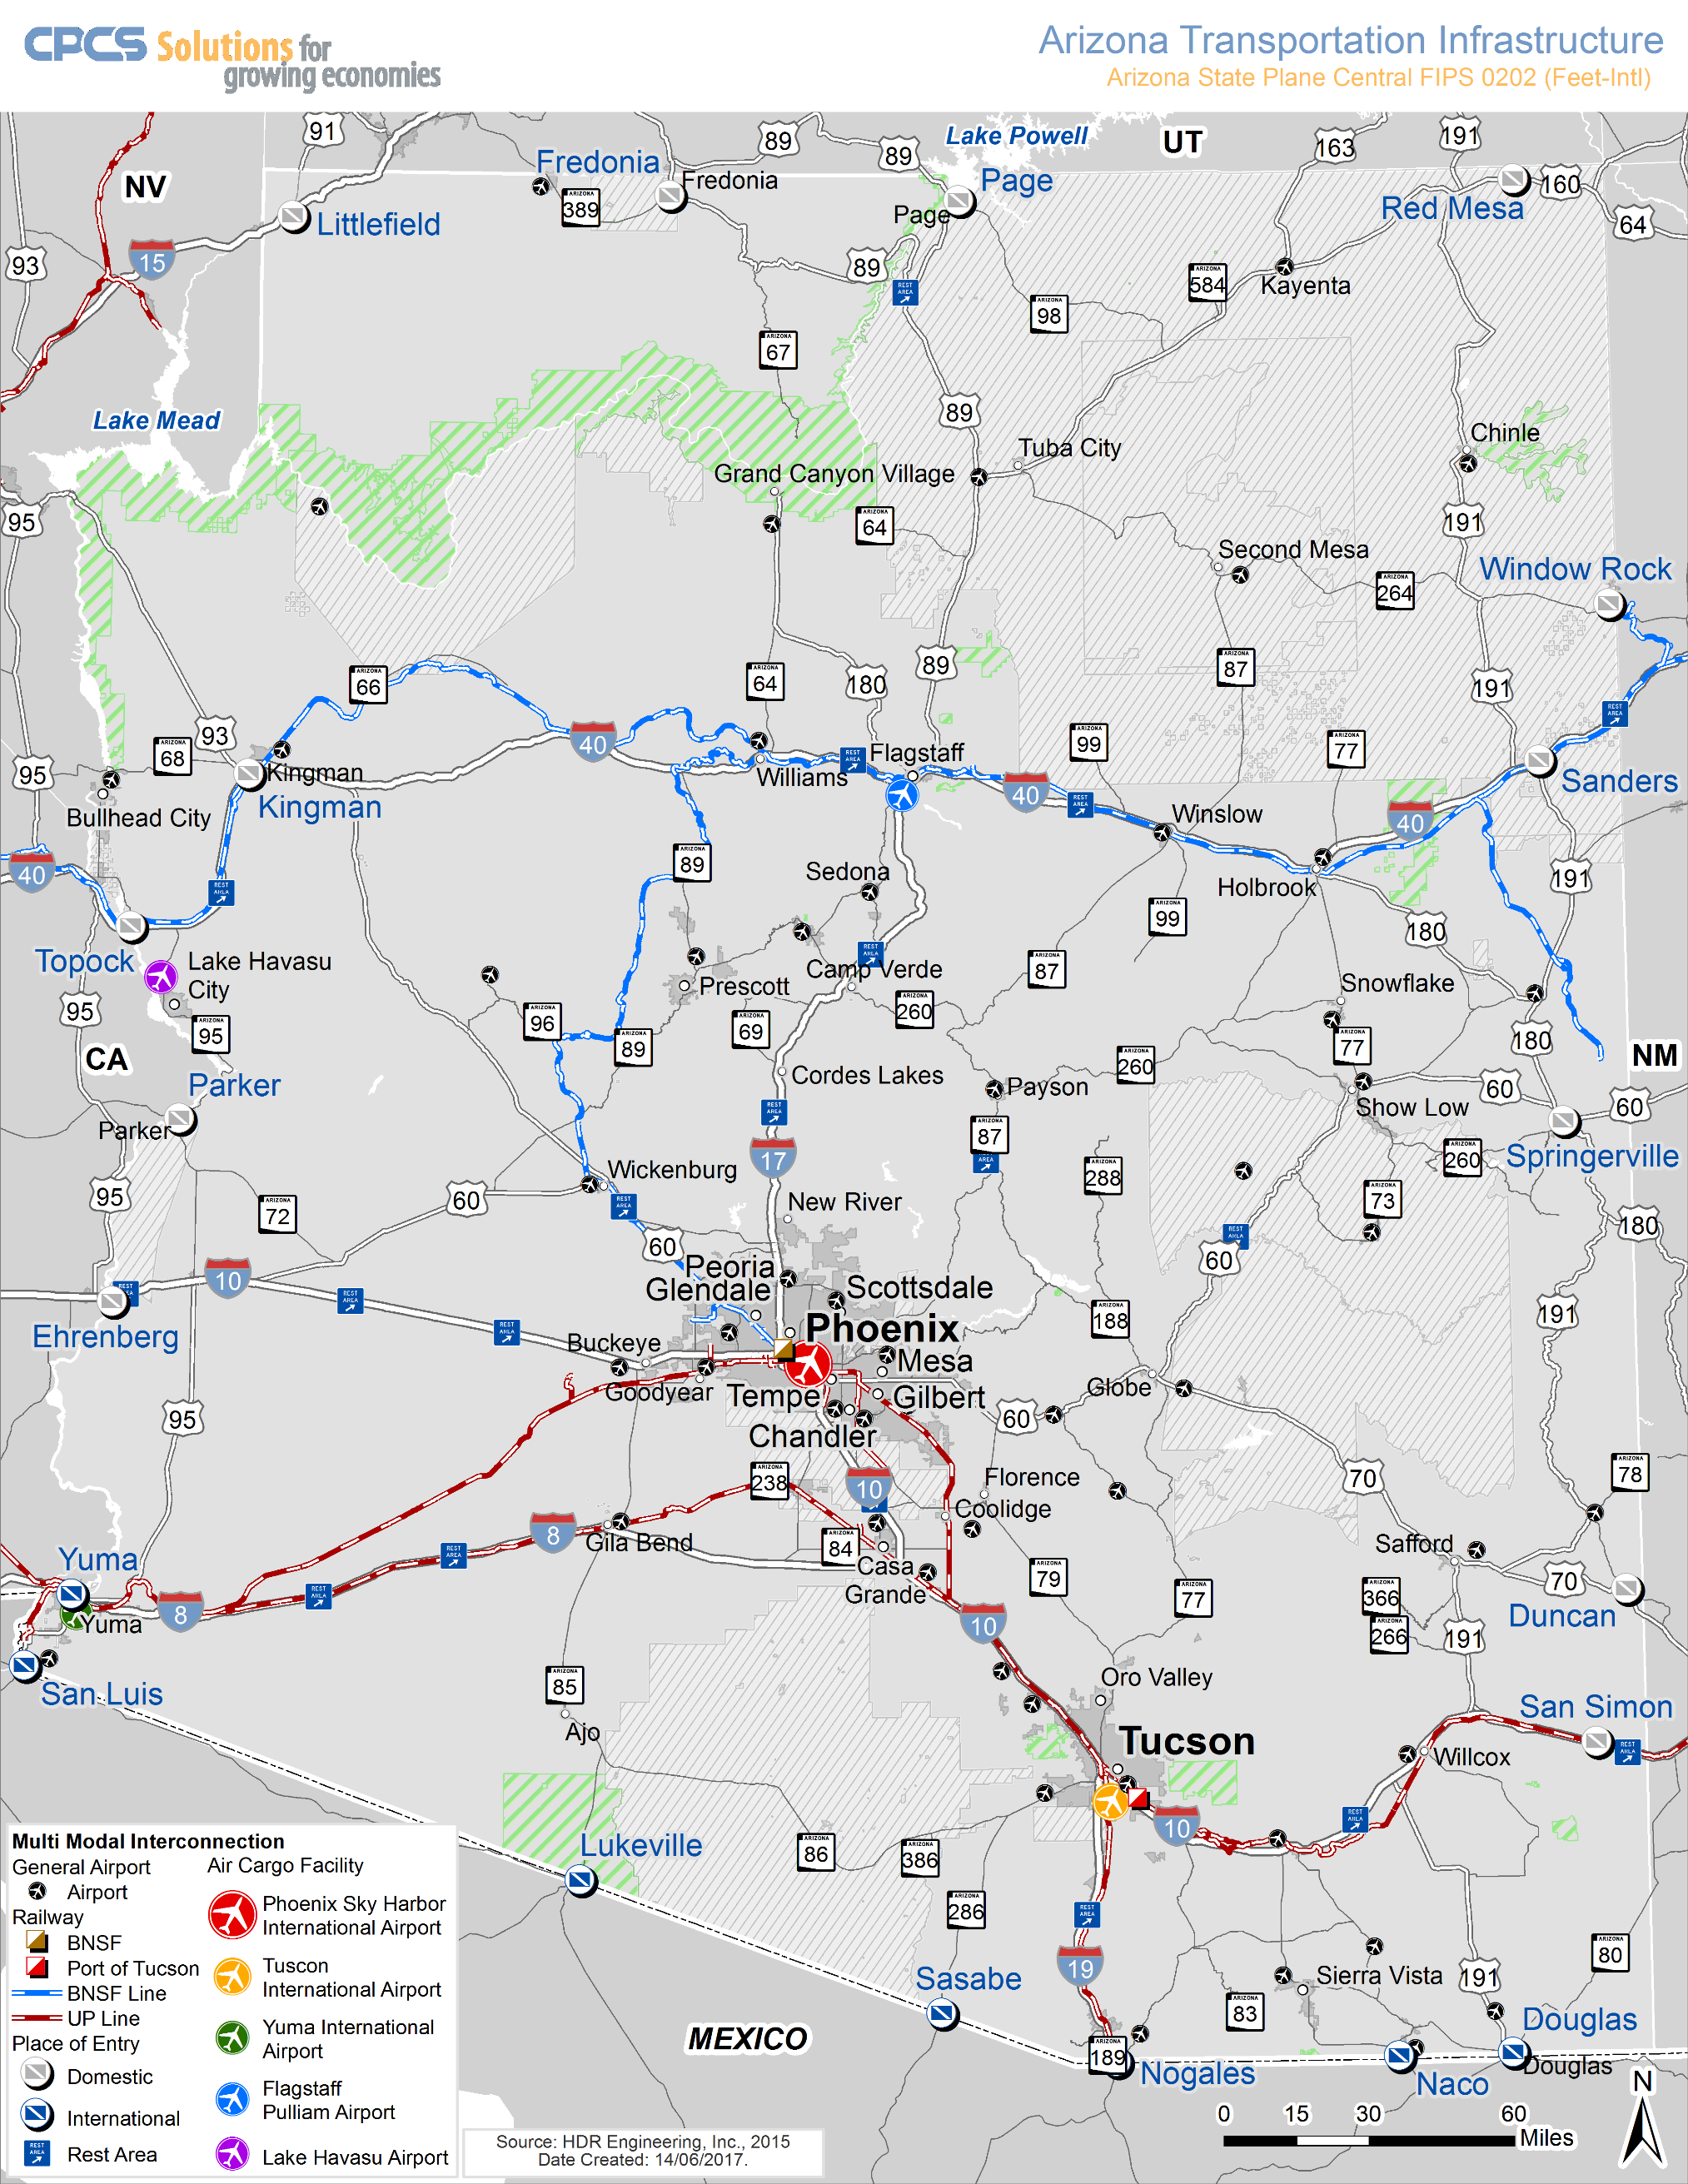
Figure 15-1 | Arizona Multimodal Freight Transportation System

15.2 | AUTHORITY
Freight planning responsibilities and requirements are provided for in the FAST Act, which was enacted in 2015. The FAST Act requires the establishment of a five-year statewide Freight Plan in order for a state to access freight-specific funding. ADOT completed the five-year freight plan, A to Z Arizona State ’s State Freight Plan, in 2017 to fulfill the federal requirements. The federal authority for freight and rail planning is listed in table 15.1
The FHWA provides a number of freight planning manuals, peer agency data, and other useful tools available online at:

https://www.fhwa.dot.gov/planning/freight_planning/
New under the FAST Act is the establishment of the Nationally Significant Freight and Highway Projects (NSFHP) program to provide financial assistance in the form of competitive grants under the Fostering Advancements in Shipping and Transportation for the Infrastructure for Rebuilding America (INFRA) program. FASTLANE grants are for nationally and regionally significant freight and highway projects that align with the program goals that will:
- Improve the safety, efficiency, and reliability of the movement of freight and people;
- Generate national or regional economic benefits and an increase in global economic competitiveness of the U.S;
- Reduce highway congestion and bottlenecks;
- Improve connectivity between modes of freight transportation;
- Enhance the resiliency of critical highway infrastructure and help protect the environment;
- Improve roadways vital to national energy security; and
- Address the impact of population growth on the movement of people and freight.

Table 15-1 | Authority
Code |  | Description
Federal | FAST Act Section 1116 | - Section 1116 titled, “National Highway Freight Program” establishes a new National Highway Freight Program to improve the efficient movement of freight on the National Highway Freight Network (NHFN) and support, including: Investing in infrastructure and operational improvements that strengthen economic competitiveness, reduce congestion, reduce the cost of freight transportation, improve reliability, and increase productivity;  - Improving the safety, security, efficiency, and resiliency of freight transportation in rural and urban areas;  - Improving the state of good repair of the NHFN;  - Using innovation and advanced technology to improve NHFN safety, efficiency, and reliability;  - Improving the efficiency and productivity of the NHFN;  - Improving State flexibility to support multi-State corridor planning and address highway freight connectivity; and  - Reducing the environmental impacts of freight movement on the NHFN
 | 23 U.S.C. § 133 | Surface Transportation Block Grant Program
 | 23 U.S.C. § 505 | State Planning and Research Program
 | 49 U.S.C. § 70202 | State Freight Plans
 | 23 U.S.C. § 167(i)(4) | National Highway Freight Program
 | 23 U.S.C. § 104(b)(5) | Apportionment

15.3 | ARIZONA FREIGHT MOBILITY
According to the 2017 Arizona State Freight Plan, Arizona Multimodal Freight Analysis Study, 65.5 percent of the total tonnage of freight moving on Arizona’s multimodal networks is carried by trucks, 34.5 percent is carried by rail, and 0.1 percent is carried by air.
Freight movements on the Arizona highway system are characterized by their high share of through traffic – that is, neither originating or destined to Arizona – accounting for 39 percent of total flows by volume and 63 percent of flows by value.

15.3.1 | Truck Freight
There are over 66,000 highway miles in Arizona. The access-controlled Interstate Highway System – comprising the core components of the state’s highway freight network – makes up two percent of total highway miles in the state or 1,168 miles, and is the most intensively utilized freight infrastructure in Arizona.
The FAST Act National Highway Freight Program (Section 1116) explains that the MPO, in consultation with the State, is responsible to designate the Critical Urban Freight Corridor (CUFC) routes if the urbanized area population is 500,000 or more, while for an area with a population less than 500,000 the State, in consultation with the MPO, is responsible to designate the CURF. The minimum population for an urbanized area is 50,000, as defined by the Census Bureau. Being located inside or outside an adjusted urbanized boundary determines whether the public road can be designated as a Critical Rural Freight Corridor (CRFC) or a CUFC. CUFC routes must be within the adjusted boundaries of an urbanized area while the CRFC routes must be outside.
A state may designate as CRFCs a maximum of 150 miles of highway or 20 percent of the Primary Highway Freight System (PHFS) mileage in the State, whichever is greater. For each State, a maximum of 75 miles of highway or 10 percent of the PHFS mileage in the State, whichever is greater, may be designated as CUFCs. The mileage is based on centerline roadway mileage. Arizona has a CRFC maximum mileage limit of 205.12 and a CUFC maximum mileage of 102.56.
National Highway Freight Program Guidance: Designating and Certifying Critical Rural Freight Corridors and Critical Urban Freight Corridors Questions and Answers

According to the Arizona Trucking Association (ATA), trucks carried 86 percent of total manufactured tonnage in the state in 2016—or 127,886 tons per day. Many smaller Arizona communities depend exclusively on trucks for the movement of freight. In 2016, the Arizona’s trucking industry provided 105,940 jobs, or 1 out of every 21.
MPO and COG transportation planners need to consider the significant contribution to the economy made by all freight transportation carriers, including the trucking industry. According to the ATA, the total trucking industry wages paid in Arizona in 2016 exceeded $4.7 billion, with an average annual trucking industry salary of $44,459. The U.S. Bureau of Labor Statistics reported in May 2016 that truck drivers, heavy, tractor-trailer and light, delivery drivers, held 23,310 jobs in Arizona with a mean annual salary of $42,310.

15.3.2 | Rail Freight
Arizona’s freight rail system covers nearly 2,000 route miles and links Arizona industries and consumers with domestic and global trading partners. As documented in the 2011 Arizona State Rail Plan prepared by ADOT, the state’s freight rail system consists of two Class I railroads and 13 short line (or Class III) and terminal railroads.
Class I carriers Burlington Northern Santa Fe Railroad (BNSF) Railway and Union Pacific Railroad (UPRR) operate 1,465 miles, or 73 percent of Arizona’s rail network, and intermodal transfer facilities in Phoenix and Tucson. Short line carriers provide local service to rail-dependent industries like mining and provide connections to the Class I network. Arizona’s active short line railroads operate 529 miles of track equivalent to approximately 23 percent of the route miles of the state’s overall freight rail system. Several key intermodal and bulk terminals provide railroad access to Arizona shippers and consumers.
BNSF Phoenix Intermodal Facility
The BNSF Phoenix Intermodal Facility is located on the west side of Grand Avenue between Camelback and Bethany Home Roads. Previously known as “Desert Lift,” this facility has mobile cranes that can be used to load and unload containerized freight to and from the rail cars designed specifically for carrying containers. The facility has five lots for transloading containers and repairing the cranes used for the process. Easy access to I-17 is provided.
For further Information for rail companies and organizations visit:

BNSF Railway

Union Pacific

Association of American Railroads
Union Pacific Phoenix Intermodal Facility
Union Pacific’s Phoenix Intermodal Facility is located on 67th Avenue south of Interstate 10 and is convenient to I-17 and SR Loop 101. Like the BNSF facility, the UP facility is equipped to load and unload containers from rail cars.
Port of Tucson
For further Information on The Port of Tucson visit:

http://www.portoftucson.net/
The Port of Tucson is an inland port rail facility located in east Tucson near UPRR’s Wilmot Siding. The port provides a variety of rail-oriented transportation services in and around the southwest region of the United States, including intermodal freight, container handling, boxcar access, and a team track facility.
San Pedro & Southwestern Railroad Benson Transload
The San Pedro & Southwestern Railroad (SPSR) operates a transload facility adjacent to its headquarters in Benson, which is convenient to I-10. The three-acre facility can accommodate up to 10 railcars. Truck parking and warehouse and storage facilities are available, and the lot is forklift accessible.
Similar “team track” type facilities are located in a number of Arizona communities for the purpose of transloading construction materials and other bulk commodities needed locally.

15.3.3 | Air Freight
While Arizona has multiple airports that handle freight, nearly all air cargo originating or terminating in Arizona is moved through Phoenix Sky Harbor International Airport (nearly 90 percent) and Tucson International Airport (nearly 10 percent).
Integrators such as FedEx and UPS have increasingly expanded their market share in the movement of air cargo. In 2013, only 13 percent of air cargo in Arizona was carried on passenger aircraft.
Any improvement that shortens the time consumed for the collection, distribution, and dispatch of air cargo enhances the efficiency of air freight operation. A roadway infrastructure serving the air cargo terminal that facilitates the movement of trucks to and from the terminal is desirable. Also desirable is easy access between the air terminal and an interstate highway or other limited access facility, effectively eliminating the need for trucks to negotiate miles of city streets and traffic to and from the airport.
While estimates suggest no new on-airport cargo infrastructure will be needed until 2031, highway access to air cargo facilities at Phoenix Sky Harbor International Airport, especially the South Air Cargo complex, will need to be addressed.

15.3.4 | Pipeline System
Two major pipelines – both operated by Kinder Morgan – supply Arizona with petroleum products. The “West Line” supplies products from the Los Angeles basin to Phoenix while the “East Line” originates in El Paso, Texas and connects to both Tucson and Phoenix. Liquid products are typically delivered to the end user by tanker truck from distribution terminals. Given the limited oil and gas production in the state, there are effectively no gathering pipelines in Arizona.
Most of the last mile gasoline deliveries in Arizona rely on truck deliveries which are made via Arizona’s petroleum product terminals. Because Arizona lacks petroleum refineries, petroleum terminals provide retail gasoline and diesel statewide via local delivery trucks. Of note, ethanol is also mixed with gasoline at the terminals, but because ethanol cannot be shipped by pipeline, it is delivered to the terminals by truck (e.g. from the ethanol plant near Maricopa). Natural gas is distributed to end users by pipeline.
Because pipelines are controlled by private businesses, information on their performance is difficult to ascertain.

15.3.5 | Borders and International Freight Gateways
Arizona and the State of Sonora, Mexico share approximately 360 miles of international border. There are six border crossing locations along Arizona’s border with Mexico
Arizona’s six border crossing locations are host to nine Land Ports of Entry (LPOE). A LPOE is an official location for the entry of goods and people, along with the enforcement of duties and laws. The border crossing location of San Luis-San Luis Rio Colorado features two LPOEs while the location of Nogales-Nogales features three LPOEs.
There are four types of flows that LPOEs on the Arizona-Sonora border may process: pedestrians, passenger vehicles, commercial vehicles, and rail. The type of flow processed by a specific LPOE depends on the infrastructure and staffing characteristics of each entry point. The complete list of LPOEs located on the Arizona-Sonora border, along with their location and the type of flows processed, is provided in Table 15-2.

Table 15-2 | Land Ports of Entry in Arizona
LPOE | Border Crossing Location | Type of Flows Processed
San Luis | San Luis, Arizona | Passenger vehicles and pedestrians
San Luis | San Luis, Arizona | Commercial vehicles
Lukeville | Lukeville, Arizona | Commercial vehicles, passenger vehicles, and pedestrians
Sasabe | Sasabe, Arizona | Commercial vehicles, passenger vehicles, and pedestrians
Mariposa | Mariposa, Arizona | Commercial vehicles, passenger vehicles, and pedestrians
DeConcini | DeConcini, Arizona | Passenger vehicles, pedestrians, and rail
Morley Gate | Morley Gate, Arizona | Pedestrians
Naco | Naco, Arizona | Commercial vehicles, passenger vehicles, and pedestrians
Douglas | Douglas, Arizona | Commercial vehicles, passenger vehicles, and pedestrians

During 2014, more than $437 billion worth of goods moved through the U.S.-Mexico border using land transportation modes (truck, rail, and pipeline). Of this value, $359 billion, or 82 percent, corresponded to goods moved by truck. The DeConcini LPOE, located in Nogales, Arizona, is the only crossing for rail. Historically, Naco, and Douglas LPOEs had railroad crossings, but these lines have since been abandoned.
The LPOEs in Arizona processed approximately $30 billion or seven percent of the total goods that traveled between the U.S. and Mexico using land transportation modes.
Of the $30 billion processed by Arizona border crossings, approximately $20 billion (or two-thirds) crossed the border by truck, $10 billion crossed by rail and a negligible amount was moved by pipeline.
For freight entering Arizona from Mexico, a greater percentage of volume/value travels by rail than for other southern border states, but trucking still comprises the largest portion of trade between Arizona and Sonora.
Land-based border flows are heavily concentrated at two border crossings:
- Over 85 percent of exports and 88 percent imports from or to Arizona use the Nogales-Nogales border crossing.
- Over ten percent of exports and imports from or to Arizona uses the Douglas-Agua Prieta border crossing.
Recent improvements to LPOEs in the region have reduced congestion; however, stakeholders expect continued growth in border volumes, suggesting the need for continued planning and investment in border infrastructure.

15.3.6 | Freight Clusters
Freight clusters are concentrations of freight-dependent businesses, often engaged in warehousing or industrial activities and frequently supported by nearby intermodal transfer terminals, airports, or pipeline terminals which facilitate the movement of goods between modes.
In Arizona, the greatest concentration of freight activity is located along the I-10 corridor in Phoenix and Tucson, and includes clusters located at Tolleson, Sky Harbor Airport, Chandler, and the Port of Tucson. Outside the two largest metropolitan areas, Phoenix and Tucson, clusters are notably located in Casa Grande, Yuma, Prescott Valley, Flagstaff, Lake Havasu City, Bullhead City, Sierra Vista, and the border city of Nogales.
Arizona’s freight clusters are generally well connected to the multimodal transportation system, although some experience congestion and delays.

15.4 | ARIZONA FREIGHT-RELATED PLANS
With the exception of studies specifically devoted to transit or passenger rail service, nearly all transportation planning conducted in Arizona includes findings and recommendations germane to freight movement. For example, climbing lane and passing lane studies respond to the needs of highway motorists sharing the road with commercial trucks. Studies of roadways of regional significance identify existing or planned arterial roadways with alignments and traffic characteristics that show them to be of critical importance to both motorists and trucks. These studies recommend improvements that consider the needs of trucks, including travel lane width, minimum turning radii, types of traffic control, and lengths of turn storage lanes. Area planning studies also consider freight needs. For example, the 2009 La Paz County Area Transportation Study analyzes access to a proposed industrial park in Quartzsite as well as improvements needed to an I-10 exit to better accommodate heavy trucks and recreational vehicles. Freight is the primary focus of recent studies summarized below:

15.4.1 | Arizona State Rail Plan, TBA
(To be filled in when study completed)

15.4.2 | Arizona-Sonora Border Master Plan
The Arizona-Sonora Border Master Plan (BMP) was prepared by ADOT in collaboration with the FHWA, Secretaría de Comunicaciones y Transportes (SCT), and the government of the state of Sonora, Mexico. The purpose of the plan is to identify means of improving the efficiency and effectiveness of transportation facilities used in the movement of people and goods between Arizona and Sonora. The principal objectives of the plan are to:
For more information on the Arizona-Sonora Border Master Plan follow:

https://azdot.gov/planning/transportation-studies/completed-transportation-studies/arizona-sonora-border-master-plan
- develop and implement a plan for identifying, prioritizing, and promoting land port of entry (LPOE) and related transportation projects and services;
- design a process to ensure relevant international stakeholders participate in the planning of LPOE projects and related transportation infrastructure improvements in the border region;
- increase understanding of the LPOE and transportation planning processes on both sides of the border; and
- establish a process for continued dialogue among relevant international stakeholders that promotes coordination on current and future projects, especially through coordination of planning and programming processes adopted and pursued by study participants and partners.
The plan identifies three hierarchical areas for evaluating the specific needs associated with the cross-border movement of people and goods between Arizona and Sonora: the Focus Area; the Area of Influence; and the Regional Area of Influence.
- The Focus Area is an approximately 20-mile-wide zone along the 389-mile Arizona- Sonora international border that extends 10 miles on each side of the border. This zone includes the three principal border metropolitan areas: Yuma/San Luis; Nogales/Nogales; and Douglas/Agua Prieta. All of Arizona’s nine ports of entry (POEs) are located within the Focus Area.
- The Area of Influence includes the Focus Area, and extends 80 miles on each side of the border to include the major east-west corridors in both Arizona and Sonora (e.g. Interstates 8 and 10 and the Union Pacific Sunset main line).
- The Regional Area of Influence includes the California-Baja California BMP to the west and the New Mexico-Chihuahua BMP to the east.
The process for continued dialogue among relevant international stakeholders as initiated with a Work Plan supported by a comprehensive Stakeholder Outreach Plan. The Stakeholder Outreach Plan included development of a Policy Advisory Committee (PAC) and Technical Working Group (TWG).
Transportation Project Evaluation Criteria
Projects were divided into three types to reflect differences in funding sources: 1) LPOEs; 2) multimodal infrastructure (MMI), including roadways, bridges, highway interchanges, transit, pedestrians, and bicyclists; 3) rail.
The planners developed categories of evaluation for use in prioritizing prospective projects. These categories are based upon similar criterion developed for BMPs prepared in California and Texas. Five major categories of evaluation criteria were developed: 1) cost effectiveness; 2) project readiness; 3) capacity/congestion; 4) regional benefit; 5) LPOE connectivity.
The evaluation criteria were used to rank projects in Sonora and Arizona separately. Logically paired projects, such as Arizona and Sonora POE facilities at the same border crossing, were combined. The top eight highest ranking combined projects pertaining to freight movement follow:
- Upgrade Nogales III POE in Sonora, which is opposite the already upgraded Nogales Mariposa facility in Arizona.
- Expand and modernize the Sonoita, Sonora facility, which is opposite the already upgraded Lukeville, Arizona POE.
- Construct a new customs processing facility for commercial vehicles at the Nogales III POE.
- Expand and modernize the San Luis I facilities on both sides of the border, including an improved connection to SR 195.
- Construct new commercial POE facilities in Douglas/Agua Prieta.
- Construct a new rail POE in Nogales west of current crossing, bypassing downtown traffic congestion.
- Construct a new rail POE at the San Luis II crossing.
- Restore the rail POE at Naco, rehabilitating and/or restoring the rail line from Naco to the Union Pacific Sunset main line at Benson.

15.4.3 | Arizona State Freight Plan
In 2017, ADOT’s Multimodal Planning Division published the five-year Arizona State Freight Plan to fulfill the federal requirements for state freight plans as stated in the FAST Act. The study summarized the state’s freight knowledge to guide ADOT’s decision-making to increase the prominence of freight in the planning and programming activities of ADOT. In addition to recognizing the goals of the FAST Act and Arizona’s LRTP, the state freight plan looks to support the state’s freight transportation system through balancing current and new funding resources along with the positions of the various stakeholders that include: Freight shippers, Consumers, Carriers, Society, and Government.

15.4.4 | Arizona State Truck Parking Study
A further step beyond the Arizona State Freight Plan, the Arizona State Truck Parking Study addresses the inadequate supply of truck parking, which affects the safety and efficiency of freight movement across the state. Inadequate truck parking results in truck drivers parking on highway shoulders, on/off ramps, vacant property, or local surface streets. These parking behaviors can negatively affect highway safety, infrastructure condition, and quality of life. Recommendations included an implementation plan for expanding state-owned rest area truck parking capacity and policies that outline a framework for continuing to address the truck parking needs in Arizona that include design standards, stakeholder partnerships, and truck parking information integration with Arizona’s 511 system.

15.4.5 | Arizona Bi-National Corridor Study
This Binational Freight Corridor Study will provide the Arizona Department of Transportation (ADOT) with sufficient information to broaden its understanding of manufacturing and production trends in the Phoenix–Mexico City Corridor (Pacific Corridor or Corridor 15) and the El Paso–Mexico City Corridor (Central Corridor or Corridor 45).
The Study Team is assessing freight performance of the Pacific and Central Corridors, compiling a comprehensive inventory of existing freight assets and planning needs, identifying and estimating several performance metrics, including travel time reliability, truck delay, and average truck speed to identify areas of improvement through various strategies (including capacity addition, intelligent transportation systems (ITS), regulatory changes, port of entry staffing, changes to land use or zoning restrictions, etc.). The study scope of work also includes developing a forecast of the future volume and value of freight that is likely to use the corridor, should all requested projects be implemented.

15.4.6 | Arizona Port of Entry Study
(To be filled in when study completed)

15.4.7 | Arizona Transportation Asset Management Plan
ADOT is responsible for the construction, operation, management and maintenance of the State Highway System (SHS) which comprises more than 21,000 lane miles and is valued at more than $20 billion. The dependable and efficient operation of this transportation network is vital to Arizona’s economic competitiveness and quality of life. Moreover, the safety and welfare of the travelling public depends on the successful management of the transportation assets on the SHS and the National Highway System (NHS).
The majority of ADOT’s bridge and pavement infrastructure will reach the end of its normal lifecycle over the next 10 years. With proper preservation treatments, the life of this infrastructure can be extended. However, as Arizona’s highway system ages, the resources needed to maintain it will increase. This makes the identification and implementation of strategies that preserve existing assets while controlling costs essential to sustaining a balanced, fiscally sound state highway program.
Managing assets throughout their lifecycle with an emphasis on preservation treatments is a proactive approach, requiring a long-term perspective and significant planning. It is becoming a standard practice for departments of transportation (DOTs) to address this planning need by the development of a Transportation Asset Management Plan (TAMP).

15.4.8 | Statewide Rail Crossing Safety Action Plan
This proposed rule would revise Federal Railroad Administration’s (FRA) existing regulation on State highway-rail grade crossing action plans (49 C.F.R. 234.11) to require 40 States and the District of Columbia to develop and implement FRA-approved highway-rail grade crossing actions plans. The proposed rule would also require the ten States previously required to develop highway-rail grade crossing action plans by the Rail Safety Improvement Act of 2008 (RSIA) and FRA’s implementing regulation at 49 C.F.R. 234.11 to update their plans and to submit reports describing the actions they have taken to implement their plans.
For more information on the State Highway-Rail Grade Crossing Action Plan
https://www.federalregister.gov/documents/2019/11/07/2019-24197/state-highway-rail-grade-crossing-action-plans

The FAST Act mandate contains specific requirements for the contents of the highway-rail grade crossing action plans. As set forth in section 11401(b)(2) of the FAST Act, each highway-rail grade crossing safety plan must identify highway-rail grade crossings that: (a) Have experienced recent highway-rail grade crossing accidents or incidents; (b) have experienced multiple highway-rail grade crossing accidents or incidents; (c) are at high-risk for accidents or incidents. Section 11401(b)(2) of the FAST Act further provides that each highway-rail grade crossing action plan must identify specific strategies for improving safety at highway-rail grade crossings, including highway-rail grade crossing closures or grade separations. Each State highway-rail grade crossing action plan much also designate a State official responsible for managing implementation of the plan.

15.5 | ARIZONA FREIGHT ORGANIZATIONS

15.5.1 | Transportation & Trade Corridor Alliance
The Transportation and Trade Corridor Alliance (TTCA) is a collaboration led by the Arizona Department of Transportation, the Arizona Mexico Commission, and the Arizona Commerce Authority that brings together the public and private sector, state and local governments, planning organizations, transportation and logistics companies, port authorities and other relevant stakeholders to assess issues and opportunities in trade, transportation, logistics and supply chain development. The Transportation and Trade Corridor Alliance addresses:
- Defining a new approach that incorporates local initiatives into a broader state context as it pertains to transportation and trade opportunities.
- Identifying ways to increase the value of our trade corridors.
- Opportunities and challenges that impact global logistics in the state of Arizona.
- Integrating rail and/or intermodal facilities for sustainable growth and job diversification in the state.
The TTCA has a freight committee that discusses freight issues/opportunities for expansion.

15.5.2 | Arizona Trucking Association
The ATA was formed in September 1937 as the Arizona Motor Transport Association—a nonprofit trade organization. The organization’s name was officially changed to Arizona Trucking Association in 2004.
The ATA conducts seminars and training at their headquarters facility located at 75th Avenue and Madison Street in Tolleson. The ATA informs the public of the integral role that trucks play in the transportation of freight and also keeps members apprised of federal and state legislation and regulations that affect the trucking industry. ATA members are encouraged to contribute to T.A.L.E., the ATA’s political action committee, which supports candidates with positions favorable to the industry.
According to the ATA, the association’s membership more than doubled from 2002 to 2008, enabling the provision of expanded programs and services at ATA’s headquarters facility.

15.5.3 | Arizona State Railroad Association
The Arizona State Railroad Association is a member of the American Short Line and Regional Railroad Association (ASLRRA). The ASLRRA enables America’s small rail lines to work together to educate federal, state, and local government officials and private sector stakeholders on the importance and function of the short line and regional railroad industry. The ASLRRA also provides safety and security information and training to member railroads on topics such as the handling of hazardous materials. Information with respect to compliance with federal and state regulations is also provided. The ASLRRA conducts meetings and seminars to inform members about new legislation, best industry practices, and new technology. The association presents annual safety awards to member railroads as warranted. The contact for the Arizona State Railroad Association is Lowell S. Jacobson, the CEO of the Copper Basin Railway.

15.5.4 | Airforwarders Association
The Airforwarders Association was founded in 1990 by three air forwarding organizations that recognized the importance of providing the industry with a unified voice on issues of importance to all industry members. In March 2013, the association represented more than 200 air forwarding companies and has more than 3,000 offices throughout the United States. The association itself does not have a presence in Arizona, however freight divisions of the major airlines serving the state, such as American and Delta, are active members. According to the association, air forwarding is a 17-billion-dollar industry.
The association is proactively involved in promoting effective improvements to air car security. It also seeks to educate stakeholders and the public on the importance of the air forwarding industry and to ensure that industry representatives are included in all discussions and planning relating to air freight.

15.5.5 | Southern Arizona Logistics Education Organization
The mission of the Southern Arizona Logistics Education Organization (SALEO) is to “educate, promote and grow the transportation and logistics industry by networking the logistics service providers and users in the Arizona-Mexico region.”
The objectives of SALEO are to:
- produce a well-qualified and self-sustaining logistics workforce.
- participate in regional transportation planning that affects freight movements.
- conduct economic development activities that promote the logistics industry.
- develop strategic partnerships designed to advance education and workforce efforts.
- identify regional logistics service providers that can facilitate the movement of freight to, from, and through the Arizona-Mexico region.
SALEO provides a forum where logistic providers and users can discuss best practices and understand ongoing issues that affect transportation and logistics. The organization also provides networking opportunities for logistics professionals.

15.6 | ARIZONA-MEXICO BORDER-RELATED FREIGHT PLANNING
Arizona has nine POEs on the Mexico border. From east to west, they are:
- San Luis I
- San Luis II
- Lukeville
- Sasabe
- Nogales Mariposa
- Nogales DeConcini
- Nogales Morley Gate
- Naco
- Douglas
Table 15-3 summarizes the freight features of the border crossing locations. As table 15-3 shows, most freight traffic to and from Mexico travels through the Nogales POEs.

15.6.1 | Arizona POE Freight Issues
The predominant freight-related POE issues are traffic congestion and the dangers that exist due to the commingling of increasing amounts of commercial vehicle, noncommercial vehicle, and pedestrian traffic at the key border crossings.
The more remote crossings, such as Lukeville, Sasabe, and Naco, are not congested, but they are far from urban areas and, more significantly, inconvenient to existing Arizona and Sonora transportation infrastructure.
On the Arizona side, the San Luis II POE opened in 2010 and SR 195, the “Area Service Highway” connecting the port with I-8 east of Yuma was completed. Currently, the San Luis II POE is going through the design phase of a Government Services Administration Rehabilitation of the facility installing more vehicle lanes and pedestrian upgrades.

Table 15-3 | Summary of Port of Entry Features
Border Crossing | Mode(s) | Port Infrastructure | Nearest Interstate Highway | Annual Commercial Truck Traffic*
San Luis I | Motor Vehicle; Pedestrian | US 95, SR 195 | I-8 | 43,967
San Luis II | Motor Vehicle | US 95, SR 195 | I-8
Lukeville | Motor Vehicle; Pedestrian | SR 85 | I-8 | 1,960
Sasabe | Motor Vehicle; Pedestrian | SR 286 | I-10, I-19 | 369
Nogales Mariposa | Motor Vehicle, Pedestrian | SR 189 | I-19 | 308,917
Nogales DeConcini | Motor Vehicle; Rail; Pedestrian | B-19, Union Pacific | I-19 | 0
Nogales Morley Gate | Pedestrian | N/A | I-19 | 0
Naco | Motor Vehicle; Pedestrian | SR 92 | I-10 | 2,825
Douglas | Motor Vehicle; Pedestrian | SR 80 | I-10 | 24,667
*Truck traffic data for October 2007 through September 2008 period, prior to the opening of San Luis II.
Source: U.S./Mexico Joint Working Committee on Transportation Planning, Public-Private Partnerships Potential for Arizona-Mexico Border Infrastructure Projects., http://www.borderplanning.fhwa.dot.gov/adot_PPPrpt/execSumm.asp

A similar need exists for improvements on the Sonora side in Nogales. In Arizona, improvements have been made to the Nogales Mariposa facility, which handles all the commercial truck traffic. A comprehensive modernization project was completed at this facility in 2014 to increase over five times the previous freight processing capacity.
Downtown Nogales is the only location where a rail connection between Arizona and Sonora exists. Previously, there were rail connections at both Douglas/Agua Prieta and Naco, but both were removed in the 1990s.
While additional improvements to the POEs remain in the planning stage, conditions may worsen before they begin to improve. Truck traffic between Arizona and Sonora is increasing. Implementation of immigration reform—which seems increasingly likely—may result in increased noncommercial and pedestrian traffic at the busiest POEs.

15.6.2 | Canamex & I-11
The Canada to Mexico Corridor (CANAMEX) is a designated high priority corridor connecting Canada with Mexico by means of Interstate 15, US 93, US 60, I-10, and Interstate19. The corridor is intended to be a four-lane, divided highway throughout its length. However, several segments of the corridor within Arizona do not meet this standard: Portions of US 93 between Kingman and Wickenburg still have only two lanes and US 60 within the metropolitan Phoenix area (Grand Avenue) is not fully access controlled.
To correct these deficiencies, and to expedite the movement of people and goods between central Arizona, Las Vegas, and the Pacific Northwest, a new I-11 has been proposed. Figure 15-2 depicts the two corridors.

Figure 15-2 | Canamex & 1-11 Corridors
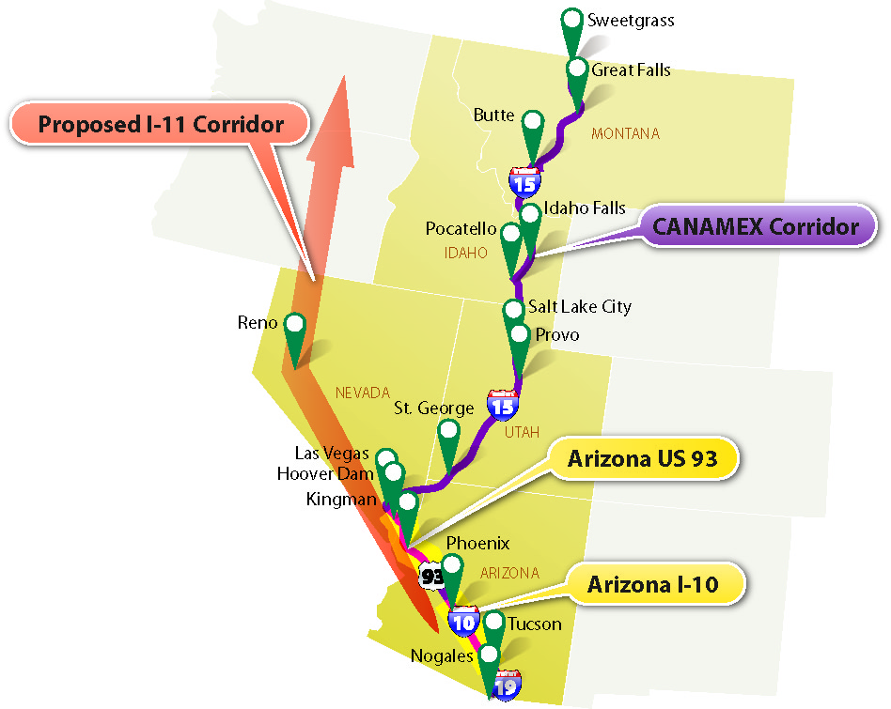

16 | AERONAUTICS
TABLE OF CONTENTS
16.1 | PURPOSE
16.2 | AUTHORITY
16.3 | SCOPE
16.4 | FAA AIRPORT IMPROVEMENT PROGRAM
16.4.1 | Federal Funding
16.4.2 | FAA Planning Process
National Plan of Integrated Airport System
State Airport System Plans
Regional Airport System Plans
Airport Capital Improvement Plans
Other Regional Airport Plans
Airport Layout Plans and Airport Master Plans
16.4.3 | Grant Requirements
16.5 | Airport Planning in Arizona
16.5.1 | ADOT - MPD - Aeronautics Group
16.5.2 | State Funding Programs & Levels
State & Local Grants
Airport Pavement Management System (APMS)
Airport Loan Program
Statewide Planning and Services Program
16.5.3 | Arizona Grant Application Timetable
16.5.4 | Arizona’s Airport System
Commercial Service Airports
Reliever Airports
General Aviation (GA) Community Airports
GA Rural Airports
GA Basic Airports
Military Airports
Tribal & Private Airports
16.5.5 | Regional Aviation System Plans
16.6 | REGIONAL PLANNING ISSUES
16.6 | REGIONAL PLANNING ISSUES
16.6.1 | Intermodal Connectivity
16.6.2 | Land Use
16.6.3 | Air Quality
16.6.4 | Homeland Security

| Aeronautics

16.1 | PURPOSE
This chapter describes the planning and project prioritization processes that are used to fund infrastructure maintenance and improvements at public airports in Arizona and the role of MPOs with regard to ensuring that airports contribute to efficient intermodal movement of people and goods in a regional transportation system.
Unlike the funding of roadway projects, where MPOs and COGs have a major role in project selection, federal funding for aviation improvements is allocated directly to airports based on project evaluations performed by the FAA. State funding for airport projects is allocated through the State Transportation Board processes administered by the ADOT Multimodal Division, Aeronautics Group.
Beyond the issue of allocating federal funds, MPOs do have the important responsibility to ensure that airports have adequate connectivity with surface transportation facilities and services, including roads and transit. Additionally, in some circumstances, MPOs may participate in the preparation of Regional Aviation System Plans (RASPs). RASPs are advisory in nature and prepared on an as-needed basis.
ADOT Aeronautics:

https://azdot.gov/planning/airport-development

16.2 | AUTHORITY
Aviation system planning efforts largely focus on facilities that are eligible to receive Airport Improvement Program (AIP) grants from the FAA. The codified federal laws and regulations for this grant program are described in Table 16-1 below.

Table 16-1 | Authority
Code |  | Description
Federal | 49 U.S.C. Chapter 481 | Airport and Airway Trust Fund Authorizations
 | 14 C.F.R. § 151 | Federal Aid to Airports
 | 23 U.S.C. § 134 | Metropolitan Transportation Planning
 | 23 C.F.R. § 450.316 | Interested parties, participation, and consultation.
 | 23 C.F.R. § 450.320 | Congestion management process in transportation management areas.
 | 23 C.F.R. § 450.322 | Development and content of the metropolitan transportation plan.
State | 28 A.R.S. Chapter 25 | Aviation

16.3 | SCOPE
Grants for improvements at public airports in Arizona are available primarily from the FAA and from the state of Arizona. Required planning processes are in place to identify needed improvements and to prioritize expenditure of federal and state funds. Section 16.4 below describes the overall FAA airport planning process, whereas section 16.5 describes airport planning in Arizona, which is administered by the ADOT -MPD- Aeronautics Group.
The role of MPOs in the airport planning process is relatively limited yet important. Regional aviation system planning is defined in section 16.5.5 | Regional Aviation System Plans and regional planning issues related to aviation are discussed in section 16.6 | Regional Planning Issues.

16.4 | FAA AIRPORT IMPROVEMENT PROGRAM
Aviation is a transportation mode that is well suited for long-distance travel, including interstate travel. Not unlike motorists on the interstate highway system, it is important for aviators and their passengers to be able to fly from airport to airport and find infrastructure that meets consistent standards for safety and operations. Accordingly, FAA develops infrastructure design standards and provides federal funds to public airports to build and maintain facilities consistent with these standards. FAA airport improvement efforts are described below. Included are discussions of the recent history of FAA funding for airports, current funding levels, the FAA airport planning process, and FAA grant requirements.

16.4.1 | Federal Funding
Nationwide, AIP grants have totaled about $3 billion per year over the past decade. Local matching funds are required, at percentage rates that vary from state to state and by airport type. In Arizona, an annual average of $193 million in federal funding is anticipated to be available for fiscal years 2013–2017. Matching funds of about $29 million are to be provided by the project sponsors (individual airports) and the state of Arizona. Out of the combined annual total of $222 million, the FAA portion represents approximately 86.9 percent.
Because one dollar of state and local funding can secure about nine dollars of federal grant money, Arizona strives to help its airports maximize the use of FAA grants. Inclusion of projects in the ACIP is necessary to implement projects but does not guarantee their funding or implementation. The airport that is the project sponsor must comply with various deadlines, information submittals, and matching fund requirements to receive an FAA AIP grant.

16.4.2 | FAA Planning Process
Comprehensive details regarding airport system planning are available in FAA Advisory Circular 150/5070-7. Key FAA planning documents are listed in Table 16-2. Figure 16-1 illustrates the Airport System Hierarchy including local, regional, state and national planning activities. Figure 16-2 depicts various elements of the FAA airport planning process, and their interrelationships.
The FAAAIP is the largest source of funding for Arizona airports. In Arizona, an annual average of $193 million in federal funding is anticipated to be available for airport improvements during fiscal years 2013–2017. Required local matching funds of $29 million will bring funding for AIP projects to $222 million. In most cases, the state and the airports each pay half of the local match.

Table 16-2 | Key FAA Planning Documents
Acronym | Title
NPIAS | National Plan of Integrated Airport Systems
SASP | State Airport System Plan
RASP | Regional Airport System Plans
ACIP | Airport Capital Improvement Plans
 | Other Regional Airport Plans
ALP | Airport Layout Plans
AMP | Airport Master Plans

Figure 16-1 | Airport System Hierarchy
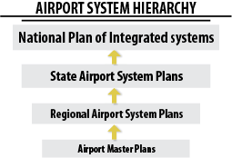
National Plan of Integrated Airport System
The NPIAS identifies, for Congress and the public, the composition of a national system of airports together with the airport development and costs necessary over the ensuing 10 years to expand and improve the system to meet the present and future needs of civil aviation, national defense, and the U.S. Postal Service (USPS).
As of December 2012, the NPIAS identifies nearly 3,400 existing and proposed airports that are significant to national air transportation and thus eligible to receive federal grants under the AIP. It also includes estimates of the amount of AIP money needed to fund infrastructure development projects that will bring these airports up to current design standards and add capacity to congested airports. The FAA is required to provide Congress with a five-year estimate of AIP eligible development every two years.

Figure 16-2 | Planning Process for Airport Improvements
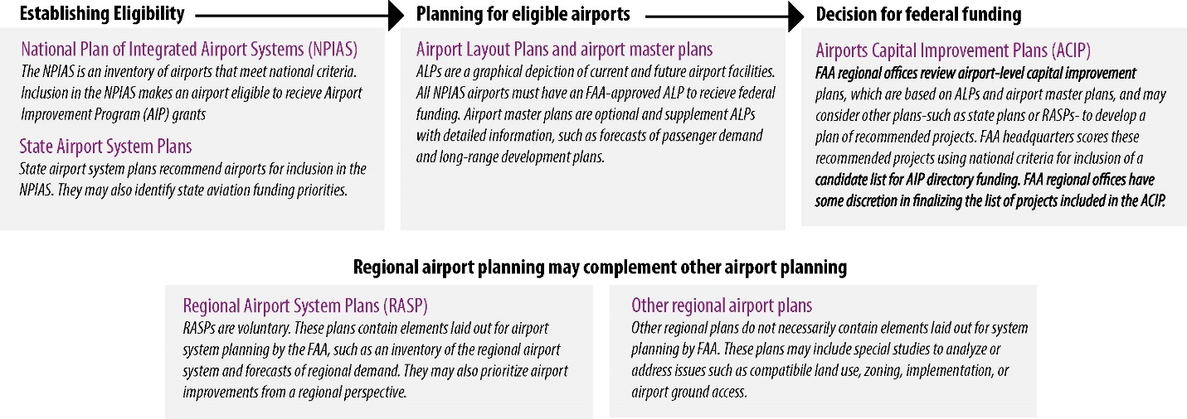

State Airport System Plans
Much of the information in the NPIAS results from compiling the findings from SASPs. The most current (2009) Arizona SASP accomplished nine planning objectives:
- Established system vision, goals, and performance measures
- Inventoried current state policies for airport development
- Inventoried existing airport/aviation assets
- Developed airport-specific growth projections through 2030
- Identified appropriate functional roles for all airports in the SASP system
- Identified adequacies and deficiencies in the existing system, based on performance measures
- Established targets for future system performance
- Estimated system development costs needed to meet the established future performance targets
- Identified actions needed to implement the SASP study recommendations
Regional Airport System Plans
From time to time, on an as-needed basis, RASPs are prepared to complement the ongoing SASP process. RASPs are not a required element of the federal planning process but can be funded by the FAA in cases where local circumstances justify the need for such a study. In 2009, the U.S. Government Accountability Office (GAO) reported that the FAA spent $34.4 million between 1999 and 2008 to fund 27 RASPs. These expenditures included $450,000 for the Phoenix area and $150,000 for the Tucson area. The findings from Arizona’s two RASPs have been taken into account in the subsequent development of Arizona’s SASP.
The ADOT Aeronautics Group prepares an Arizona ACIP as part of the state’s Five-Year Transportation Facilities Construction Program, which is approved by the Arizona State Transportation Board (ASTB).
FAA’s Advisory Circular 150/15070-7, Section 206 (“Role of the Metropolitan or Regional Planning Agency”) indicates that a RASP can be conducted by an MPO “when that agency has the interest in and the capability to conduct such planning.” The circular indicates that this is allowed in areas that include a large or medium hub airport. Phoenix has a large hub airport and Tucson has a medium hub airport. No other facility in Arizona currently meets the FAA enplanement criteria for these classifications.
Arizona’s limited preparation of RASPs is consistent with national practice. A GAO survey of 324 MPOs found that fewer than 20 percent of MPOs have an active role in aviation planning and that nearly all of these are in metropolitan areas with a population of one million or more residents. It takes a region with a large population to make a medium or large hub airport necessary and financially viable.
Airport Capital Improvement Plans
To implement the NPIAS over time, the FAA prepares a national ACIP that identifies the specific improvements to be undertaken within the next three to five years and that are considered likely to be funded by the AIP. The FAA maintains the NPIAS and the ACIP as internal documents in a common database (NPIAS-ACIP. The national ACIP is prepared by compiling input from the regional ACIPs prepared by the FAA’s nine regional offices. Each ACIP is prepared in accordance with FAA Order 5100.39A, “Airport Capital Improvements Plan.” The regional ACIP addressing the needs of Arizona is prepared by the Los Angeles Airport Districts Office (ADO), which is part of the FAA’s Western-Pacific Region. Recently, the FAA opened a Phoenix Airports Field Office. This office will assume the duties of the development of the ACIP.
Other Regional Airport Plans
A wide range of other special studies that are eligible for AIP funding are discussed in FAA Advisory Circular 150/15070-7, Chapter 7, “Special Studies.” A list of special studies is also included in ADOT’s October 2011 Airport Development Guidelines (see section 16.5.2 | State Funding Programs & Levels below). Specific examples cited in the FAA circular include statewide air cargo studies, pavement management studies, and the following aviation-related topics:
- Identification of airports (and priorities) that should be improved to accommodate business jets on a regional basis
- Identification of airports that need improved instrument approaches and the facility improvements required to support those approaches
- Identification of airport improvements needed at smaller commercial service airports to accommodate regional jets, statewide navigational aids, or automated weather observing system (AWOS) studies
- Studies to develop statewide guidance or standards on noise, zoning, or land use compatibility
- Statewide economic impact studies
- Emergency services and security planning
- Evaluation of market routes
- General aviation airport security
- Strategic planning
Airport Layout Plans and Airport Master Plans
The basic building blocks for regional, state, and national airport system plans are the specific plans developed by each individual airport, identifying what facilities it has and needs to meet its intended role in serving the community. These plans are context-sensitive, because every airport has different geographical and social constraints based on its setting and surrounding development. Each airport plan must be compatible with FAA standards to provide consistent levels of safe infrastructure for users, including interstate air travelers.

16.4.3 | Grant Requirements
For airports that are included in the NPIAS and are eligible to receive AIP grants, it is important that the airport operator understand the grant application process and the grant application requirements.
Extensive details are not provided in this manual but are available online from the FAA. The 318-page AIP Handbook was issued in 2005 as FAA Order 5100.38C.
AIP Handbook is available online at:

https://www.faa.gov/airports/aip/aip_handbook/
Please note that as of January 2013, the AIP Handbook is undergoing revision. The FAA advises that until the revised version is issued, the 2005 version remains current but must be used in conjunction with any applicable FAA Program Guidance Letters (PGLs).
The PGLs are available online at:

https://www.faa.gov/airports/aip/guidance_letters/

16.5 | Airport Planning in Arizona
Statewide airport planning in Arizona is performed by the ADOT – MPD- Aeronautics Group. The Aeronautics Group prepares Arizona’s SASP and its ACIP, which is part of the state’s Five-Year Transportation Facilities Construction Program.
The statewide SASP and the ACIP prepared by ADOT for airports are analogous to the RTP and the TIP prepared by an MPO for surface transportation modes. The SASP is a long-range assessment of needs, whereas the ACIP identifies the high-priority projects that are expected to be funded over the immediate one three to five years.
Specific improvements needed at individual airports are identified by the operators of those airports, consistent with their approved ALPs and AMPs. The individual airports prioritize their own needs, submit grant requests, and provide the required local matching funds. All FAA grant monies awarded go directly from the FAA to the individual airports; they do not pass through an MPO or ADOT.

16.5.1 | ADOT - MPD - Aeronautics Group
The ADOT -MPD - Aeronautics Group administers the airport planning process in Arizona, in partnership with the FAA Airports Office. In addition to its partnership role with the federal AIP process, ADOT administers Arizona airport funding programs that are described below.
The ADOT Aeronautics Group provides several tools to assist in master plan development including:

Master Plan Checklist

Environmental Checklist

Land Acquisition Checklist

16.5.2 | State Funding Programs & Levels
In addition to providing matching state funds to the federal AIP grants discussed above (averaging $229 million per year), ADOT administers four other state programs that total about $20 million annually:
Any use of AIP funds for special studies in Arizona must be approved by the ASTB and determined in close consultation with the ADOT Aeronautics Group and FAA officials.
State & Local Grants
Projects utilizing state and local funds include: design, construction, safety, security, capacity enhancement, environmental, planning, and land acquisition. The state provides either 90 percent or 95 percent funding for prioritized approved grants directly to the airports. For FY 2013–2017, this program is expected to average $10.3 million annually.
Airport Pavement Management System (APMS)
Prioritized projects maintaining and protecting eligible aviation pavement surfaces are performed by the state. The state provides 100 percent of the design and construction administration for the project and 90 percent of the construction costs. For FY 2013–2017, this program is expected to average $8.2 million annually.
Airport Loan Program
The state considers and awards loans to airports. These loans have typically included revenue-generating projects such as construction of new fuel farms, aircraft “T-hangars” and large aviation business hangars. Individual loans are reviewed and evaluated by an Airport Loan Committee. This Committee will make recommendation the State Transportation Board and requires their approval.
Statewide Planning and Services Program
Separate from the above programs that fund airport improvements, ADOT performs statewide system studies and projects. For FY 2013–2017, an average of $1.9 million annually in state funds will be programmed and obligated to pay for these efforts. According to ADOT’s October 2011 Airport Development Guidelines, examples of the types of work and studies that can be undertaken with these funds include:
Detailed information on all Arizona airports can be found at:

https://azdot.gov/planning/airport-development/airports
- State Airport System Planning
- Metropolitan regional planning
- Aviation economic impact studies
- Statewide aeronautical charts
- System-wide navigation aids
- Recreational airport development
- Weather reporting studies
- Pavement preservation
- LPV surveys (for approaches using Localizer Performance with Vertical guidance)
- 5010 inspections (Airport Master Records)
Metropolitan regional planning is discussed below in section 16.5.5, “Regional Aviation Systems Plans.”

16.5.3 | Arizona Grant Application Timetable
Airport operators are advised that the administrative steps required to select and approve airport improvement projects for funding entail a yearlong process. ADOT prepares the ACIP concurrently with FAA’s ACIP development process.
For further information on the Five-Year Airport Development Program and Grant Management follow:

https://azdot.gov/planning/airport-development/development-and-planning/five-year-airport-capital-improvement-program
A flow chart depicting this process is provided in Figure 16-2. This figure is adapted from ADOT’s October 2011 Airport Development Guidelines: Five-Year Airport Development Program and Grant Management.

16.5.4 | Arizona’s Airport System
The current Arizona SASP indicates that there are over 200 airports in Arizona; however, the analysis in the SASP focused primarily on public-use airports. For purposes of the SASP, 83 airports, including 11 privately owned airfields and 14 Native American owned airports, were identified in previous system plans as the “system of airports.” These 83 airports vary in size and serve different functions in meeting Arizona’s aviation and economic needs. Because all airports do not serve the same needs, a method of determining roles among the airports is necessary for evaluating the system. The airports were assigned to one of the five SASP roles following an in-depth analysis of 21 factors. The number of Arizona airports reported by category as of July 2009 is included in the table 16-3.
The Airport Boundary Maps are available online at:

https://azre.gov/airport-boundary-maps

Figure 16-2 | Grant Application Timetable
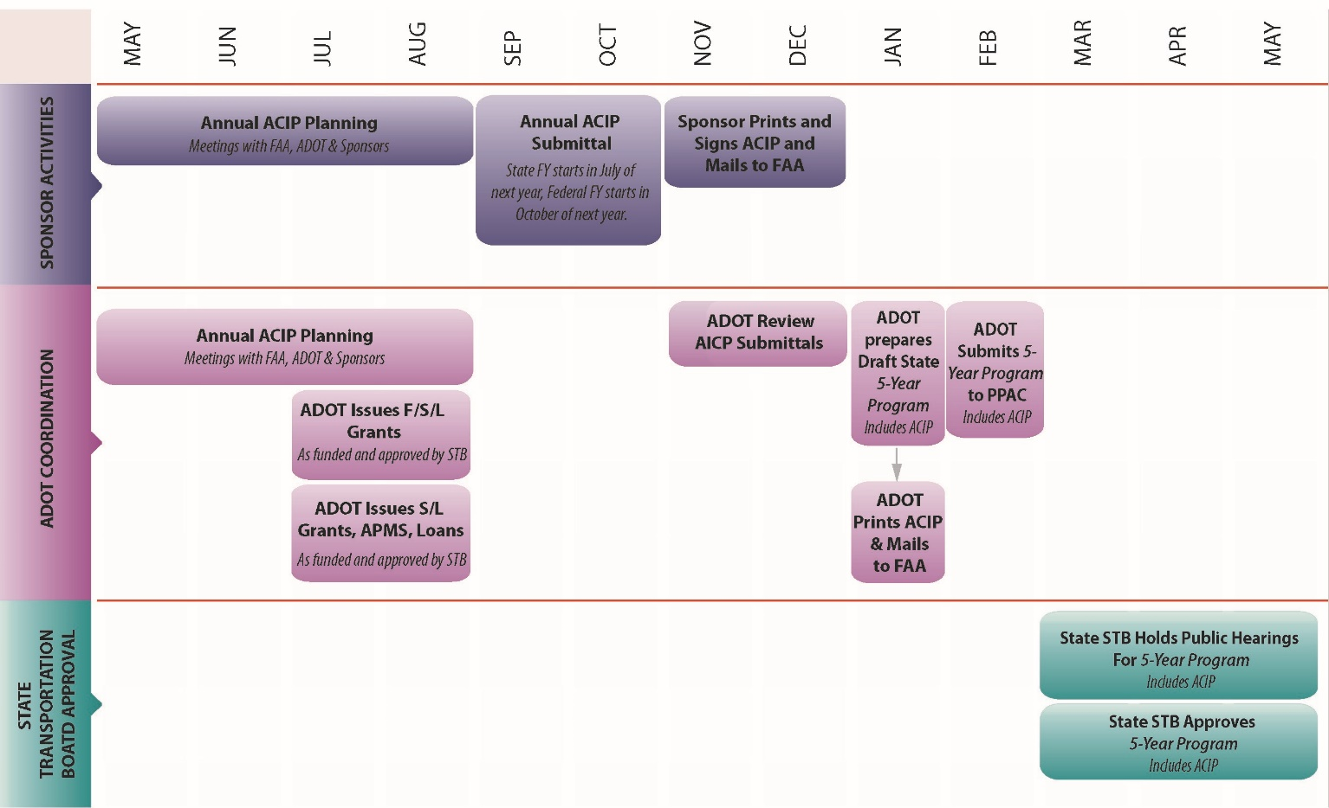

Table 16-3 | Categorization of Arizona Airports
Category | # of Airports | Use | Example Airport
Commercial Service Airports | 9 | Primary | Phoenix Sky Harbor
Reliever Airports | 8 | Congestion Relief | Ryan Field
GA Community Airports | 32 | Regional Connector | Holbrook Municipal Airport
GA Rural Airports | 23 | Small business-recreational-personal | Sun Valley San Manuel Airport
GA Basic Airports | 11 | Recreational-personal | Tombstone Municipal Airport

Commercial Service Airports
These are publicly owned airports that enplane 2,500 or more passengers annually and receive scheduled passenger air service. In the 2009 SASP, Arizona had 12 commercial service airports. The current FAA NPIAS show Arizona with only nine.
FAA categorizes all commercial service airports by their number of annual enplanements. The nation’s busiest airports are considered large hubs. Arizona has one large hub, which is Phoenix Sky Harbor International Airport. The second tier of commercial service airports consists of medium hubs, which is Tucson International Airport. The third tier of commercial service airports consists of small hubs, which is Phoenix-Mesa Gateway Airport. Arizona’s other 6 commercial service airports are classified as non-hubs.
Reliever Airports
These are FAA-designated airports that relieve congestion at a commercial service airport. Arizona currently has eight reliever airports (e.g., Ryan Field in Tucson or Glendale Municipal).
Military Airport Boundary Maps are available online at:

https://azre.gov/military-airports
General Aviation (GA) Community Airports
These Airports serve regional economies, connecting to state and national economies, and serve all types of general aviation aircraft. Arizona currently has 32 GA community airports (e.g., Holbrook Municipal Airport or Sierra Vista).
GA Rural Airports
These are Airports that serve a supplemental role in local economies, primarily serving small business, recreational, and personal flying. Arizona currently has 23 GA rural airports (e.g., San Manuel Airport).
GA Basic Airports
These Airports serve a limited role in the local economy, primarily serving recreational, personal flying or serving emergency flight support. Arizona currently has 11 GA basic airports (e.g., Tombstone Municipal Airport or Superior Municipal).
Military Airports
There are five Military aviation facilities in Arizona: Luke Air Force Base (AFB); Davis-Monthan AFB; Ft. Huachuca/Libby Army Airfield; Yuma Marine Corp Air Station; and, Yuma Proving Grounds/Laguna Army Airfield. All are major employment centers that infuse a substantial amount of federal payroll money into the surrounding local economy. For example, as of 2012, Davis-Monthan AFB near Tucson had approximately 6,000 military and reserve personnel and 1,700 civilian employees, whereas the corresponding numbers for Luke AFB (in Litchfield Park, west of Phoenix) were 7,000 and 1,500. Also, MCAS Yuma and Libby Army Airfield play a vital role in each community’s civilian airport services. Each is a joint use facility where civilian aviation activity occurs with the military activity. These major employment centers are well integrated into the land use and transportation models maintained by PAG and MAG. Similarly, military aviation facilities elsewhere in Arizona have population and employment impacts that are appropriately addressed through regional land use and transportation plans.
Pursuant to state law, the Arizona Department of Real Estate makes maps of areas affected by military aviation activities available online. The Arizona disclosure requirements apply to property that is within “territory in the vicinity of a military airport” or “territory in the vicinity of an ancillary military facility” as defined in A.R.S. § 28-8461, or under a “military training route” as delineated in the military training route map prepared pursuant to Section 37-102.
- Military airport maps (Luke AFB; Davis-Monthan AFB; Fort Huachuca—Libby Airfield; Yuma Marine Corps Air Station; Yuma Proving Grounds—Laguna Army Airfield)
- Military electronic range maps
- Auxiliary airfield maps
- Restricted airspace maps
- Military training route maps
The airspace impacts of military aviation facilities are already taken into account in the flight patterns used by surrounding civilian airports in affected areas. The FAA is the agency responsible for the planning and management of airspace.
Given the trend of defense budget cutting in 2012, there is little likelihood that any new Air Force bases will be added in the United States in the foreseeable future. Instead, states across the nation are working hard to keep their bases from being downsized or closed. One key to sustainability for Air Force bases is ensuring that local development does not interfere with the ability of the base to continue and/or expand its operations.
When an Air Force base does close, historic land use and airspace use may offer opportunities for redevelopment of that facility as a civilian airport. The FAA’s Military Airport Program (MAP) provides federal funds to convert former military airports to civilian use and supports joint-use airports. The 2012 Reauthorization Act increased the number of general airports that could participate in the program from one to three.
Tribal & Private Airports
As part of the 2008 SASP, a detailed review of airports located on Native American tribal lands was conducted. Arizona is home to 22 federally recognized Native American tribes (ADOT 2012). Tribal property and reservations occupy over 25 percent of Arizona’s land. A review of FAA data by the ADOT – MPD - Aeronautics Group Division found that there are 24 airfields on tribal land. Through further research, it was determined that only 14 of those airports were open and available for public use. They are part of the overall system and they are reflected in the SASP. Tribal airports not included in the SASP include those that are not open for public use. Some of these are used primarily for transport of physicians and patients for medical purposes in remote rural areas.
Arizona law (A.R.S. § 28-8202) specifies that monies from the State Aviation fund may be distributed to publicly owned and operated airport facilities “in which one or more agencies, departments or instrumentalities of this state or a city, town or county of this state holds an interest in the land on which the airport is located.” This law was recently revised to include tribal airports in the definition of “publicly owned and operated.” This revision will become effective on September 13, 2013. ADOT is now developing training and guidance for theses tribal airports. Tribal airports that are included in the SASP and the NPIAS may receive FAA and/or State project funding, and these projects are included in the ADOT Airport Capital Improvement Program.

16.5.5 | Regional Aviation System Plans
Section 16.4.3 above, “FAA Planning Process,” includes a discussion about Regional Aviation System Plans (RASPs) and other special planning studies. As noted, RASPs have been prepared in Arizona for the Phoenix metropolitan area and the Tucson metropolitan area, with extensive involvement by these areas’ respective MPOs, the MAG and PAG RASPs are prepared occasionally, on an as-needed basis, as advisory input to complement the ongoing SASP process. RASPs are not prepared or updated on a fixed, periodic basis.
Intermodal Connectivity
Land Use (including consideration of noise impacts)
Air Quality
Homeland Security

KEY DOCUMENTS
The checklist below shows the four primary aviation elements MPOs and COGs need to take into account for planning activities.

16.6 | REGIONAL PLANNING ISSUES
This section discusses the aviation activities MPOs and COGs need to take into account in their planning processes.

16.6.1 | Intermodal Connectivity
Federal laws and regulation pertaining to metropolitan transportation planning stress the need for surface transportation facilities (roads and transit services) to accommodate movement of people and goods by other transportation modes, which includes air transportation. For example, 23 C.F.R. § 450.306(a), which describes the scope of the metropolitan planning process, states, “The metropolitan transportation planning process shall be continuous, cooperative, and comprehensive, and provide for consideration and implementation of projects, strategies, and services that will address the following factors: … (6) Enhance the integration and connectivity of the transportation system, across and between modes, for people and freight.” Therefore, it is important for regional transportation plans to provide adequate capacity and access to serve airport facilities.

16.6.2 | Land Use
MPOs do not mandate land use types or zoning, which is the responsibility of cities, towns, or counties (in unincorporated areas). Land uses and zoning influence the amount of population and employment that exists or is planned in a given area, which in turn affects transportation needs. Airport operations result in noise impacts that may be incompatible with certain land use types. Another aviation consideration that affects land use outside of airport property boundaries is the need to have airspace that is clear of obstructions where aircraft take off and land. Maps depicting areas with aircraft-related noise and crash potential are available as discussed below.
For the benefit of those who would consider purchasing property in the vicinity of an airport, Arizona law directs the Arizona Department of Real Estate to make available maps of the areas that are considered to be affected by aviation-related noise. As of January 2013, the department’s website offers maps of 54 public airports. Similar requirements apply to land affected by military aviation activities. These are discussed below in Section 16.7, “Military Airports.”
A.R.S. § 28-8486 states that “territory in the vicinity of a public airport” means property that is within the traffic pattern airspace as defined by the FAA and includes property that experiences a day-night average sound level as follows:
- In counties with a population of more than five hundred thousand persons, sixty decibels or higher at airports where such an average sound level has been identified in either the airport master plan for the twenty-year planning period or in a noise study prepared in accordance with airport noise compatibility planning, 14 Code of Federal Regulations part 150.
- In counties with a population of five hundred thousand persons or less, sixty-five decibels or higher at airports where such an average sound level has been identified in the airport master plan for the twenty-year planning period.

16.6.3 | Air Quality
Airports generate amounts of air pollution that can affect regional air quality. Air pollutants generated by aviation are taken into account in emission inventories that are used in preparation of regional air quality plans. For example, the Maricopa County 2005 Periodic Ozone Emission Inventory estimated that more than 1,600 tons of ozone-causing volatile organic compounds (VOC) are emitted annually by the use of aircraft, airport ground support equipment, and aircraft-related solvents. Slightly more than 12,500 tons of carbon monoxide (CO) was emitted from aircraft and airport ground equipment. Dividing by 365 days per year yields average daily emissions of about four tons of VOC and over 34 tons of CO per day in this region. About half of these airport-related emissions were generated at the two largest sources, Phoenix Sky Harbor International and Luke Air Force Base, with the remaining half coming from 12 other airports in the county. Although these emissions contributed only 1 percent or less of the respective total emissions from all sources in the region, nevertheless they must be taken into account in air quality plans. Other areas in Arizona have less population, less aviation activity, and less air pollution.

16.6.4 | Homeland Security
Because major airports contribute to our nation’s economic vitality, they are one of many types of public and private infrastructure that could potentially be targeted for disruption or destruction by terrorists. “Transportation Systems,” encompassing all transportation modes including airports, is 1 of the 18 Critical Infrastructure and Key Resources (CIKR) sectors that are addressed in America’s National Infrastructure Protection Plan (NIPP), maintained by the U.S. Department of Homeland Security (DHS). DHS partners directly with USDOT to identify transportation-related infrastructure protection needs.
Security is a performance measure relevant to identification of airport improvement needs in the SASP. Most infrastructure protection projects occur within airport boundaries and can be addressed within the framework of AMPs or related processes. Accordingly, MPOs and COGs ordinarily have little or no involvement in planning infrastructure protection improvements for airports. However, they may be invited to participate with federal agencies in various homeland security planning efforts from time to time, as needed.

17 | SUPPORTING PROGRAMS
TABLE OF CONTENTS
17.1| AIR QUALITY (TABLE OF CONTENTS)
17.2| CONGESTION MANAGEMENT PROCESS (TABLE OF CONTENTS)
17.3| TRANSPORTATION DATA & FUNCTIONAL CLASS (TABLE OF CONTENTS)
17.4| TECHNOLOGY APPLICATIONS FOR PLANNING: MODELING AND GIS (TABLE OF CONTENTS)
17.5| SAFETY (TABLE OF CONTENTS)
17.6| TRIBAL PLANNING (TABLE OF CONTENTS)
17.7| BORDER PLANNING (TABLE OF CONTENTS)
17.8| PUBLIC PRIVATE PARTNERSHIPS (TABLE OF CONTENTS)
17.9| PLANNING & ENVIRONMENTAL LINKAGES (TABLE OF CONTENTS)
17.10| STATE LAND DEPARTMENT PLANNING (TABLE OF CONTENTS)
17.11| SUSTAINABILITY (TABLE OF CONTENTS)
17.12| BICYCLE & PEDESTRIAN PLANNING (TABLE OF CONTENTS)

| Supporting Programs

17 | PURPOSE
Chapter 17 is a compilation of supporting programs that are introduced in other chapters of this document.
17.1 | AIR QUALITY
TABLE OF CONTENTS
17.1.1 | Purpose
17.1.2 | Transportation Conformity
State Implementation Plan
17.1.3 | Conformity Process
Transportation Plans & TIPs
Project-Level Conformity
Transportation Control Measures
Interagency & Public Consultation

17.1 | Air Quality
ADOT has identified the need to organize, update, and streamline current transportation air quality conformity procedures into a comprehensive guidebook. ADOT’s Complete Air Quality Guidebook:

https://azdot.gov/business/environmental-planning/air-quality/guidance-air-quality

17.1.1 | Purpose
When an MPO or COG is within or part of a designated air quality nonattainment or maintenance area, additional steps must be taken to protect and improve air quality. Transportation plans, programs, and projects must conform to the relevant air quality plan, which is the SIP approved by the EPA. The Clean Air Act requires state and local agencies to install and operate air quality monitoring equipment to determine if the National Ambient Air Quality Standards (NAAQS) are being met. An analysis referred to as “transportation conformity” requires an analysis to demonstrate that a transportation plan meets emission limits of the SIP.
Pursuant to the Clean Air Act Amendments (CAAA) of 1990, the EPA established NAAQS. These standards may change over time. For example, the 8-hour standard for ozone was set in 2008, and in 2010 the EPA issued a proposed rule to tighten those standards. In 2015, the EPA revised the ozone standard to 0.070 ppm. Current NAAQS are shown in table 17.1-1.

Table 17.1-1 | National Ambient Air Quality Standards (NAAQS)
Pollutant  [Final Rule Citation] |  | Primary / Secondary | Averaging Time | Level (Concentration) | Form
Carbon Monoxide (CO)  76 FR 54294, Aug 31, 2011 |  | Primary | 8-Hour | 9 ppm | Not to be exceeded more than once per year
 |  | Secondary | 1-hour | 35 ppm
Lead  73 FR 66964, Nov 12, 2008 |  | Primary & Secondary | Rolling 3 month average | .15 μg/m³ | Not to be exceeded
Nitrogen Dioxide (NOx)  75 FR 6474, Feb 9, 2010 |  | Primary | 1-Hour | 100 ppb | 98th percentile, average over 3 years
 |  | Primary & Secondary | Annual | 53 ppb | Annual mean
Ozone  80 FR 65292, Oct 26, 2015 |  | Primary & Secondary | 8-Hour | 0.070 ppm | Annual fourth-highest daily maximum 8-hr concentration averaged over 3 years
Particle Pollution  78 FR 3086, Jan 15, 2013 | PM2.5 | Primary | Annual | 12 μg/m³ | Annual mean, averaged over 3 years
 |  | Secondary | Annual | 15 μg/m³ | Annual mean, averaged over 3 years
 |  | Primary & Secondary | 24-Hour | 35 μg/m³ | 98th percentile, averaged over 3 years
 | PM10 | Primary & Secondary | 24-Hour | 150 μg/m³ | Not to be exceeded more than once per year on average over 3 years
Sulfur Dioxide  75 FR 35520, Jun 22, 2010 |  | Primary | 1-Hour | 75 ppb | 99th percentile of 1-hour daily maximum concentrations, averaged over 3 years
 |  | Secondary | 3-Hour | 0.5 ppm | Not to be exceeded more than once per year
* ppm means parts per million; ppb means parts per billion; µg/m³means micrograms per cubic meter.
Source: Data from EPA 2020. https://www.epa.gov/environmental-topics/air-topics

County | Pollutant | Location | Status & Severity
Cochise | PM10 | Paul Spur / Douglas | Nonattainment, moderate
 | Sulfur dioxide | Douglas | Maintenance, primary
Gila | PM10 | Miami | Nonattainment, moderate
 | PM10 | Payson | Maintenance
 | Sulfur dioxide | Miami | Maintenance, primary
Greenlee | Sulfur dioxide | Morenci | Maintenance, primary
Maricopa | Carbon monoxide | Phoenix-Mesa | Maintenance
 | Ozone, 1 hr | Phoenix-Mesa | Maintenance
 | Ozone, 8 hr | Phoenix-Mesa | Nonattainment, marginal
 | PM10 | Phoenix-Mesa | Nonattainment, serious
Mojave | PM10 | Bullhead City | Maintenance
Pima | PM10 | Ajo | Maintenance
 | PM10 | Rillito | Nonattainment, moderate
Pinal | Carbon monoxide | Phoenix-Mesa | Maintenance
 | Lead | Hayden | Nonattainment
 | Ozone, 8 hr | Phoenix-Mesa | Nonattainment, marginal
 | PM10 | Phoenix-Mesa | Nonattainment, serious
 | PM10 | West Pinal | Nonattainment, serious
 | PM10 | Hayden | Nonattainment, moderate
 | PM2.5 (2006) | West Central Pinal | Nonattainment
 | Sulfur dioxide | Hayden | Nonattainment, primary
Santa Cruz | PM10 | Nogales | Nonattainment, marginal
 | PM2.5 (2006) | Nogales | Nonattainment
Yuma | Ozone, 8hr | Yuma | Nonattainment, marginal
 | PM10 | Yuma | Nonattainment, moderate
Federal and state air quality monitoring equipment in operation in or near a majority of the nation’s most populated areas provide the quality-controlled data used to determine whether or not the NAAQS are being met. Areas that exceed these standards are designated as “nonattainment areas.” Areas once designated as nonattainment areas that later meet compliance requirements are designated as maintenance areas.
Table 17.1-2 lists the areas in Arizona that currently are classified either as nonattainment or maintenance areas for various pollutants. Transportation-related pollutants include PM10, PM2.5, carbon monoxide, ozone, and nitrogen oxide. Nonattainment area boundaries are proposed by ADEQ and approved by the EPA.

17.1.2 | Transportation Conformity
Transportation conformity is a requirement of Section 176(c) of the CAA (42 U.S.C. § 7506(c)) requirement that connects air quality and transportation planning activities. The goal of transportation conformity is to ensure that FHWA and FTA funding and approvals are given to highway and transit activities that are consistent with air quality goals. Conformity means that transportation activities do not cause new air quality violations, worsen existing violations, or delay timely attainment of the NAAQS. The EPA and USDOT have established conformity requirements that states and MPOs are required to meet.
The FHWA Transportation Conformity Reference Guide can be found at:

https://www.fhwa.dot.gov/environment//air_quality/conformity/con_broc.pdf
For further policy & guidance information follow:

https://www.fhwa.dot.gov/environment/air_quality/conformity/policy_and_guidance/

Table 17.1-2 | Arizona Air Quality Nonattainment and Maintenance Areas
Note: As of August 7, 2020
Source: Data from MPD, ADOT Air Quality Management Guidebook
Conformity requirements were first mandated in the 1990 CAAA and have been revised multiple times over the past two decades.
Transportation conformity applies to all areas that are in nonattainment or maintenance for particulate matter (PM10 and PM2.5), ozone, carbon monoxide, and nitrogen oxide. In nonattainment and maintenance areas, conformity determination is required for RTPs, regional TIPS, MTIPs, and projects that receive FHWA or FTA funding or approval. Table 17.1-2 provides a list of the nonattainment and maintenance areas in Arizona. The table includes references to a 1-hour ozone standard that was superseded in 2008, as well as referencing sulfur dioxide areas that are not subject to transportation conformity.
State Implementation Plan
A SIP defines how a state plans to attain and/or maintain the NAAQS. The SIP is developed through a public process, formally adopted by the state, and submitted to the EPA for review and approval. A SIP typically includes state-adopted control measures and comprehensive air quality plans, such as attainment plans, maintenance plans, and transportation control plans. SIP elements often focus on sources of pollution other than transportation, such as point and area sources (e.g., power plants, industrial plants, etc.), over which transportation agencies have no jurisdiction or expertise. The ADEQ is the state agency responsible for regulating all emission sources throughout Arizona. County air pollution agencies also have a substantial role in developing rules and regulations for the SIP and have been delegated authority to regulate certain emission sources.
ADOT Environmental Services & Planning, Air Quality Planning Section can be found at:

https://azdot.gov/business/environmental-planning/air-quality
The ADOT MPD Air Quality Team is responsible for developing transportation-related portions of SIPs for nonattainment and maintenance areas outside of MPO jurisdiction. In nonattainment and maintenance areas, SIPs include an emissions inventory for mobile sources that establishes an emissions budget and contains specific Transportation Control Measures (TCMs) to be implemented to meet NAAQS.
Guidance for Developing Transportation Conformity State Implementation Plans (SIPs) can be found at:

https://www.epa.gov/state-and-local-transportation

17.1.3 | Conformity Process
Transportation Plans & TIPs
MPOs are responsible for evaluating the conformity of RTPs and TIPs. Conformity evaluation of these plans is required in nonattainment and maintenance areas:
- at least every four years;
- 24 months after certain SIP actions;
- within 12 months after new nonattainment designation becomes effective; and
- prior to acceptance of a new or updated RTP, TIP, and certain plan and TIP amendments.
Conformity determinations are approved by the FHWA and/or the FTA. MPOs make initial conformity determinations for plans and programs in metropolitan areas, whereas ADOT leads conformity determination for areas outside of MPO jurisdiction. When a conformity determination is not made according to schedule, areas have a one-year grace period to make the determination before there is a conformity lapse and the use of federal-aid funds is restricted. Such restrictions typically target projects that would provide additional roadway capacity usable by single-occupancy (or occupant) vehicle (SOV).
In the transportation conformity evaluation, emissions associated with the RTP and TIP are estimated. Emissions estimates are made using the latest emissions model adopted by the EPA and are based on the latest planning assumptions (population, employment, land use, mode split, etc.) for the region. For pollutant emissions, the EPA’s Motor Vehicle Emission Simulator (MOVES) is the approved model for estimating current and future emissions from motor vehicles (EPA 2014b). Network-based travel demand model (TDMs) may be used to generate estimates of traffic volumes associated with each plan. Estimated regional emissions are compared with the emissions budget defined in the regions SIP. Under some circumstances, the resulting MOVES emission forecasts are then used as inputs for other models that predict localized concentrations of pollution in the air.
EPA,
Transportation Conformity Regulations

MPOs and COGs not in nonattainment and maintenance areas must at a minimum ensure that RTPs and TIPs are in conformity with the Clean Air Act.
Project-Level Conformity
In addition to regional conformity determinations, project-level conformity determinations are required in CO, PM2.5 and PM10 nonattainment and maintenance areas (40 C.F.R. § 93.109 (d)). For regionally significant nonfederal projects, the implementing agency is also responsible for meeting applicable conformity and emissions analysis criteria required under federal regulations. ADOT will assist agencies in project-level conformity analyses for both federal and nonfederal projects by performing regional emissions analyses as appropriate. To demonstrate project-level conformity must have:
ADOT’s Air Quality Processes Guidance
- Come from a conforming STIP or MPO TIP.
- No significant changes to the project’s design concept and scope from that in the STIP or MPO planning documents.
- An analysis that used the latest planning assumptions and the latest emissions model.
- In PM2.5/PM10 areas, there must be a demonstration of compliance with any control measures in the SIP.
Additional analysis may be necessary to determine if a project has localized air quality impacts. This localized air analysis is referred to as a “hot-spot” analysis. A hot-spot analysis is defined as an estimation of likely future localized CO, PM10, and/or PM2.5 pollutant concentrations and a comparison of those concentrations to the NAAQS. A hot-spot analysis assesses impacts on a scale smaller than the entire nonattainment or maintenance area including, congested roadway intersections and highways or transit terminals, and uses an air quality dispersion model to determine the effects of emissions on air quality (40 C.F.R. § 93.101).
Note that there are three groups of transportation projects that are exempt from conformity:
- Projects designated under the categories of safety, mass transit, air quality, and other, as listed in Table 17.1-3 are exempt from all conformity requirements.
- Intersection channelization and interchange reconfiguration projects are exempt from regional emissions analysis.
- Traffic signal synchronization projects do not require project level conformity however do need to be included in the regional emissions analysis required for an RTP or TIP.

Table 17.1-3 | Projects Exempt from Conformity Evaluation
Projects
Safety | Railroad/highway crossing
 | Projects that correct, improve, or eliminate a hazardous location or feature
 | Safer non-federal-aid system roads
 | Shoulder improvements
 | Increasing sight distance
 | Highway Safety Improvement Program implementation
 | Traffic control devices and operating assistance other than signalization projects
 | Railroad/highway crossing warning devices
 | Guardrails, median barriers, crash cushions
 | Pavement resurfacing and/or rehabilitation
 | Pavement marking
 | Emergency relief (23 U.S.C. 125)
 | Fencing
 | Skid treatments
 | Safety roadside rest areas
 | Adding medians
 | Truck climbing lanes outside the urbanized area
 | Lighting improvements
 | Widening narrow pavements or reconstructing bridges (no additional travel lanes)
 | Emergency truck pullovers
Transit | Operating assistance to transit agencies
 | Purchase of support vehicles
 | Rehabilitation of transit vehicles 1
 | Purchase of office, shop, and operating equipment for existing facilities
 | Purchase of operating equipment for vehicles (e.g., radios, fareboxes, lifts, etc.)
 | Construction or renovation of power, signal, and communications systems
 | Construction of small passenger shelters and information kiosks
 | Reconstruction or renovation of transit buildings or structures (e.g., rail or bus buildings, storage and maintenance facilities, stations, terminals, and ancillary structures)
 | Rehabilitation or reconstruction of track structures, track, and trackbed in existing right-of-way
 | Purchase of new buses and rail cars to replace existing vehicles or for minor expansions of the fleet 1
 | Construction of new bus or rail storage/maintenance facilities categorically excluded in 23 C.F.R. part 771

Table 17.1-4 | Projects Exempt from Conformity Evaluation (continued)
Projects
Air Q. | Continuation of ride-sharing and van-pooling promotion activities at current levels
 | Bicycles and pedestrian facilities
Other | Specific activities which do not involve or lead directly to construction as planning and technical studies. Grants for training and research programs. Planning activities conducted pursuant to titles 23 and 49 U.S.C. Federal-aid system revisions
 | Engineering to assess social, economic, and environmental effects of the proposed action or alternative to that action
 | Noise attenuation
 | Emergency or hardship advance land acquisitions (23 C.F.R. 710.503 )
 | Acquisition of scenic easements
 | Plantings landscaping, etc.
 | Sign removal
 | Directional and informational signs
 | Transportation enhancement activities (except rehabilitation and operation of historic transportation buildings, structures, or facilities)
 | Repair of damage caused by natural disasters, civil unrest, or terrorist acts, except projects involving substantial function, location, or capacity changes
Source: EPA Transportation Conformity Regulations, Part 93-126
ªIn PM10 nonattainment or maintenance areas, such projects are exempt only if they are in compliance with control measures in the applicable implementation plan
Transportation Control Measures: An Information Document for Developing and Implementing Emissions Reductions Programs can be found at:

https://www.epa.gov/state-and-local-transportation
Transportation Control Measures
Under the Transportation Conformity Rule, TCMs are strategies that are specifically identified and committed to in SIPs, and are either listed in Section 108(f) of the CAA or will reduce transportation-related emissions by reducing vehicle use or improving traffic flow.
Timely implementation of TCM’s criterion must be satisfied before conformity determinations can be made. CAA section 176(c)(2)(B) and section 40 C.F.R. § 93.113 of the transportation conformity rule require that TCMs in an approved SIP that are eligible for federal funding under title 23 U.S.C. or under the Federal Transit Laws (Title 49 U.S.C.) must be implemented on the schedule established in the SIP. If a TCM falls behind schedule and the area still intends to implement it, the MPO must demonstrate that past obstacles to implementation have been identified and have been overcome and that state and local agencies with funding authority are giving the delayed TCM maximum priority, according to 40 C.F.R. § 93.113(c)(1).
Further CMAQ and TCM Resources on ADOT’s website

https://azdot.gov/business/environmental-planning/air-quality/congestion-mitigation-air-quality-transportation-control
Many other measures, similar to the TCMs listed in the CAA, are being used throughout the country to manage traffic congestion on streets and highways, to reduce vehicle emissions, and to reduce fugitive dust emissions. Increasingly these control measures are being recognized for their benefits toward improving an area’s livability. These type of activities may also be eligible for CMAQ funding (see chapter 10), whether or not they are in approved SIPs, if they are documented to have emission reduction benefits in nonattainment and maintenance areas. Examples of Arizona specific TCMs and CMAQ funded projects can be found on ADOT’s Air Quality Planning website.
Interagency & Public Consultation
A formal interagency consultation process is required in nonattainment and maintenance areas to address technical and procedural issues related to air quality planning. Public consultation includes a proactive public involvement process with access to technical and policy information and opportunities for review and comment. These activities are required to be consistent with the public involvement conducted under the FHWA and FTA’s transportation planning regulations.
Transportation conformity regulations (40 C.F.R. § 93.105) require interagency consultation and outline general factors, specific procedures, resolution of conflicts, and public consultation procedures. Further, the regulations require the development of a state implementation plan (40 C.F.R. § 51.390) which must include procedures to be undertaken before making conformity determinations or developing implementation plans. Agencies involved should include MPOs, state departments of transportation, and FHWA / FTA, state and local air quality agencies, and EPA. Table 17.1-4 describes the General and Specific Interagency Consultation Requirements.
Interagency consultation procedures for a nonattainment or maintenance area are formally integrated into the Conformity SIP, and are legally enforceable. A state’s Conformity SIP or the federal regulations (40 C.F.R. § 93.105) govern the decision-making process and specifically require that a process be established to evaluate and choose a model, associated methods, and any assumptions that will be used in the regional emissions analysis.

Table 17.1-5 | General and Specific Interagency Consultation Requirements
Federal Conformity Rule General & Specific Interagency Consultation Requirements
General | Specific
- Agency roles and responsibilities for each stage of the planning process  - The organizational level for regular consultation  - A process for circulating documents  - Frequency of and process for convening meetings  - A process for responding to comments of involved agencies  - A process for the development of TCMs | - Evaluating and choosing a model and associated methods and assumptions for regional and project-level analyses  - Determining which minor arterials and other transportation projects should be considered “regionally significant”  - Evaluating whether projects otherwise exempt should be treated as non-exempt  - Reevaluating TCMs with respect to delays  - Evaluating conformity triggers  - A process for providing final documents

17.2 | CONGESTION MANAGEMENT PROCESS
TABLE OF CONTENTS
17.2.1 | Introduction
17.2.2 | CMP & Metropolitan Planning Process
CMP Development Process
Step 1: Develop Regional Objectives for Congestion Management
Step 2: Define the CMP Network
Step 3: Develop Multimodal Performance Measures
Step 4: Data Collection & Monitoring System Performance
Step 5: Analyze Congestion Problems & Needs
Step 6: Identify & Assess CMP Strategies
Step 7: Program & Implement CMP Strategies
Step 8: Monitor Strategy Effectiveness
17.2.3 | CMP within the Regional Transportation Planning Process
Relationship to the RTP
Relationship to Air Quality Attainment/Nonattainment
Role of Demand Management, ITS/ Management, & Operations Strategies
Linkage to NEPA & the Project Development Process
17.2.4 | Documentation of the CMP
17.2.5 | Legislative Language

17.2 | Congestion Management Process

17.2.1 | Introduction
Congestion Management Process (CMP) is a federally mandated program to help large urban areas analyze and better manage traffic congestion. It applies only to TMAs, as described in section 1.6. TMAs, which have a contiguous urban population of more than 200,000 people, are the areas most likely to experience significant traffic congestion. However, smaller areas may benefit from some of the techniques and process that are part of the CMP. Currently, in Arizona only MAG and PAG are designated as TMAs.
Federal congestion management requirements were first mandated beginning in the early 1990s, along with a number of other management systems. Although originally referred to as a congestion management “system,” more recent federal legislation has renamed it a “process” to better reflect the ongoing nature of the planning requirement. The most recent federal transportation bill, FAST Act, left the CMP requirements unchanged.
The purpose of the CMP is to provide for effective management and operation of the existing transportation system and identify areas where improvements are most needed. It is intended to provide an enhanced linkage to both the planning process and the environmental review process that is based on cooperatively developed travel demand reduction and operational management strategies and capacity increases. It retains the traditional role of the MPO in long-range transportation planning, but it also empowers the MPO and its partners in planning for the ongoing operations and management of the transportation system. This requires enhanced collaboration between the MPOs, ADOT, and local governments.
For complete information on the CMP follow:

https://www.fhwa.dot.gov/planning/congestion_management_process/
This section briefly explains the requirements of the federal CMP and provides resources for additional information.

Table 17.2-1 | CMP Clarification
A CMP is NOT
- A massive data collection effort.
- A database management system.
- A separate or parallel process to the established planning process.
- A system to eliminate all congestion.
- A system to prevent capacity expansion projects from being implemented.
- A detailed operations plan. (FDOT 1994)

17.2.2 | CMP & Metropolitan Planning Process
CMP Development Process
It is important to avoid misconceptions about what the CMP is and is not. Table 17.2-1 shows what a CMP is not.
The complete CMP 8 step process can also be found at:

https://www.fhwa.dot.gov/planning/congestion_management_process/cmp_guidebook/cmpguidebk.pdf
The CMP consists of the following eight steps as defined in the FHWA’s CMP guidebook (FHWA 2011, 8). Many of these steps include acquiring information that has been developed, at least in part, for other purposes in regional transportation planning, so that the resource requirements are modest; in other words, not all the information needs to be produced from scratch but instead can be repurposed for the CMP.
- Develop regional objectives for congestion management.
- Define CMP network.
- Develop multimodal performance measures.
- Data collection/monitoring system performance.
- Analyze congestion problems and needs.
- Identify and assess strategies.
- Program and implement strategies.
- Evaluate strategy effectiveness.
Step 1: Develop Regional Objectives for Congestion Management
This is the starting point for development of the CMP. Usually these objectives can be adapted easily from the goals and objectives in the RTP or RTP. In some cases, MPOs develop objectives specifically for the CMP. The FHWA guidebook suggests that these objectives be specific, measurable, agreed upon by stakeholders, realistic, and time-bound (the so-called SMART characteristics). (FHWA 2011, 11)
Step 2: Define the CMP Network
The CMP network involves both the geographic boundaries and the system components/network of surface transportation facilities. The MPO TDM is usually a starting point for this process. The rules for determining the network itself are fairly flexible and often include functional classification, traffic volumes, high demand/congested corridors, routes that serve important transit or goods movement functions, access to major transportation terminals (such as airports), and professional judgment. The CPM network should include transit networks, especially when they play a significant role in a corridor, as well as routes that serve a large volume of through trucks and freight/warehousing facilities. Likewise, bicycle and pedestrian networks should be included when they play a regional role.
Step 3: Develop Multimodal Performance Measures
There are a wide range of measures that can be considered for use in the CMP. These have been described in other publications (e.g., FHWA 2011, 15–26), but generally should relate to the intensity, duration, extent, and variability of congestion. In many cases, the MPO may want to use measures that it has developed for other planning and operations purposes.
Step 4: Data Collection & Monitoring System Performance
- Once again, MPOs already collect considerable amounts of information that can be used for CMP purposes, including the following data:
- Traffic volume counts;
- Speed and travel time data;
- Archived Intelligent Transportation System (ITS) and operations data;
- Other electronic datasets (some available from private vendors);
- Aerial photography-based congestion data;
- Transit data (on/off, load factor, transit pass sales, etc.);
- Bicycle/pedestrian usage data;
- Safety data (crash records); and
- Travel survey data.
While data collection for the purposes of the CMP is not a massive effort, this part of the CMP is often the most resource consuming portion of the work, but it also has the highest benefit and provides information that can be used in other planning and operational analyses of facilities in the MPO region. The data collected should, of course, relate to the performance measures chosen in Step 3. The ADOT Multimodal Planning Division can provide available data related to state highways.
Step 5: Analyze Congestion Problems & Needs
The purpose of this step is to identify specific locations with congestion problems, identify the sources of the problems, and facilitate the development of remedial strategies in step 6. There are several issues that MPOs should take into account when analyzing data for the purpose of defining or locating congestion problems, including:
- locations of major trip generators;
- seasonal traffic variations;
- time-of-day traffic variations; and
- work (commute) vs. non-work trips.
This step should create three products:
- an identification of the areas or corridors defined as congested based on the performance measures;
- A ranking of corridors throughout the region from most to least congested; and
- an analysis of how well the region is meeting its congestion management objectives.
Step 6: Identify & Assess CMP Strategies
- The identification and assessment of appropriate congestion mitigation strategies is a key component of the CMP. There are several important considerations that facilitate the selection of strategies in step 7:
- the strategy’s contribution toward meeting regional congestion management objectives;
- local context;
- contribution to other goals and objectives; and
- jurisdiction over CMP strategies.
Although the number of strategies is too numerous to mention here (see FHWA 2011a, 33–36), many are probably already part of the MTP and RTIP. There is considerable flexibility and strategies can be tailored to each region’s specific needs.
Step7: Program & Implement CMP Strategies
Implementation of CMP strategies occurs at three levels: system/regional, corridor, and project. Regional-level implementation occurs through inclusion of strategies in the fiscally constrained MTP and TIP. At the corridor level, more specific detailed strategies, such as bicycle and pedestrian improvements and operational improvements, can be assessed in studies and implemented using several funding sources, including Surface Transportation Block Grant Program (STBGP), NHS, and CMAQ, as well as through state or local funding. For larger projects, particularly capacity-adding projects, demand management and operational strategies should also be analyzed for incorporation in the project as part of the project development process.
Step 8: Monitor Strategy Effectiveness
MPOs may choose to evaluate strategy effectiveness either as the final step of the CMP or as an ongoing activity. The lessons learned from evaluation should be used to inform the TIP and MTP as well as other steps within the CMP, especially the identification and assessment of strategies. Approaches may include before and after or with-and without- studies, or comparisons with control locations. In some cases, responsibility for these activities can be devolved to implementing agencies, such as local governments, that benefit from the strategy.

17.2.3 | CMP within the Regional Transportation Planning Process
Relationship to the RTP
The CMP fits under the RTP and in many cases can share information with the RTP update process. Like the RTP, the CMP requires a collaborative process among stakeholders, including MPO planners, ADOT staff, transit agencies, local governments, special districts, and the private sector.
Relationship to Air Quality Attainment/Nonattainment
In a TMA designated as a nonattainment area for ozone or CO pursuant to the CAA, there are two major requirements:
- Federal funds cannot be programmed for any project that will result in significant increases in the carrying capacity of single occupant vehicles (SOVs), except for safety improvements or the elimination of bottlenecks, unless the project is addressed through a process meeting the requirements of federal law (23 U.S.C. § 450.320).
- The CMP shall provide an appropriate analysis of reasonable (including multimodal) travel demand and reduction and operational management strategies for the corridor in which a project resulting in significant increase of capacity for SOVs is proposed to advance with federal funds. All identified reasonable travel demand reduction and operational management strategies shall be incorporated in the SOV project or committed to by the state and MPO for implementation. (23 U.S.C. § 450.320).
Role of Demand Management, ITS/ Management, & Operations Strategies
The CMP can play an important role in determining the effectiveness of demand management strategies by providing feedback as these strategies are deployed. Knowledge regarding current congestion problem areas can inform decisions about where ITS detection equipment (detector loops, closed-circuit television (CCTV), etc.) should be deployed. The ITS equipment, once installed, can provide ongoing information about the congestion in the region and provide some of the data required in the CMP process.
Linkage to NEPA & the Project Development Process
As part of the efforts to streamline and simplify the NEPA process, the CMP offers opportunities to link planning and NEPA. A CMP that is structured to focus on data, analysis, and performance measures supports the linkage between an environmental review and the CMP.
The FHWA provides more information online at:
https://www.environment.fhwa.dot.gov/nepa/nepa_projDev.aspx
Some ways the CMP can inform and reduce efforts in the NEPA process include:
- documenting the purpose and need for capacity enhancement;
- developing project alternatives to be studied in NEPA;
- collecting and analyzing before and after data; and
- providing part of the existing conditions documentation for the NEPA project.

17.2.4 | Documentation of the CMP
Documenting the results of the CMP provides important information to stakeholders, including the public. The CMP can be incorporated directly into the MTP, usually in a summary format. CMP information, including data, can be placed on the MPO’s website. Some MPOs produce annual or periodic reports with maps and charts for the public and decision makers. Others have developed detailed technical reports and guidebooks on congestion management for use in the MPO and with partnering agencies.
Useful visualization and communication tools can be found in FHWA’s Congestion Management Process: A Guidebook (2011a, 50–61).

17.2.5 | Legislative Language
A full copy of SAFETEALU, in PDF format, can be downloaded at:

https://www.govinfo.gov/content/pkg/PLAW-109publ59/pdf/PLAW-109publ59.pdf
Although the FAST Act is the most recent federal surface transportation act, a prior act, known as SAFETEA-LU, still contains current language regarding federal congestion management requirements. Title III Section 3005 and Title VI Section 600 mandate the incorporation of a CMP within the metropolitan planning process.

17.3 | TRANSPORTATION DATA & FUNCTIONAL CLASS
TABLE OF CONTENTS
17.3.1 | Purpose
17.3.2 | HPMS Traffic Data Collection and Reporting
17.3.3 | ADOT HPMS Traffic Data Collection Process
17.3.4 | Traffic Reporting Requirements Using the MS2 TCDS Module
17.3.5 | Functional Classification
17.3.6 | Changing Functional Classification

17.3 | Transportation Data and Functional Class

17.3.1 | Purpose
This section serves as a reference for understanding functional classification of roadways and the role functional classification and traffic volume play in planning and funding opportunities. It explains the role ADOT has with the FHWA and MPOs within the state of Arizona. The authority to collect transportation data and functional class is listed in table 17.3-1.

Table 17.3-1 | Authority
Federal | Code | Description
 |  | ISTEA of 1991
 |  | TEA-21 of 1998
 |  | SAFETEA-LU of 2005
 | 23 C.F.R. § 1.5 | Provides FHWA authority to request such information deemed necessary to administer the Federal-Aid Highway Program
 | 23 U.S.C. § 104 | Apportionment of Federal-Aid Highway Program funds
 | 23 C.F.R. § 420.105 | HPMS annual data submittal from State and field verification review and report (including traffic volume monthly automatic traffic recorder data and annual truck weight data)
 | 23 C.F.R. § 420.105(b) | Requires states to provide data that supports FHWA’s responsibilities to Congress and the public
 | 23 C.F.R. § 450.216 (m) | STIP includes financial plan to demonstrate adequate operations and maintenance of federal-aid highways
 | 23 C.F.R. § 460.3 | Certification of public road mileage
 | 23 C.F.R. § 500 | Program that supports: Traffic data collection-Traffic monitoring
 | 23 C.F.R. § 500.106 | Pavement Management System (PMS)
 | 23 C.F.R. § 924.5 (b) | HSIP project/program eligibility
 | 23 U.S.C. § 502(h) | Biennial conditions and performance estimate

17.3.2 | HPMS Traffic Data Collection and Reporting
As part of the COG and MPO GRTs, HPMS data collection is a critical element of the WP that is to be performed on an annual basis. HPMS data is integral to support the data-driven process within ADOT, FHWA, and Congress. This data is also very important for the COGs and MPOs as it can be an excellent resource for performance-based planning activities. The HPMS database includes information regarding the extent, condition, performance, use, and operating characteristics of the nation’s highways. HPMS is used extensively in the analysis of the highway system’s condition, performance, and investment needs, which make up the biennial Conditions and Performance (C & P) reports to Congress. Congress uses these reports to establish both authorization and appropriation legislation.
These activities ultimately determine the scope and size of the Federal-Aid Highway Program and the level of federal highway taxation.
In August 2012, the FHWA issued a requirement for states to provide extensive coverage of the geospatial network for all highways in their state. This coverage applies to all public non-federally owned highways; FHWA works with federal agencies for federally owned highways. The state is required to report all public road mileage data; this also includes non-state-owned public roads and roads on tribal lands.
The Highway Performance Monitoring System Field Manual details the HMPS core components, data model requirements, special guidance, sampling, workflow, and the submittal process. This manual serves as the primary guide to the ins and outs of how to prepare the datasets, delegate the workload, and submit the HMPS data.
FHWA Highway Performance Monitoring System Field Manual:

https://www.fhwa.dot.gov/policyinformation/hpms/fieldmanual/
The ADOT HPMS program requires updated traffic counts at minimum cycles as detailed in Table 17.3-2.
FHWA HPMS

https://www.fhwa.dot.gov/policyinformation/hpms.cfm

Functional System | Current Minimum Count Cycle¹ | Volume² Counts? | Vehicle Classification³ Count?
Interstates and Other Freeways/Expressways | 3-year | Yes | Yes
Ramps  (on- and off-ramps) | 6-year | Yes | Not required
Other Principal Arterials | 3-year | Yes | Yes
Minor Arterials | 6-year | Yes | Needed on NHS Connectors⁴ and Sample Panels
Major Collectors | 6-year | Yes | Needed on NHS Connectors and Sample Panels
Urban Minor Collectors | 6-year | Yes | Needed on NHS Connectors and Sample Panels
Local and Rural Minor Collectors | Not required | Not required | Not required
Sample Panels⁵ | Based on roadway functional classification | Yes | Yes

Table 17.3-2 | Traffic Count Minimum Cycles
Source: This table has been developed from ADOT traffic monitoring policy and guidance in the HPMS Field Manual, December 2016.
Notes:
¹Performing Volume and Classification counts more frequently than the above stated minimum count cycle requirements is permissible and even encouraged—particularly in high growth areas.
²Volume Counts are performed to count the total number of vehicles, and often do not identify vehicle classification types. Total volumes are used by ADOT to develop Annual Average Daily Traffic (AADT) estimates.
³Vehicle Classification Counts for HPMS are traffic counts grouped into FHWA’s 13 vehicle classification categories. Vehicle classification counts are volume counts but provide more detail by distributing total traffic volumes into vehicle type categories. Note that FHWA and ADOT encourage collection of the more detailed vehicle classification counts wherever possible.
⁴In Arizona, all Principle Arterials are on the National Highways System (NHS). NHS Connectors can exist off the Principle Arterial network to connect the primary NHS to other nationally significant intermodal facilities. A listing or map of NHS Connector locations can be provided upon request to ADOT.
⁵HPMS Sample Panels are a representative selection of road sections from the total network of functionally classified roads where more detailed data reporting is required for HPMS. Total traffic volume counts are required on all functionally classified roads and inform annual changes/additions to the selection of Sample Panels. Full bidirectional 15-minute bin vehicle classification traffic counts are required at Sample Panel locations which then facilitates reporting of peak hour and directional factors, as well as truck traffic statistics. A listing or map of Sample Panel locations can be provided upon request to ADOT.

17.3.3 | ADOT HPMS Traffic Data Collection Process
ADOT encourages all MPOS, COGs, and any local public agency (LPA) to continue traffic data collection for their own purposes and to supplement the State’s needs on a voluntary basis. There is currently no penalty if a TMA, MPO, COG, or LPA does not participate in performing traffic counts for HPMS compliance purposes, but ADOT heavily relies on local and regional participation to meet federal compliance, particularly on roadways functionally classified as Minor Arterials, Major Collectors, and Urban Minor Collectors.
HPMS Overview:

https://storymaps.arcgis.com/stories/5278a189882148b79d7422ef94a3c4be
Any MPO, COG, or LPA-collected traffic data for purposes of uploading to our Traffic Count Data System (TCDS) database, must meet the following requirements:
- Traffic volumes should be collected directionally and aggregated to 15-minute bins that allow for calculation of peak hour and directional factors.
- All short-term traffic counts must be at least 48-hour duration. Traffic counts must also be collected on days that are representative of typical traffic volumes so counts can effectively be calculated to an accurate estimate of annualized ADT volumes during the year-end traffic data processing and HPMS assembly.
- A comprehensive set of updated traffic count data shall be collected at a frequency no less than the minimum count cycle stated in the above table (i.e., a 3-year cycle for principal arterials and a 6-year cycle for minor arterials and collectors).
- Local traffic counting programs already in existence at the COG or local level are urged to continue. Where updated traffic count results are already available or planned to be available, this provision strongly encourages the COG to share that data so ADOT can minimize the potential for redundant costs/efforts.
- MPOs and COGs shall encourage LPAs to submit traffic count field notes or other information about the collected traffic counts and shall be maintained and provided to ADOT staff or its contractors when requested by ADOT or its contractors.

17.3.4 | Traffic Reporting Requirements Using the MS2 TCDS Module
Since 2010, ADOT has provided each MPO and COG with a publicly viewable web-based Traffic Count Data System (TCDS) module to support improved data sharing and management of HPMS traffic data items. The ADOT TCDS portal is viewable at https://adot.ms2soft.com. Corresponding local agency sites are viewable from a similar web address where “adot” is replaced with the abbreviated MPO or COG name (i.e., https://nacog.ms2soft.com). Raw traffic counts are processed by ADOT inside the TCDS application to derive and/or apply seasonal factors to compute annualized ADTs, vehicle class distribution, and other traffic statistics. Traffic information is used for the annual HPMS submittal by ADOT to FHWA, as well as for statewide traffic analysis and planning.
If an MPO, COG, or LPA collects traffic data for use by ADOT, it will agree to perform the following tasks related to reporting of traffic count data using the respective COG TCDS module:
- Ensure that traffic data collected by or for its member agencies is completely and successfully posted to the web-based TCDS application where it can be reviewed, processed, and analyzed by ADOT.
- Tools inside the TCDS application shall be used to update and maintain traffic count station locations and site identifiers employed by the agency.
- Member agency raw traffic counts and vehicle classification counts shall be uploaded using the Multi-file Upload tool in the TCDS module. The Count Group Assign List interface must be used following upload for review and quality control.
- Traffic counts should be uploaded in directional raw 15-minute bins where possible.
- All collected traffic data is strongly encouraged to be reported to TCDS.
- Short-term traffic counts should be loaded continuously throughout the calendar year as the counts are collected. The previous calendar year’s traffic collection efforts shall be uploaded no later than by February 1st of the next year. For example: by February 1st, 2021, all the traffic data collected within the MPO or COG in the calendar year 2020 shall be uploaded onto TCDS and be available for ADOT to process into the HPMS Submittal.
- If permanent/continuous count station data is available on non-state system roadways within the COG, the local agency will work with ADOT to connect the permanent/continuous count station data to the TCDS module where it can assist in development of local seasonal factors.
Where helpful to agencies, MPOs and COGs may coordinate with the ADOT Transportation Analysis Group to receive training on traffic data collection and application of the TCDS web tools. Training workshops may be provided by ADOT staff and/or its contractor in person or through internet webinars as needed.

17.3.5 | Functional Classification
Functional classification is used to group roadways into classes according to their capacity to accommodate travel. It is necessary to understand that travel involves movement through a network of roadways. This network is made up of multiple roads of varying functional classification. The Functional Classification System provides a uniform evaluation of different levels of service provided by each facility. The roadway network is a hierarchical structure comprised interstates, other freeways and ofexpressways, other principal arterials, minor arterials, major collectors, minor collectors, and local roadways. The classification of roadways varies between and among communities according to the design and function of its roadway network. Figure 17.3-1 illustrates the federal functional classification system hierarchy.
Federal Functional Classification Overview

https://adot.maps.arcgis.com/apps/MapJournal/index.html?appid=32bd9c6bf7634a29ae8997c15c88771a

Figure 17.3-1 | Federal Functional Classification System Hierarchy
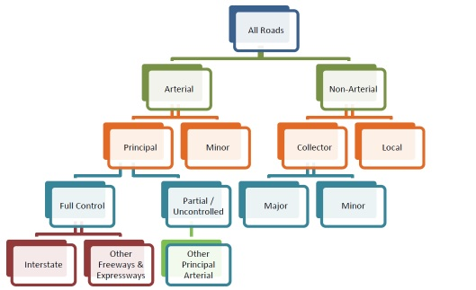
A roadway’s functional classification is based on the following factors or criteria:
- Function (Provides mobility vs land access)
- Destination (city centers, terminals, schools, commerce, industry, residential, etc.)
- Design (lanes, medians, ingress/egress, etc.)
- Context (Urban, Rural, Adjacent Land Uses)
- Topology (Hierarchical connectivity)
- Quantitative (mileage range quotas)
For example, arterial roadways provide a network of continuous routes that typically accommodate long trips and heavy travel demand and primarily serve interregional travel. Collectors basically serve a dual purpose, whereby they provide a significant amount of relatively long-distance travel and also provide more frequent access to abutting properties.
The HPMS reassessment determined a consolidation of rural and urban designations used in defining functional classifications to be beneficial. This consolidation reduces emphasis on separate urban and rural designations, so that now, for example, “rural interstate” and “urban interstate” are simply referred to as “interstate.” Although the new functional classification codes do not distinguish between urban, small urban and rural, such distinctions may still be necessary for planning and funding purposes. These distinctions can be found in the Highway Functional Classification Guidelines and are still considered to be useful and valid. The FHWA published “FHWA Functional Classification Guidance Update,” that provides an overview of the changes. The new system utilizes GIS to promote efficiency and cost-effective use of resources. For example, instead of the separate urban/ rural designations, updated urban layers from census data are used to define the urban roadways. The new guidance also allows for consistency between states because there is a clear process to follow.
USDOT FHWA. 2008. Policy Information, “Guidance for the Functional Classification of Highways (Updated).” Last modified November 7, 2014.

https://www.fhwa.dot.gov/policy/ohpi/hpms/fchguidance.cfm

Following the 2018-2019 rebalancing effort, ADOT sought an unbiased reflection of the actual function of the road to determine roadway classification in conjunction with FHWA mileage limitations to classify roadways to arterial and collector systems. This methodology began with classifying Arizona’s rural arterial system, and then the principal task was to distinguish the difference between the major and minor collectors. Once these tasks were accomplished, the remaining roads not assigned were identified as local roadways. The urban roadways were also classified using the top-down methodology in addition to the mileage limitation imposed by FHWA.
Functional Classification change request tool:

https://azgeo.az.gov/adot/WeLoveYourInput.aspx#ajax/FCmap.html
ADOT Functional Classification Maps
https://works.maps.arcgis.com/apps/webappviewer/index.html?id=4bcb96763e48482799906407a0cdb7cb
https://origin.azdot.gov/maps/functional-classification-maps

Tables 17.3-3 and 17.3-4 list the Arizona specific FHWA Functional Classification following Arizona’s rebalancing efforts started in 2018.

Table 17.3-3 | FHWA Guidelines Regarding the Extent of Rural Systems
Rural System | Percentage of Total Rural Mileage
Interstates | 1 – 2%
Other Freeways | 0 – 2%
Other Principal Arterials | 2 – 5%
Minor Arterials | 3 – 7%
Major Collectors | 10 – 17%
Minor Collectors | 5 – 13%
Local Roads | 66 – 74%
Source: FHWA Highway Functional Classification Concepts, Criteria and Procedures
Functional Classification Guidelines, https://www.fhwa.dot.gov/planning/processes/statewide/related/highway_functional_classifications/fcauab.pdf

Table 17.3-4 | FHWA Guidelines Regarding the Extent of Urban Systems
Urban System | Percentage of Total Urban Mileage
Interstates | 1 – 2%
Other Freeways | 0 – 2%
Other Principal Arterials | 4 – 5%
Minor Arterials | 7 – 12%
Major Collectors | 7 – 13%
Minor Collectors | 7 – 13%
Local Roads | 67 – 76%
Source: FHWA Highway Functional Classification Concepts, Criteria and Procedures
Functional Classification Guidelines, https://www.fhwa.dot.gov/planning/processes/statewide/related/highway_functional_classifications/fcauab.pdf

17.3.6 | Changing Functional Classification

The following process has been developed to ensure that the preceding federal guidance is met when modifications to Arizona’s approved Urban Area Boundary System and Functional Classification System are considered.
Chapter 2, “State & Federal Planning Partners”, describes the responsibilities of each ADOT division. USDOT FHWA. 2013. Arizona Division, “Stewardship and Oversight Agreement for Arizona.” Last Modified April 9, 2015

https://www.fhwa.dot.gov/azdiv/Arizona_SO_Agreement_signed_2015_04_09.pdf
17.4 | TECHNOLOGY APPLICATIONS FOR PLANNING: MODELING AND GIS
TABLE OF CONTENTS
17.4.1 | Purpose
17.4.2 | Travel Demand Models and Other Techniques
Growth Factor Models
Static Traffic Assignment Models
Activity-based Models
17.4.3 | Federal and State Requirements for Travel Demand Modeling
17.4.4 | ADOT Modeling Support
17.4.5 | ADOT GIS Support

17.4 | Technology Applications for Planning: Modeling & GIS

17.4.1 | Purpose
This section discusses the application of travel demand modeling (TDM) and GIS data to support various planning functions conducted by MPOs and COGs.
TDMs are invaluable tools that enable MPOs, ADOT, and other planning agencies to:
- provide technical analyses that support plan and policy development;
- evaluate proposed transportation improvement projects and programs;
- identify transportation system deficiencies;
- evaluate land use and development scenarios;
- conduct traffic, corridor, and subarea studies;
- support air quality and energy analyses; and
- conduct freight and goods movement studies.
Quantifying future transportation system performance and identifying potential operational deficiencies benefits the decision-making process. Additionally, they are used to generate the forecasts necessary to develop traffic operations strategies and roadway design.
GIS is rapidly becoming a necessary tool for planning, analyzing, modeling, and managing information. Transportation planners use GIS data to assess transportation services, plan future routes, and identify transportation deficiencies. GIS helps identify areas that are underserved by transportation infrastructure, pinpoint appropriate sites for the placement of a roadway or public transit facility, and match transportation services with demographic and environmental features.
Users can query GIS databases by spatial location and generate a visual array of information that allows them to readily understand complex environmental, economic, and social issues. By using GIS to efficiently bring information together, transportation planners are able to effectively review, analyze, and understand the challenges they face. This saves time and money and often facilitates improved decision making.

17.4.2 | Travel Demand Models and Other Techniques
Travel demand modeling is essentially a process for estimating travel in a region or locality based on population, socioeconomic characteristics, economic activity, and available transportations systems and modes. Depending on scale and purpose, travel models can range widely in complexity and are grouped into several broad categories as follows.
Growth Factor Models
Simple so-called sketch planning or growth factor models are sometimes used for planning applications that do not require much detail, and instead simple projections of travel based on changes in population and employment are standard measures of analysis. These models may be used in regions or localities with small populations where little fluctuation in population and employment is expected. These models are typically represented as simple growth factor calculations and are usually carried out in a spreadsheet application.
Static Traffic Assignment Models
Static traffic assignment models are more complex and require computer-generated forecasts. These models contain representations of major parts of the road network—typically freeways, major and minor arterials, and some collectors. These models work by dividing a region into a number of smaller Transportation Analysis Zones (TAZs) and forecasting travel using a four-step modeling process:
- Trip generation: How many trips are produced by (origin) and attracted to (destination) each zone?
- Trip distribution: Where are the trips going?
- Mode choice: By which mode are people traveling? (For regions where transit carries only a very small proportion of trips, this step may be omitted.)
- Assignment: On which roads are people traveling from a given origin to a given destination?
Four-step models have been the main method for travel demand forecasting in the United States since the 1950s. This model process is shown in figure 17.4-1.

Figure 17.4-1 | Conceptual Four-step Travel Demand Modeling Process
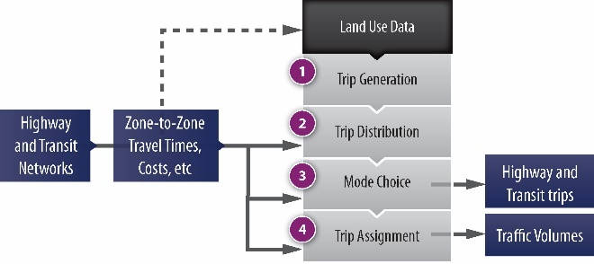
Travel models in large urban areas are further refined to produce forecasts of travel demand by time of day. For example, some regions use TDMs to produce forecasts for a single peak period (AM or PM) and the off-peak whereas other regions’ travel models produce forecasts of demand for both AM and PM periods, as well as off-peak; a growing trend is to divide the day into four or more time periods and produce forecasts for all of these: for instance, AM peak, midday, PM peak, and late night/early morning. Many smaller regions develop only 24-hour travel demand forecasts.
Travel demand modeling is used for a wide variety of purposes at the regional level. Examples include the following:
- Development of regional transportation plans: Travel demand forecasts are essential components of regional transportation plans, especially for comparing alternative development scenarios for a region.
- Forecasting traffic on a new highway facility: Forecasts of traffic on a new highway facility are often used to help determine tradeoffs between the size of the proposed facility, traffic on the facility, and the resulting level of service.
- Forecasting use of a new fixed-guideway transit facility: Federal guidelines for aid to new transit starts require detailed estimates of use of a proposed new facility. The travel models used to produce these forecasts are subject to detailed scrutiny by federal officials.
- Forecasting air quality” For nonattainment areas, travel models are used in conjunction with air quality models to produce estimates of future air quality as part of the regional planning process.
Activity-based Models
Activity-based models (ABMs) first populate a region with a synthetic population and then carry out travel modeling (also known as microsimulation travel demand modeling) on each individual in the population. The aggregated results produce estimates of total trips by origin-destination pair, by mode, by road and transit route, and by time of day. ABMs typically are implemented in large, complex urban areas where travel demand forecasts for non-auto modes are critical components of regional plans or applications for new fixed-guideway transit facilities.
Further details on the requirements can be found on the EPA’s “Transportation Conformity: Policy and Technical Guidance” webpage:
https://www.epa.gov/state-and-local-transportation#require
Dynamic Traffic Assignment Models
Dynamic Traffic Assignment (DTA) models utilize a methodology dependent on time and cost factors that capture travelers’ route choice behaviors as they traverse from origin to destination. It has become increasingly evident that travel time and cost measures used within static models are inadequate as explanations of influences on travel choices and as standards used to evaluate impacts when deciding how to develop policies for managing and funding transportation systems. DTA models describe the process and outcomes of how travelers on a transportation system with different departure times find their respective experienced shortest (minimal-cost) path from origin to destination in response to roadway connectivity, capacity, or travel demand changes. It is based on the idea of drivers choosing their routes through the network according to the travel cost experienced during the simulation. At a given point, after many iterations, travelers learn and adapt to the transportation network conditions.

17.4.3 | Federal and State Requirements for Travel Demand Modeling
At the federal level, the transportation conformity rule for air quality (C.F.R. 93.122 (b) and (c)) establishes a regulatory requirement of minimum specifications for travel models used to forecast vehicle activity as part of the air quality conformity process. The regulations state that network-based travel models must be used to support air quality conformity determinations and that these models must conform to procedures and methods that are in practice and supported by current available documentation.
Strictly speaking, there are no other federal or state requirements that TDMs be used in the metropolitan planning process. Nonetheless, when an MPO is reviewed for certification, the travel forecasting methods used by the MPO receive close scrutiny by federal agencies.
The FHWA requires ADOT to provide modeling oversight and reporting. Therefore, MPOs need to provide timely updates of the modeling processes that they perform during the year. Updates must include a simple annual report that describes the modeling process (i.e., updates, upgrades, etc.) completed over the past year and what is anticipated in the coming year. Copies of progress reports and final results of regional and subregional planning studies must also be provided to ADOT MPD.

17.4.4 | ADOT Modeling Support
Development of TDMs is a cooperative process between local agencies, MPOs, and ADOT. Local agencies and MPOs collect much of the data used in the development, calibration, and validation of TDMs. MPOs typically develop and validate the travel models either independently or with ADOT assistance, however ADOT can also lead development of a regional model for an MPO.
ADOT MPD modeling staff members are available to assist MPOs and COGs in model development and application. Technical support provided by ADOT can include providing data to be used by an MPO to develop or update a regional model, generating traffic forecasts using the statewide model, and developing a regional model for the MPO/COG. Regardless of the level of assistance desired, a memorandum of understanding (MOU) between the MPO/COG and ADOT is required.
Further details on the Average Annual Daily Traffic requirements can be found on the ADOT website:

https://azdot.gov/traffic-monitoring
Data provided by ADOT for regional travel demand modeling include certified demographic data for base- and future-year scenarios, regional roadway inventory data (HPMS), and external trip estimates. Traffic estimates generated by regional models must be within 5 percent of the VMT included in the HPMS database. ADOT has developed the Arizona statewide Travel Demand Model (AZTDM) to provide “external” interregional travel and goods movement estimates. The ADOT statewide model, AZTDM, is used to determine external trips so that consistency between the regional and statewide models is maintained.
Further details on the Travel Demand requirements can be found on the ADOT website:

https://azdot.gov/node/5625
ADOT MPD has formed the Arizona Modeling Users Group (AMUG) to facilitate coordination between travel demand modelers and ADOT, as well as to promote the advancement of modeling in Arizona. This forum is intended to discuss modeling considerations and exchanges information on methodologies, applications, case studies, and other items of interest to the Arizona travel demand modeling community.

17.4.5 | ADOT GIS Support
The ADOT GIS-T Section maintains the statewide street centerline GIS database and coordinates GIS issues for ADOT. The GIS database ATIS Roads is the foundation for numerous planning studies and programs. The GIS-T team continually creates and maintains statewide GIS databases in addition to obtaining databases from other sources, such as private, local government, state, and federal agencies. These databases are then used as overlays to the ATIS Roads base, converting a static representation of the roads and streets into a dynamic GIS application. Data sharing is at the heart of GIS technology’s effectiveness. The GIS community in the Arizona state government is a diverse group with a strong commitment to cooperative data sharing. The ADOT GIS-T Section can provide data (GIS layers) and technical support to local agencies and MPOs.

17.5 | SAFETY
TABLE OF CONTENTS
17.5.1 | Purpose
17.5.2 | Authority
17.5.3 | Scope
Project Identification
Project Prioritization
Safety Project Submittal to ADOT
17.5.4 | Safety Goals
17.5.5 | Recommended Elements
Project Identification
Prioritization
17.5.6 | Funding
17.5.7 | Key Stakeholders

17.5 | Safety

17.5.1 | Purpose
This section provides guidance to MPOs and COGs on compliance with federal requirements and obtaining federal-aid funds through ADOT for safety projects.
ADOT has developed the Arizona HSIP to meet federal requirements and reduce traffic fatalities and serious injuries on public roads. A core element of the HSIP is the Arizona Strategic Traffic Safety Program (STSP), which identifies the state’s traffic safety goals and establishes a strategic framework for achieving them. The strategy outlined in the STSP is implemented through the HSIP.
To view the full Arizona STSP update:

https://azdot.gov/sites/default/files/2019/10/az-stsp-report-2019.pdf

17.5.2 | Authority
FAST Act requires each state to have a highway safety program that is designed to reduce frequency and severity of crashes (23 U.S.C. § 402(a)(1)). Requirements for the HSIP are defined in 23 C.F.R. § 924. The FAST Act, Section 1113, added 4 new categories of eligible projects, increasing the total eligible categories to 28. These project categories under the highway safety program structure are identified as eligible and listed under 23 U.S.C § 148 (a)(4)(B). The FAST act also ended the ability of the State to shift funds designated for infrastructure safety projects to behavioral or educational activities. The ADOT HSIP program places additional constraints on the eligibility of individual project categories in order to meet the most critical safety needs on all of Arizona’s public roadways and to help ensure Arizona’s FAST performance targets are met.
A.R.S. § 28-503 establishes that the state develop and assist in applying performance-based planning and programming processes that influence allocation of state and federal financial resources based on performance factors established per A.R.S. §§ 28-504 and 28-505. A.R.S. § 28-504 establishes that uniform safety performances measures and factors must be developed; these are used “to select projects and services in the five-year transportation facilities construction program” (A.R.S. § 28-505(C)(1) and “allocate state and federal financial resources” (A.R.S. § 28-505(C)(2)).”
Table 17.5-1 below shows the authorities for safety regulations.

Table 17.5-1 | Authority
Code |  | Definition
Federal | 23 C.F.R. § 924 | Defines requirements for the HSIP.
 | 23 U.S.C. § 402(a)(1) | Establishes factors that are designed to reduce frequency and severity of crashes.
State | A.R.S. § 28-503 | Establishes that the state develop and assist in applying performance-based planning and programming processes.
 | A.R.S. § 28-504 | Establishes that uniform safety performances measures and factors must be developed.
 | A.R.S. § 28-505 | Establishes performance factors that must be followed.

17.5.3 | Scope
ADOT has developed the Arizona Highway Safety Improvement Program Manual to provide guidance for implementing the HSIP. The manual provides background on HSIP legislation, funding, and project eligibility. It specifies that all State, Local, and Tribal Agencies’ projects will compete for HSIP funds based on a project’s Benefit/Cost (B/C) ratio.
To view the full Arizona HSIP Manual:

https://azdot.gov/business/transportation-systems-management-and-operations/operational-and-traffic-safety/arizona-0
The process generally includes the following elements, as documented in Section 2 of the Arizona HSIP Manual:
Project Identification
Projects are identified through network screening (an objective, repeatable method) and/or by local agency selection. Projects must focus on reducing fatal and injury crash frequency and other trends, identified as “emphasis areas” as defined in the Arizona SHSP. Projects may include one or more countermeasures at a single location or a series of countermeasures implemented on a systematic basis.
Project Prioritization
The ADOT HSIP Program Manager will rank all potential HSIP projects based on the B/C ratio as calculated in the HSIP application. A Safety Review Committee, comprised of FHWA, MPO/COG, local, and ADOT staff will be convened to review and approve the proposed list. The HSIP Program Manager will then submit the prioritized list to the Transportation Systems Management and Operations (TSMO) Manager for final ranking and approval.
Safety Project Submittal to ADOT
HSIP applications will be submitted based on dates established in the Call-for-Projects from the ADOT HSIP Manager.
The MPOs and COGs include the selected projects in their TIPs. After implementation the MPOs and COGs are required to report the effectiveness of the improvement to the HSIP coordinator.

17.5.4 | Safety Goals
FAST Act establishes national goals in seven areas, one of which is safety. USDOT is responsible for establishing specific performance measures based on serious injuries and fatalities. FHWA Office of Safety is committed to the vision of zero deaths and serious injuries on the nation’s roadways.
Arizona’s LRTP (2010-2035) and the Arizona STSP identify statewide goals. Arizona’s LRTP identifies goals to “enhance safety and security” and introduces two performance measures: number of fatalities (by mode) and number of crashes (by mode).
The 2019 Arizona Strategic Traffic Safety Plan’s Executive Committee established an over-arching goal to save lives – reduce traffic fatalities on Arizona’s roadways. The Vision of the STSP is “Toward Zero Deaths by Reducing Crashes for a Safer Arizona” is consistent with the national movement of Toward Zero Deaths. The STSP Goal is to “Reduce Traffic Fatalities on Arizona’s Roadways.” The STSP identified five emphasis areas and strategies that HSIP projects must support. They are:
- Highway Safety (Behavior Related)
- Intersections
- Lane Departure
- Pedestrians
- Safety – Related Data

17.5.5 | Recommended Elements
FAST Act defines HSIP as projects, activities, plans, and reports as defined in 23 U.S.C. § 148. HSIP projects mean strategies, activities, and projects on a public road that are consistent with the Arizona Strategic Highway Safety Plan and
- Correct or improve a hazardous road location or feature, or
- Address a highway safety problem.
Highway safety improvement projects should be identified on the basis of crash experience, crash potential, crash rate, or other safety data-supported means. The data-driven framework for funding projects allows states to administer the HSIP funds to address their specific safety needs. The guidelines outline the components to be documented for evaluations of individual sites or study corridor. The following provides an overview of the key evaluation elements included in the guidelines along with references to the FHWA Highway Safety Improvement Program (HSIP) Manual (2010), the Highway Safety Manual (HSM) (AASHTO 2010), and other reference materials that can help improve safety evaluations
Project Identification
Project sites and countermeasures must be selected based on data-driven, objective reviews that take into account crash and volume data. This improves the probability that funding is allocated to projects where reductions in fatal and serious injury crash frequency can be realized. Section 2.1.1 of the Arizona HSIP Manual recommends the 13 methods for conducting an objective review that are included in the FHWA HSIP Manual (2010, 2-20 to 2-21). These methods are also described in the HSM, published by the American Association of State Highway Transportation Officials (AASHTO 2010).
Most methods depend on data availability and identified safety priorities. At a minimum, network screening methods require five years of crash data. When traffic volume data is also available, more advanced methods can be applied. The most statistically rigorous methods require crash data, volume, and locally developed or calibrated crash prediction models (Safety Performance Functions or SPFs). Base crash prediction models are available in Part C of the HSM, but ADOT has not developed statewide calibration factors for these models.
Once a list of priority sites has been identified through network screening, the sites can be reviewed to identify a range of countermeasures. The countermeasures at multiple sites can be compared with one another with respect to their expected benefit-cost (B/C) ratio. Appendix D of the Arizona HSIP Manual provides B/C analysis guidelines. The benefits of countermeasures, in terms of the change in crash frequency (by type and severity) are documented as Crash Modification Factors (CMFs) in the FHWA’s online CMF Clearinghouse.
For more information on the CMF Clearinghouse follow:

http://www.cmfclearinghouse.org/
Although not preferred, individual projects may be selected by an MPO or a COG independent of an objective, data-driven process. To maintain some level of objectivity, the agency can develop and apply performance thresholds that indicate whether a project qualifies for safety evaluation or has potential for crash reduction. This minimizes the potential that a site is selected for study based on a perceived safety issue, when little or no crashes have occurred. Performance measures that can serve as performance thresholds are identified in table 2.1 of the FHWA HSIP Manual (2010, 2-22 to 2-23).
Prioritization
Projects (including one or more countermeasures) can be compared to determine priority for funding. Multiple factors influence prioritization of safety projects, including political factors, funding availability, and expected benefit. However, in order to establish a consistent measure for comparison between sites, a B/C ratio should be calculated, in accordance with the specifications outlined in Appendix A, “HSIP Project Application Processes and Worksheets (Rev Dec 18),” in the Arizona HSIP Manual. The B/C ratio indicates those projects that are most likely to achieve the greatest reduction in crashes compared with the cost to implement. Once B/C ratios have been established for each project and submitted to the ADOT Traffic Safety Section, the projects will be prioritized by the B/C ratio.
CMFs have not been developed for many countermeasures, especially those that are innovative or include ITS improvements. Per the FHWA HSIP Manual, “It is important to recognize the potential limitations and vulnerabilities associated with CMFs. Engineering judgment should always be applied when using CMFs. Despite the potential weaknesses, valid CMFs are a key component of existing safety tools and resources used to prioritize safety programs” (2010, 3-15).
A safety evaluation report should be prepared to document the evaluations and prioritization of projects. Regardless of whether a report is prepared for an individual project or for a group of projects, the report should reflect the content and organization provided in the report guidelines provided in Appendix C of the Arizona HSIP Manual.

17.5.6 | Funding
All projects at the same funding levels submitted by LPAs, COG/MPOs, Tribes, and State agencies will be selected with priority going to projects with highest benefit cost (B/C) ratios. In past years, the HSIP Program has been funded at approximately $40 million. During the same periods, HSIP eligible project applications have been submitted in significantly greater amounts than available funds resulting in those projects with low B/C ratio scores falling below the funding cut-offline. If an eligible project is recommended for HSIP funding a letter will be issued to the agency by the HSIP Program Manager. A copy will be provided to the MPO or COG Transportation Planner in order for the project to be entered in their TIP.

17.5.7 | Key Stakeholders
In Arizona, the STSP was developed through collaborative efforts of representatives from a range of local, regional, state, and national organizations. Their collective interest is in reducing crash frequency through the “4 E’s” (engineering, education, enforcement, and emergency response). Examples of the range of groups involved are law enforcement, transportation engineering and planning agencies, education-based organizations (Driver and Safety Education Association), safety-focused groups (Safe Kids Coalition, National Safety Council, Department of Public Safety, etc.), and local advocacy groups.
The Arizona Governor’s Office of Highway Safety (GOHS) has pursued and supported legislative initiatives on numerous highway safety issues in conjunction with the Governor’s Office.
ADOT’s Traffic Safety Section manages the HSIP.

17.6 | TRIBAL PLANNING
TABLE OF CONTENTS
17.6.1 | Introduction
17.6.2 | Authority
17.6.3 | Scope
17.6.4 | Tribes in Arizona
17.6.5 | Public Involvement
17.6.6 | Consultation with Tribes
ADOT Tribal Consultation Actions
Statewide & Regional Tribal Consultation, Cooperation, & Coordination
MPO & COG Consultation with Tribes
17.6.7 | ADOT Transportation Planning
17.6.8 | Federal Transportation Funding Sources

17.6 | Tribal Planning
Arizona Tribal Transportation website:

http://www.aztribaltransportation.org/
ADOT Transportation Planning and Programming Guidebook for Tribal Governments:

http://www.aztribaltransportation.org/PDF/Transportation_Planning_Programming_Gdbk_Tribal_Govts.pdf

17.6.1 | Introduction
Arizona MPOs and COGs should encourage Tribal Governments to participate in regional planning activities. This chapter serves as a reference for working with tribal governments and tribal planning departments. It explains MPO and COG roles in transportation planning and programming for tribal lands within the state of Arizona.
Tribal Governments play a vital role in the transportation system statewide as approximately 18% of state highways cross tribal lands. Tribal sovereignty is recognized by ADOT and continuous communication regarding transportation issues is encouraged and welcome.
- ADOT Tribal Transportation Planning and Programming Guidebook for Tribal Governments

17.6.2 | Authority
Executive orders and government mandates have been instituted by the federal government and the state of Arizona regarding tribal transportation planning. Current transportation planning legislation emphasizes cooperative planning that comprehensively addresses transportation issues within and adjacent to tribal lands. Coordinated efforts are required between the tribal governments, BIA, the state of Arizona, MPOs, COGs, and local governments. Table 17.6-1 summarizes federal and state policies and mandates.

17.6.3 | Scope
Native Nations and tribal governments have sovereign status and jurisdiction over lands within reservation boundaries as defined by federal law 18 U.S.C. § 1151, but ADOT has exclusive control and jurisdiction over state highways within reservation boundaries, as defined in A.R.S. § 28-332(A). Approximately 1,237 miles, or 18.2 percent, of Arizona’s state highway system crosses tribal lands. To facilitate needed state-tribal discussion, coordination, and consultation, ADOT’s role focuses on transportation-related partnerships, projects, and information-sharing activities. ADOT has tribal planning program managers/tribal liaisons assigned to work with the tribes in Arizona. COGs and MPOs should use the ADOT Tribal Policy as a guide for working with tribes if the COG or MPO does not have a tribal policy of their own.
Just as transportation issues and problems do not end at a city boundary, they also are not confined by reservation boundaries; often they are regional in nature. Accordingly, tribes are eligible and welcome (but not required) to participate in regional transportation planning processes as members of COGs or MPOs. Tribal membership in Arizona’s COGs and MPOs is discussed in Module 5 of the ADOT Tribal Transportation Consultation Online Training Course.

Table 17.6-1 | Authority
Code |  | Description
Federal | ISTEA | These five federal policies specifically impact all statewide and tribal transportation project development processes.
 | TEA-21
 | SAFETEA-LU
 | MAP-21
 | FAST Act
 | 23 U.S.C. §§ 201, 202 | This policy, Federal Lands and Tribal Transportation Programs is a part of FACT Act Section 1117. The purpose of the TTP is to provide access to basic community services to enhance the quality of life in Indian communities. The TTP replaces the former Indian Reservations Road Program. The program set-asides include Administration, Planning, Bridge, Tribal Safety, and Supplemental Funding.
 | 18 U.S.C. § 1151 | Native nations and tribal governments have sovereign status and jurisdiction over lands within reservation boundaries.
 | 23 U.S.C. § 135(d)(2) | Each state must consider the concerns of Indian tribal governments that have jurisdiction over land within the boundaries of the State
 | 23 U.S.C. §§ 135 (e)(2) | States are required to consult with Indian tribal governments and the secretary of the interior in the development of state transportation plans “with respect to each area of the State under the jurisdiction of an Indian tribal government.”
 | 23 U.S.C. § 135(f)(2)(D)(i)
 | USDOT Order 5301.1 | This order, “Department of Transportation Programs, Policies and Procedures Affecting American Indians, Alaska Natives and Tribes” provides 17 points of policy and specific guidelines with regard to how the USDOT conducts communication and consultation with Native nations/Indian tribes.
 | Executive Order 13175 | This order, “Consultation and Coordination with Indian Tribal Governments” requires consultation and collaboration with tribal officials in the development of federal policies with tribal implications to strengthen relationships and reduce imposition of unfunded mandates on Indian tribes.
 | Title VI and Executive Order 12898 | These policies under “Federal Actions to Address Environmental Justice with Minority Populations and Low Income Populations,” ensure that individuals are not excluded from, denied the benefit of, or subjected to discrimination because of their race, color, national origin, age, sex, or disability.
 | National Historic Preservation Act (NHPA) Section 106 | Relevant federal legislative acts include protection of specific lands which require consultation with tribes and protection of freedoms to exercise.
 | NEPA | ADOT monitors its tribal consultation efforts and provides an annual report to the governor’s office for distribution to all tribal leaders.
 | Archaeological Resources Protection Act (ARPA)
 | Native American Graves Protection & Repatriation Act (NAGPRA)
 | American Indian Religious Freedom Act (AIRFA)
 | Governor’s Bimonthly Tribal Consultation

Table 17.6-1 | Authority (continued)
Code |  | Description
State | A.R.S. § 41-2051(C) | This statute, “Responsibility of State Agencies” directs all state agencies to develop and implement consultation policies, designate staff to be responsible for the policy and act as points of contact, review the policy each year, and submit a report to the governor, state legislature, and tribal leaders.
 | ADOT MGT-16.01 | This policy, “Department-Wide Native Nation/Tribal Government Consultation Policy” provides additional guidance to ADOT personnel when working with tribal governments.
 | ADOT Tribal Consultation Policy Priorities | ADOT has established 13 policy priorities that respect the values, culture, codes, laws, and work of Native nations and tribal governments.
 | A.R.S. § 28-332(A) | ADOT has exclusive control and jurisdiction over state highways within reservation boundaries.
 | A.R.S. § 28-506 | ADOT updates the statewide transportation plan as required by A.R.S. § 28-506.
 | A.R.S. § 28-307 | The Arizona State Transportation Board’s role in the development of ADOT’s planning process is described in A.R.S. § 28-307.
 | A.R.S. § 28-6951 | A.R.S. § 28-6951, also known as the Priority Programming Law, establishes processes and guidelines for the Arizona State Transportation Board to prioritize projects for the five-year transportation facilities construction program.

Federal laws and regulations have several provisions pertaining to transportation planning on tribal lands, including a separate tribal funding program. Previously, tribal transportation planning and programs were handled under the Indian Reservations Roads (IRR) Program, administered by the CFLHD of the FHWA. The new FAST Act legislation is intended to maintain many of the same goals and obligations of tribal transportation planning; however, certain stipulations, including funding formulas and program requirements, have been altered.
FHWA Tribal Transportation Program Fact Sheet:

https://www.fhwa.dot.gov/fastact/factsheets/tribaltransportationfs.cfm
The regulations for this program, found in 25 C.F.R. § 170, state that a participating tribe must inform the state DOT and, as appropriate, any MPO of its transportation planning process to ensure any programs and projects adjacent to tribal lands are consistent and appropriate with tribal needs and interests. ADOT recommends that the same level of coordination occur with COGs as there are several tribal governments that conduct transportation planning activities but are not within an MPO.
FTA Public Transportation Program for tribal lands:

https://www.transit.dot.gov/funding/grants/applying/public-transportation-indian-reservations-2013-nofa
FTA Section 5311 Fact Sheet:

https://www.transit.dot.gov/funding/grants/formula-grants-rural-areas-fact-sheet-section-5311
The FHWA provides several resources related to Tribal Transportation and FAST Act regulations. The FTA provides specific grant information for public transportation on tribal lands.

17.6.4 | Tribes in Arizona
There are 22 federally recognized Indian tribes and Native nations in Arizona, which encompass more than 28 percent of the state land area. There are also seven tribes from out of state that have ancestral land interests in Arizona.

Table 17.6-2 | Indian and Native Nations in Arizona
Tribes & Native Nations | MPO | COG
Ak-Chin Indian Community | MAG | CAG
Cocopah Indian Tribe | YMPO | WACOG
Colorado River Indian Tribes |  | WACOG
Fort McDowell Yavapai Nation | MAG
Fort Mojave Indian Tribe |  | WACOG
Fort Yuma Quechan Indian Tribe | YMPO
Gila River Indian Community | MAG | CAG
Havasupai Tribe |  | NACOG
Hopi Tribe |  | NACOG
Hualapai Indian Tribe |  | NACOG, WACOG
Kaibab Band of Paiute Indians |  | NACOG, WACOG
Navajo Nation |  | NACOG
Pascua Yaqui Tribe | PAG
Pueblo of Zuni |  | NACOG
Salt River Pima-Maricopa Indian Community | MAG
San Carlos Apache Tribe |  | CAG, SEAGO
San Juan Southern Paiute Tribe |  | NACOG
Tohono O’odham Nation | PAG, MAG | CAG
Tonto Apache Tribe |  | CAG
White Mountain Apache Tribe |  | NACOG, CAG
Yavapai-Apache Nation |  | NACOG, CAG
Yavapai-Prescott Indian Tribe |  | NACOG

17.6.5 | Public Involvement
Public involvement is a critical component of any transportation planning process and includes the engagement of community citizens in the early stages of the planning project through completion of the project. Through careful consideration of input from citizens, the needs of all modes of transportation can become a shared vision and mission for technical planning staff and policy makers. The Public Participation Plan, described in chapter 13, officially describes the goals, policies, and procedures for successful public involvement. Tribes are encouraged to participate in all public participation activities and must be considered in any Public Participation Plan.
Chapter 13, “Public Involvement,” of this manual describes the public involvement processes.

17.6.6 | Consultation with Tribes
To carry out tribal consultation in the state program development process, including transportation planning, programming, and project development, ADOT works to comply with numerous presidential memorandums, USDOT executive orders, state executive orders, and state and federal laws and policies; which are outlined above in section 17.6.2, “Authority.” Any process, study, project, or initiative that a COG or MPO is conducting should include the following basic steps or consultation protocols:
- Send a formal tribal consultation letter to tribal leaders;
- Send copies of the letter to designated tribal staff; and
- Follow-up on the correspondence with an email or phone call to the designated tribal staff.
In addition to the miles of state highway that cross tribal lands, 14 airports and 7 public transportation systems are maintained and operated by native nations or tribal governments. ADOT’s district engineers often serve as the primary points of contact for tribes regarding state transportation issues. Some tribes whose land overlaps district boundaries may need to coordinate with multiple district engineers. Figure 17.6-1 illustrates tribal reservation land in relation to the state highway routes, other jurisdictional boundaries, and ADOT engineering districts.

ADOT Department-Wide Native Nation/Tribal Government Consultation Policy
ADOT Engineering Districts and Contact Information:

http://www.aztribaltransportation.org/contacts.asp

Figure 17.6-1 | Indian and Native Nations in Arizona
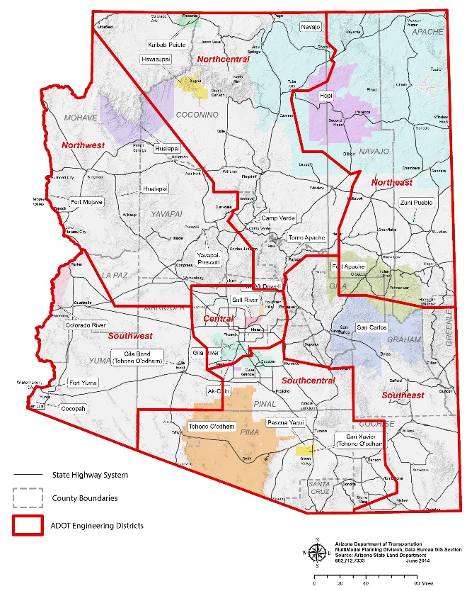
The ADOT Department-Wide Native Nation/Tribal Government Consultation Policy provides guidance to ADOT personnel when working with Native nations and tribal governments in Arizona regarding transportation-related issues. It provides ADOT and the nations and tribes a basis for mutual understanding in order to come to agreements to address state and tribal transportation issues, needs, and concerns
ADOT Tribal Consultation Actions
Once a year ADOT MPD compiles a report that provides a summary of the tribal-related consultation and coordination activities conducted by the ADOT Tribal Liaisons in coordination with the various ADOT divisions, districts, sections, and groups during the prior fiscal year. The annual report is submitted to the Governor’s office and shared with Tribal leaders and legislators.
There are several methods by which ADOT and the tribal governments interact. The ADOT Tribal Consultation Report highlights studies, projects, and processes that are either completed or underway with regard to tribal consultation, cooperation, and coordination. Included in the report are specific partnership accomplishments relevant to tribal transportation planning, outreach, and improved intergovernmental relations in Arizona.
The Arizona Tribal Strategic Partnering Team (ATSPT) brings together representatives from state, tribal, federal, and local agencies to address tribal-related transportation issues:

http://www.aztribaltransportation.org/contacts.asp

Table 17.6-3 | Member & Participating Tribes in Regional Planning Organizations
2012 ADOT Tribal Consultation Report:

http://www.aztribaltransportation.org/PDF/FY19-ADOT-Annual-Tribal-Consultation-Report-100119.pdf
Promoting Partnerships: ADOT strives to actively involve tribes throughout the transportation planning and programming process. The key for successful interaction through the planning/programming process for all tribes is to participate, participate, participate.
Regional Planning Organization |  | Member Tribes | Participating Tribes (non-voting)
TMA | MAG | Fort McDowell Yavapai Nation, Gila River Indian Community, Salt River Pima-Maricopa Indian Community
 | PAG | Pascua Yaqui Tribe, Tohono O’odham Nation
MPO | CYMPO |  | Yavapai-Prescott Indian Tribe
 | YMPO | Cocopah Indian Tribe
COG | CAG | San Carlos Apache Tribe, Gila River Indian Community | Ak-Chin Indian Community, White Mountain Apache Tribe
 | NACOG |  | Navajo Nation, Hopi Tribe, White Mountain Apache Tribe
 | SEAGO | San Carlos Apache Tribe
 | WACOG |  | Hualapai Indian Tribe, Colorado River Indian Tribe
Previous chapters of this manual describe the processes of transportation planning including statewide long-range transportation visioning, state transportation plan, specialized transportation studies, regional transportation system plans, and PARA.
Statewide & Regional Tribal Consultation, Cooperation, & Coordination
When possible and where applicable, COG and MPO regional planners should participate in tribal related events, be appointed to project steering committees, and serve as the tribal liaisons for the regional organizations. The ADOT Tribal Consultation Report lists many ongoing efforts in which COGs and MPOs can contribute and participate. It is also recommended that regional planners complete the ADOT Tribal Transportation Consultation Online Training Course available at the Arizona Tribal Transportation website.
MPO & COG Consultation with Tribes
Tribal governments are encouraged to participate in regional planning activities coordinated by Arizona’s MPOs and COGs. Tribes that participate in MPOs or COGs are provided an opportunity to vote on transportation projects occurring in their region. Some of the MPOs and COGs do have a fee structure for membership. If there is a fee structure that is not acceptable to the tribe, all are still encouraged to participate at committee meetings in a nonvoting capacity. Table 17.6-3 illustrates tribes that are members of or participate in MPO and COG committees.
COGs and MPOs can access ADOT’s “Tribal Transportation Consultation Process Reference Manual - For ADOT Personnel Use”

17.6.7 | ADOT Transportation Planning
The planning and programming of transportation improvements to the state highway system and other modes of transportation are the responsibility of ADOT MPD, which is divided into five sections as shown in figure 17.6-2. Within the Planning and Programming section of ADOT MPD is the Tribal Planning and Coordination staff. Several statewide transportation planning initiatives overlap with tribal transportation planning; these planning projects are further described in separate chapters of this manual.
ADOT is responsible for planning, operating, and maintaining all interstate and state highways in Arizona and providing financial assistance to airports. Therefore, ADOT MPD uses the Public Participation Plan to solicit extensive public involvement and conducts technical evaluations to determine projects to include in the ADOT Five-Year Transportation Facilities Construction Program.
Chapter 10, “Financial Planning and Programming,” describes the priority programming and funding approval process including transportation funding sources.

17.6.8 | Federal Transportation Funding Sources
Both state and federal funding sources are used in funding transportation projects which typically fall into three categories: (1) inventory, (2) bridges, and (3) safety. The most significant funding comes from the federal government established in the FAST Act.
Chapter 2, “State & Federal Planning Partners, describes the responsibilities of each ADOT division.

Figure 17.6-2 | Tribal Planning & Coordination within ADOT MPD
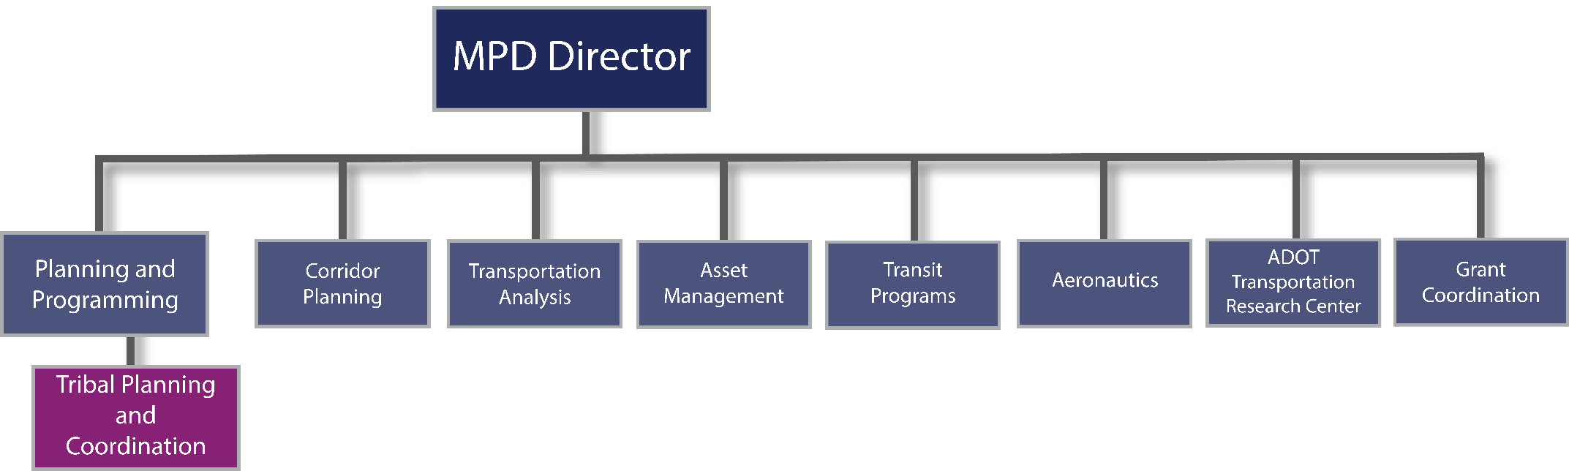

17.7 | BORDER PLANNING
TABLE OF CONTENTS
17.7.1 | Introduction
17.7.2 | Border Master Plan
17.7.3 | Relationship to MPOs & COGs

17.7| Border Planning
Based on the Arizona-Sonora BMP findings, the three LPOEs in Nogales account for 60 percent of all pedestrian crossings, 40 percent of privately owned vehicle crossings, and 75 percent of all commercial truck crossings.

DID YOU KNOW

17.7.1 | Introduction
Travel between the state of Arizona in the United States and the state of Sonora in Mexico at the international border has increased over the last 10 years. There are nine specific LPOEs facilitating movement between the two states. The majority of LPOEs have experienced an increase in the movement of people and goods, and the increases are expected to continue to grow in future years as population and economic growth occur in the border region. This section provides additional resource material references for the MPOs and COGs that conduct planning activities in the border region.

17.7.2 | Border Master Plan
During February 2013, ADOT released the Arizona-Sonora BMP. The BMP was prepared by ADOT in collaboration with the FHWA, the SCT, and the State of Sonora, Mexico. The Arizona-Sonora BMP provides a roadmap for improving the efficiency and effectiveness of Arizona-Sonora transportation facilities supporting critical social and economic interactions across the international border.

17.7.3 | Relationship to MPOs & COGs
During 2017 and 2018, ADOT worked with stakeholders throughout Arizona to develop and release the LRTP, What Moves You Arizona 2040, in 2018. The plan identified $155 million of improvements throughout the Arizona-Sonora border region, but did not specifically consider individual LPOEs. At each LPOE, heavy congestion and security issues affect daily pedestrian, commercial, and vehicular traffic traveling across the border. As such, from 2012-2013, stakeholders from both countries prepared the Arizona-Sonora BMP.
This BMP provides key details on planning and programming of improvements for all of the Arizona-Sonora LPOEs. The study area for the Arizona-Sonora BMP generally extends 10 miles north of the Arizona-Sonora international border, with expanded areas in the vicinity of Yuma, Nogales, and Douglas as displayed in Figure 17.7-1. As the figure illustrates, the Arizona-Sonora BMP has influences in the following MPOs and COGs:
The Arizona-Sonora BMP can be found at:

https://azdot.gov/planning/transportation-studies/completed-transportation-studies/arizona-sonora-border-master-plan
- YMPO
- SVMPO
- WACOG
- SEAGO

Figure 17.7-1 | Arizona-Sonora Land Ports of Entry

17.8 | PUBLIC PRIVATE PARTNERSHIPS
TABLE OF CONTENTS
17.8.1 | Introduction
17.8.2 | Authority
17.8.3 | Background
17.8.4 | ADOT Responsibility & Guidelines
17.8.5 | Proposal Processes
17.8.6 | FHWA Resources

17.8 | Public Private Partnerships

17.8.1 | Introduction
This section provides guidance to ADOT on compliance with federal and state processes for P3s.

17.8.2 | Authority
Congress mandated increased financial innovation in the 1991 Intermodal Surface Transportation Efficiency Act ISTEA, and as of 2012, 33 states have enacted statutes that enable the use of various P3 approaches for funding transportation projects. In 2009, enactment of Arizona’s House Bill 2396 added Chapter 22 (“Public-Private Partnerships in Transportation”) to Title 28 of the Arizona Revised Statutes to guide P3 use in Arizona.

17.8.3 | Background
A P3 is a contractual agreement formed between a public agency and a private sector entity that allows for private sector participation in the delivery and financing of public infrastructure such as transportation projects. Public-private partnerships are not a new model for funding surface transportation infrastructure, but their use has become more common since the early 1990s as gasoline fuel tax revenues have not kept pace with escalating construction costs.
Common types of P3 facilities are toll lanes and toll roads, where the State might contract with a private party to build new freeway lanes or even entirely new highways and maintain them for a fixed number of years in exchange for the right to collect tolls on those roadways. Other facility types eligible for P3 agreements under Arizona’s statutes include the following:
The ADOT P3 web page provides many resources for P3 programs.

https://azdot.gov/business/programs-and-partnerships/p3-initiatives
- Highways
- Railways
- Monorails
- Transit
- Bus Systems
- Vehicles
- Parking facilities
- Guided rapid transit
- Rail yard and storage
- Rolling stock and other related equipment, or property
- Other ADOT related facilities and structures

17.8.4 | ADOT Responsibility & Guidelines
The Arizona statute authorizes a wide range of allowable P3 agreement types, including:
- pre-development agreements leading to other implementing agreements.
- design-build agreements.
- design-build-maintain agreements.
- design-build-finance-operate agreements.
- design-build-operate-maintain agreements.
- design-build-finance-operate-maintain agreements.
- concessions providing for the private partners to design, build, operate, maintain, manage, or lease eligible facilities.
- any other project delivery methods or agreements or combination of methods or agreements that the department determines will serve the public interest.

DID YOU KNOW
ADOT’s Office of P3 Initiatives and Major Projects is responsible for developing P3 agreements with interested private parties. This ADOT office has in-house legal and financial expertise and retains engineering management experts to assess the extremely technical details of such agreements.

17.8.5 | Proposal Processes
Arizona has processes in place to consider solicited as well as unsolicited P3 proposals. Solicited means that ADOT has identified a transportation need and invited the private sector to respond with proposed solutions.
The ADOT P3 Program Guidelines is a resource that outlines the procedures for managing an ADOT public-private partnership.

https://azdot.gov/sites/default/files/2019/07/p3-program-guidelines.pdf
An unsolicited proposal means that a private entity identifies a transportation need and proposes a P3 approach for addressing it. In either case, the Arizona procedures involve transparent processes designed to encourage competition and innovation. Figure 17.8-2 illustrates the ADOT process for P3 solicited proposals. Figure 17.8-3 illustrates the ADOT process for P3 unsolicited proposals.

17.8.6 | FHWA Resources
FHWA’s Office of Innovative Project Delivery developed a summary of the various P3 options included in Figure 17.8-1 to compare some of the above project delivery methods, in terms of the degree of private sector involvement in various phases of project delivery.
The FHWA P3 website provides many resources for P3 programs.

https://www.fhwa.dot.gov/ipd/p3/default.aspx

Figure 17.8-1 | P3 Options
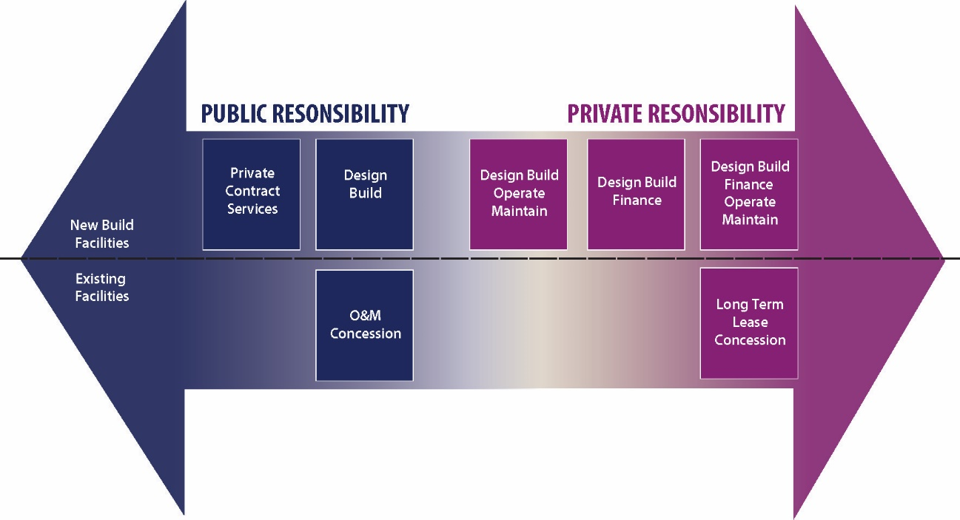

Figure 17.8-2 | Process for P3 Solicited Proposals
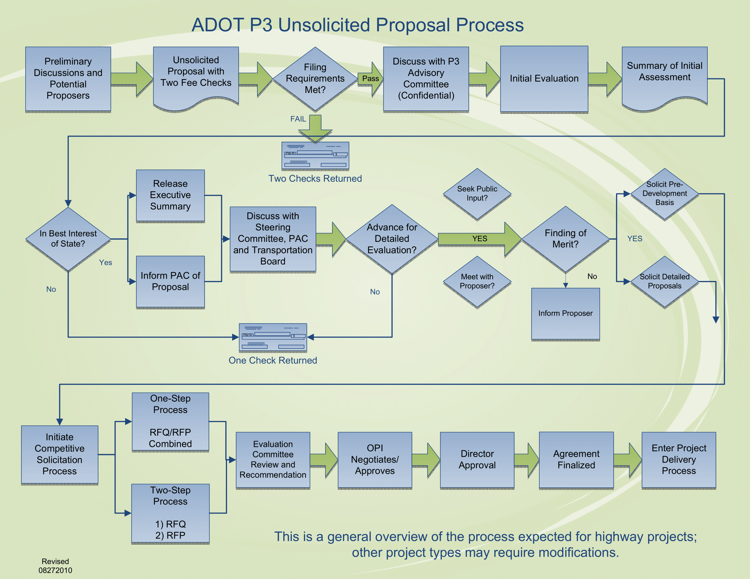

Figure 17.8-3 | Process for P3 Unsolicited Proposals
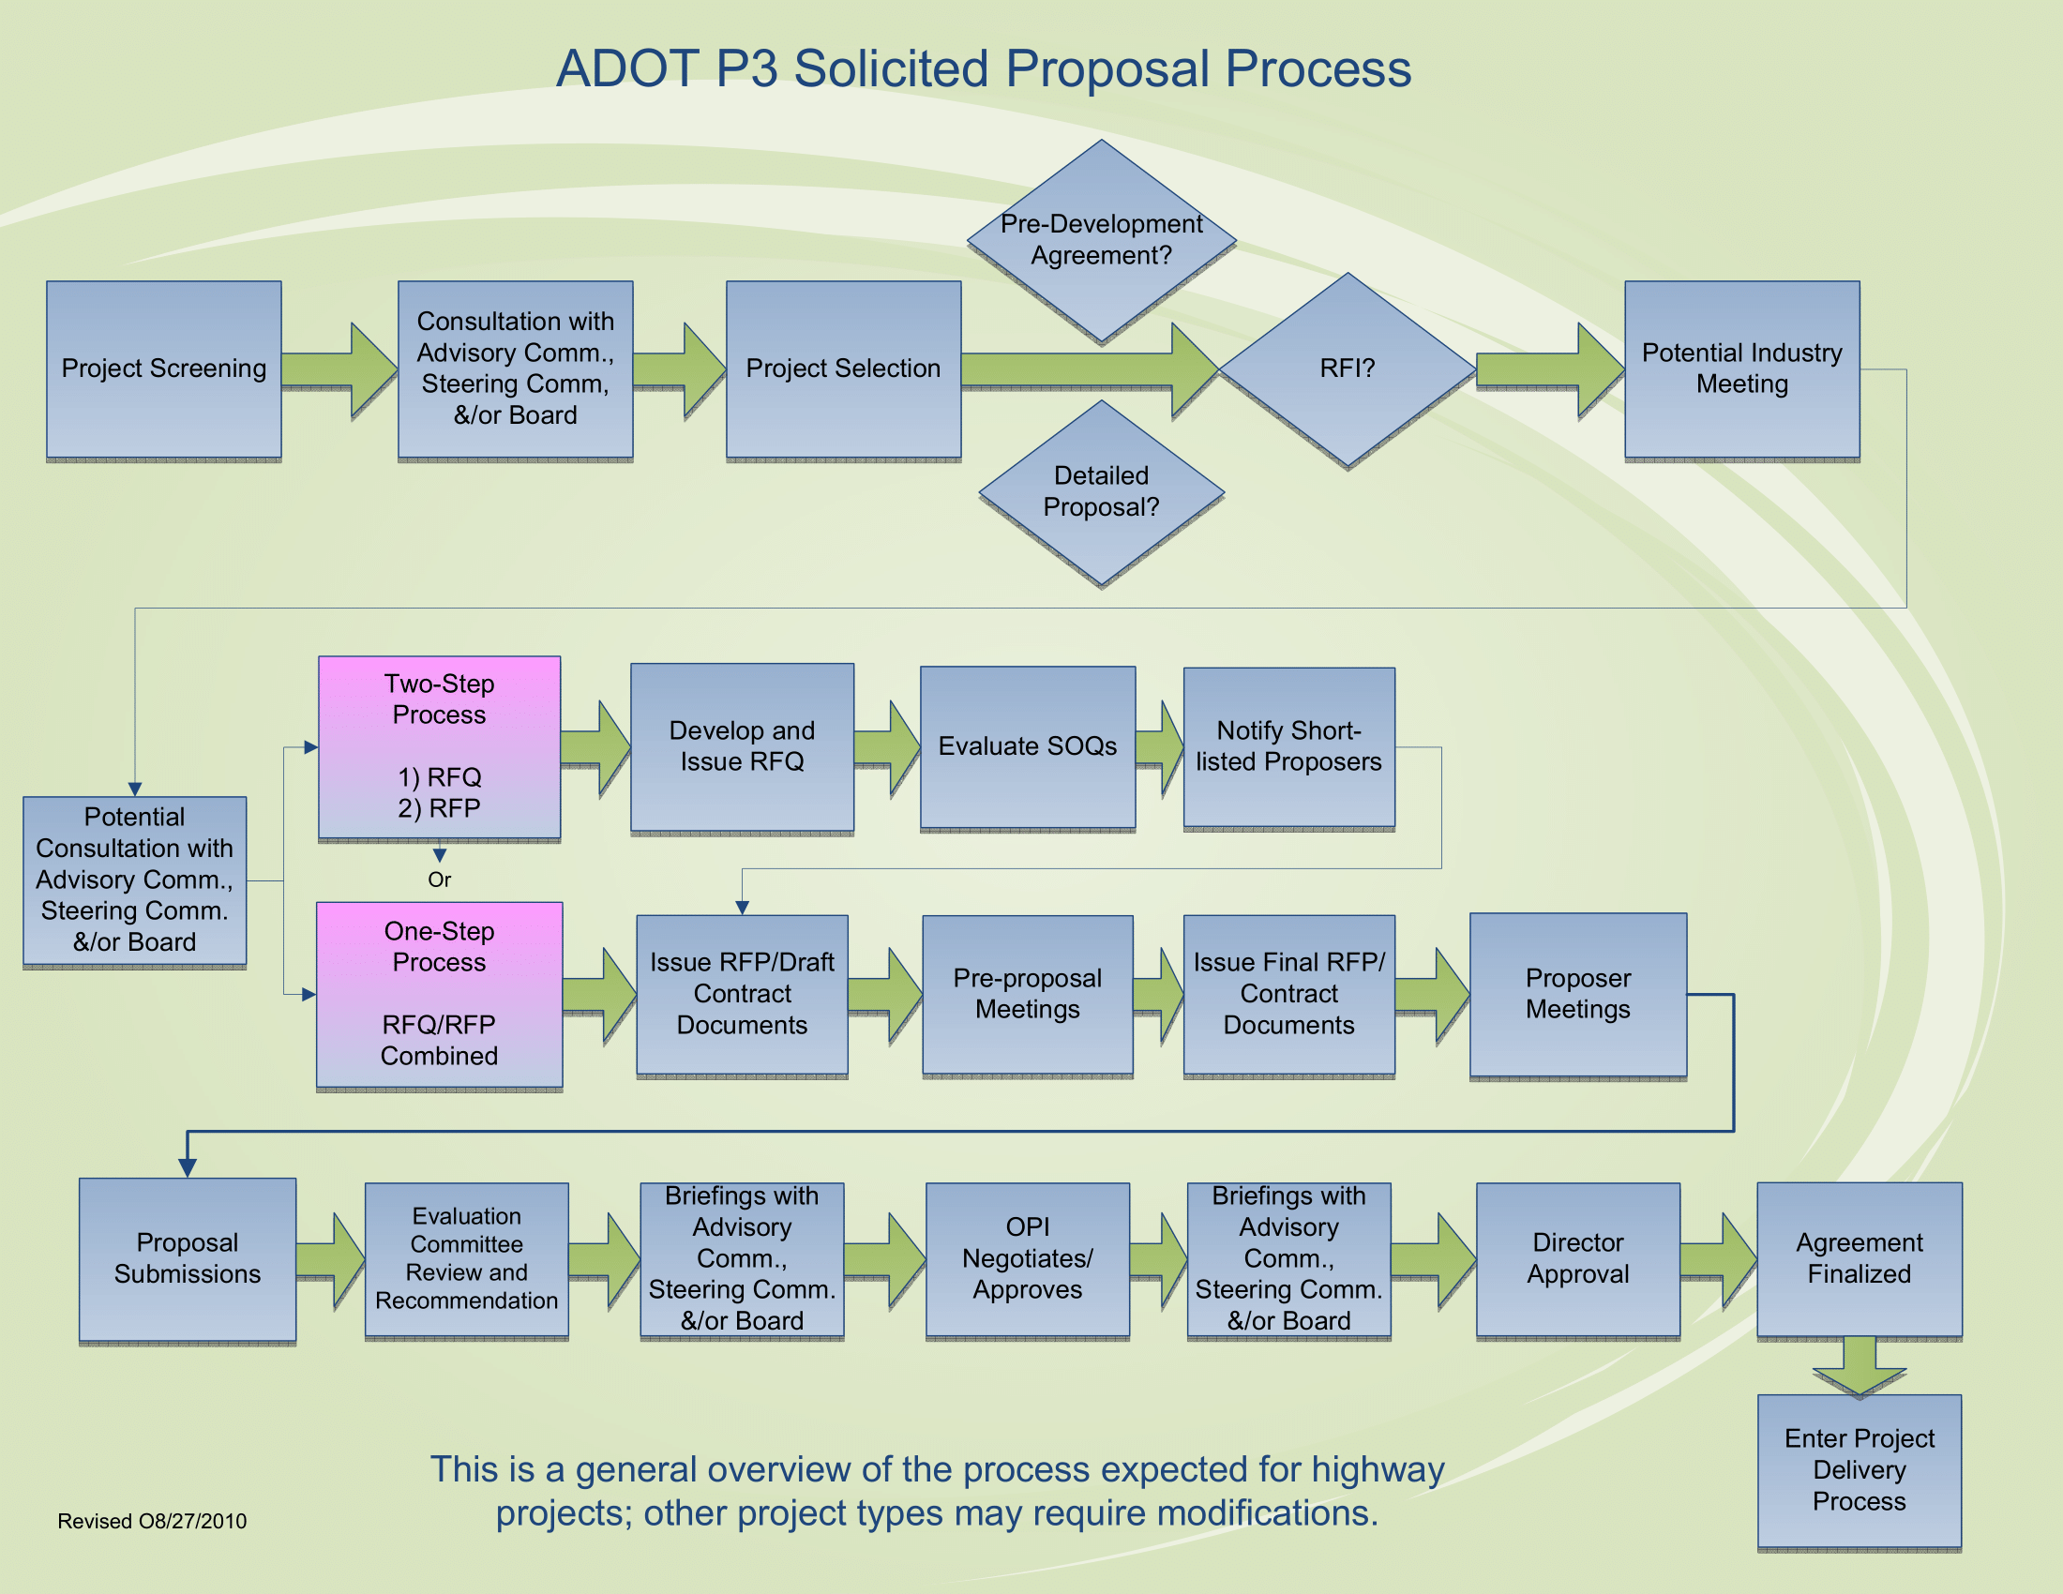

17.9 | PLANNING AND ENVIRONMENTAL LINKAGES
TABLE OF CONTENTS
17.9.1 | PEL Documentation Outline
17.9.2 | MPO/COG Role in PEL Documents
17.9.3 | PEL Resource Material

17.9 | Planning and Environmental Linkages

The Planning and Environmental Linkages (PEL) Program was a major step in federal legislation to streamline environmental clearances and integrate previous planning studies in NEPA-related work. In the past, transportation planning processes have led to allocation of funding for recommended transportation projects that have run into obstacles in the subsequent environmental analysis required under NEPA, thereby delaying project delivery. The need to streamline project delivery for transportation projects has been a congressional concern since the 1990s and received emphasis in the 2005 SAFETEA-LU legislation, leading to a new FHWA approach called Planning and Environmental Linkages. Responding to congressional mandates in SAFETEA-LU, FHWA added an appendix (“Appendix A to Part 450—Linking the Transportation Planning and NEPA Processes) to its regulations on metropolitan transportation planning and programming (23 C.F.R. § 450). More recently, the PEL Program has been incorporated into FHWA’s Every Day Counts (EDC) initiative, and the MAP-21 transportation law in 2012 added new language (23 U.S.C. § 168) guiding the integration of planning and environmental review. In 2015, FAST Act continued the PEL Program. However, the new legislation allows states with more or equally stringent environmental laws may use those own review processes instead of NEPA, which reduces requirements that encourage greater use of the PEL process.
The focus of PEL efforts is to ensure that advance planning efforts, such as corridor or area studies, are undertaken in cooperation with affected agencies and stakeholders. Additionally, advanced planning efforts should take into account understood environmental resources prior to beginning the NEPA process. Done properly, this allows the findings of the pre-NEPA studies to be incorporated into the NEPA process without the need for major backtracking. For example, a PEL study may result in a NEPA-approvable project purpose and need, a range of reasonable alternatives that have been screened through a technical and public process, and a proposed action. Important to successfully incorporating PEL findings into the NEPA process is the need to plan this approach from the outset, with review and input from ADOT, FHWA, and the COGs and MPOs representing the area under study.
Arizona is one of a growing number of states that have embraced the PEL approach. ADOT’s MPD has assigned staff resources to support PEL studies. ADOT has developed the project-level PEL Questionnaire and Checklist to provide guidance, particularly to transportation planners and environmental planners. By considering the questions and issues raised in this questionnaire, transportation planners become more aware of potential gaps in their subarea and corridor studies, better understand the needs of future users of the studies, and are reminded of the benefits of broader and/or deeper collaboration with agencies, the public, and other stakeholders. Environmental planners who fill out the checklist are able to advocate for early awareness of environmental issues before the NEPA process begins.
Applicable federal guidance relating to PEL is in the April 5, 2011 publication, Guidance on Using Corridor and Subarea Planning to Inform NEPA:

https://www.environment.fhwa.dot.gov/env_initiatives/pel/corridor_nepa_guidance.aspx
The PEL Questionnaire and Checklist is available online at:

https://azdot.gov/sites/default/files/2019/05/pel-questionnaire-checklist-022712.pdf

17.9.1 | PEL Documentation Outline
ADOT has developed draft PEL document outlines to provide guidance for PEL evaluation and context. The two outlines are directed towards developing PEL documents for corridor/spot location and subarea studies.

17.9.2 | MPO/COG Role in PEL Documents
The MPO and/or COG role in PEL document development is critical for the ultimate success of the accepted PEL document. Arizona MPOs and COGs are the most familiar with relevant past study documents that are critical input to a PEL study. The MPO/COG role in developing relevant study reference documents that pertain to the PEL study corridor or area study is fundamental to the role of regional planning responsibility. Ideally, Arizona MPOs and COGs make the organized list of documents available electronically to those conducting the PEL study. This critical interaction helps to provide those that may not be as familiar with the study area the additional history and context necessary for a successful PEL document.
MPOs and COGs are encouraged to organize and make available key information to support the PEL document development, including:
- socioeconomic projections,
- the RTP,
- approved TIP projects,
- stakeholder contacts,
- MPO/COG Technical Advisory Committee participation/facilitation relating to the project,
- public involvement support to ensure consistent public participation,
- any known environmental datasets not readily available, and
- relevant GIS datasets

17.9.3 | PEL Resource Material
The PEL process requires a planning level evaluation of natural, cultural, and physical resources within the study area. Many of the resources that need to be examined in the PEL process can be evaluated using readily available GIS datasets. Much of this information can be extracted from the Arizona Geographic Information Council (AGIC), Bureau of Land Management (BLM), Habimap, and U.S. Geological Survey (USGS) websites. Table 17.9.1 includes links to download typical key resource data for PEL documentation. County resources are also frequently available.

Table 17.9-1 | Resource Evaluation Links
Resource | Agency | Link
Soils | Soil Conservation Service | http://soils.usda.gov/  http://websoilsurvey.sc.egov.usda.gov/app/WebSoilSurvey.aspx
Topography | USGS | https://www.usgs.gov/core-science-systems/national-geospatial-program/topographic-maps
Sensitive Biological | Habimap | http://www.habimap.org/
Surface Waters | Federal Emergency Management Agency (FEMA) | https://hazards.fema.gov/femaportal/wps/portal
Wetlands | U.S. Fish and Wildlife Service (USFWS) | http://www.fws.gov/wetlands/Data/State-Downloads.html
Archaeological/  Historical | State Historic Preservation Office | http://azstateparks.com/SHPO/
Section 4(f) | Local Agency Information | https://www.environment.fhwa.dot.gov/env_topics/4f_tutorial/default.aspx
Section 6(f) | Arizona State Parks- Land and Water Conservation Fund | http://azstateparks.com/find/map.html
Prime and Unique Farmlands | Readily Available Aerial Mapping | https://www.nrcs.usda.gov/wps/portal/nrcs/site/national/home/
Title VI/  Environmental Justice | 2010 Census | https://www.census.gov/programs-surveys/decennial-census/decade.2010.html
Socioeconomic | MPO/COG and 2010 Census | http://www.census.gov/cgi-bin/geo/shapefiles2013/main
Hazardous Materials | EPA | http://www.epa.gov/osw/hazard/
Air Quality | ADOT | https://azdot.gov/business/environmental-planning/air-quality/guidance-air-quality
Noise | N/A | https://www.ecfr.gov/cgi-bin/text-idx?SID=ecc41c96bf7f3fad84dcb175a361d785&mc=true&node=pt23.1.772&rgn=div5

17.10 | STATE LAND DEPARTMENT PLANNING
TABLE OF CONTENTS
17.10.1 | Purpose
17.10.2 | Authority
17.10.3 | Scope
17.10.4 | ASLD organization
Rights of Way, Agriculture, and Minerals Division
Planning and Engineering Division
Natural Resources Division
Real Estate Division
Administration Division
Information Systems and Resource Analysis Division
Internal Services Division
Board of Appeals

17.10 | State Land Department Planning

17.10.1 | Purpose
Responsible for over 9 million acres of State Trust Land (STL), the Arizona State Land Department (ASLD) should be considered a major stakeholder in any project that may impact STL. ASLD’s mission is to responsibly manage the assets of a multi-generational perpetual trust in alignment with the interests of the Beneficiaries and Arizona’s future. To achieve this mission, ASLD seeks to generate maximum revenues through sound stewardship, conservation, and business management principles.
In both rural and urban contexts, STL provides substantial benefit to local communities through economic stimulation, such as supporting and planning infrastructure and development corridors. Land management decisions are made based on the potential use of each parcel allowing Trust lands that are sold or leased to become significant contributors to the health and vitality of Arizona’s economy, providing a significant economic development asset in all parts of the state.

DID YOU KNOW

17.10.2 | Authority
The Territory of Arizona was established on February 24, 1863, by an Act of Congress and was granted sections 16 and 36 of each township for the benefit of “Common Schools.” The Arizona-New Mexico Enabling Act of 1910 (Act) authorized the Territory of Arizona to become a state and enter the Union on equal footing with the existing states. In addition to the previously designated sections of land, the Act granted sections 2 and 32 of each township plus millions of additional acres. The combination of these original endowments plus “in lieu” land selections and previous land exchanges resulted in the checkerboard pattern seen throughout rural Arizona and larger contiguous parcels of STL around the more urbanized areas.
Arizona State Land Department Annual Reports:

https://land.az.gov/content/annual-reports
Congress authorized conveyance of these federal land grants to provide foundational financial support for basic public services and mandated that those lands be held in perpetual trust, with the standards for their management and disposition codified in the states’ constitution. Arizona has 13 Trust Beneficiaries, the largest of which are the K-12 public schools in the state.
ASLD, and the system by which STL is managed, was established in 1915 by the State Land Code, with its authority vested from the Enabling Act and the State Constitution. ASLD’s authority is described in A.R.S. § 37 . As a result of lessons learned from how other states oversaw their land grants, Arizona has some of the most restrictive requirements for managing the STL.

17.10.3 | Scope
All STL uses must compensate the Beneficiaries, a requirement that distinguishes STL from public land such as U.S. Bureau of Land Management land, national parks, or national forests. ASLD has a fiduciary obligation to the Beneficiaries and generates revenue through the lease of surface or subsurface resources, or through the sale of STL.
Case law has substantiated the requirement that all sale or long-term lease of STL must be conveyed via public auction. For roadway construction or improvement projects, this might include auction of land necessary for the transportation corridor, but also any land that may become severed or otherwise negatively encumbered by the project. Accordingly, ASLD should be involved as a key stakeholder for any projects that may impact STL to ensure that the impact has minimal conflict to current or future uses. Early coordination with ASLD in project planning can avoid potential conflicts, ultimately saving time and money.

17.10.4 | ASLD organization
To ensure that questions or requests are correctly routed, agencies should initiate requests through ASLD’s case tracking system at:
https://land.az.gov/contact.
The Arizona State Treasurer manages the fiscal corpus of permanent revenue produced by STL within the Permanent Land Endowment Trust Fund.

DID YOU KNOW
ASLD is managed by the State Land Commissioner who oversees seven divisions that include: Right-of- Way, Agriculture, and Minerals Division; Planning and Engineering Division; Administration Division; Internal Services Division; Natural Resources Division; Information Systems and Resource Analysis Division; and the Real Estate Division. Each division is made up of additional sections, which are indicated in the organization chart in Figure 17.10-1.

Figure 17.10-1 | ASLD Organization
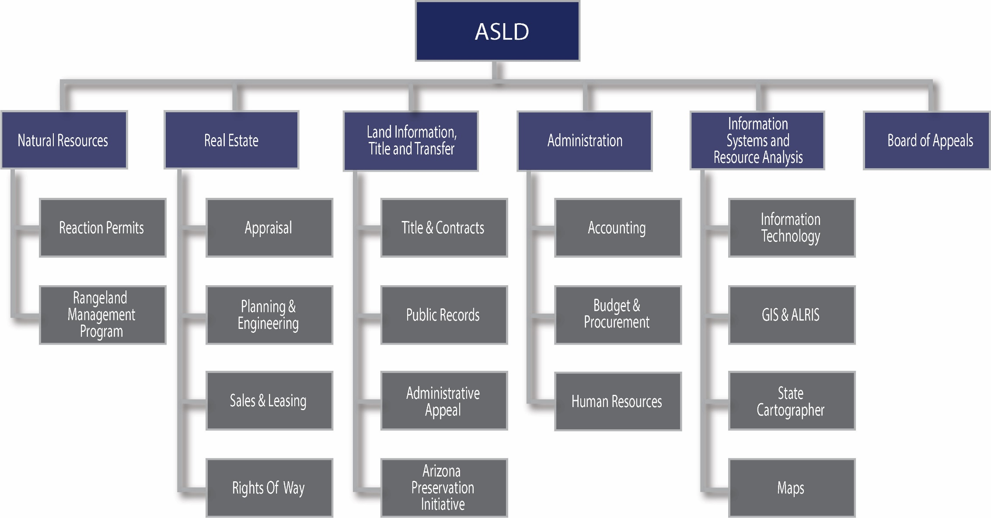

Rights of Way, Agriculture, and Minerals Division
The Rights of Way, Agriculture, and Minerals Division administers all right-of-way applications for circulation, utilities, and infrastructure projects on STL. The Division also manages applications and leases for agriculture and surface and subsurface mineral uses of STL.
Planning and Engineering Division
The Planning and Engineering Division secures land entitlements for STL to increase the value of lands ready for near-term disposition. This division also considers annexation requests and evaluates engineering opportunities and constraints associated with proposed development on and adjacent to STL. Jurisdictional Delineations, drainage, and infrastructure projects affecting STL are assessed by the Planning and Engineering team.
Natural Resources Division
The Natural Resources Division is responsible for natural resources-related issues including water rights and trespass on STL. The Division also oversees the Natural Resource Conservation Districts and is responsible for recreation permits and the Rangeland Management Program.
Real Estate Division
The Real Estate Division supports the sale and commercial leasing of STL. The Division manages the land disposition process and provides recommendations that maximize the revenue for Trust beneficiaries.
Administration Division
The Administration Division oversees the State’s land ownership title; manages public records; and prepares leases, permits, and other contracts related to the surface acreage within the STL. Administrative appeals, hearings, and Board of Appeals, budget development and implementation, fiscal monitoring and reporting, accounting, and purchasing all are handled by the Administration Division.
Information Systems and Resource Analysis Division
The Information Systems and Resource Analysis Division manages the Department’s information systems, business systems, and supports development and implementation of GIS throughout Arizona via the Arizona Land Resource Information System (ALRIS) and the State Cartographer’s Office.
Internal Services Division
The Internal Services Division oversees ASLD’s Central Arizona Project water allocations, sovereign waterways and manages cultural resource compliance for proposed uses of STL. The Division also manages audit and compliance of lease and sales payments.
Board of Appeals
All sales and commercial leases on State lands must be approved by the Board of Appeals (A.R.S. § 37-215). Additionally, the Board of Appeals serves as the Administrative Review Board.

17.11 | SUSTAINABILITY
TABLE OF CONTENTS
17.11.1 | Overview
17.11.2 | Federal Partnership for Sustainable Communities
17.11.3 | Sustainable Transportation
17.11.4 | Sustainability Planning for Arizona MPOs and COGs
17.11.5 | Other National Resources for Sustainability Planning
17.11.6 | Additional Arizona Sustainability Planning Resources

17.11 | Sustainability

17.11.1 | Overview
Sustainability is long established and an evolving area of practice that can be defined in different ways by individual agencies depending on specific priorities or constraints. However, the basic conceptual framework for sustainability often stresses the importance of a comprehensive and holistic consideration of economic, social, and environmental goals – often referenced as the “Triple Bottom Line.”

Figure 17.11-1 | Triple Bottom Line
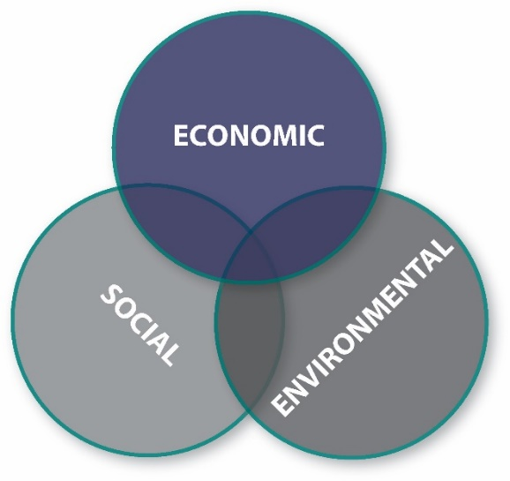
Economic, social and environmental activities interact in so many ways, so sustainability principles encourage balancing their interrelationship. Ideal solutions will generate long-term benefits in all three areas to preserve and enhance ecological systems and minimize environmental impact/maximize environmental benefits to save money and use resources more efficiently over a project life-cycle, to promote economic competitiveness and prosperity, and to facilitate equity and community quality of life.
Sustainability and livability are closely related concepts that are often referenced interchangeably because livability hones in on sustainability related goals that directly affect how people live in a community, such as increasing travel choices, making housing more affordable, or creating high wage jobs. In practice, transportation solutions that support both livability and sustainability concepts are likely to be similar.
Support for sustainability has been on the rise nationally as evidenced by the growing body of policies, plans, programs, methodologies, assessment and rating tools, even legislative action. There is demand from the public and stakeholders to respond to many sustainability concerns, so government at all levels are incorporating the principles of sustainability into their traditional planning processes to address cross-cutting issues, such as land use, health, or multimodal transportation, and are even using sustainability performance measures to help prioritize and influence funding decisions.
During 2011, ADOT MPD expanded their capabilities to include a Sustainability Program. This program is intended to provide ADOT, MPOs, COGs and local agencies a resource to assist with sustainable practice planning and implementation strategies. The ADOT Sustainability Program monitors the industry at local and national levels to bring that knowledge base and experiences to Arizona’s communities. It is a resource to support the connection between community development and transportation and the contribution to the triple bottom line – economic vitality, community livability, and environmental health. The Program provides technical assistance, including how ADOT furthers its partnerships, to support new decision-making around sustainable growth and economic development, building healthy communities, climate / extreme weather resiliency and preparedness, green infrastructure and renewable resource opportunities.
Substantial planning resources related to sustainability are readily available. ADOT is creating a Smart Transportation Guidebook to provide a framework for the agency to more resilient, flexible, and responsive to new concepts in smart transportation, sustainability and livability. The Guidebook will be an online reference toolkit for incorporating new concepts into planning, decision‐making, project scoping, and design, operations, and maintenance practices.

17.11.2 | Federal Partnership for Sustainable Communities
1| | Provide more transportation choices. Develop safe, reliable, and economical transportation choices to decrease household transportation costs, reduce our nation’s dependence on foreign oil, improve air quality, reduce greenhouse gas emissions, and promote public health.
2| | Promote equitable, affordable housing. Expand location- and energy-efficient housing choices for people of all ages, incomes, races, and ethnicities to increase mobility and lower the combined cost of housing and transportation.
3| | Enhance economic competitiveness. Improve economic competitiveness through reliable and timely access to employment centers, educational opportunities, services and other basic needs by workers, as well as expanded business access to markets.
4| | Support existing communities. Target federal funding toward existing communities—through strategies like transit-oriented, mixed-use development (TOD) and land recycling—to increase community revitalization and the efficiency of public works investments and safeguard rural landscapes.
5| | Coordinate and leverage federal policies and investment. Align federal policies and funding to remove barriers to collaboration, leverage funding, and increase the accountability and effectiveness of all levels of government to plan for future growth, including making smart energy choices such as locally generated renewable energy
6| | Value communities and neighborhoods. Enhance the unique characteristics of all communities by investing in healthy, safe, and walkable neighborhoods—rural, urban, or suburban.

PARTNERSHIP FOR SUSTAINABLE COMMUNITIES GUIDING LIVABILITY PRINCIPLES

Sustainable communities have been characterized as places that offer a variety of housing and transportation choices with destinations close to home. As a result, they tend to have lower transportation costs for both provider and user, decreased infrastructure costs, and reduced air pollution. These communities preserve historic properties and sensitive lands and are more economically resilient. A sustainable community can be urban, suburban, or rural. They are places that provide homes working families can afford, reliable and economical transportation options, shopping and other daily needs close to where people live, and vibrant and healthy neighborhoods that attract young people and businesses.
The U.S. Department of Housing and Urban Development (HUD), U.S. Department of Transportation (DOT), and the U.S. Environmental Protection Agency (EPA) have come together to form the Federal Partnership for Sustainable Communities to work to support national goals for strengthening our economy, for creating good jobs while providing a foundation for lasting prosperity, for using energy more efficiently to secure energy independence, and for protecting our natural environment and human health. This federal initiative has been working to break down the traditional silos of housing, transportation, and environmental policy to consider these issues as they exist in the real world—inextricably connected.
These partnering agencies incorporate six principles of livability into federal funding programs, policies, and future legislative proposals.

17.11.3 | Sustainable Transportation
When thinking about delivering transportation solutions and infrastructure in a more sustainable manner, agencies and companies are considering how to support a variety of environmental, economic, and social objectives to guide planning, policy decisions, and implementation. Historically, much of the existing transportation infrastructure in the United States was developed with an emphasis on vehicle mobility and safety that focused more on capacity expansion than on addressing demand management, improving operational efficiency, or considering integration with land use and surrounding communities. However, sustainable transportation emphasizes multi-objective, integrated planning. Rather than just build a wider road to provide access and mobility, transportation strategies might focus on pedestrians, bicycles, and transit to better link residential areas to schools, parks, and businesses, and also accomplish improved public health, neighborhood revitalization, congestion reduction, and infrastructure cost savings. Figure 17.11-2 illustrates potential community goals that can be addressed through sustainable transportation. Table 17.11-1 lists some potential strategies for achieving sustainable transportation.

Figure 17.11-2 | Sustainable Transportation Concept
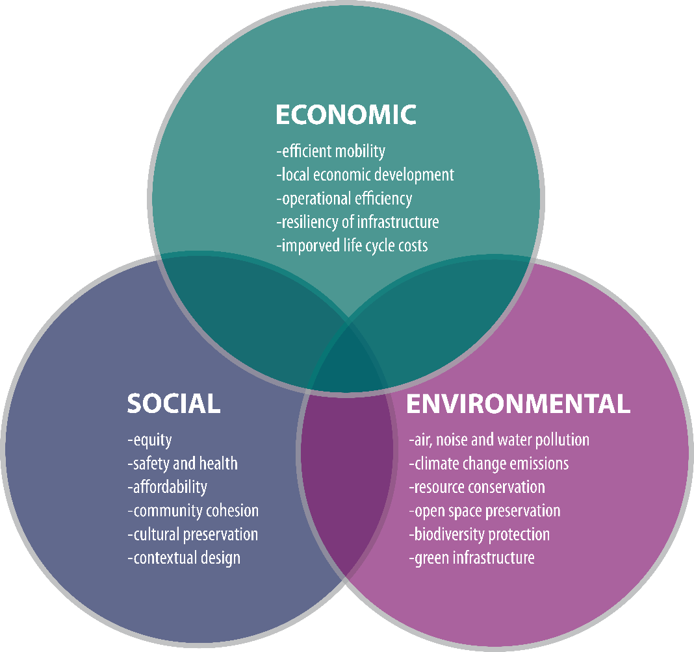

17.11.4 | Sustainability Planning for Arizona MPOs and COGs
Many Arizona MPOs, COGs, and local agencies are integrating a focus on sustainability into their local general and comprehensive plans and transportation plans, and regional transportation work programs, to coordinate policies and programs for human services, energy, land-use, economic development, transportation, stormwater mitigation, air quality, and other components. Many of the Federal Planning Factors and Emphasis Areas included these sustainability topics. Table 17.11-2 at the end of this topic section lists some potential sustainability goals and objectives that could be integrated into MPO and COG planning.

17.11.5 | Other National Resources for Sustainability Planning
The following national resources provide some excellent resource materials for sustainability planning:
- The FHWA Transportation Planning and Sustainability Guidebook presents critical issues involved in planning for sustainable transportation systems and reviews current practices in the United States and abroad that address these issues. Case studies of sustainability practices are presented and cutting-edge evaluation methods are discussed.
- FHWA’s Sustainable Highways Self Evaluation Tool, also known as INVEST, is a web-based tool and resource to help transportation agencies make roadway projects more sustainable. The tool takes a lifecycle approach to sustainable roadway projects, by evaluating them from system and project planning through design, construction, and operations and maintenance.
- The Housing and Urban Development Office of Sustainable Housing and Communities has tools available create strong, sustainable communities by connecting housing to jobs, fostering local innovation, and helping to build a clean energy economy.
- The EPA researchers and their partners from across a wide spectrum of investigative fields are working together to form a deeper understanding of the balance between the three pillars of sustainability - environment, society, and economy. The EPA Sustainable Practices Program has several resources that are applicable to state, MPO and COG planning activities.
- The AASHTO Center for Environmental Excellence provides a database of case studies, best practices and innovative tools/approaches relating to plan development which typically includes a review and evaluation of best practices and case studies.
- The State Smart Transportation Initiative (SSTI) promotes transportation practices that advance environmental sustainability and equitable economic development, while maintaining high standards of governmental efficiency and transparency.
- The American Planning Association Centers for Planning provide resources to engage in policy-relevant research and education involving community health, natural and man-made hazards, and green communities.

Table 17.11-1 | Sustainable Transportation Strategies
Strategy | Definition
Transportation Demand Management (TDM) | Strategies intended to reduce single-occupant vehicle (SOV) demand or redistribute this demand across the transportation system. Examples include ride-sharing programs, increased public transportation and bicycle facilities, high occupancy vehicle (HOV)/HOT lanes, congestion pricing, and increased parking pricing.
Increase Opportunities for Walking and Bicycling | Strategies to improve the safety and accessibility for walking and bicycling by providing sidewalks and signed routes for bicycles (either delineated bicycle lanes or share-the-road markers).
Increase Transit Access and Coverage | Transit accessibility relates directly to the ability for a transit user to easily and safely access a transit stop from the stop catchment area. This is generally one-half of a mile radius around the stop location for pedestrians and two miles for bicyclists.
Location Efficiency/  Jobs-Housing Balance | As areas develop, it is important to maintain a balance between the jobs offered in the region with the available housing that is also available.
Land-Use Connection | Providing cross access between adjacent parcels, particularly commercial parcels, improves safety and travel opportunities for all users. This also helps to lessen unnecessary travel demand from the roadway.
Complete Streets | Roadways designed to safely and efficiently accommodate all modes of travel and all users. Provision of safe pedestrian crossings and walkways is typically a focus of complete streets.
Multimodal Corridors | Creating high capacity inter- and intra-city corridors that integrate travel modes to optimize mobility. Multimodal corridors typically accommodate vehicular traffic and high capacity transit service, and often provide separated multi-use (bicycle/pedestrian) paths.
Network Connectivity | Aligning street intersections, providing redundancy such as a grid network, and reducing cul-de-sac use improves network connectivity.
Transit Oriented Development (TOD) | Development approaches in urban areas that create relatively higher density mixed-use residential /commercial neighborhoods centered around transit stations or hubs. This development strategy reduces auto trips, by creating an environment highly conducive to pedestrians, bicycles, and transit.
Safe Routes to School (SRTS) | Program focused on improving children’s safety while walking and bicycling in proximity to schools.
Bicycle Sharing | Bicycle systems that provide a means, typically paid for by the user, to use a bicycle for short durations.
Active Transportation and Health | Effort to make it safe and convenient to walk, bicycle and access transit.
Context Sensitive Solutions (CSS) | A collaborative, interdisciplinary approach to developing transportation projects that consider the entire roadway environment (mobility, access, safety, aesthetics, and preservation of historic, community and environmental resources) when developing solutions to fit the setting and goals.
Road Diets | A technique typically applied to roadways with excess vehicular capacity in which lanes and/or parking are removed and replaced with bicycle lanes, transit lanes, sidewalks or paths, a center turn lane, or landscaping strips.
Lane Diets | Similar to road diets, however lane and median widths are reduced to accommodate bicycle and pedestrian facilities.
Alternative Fuel/  Vehicle Efficiency | Regional policies/programs that support and encourage alternative fueled vehicles, such as establishing a network of electric charging stations, or set minimum fuel efficiency requirements for vehicles sold in the area.

Table 17.11-1 | Sustainable Transportation Strategies (continued)
Strategy | Definition
Green Design/  Green Infrastructure/  Green Materials | Natural strategies and techniques intended to address urban climate change and pollution issues, including storm water management, increased shade and use of lower heat absorbing materials to reduce heat stress, air quality, safety of active modes, water harvesting and water conservation, non-fossil fuel energy production, and local food production.
Rail and Freight Efficiency Improvements | Locating rail and freight corridors for quick and efficient access to systems for transfer and distribution.
Smart Parking | Parking systems that can provide motorists direction to available parking stalls, provide other means for payment (electronic), reduce operations requirements and ways to reduce maintenance activities on equipment.
Intelligent Transportation Systems | The application of a broad range of advanced traffic control and traveler information technologies to optimize the operation of all transportation systems throughout the day to achieve maximum capacity and efficiency. Examples include ramp metering, adaptive traffic signal control, signal system coordination, transit and emergency vehicle signal priority or pre-emption, and automated transit vehicle locating systems.
Climate Change Mitigation/Adaption | Strategies to reduce green-house gas emissions, address increased flood hazards, and manage solar radiation (heat stress).
Wildlife Crossings/Fencing | Use of specially designed bridges or underpasses with fencing to mitigate the impact of roadways on wildlife corridors and reduce road kills while increasing transportation safety

17.11.6 | Additional Arizona Sustainability Planning Resources
HabiMap™ & the State Wildlife Action Plan: The Arizona Game and Fish Department (AZGFD) recently revised its State Wildlife Action Plan that provides a framework and information to assist in setting conservation priorities for the state’s wildlife and habitats. Data gathered for Arizona’s State Wildlife Action Plan represents myriad sources and extensive public comment, and is used to support the Department’s efforts to develop proactive conservation goals and objectives. Much of that data (more than 300 data layers) is compiled into a single model of wildlife conservation potential, the Species and Habitat Conservation Guide.
To ensure the State Wildlife Action Plan information is accessible and useful to everyone, the AZGFD developed HabiMap™ Arizona. This user-friendly, web-based tool allows users to visually explore the distribution of Arizona’s wildlife, potential stressors to wildlife, the Species and Habitat Conservation Guide, and other relevant data.
The Species and Habitat Conservation Guide provides non-regulatory information compiled from the best available data, and is meant to identify Arizona’s wildlife conservation potential at a statewide scale, regardless of ownership. It does not replace or supersede consultation with the AZGFD. HabiMap™ Arizona is intended to be used as an early planning tool for landscape-level analysis and should be used in concert with all available data and expertise to ensure project plans address wildlife and habitat conservation at all levels. Site-specific analysis will require additional wildlife information and on-the-ground expertise from the AZGFD biologists. For more information on environmental compliance issues and special status species (including plants), please use the Online Environmental Review Tool at https://ert.azgfd.gov/.
Urban Land Institute – Arizona: supports the development of livable communities and sustainable development practices.
Health in Policy and Practice: focused on developing healthy communities in Arizona. A Health Impact Assessment (HIA) is a data-driven tool used to assess the potential health impacts of a policy, project, program or proposal. The goal of a HIA is to ensure that health and health disparities are considered in decision-making using an objective and scientific approach, and engaging stakeholders in the process. HIAs have been used at the national, state, and local levels for a variety of proposals including transportation, general and comprehensive plans. Explicit health impacts highlight health disparities and provide recommendations to shape public decisions and discourse. The purpose of the HIA process is to engage and empower communities, emphasize lay knowledge in decision-making, strengthen relationships and collaboration, and build consensus around decisions.
Housing + Transportation Affordability Index: an innovative tool that measures the true affordability of housing based on its location.

Table 17.11-2 | Sample Sustainability Goals and Objectives
Goal | Objectives
Mobility
The transportation system should provide the general public and those who move goods with convenient travel options. The system also should operate in a way that maximizes productivity. It should reduce the time it takes to travel and the costs associated with travel. | Tailor transportation improvements to better connect people with jobs and other activities.
 | Provide convenient travel choices including transit, intercity and high speed trains, driving, ridesharing, walking, and biking.
 | Preserve and expand options for regional freight movement.
 | Increase the use of transit, ridesharing, walking and biking in major corridors and communities.
 | Provide transportation choices to better connect the San Diego region with Mexico, neighboring counties, and tribal nations.
Reliability
The transportation system should be reliable. Travelers should expect relatively consistent travel times, from day to day, for the same trip and mode of transportation. | Employ new technologies to make travel more reliable and convenient.
 | Manage the efficiency of the transportation system to improve traffic flow.
System Preservation and Safety
The transportation system should be well maintained to protect the public’s investments in transportation. It also is critical to ensure a safe regional transportation system. | Keep the region’s transportation system (including right-of-way) in a good state of repair.
 | Reduce the bottlenecks and increase safety by improving operations.
 | Improve emergency preparedness within the regional transportation system.
Social Equity
The transportation system should be designed to provide tan equitable level of transportation services of all segments of the population in accordance with Title VI and Environmental Justice objectives. | Create equitable transportation opportunities for all population regardless of age, ability, race, ethnicity, or income.
 | Ensure access to jobs, services, and recreation for population with fewer transportation choices.
Healthy Environment
The transportation system should promote environmental sustainability and foster efficient development patterns that optimize travel, housing, and employment choices. The system should encourage growth away from rural areas and closer to existing and planned development. | Develop transportation improvements that respect and enhance the environment.
 | Reduce greenhouse gas emission from vehicles and continue to improve air quality in the region.
 | Make transportation investments that result in healthy and sustainable communities.
Prosperous Economy
The transportation system should play a significant role in raising the region’s standard of living. | Maximize the economic benefits of transportation investments.
 | Enhance the goods movement system to support economic prosperity.

17.12 | BICYCLE AND PEDESTRIAN PLANNING
TABLE OF CONTENTS
17.12.1 | Introduction
17.12.2 | Arizona Policies
17.12.3 | Bicycle & Pedestrian Planning Considerations
Create a Vision Statement, Goals, and Performance Criteria
Develop Regional Objectives for Non-Motorized Facilities
Define the Bicycle Network
Develop Intermodal Connections and Wayfinding
Safety
Facility Maintenance
Education, Encouragement, and Awareness
17.12.4 | Funding Sources for Non-Motorized Improvements
Federal-Aid Highway Programs
Federal Transit Programs
Highway Safety Programs
NHTSA 402 Grants

17.12 | Bicycle and Pedestrian Planning
The ADOT Statewide Bicycle and Pedestrian Plan Update can be found here:

https://azdot.gov/adot-news/adot-finalizes-bicycle-and-pedestrian-plan-update
ADOT Bicycle and Pedestrian Program:

http://www.azbikeped.org/

17.12.1 | Introduction
Bicycle and pedestrian planning considers the ways bicycling and walking can be integrated into MPO/COG transportation programs and planning in order to meet the USDOT policy requirements.
Based on various sections of the United States Code and the Code of Federal Regulations, the United States Department of Transportation Policy Statement on Bicycle and Pedestrian Accommodation Regulations and Recommendations requires that bicycle and pedestrian facilities be incorporated into state, regional and local transportation systems and projects. 23 U.S.C. § 217: Bicycle Transportation and Pedestrian Walkways includes this requirement: Bicyclists and pedestrians shall be given due consideration in the comprehensive transportation plans developed by each metropolitan planning organization and state in accordance with sections 134 and 135” (23 U.S.C. § 217(g)(1); see also 23 U.S.C. § 134 and 23 U.S.C. § 135).
US DOT Policy Statement on Bicycle and Pedestrian Accommodation:

https://www.fhwa.dot.gov/environment/bicycle_pedestrian/guidance/policy_accom.cfm
The USDOT considers bicycles equal with other modes of transportation, and its policies encourage transportation agencies to adopt similar statements on bicycle and pedestrian accommodations, particularly because of the individual and community benefits provided by bicycling and walking. The needs of bicyclists and pedestrians of all abilities should be involved throughout the planning process and should not be adversely affected by other transportation projects. Regional and local transportation agencies should be able to track annual obligations and expenditures of non-motorized transportation facilities.
USDOT Bicycle and Pedestrian Program:

https://www.transportation.gov/bicycles-pedestrians
The recently updated ADOT Statewide Bicycle and Pedestrian Plan presents a vision for bicycling and walking in Arizona. This plan is intended to guide transportation decisions regarding the creation of shared roadways and bicycle and pedestrian facilities along the state highway system. The plan includes:
- Goal No. 1: Increase bicycle and pedestrian trips.
- Goal No. 2: Improve bicycle and pedestrian safety.
- Goal No. 3: Improve bicycle and pedestrian infrastructure.

17.12.2 | Arizona Policies
ADOT’s adopted bicycle policy (MGT 02.1, Bicycle Policy) promotes safe and convenient access to the state highway system for bicyclists. Section 1(d) of the policy reads: “Provide shared roadway cross-section templates as a minimum condition with new major construction and major reconstruction projects, regardless of the presence of a shared-use path” (ADOT 2007, 2).
MGT 02.1, Bicycle Policy:

http://www.azbikeped.org/downloads/MGT01-2-Bike-Policy.pdf
The FHWA provides numerous resources that cover a wide range of bicycle facility planning.

The Bicycle Compatibility Index: A Level of Service Concept Final Report
This report presents a methodology to determine how compatible a roadway is for allowing efficient operation of both bicycles and motor vehicles.

Guidebook on Methods to Estimate Nonmotorized Travel: Overview of Methods
This guide describes and compares the various methods and tools that can be used to forecast nonmotorized travel demand.

Geographic Information Systems Applications for Bicycle and Pedestrian Decision-Making Peer Exchange Summary Report
This summary report is as a resource for transportation agencies looking to learn more about the implementation of GIS for bicycle and pedestrian planning.

DID YOU KNOW

A related policy is Subsection 1031: Signing and Marking of Shared-Use Paths in ADOT’s Traffic Engineering Policies, Guidelines and Procedures, which states that “shared-use paths on State right-of-way parallel and adjacent to roadways shall not be marked or signed for the preferential or exclusive use of bicyclists. This includes the use of centerline markings, BIKE ROUTE signs, STOP or YIELD signs, or similar devices” (ADOT 2004).
Subsection 1031:

https://azdot.gov/business/engineering-and-construction/traffic/guidelines-and-processes

17.12.3 | Bicycle & Pedestrian Planning Considerations
Guidance for integrating bicycle and pedestrian facilities into regional transportation plans is available in the FHWA Bicycle Planning Guide. The inclusion of non-motorized elements in transportation plans and programs can be achieved by addressing these issues and needs as part of the transportation planning process. Including a separate section on bicycle-specific issues in the RTP in addition to or in place of integration into the overall system plan may be appropriate.
Bicycle and Pedestrian Transportation Planning Guide:

https://www.fhwa.dot.gov/environment/bicycle_pedestrian/guidance/guidance_2019.cfm
This approach addresses the USDOT requirement of developing an intermodal transportation system. A bicycle and/or pedestrian plan element should contain policy statements and goals as well as the inclusion of specific projects and programs. Bicycle facilities include a new or improved lane, path, trail, or shoulder for use by bicyclists and a traffic control device, shelter, or parking facility for bicycles. As such, facilities that enhance the public’s ability to use bicycles as a transportation mode on a daily basis should be considered. The following steps are useful in developing a bicycle-specific plan at the regional level or incorporating bicycle policies and projects in the overall long-term transportation plans.
Create a Vision Statement, Goals, and Performance Criteria
The vision statement expresses what the plan expects to accomplish. Specific plan goals to reach the vision need to be clearly defined and measurable and include a realistic timeframe. An example goal might be to increase bicycle ridership 10 percent each year over the next five years or to double the miles of bicycle lanes, multi-use paths, and trails in 10 years.
Develop Regional Objectives for Nonmotorized Facilities
Existing non-motorized facilities and activity in the community should be assessed and documented to identify the regional bicycling issues and needs. Objectives that build on existing conditions should be developed to define which elements of the bicycle network should be prioritized and what transportation policies and community activities can enhance usage. This assessment should include determining the current level of bicycle trips, bicycle and pedestrian crash history, evaluation of the existing transportation infrastructure relative to bicycle facilities, identification of desired travel corridors, review of planning and design standards relative to bicycle and pedestrian capacity and safety, and review of the ability of transit to accommodate cyclists.
Pedestrian and Bicycle Information Center: A clearinghouse for information about health and safety, engineering, advocacy, education, enforcement, access, and mobility.
http://www.pedbikeinfo.org/state_contacts.cfm?ID=1
Define the Bicycle Network
Cyclists should be considered at all levels of the transportation system; therefore, the bicycle network could evolve into local, regional, and interregional levels of facilities. Planning for the widest bicycle user population requires a range of facilities that are accessible to cyclists of all comfort levels, from the assertive rider to the casual beginner.
Develop Intermodal Connections and Wayfinding
Cyclists, just like drivers, require reliable, accessible parking or storage spaces, ideally at locations close to destinations or intermodal exchange centers, such as transit terminals. Guiding cyclists and informing them of available destinations and facilities is an effective way to increase bicycle usage at the regional level. Similar to automobile drivers, cyclists need information about the best routes to regional destinations and connections to intersecting facilities.
Association of Pedestrian and Bicycle Professionals:
https://www.apbp.org/
Safety
Bicycle and pedestrian safety can be integrated in the overall regional safety plan or be designated as its own priority based on regional needs and existing condition assessments. Improving safety can involve a number of facility enhancements but also may include driver and rider education. Targeted enforcement of the state statutes on the road for drivers, cyclists, and walkers can improve compliance and increase safety.
Facility Maintenance
Integrate non-motorized facilities into the routine roadway maintenance programs. Inventory and update the state of existing facilities on a regular basis to facilitate improvement projects across the entire network in a timely manner.
Education, Encouragement, and Awareness
Engaging the widest possible population in walking and the use of bicycles for recreational and daily use requires programs that interact with the public. Examples of such programs include:
- school outreach programs;
- helmet safety and compliance programs;
- motorist awareness and safety programs; and
- training materials, brochures, and maps.

17.12.4 | Funding Sources for Nonmotorized Improvements
Walking and cycling can be tied to health, economic, and transportation mobility improvements, to name a few benefits. Federal funding sources for those project types are available through a number of programs:
Federal-Aid Highway Programs
- NHPP Program
- STBGP
- Transportation Alternatives Program (TAP)
- Hazard Elimination and Railway-Highway Crossing Program
- CMAQ Improvement Program (MAG only—Casa Grande Accord)
- Recreational Trails Program
- FLTP
- Job Access and Reverse Commute (JARC Grants) MOA
- Designated Transportation Enhancement Activities
Federal Transit Programs
- Urbanized Area (UZA) Formula Grants
- Capital Investment Grants and Loans
- Formula Program for Other than Urbanized Area
Highway Safety Programs
HSIP funds can be used for bicycle and pedestrian facility safety improvements.
NHTSA 402 Grants
Arizona GOHS Bike and Pedestrian Safety programs
The Arizona GOHS administers National Highway Traffic Safety Administration (NHTSA) 402 funds to agencies throughout Arizona to promote pedestrian and bicycle safety. Programs include the following:
- Bicycle Programs
- Driver Behavior Modification/Keeping Bicyclists Safe
- Sharing the Road with Pedestrians guide
- Bike Safety and Laws
- Arizona Bicycle Laws
- Laws for Bicycle Riders Only
- Bicycle Safety Tips
- Safe Bicycle Riding

Appendix A | Common Acronyms
Acronym | Phrase | Section First Mentioned
3-C | comprehensive, cooperative, and continuing (planning process) | 1
AASHTO | American Association of State Highway and Transportation Officials | 17.5
ABMs | activity-based models | 17.4
ACIP | Airport Capital Improvement Plan | 2
ADA | Americans with Disabilities Act | 8
ADEQ | Arizona Department of Environmental Quality | 2
ADOT | Arizona Department of Transportation | 1
ADT | average daily traffic | 17.3
AFB | Air Force Base | 16
AGIC | Arizona Geographic Information Council | 17.9
AIP | Airport Improvement Program | 16
Acronym | Phrase | Section First Mentioned
AIRFA | American Indian Religious Freedom Act | 17.6 (in table)
ALP | Airport Layout Plans | 16 (in table)
ALRIS | Arizona Land Resource Information System | 17.10
AMP | Airport Master Plan | 16 (in table)
AMUG | Arizona Modeling Users Group | 17.4
ARPA | Archaeological Resources Protection Act | 17.6 (in table)
A.R.S. | Arizona Revised Statutes | 1
ASLRRA | American Short Line and Regional Railroad Association | 15
ASTB | Arizona State Transportation Board | 1
ATA | Arizona Trucking Association | 15
ATIS Roads | Arizona Transportation Information System | 2
Acronym | Phrase | Section First Mentioned
ATSPT | Arizona Tribal Strategic Partnering Team | 17.6 (in text box)
AWOS | automated weather observing system | 16
ADEQ | Arizona Department of Environmental Quality | 2
AZGFD | Arizona Game and Fish Department | 17.11
AZTDM | Arizona Travel Demand Model | 2
B/C | benefit-cost | 17.5
BIA | Bureau of Indian Affairs | 2
BIADOT | Bureau of Indian Affairs Division of Transportation | 2
BLM | Bureau of Land Management | 17.9
BMP | Border Master Plan | 15
BNSF | Burlington Northern Santa Fe Railroad | 15
BqAZ | Building a Quality Arizona | 1
CAA | Clean Air Act | 10
Acronym | Phrase | Section First Mentioned
CAAA | Clean Air Acts Amendments | 17.1
CAG | Central Arizona Governments | 1
CANAMEX | Canada to Mexico corridor | 15
CAP | Corrective Action Plan | 2
CASPP | Continuous Airport System Planning Process | 2
CCTV | closed circuit television | 17.2
CFLHD | Central Federal Lands Highway Division | 2
CFR | Code of Federal Regulations | 1
CIKR | Critical Infrastructure and Key Resources | 16
CMAQ | Congestion Mitigation and Air Quality | 4
CMFs | Crash Modification Factors | 17.5
CMP | Congestion Management Process | 7
Acronym | Phrase | Section First Mentioned
CMSA | Consolidated Metropolitan Statistical Area | 3
CO | carbon monoxide | 1 (in table)
COG | Council of Governments | 1
CTOC | Citizens Transportation Oversight Committee | 2
CYMPO | Central Yavapai Metropolitan Planning Organization | 1
DBE | Disadvantaged Business Enterprise | 1 (in table)
DHS | U.S. Department of Homeland Security | 16
DIF | development impact fee | 10
DOI | U.S. Department of Interior | 2
DOJ | U.S. Department of Justice | 12
DOTs | departments of transportation | 15
EPA | U.S. Environmental Protection Agency | 2
Acronym | Phrase | Section First Mentioned
ESTIP | Electronic State Transportation Improvement Program | 8
FAA | Federal Aviation Administration | 2
FEMA | Federal Emergency Management Agency | 17.9 (in table)
FHWA | Federal Highway Administration | 1 (in text box)
FLTP | Federal Lands Transportation Program | 2
FMPO | Flagstaff Municipal Planning Organization | 1
FMS | Financial Management Services | 8
FPN | financial project number | 8
FTA | Federal Transit Administration | 1
FR | Federal Register | 1
FRA | Federal Railroad Administration | 2
GA | general aviation | 16
Acronym | Phrase | Section First Mentioned
GAO | Government Accountability Office, U.S. | 16
GARVEEs | Grant Anticipation Revenue Vehicles | 10
GIS | geographic information system | 2
GIS-T | Geographic Information Systems for Transportation | 2
GOHS | Governor’s Office of Highway Safety | 17.5
GPS | global positioning system | 2
GRT | Grant Agreement | 1
HEW | Department of Health, Education, and Welfare | 12
HOV | high occupancy vehicle | 17.11 (in table)
HPMS | Highway Performance Monitoring System | 2
HSIP | Highway Safety Improvement Program | 10
HSTCP | Human Services Transportation Coordination Plan | 14
Acronym | Phrase | Section First Mentioned
HTF | Highway Trust Fund | 10
HUD | Housing and Urban Development | 2
HURF | Highway User Revenue Fund | 10
IRR | Indian Reservation Roads Program | 17.6
ISDEAA | Indian Self-Determination and Education Assistance Act of 1975 | 2
ISTEA | Intermodal Surface Transportation Efficiency Act | 3
ITEA | Indian tribal economic alliance | 10
JARC | Job Access and Reverse Commute | 17.12
LEP | Limited English Proficient | 12
LPA | Local Public Agency | 17.3
LPV | Localizer Performance with Vertical guidance | 16
LPOE | land port of entry | 15
LRTP | Long-Range Transportation Plan | 2
Acronym | Phrase | Section First Mentioned
MAG | Maricopa Association of Governments | 1
MAP | Military Airport Program, FAA | 16
MAP-21 | Moving Ahead for Progress in the 21st Century Act | 1 (in table)
MMI | Multimodal Infrastructure | 15
MOA | Memorandum of Agreement | 3
MOU | memorandum of understanding | 17.4
MOVES | Motor Vehicle Emission Simulator | 17.1
MPA | Metropolitan Planning Area | 3
MPD | Multimodal Planning Division | 1
MPO | Metropolitan Planning Organization | 1
MSA | Metropolitan Statistical Area | 3
MTIP | Metropolitan Transportation Improvement Program | 2 (in table)
Acronym | Phrase | Section First Mentioned
MTP | Metropolitan Transportation Plan | 1
NAAQS | National Ambient Air Quality Standards | 5
NACOG | Northern Arizona Council of Governments | 1
NAGPRA | Native American Graves Protection and Repatriation Act | 17.6 (in table)
NEPA | National Environmental Policy Act of 1969 | 2
NHPP | National Highway Performance Program | 10
NHPA | National Historic Preservation Act | 17.6 (in table)
NHS | National Highway System | 6
NHTSA | National Highway Traffic Safety Administration | 17.12
NIPP | National Infrastructure Protection Plan | 16
NOFA | Notice of Funding Availability | 14
NOx | nitrogen dioxide | 17.1 (in table)
Acronym | Phrase | Section First Mentioned
NPIAS | National Plan of Integrated Airport Systems | 16 (in table)
OIG | Office of the Inspector General | 9
OMB | U.S. Office of Management and Budget | 3
P3 | public private partnership | 10
PAC | Policy Advisory Committee | 15
PAG | Pima Association of Governments | 1
PABs | private activity bonds | 10
PARA | Planning Assistance for Rural Areas | 2
PE | preliminary engineering | 7
PEL | Planning and Environmental Linkages | 2
PGLs | Planning Grant Program | 16
PL | Metropolitan Planning program | 14
PM | particulate matter | 17.1
Acronym | Phrase | Section First Mentioned
PMS | pavement management system | 17.3 (in table)
POE | port of entry | 15
POP | Program of Projects | 13
PPAC | Priority Planning Advisory Committee | 2
PPP | Priority Programming Process | 2
RASP | Regional Aviation System Plan | 16
RIC | Recommended Investment Choice | 2
RIMS | Roadway Inventory Management Section | 2
ROW | right-of-way | 10
RTAP | Rural Transit Assistance Program | 14 (in table)
RTP | Regional Transportation Plan | 1 (in table)
RTPO | Regional Transportation Planning Organization | 1
Acronym | Phrase | Section First Mentioned
SAFETEA-LU | Safe, Accountable, Flexible, Efficient Transportation Equity Act: A Legacy for Users | 1 (in table)
SALEO | Southern Arizona Logistics Education Organization | 15
SANS | State Aviation Needs Study | 2
SASP | State Airports System Plan | 2
SCT | Secretaría de Comunicaciones y Transportes | 15
SEAGO | Southeastern Arizona Governments Organization | 1
SGR | State of Good Repair | 6
SHS | State Highway System | 15
SIBs | State Infrastructure Banks | 10
SIP | State Implementation Plan | 2
SOV | single-occupancy (or occupant) vehicle | 17.1
Acronym | Phrase | Section First Mentioned
SPF | Safety Performance Function | 17.5
SPR | State Planning and Research | 1
SPSR | San Pedro & Southwestern Railroad | 15
SRP | State Rail Plan | 2
SSPP | System Safety Program Plan | 2
STBG | Surface transportation Block Grant | 1
STIP | State Transportation Improvement Program | 2
STSP | Strategic Traffic Safety Plan | 2
SVMPO | Sierra Vista MPO | 1
TA | Transportation Alternatives | 4
TAC | Technical Advisory Committee | 1
TCM | Transportation Control Measure | 8
TDM | travel demand model | 17.1
Acronym | Phrase | Section First Mentioned
TDM&A Group | Travel Demand Modeling & Analysis Group | 2
TDMS | Transportation Data Management System | 2
TDP | Transit Development Plan | 8
TEA-21 | Transportation Equity Act for the 21st Century | 1 (in table)
TIFIA | Transportation Infrastructure Finance and Innovation Act | 10
TIP | Transportation Improvement Program | 1
TMA | Transportation Management Area | 1
TOD | Transit Oriented Development | 17.11
TTAC | Transportation Technical Advisory Committee | 4
TTIP | Tribal Transportation Improvement Program | 2
TTP | Tribal Transportation Program | 1
Acronym | Phrase | Section First Mentioned
TWG | Technical Working Group | 15
UPRR | Union Pacific Railroad | 5
UPWP | Unified Planning Work Program | 1 (in table)
U.S.C. | United States Code | 1
USDOT | U.S. Department of Transportation | 1
USFWS | U.S. Fish and Wildlife Service | 17.9 (in table)
USGS | U.S. Geologic Service | 17.9
USPS | U.S. Postal Service | 16
UZA | urbanized area | 3
VLT | vehicle license tax | 10
VMT | vehicle miles traveled | 6 (in table)
VOC | volatile organic compounds | 16
WACOG | Western Arizona Council of Governments | 1
WP | Work Program | 1 (in table)
Acronym | Phrase | Section First Mentioned
YMPO | Yuma Metropolitan Planning Organization | 1
YOE | Year of Expenditure | 7

1 | Note: USDOT Order 5610.2(a) requires administrators to obtain information regarding “the present and proposed membership, by race, color or national origin in any planning or advisory body [associated with USDOT] policy s, programs, and activities,” which implies that membership composition is relevant with respect to Title VI and Environmental Justice matters. (See chapter 13, “Public Involvement”).

