# Project Master

All ADOT Projects have a unique ADOT Project Number (e.g., H8933) to capture project data, such as, location or Geographic Information Systems (GIS), financial and political demographics. During project inititation, to create a project ADOT Project Number, the ADOT PM may access the [Project Master Web Portal](http://aidw/projectmasterportal/Index.aspx) within Arizona

Information Data Warehouse (AIDW). The web site home page has helpful hints, data and features as illustrated in the following exhibits.

To create a new ADOT Project Number, the ADOT PM must select “Request ITD Project“, listed under quick links as shown below or select the “Project” tab in the menu bar.

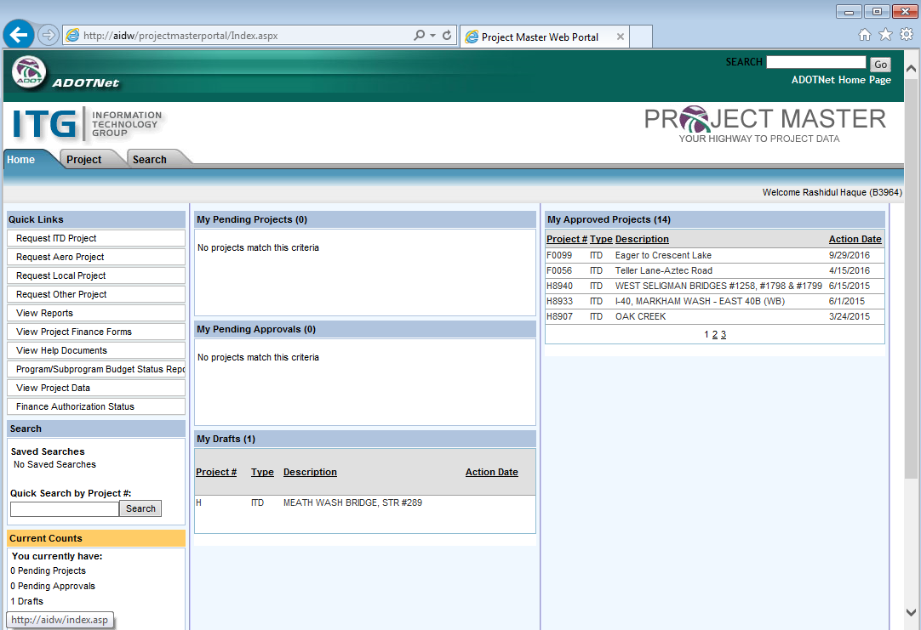

The form below will appear after selecting “Request Local Project”. The PM must populate the form with project location information, funding sources, etc. It is common for many of the cells to auto-populate after the project name, route, milepost and project length are entered. Most of the fields in the form will show directive notes or options to choose from when filling out these cells. To activate guidance and suggestions hover cursor over desired field or, in some cases, select from drop down menu options. Due to software limitations or administratively accepted field size, some of the cells may have limited character capacity. “Major Program Short Name“, as an example, is limited to 15 characters.

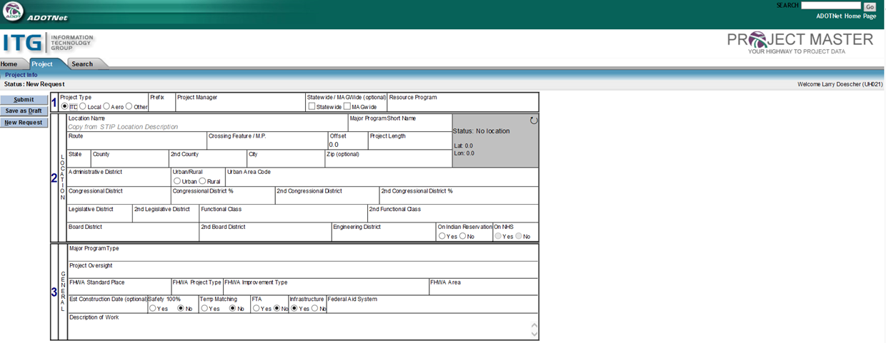

After filling out the form, the PM may select the “Submit” button for approval of the ADOT Project Number The request will be forwarded for approval by a Project Management Group (PMG) Manager and ADOT Project Accounting. Typically within a day or two, the submittal is approved with an email notification to the PM. The PM can check the status of the submittal through the same website via the “My Pending Approvals” window. If critical information is missing, incomplete or in error, the approving authority can reject the submittal, which will also automatically generate an email back to the PM, providing the reasons for the action.

A project ADOT Project Number consists of both a unique project number (e.g., H8933), as well as, subproject/subphase such as (e.g., 01L for studies, 01D for design, 01C for construction, etc.). Once the project TRACS no. is approved, the PM will request appropriate subproject/subphase as shown in the following exhibit:

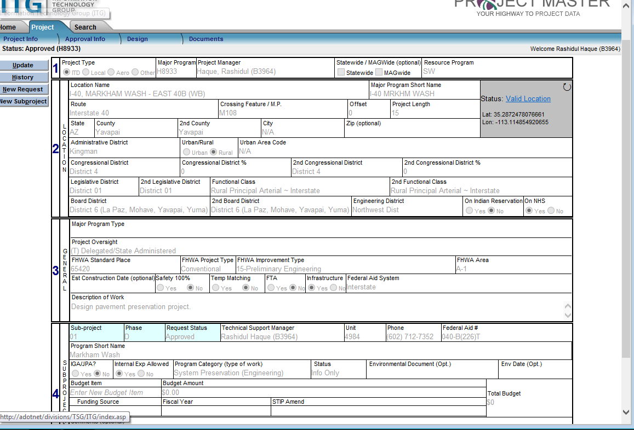

The project and subprojects approvals history can be viewed any time from the project menubar, as shown in

the following example.

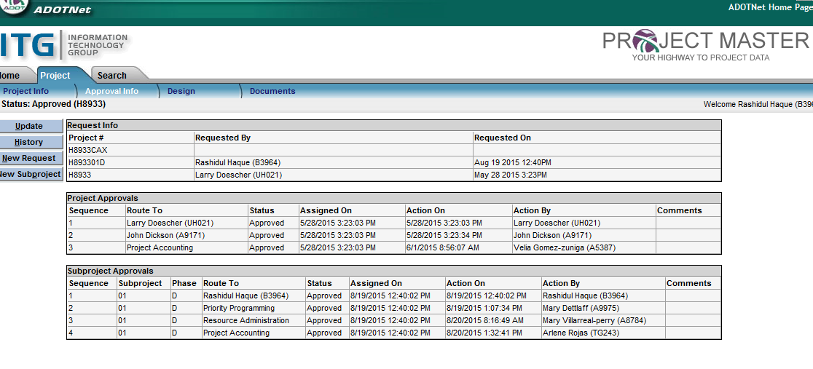

Following approval, all ADOT Project Numbers and subphases will autopopulate the AFIS & PRO tabs within the PIRT system.