

**Arizona Department of Transportation**

**Environmental Planning Group**

**Jurisdictional Delineation Report   
Including Wetlands**

**For**

**[Project Name]**

**Corps File Number:**

**[TRACS Number]**

**[Federal Aid Number]**

**[Date]**

**Submittal #**

*All information contained in this document is the property of ADOT.*

*ADOT approval is required prior to reproduction or distribution.*

Table of Contents

##### 

1. Location 2

2. Purpose 2

3. Location Description 2

4. Methods 6

5. Results 8

6. Summary 10

7. Coordination 10

8. References 11

9. Signatures 11

List of Tables

Table 1. Summary of Open Water and Other Waters of the US. 8

Table 2. Plant Communities and Presence of Hydrophytic Vegetation in the Wetland Survey Area 8

Table 3. Indicators of Hydric Soils in the Wetland Survey Area 9

Table 4. Indicators of Wetland Hydrology in the Wetland Survey Area 9

Table 5. Cowardin Classification of Wetlands in the Wetland Survey Area 9

Table 6. Summary of Characteristics and Presence of Wetlands in the Wetland Survey Area 10

Table 7. Summary of Waters Type and Amount of Proposed Waters of the US. 10

List of Figures

Figure 1. State Location Map 3

Figure 2. Vicinity Map 4

Figure 3. Jurisdictional Delineation Survey Area, Topographic, and Floodplain Map 5

Figure 4. Wetland Plant Communities Map 7

List of Appendices

Appendix A. Proposed Waters of the US Delineation with Wetlands and Blank Aerial

Appendix B. Ground Photographs of Project Drainages (date of survey)

Appendix C. JD Physical Characteristics and Other Information Table

Appendix D. Preliminary Jurisdictional Determination Form and Corps Water Data Sheet

Appendix E. Wetland Determination Data Sheets

Appendix F. Ground Photographs of Wetland Delineation Data Plots (date of survey)

Appendix G. US Fish and Wildlife Service National Wetlands Institute Wetland Map [include pdf printout from National Wetlands Institute website if available]

Appendix G. [include any other pertinent information such as drainage report, etc]

# 1. Location

The Jurisdictional Delineation (JD) including wetlands survey area is located along [Route] between milepost (MP) [#] and MP [#] approximately [#] miles [cardinal direction] of the [nearest town/city], [county name] County, Arizona (Figures 1 and 2). The cadastral location of the project is Township [#] [North/South], Range [#] [East/West], portions of Sections [#s]. The project would occur [“within” or “within and adjacent to”] Arizona Department of Transportation (ADOT) [right-of-way (R/W) and/or easement] through [land ownership information]. [Project drainage name] crosses [route] at [latitude], [longitude], NAD 83 decimal degrees. The project [occurs or does not occur] within the 100-year floodplain (Figure 3).

# 2. Purpose

This report documents the JD (including presence/absence of wetlands) conducted on [date(s) of survey], to determine the presence of potential jurisdictional waters of the United States (US) within the limits of a proposed ADOT project along [route]. ADOT proposes to [brief description of project such as “repair and install erosion control measures within name of drainage”] to [brief description of need such as “repair and reduce structural damage incurred from scour during heavy storm events.”]

# 3. Location Description

The JD survey area occurs in [description of project area such as “an undeveloped area that is located within the Great Basin Conifer Woodland Biotic Community at an approximate elevation of 5,000 feet (Brown 1994)”]. Vegetation within the vicinity consists of [description of vegetation.] [Description of riparian and potential wetland vegetation.] Soils in the area are [description of soils.] Terrain in the greater project vicinity is [description of the terrain and geologic features.]

[Include a description of the hydrology in the project area such as permanent and semi-permanent water sources, USGS real-time water data and monthly or seasonal patterns of flow, and the flow regime/event data, if available.] [Provide any additional information that will help describe the environmental conditions in the area such as climate data, channel geomorphology, etc.]

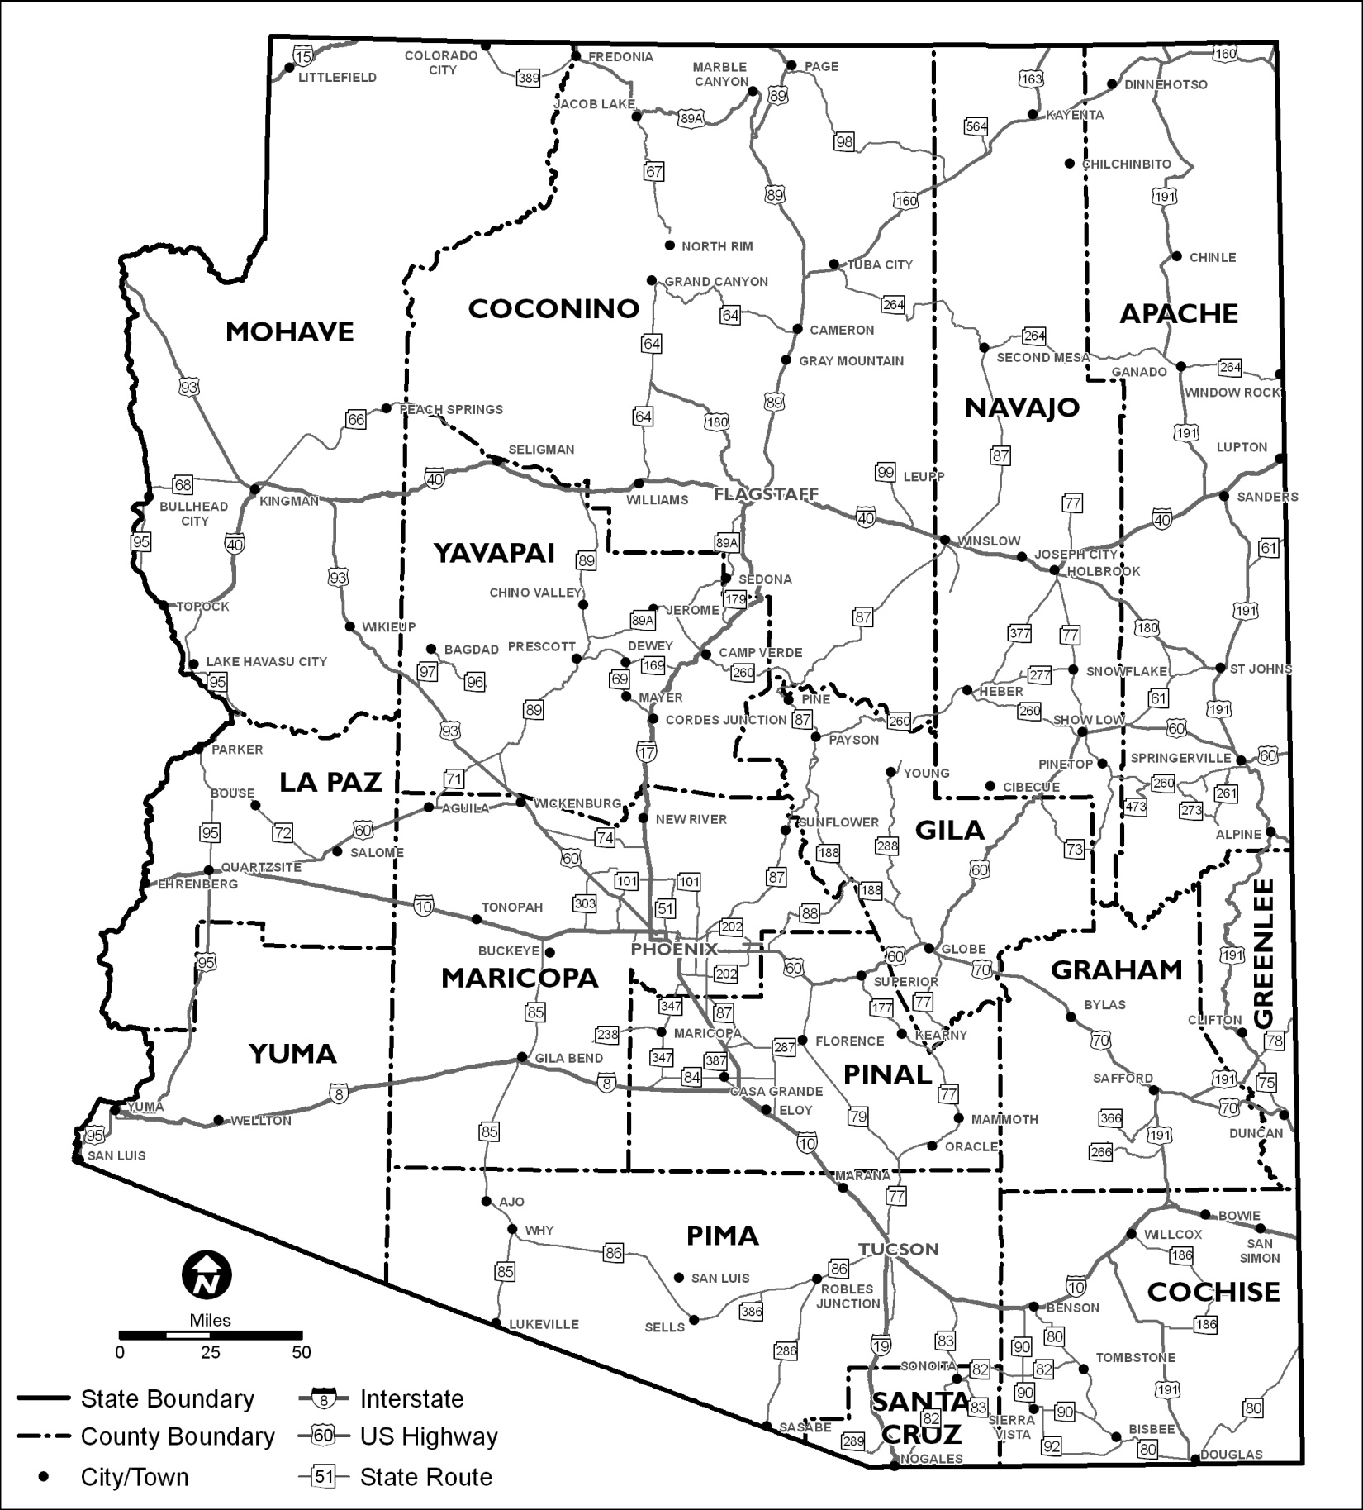

**Project Location**

## Figure 1. State Location Map

[Project Name]

[TRACS Number]  
[Federal Aid Number]



## Figure 2. Vicinity Map

[Project Name]

[TRACS Number]  
[Federal Aid Number]

## 

## 

## Figure 3. Jurisdictional Delineation Survey Area, Topographic, and Floodplain Map

[Project Name]

[TRACS Number]  
[Federal Aid Number]

# 4. Methods

Delineation of “Other” Waters of the US

[Include a description of the information that was reviewed prior to the site visit] A site visit was then conducted on [dates of survey], where the width and depth of all potentially jurisdictional non-wetland watercourses in the JD survey area were measured, indicators of surface flow (physical characteristics) were identified, and ground photographs were taken. Approximately [size of survey area in acres] acres were surveyed for waters of the US.

[“The site visit was conducted” or “A subsequent site visit was conducted on (date of wetland site visit)”] during the growing season to determine if wetlands are present within the project limits. [Include a statement and reasoning if the survey was not conducted during the growing season] The wetland delineation survey was conducted in a subset of the JD survey area in [name of specific drainage wetland survey was conducted] drainage due to riparian vegetation that was observed in the area. Approximately [size of wetland survey area] acres was surveyed for wetlands.

Wetland Determination

A wetland delineation per the *US Army Corps of Engineers 1987 Wetland Delineation Manual* (1987 Manual) and the [Name of Regional Supplement such as the Arid West or Western Mountains, Valleys, and Coast supplements] (Supplement) was conducted on [date of wetland survey]. The Supplement was selected for this survey due to [including reasoning for selecting the supplement]

Per the 1987 Manual, the method selected was a [include the method such as “Routine Determination with onsite inspection for an area less than 5 acres in size” or “larger than 5 acres”] [insert a description of the size of the sample plots.] [Include a statement regarding the resources used during the wetland delineation fieldwork.] [If applicable, include a statement regarding directions in the Supplement to use an adjacent region’s wetland delineation plant list to determine the indicator status. Region 0 and 8 are acceptable to use.]

[Include a description of the methods for excavating a soil pit, the number and general size of soil pits, and any issues encountered in the field.] [Include a statement regarding the number of photographs taken from the sample plot. Minimum 2 preference is 4 one in each of the cardinal directions (N,S,E,W)] [If a soil pit could not be dug, include a statement regarding whether or not soils are assumed to be hydric such as “In plots [#]-[#] where a soil pit was not dug, soils were assumed to be hydric if both hydrophytic vegetation and wetland hydrology were observed, per the 1987 Manual.”] [Include a statement about extrapolating the data collected from the sample plot across the plant community it was observed within and include a map depicting the plant communities.]

[Include a description of the methods used for any difficult wetland situations associated with problematic soils, hydrology or vegetation.]



## Figure 4. Wetland Plant Communities Map

[Project Name]

[TRACS Number]  
[Federal Aid Number]

# 5. Results

Delineation of “Other” Waters of the US

See Appendix A for the proposed jurisdictional delineation with ground photograph points for drainages, Appendix B for a photograph log of documented drainages, Appendix C for the physical characteristics table, and Appendix D for the preliminary JD form and corps water data sheet. A total of [#] drainages within the JD survey area are proposed as jurisdictional waters of the US including [#] unnamed ephemeral drainages and [named] drainage which exhibit the physical characteristics of waters of the US (refer to Appendix C). A total of [#.##] acre of open waters of the US is proposed for the [name of water body with open water] within the survey area. A total of [#.##] acre of “other” waters (intermittent or ephemeral) is proposed within the JD survey area.

|  |  |  |  |
| --- | --- | --- | --- |
| **Table 1. Summary of Open Water and Other Waters of the US.** | | | |
| **Drainage** | **Waters Type** | **Waters of the US** | **Amount (Acre)** |
| 1 | Open Water | Yes/No | #.## |
| Other Water | Yes/No | #.## |
| 2 | Other Water | Yes/No | #.## |
| 3 |  |  |  |
| 4 |  |  |  |
| 5 |  |  |  |
| Total = #.## | | | |

Wetland Determination

Refer to Appendix A for the proposed wetland delineation. [If ground photograph points could not be depicted on the graphic, insert a statement such as “Ground photographs occur at the center of each sample plot and are not depicted on the graphic due to the quantity of photographs taken at each plot.”] See Appendix E for the wetland determination data sheets and Appendix F for the photograph log of the sample plots.

*Vegetation Information*: A total of [#] plant communities were observed in the wetland survey area. One sample data plot was established in each plant community to evaluate the presence of hydrophytic vegetation. Hydrophytic vegetation was observed in plot [#s] due to the vegetation passing the dominance test as well as the prevalence index being less than or equal to 3. Table 2 identifies the plant communities observed in the survey area and summarizes the presence of hydrophytic vegetation. See the wetland determination data sheets in Appendix E for details of each sample plot.

|  |  |  |  |
| --- | --- | --- | --- |
| **Table 2. Plant Communities and Presence of Hydrophytic Vegetation in the Wetland Survey Area** | | | |
| **Sample Data Plot** | **Plant Community** | **Dominance Test\*** | **Hydrophytic Vegetation Present** |
| 1 | *Populus-Fraxinus-Amorpha* | Passed or Failed | Yes or No |
| 2 |  |  |  |
| 3 |  |  |  |
| 4 |  |  |  |
| 5 |  |  |  |
| 6 |  |  |  |
| *Dominance test from *Regional Supplement to the Corps of Engineers Wetland Delineation Manual:* [name of supplement and date]. | | | |

*Soils*: Soil pits were observed in plots [#s] [include a statement regarding the presence of hydric soils such as “with several indicators of anaerobic soils occurring in each of the plots.”] [Include a description of the soils observed such as “The soils observed were generally dark (matrix beginning with 10YR) fine silt to sandy soils with organic matter present within the matrices. A sulfurous odor was observed in plot [#] as well as a 4-inch layer of greasy muck mottled with dense organic material that continued throughout the 16-inch soil plug cross-section. The 18-inch soil plug cross-section for plot [#] was also densely mottled with organic material though the amount of organic material present within the plug began to decrease below 15 inches. Redoximorphic features such as concentrations along pore linings and soft masses as well as a reduced matrix were observed in the soil plugs for plots # and #.”] Table 3 identifies the hydric soil indicators and indicates whether hydric soil was present in the survey area. See the wetland determination data sheets in Appendix E for details of each sample plot.

|  |  |  |  |
| --- | --- | --- | --- |
| **Table 3. Indicators of Hydric Soils in the Wetland Survey Area** | | | |
| **Sample Data Plot** | **Plant Community** | **Hydric Soil Indicators\*** | **Hydric Soils** |
| 1 | *Populus-Fraxinus-Amorpha* | Not observed | Yes** |
| 2 | *Vitis* | A1, A4 | Yes or No |
| 3 |  |  |  |
| 4 |  |  |  |
| 5 |  |  |  |
| 6 |  |  |  |
| *Codes defined in *Regional Supplement to the Corps of Engineers Wetland Delineation Manual:* [name of supplement and date].  [include if necessary “**Per the 1987 Manual, soils are assumed to be hydric due to presence of hydrophytic vegetation and wetland hydrology.”] | | | |

*Hydrology Information*: [include a discussion regarding the presence of wetland hydrology.] Indicators of wetland hydrology were observed in plots [#s]. Table 4 identifies the wetland hydrology indicators observed in the survey area and indicates whether wetland hydrology was present. See the wetland determination data sheets in Appendix E for details of each sample plot.

|  |  |  |  |
| --- | --- | --- | --- |
| **Table 4. Indicators of Wetland Hydrology in the Wetland Survey Area** | | | |
| **Sample Data Plot** | **Plant Community** | **Wetland Hydrology Indicators\*** | **Wetland Hydrology Present** |
| 1 | *Populus-Fraxinus-Amorpha* | B2, B3, D3 D5 | Yes or No |
| 2 |  |  |  |
| 3 |  |  |  |
| 4 |  |  |  |
| 5 |  |  |  |
| 6 |  |  |  |
| *Codes defined in *Regional Supplement to the Corps of Engineers Wetland Delineation Manual:* [name of supplement and date]. | | | |

*Existing Wetland Mapping*: [Include information regarding available wetland mapping if available.

Table 5 identifies the classification for wetlands in the survey area to provide supplemental information regarding the survey area. Refer to Appendix G for the US Fish and Wildlife Service (USFWS) NWI wetlands mapping data for the project area.”]

|  |  |  |
| --- | --- | --- |
| **Table 5. Cowardin Classification of Wetlands in the Wetland Survey Area** | | |
| **Sample Data Plot** | **Plant Community** | **Cowardin Class\*** |
| 1 | *Populus-Fraxinus-Amorpha* | Not Applicable |
| 2 | *Vitis* | PUBHh |
| 3 |  |  |
| 4 |  |  |
| 5 |  |  |
| 6 |  |  |
| [Insert definition of applicable Cowardin Class codes such as “PUBHh = Palustrine unconsolidated bottom permanently flooded, diked, impounded”]  *Cowardin et al. 1979 and USFWS 2010 | | |

*Proposed Wetland*: A total of [#] plant communities within the wetland survey area were determined to have all three characteristics of wetlands including hydrophytic vegetation, hydric soils, and wetland hydrology. [Insert a statement regarding where the wetland patches occur.] A total of [#.##] acres is proposed as wetland within the survey area (refer to Appendix A). Table 6 below summarizes the presence of wetland characteristics observed in each plant community. See the wetland determination data sheets in Appendix E for details of each sample plot.

|  |  |  |  |  |  |
| --- | --- | --- | --- | --- | --- |
| **Table 6. Summary of Characteristics and Presence of Wetlands in the Wetland Survey Area** | | | | | |
| **Sample Data Plot** | **Plant Community** | **Hydrophytic  Vegetation** | **Hydric Soils** | **Wetland Hydrology** | **Wetland** |
| 1 | *Populus-Fraxinus-Amorpha* | Yes or No | Yes** or No | Yes or No | Yes or No |
| 2 | *Vitis* | Yes or No | Yes or No | Yes or No | Yes or No |
| 3 |  |  |  |  |  |
| 4 |  |  |  |  |  |
| 5 |  |  |  |  |  |
| 6 |  |  |  |  |  |
| [include if necessary “**Per the 1987 Manual, soils are assumed to be hydric due to presence of hydrophytic vegetation and wetland hydrology.”] | | | | | |

# 6. Summary

In total, [#] drainages within the survey area exhibit the physical characteristics of waters of the US including [#] unnamed drainages and [named] drainage. Table 7 summarizes the type and amount of proposed waters of the US within the survey area.

|  |  |  |
| --- | --- | --- |
| **Table 7. Summary of Waters Type and Amount of Proposed Waters of the US.** | | |
| **Waters Type** | | **Amount (Acre)** |
| Other Waters | |  |
| Open Water | |  |
| Wetland | |  |
| **Total** |  | |

# 7. Coordination

[Agency

Name, Title and or Group

Name, Title and or Group

Agency

Name, Title and or Group]

# 8. References

[insert all references used for report such as:

Cowardin, L.M., V. Carter V., F.C. Golet, and E.T. LaRoe. 1979. *Classification of Wetlands and Deepwater Habitats of the United States*. US Fish and Wildlife Service Report No. FWS/OBS/-79/31.Washington, D.C.

Munsell Color. 2000. Munsell Soil Color Charts. Macbeth, New Windsor, New York.

Reed, P.B. 1988a. National List of Plant Species that Occur in Wetlands, 1988 National Summary. Biological Report 88-26.8. Washington D.C.: US Fish and Wildlife Service.

US Army Corps of Engineers. 1987. *Corps of Engineers Wetlands Delineation Manual*. Technical Report Y-87-1, US Army Engineer Waterways Experiment Station, Vicksburg, Mississippi.]

# 9. Signature(s)

|  |  |  |  |
| --- | --- | --- | --- |
| Prepared by: |  | Date: |  |
|  | Name  Title  Firm/Agency |  |  |

##### 

##### Appendix A

##### PROPOSED JURISDICTIONAL DELINEATION WITH WETLANDS

##### AND BLANK AERIAL

[include the JD graphic at a scale of no more than 1-inch = 200-feet that depicts the boundaries of waters of the US including wetlands as well as a blank aerial at the same extent of the JD graphic]

##### Appendix B

##### GROUND PHOTOGRAPHS OF PROJECT DRAINAGES (Date of Site Visit)

[include ground photographs of at least 4 photos for each drainage with no more than 4 photos per each page]

##### Appendix C

JD PHYSICAL CHARACTERISTICS AND OTHER INFORMATION TABLE

[include the standard JD table]

##### Appendix D

PRELIMINARY JURISDICTIONAL DETERMINATION FORM AND   
CORPS WATER DATA SHEET

[include appropriate JD form; include Corps Water Data Sheet if there is a combination of more than 5 drainages or wetland patches in the survey area]

**Appendix E**

WETLAND DETERMINATION DATA SHEETS

[include the wetland determination field data sheets from the appropriate wetland delineation supplement]

**Appendix F**

GROUND PHOTOGRAPHS OF WETLAND DELINEATION DATA PLOTS   
(Date of Site Visit)

[include ground photographs with no more than 4 per page]

**Appendix G**

GROUND US FISH AND WILDLIFE SERVICE   
NATIONAL WETLANDS INSTITUTE WETLAND MAP

[include pdf printout from NWI website if available]