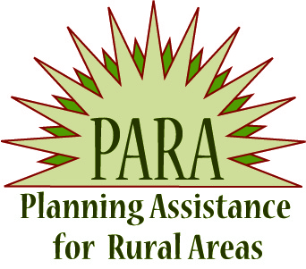


PLANNING ASSISTANCE FOR RURAL AREAS
FISCAL YEAR 2018 PLANNING STUDY APPLICATION INSTRUCTIONS

The Planning Assistance for Rural Areas (PARA) program is sponsored by the Arizona Department of Transportation (ADOT) Multimodal Planning Division (MPD) to provide assistance to Local Public Agencies (LPAs) and Tribal Government in the development of Preliminary Scoping (Pre-Scoping) Reports and Transportation Planning Studies (Planning Study) that lead to transportation improvements.

A “Planning Study” refers to a broad range of local and regional planning issues related to, roadway, transit, and non-motorized transportation modes. The geographic focus of studies can vary and include neighborhoods, incorporated communities or entire counties. Studies may also center on specific roadway corridors, transit feasibility or recreational trails systems.
Transportation Planning Studies include a variety of topics, which may include (but not limited to): Long Range Transportation Plans, Regional Transportation Plans, Transportation Master Plans, Corridor Location Studies, Corridor Master Plans, Access Management Plans, Pavement Assessment Plans, Feasibility Studies, Transit Plans, Bike & Pedestrian Plans, Trail Plans, and others.

Eligible applicants include:
Counties, cities, towns, and tribal governments (including chapters, districts, and villages) located outside Maricopa Association of Governments and Pima Association of Governments planning area boundaries.

All applications must be prepared by LPA staff. Any private sector consultant that provides application assistance will be ineligible to bid on project solicitations associated with a funded study request for proposals.

Partnerships between communities are encouraged; however, a lead LPA must be designated. PARA funds may be used for Planning Studies that address the needs of multiple jurisdictions, as well as for needs that are limited to neighborhoods within the LPA’s jurisdiction. Applicants are encouraged to focus their requests for funding on the most critical transportation planning needs identified in their communities (see Appendix B for examples). Examples of studies can be found on the PARA website at: http://www.azdot.gov/planning/CurrentStudies/PARAStudies

The PARA Program is competitive and covers 100% of the Planning Study cost, meaning there is no funding match required on the applicant’s part.

ADOT Responsibilities
An assigned ADOT Regional Transportation Planner will be responsible for overall project management, including oversight of the consultant selection process and payment for consultant services upon ADOT and LPA deliverables approval.

LPA Applicant Responsibilities
In general, the LPA will be responsible for providing staff that will perform the following functions:
- Assist the ADOT project manager as part of the study team, helping develop all materials used in public involvement activities, including but not limited to: public meetings, Technical Advisory Committee (TAC) meetings, forums, and stakeholder meetings.
- Provide local perspectives and information to the ADOT project manager in all aspects of the study, including the review and final approval of all materials produced.
- Provide technical input and administrative guidance, as needed, to the study team.
- Assist with securing meeting rooms for TAC meetings and public outreach activities.

FAQ Website
A Frequently Asked Questions page is provided on the PARA website at:
http://www.azdot.gov/docs/default-source/planning/para-program-frequently-asked-questions.pdf

Application Deadline and Submittal Requirements
Applications should be emailed to the PARA Program Manager, Jason Bottjen (JBottjen@azdot.gov) by Wednesday May 31, 2017. Applications received after the deadline will not be considered.

PARA APPLICATION ATTACHMENTS

In addition to completing the Planning Study Application (page 4), please complete and attach items 1 through 6 below for a complete application.

- State Location Map depicting where the Planning Study is located regionally – a State Map template is attached (Appendix A)
- Project Vicinity Map depicting the boundary of the Planning Study area - maximum one page (11x17 if necessary). This map should mark the full limits of the project. Google Maps or a legible drawing with street names labeled will suffice.
- Background, Purpose, Need and Goals Statement for the proposed planning study – maximum five (5) pages (12 point font), excluding letters of support. Please address the following when developing the Background, Purpose, Need and Goals Statement:
- Overall Project Considerations
- Demonstration of the Need for the Planning Study
- FAST Act National Performance Goals
- Demonstration of Community Support (see number 5 below).
- Demonstration of how the Planning Study will benefit the State, Region, and / or Community
See Appendix B for detailed scoring factors as outlined above.

- Estimated timeline for completion of the Planning Study (maximum 12 months, shorter timeframes are encouraged when possible) including: critical target dates, milestones, or deliverables. Any unique constraints (i.e. Council – Board meetings, furloughs, implementation deadline, etc.) should be incorporated into the schedule to the best of the applicant’s knowledge. Maximum length: one (1) page (11X17 if necessary).
- Letters of Support – A minimum of three (3) letters of support for the proposed Planning Study (from the appropriate COG/MPO, ADOT District Engineer, Council / Board, public stakeholder group, etc.). Maximum letter length: one (1) page per letter, maximum of five (5) letters or five (5) total page(s). Applications for planning studies that address any road on the State Highway System must be accompanied by the written support of the appropriate ADOT District Engineer(s).
- If applicable, provide a list of previous relevant studies and a list of projects implemented based on the recommendations made by previous ADOT funded planning studies, such as Small Area Transportation Studies, PARAs, and transit needs studies (may also include relevant non-ADOT funded transportation studies and projects) – maximum one (1) page.

PARA PLANNING STUDY APPLICATION

APPLICANT INFORMATION
1. Applicant: (Lead City, Town, Tribe, or County Name) | 2. Mailing Address:
3. Lead Contact Name / Title: | 4. Phone No.: | 5. Email Address:
6. Backup Contact Name / Title: | 7. Phone No.: | 8. Email Address:
9. MPO / COG Name: | 10. ADOT Engineering District Name(s):

PLANNING STUDY LOCATION
11. Jurisdictional Limits: | For Corridor Studies or other applicable studies…  12. Primary Route/Street or Description of Area:
For Corridor Studies or other applicable studies…  13. Beginning Limit: (Milepost or Cross Street) | For Corridor Studies or other applicable studies…  14. End Limit: (Milepost or Cross Street)
FUNDING
15. Amount Requested for PARA Planning Study: (Not to exceed $250,000) |  |  | $

PERFORMANCE MANAGEMENT
16. The FAST Act establishes national performance goals for Federal highway programs. Which of the following National Performance Goals will the Planning Study achieve? (Check all that apply)
Safety | Infrastructure Condition | Congestion Reduction
System Reliability | Freight Movement and Economic vitality | Environmental Sustainability
Reduced Project Delivery Delays
- Safety—To achieve a significant reduction in traffic fatalities and serious injuries on all public roads.
- Infrastructure condition—To maintain the highway infrastructure asset system in a state of good repair.
- Congestion reduction—To achieve a significant reduction in congestion on the National Highway System (NHS). (Refer to page 7 of the following link: http://azdot.gov/docs/default-source/maps/mapbook_2014.pdf?sfvrsn=4)
- System reliability—To improve the efficiency of the surface transportation system.
- Freight movement and economic vitality—To improve the national freight network, strengthen the ability of rural communities to access national and international trade markets, and support regional economic development.
- Environmental sustainability—To enhance the performance of the transportation system while protecting and enhancing the natural environment.
- Reduced project delivery delays—To reduce project costs, promote jobs and the economy, and expedite the movement of people and goods by accelerating project completion through eliminating delays in the project development and delivery process, including reducing regulatory burdens and improving agencies’ work practices.

Date Received (ADOT Staff):

Appendix A

STATE LOCATION MAP

Instructions: Click on the circle line, then drag to the general project location. Perform the same step to adjust the “Project Location” text box accordingly.

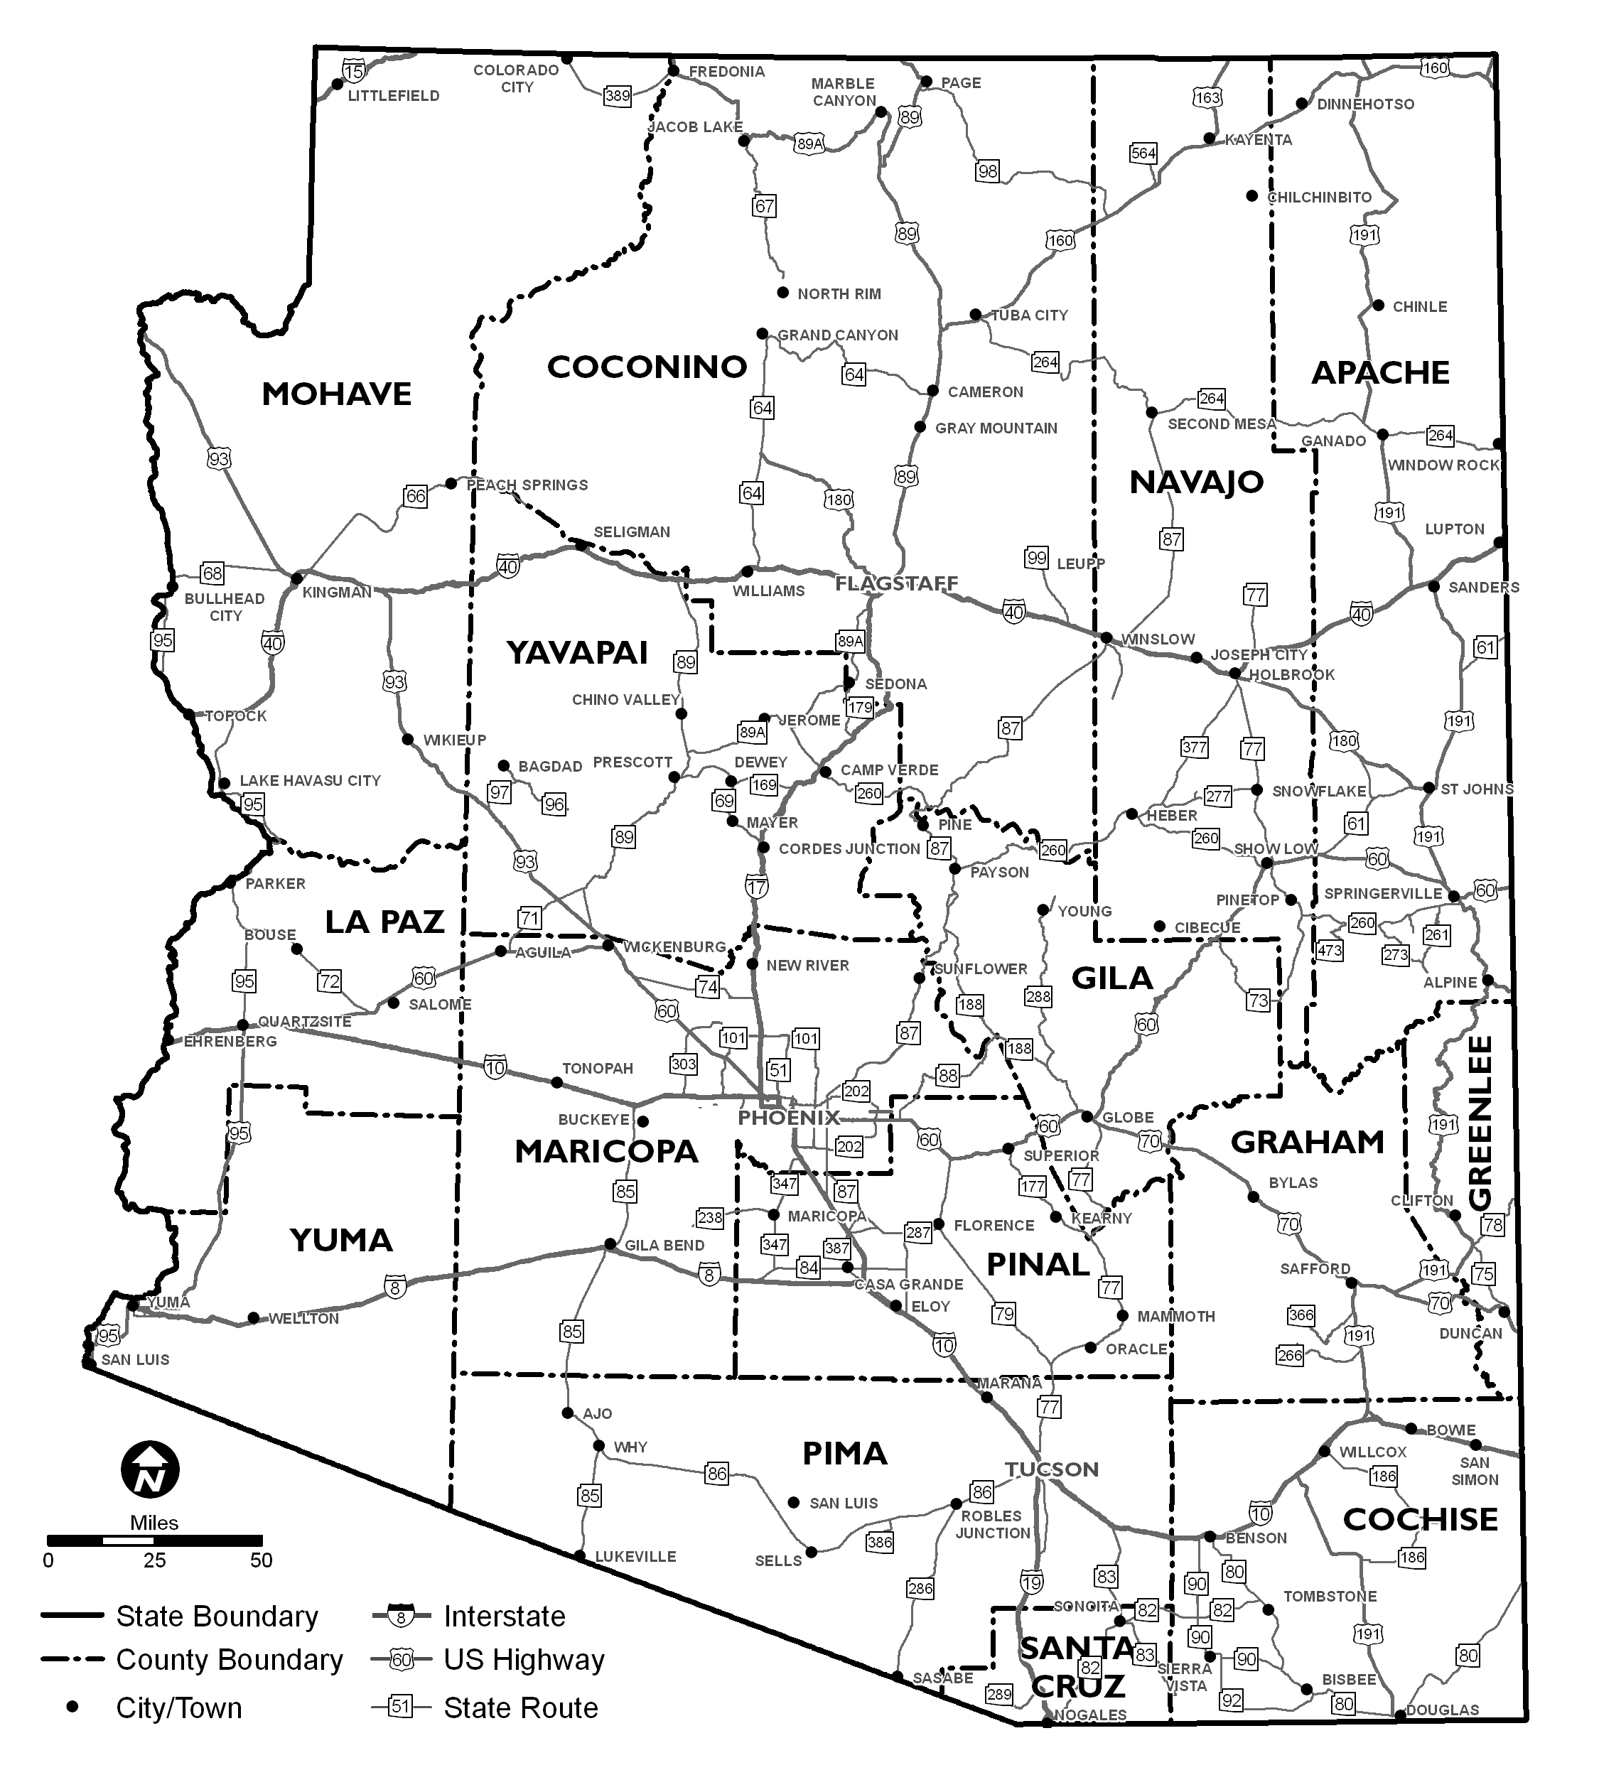
Project Location
Appendix B

PARA PLANNING STUDY EVALUATION CRITERIA

All project proposals are scored by the same point system and can receive a maximum of 100 points.

Scoring ranges for the Project Evaluation Form:
1. Overall project considerations 0-20 points
2. Need for study 0-25 points
3. Incorporates planning elements 0-15 points
4. Community support 0-15 points
5. Community Benefit or Improvement 0-25 points

Maximum Points Possible (100 points)
Below are examples of factors that affect scoring:
1. Overall Project Considerations (possible 20 points)
- Relationship to existing transportation infrastructure
- Availability of jurisdiction staff to participate in the study
- Clear communication of the study’s objectives and desired outcomes
- Includes a possible implementation plan
2. Demonstrates Need for Study (possible 25 points)
- Absence of updated transportation plan
- Availability of supportive traffic data and / or transit ridership data
- Prior supporting plans, studies, etc.
- Other supporting documentation of study need
3. Incorporates FAST Act National Performance Goals (possible 15 points)
- Safety
- Infrastructure condition
- Congestion reduction
- System reliability
- Freight movement and economic vitality
- Environmental sustainability
- Reduced project delivery days
4. Demonstrates Community Support (possible 15 points)
- Letters of support / Council resolutions
- Community history of implementing plans
5. Benefits the State, Region, and/or Community (possible 25 points)
- Anticipated use
- Benefits to quality of life, community goals, etc.
- Impact on local economy
- Safety improvements
- Improved accessibility
- Economic benefits

