GENERAL PROJECT INFORMATION
Date: | ADOT Project Manager:
Project Name:
City/Town: | County:
COG/MPO: | ADOT District:
Primary Route/Street:
Beginning Limit: (Milepost / Cross Street)
End Limit: (Milepost / Cross Street)
Project Length:
Right-of-Way Ownership(s) (where proposed project construction would occur): (Check all that apply)
City/Town; County; ADOT ; Private ; Federal; Tribal; Other:
Adjacent Land Ownership(s): (Check all that apply)
City/Town; County; ADOT; Private; Federal; Tribal; Other:
http://gis.azland.gov/webapps/parcel/

LOCAL PUBLIC AGENCY (LPA) or TRIBAL GOVERNMENT INFORMATION
(If applicable)
LPA/Tribal Name:
LPA/Tribal Contact:
Email Address: | Phone Number:
Administration: ADOT Administered Self-Administered Certification Acceptance

PROJECT NEED
(Describe the issues and deficiencies that need to be fixed)

PROJECT PURPOSE
What is the Primary Purpose of the Project? | Preservation | Modernization | Expansion
(Generally describe the project goals. What will be done to fix the problem?)

PROJECT RISKS
Check any risks identified that may impact the project’s scope, schedule, or budget:
Access / Traffic Control / Detour Issues | Right-of-Way
Constructability / Construction Window Issues | Environmental
Stakeholder Issues | Utilities
Structures & Geotech | Other:
Risk Description: (If a box is checked above, briefly explain the risk)

POTENTIAL FUNDING SOURCE(S)
Anticipated Project Design/Construction Funding Type: (Check all that apply) | STBG | TAP | HSIP | State
 | Local | Private | Tribal | Other:

COST ESTIMATE
Preliminary Engineering  $ | Design  $ | Right-of-Way  $ | Construction  $ | Total  $

RECOMMENDED PROJECT DELIVERY
Delivery: Design-Bid-Build Design-Build Other:
Design Program Year: FY
Construction Program Year: FY

ATTACHMENTS
- State Location Map
- Project Vicinity Map
- Project Scope of Work
- Project Schedule
- Itemized Cost Estimate
- Conceptual Design Plans (not to exceed 15% design)
- Final Field Review Report

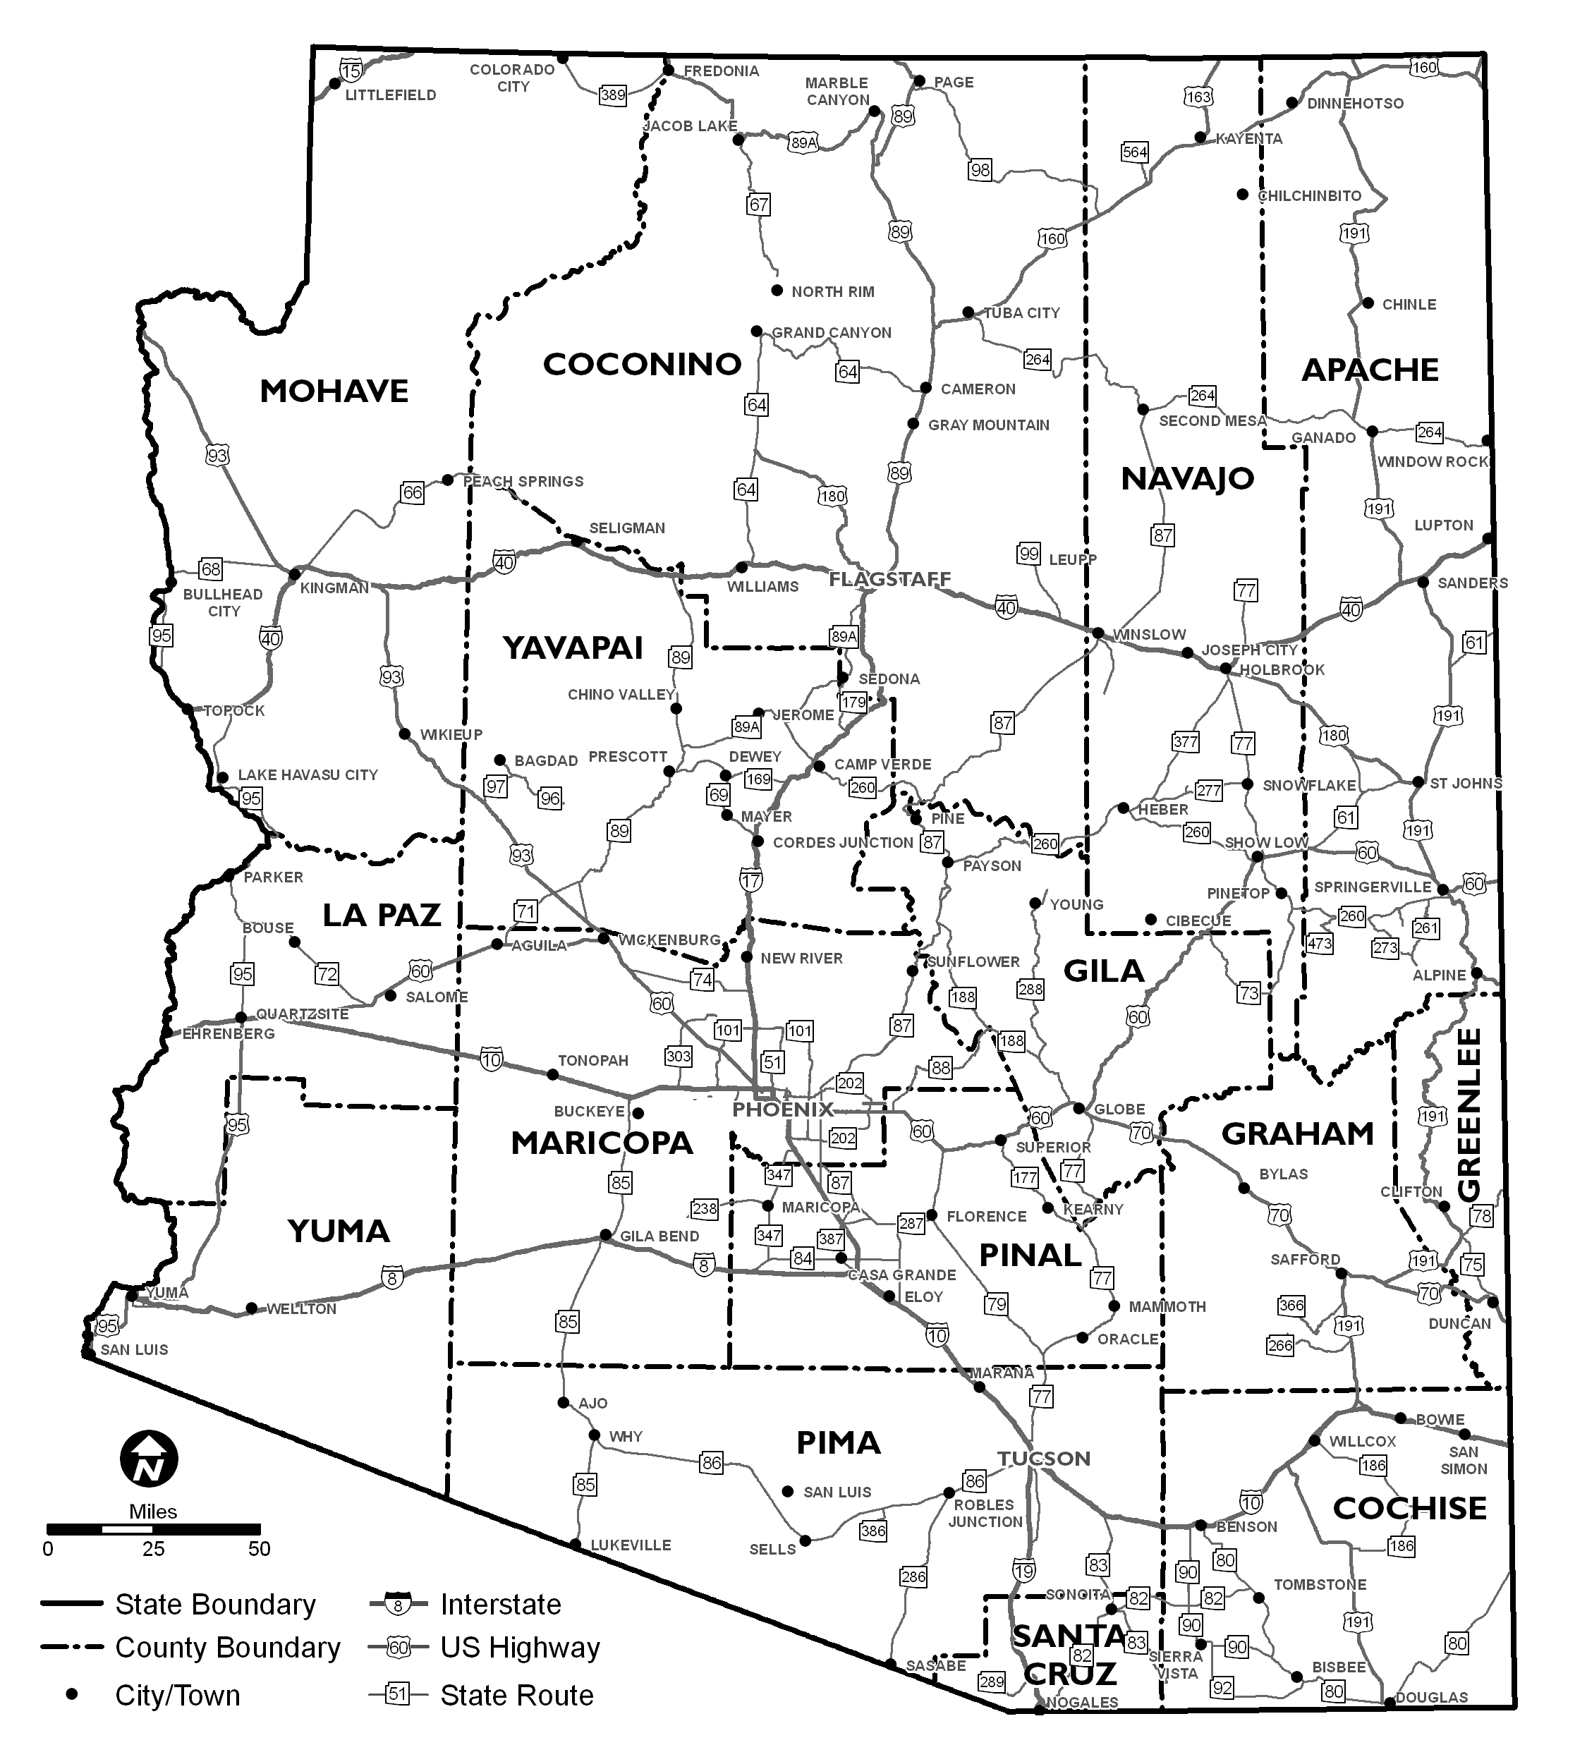
Project Location

[INSERT PROJECT VICINITY MAP HERE]

This map should show the full limits of the project. Google Maps or a legible drawing with street names labeled will suffice.

Include and label the following details in your map (if known):

- Project Start Location
- Project End Location
- Known Section 4(f) resources
- Known avoidance areas
- Potential Staging and Stockpiling Areas (if offsite areas are used, a separate map could be used)
- Material Source Pits (if used – a separate map could be used)
- North Arrow
- Legend

SCOPE OF WORK
(Provide a detailed breakdown of the project’s scope of work using bullet format)
- Example: Staging and stockpiling of vehicles and equipment will occur throughout the project limits.
- Example: A 300’ X 400’ off-site staging and stockpiling area will occur at [location].

SCOPE ITEMS CONSIDERED, BUT NOT INCLUDED
(Describe scope items considered, but not accepted by the Pre-Scoping Team and why)
- Example: Sidewalk replacement was requested by [Agency], but eliminated from further consideration as the existing sidewalk is in good working condition and is ADA compliant.
- Example: Pedestrian lighting was considered, but eliminated due to maintenance concerns expressed by [Agency].

The below 23 USC 409 disclaimer is to be included in the Final Pre-Scoping Report and Field Review Report:

Pursuant to 23 USC 409: Notwithstanding any other provision of law, reports, surveys, schedules, lists, or data compiled or collected for the purpose of identifying, evaluating, or planning the safety enhancement of potential accident sites, hazardous roadway conditions, or rail-way-highway crossings, pursuant to sections 130, 144, and 148 [152] of this title or for the purpose of developing any highway safety construction improvement project which may be implemented utilizing Federal-aid highway funds shall not be subject to discovery or admitted into evidence in a Federal or State court proceeding or considered for other purposes in any action for damages arising from any occurrence at a location mentioned or addressed in such reports, surveys, schedules, lists, or data.

[INSERT PROJECT SCHEDULE HERE]

Project Schedule Notes (for an average project):
- Allow 3 months between each plan set (30%, 60%, 95%, and 100%)
- Environmental Clearance is required prior to Final Design (typically 95% plans) for Single Step Federal Authorization projects, or at 30% design for Two Step Federal Authorization projects.
- Right-of-Way (ROW) and Utility Clearances cannot be completed until after the Environmental Clearance is obtained.
- Allow two months between the Bid Ready Date (BRD) and Bid Advertisement Date (BAD).
- Additional time should be allotted for complex projects, projects with multiple alternatives, politically sensitive projects, ROW acquisition, or Utility relocation.
- All project schedules should be reviewed by all applicable ADOT Technical Groups and District Staff for accuracy.

[INSERT ITEMIZED COST ESTIMATE OF PROJECT BUDGET HERE]

Project Budget Notes:
- An Itemized Cost Estimate should be provided for both project Design and Construction, based upon the agreed-upon Scope of Work.
- It can be assumed that $30,000 is required for ADOT Project Management Design Review (PMDR) Fee for an average project.
  - Exception: When acquiring easement on tribal lands, ask ADOT ROW for anticipated additional coordination fees. Ensure any additional fees are called out separately and explained, so the Design PM will know to coordinate and negotiate any additional fees in the IGA.
- ADOT’s E2C2 Tool (or equivalent tool) should be used to develop the construction cost estimate.
- High Risks identified should be included in the cost estimate as a line item or incorporated as part of the Contingency.
- An ICAP fee is typically not applied to a Local Public Agency (LPA) Project.

