Quantlists

A Comprehensive Guide
ADOT Construction Operations Group, May 2023

1. An Introduction to Quantlist 2
1.1. What is a Quantlist 3
2. Training Requirements 3
2.1. Required and Related Courses 3
3. Your Assigned Role 4
4. Communicating Expectations With Your Contractor 4
4.1. Setting Expectations 4
5. Quantlist 101 5
5.1. Online, In The Office 5
5.2. Offline, In The Field 6
5.3. Selecting a project 6
5.4. Creating a Quantlist 6
5.5. Quantlist Scoring 7
5.6. Printing Quantlist 8
6. Performing Acceptance Inspections With Quantlists. 9
6.1. Before Performing Acceptance Inspections 9
6.2. Performing Acceptance Inspections 9
6.3. Following Acceptance Inspections 10
6.4. Non-conformance 10
7. Quantlist Frequency 10
7.1. Tracking Quantlist Frequency on a project 10
7.2. Quantlist Tracking Through Reports 11
7.3. Building Reports 11
7.4. Filling In A Report With Known Data 12
8. Construction Operation Inspections. 14
8.1. Independent Quality Assurance Inspections: 14
8.2. Quantlist Correlation Inspections 14

An Introduction to Quantlist
Construction Inspection Checklists AKA “Quantlist” have been developed to memorialize inspections at key points in the construction process. Quantlists also serve as a reinforcement to the Department's Standard Specifications and Construction Manual, while ensuring contractor quality and uniformity within their construction processes. Quantlists assist Inspectors in performing acceptance inspections on most disciplines involved in highway construction projects. Quantlists may also serve to assist new inspectors in learning what to look out for during an acceptance inspection. However, Inspectors should not rely on the Quantlist alone and must read all relevant contract documents to ensure necessary compliance.

What is a Quantlist
A Quantlist is a quantitative checklist, converting attribute information into a weighted number score according to the gravity or necessity of individual attributes and how the lack of completing said specific attributes may adversely affect the quality of a finished product. This in turn allows for an objective evaluation of the construction processes and the review of Specification changes. Each attribute in a quantlist references the most recent specification, each Specification should be reviewed independently for additional details by the Inspector prior to performing any acceptance inspection. The intent of a Quantlist is to affirm quality requirements at the beginning of a project, assure construction processes are in control and stabilized throughout the project and that the final product meets the Departments quality goals. Quantlist attributes complement the Standard and Specifications, ADOT Construction Manual - Subsection 105.11 Authority and Responsibility of Project Supervisor and Inspectors, 105.12 Inspection of Work, and Inspectors daily diaries. In doing so, Quantlists serve to reinforce the Department’s quality and craftsmanship requirements. It should be noted that Quantlists were developed as an aid to the Inspector and do not include all items to be inspected, therefore due diligence is required by the Inspector.

Training Requirements
Quantlists are created and submitted through ADOT’s PEN program. This application is only available to users who have access to the ADOTNet and have been given prior permissions. Prior to the installation of PEN5, training on the use of PEN5 Quantlists application is required (PEN Based Systems). Contact your training coordinator to schedule the applicable training courses.

Required and Related Courses
The courses listed below may be found on ADOT’s Learning and Development Center.
- TCH3056 - PEN Based Systems
- TC3CN001-15-T1 - Daily Diary Basics
- TCH3080 - Integrating Requirements
- TCH3001 - Pay Item/Daily Diary Documentation
- TCH3000 - Force Account Documentation for Inspectors
Once training has been completed, the Resident Engineer or the Project Supervisor will inform the Office Manager of the duties/roles the employee will be performing in PEN. Next, a HEAT Ticket will need to be created on the ADOTNet through ADOT Service Desk or by calling the ADOT Help Desk at (602) 712-7249. Following the creation of the HEAT ticket, a Computer Access Request Form CARF will need to be created and approved by the Resident Engineer or your immediate supervisor. Once the CARF has been approved by your supervisor and accepted by the ITG Group, only then will PEN5 be installed under the employee’s profile on each computer the Inspector or Office Staff will need to use.

Your Assigned Role
Once ITG has granted you access to the PEN5 program and downloaded PEN5 to your computer's user profile you may see your assigned roles by clicking on the "?” mark.
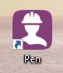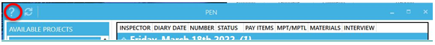
Assigned roles will vary and are determined by the duties and work activities you will be performing on the project. For example Project Supervisor will be assigned reviewer and approval privileges whereas an Inspector will be assigned Inspector & author privileges.
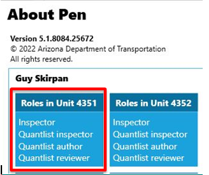

Communicating Expectations With Your Contractor
Prior to a contractor starting work on any major construction disciplines, a pre-activity meeting should be held in accordance with a project's Special Provisions. The Inspectors should obtain any and all current updated copies of Quantlists that may be relevant to the discipline being inspected. The Project Supervisor and Field Inspector should discuss the Department’s quality expectations for each attribute covered by the Quantlists with the contractor during these pre-activity meetings.

Setting Expectations
One Quantlist should be completed after each construction process change until the process is in control and stabilized to the satisfaction of the Engineer. Once the process is in control, the minimum number of Quantlists must still be completed. Inspectors should always document any reason for reducing the Quantlist frequency in their daily diary. The minimum Quantlist frequencies can be found in the current Quantlists Versions and Minimum Quantlist Frequency Chart. This information is available on the Construction & Materials Group Quantlist Guide web page on the ADOTNet or the internet. This guideline also shows the corresponding Standard Specification numbers and most recent versions of each Quantlist. Throughout the life of a project, the Resident Engineer and Project Supervisor should continuously track the project's Quantlist frequency compliance (see section 7). The Department’s Internal Construction Quality Assurance Group will also be performing independent audits throughout the project to verify the Inspectors Quantlist frequency compliance.

Quantlist 101
This PEN5 Quantlist application may be used offline as well as online for field inspection purposes. However, Quantlists can only be downloaded and uploaded to the ADOT Data Warehouse while online. For newly created Quantlists to be finalized, while online you must click the submit button and then sync the PEN5 program. Important reminder, once a Quantlist has been submitted, you will be unable to make any further changes to it. To minimize clerical errors it is highly recommended that the Inspector review and confirm that all blank fields have been filled out with the pertinent information and that each “narrative” has been correctly answered prior to submitting each Quantlist.

Online, In The Office
    - Once PEN5 has been downloaded to the user account on your computer, you can open the Quantlist Application by double clicking the PEN5 icon.
    - The main PEN5 Home Window should open up.
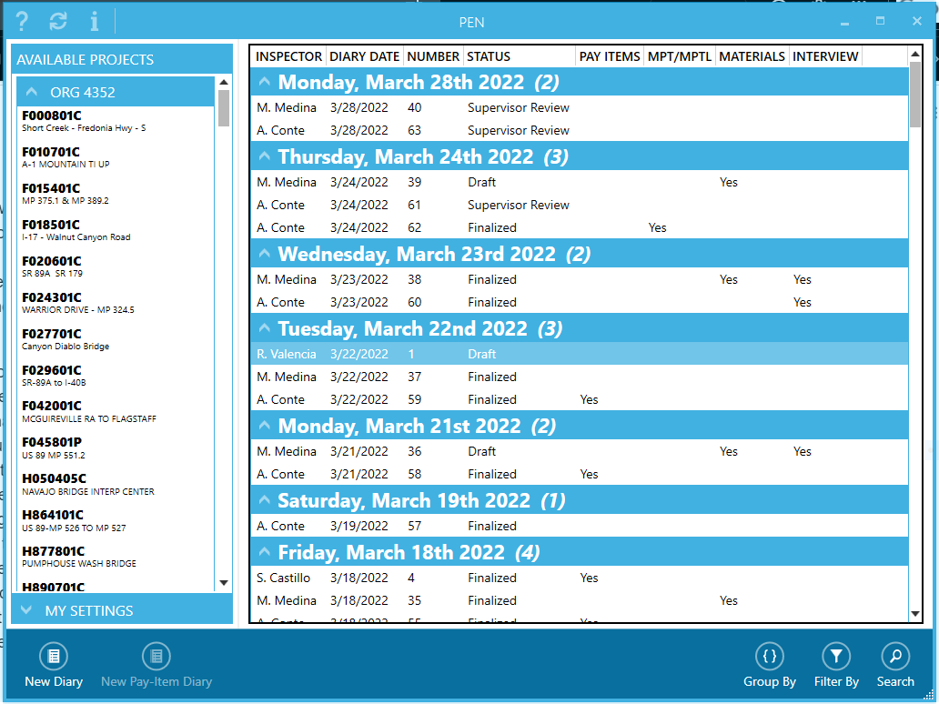
    - Once the PEN5 Home Window is open you will need to sync the program by clicking on the sync button in the upper left hand corner of the window.
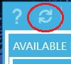
    - Any new or updated Quantlists created by the Construction Quality Assurance Group will be automatically downloaded to your computer's PEN5 application and defaulted to their most current version.
    - Any Quantlists that you may have created or submitted while offline will also be automatically uploaded to the Quantlist Database at this time. You may now continue on to section 5.3.

Offline, In The Field
    - Once PEN5 has been downloaded to the user account on your computer, It will be required to initially start and sync PEN5 online. This will allow the program to make the necessary system updates. For initial startup procedures refer back to section 5.1.
    - Even though you are not able to sync the PEN5 program in the field, any updates the system received after the last time the program was synced will now be on your computer and will remain unchanged until you are back in the office and sync the program again.
    - Once the initial startup and sync has been completed, open the Quantlist Application by double clicking the PEN5 icon.
    - With the exception of syncing and updating the PEN5 program, the offline features of PEN5 are identical to its online features, still allowing the creation of inspection diaries and Quantlist. You may now continue on to section 5.3.

Selecting a project
    - For most personnel, all of your current Unit’s projects will already be listed on the left column of the PEN5 Home Screen under “Org ####”. You can open projects by simply double clicking on the appropriate project in your list.
    - For those who may require access to a greater number of projects can navigate utilizing the following steps:
      - Enter the Tracs Number in the box labeled Tracs# and click enter, or
      - By clicking on the Find button then click on the Select Project box, a list of projects will become available. Scroll through the listed projects until you find the appropriate project, highlight it and click on the Select button.

Creating a Quantlist
    - On the project homescreen, click on “Create A New Diary”.
    - Once a diary has been created, locate the diary tab bar at the top portion of the diary window.
    - Click on the “Quantlist” tab, a sub-window will open on your screen.
    - Locate the appropriate “Division” for the construction activity you are inspecting and click on it. Hint, the Division numbers correlate to the ADOT Standard Specification numbers.
    - A list of associated Quantlists will formulate on the right hand side of this sub-window, click on the appropriate Quantlist and click the “ok” button in the lower right corner of the sub- window.
    - A Quantlist will now populate on your screen and is ready to be completed.
      - Fill out all “FIELDS” with the appropriate information. If any field is not needed, fill in the field with NA for non applicable. Hint, once completed this field portion of the form is collapsible by clicking the chevron next to “FIELDS”.
      - Continue filling out the form by completing the Quantlist “ATTRIBUTES”. To complete this form, all attributes must be answered with “Yes” “No” or “NA”.
      - Any attribute that receives an answer of NA should be discussed with your supervisor in advance.
    - Once a Quantlist has been completed, It is advised that you go back and review all information you have put in the “FIELDS” section along with reviewing your answers to all “ATTRIBUTES” prior to submitting the Quantlist. Once submitted the Quantlist can no longer be altered and the Quantlist score will be recorded as is.
    - Once the Quantlist has been submitted, follow step 5.1.3 and sync the PEN5 program to upload the submitted Quantlist to the Database. Hint, only after syncing may your Quantlist be printed or downloaded to a pdf. file on your computer.

Quantlist Scoring
Quantlist scoring is based on the severity of the attributes on the Quantlist being used, e.g. an attribute requiring a certification of compliance or analysis will be weighed less than an attribute with a safety or environmental requirement. The weight definitions are as follows: Non Applicable (NA), Administrative, Minor, Major, and Critical each weight is assigned a value that is compiled after the quantlist is completed and submitted resulting in a percentage score.
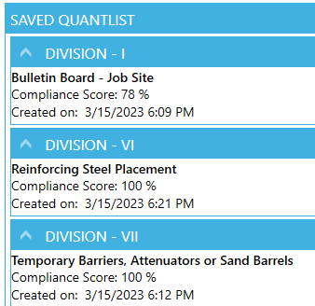
After the submission of a Quantlist a compliance score will be displayed next to the Quantlist in the “Saved Quantlist" tab on the left side of your PEN5 Quantlist window. Quantlist don't necessarily have a minimum passing score to be considered acceptable in the field. However, some projects may have a contractor Incentive associated with their overall Quantlist scoring, this information will be found in the project special provisions. All narratives in a Quantlist found to be in non-compliance, should be corrected by the contractor unless approved “as is” by the appropriate authority and Project RE.

Printing Quantlist
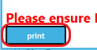
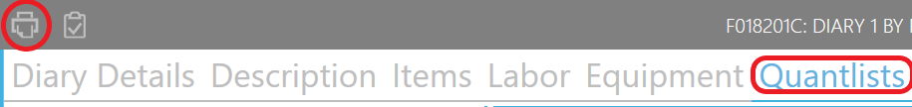
PEN5 printing requires users to connect to the ADOT network and “SYNC” their application before printing diary contents. All attributes in the Quantlist need to be filled in with a “Yes” “No” or “NA” and saved, this allows each attribute to be viewable on the Quantlist. Once a “SYNC” session has been completed the user can print any quantlist in the diary entry by selecting the “print” icon then selecting the quantlist to be printed.

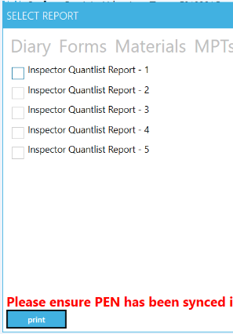
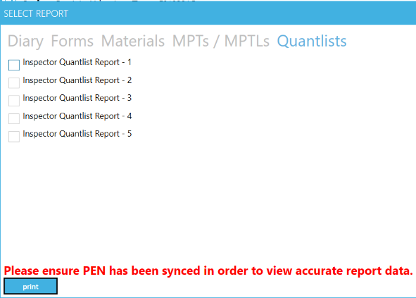
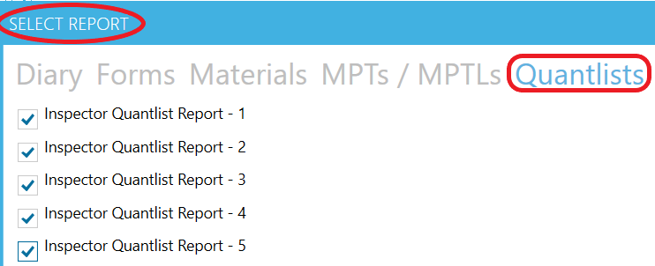
When the print button is selected the “SELECT REPORT” screen will appear. To print Quantlist select “Quantlist” at the right end of the menu. When “Quantlist” is selected a checklist of printable Quantlist will populate. Checkoff Quantlist for printing. Note, Quantlist are numbered and do not necessarily correspond to the order created in PEN5. After selecting/checking the Quantlist to be printed click the “print” button on bottom left of the “SELECT REPORT” screen. After clicking “print” the Quantlist will appear as PDF’s and can be saved or printed as needed.

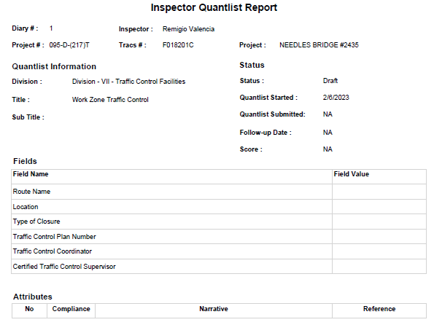

Performing Acceptance Inspections With Quantlists.
Quantlists shall be completed in the PEN System, within the daily diary created by an inspector and associated with the work being performed. Reminder, the inspector’s daily diary should be synced on a daily basis to ensure the completed Quantlists have been uploaded to the Quantlist Database and are viewable by your supervisor for review. Quantlist are to be completed at the required frequency. Note, Quantlist are dated the day they are created and can not be backdated. In order to obtain an accurate measurement of the contractor’s workmanship, the Quantlist must capture the results of each attribute at the time of inspection. An attribute/"narrative” is a characteristic that is used to classify a product or process.

Before Performing Acceptance Inspections
Prior to performing any Acceptance Inspection utilizing Quantlists, inspection preparation is crucial. Inspectors should investigate and or review the discipline being inspected, even if the Inspector is already familiar with the discipline being inspected, specifications change and may be updated without notice. This discipline review process can be accomplished by utilizing the “project guiding documents” and ADOT specifications, e.g. Project Special Provisions, Project Plans, 2022 Standard & Specification, C-Standards & SD-Standards, ITS Standards, Electrical Standards, ADOT Sampling Guide - Appendix C, Construction Bulletins, and Policy Procedure Directives - AKA PPDs.
The Inspector should also discuss the Department's expectations with the contractor; discuss what narratives are on each of the Quantlist with the contractor in a pre-activity meeting (see section 4). Additionally, some contractors may request a copy of the finalized Quantlist after each inspection. This should be a formal process for project document tracking purposes, utilizing email or DocuSign works best, this process should also be addressed and agreed upon in the pre activity meeting. Finally, if the contractor has not requested an inspection, then notification of the upcoming inspection to the contractor should be formally issued at least 24 hours in advance, earlier if at all possible. Surprising the contractor with an inspection can cause resentment and partnering issues on a project; remember your job is not to catch the contractor making a mistake, but instead to assist the contractor in preventing mistakes from ending up in the final product. It is beneficial to both parties to be open and transparent when performing any type of inspection.

Performing Acceptance Inspections
If at all possible, all “Acceptance Inspections'' should be performed with a contractor’s representative present. Clearly establish and agree upon the limits of the inspection with the contractor's representative, i.e. where does the inspection start & stop and what you will be looking out for. Remember to take note of who the contractor's representative was (full name & position) along with what Quantlist narratives were found to be deficient, along with the location of each deficiency, if applicable. Taking photos of any areas of concern can be extremely useful in relocating the deficiency, when performing a reinspection, discussing issues with the Project Supervisor / RE, when notifying the contractor of a non compliance, and if a representative was not present during the Acceptance Inspection.

Following Acceptance Inspections
Review Quantlist results with the contractor’s representative. If a contractor representative was not present, the inspector should notify the contractor of any non-conformance items that were found in a timely manner. A concise description of the acceptance inspection should be documented in your daily diary. This description should include: Who requested the inspection or why Inspection is being performed, arrival time, ambient temperature, weather (sunny, cloudy, raining), the inspection location/limits, what discipline was being inspected, any non-conformance issues, what additional work was being performed within the immediate area, the contractor's representative present during the inspection, along with any discussions of note that were related to the acceptance inspection, and finally your departure time.

Non-conformance
For each Attribute the inspector is required to mark Yes, No, or NA (Non Applicable) under the compliance dropdown. If an Attribute is marked as “No” under the compliance dropdown, the Inspector has the option to select “Follow Up Required” prompting a reinspection. If this follow up option is chosen, when creating a new Quantlist of the same type you will be required and must perform a reinspection until the deficient attribute has been marked as “Yes” under the compliance dropdown. Followup inspections for each non-conformance attribute will also need to be documented within the Inspectors daily diary capturing all of the aforementioned data. A followup Quantlist should be completed (at a minimum) for any initial quantlist that was scored ‘No’ on any attribute(s) weighted 4 or 8. Corrective actions should also be documented in the inspector’s daily diary.
Once the contractor has corrected the nonconformance, the inspector should create a new Quantlist and perform a reinspection. Inspectors should note all corrections made by the contractor in their daily diary under the section the quantlist is noted within.
If the contractor disputes a narrative requirement that has been marked as NO by the inspector, the inspector should immediately contact their Project Supervisor per the partnering escalation process. The Project Supervisor will then review the contractor's non-conformance request with the RE. If after review and only after contacting the appropriate authority, a Resident Engineer may decide to accept the non-conformity. In this instance the inspector should still select the NO option but must explain the justification as to why the non-conformance was accepted and noting the authorizing authority within their daily diary.
In the rare instance that a non-conformance was not corrected and was not accepted by the RE, the inspector will retain the default value of NO and should comment as to why the attribute was not corrected by the contractor within their daily diary. Remember to include facts only, no comments related to your personal feelings should be included within your Daily Diaries.

Quantlist Frequency
Each Quantlists has its own specified time as to when it should be used to perform an acceptance inspection. These specified times vary greatly and should be strictly adhered to throughout the life of the project. You can find the frequency of each Quantlist on the Construction & Materials Group Quantlist Guide web page on the ADOTNet or the internet.

Tracking Quantlist Frequency on a project
Quantlist frequency should be tracked and checked regularly by the Project Supervisors throughout the life of a project. The mandated frequency requirements are set by ADOT in Construction Bulletins 02-04, 06-01, 07-01 and are designed to meet the project documentation requirements set by the FHWA. It is paramount that the Quantlist frequencies be consistently adhered to, failure to follow the mandated Quantlist frequencies can cause issues with quality control on a project. Frequency compliance will be reviewed during Quality Assurance Inspections, FHWA audits, and the Arizona Auditor General’s Office audits.

Quantlist Tracking Through Reports
Various statistical reports regarding past performance of completed Quantlists that can be accessed on the ADOT Data Warehouse web page on the ADOTNet Reports will be found under “Pen / FAST Reports”, “Quantlist Tab Info”.

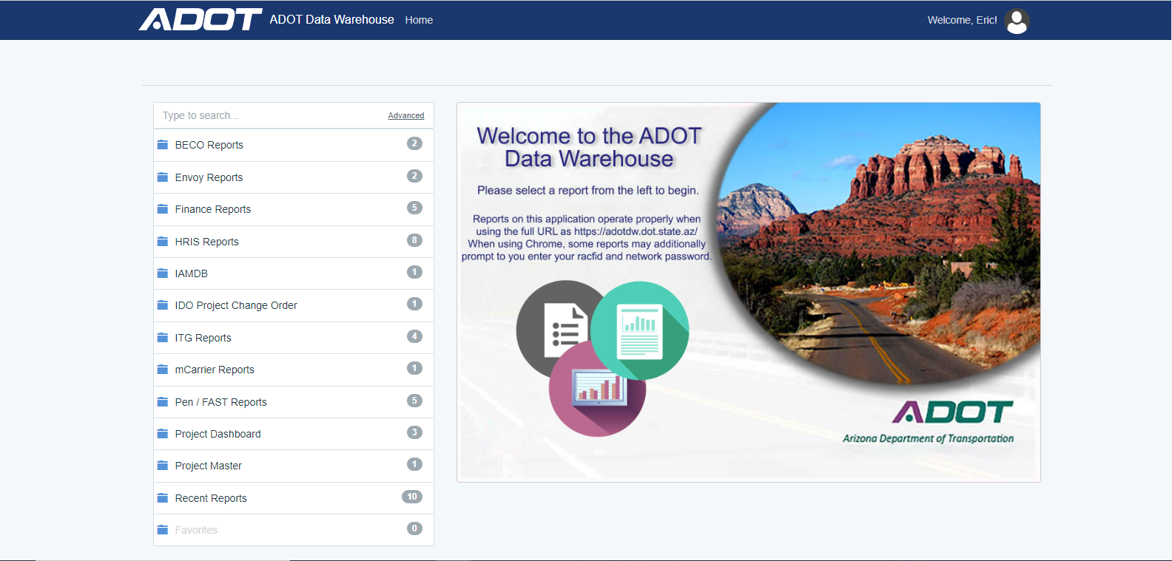
  - Below are various statistical reports regarding past performance of completed quantlists. (This can be found on the Construction Group web page on the ADOTNet under Construction Checklist (Quantlist) Reports):
    - Conformance Report by Product
      - Average conformance of quantlists statewide or by ORG.
    - Subcontractors Conformance Report
      - Statewide average conformance of each contractor or subcontractor.
    - Project Conformance Report by Product
      - Average conformance of quantlists for a specific project.
    - Inspector Report by Product
      - Type of quantlist, number completed and conformance for each inspector (per ORG).
    - Detailed Inspector Report by Product
      - Lists each quantlist, project number, date of inspection and conformance for each Inspector (per ORG).
    - Product Attribute Report
      - Results of each attribute in a quantlist (available statewide or by project).

Building Reports
Below is a list of various statistical reports regarding past performance of completed Quantlists that can be accessed on the ADOT Data Warehouse web page on the ADOTNet https://adotdw/ Reports will be found under:
    - From the Menu on the Left hand side of the page select
    - From the Pen/FAST Reports Select
    - From the Quantlist Tab Info drop down select

Filling In A Report With Known Data
    - Drop downs will now open on the right side of the page
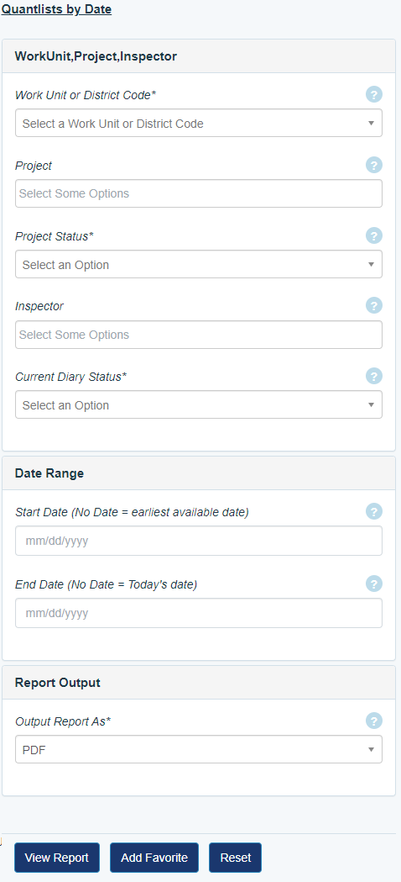
    - From the dropdown menu of Work Unit or District Code Select.
    - Type in your TRACS number here.
    - From the Project Status dropdown select.

    - From the Inspector dropdown select all Inspectors that apply.
    - From the Current Diary Status dropdown select
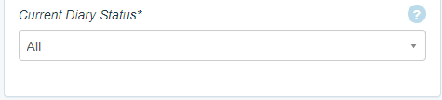
    - From the Date Range dropdown select known dates or refer to data boxes
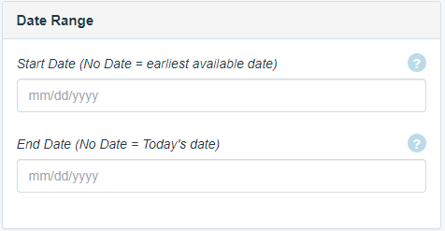
    - From the Report Output dropdown select
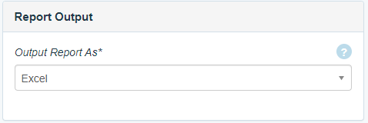

    - After all of the boxes are filled out select View Report
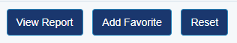
    - These reports can be run in either Excel, Pdf, or Web Report formats; however, Excel is the recommended format.
    - After the report prints, save it in the appropriate designated folder.
    - For ease of Quantlist frequency tracking at the project level, the Construction Group has created an Excel program that quantifies the information provided within these reports. This Quantlist Frequency Table Processor may be found on the ADOT Intranet under Inspector Resources. Just download Excel and follow the instructions provided.

Construction Operation Inspections.

Independent Quality Assurance Inspections:
The Quality Assurance Group (QA Group) is tasked with performing the independent reviews of statewide ADOT construction projects utilizing Quantlists. The QA Inspector will contact the unit for an updated contractors schedule, If any activities are of interest, an onsite visit will be scheduled with the Project Supervisor. These inspections are required by the Federal Highway Administration (FHWA) to ensure the funding provided is receiving the best quality product from the contractor and the field office.
Once an independent QA inspection has been conducted, any non-conforming attributes marked as "NO” on the Quantlist will be discussed with the Resident Engineer and the Project Supervisor. The contractor will be given a 24 hour period to correct the non-conformity, if corrected the deficiency will not be reflected on the initial score. If a deficiency is not corrected within that 24 hour period, an initial report will be generated listing the non-conformities from the same Quantlist completed during the initial inspection. The project Unit will have 14 calendar days (more time can be formally requested by the RE or project supervisor, reason as to why must be provided) to provide any missing documents or provide proof that any non-conforming items were corrected by the contractor. After the allotted time frame, the QA Inspector will compile any updated information received from the Unit and/or may perform a re-inspection (if necessary) to create a new Quantlist reflecting the efforts to correct the non-conformance issues found in the field.

Quantlist Correlation Inspections
Inspection Quantlist attribute results between field inspectors and QA inspectors can vary considerably. Interpretation of quantlist attributes and the time frame at which Quantlist inspections occur were found to contribute to these discrepancies. This variation in interpreting attributes can cause a number of issues on a project, such as, missed deficiencies not conforming to the Departments expectations, contractor QC / ADOT Inspector frustration, and considerable frustration from contractors who are told they need to perform work one way by an inspector only to have another inspector tell them they need to do the same work in another way. To combat the issue of varraying interpretation of attributes and to achieve consistency throughout the Department, Quantlist Correlation Inspections have been implemented.
Quantlist Correlation Inspection is an inspection of a product using quantlists that are completed by a field inspector and the QA inspector at the same time and same location but independent from one another. The Quantlists are then compared to each other for discrepancies in an attempt to identify the misinterpretation of a Quantlist attribute.
These inspections can be extremely useful for new Inspectors in learning how to look up Quantlist related specifications and interpret these specifications and project documents. In addition, this process can be a useful tool for more seasoned Inspectors, by establishing what the Department’s conformance expectations are in relation to the work being performed on a project by the contractor.
Quantlist Correlation Inspection Process:
- Quantlist Correlation Inspections will be performed in conjunction with an “official” project QA Inspection. Although, a construction unit may request a correlation inspection at any time if they feel this would benefit their project inspectors.
- There should be one correlation inspection by discipline per project receiving a QA Inspection. Example: SWPPP discipline has three parts, the QA Inspector will do the two field Quantlists (BMP & Housekeeping) with a Field Inspector and the Administrative Quantlist with the Project Supervisor. This goes for any discipline having multiple associated Quantlists such as, Traffic Control, Bulletin Boards, Supper Structures, Electrical, Etc.
- The QA Inspector will contact the RE and the Project Supervisor at a minimum of 48 hours prior to performing a correlation inspection. This notification should be done at the same time a unit is informed of an expected Independent QA Inspection (see 8.1 of this section).
- The Project Supervisor will make every effort to ensure that they themselves and/or a field inspector will be available to the QA inspector as needed, for the duration of the inspection process, in order to facilitate the Quantlist Correlation Inspection.
- Following the correlation inspection, a joint outbrief with the Project Supervisor and the field inspector will be held, either before or after the QA Inspection outbrief. In this correlation outbrief the attribute answer results will be reviewed and discrepancies discussed, in an effort to achieve consistency in interpreting the attribute throughout the Department.
- The findings will then be compiled into a QA inspector’s Correlation Inspection Report and will be attached to the initial QA Inspection Report, but will not be attached to the final QA Inspection Report.
- A QA Inspector’s Correlation Report findings will not affect scoring or otherwise influence the official QA Inspection Report in any way.
Additional Correlation information may be found in Construction Bulletin 07-01 on the ADOTNet

For further information or assistance contact:
Construction Operations, located at 1221 North 21st Avenue
Construction Quality Assurance Administrative Manager Robert Brook
Construction Quality Assurance Transportation Engineer Specialist Remigio Valencia
Construction Quality Assurance Transportation Engineer Specialist David Zook
Construction Quality Assurance Transportation Engineer Specialist Eric Gaedert
Construction Quality Assurance Transportation Engineer Specialist (Vacant)

