Airport Development

Guidelines

Five-Year Airport Development Program

And

Grant Management



Multimodal Planning Division

Aeronautics Group

January 2024

1801 W. Jefferson St.

Phoenix, AZ 85007

Contents

**Page**

**Introduction** 5

**Part I – Administrative Guidelines**

**Chapter Page**

# 

1. State Airports System 9
2. State Aviation Fund 11
3. Five-Year Airport Development Programming 13
4. Airport Pavement Management System (APMS) 18
5. Arizona Airport Development Loan Program 30
6. Airport System Planning Services 34

**Part II – ADOT MPD Aeronautics Group Grant Management Procedures**

**Chapter Page**

1. Grant Administration 37
2. Expenditure/Revenue Coding System “AFIS” 55

**Part III – Glossary and Appendices**

**Page**

**Glossary** 63

**Appendices for Part I**

1. State Transportation Board Policies – Aviation 67
2. Airport Listing by System Role 71
3. Project Components and Priority Value System 73
4. Arizona Airport Development Loan Program 90

**Introduction**

This manual provides guidance to the ADOT Multimodal Planning Division Aeronautics Group, hereafter simply called Aeronautics, and sets forth policies and procedures for the administration of the Arizona Airport Development Program. In 2021, the State Transportation Board (STB or Board) published policies, State Transportation Board Policies-Aviation (see Appendix A) that integrate the functions of Aeronautics into the multimodal systems of ADOT.

In the process of administering the Airport Development Program, Aeronautics utilizes a software package called Aviation System Manager (ASM). It is a database program which generates virtually all administrative forms and reports and conducts the prioritization of development projects, maintains the FAA’s 5010 database, and provides the Five-Year Program Web interface. The forms depicted in the Appendices are in digital format and can be completed in a word processing program.

It is the STB’s policy (see Appendix A statement number 3) that ADOT parallels FAA’s Airport Improvement Program (AIP). The FAA Order and AC references appear throughout the manual as the basic publication number without any suffix (which indicates revision). However, both resources always reference the latest issuance of the publications.

This manual has three parts: Part I, Guidelines; Part II, Procedures; and Part III, Appendices. Chapters 2 through 6 deal with the administrative aspects of the Aeronautics’ primary programs. Chapters 7 and 8 are procedural aspects related to the processing and internal activities for administering Grants, Loans and Studies within Aeronautics. The Appendices including Board Policy, airport listings, project components & project priority value system, Arizona airport development loan program, local government investment pool program, and airport development grants & other grants documents.

Part I

**Administrative Guidelines**

Chapter One – **State Airports System**

**I.** **STATE AIRPORTS SYSTEM:** The 2018 State Airports System Plan (SASP) focused primarily on public use airports. The SASP identifies 67 airports, including 12 Tribal airports as the “system of airports”. These 67 airports vary in size and serve different functions in meeting Arizona’s aviation and economic needs. These airports were assigned to one of six SASP roles (discussed below in part II) following an in-depth analysis of these 7 factors:

|  |  |  |
| --- | --- | --- |
| * Availability of international and/or domestic commercial air service * Number of based aircraft * Total Operations | * FAA-designated reliever status * Number of based jets | * Number of instrument approach operations * Availability of JetA and/or AvGas (100LL) |

**II. AIRPORT ROLES:** The following definitions are applicable to the 67 airports identified within the State System.

A. Commercial Service - International Airports: Publicly owned airports which enplane 2,500 or more passengers annually and receive both International and Domestic scheduled passenger air service.

B. Commercial Service - National Airports: Publicly owned airports which enplane 2,500 or more passengers annually and receive scheduled passenger air service.

C. Reliever Airports: FAA-designated airports that relieve congestion at a commercial service airport.

D. GA-Community Airports: Airports that serve regional economies, connecting to State and national economies with at least 250 annual instrument operations, 10 based non-jet aircraft or 1 based jet and aircraft fuel services.

E. GA-Rural Airports: Airports that serve a supplemental role in local economies, primarily serving smaller business, recreational, and personal flying and have at least 2,500 annual operations or 10 based aircraft and aircraft fuel services.

F. GA-Basic Airports: All of the remaining 67 airports, which serve a limited role in the local economy, primarily serving recreational and personal flying.

A.R.S. 28-8202 states airports must be: publicly owned and operated, open to the public, and owned by a political jurisdiction within the State of Arizona to be eligible to receive development funding. Figure 1 shows all 67 airports in the State and Appendix B list all 67 airports in alphabetic order by the airport’s name.

**Figure 1**

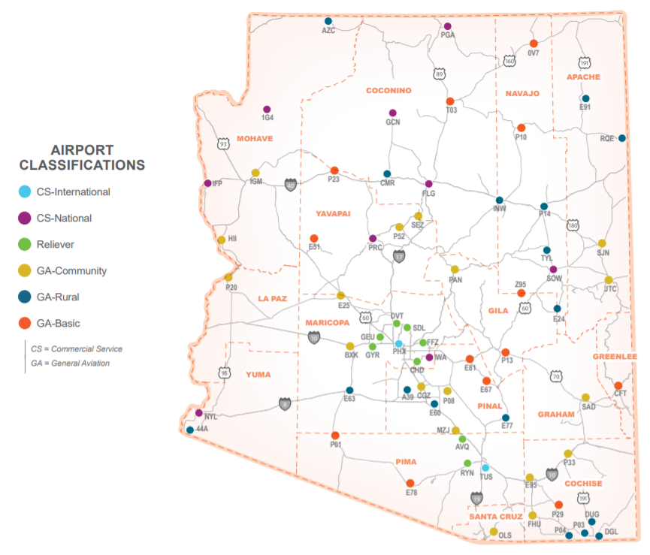**STATE AIRPORTS SYSTEM – ARIZONA AIRPORT ROLES – SASP MAP**

Chapter Two – **State Aviation Fund**

The State Aviation Fund is made up of monies collected from a variety of sources (see Table 1 below) to be distributed to airports for airport development. In 2022, the fund received more than $23.4 million annually from these revenue sources in approximately the ratios in Table 1.

**Table 1**



The programs approved by the STB for Aeronautics to distribute the Aviation Fund are discussed in more detail in the next chapter. The STB allocates the State Aviation Fund dollars in an equitable, efficient, and effective manner. The primary distributions are established as guidelines for Aeronautics’ use in preparing the annual airport development programs. Each year, the STB may review and amend these distributions.

The 2018 SASP airport roles are adopted by the STB (see Appendix A statement number 4), with an allocation set by ADOT administrative guidelines for the Program. The allocations typically follow the figures shown in Table 2. However, program initiatives, system needs, or the balance of the fund may require occasional administrative adjustments.

**Table 2**

**Approximate STB Allocations for State/Local Funding, by Percentage**

* Commercial Service Airports – International 43%
* Reliever Airports 35%
* General Aviation Airports-Community 19%
* General Aviation Airports-Rural 2%*
* General Aviation Airports-Basic 0.27%** Minimum $500,000 **Minimum $100,000

Chapter Three – **Airport Capital**

**Improvement Program - ACIP**

The STB supports Aeronautics’ development of publicly owned airport facilities with a balanced financial program that maximizes State investments to meet prioritized aviation needs by:

* Providing for a safe airport system, as measured by compliance with applicable safety standards, which supports health, welfare, and safety related services and activities.
* Providing an airport system that is adequately maintained to meet current and projected demand and is easily accessible from both the ground and the air.
* Advancing a system of airports that is supportive of Arizona’s economy, ensuring that the airport system is matched to Arizona’s socioeconomic and demographic characteristics.
* Promoting a system of airports that is sensitive to and considerate of the environment. The system should support aviation outreach opportunities.

I. PROGRAMS ESTABLISHED BY THE STATE TRANSPORTATION BOARD (see Appendix A statement 3)

**II.**

* 4 to $5 million in State funds per year.
* State/Local Matching Grants –
* now a set-aside program.
* The historical State

B.

C. Airport Sponsors will be required to complete all active grants and project efforts (including the grant administration) within four years from the grant issuance date.

**III. FIVE-YEAR AIRPORT DEVELOPMENT PROGRAM PRIORITIZATION**

Before any grants could be considered, a process was developed by an Industry-based committee of ADOT Aeronautics, airports, airport development consultants and representatives from the Arizona Airports Association. This process, published in 2011, was the result of three years of analysis, research and considerable discussion. When setting the priority points for the Annual ACIP Process the Committee considered the projects in their most likely purpose and benefit to the State Airports System overall. The result was submitted to the STB and adopted in October of 2011.

The program uses three levels of ranking to determine the priority importance of a project.

**FIRST LEVEL** is comprised of six general categories used as a framework only for ordering the project’s importance.

1. SAFETY: Projects that are directly associated with the effective safety of operations of an aircraft at an airport are considered the highest in importance. These types of projects are best characterized by airfield improvements to runways and taxiways that must be done to meet FAA’s design standards for the typical aircraft using that airport. Other safety projects may include items deemed necessary by the FAA’s Runway Safety Action Team inspections and Airport Certification Inspections including land acquisition to provide for these types of developments.

2. SECURITY: An airport’s security needs are to be delineated by an airport security document that clearly demonstrates what projects are needed to advance security under the guidance of the Transportation Security Administration (TSA). Commercial Service airports are required by the TSA to have such a document. General Aviation airports do not have such requirements. However, TSA publishes guidance for General Aviation airports that must be followed in preparing their security document supporting their grant request.

3. CAPACITY: An airport’s ability to accommodate growth is what characterizes capacity type projects. This category includes projects associated with and improving/upgrading aviation facilities not associated with specific safety efforts on the airport but are planned to increase the airport’s accommodation of growing conditions. These can include expansion/construction of runways/taxiways; new NAVAIDs; instrument approach surveys; apron construction/expansion; signage; environmental mitigation construction; and land acquisition to provide for these types of developments.

4. ENVIRONMENTAL: This category will include Environmental Categorical Exclusions, Environmental Assessments, and Environmental Impact Statements associated with planned and programmed development projects. The FAA’s requirements for environmental services will control the issuance of State grants. For projects that do not result in federal action, ADOT-Environment will provide environmental determination.

5. PLANNING: Eligible planning projects in this category are specific to demonstrating airport needs and defining near future airport development improvements. In this category only those projects listed below are eligible as stand-alone projects for consideration as an SL grant:

* + - Airport Master Plans
    - Airport Site Selection/Feasibility Studies
    - Airport Layout Plan Updates
    - Airport-wide Drainage Studies

Other planning projects may be permitted, but only as an adjunct to a Master Plan study. Types of projects of this nature include:

* + - Business Plans
    - Rates and Charges Surveys

Some types of planning projects are not eligible to be funded with SL grants. Those include, but are not limited to, preparing administrative documents such as FAA Part 139 certification manuals, security manuals, airport rules and regulations, and minimum operating and development standards for airport tenants.

6. ECONOMIC SUSTAINABILIITY: In this category, projects are of a nature that indirectly support aviation-based activities but are not typically used to generate airport revenue such as public terminal areas (may include free public parking and roads); airfield maintenance facilities; and land acquisition to provide for these types of developments.

**SECOND LEVEL** is comprised of 46 “Project Components” carrying a specific value within a range of 17 to 255 points. See Appendix C for a more detailed discussion and complete listing of the Project Components, their detailed definitions and assigned priority points.

**THIRD LEVEL** is “Airport Measures”, with three specific attributes: “Registered Aircraft”; “Scheduled Air Carrier Enplaned Passengers”; and “Aircraft Operations Compared to Airport Service Volume”. Each attribute can provide each airport with a value of 1-6 points. Appendix 3 also provides a more detailed explanation of these attributes.

A. Each year Aeronautics will contact all public airports in the State and obtain their desired projects for consideration. Aeronautics will administer these guidelines in their evaluations and present the recommendations for projects to be funded to the STB for approval as a part of Aeronautics’ Five-Year Airport Capital Improvement Program (ACIP). This document becomes a part of the ADOT Tentative Five-Year Transportation Facilities Construction Program.

B. Project Component ratings are set in general depending on the typical purpose and benefit of the project for the State Airport System; safety, security, capacity, planning, environmental, or sustainability. The factors and order used to develop the project priority ratings were determined by Aeronautics in coordination with the aviation community and approved by the STB. See Appendix C for the list and title of each Project Component.

C. Airport Measure ratings are set using a series of three common airport measures of activity and assigning points for each level of activity within each of these measures. These measures are State registered based aircraft, scheduled air carrier enplaned passengers, and sponsor reported aircraft operations compared to the airport service volume. See Appendix C for the airport measures and their respective point assignments.

D. The overall priority of a project for the development of the ACIP will be the sum of the Project Component points plus any Airport Measure points.

**IV. SPONSOR SUBMITTALS AND AERONAUTICS ACCEPTANCE**

A. Typical annual schedules: Airport sponsors should be aware of the time frames and deadlines presented in the figure below and plan their ACIP and grant processes accordingly.



B. Web entry by sponsor: The ACIP is built each year based upon projects submitted by sponsors via the Aeronautics’ ACIP website. Each year, usually in August, after the Annual Planning Meetings have been conducted with Aeronautics, sponsors, and the FAA, notice is sent to the sponsors with the date that they may begin to submit their projects. The notice also includes their new login ID and password. The login screen is shown below.

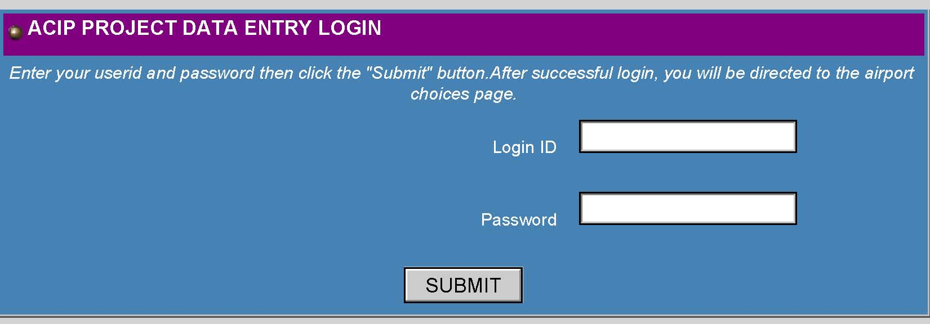

C. Initial Review by Aeronautics: The submitted projects will be reviewed by Aeronautics to ensure project eligibility, project components match project scope, budget appears feasible, description and justification make sense, project schedules are realistic, environmental reviews are included, and projects/program agrees with airport planning documents (master plans) and whether the project is on the approved ALP.

1. If the project meets Aeronautics criteria, and if the sponsor filled in the data fields completely and correctly, Aeronautics will accept the project into the ACIP database.
2. If changes are required, the project will be rejected and notification will be sent to the sponsor. The sponsor will make corrections and resubmit the project to Aeronautics.

D. Aeronautics will conduct a second review, if necessary, and will accept or reject the project.

E. Aeronautics application of priority system values: Aeronautics prioritizes Airport Development projects requesting State/Local (SL) funding as outlined in Chapter 3 Section III and in accordance with the State priority programming requirements of A.R.S. 28-6951.

F. Preparation of Tentative Five-Year Program: Aeronautics reviews, edits, and combines the submitted approved projects into the Tentative Five-Year ACIP. Project priorities are assigned to the SL projects and funding is assigned to projects based upon the project priority and the funding level. Funding levels for each airport development program area are then applied to the prioritized projects to determine which SL projects will be included in the Tentative ACIP. Only those SL projects selected for funding appear in the ACIP. All FSL grant request projects are included. This ACIP document is combined with the ADOT Highway Program and the Regional Transportation Plan Freeway Program to form a single document for review and approval: the Tentative Five-Year Transportation Facilities Construction Program.

G. Five-Year Program approval process: The Tentative Five-Year Program is presented to the ADOT Priority Planning Advisory Committee (PPAC) in January. The ACIP is included as a part of the Tentative Five-Year Program. Comments may be addressed and changes may be made if needed. The Tentative Five-Year Program (which includes the ACIP) is then submitted to the STB in February. Public hearings are conducted from March through May, comments are received and addressed, changes made, if warranted. Final STB action is done in June. The STB approves the first year of the ACIP for the funding fiscal year. The remaining 4 years of the 5-year plan are approved, but not funded. Grants may be issued in July. The process is summarized in the figure below.

Chapter Four – Airport Pavement Management System (APMS)

**I. PURPOSE**

The airport system in Arizona is a multi-million dollar investment of public and private funds that must be protected and preserved. State Aviation Fund dollars are limited, and the STB recognizes the need to protect and extend to the maximum the useful life of the airport system's pavement. The Airport Pavement Management System (APMS) policy is established primarily to create an airport pavement preservation program (APPP) to assist in the preservation of the Arizona airport system infrastructure.

Secondarily, the APMS serves airport sponsors and the FAA in meeting pavement management compliance requirements. As a result of Public Law 103-305, which amends Title 49, section 47105, of the United States Code, the FAA incorporated into all AIP grants an additional grant assurance. This assurance, Number 11, requires that any airport sponsor receiving or requesting a grant for a pavement improvement project must have a pavement management program. To provide airport sponsors with guidance on developing a pavement maintenance management program the FAA issued Program Guidance Letter (PGL) 95-2. This PGL identified four main components required to make up a satisfactory pavement maintenance management program. These four components are: pavement inventory, inspection schedule, record keeping, and information retrieval.

The ADOT APMS reports provide an inventory map, PCI inspection data, and project recommendations. However, to comply with all requirements of the most recent versions of FAA AC 150/5380-6 for airport pavement maintenance and FAA AC 150/5380-7 for airport pavement management, and to comply with Public Law 103-305, the airports must: retain the plan, implement plan recommendations, and keep records of periodic inspections. This section will explain the APMS in Arizona and how it assists the Aeronautics division to fulfill the primary purpose of maximizing pavement life of Arizona airports. in fulfilling all related requirements.

To assist airports in meeting federal obligations related to airfield pavement maintenance as well as to preserve past investments in airfield pavements, pavement maintenance services may receive funding for a portion of eligible airport’s airfield pavement maintenance needs. An eligible project’s costs up to a maximum of 90% of eligible costs at Commercial Service, Reliever, General Aviation (GA)-Community and GA-Rural airports and 95% at GA-Basic airports.

**II. BACKGROUND**

In 2000, ADOT implemented an APMS to monitor the condition of the Arizona airport pavement infrastructure and to proactively plan for its preservation.

Public Law 103-305 requires that airports requesting Federal AIP funding for pavement rehabilitation or reconstruction have an effective pavement maintenance management system. Specifically, FAA requires compliance with:

“Public Law 103-305, section 107, amended Title 49, Section 47105, of the United States Code by requiring sponsor assurances on preventative maintenance for project applications involving airfield pavements. For any project to replace or reconstruct pavement, the sponsor must provide assurance to the FAA that they have implemented an effective pavement maintenance management program. The amendment also provides for the submittal of reports addressing the pavement condition and the management program.

The requirement to establish a pavement maintenance management program applies to any pavement at the airport which has been constructed, reconstructed, or repaired, with federal assistance. All grants involving pavement rehabilitation or reconstruction contain a grant assurance that addresses the pavement maintenance obligation.” (FAA Airports Website)

The Aeronautics’ grants also contain a grant assurance for airport pavement maintenance. Non-performance of regular maintenance and inspection and/or inability to provide related documentation could jeopardize the airport’s eligibility to receive grant funding from both FAA and Aeronautics. To this end, Aeronautics has completed and is maintaining an APMS which, coupled with monthly pavement evaluations and regular maintenance by the airport sponsors, fulfills this requirement.

The Arizona Airport Pavement Management System uses the Army Corps of Engineers' “Micropaver” program as a basis for generating a Five-Year Airport Pavement Preservation Program (APPP). The process begins with visual inspections of all airport pavements. Evaluations are made of the types and severities of pavement distresses observed and entered into a computer program database. Pavement Condition Index (PCI) values are determined through the visual assessment of pavement condition in accordance with the most recent version of FAA AC 150/5380-6 and range from 0 (failed) to 100 (excellent). Every three years complete database updates, with new visual observations, are conducted. Individual airport reports from the update are shared with all participating system airports. Aeronautics ensures that the Arizona APMS database is kept current, in compliance with FAA requirements.

All NPIAS airport sponsors have responsibility beyond the ADOT APMS to implement a full pavement management program that satisfies Public Law 103-305 and the FAA ACs for their airports. This includes following any recommendations in the APPP for: maintaining records of any monthly pavement condition inspections, performing regular maintenance, and providing funding for regular maintenance activities. In addition, major rehabilitation projects must be requested and completed by the sponsor outside the APMS projects. Major rehabilitation projects are typically eligible for AIP funding when the sponsor is in compliance with the requirements of Public Law 103-305 and the FAA ACs.

**III. DEFINITIONS**

A. Airport Pavement Management System (APMS): ADOT has developed an APMS that includes all paved, public use airports. It is the basis for assigning Pavement Condition Index (PCI) numbers to pavement areas. This system will be managed in the MPD Aeronautics Group with the information in the database available to all airports.

B. Pavement Condition Index (PCI): The PCI is a calculated number based upon the distress types, severities, and quantities observed during a visual inspection of the pavement surface. For the purpose of this policy, overall airport pavements are first divided into airport branches/sections, and sample units before a visual distress condition evaluation is accomplished. The final analysis averages many distress types and severities to arrive at an overall PCI for each branch.

C. Pavement Priority Rating Number (PPRN): The PPRN is a value assigned to each pavement section that represents its priority level within the entire Arizona airport system. The number is derived from a table using the PCI ranges of different airport classifications (Commercial, Reliever, GA-Community, GA-Rural and GA-Basic) versus airport uses (Main Runways, Aprons, Secondary Runways, and Taxiways). The PPRN for each individual identified project is ranked in the Priority Rating System to select projects to be funded during a five-year period. The PPRN table is given below.

**Pavement Priority Rating Number (PPRN) Table 3**



1. Airport Pavement Preservation Program (APPP): This program involves the management by Aeronautics and airport sponsors of projects associated with the maintenance and repair of airport pavements. The projects developed through an analysis of the PCI values and treatment matrixes are prioritized for recommendation to be funded through this program. Projects are prioritized within the APPP using the PPRN, as well as included in the Five-Year Airport Capital Improvement Program via the Aeronautics priority programming system. Project definitions and their ACIP priority numbers are given below.
2. Apron Pavement Preservation: The improvement of public use apron areas is eligible. Pavement preservation activities recommended by a pavement management system and verified by appropriate field testing. Includes crack seal, slurry seal, overlays, and rehabilitation projects. Includes removal and replacement of previously existing striping or pavement markings. All work to be done must meet either FAA specs where required or local government paving specs where allowed. ADOT paving specs are not recommended. Does not include increasing scope beyond recommendations (i.e. slurry seal recommended and verified, but sponsor requests overlay, or 1/2 of apron recommended but sponsor wants whole apron).
3. Runway Pavement Preservation: Pavement preservation activities recommended by a pavement management system and verified by appropriate field testing. Includes crack seal, slurry seal, overlays, and rehabilitation projects. Includes removal and replacement of previously existing striping or pavement markings. All work to be done must meet either FAA specs where required or local government paving specs where allowed. ADOT paving specs are not recommended. Does not include increasing scope beyond recommendations (i.e. slurry seal recommended and verified, but sponsor requests overlay, or 1/2 of runway recommended but sponsor wants whole runway). Does not include upgrade of pavement strength to accommodate larger aircraft.
4. Taxiway Pavement Preservation: Taxiways to expedite the flow of traffic between runways and aircraft parking areas available for public use are eligible. Pavement preservation activities recommended by a pavement management system and verified by appropriate field testing. Includes crack seal, slurry seal, overlays, and rehabilitation projects. Includes removal and replacement of previously existing striping or pavement markings. All work to be done must meet either FAA specs where required or local government paving specs where allowed. ADOT paving specs are not recommended. Does not include increasing scope beyond recommendations (i.e. slurry seal recommended and verified, but sponsor requests overlay, or 1/2 of taxiway recommended but sponsor wants whole taxiway). Does not include upgrade of pavement strength to accommodate larger aircraft.
5. Arizona Treatment Matrix: PCI numbers and ranges trigger different pavement repairs or treatments (i.e. crack seal/slurry seal; overlays [both thin and thick]; complete reconstruction [both asphaltic concrete and Portland cement concrete]; etc). See below for the treatment matrix table. Note that not all treatments are APPP eligible because of limited available funding.

Five treatment options are identified by ADOT for consideration in its APPP: 1) thin rubberized asphalt overlay, 2) mill and replace porous friction course, 3) crack seal and slurry seal, 4) crack seal and rubberized asphalt emulsion seal coat, and 5) PCC joint resealing and spall repairs. Pavements with a PCI value falling below 55 for asphalt-surfaced pavements and 65 for PCC pavements were not eligible for the APPP and instead have been identified as requiring major rehabilitation.

**Arizona Treatment Matrix**

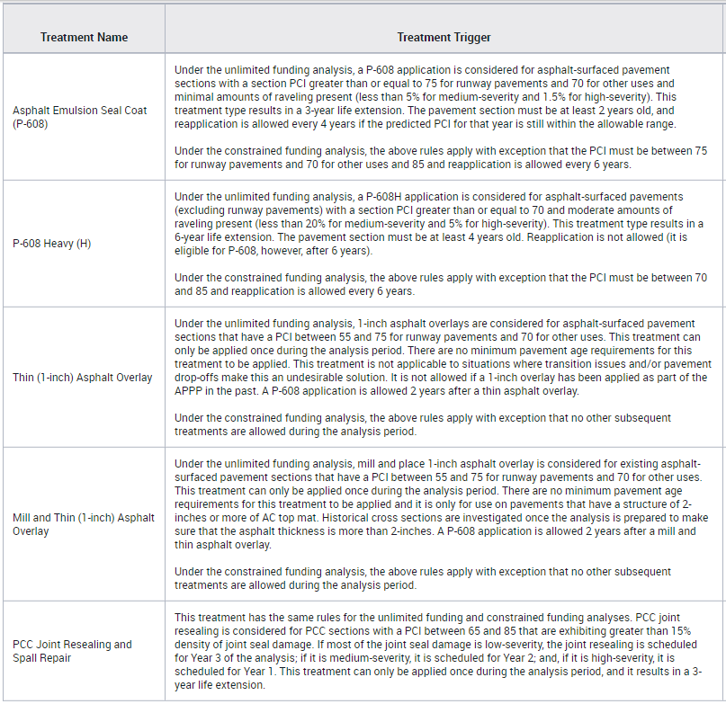

I. Statewide Maintenance Contract: A statewide maintenance contract to provide materials and such construction services as crack sealing, surface treatments, and thin overlays. Aeronautics may issue these contracts to have the prescribed APPP work performed or any airport sponsors may opt to use their own maintenance forces or contracts to perform the work.

J. Inter-Governmental Agreement (JPA): An agreement between Aeronautics and any airport sponsor. These agreements allow statewide maintenance contracts to be administered by Aeronautics on behalf of the airport sponsor and incorporate the same grant assurances as the current Aeronautics grant agreements.

K. Network: All of the airside pavements of the airports included in the Airport Pavement Management System, excluding paved hangar areas.

L. Routine Maintenance: Routine pavement maintenance is an essential part of preserving the pavement infrastructure at the airport. The airport sponsor is responsible for regular maintenance in order to be eligible for the APMS and to be eligible for FAA AIP funding. Each individual airport pavement plan report details how to conduct routine pavement inspections. Sponsors should follow maintenance recommendations in the APPP and follow the required actions and documentation in the most recent version of FAA AC 150/5380-6. This work includes, but is not limited to:

It is recommended that the following strategies be considered for a successful airport maintenance program:

1. Regularly inspect all safety areas of the airport, and document all inspection activity.
2. Provide a method of tracking all maintenance activities that occur as a result of your inspections. These need to be reported to the FAA and ADOT. This is important as this information is used to update the APMS records and is required to remain in compliance with Public Law 103-305.
3. Conduct an aggressive campaign against weed growth through timely herbicide applications and/or mowing programs for the paved areas. Vegetation growing in pavement cracks is very destructive and significantly increases the rate of pavement and shoulder deterioration.
4. Implement a periodic crack sealing and joint sealing program. Keeping water and debris out of the pavement system by sealing cracks and joints is a proven method for cost-effectively extending the life of the pavement system.
5. Ensure that dirt does not build up along the edges of the pavements. This can create a "bathtub" effect, reducing the ability of water to drain away from the pavement system.
6. Closely monitor the movement of heavy equipment, such as construction equipment, emergency equipment, and fueling equipment, to make sure that it is only operating on pavement designed to accommodate the heavy loads this type of equipment often applies. Failure to restrict heavy equipment to appropriate areas may result in the premature failure of airport pavements.
7. Other maintenance necessities include keeping all pavement markings well painted, keeping safety signage clear of debris and weeds, ensuring the continuous operation of lighting systems (bulb replacement), and the frequent removal of any debris found in any of the operating areas. In addition, failed pavement areas should be patched as necessary.

These recommendations are only a portion of the responsibility each sponsor has in maintaining an airport. Each airport sponsor must provide regular airport maintenance to all its aviation facilities both in the aircraft movement areas and all adjacent areas supporting aviation. It is particularly important to be vigilant in repairing pavements where conditions can pose a hazard to safe operations. For further information on pavement maintenance techniques, refer to the FAA AC 150/5380-6C, Guidelines and Procedures for Maintenance of Airport Pavements, presented in the adjacent tab.

**IV. ELIGIBILITY**

Every year Aeronautics, utilizing the APMS, will identify airport pavement maintenance projects eligible for funding for the upcoming five years. These projects will appear in the State’s Five-Year Airport Development Program. Once a project has been identified and approved for funding by the STB, the airport sponsor may elect to accept a State grant for the project and not participate in the APPP or the airport sponsor may sign an Inter-Governmental (IGA) with Aeronautics to participate in the APPP.

A. Eligible Airports: To be eligible for this program, the airport sponsor must certify an annual maintenance program to Aeronautics. This certification includes information concerning the prior year’s type, cost and frequency of regular pavement maintenance conducted at the airport. It is important that the local airport sponsor recognizes that the APPP is not designed to relieve the airport owner of the responsibility to maintain the airport. The APPP is envisioned to assist the airport in meeting this obligation only and is not assuming any liability or obligations of the airport owner.

B. Eligible Projects: The pavement maintenance treatments that are recommended for funding through the APPP include crack sealing, surface treatments (including slurry seals) and thin overlays. Other more expensive and extensive treatments are currently not eligible due to limited funds available. The Arizona Treatment Matrix included above in the definitions section describes all the recommended airport pavement treatments.

C. Grant Duration Limitation: One of the objectives of the APPP is to protect and extend the useful life of the existing pavement investment. In order to ensure the maximum return of the expenditure of State funds for pavement preservation, it is imperative that the work be completed within as short a timeframe as possible. Therefore, the pavement maintenance projects will typically be completed in twelve months.

D. Active Pavement Maintenance Projects: Only one pavement maintenance project per airport will be identified annually. No subsequent pavement maintenance projects will be programmed until the current identified and funded project is completed.

**V. AIRPORT PAVEMENT PRESERVATION PROGRAM PROCEDURES**

A. Project Selection: Aeronautics inputs statewide data including PCI numbers (which trigger various pavement treatments - see table below) and priority numbers (see definitions section above) into the APMS. The result is a network - project prioritized - construction list. The pavement maintenance treatments that are recommended for funding include crack sealing, surface treatments (such as slurry seals) and thin overlays. As a rule, pavement repairs performed early in the life cycle of a pavement (such as crack sealing or surface treatments) are more cost-effective than repairs that have been delayed until major rehabilitation is required (such as reconstruction). See Figure 2 below for comparison.



Figure 2

Therefore, to maximize the benefit received from the expenditure of pavement preservation funds, projects with very low PCI values — (which require a great deal of money to rehabilitate with little effect on the overall statewide PCI) — are not currently eligible considering the limited State resources available for the program. However, these projects will be recommended for construction with Federal aid funds. Projects with high PCI values, where timely maintenance will render excellent life cycle potential, are given a high program funding priority within the pavement preservation program. Projects not selected for funding will be considered as back-up projects and reconsidered for future programming. See Figure 2 below for eligibility distribution (yellow area is within PCI range for APPP).

Figure 2. Arizona PCI-Based Eligibility Values.



1. STB Approval: The statewide pavement preservation program generated by Aeronautics is sent to the PPAC and the STB along with the annual update to the Five-Year ACIP for approval. The STB must approve program changes.
2. Non-Participating Airport Sponsors: Any airport sponsor may elect to not participate in the APPP. Under this option, the Airport Sponsor are responsible for performing pavement inspections and evaluations, performing maintenance and keeping records, programming funding and requesting projects, accomplishing project construction, including the hiring and supervision of consultants and contractors as required. These projects will be handled the same as the current airport development grant program.
3. Participating Airport Sponsors: If an airport sponsor decides to participate in the program, then an Inter-Government Agreement (IGA) between the Airport Sponsor and Aeronautics will be required. The airport maintenance construction projects will be managed and administered by Aeronautics. Aeronautics will contract for a Pavement Management Engineering Consultant to assist in the management, design, testing and quality control to administer the program. Through the use of statewide maintenance contracts for materials and construction services it is believed that there will be a large “Economy of Scale” cost savings.

E. Project Construction: When a project is constructed under the Inter-Governmental Agreement (IGA) process, Aeronautics and its Pavement Management Engineering Consultant will be responsible for the contract administration. This involves the following:

1. Meet with the sponsor at the airport - prior to construction - to assure that the prescribed pavement treatment is prudent and to coordinate the start to finish schedule including how project quality control will be administered.

2. Activate the appropriate statewide contract and oversee the project construction.

3. Schedule progress meetings as necessary with Aeronautics, the contractor, and the airport sponsor.

4. Conduct inspections as necessary including a final inspection with all interested parties participating.

5. Assure that the contractors, suppliers, etc. are properly paid on time; that the work is completed in a timely fashion; and that all documentation (including "record drawings") is properly submitted before final payment is made.

F. Project Completion and Acceptance: Aeronautics staff and an airport representative will conduct final inspections for all pavement preservation projects. No project can be closed with final payment made until Aeronautics Group receives final documents.

VI. ADDITIONAL RESOURCES

1. Federal Aviation Administration – AC 150/5380-6 (most current version) - Guidelines and Procedures for Maintenance of Airport Pavements – 10/10/14. Contains specific guidelines and procedures for maintaining airport pavements and for establishing an effective maintenance program. Specific types of distress, their probable causes, inspection guidelines, and recommended methods of repair are presented.
2. Federal Aviation Administration - AC 150/5380-7 (most current version) – Airport Pavement Management Program - 10/10/14. Presents concepts in pavement management, and outlines how it can be used to make cost-effective decisions.
3. Public Law 103-305, section 107, amending Title 49, section 47105, of the United States Code, includes requirements for grants to include assurances on preventative maintenance with certain project applications.

Chapter Five - Arizona Airport Development Loan Program (Currently Suspended)

**I. PURPOSE**

This program provides financial assistance through the State Aviation Fund to public agencies (airport sponsors) owning and operating an airport to expand and enhance aviation business opportunities at their respective facilities. These monies will be made available to eligible airport sponsors in the form of interest-bearing loans. The program has one purpose:

A. To provide interest bearing loans for airport development projects designed to generate direct revenue to the airport. These types of revenue generating projects are typically not able to receive funding through an airport development grant outlined in Chapter 2 of this manual.

**II. DEFINITIONS**

A. Airport Development Loan: This is an interest-bearing loan available to publicly owned airports identified in the ADOT State Airports System Plan dated October 2018 (or most current version). Loans may be utilized for projects that generate direct revenue to the airport.

**III. QUALIFYING**

To receive assistance under the Arizona Airport Development Loan Program, an airport sponsor and the proposed project(s) must meet four conditions to qualify for a loan.

A. Sponsor Eligibility: A sponsor’s airport must be identified in the ADOT State Airports System Plan dated October 2018 (or most current version). The airport must be owned by the public agency making an application for the loan. The airport must be open to the public on a nondiscriminatory basis.

B. Airport Benefits: In determining whether the project has “Airport Benefits”, Aeronautics will examine such factors as how the project will enhance operational airport capacity, aviation safety on the airport, improve air service to the local community, or enhance the local economy.

C. Project Feasibility: The sponsor must demonstrate the proposed project is feasible with respect to its location and operation on the airport and with how it performs a significant economic and aviation purpose for the airport. Applicant must also demonstrate how the loan will be financially secured.

1. Practicality: A proposed project is practical from an engineering standpoint when it can be designed, constructed and operated to safely accomplish the aviation purpose for which it is intended in accordance with FAA aviation design criteria and generally accepted engineering principles and concepts. Practicality must also be demonstrated that the project is in an operationally acceptable location on the airport.

2. Economic Purpose: This purpose can be demonstrated when, within one year of the project’s completion, the airport will experience: 1) an increase in aviation activity in the form of aircraft operations and/or based aircraft; or 2) an increase in new businesses or ancillary business activities. Either must be clearly associated with the project’s presence on the airport.

3. Financial Responsibility: The applicant must provide a pro forma cash flow and financial responsibility acceptance statements. All financial statements must be prepared by a certified public account from the sponsor’s governing body and responsibility statements must be formal resolutions of the governing body.

D. Any project(s) shall be developed inside the official property boundaries of the airport as shown on the airport’s official Airport Layout Plan documents.

**IV. LOAN APPLICATION PROCESS**

ADOT’s Airport Development Loan Committee is responsible for review and recommendations to the STB. The STB is the approving authority for an Airport Development Loan. Applications for loans under this program will be submitted to the Aeronautics Group.

A. The Loan Committee is comprised of the Multimodal Planning Division Director as the Committee Chair, Aeronautics Group Manager, ADOT Chief Financial Officer (CFO), one member of the STB appointed by the STB Chair, and one member from the public financial sector selected by the ADOT CFO.

B. The STB, who, at their discretion, may award loans for the purposes applied for, within the limitations imposed by budgetary restraints. Successful applicants will enter into a contract with the ADOT within four (4) months of STB approval.

C. Applications and instruction material will be prepared by Aeronautics and made available to any qualified sponsor. (See Appendix D) Sponsors may submit an application to Aeronautics at any time. Committee and STB reviews and approvals are scheduled only as need arises.

**V. LOANS**

A. Principal: Monies from the State Aviation Fund will be used for the principal amount of the loan approved by the STB.

B. Interest: Interest rates will be the average rate of the Delphis-Hanover Index during the preceding six (6) month period. The interest rate will be adjusted every six months. Interest on a loan will be accrued quarterly.

C. Duration and repayment schedule: Duration for any loan may vary and will be considered on a case-by-case basis. The duration of any loan cannot exceed 20 years.

Payments will be scheduled on aquarterly basis commencing the first day of the third month from the date of the loan agreement.

D. The maximum loan for these purposes shall be at the discretion of the STB and will be based upon the unique circumstances of each individual project. The Loan Committee, based on State Aviation Fund resources, may impose limits on loans amounts.

E. Success in securing a loan will depend on the quality and thoroughness of the application and the level of detail submitted. The Loan Committee will closely evaluate applications in order to fund the most meritorious projects. The types of projects we anticipate are those that will contribute to the economic well-being of the airport. Examples are, but not limited to:

* Hangars
* Utility Improvements
* Fuel Farms
* Terminals
* Auto Parking (Revenue Generating)
* Office/Hangar Complex
* Terminal Restaurants
* Recreational Improvements

Sponsors who plan to submit an application for consideration must review the entire Loan Application packet (Appendix D) carefully and submit one original and six complete copies of the loan request to:

Matthew Munden, Aeronautics Group Manager  
1801 W Jefferson St, MD 426M  
Phoenix, AZ 85007

There is no deadline for these submissions. Consideration will be on a first-come, first-serve basis.

A sponsor may attach any supporting documentation to the application for the requested loan project. These types of documents may include regionally and municipally approved economic development plans that include the project, letters of support for the project from economic development organizations, and/or a petition of public support for the project.

Chapter Six **– Airport System Planning Services**

**I. GENERAL**

A. All 67 State System airports are owned by separate public and private entities. These range from small home-owner cooperatives operating a single runway to the City of Phoenix operating Phoenix Sky Harbor International Airport and two large general aviation airports. This diversity brings a strong need for the State to provide statewide planning services that will ensure safe and orderly development and growth of aviation in the State.

B. At the national level, airport development is controlled by the FAA. FAA’s responsibilities include the management of all airspace matters in the country, flight rules of all types of aviation and airport development. The State is actively engaged with the FAA to ensure the voice of Arizona aviation is heard and supported.

C. Arizona Revised Statutes 28-8202 states in part. “… The board shall distribute monies appropriated to the department from the State Aviation Fund for planning, design, development, acquisition of interests in land, construction and improvement of publicly owned and operated airport facilities in counties and incorporated cities and towns. The board shall distribute these monies according to the needs for these facilities as determined by the board.” It is with this in mind the STB needs regular input to the State’s current and projected conditions in Aviation.

**II. SERVICES**

A. In pursuant of these statewide responsibilities, the STB will set aside annually sufficient monies from the State Aviation Fund to support Aeronautics’ planning effort on behalf of the airports in Arizona. Aeronautics will provide recommendations each year during the preparation of the State’s Five-Year ACIP. Examples of the types of work and studies anticipated are listed below, but are not intended to be an exclusive list. Other studies as recommended by Aeronautics will also be considered.

* 1. State Airport System PlanningMetropolitan Regional Planning
  2. Aviation Economic Impact Studies
  3. Statewide Aeronautical Charts
  4. System Wide Navigation Aids
  5. Recreational Airport Development
  6. Weather Reporting Studies
  7. Pavement Preservation
  8. LPV Survey
  9. 5010 Inspections
  10. Aviation System Manager (ASM) Update

Part II

ADOT MPD Aeronautics Group

Grant Management Procedures

Chapter Seven – **Grant Administration**

The processes outlined and described in this chapter are based on the **Aviation Systems Manager (ASM)**, a database program. The reader must have proficiency with Access database software and be an employee of ADOT responsible for some portion of airport grant management.

The ASM software is activated by clicking the ASM desktop screen icon. Once active, the user is prompted to enter a user name and a password. Typically, the user name is the first name of the user. The Aeronautics Group Manager will provide both the user name and the password. Once in the system, the **ASM Main Menu** screen will appear. The ASM Main Menu Screen is shown below.

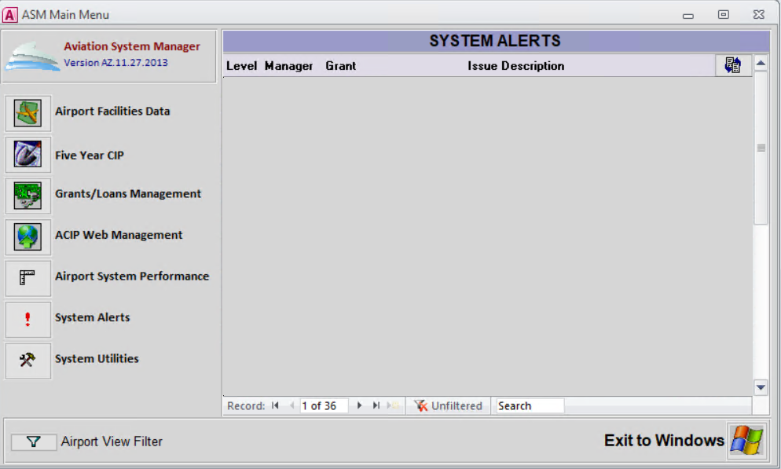

**Grants/Loans Management**

All ASM-related work for approved airport grants will be accomplished in the **Grants/Loans Management** module**.** This includes setting up new grants, amending grants, making grant reimbursements, entering scheduled and actual milestone dates, closing grants, and other activities that will be described in detail throughout the chapter. In addition to ASM, other resources will be used to manage grants. These will also be introduced in the following sections as they are used in grant management.

**Five Year CIP & ACIP Web Management**

work for the Five-Year Airport Capital Improvement Program (ACIP) will be done under the **Five-Year CIP** and **ACIP Web Management** modules of ASM. ACIP work is covered in another chapter.

Other areas of the **ASM Main Menu** and **Data Maintenance** are used by ADOT staff for various functions that are not directly related to day-to-day grant management duties. Those functions will not be discussed in this document.

**STB APPROVAL & CREATION OF NEW AGREEMENTS**

The Five-Year ACIP process is used to gain STB approval for the airport development program, which includes both grants funded by State and Local contributions (SL) and grants funded by Federal, State and Local contributions (FSL). For SL grants approved as a part of the Five Year ACIP, the Sponsor requests the grant via the ACIP website. After the Airport Grants Manager (AGM) reviews the request for eligibility, syntax, completeness, and accuracy, the project is entered into ASM by accepting the project request on the Five Year ACIP screens. For FSL grants, the sponsor also requests the grant via the ACIP website. The AGM does not review eligibility of FSL grant requests, but does review the requests for syntax, completeness, continuity and accuracy. After acceptance by the AGM, the sponsor prints a copy, signs the paper version, and submits their requests to the Federal Aviation Administration (FAA).

ADOT prioritizes the SL grant requests in accordance with program guidelines, providing funding to the highest priority projects within the funding limits for each program area within each program year. The ACIP document published for comment and submitted to the STB for approval lists only those SL projects selected for funding. The ACIP will list **all** **requested** FSL projects because the FAA makes funding decisions after the ACIP development process is complete. Each year, ADOT coordinates with the airport sponsors to issue grants for the STB approved SL grants in the first year of the approved Five Year ACIP. Approval of the ACIP by the STB authorizes ADOT to issue the SL grants in the first program year of the ACIP. For each FSL, a matching ADOT grant will be issued after ADOT receives a copy of the grant issued by the federal funding agency and a written request from the airport sponsor for matching ADOT funds. ADOT then sends the matching FSL grant to the STB for approval.

The “Off-ACIP” process is used to obtain STB approval for the following requested grant actions:

* New FSL grant requested for State match (Each request, even if the project is already in the first year of the approved ACIP, must follow this process because the STB approval covers the concept of FSL matches, and lists the requests submitted to FAA, but the list of funded grants is unknown at the time of ACIP approval.)
* New SL grant (At any time during the year, a Sponsor may request an SL grant from ADOT for an eligible project. The request must include justification as to why the project cannot wait to be submitted through the annual ACIP process. These projects are considered by ADOT on a case-by-case basis as funding levels allow.)
* To change certain conditions of an existing grant (known as a grant amendment), i.e., Sponsor has requested additional scope items or additional budget more than 15%. Scope and budget items over 15% must also be approved by the STB. Budget increases of less than 15% and all time extensions are approved administratively by the ADOT Aeronautics Group.

New grants “Off-ACIP”, changes requiring STB approval, and administrative changes shall all be accomplished via the following database process in ASM to document the change to the respectivegrant.

**Setting Up a New Grant – Pre-STB Action**

1. First, a written grant request from the Sponsor is received by ADOT. The Airport Grants Manager (AGM) reviews the sponsor’s request and brings a recommendation to the Airport Development Staff meeting. The Aeronautics staff discusses the project’s merits, evaluates the funding available, and reviews the sponsor’s other active grants and performance to decide whether or not to issue the grant.

If the grant is rejected by Aeronautics, a letter will be sent to the airport sponsor explaining why ADOT Aeronautics will not issue the grant. If the grant is accepted, the AGM proceeds with steps 2 through 11 below.

1. First, the project priority number is obtained from the **ASM Five-Year** CIP module. Select the appropriate sponsor and hit the button on the bottom for “Hypothetical Project”. On this screen (see example below) you will select the Program Year, Funding Source, appropriate rating factors, and project component. Select rating factors prior to project component for calculations to work properly. Always enter SL as the funding source because FSL priority calculations are not set up in the system. The resulting total priority number will be shown on the lower right of the screen. If the message ‘measure not found’ appears, be sure to have the proper Program Year selected.

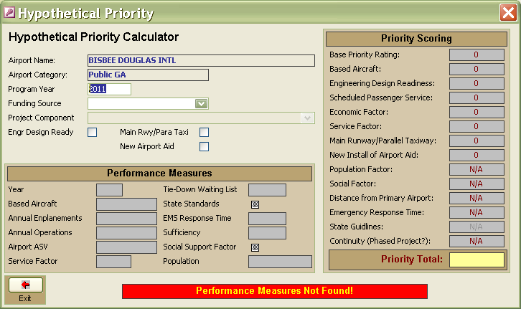

1. After obtaining the priority number from step 2, the AGM will return to the **Grants/Loans Management** module. Selecting this module from the menu opens the “Project Listing” screen shown below. This screen will always start with ADOT Aeronautics (The screens are available in alphabetical order by sponsor name). The appropriate airport must first be selected by pressing the “Airport” button and choosing the airport from the list provided. With the proper airport showing on the project-listing screen, press the “Add New Grant” button.

.

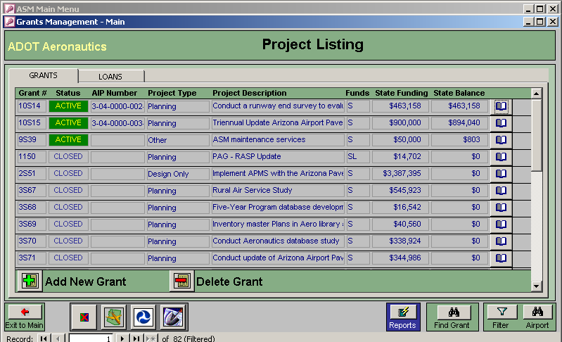

1. On the screen shown below for “Adding a New Grant”, enter the mandatory information in the boxes. The Sponsor information and fiscal year is automatically added to this screen. All other data fields in white must be completed, with the exception of the two dates for the Priority Plan Committee (PPAC) and STB.
2. Grant Status: select Pre-STB if a new grant (Pre-STB, Pending, Active, Special, Closed or Special)
3. Grant Type (Land Acquisition, Planning, Design Only, Environmental, Design and Construction, Construct Only, or Other)
4. Grant Manager (initials in CAPS only)
5. FAA AIP Number (if applicable)
6. State Grant Number issue date
7. Grant Description: Language copied verbatim from the federal grant or from the STB-approved ACIP.
8. Grant Justification: Describe why the grant is to be approved by the Board, i.e., Federal Match Grant
9. Requested Action: Specific action you want the Board to take: Approve, Amend, Delete.
10. Funding type: APMS; Federal State & Local; Loans; State Only; State and Local
11. Grant Amount: The State Share is the State portion only.

.

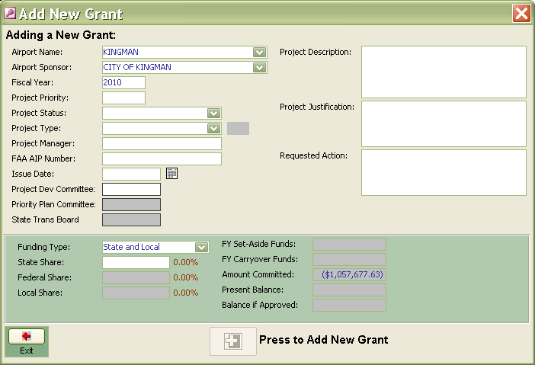

All white fields must be completed. Once all the information is entered, the computer will issue a new State Grant number including the proper suffix denoting phase and type grant. This will be the **official ADOT number** for all grant business. This grant number is referred to as the TRACS number by other sections in ADOT.

Insert Screen Shot Here

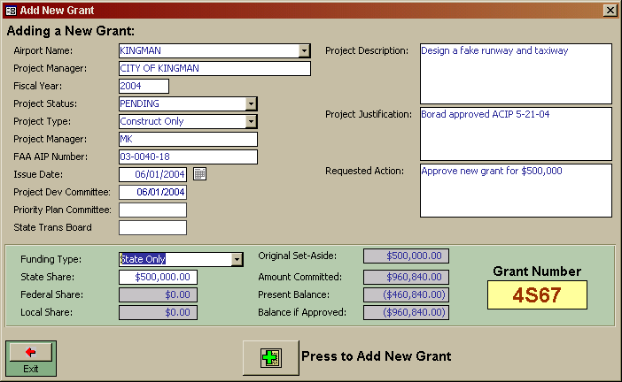

1. The AGM takes the next step by pressing the “Press to Add New Grant” button. This will give you a dialog box making sure that you want to enter this data into the database. Do one final review of the inputted information for correctness. If so, then click on the “yes” button. The computer will then presents the Project Committee Recommendations (PPAC) Form, as shown below. This form will be completed with the data previously entered.

Review all information to be sure it is correct. The information in the box labeled Source of Funds is automatically calculated and placed into the form. Print the document and sign it where indicated for the AGM.

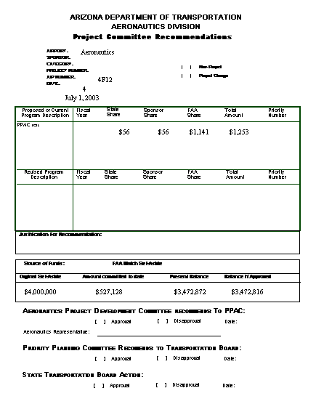

Insert Screen Shot Here

Once all proposed grants have a PPAC Form signed by the AGM and sponsor-submitted documentation is received (typically this includes the sponsors letter and the FAA grant offer) AGMs will have the PPAC form reviewed and approved by the Group Manager or designee. The Group Manager will initial near the approve text. The AGM will work with the AD Secretary to prepare the PPAC agenda and cover memo. These forms are found on the “G” drive in the Airport Development Folder. All AGMs have the primary responsibility to ensure the data and figures in the agenda are correct.

Place all PPAC materials in a separate file in the State Airport Engineer’s office. After each STB meeting, the State Airport Engineer will return PPAC Forms for all approved grant to their respective AGMs.

**Post STB approval action**:

1. The AGM will update the ASM and the PPAC form with the dates of PPAC and STB approvals (or Group approval date for time amendments or cost amendments below 15%). See section on Grant amendments).
2. AGM will then prepare the draft grant documents. Basic forms of the agreements are located on “G:/Airport Development/Grants and Grant Documents”. They include:
3. Grant Agreement-Design and Construct
4. Grant Agreement-Planning
5. Grant Agreement-Land Acquisition
6. Copy the basic form into a local working file folder for modification of only the red data points in the agreement to reflect the sponsor’s specific grant information. This will include: Header data, sponsor name, airport name, obligation figures, percentage figures, dollar amounts, signature blocks, and Exhibit A data. (See appendix for a sample grant).
7. Change all red figures to black, save document. Be sure to contact sponsor for the ‘Preliminary Date’ so that can be filled in prior to sending grant to sponsor.
8. Prepare the grant offer cover letter to the sponsor using the current template from the same folder in G:\ Drive.
9. Prepare a second letter to be sent to the elected official of the Sponsor as well, again using the current template.
10. Insert copies (of PDF version) of letters into electronic grant file. Send original grant agreements sponsor via email for their signatures and update the ASM to show grant status as “pending” and add the date these documents were sent to the sponsor.

Insert Screen Shot Here

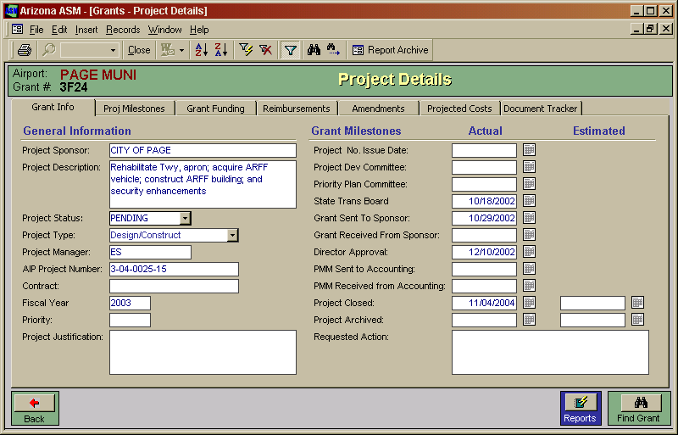

**Post Sponsor Execution ___ _________ _____**

1. Upon receipt from the Sponsor signed agreement, AGM will make sure all parts of the agreement are intact and no unauthorized changes have been made. Be sure all sponsor information is complete. Update the ASM database with all Schedule information for milestones and date of receipt of the signed documents. AGM will attach the appropriate routing slip and send to the State Airport Engineer and Aeronautics Group Manager for review of grant material, and then send to the MPD Director for signatures. As a general rule, the effective date on Page 1 of the agreement is the same as the Division Director’s execution date on Page 4.

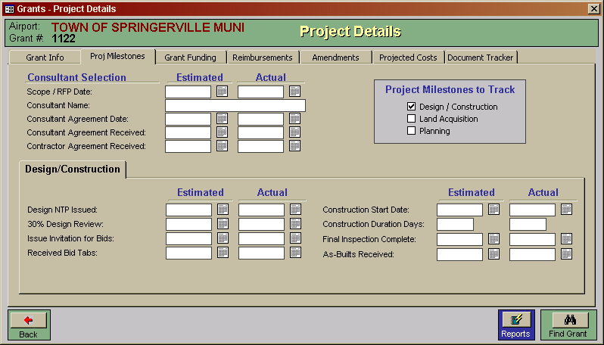

Insert Screen Shot Here

1. AGM shall sign each grant as a witness, indicating the same date as the Division Director’s execution. The AGM will then change the grant’s status in the ASM database to “Active” and enter the appropriate date of execution.
2. AGM prepares the executed grant cover letter using the current template.
3. Grant and a copy of the cover letter is filed in Section A of the Electronic Grant File in the G:\ Drive project file.
4. AGM sends copy of the executed grant and original cover letter to sponsor via email.
5. AGM prepares an electronic “Project Management Master” using the ADOT Information Data Warehouse (AIDW): http://aidw/dw/ReportManager.aspx. Go to the “Project Master” pull-down menu and follow the instructions under the “Request a New Project” item. This will send the project (grant) data to accounting and sets up the grant as a project in Advantage.

When the Project Manager system returns the notice of setup completion via e-mail, AGM places an electronic copy in Section B of electronic file.

**Comprehensive Agreement Resource**

All newly executed grant agreements and grant amendments must be catalogued in ADOT’s Comprehensive Agreement Resource (CAR). The system was established in 2013 to enable ADOT’s management to better track all agreements to which ADOT is a party. CAR links each grant agreement and amendment to the project in AIDW and also stores additional data points, entered directly into CAR by the AGM. CAR is located in the network at <http://car/Agreements/AddAgreement.aspx>

On this page (below), the AGM opens the Dashboard pull-down menu, then clicks “Add Agreement”. The Aeronautics grant number is entered in the “ADOT Project Number” data field. CAR then locates the corresponding project, complete with subproject suffix, in AIDW. Click on the correct number when it appears below the data field, then click “Add Agreement”.

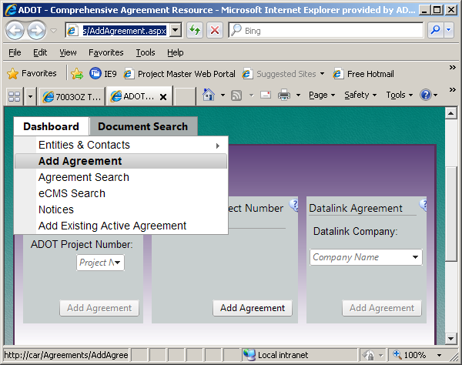

The next screen (below) has five required data fields. Agreement type is always “GRT” for Grant, Information Exchange is always “No”. The remaining three required fields all identify the project as aeronautical. After the five fields are populated, click “Initiate” at the bottom of the screen.

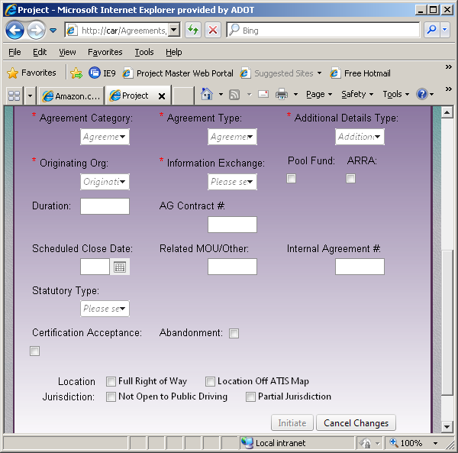

The initiated agreement is then assigned a CAR agreement number by the system. The next screen (below) has several tabs which must each be clicked and populated by the AGM:

* 1. For the “Contacts” tab, enter the airport sponsor as the “External Entity”. The Internal Contact is always the AGM (“Administrator”). The External Contact is the sponsor representative who is the most appropriate for the grant. More than one sponsor representative may be entered at the AGM’s discretion.
  2. For the “Budget” tab, the Financial Reporting Flag is “Payable”. The **grant amount** should be divided between Design and Construction, with the Total also entered. If the Cost Allocations in the grant agreement don’t definitively separate Design and Construction grant amounts, use a reasonable approximation. For Design- or Construct-Only grants, enter “0” as appropriate. No required data field should be left unpopulated. For Planning grants, enter all grant amounts in Design. Near the middle of the screen, click “Enter State Funding”, then note the **grant amount** coming from the State Aviation Fund as 100% State funds.
  3. On the “Documents” tab, the “Section A” pdf file from the project file in G:\ Drive is uploaded. There’s no need for the AGM to remove cover letters or other ancillary documents before uploading.

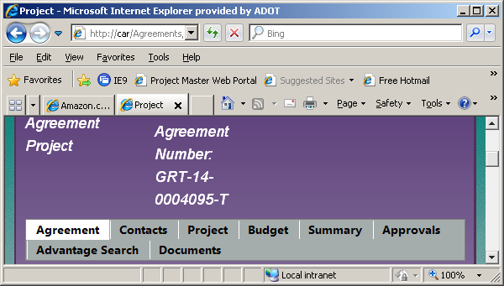

**GRANT AMENDMENT PROCESS**

Grant amendments are prepared when one or more of the following three elements are to be changed in a grant:

* Time of contract termination (time extension amendment);
* Amount of funds (dollars amount amendment);
* Grant content (scope amendment).

The sponsor must provide a written request to have the grant amended. Aeronautics staff has Board authority to approve and process time extensions, cost increases of less than 15%, and minor scope changes that do not **materially change** the grant. STB must approve any other changes/amendments. After the Aeronautics grant review committee has reviewed the written request and has concurred to the amendment then, if a material change, the same process used to approve new grants is used to approve grant amendments.

1. To initiate the process for any of the three elements, Steps 1-3 of the “Pre-Board Action” process is used. However, instead of starting a new grant, the AGM selects the desired grant, then clicks on the “Amendment" tab. At this screen, click on the “Add New Amendment” button. The following screen will appear. The AGM will then enter the appropriate amendment data and confirm the data after clicking on the “Press to add new amendment” button.

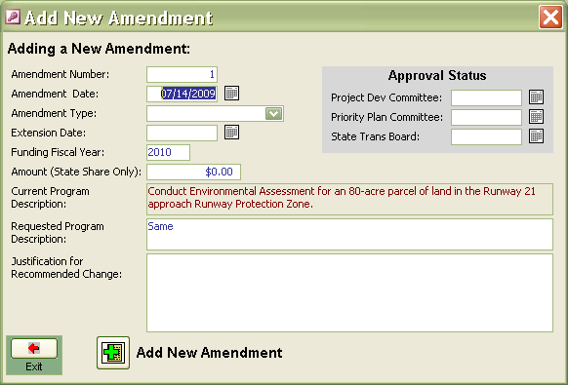

Insert Screen Shot Here

1. The computer will then present the PPAC Recommendation Form, as shown below. This form will be partially completed with the data previously entered. The AGM will complete that form by adding the following information:

* Checking the Change Grant box
* Enter the priority number obtained from Step 2
* Enter the date this recommendation was made

The Dates for the PPAC meeting and the STB meeting will be typed in the form. Review all information to be sure it is correct. The information in the box labeled Source of Funds is automatically calculated and placed into the form. Print the document and sign where indicated for the AGM.



Insert Screen Shot Here

1. MPD administrative staff will prepare a standard cover memo to the Multimodal Planning Director (Word File: “Master PPAC cover memo”) for the Aeronautics Group Manager’s signature. The memo will summarize all grant actions and give explanation of special issues such as dollars increases, scope changes and federal assistance changes. The memo must also contain the Fund balance before approval and the balance if all grants are approved. All agenda items are tabulated at the bottom of the memo.
2. After the Group Manager has approved the memo and agenda two steps are required to transmit this date to the Board:
   1. Make PDF copies of the PPAC form(s). Supporting documentation sent by the sponsor is not copied. Send the original cover memo (signed by the Group Manager) and the copies of the PPAC forms for each grant to MPD Priority Planning Group. The Group Manager will keep a copy of the cover memo and the original PPAC material (including the original sponsor submitted documentation) for use at the PPAC committee meeting.
   2. The agenda prepared in Step 8 above is to be e-mailed to MPD. He needs this electronically so he can cut and paste the information into a larger document for the STB’s use. When PPAC is over, all information used at PPAC will be used at the STB meeting. No other action is needed at this time unless the PPAC removes or modifies an item from the agenda. If that happens, the Group Manager will provide that information with instructions on completing the changes for the STB meeting
3. Place all PPAC materials in a separate file for holding until the Group Manager has reported Board action.
4. After STB approval or after Aeronautics approval, the Aeronautics Group Manager will return the PPAC memo material from the approval process described above. The AGM will update the ASM and the PPAC form with the dates of PPAC and STB approvals (or Group approval in the case of time amendments).
5. AGM will then prepare the amendment document. Basic forms of the amendments are located on G:\MPD\Aero\Airport Development\Grants and Project Documents. They include:
   1. Amendment-Date
   2. Amendment-Date-Dollars
   3. Amendment-Dollars
   4. Amendment-Scope
6. Copy the basic form into a local working file folder for modification of only the red data points in the agreement to reflect the sponsor’s specific grant information. This will include: Header data, sponsor name, airport name, obligation figures percentage figures, dollars amounts, and signature blocks. (See appendix for a sample amendment).
7. Change all red figures to black, save document and print two, two-sided.
8. Prepare the cover letter to the sponsor, using the current template.
9. File a copy of letter for the project file in the G:\ Drive. Send originals to sponsor for their signatures via email and update the ASM to show date these documents were sent to the sponsor.
10. When the amendment is returned it needs to be signed by MPD Director.

**GRANT REIMBURSEMENT PAYMENT PROCESS**

1. Grant Reimbursement Request (GRR) forms are received electronically or by mail. The date of receipt will be stamped on the forms by the AGM.
2. AGM accomplishes the following tasks to process each GRR:
   1. Reviews paperwork for consistency with program and eligible expenses.
   2. Ensure that the requested reimbursement is supported by adequate documentation.
   3. Ensure that invoice(s) comply with the grant scope/assurances and State statutes.
   4. Make sure that the executed Grant Agreement is in the electronic grant file.
   5. Open ASM database and ensure funds are available in the “Grant Funding” tab

to pay the GRR. Be sure funding percentages are according to the grant (i.e. SL/FSL).

* 1. Ensure grant amendments are current in the “Amendment” tab.
  2. AGM checks for Cash Flow conformity
  3. AGM enters GRR into Data Base by clicking on the “Reimbursement” Tab and clicking on the “Add new payment” button; Fill in applicable information into the fields:
     1. Application Number
     2. Reimbursement Amount
     3. Percent Grant complete
     4. Application date
     5. Initial date received
     6. AGM Approval date
     7. Comments, if any.

Insert Screen Shot Here

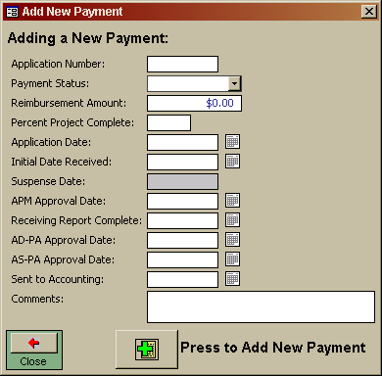

* 1. Click the “Press to Add New Payment” button
  2. Confirm the data is correct and click yes.
  3. AGM enters accounting line payment codes, (see Chapter Eight) and the airport sponsor’s vendor number, then signs and dates the bottom of the GRR form received from the sponsor.
  4. AGM highlights the following data fields: Name of Airport, Application #, Date, % Complete, and State Share on the line noted as L) Total.
  5. AGM places completed GRR in the State Airport Engineer’s receiving folder.

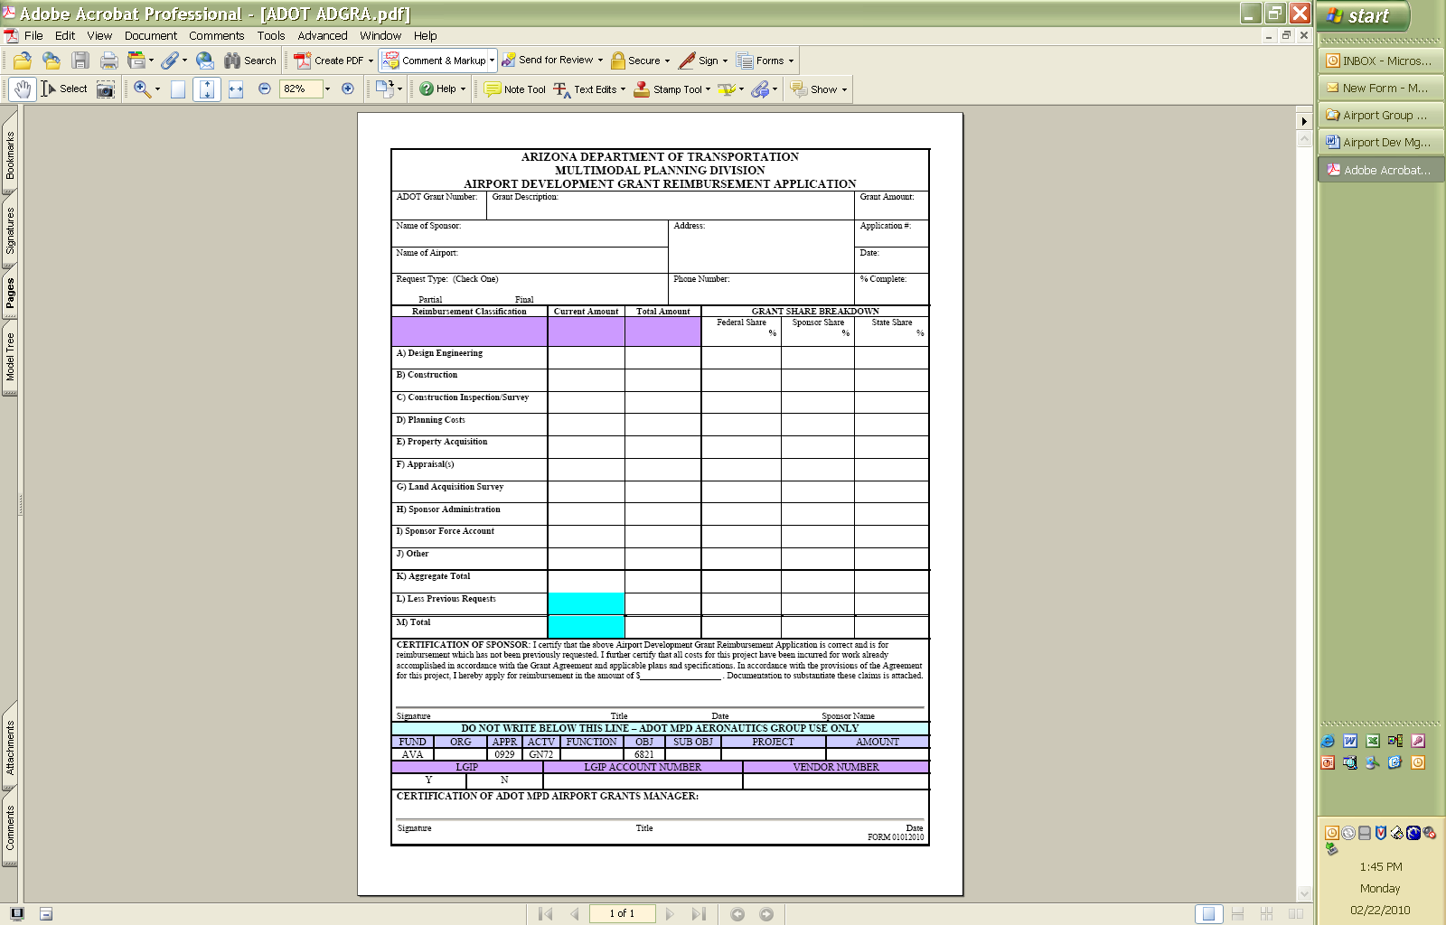

Insert Screen Shot Here

After payment is processed, AGM will receive back the GRR and backup material. The documents are digitized for inclusion in the project file in G:\ Drive,

1. The State Airport Engineer will review the GRR to:
   1. Confirm funds are available in the Aviation Fund to make the payment.
   2. Enters AD-PA Approval Date in the Reimbursement tab.
   3. Enter Sent to Accounting date and transmit, via e-mail, a PDF of the first page of each GRR to “Contract Payables”.

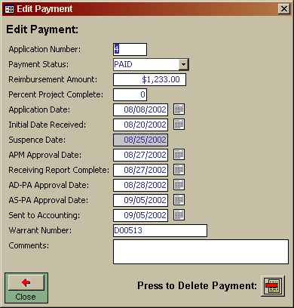

Insert Screen Shot Here

**GRANT CLOSURE PROCESS**

1. The Airport Grant Manager (AGM) certifies that all final grant documents (listed below) for design/construction projects are in the grant file or, in the case of “as-builts”, included in electronic format.
   1. As-Built drawings (for construction/design grant); or,

Final design drawings (for design only grant); or,

Final Plan document (for master plans, environmental assessments or other planning grants); or,

Appropriate copy of Title (for land acquisition grants).

* 1. Final engineers report (only for construction grants)
  2. Sponsor’s letter of project acceptance
  3. Final Grant Reimbursement Request

2. AGM certifies that all final grant documents (listed below) for planning projects are in the grant file.

a. Final Paper copy of the Planning Document (Master Plan, Planning Study, etc.).

b. Final Electronic copy of the Planning Document (Master Plan, Planning Study, etc.).

c. A copy of the board’s adoption/approval of the Master Plan

d. A paper copy of the Approved and signed Airport Layout Plan (ALP).

3. AGM certifies that all final grant documents (listed below) for environmental projects are in the grant file.

a. Final Paper copy of the Environmental Document (Part 150, EA, Cat Ex, etc.).

b. Final Electronic copy of the Planning Document (Part 150, EA, Cat Ex, Planning Study, etc.).

4. AGM reconciles electronic grant files. The electronic file should contain all documentation necessary/needed.

5. AGM obtains an electronic Project Management Master Report (see Post Sponsor Execution, step 6 & 7)

* 1. Verify the closing balances agree between PRBL table, database record and final documentation.
  2. Change Grant Status in ASM database to “Closed” with the appropriate date entered.

1. The AGM will send an email to Contract Payables, with copies to Project Accounting, Aeronautics Group Manager, Ad Secretary, and Administrative Supervisor. The email should be as follows:

Please place the following projects in “C” status.

Project Accounting please zero out the balance and notify me when closed.

Project Number   Airport    Original Budget    Encumbrance Amount    Expended Amount  Available Budget

|  |  |  |  |  |  |
| --- | --- | --- | --- | --- | --- |
| E1F2701C | Glendale | $8,587.00 | $0.00 | $8,587.00 | $0.00 |
|  |  |  |  |  |  |
| E3F2O01D | Laughlin/Bullhead | $7,364.00 | $0.73 | $7,363.27 | $0.00 |
| E2F2N01C | Springerville | $35,527.00 | $111.79 | $35,415.21 | $0.00 |

Thank you,

Airport Grant Manager name

The AGM will receive an email form Project Accounting when the project status is changed in Advantage.

* 1. Change Grant Status in ASM database to “Closed” with the appropriate date entered.
  2. Note any remaining funds and send for reinvestment tally to the appropriate person in the Aeronautics Group.

After accounting returns the electronically signed PMM, AGM verifies grant is closed in the database and properly dated. AGM then advises MPD administrative staff of the final closure, who then places the entire grant file in a consolidated file and places it in the closed grants file cabinet for three years. ASM is annotated to show location of the closed grant book and related material. After three years each July, MPD administrative staff uses a separate process to send closed grants to archives.

1. Must advise Aeronautics to have MPD Contracts close the project in CAR.

Chapter Eight - **Expenditure/Revenue Coding in Arizona Financial Information system “AFIS”**

ADOT’s accounting system uses a software program called Advantage. It is the only official accounting method available to Aeronautics. Separate databases may be used for various purposes, but for accounting, all data must be entered and used from Advantage at all times. Any separate databases that contain accounting data shall be reconciled with Advantage.

Several coding requirements have been established in the Advantage system specifically for Aeronautics. This section will provide the codes, their uses and definitions for the Aeronautics employees charged with entering this information into the Advantage system. This section assumes the reader/user has received the formal Advantage training by ADOT and is familiar with all aspects of using Advantage.

**Grant Expenditures**

For all FSL and SL grants issued to airport sponsors

**Loan Expenditures**

For all loans issued by Aeronautics to airport sponsors

**Contracted Aeronautics Services Expenditures**

**Eligible for Federal funding**

Agreements whose payments will be reimbursed by the FAA under an AIP Grant for either the GCN or Aeronautics Group Administration such as Statewide planning or construction at GCN

**Ineligible for Federal funding**

Agreements with no FAA AIP grants for reimbursement: Planning contracts

**Reductions in Expenditures**

Payments received from sponsors, or others, which are a reimbursement of expenditures paid by the State on behalf of the sponsor such as in the APMS or air service programs.

**Below is an example of an “Accounting line” found on all Payment documents such as Supplemental receivers, PG’s, etc. Each item and its associated coding will be explained in the following narrative.**

|  |  |  |  |  |  |  |  |  |
| --- | --- | --- | --- | --- | --- | --- | --- | --- |
| FUND | ORG | APPR | ACTV | FUNCTION | OBJ | SUB OBJ | PROJECT | AMOUNT |
|  |  |  |  |  |  |  |  |  |

**FUND:** Presently, only “AVA” is used in this box. Occasionally, special appropriations are issued to the Group and a new fund will be provided.

**ORG:** Source of funds being used to pay contracted expenses or to process sponsor reimbursement requests.

5900 – State/Local Grants (SL) issued to sponsors

5810 – Federal grants for the Grand Canyon Airport

5820 – Federal/State/Local Grants (FSL) issued to sponsors

5510 – Airport Development Loans

5200 – Airport Pavement Maintenance System (APMS)

5400 – Aeronautics Studies and Services

**APPR:** Appropriations identifier: Always “0929”

**ACTV:** Payments that are eligible for federal reimbursements are to use these codes

AR14 – GCN construction, eligible (for federal funding)

AV01 – GCN equipment purchases, eligible (for federal funding)

AV02 – GCN planning and admin services, eligible (for federal funding)

AV03 – Statewide planning and admin services, eligible (for federal funding)

Payments and grant reimbursements that are not eligible for federal reimbursements are to use these codes

AR15 – GCN Construction, other, ineligible (for federal funding)

GN72 – State Grants only, ineligible (for federal funding)

AV04 – Statewide planning and admin services, ineligible (for federal funding)

**FUNCTION:** Identifies the ultimate owner of asset developed by a grant from the State Aviation Fund. For GCN this code will always be 5100. For Aeronautics this code will always be 3700. For grants the number will be the same as the ORG number

**OBJ** and **SUB OBJ:** Further descriptive details of the expenditure. Where a blank appears in the sub object, leave the box blank in the accounting line. “Other Gov’t” includes Airport Authorities.

**OBJECT SUB OBJECT DESCRIPTION­­­­­____________________________________**







6811 -01 Aviation - Federal Match Grant – Aid to Counties

6811 -02 Aviation – State/Local Grant Primary – Aid to Counties

6811 -04 Aviation Revenue Loan – Aid to Counties

6811 -07 Airport Pavement Management Systems – Aid to Counties

6821 -01 Aviation - Federal Match Grant – Aid to Municipalities

6821 -02 Aviation - State/Local Grant, Primary – Aid to Municipalities

6821 -04 Aviation – Airport Development Loan – Aid to Municipalities

6831 -01 Aviation - Federal Match Grant – Aid to Other Gov’t

6831 -02 Aviation – State/Local Grant Primary – Aid to Other Gov’t

6831 -04 Aviation Revenue Loan – Aid to Other Gov’t

6831 -07 Airport Pavement Management Systems – Aid to Other Gov’t

For Aeronautics and GCN projects only

6231 Design, Professional Services

6232 Construction Administration Services

8131 Construction of Buildings

8191 Construction of Aviation Facilities

6299 -01 Airport and System Planning services

6299 -02 Environmental Planning

6299 -04 Appraisal

**PROJECT:** This alphanumeric character is issued by the Aeronautics’ grant managers and is always used to track expenditures and revenues. At the Grand Canyon Airport, these characters represent specific areas of the airport accountable for the expenditure or responsible for the revenue.

All grant numbers are constructed to describe the project funding. All Aeronautics grant numbers have 8 characters and all start with the letter E. Grant numbers issued for development of any kind. The number will, in sequence after the “E”, tell the reader the fiscal year issued type of grant, a sequential number, a phase number and a phase type.

**For example:** **E7F34 01P** “C”onstruction or “P”lanning or “D”esign or “X” other

Phase number, usually “01”. Grant manager will determine need for a different or additional phase.

Arbitrary number issued by PM via the ASM

**“**F” = FSL; “S” = S/L; “L” = Loan; “G” = GCN

Represents the last number of the fiscal year: “6” = 2006; “0” = 2010, etc; then repeats for each decade.

“E” will always be used for Aeronautics in the AFIS system.

**AMOUNT:** Dollar figure of State’s obligation.

**VENDOR NUMBER:** Selected documents such as contractor payment requests and Grant Reimbursement Requests will require this number. Every organization that has a formal financial arrangement with ADOT has a vendor number. This number is available from the MPD Administrative staff. Multiple vendor numbers may exist if a vendor has more than one unique address. A vendor may want different types of payments to be sent to different addresses. Therefore, be sure the Aeronautics staff knows the correct vendor address desired for each payment request.

Part III

**Glossary and Appendices**

**Glossary**

AC Advisory Circular

ACIP Airport Capital Improvement Program

AIP Airport Improvement Program

ADOT Arizona Department of Transportation

APMS Airport Pavement Management System

A.R.S. Arizona Revised Statutes

ASM Aviation System Manager (Access Based Software)

FAA Federal Aviation Administration

FSL Federal, State and Local Funding Grant

GRR Grant Reimbursement Request

IGA Inter-Governmental Agreement

LGIP Local Government Investment Pool

MPD Multimodal Planning Division

SASP State Airports System Plan

SL State and Local Funding Grant

STB State Transportation Board

**Appendices**

**APPENDIX A**

**State Transportation Board Policies - Aviation**

Introduction

Arizona Revised Statutes Title 28, Chapter 2, Article 1, establishes and outlines the powers and duties of the State Transportation Board. With respect to Aeronautics, the Board’s duties are further outlined in Chapter 25 – Aviation. It is noted that many of the statutory requirements have been written specifically for Highways and Transportation Planning, and are not directly intended or applicable to aviation. This circumstance requires the development of Board policies establishing priority programs for airport development (A.R.S. 28-305 (1)) and issuing of airport grants (A.R.S. 28-305 (5)).

***1.*** State Airport System Policy

It is the policy of the Board to provide a safe and secure airport system that accommodates demand, supports economic and transportation needs, and maximizes funding resources. The goals of this Policy are to:

* Provide for a safe airport system, as measured by compliance with applicable safety standards, which supports health, welfare, and safety related services and activities.
* Provide an airport system that is adequately maintained to meet current and projected demand and is easily accessible from both the ground and the air.
* Advance a system of airports that is supportive of Arizona’s economy, ensuring that the airport system is matched to Arizona’s socioeconomic and demographic characteristics.
* Promote a system of airports that is sensitive to and considerate of the environment. The system should support aviation outreach opportunities.

***2.*** State Airports System Plan (SASP) Policy

It is the policy of the Board to develop, adopt, and periodically update a long-range statewide aviation plan in the form of a State Airports System Plan (SASP). The SASP shall include extensive public involvement in its development, including coordination with airports, the Federal Aviation Administration (FAA), regional associations of governments, League of Cities and Towns, aviation related businesses, aviation related associations, and the general public. Among other things, the SASP shall:

* Establish and define airport roles to be used in the allocation of State Aviation Funds; these roles will be:
  + Commercial Service - International Airport
  + Commercial Service – National Airport
  + Reliever Airport
  + General Aviation-Community Airport
  + General Aviation-Rural Airport
  + General Aviation-Basic Airport
* Ensure Arizona’s airport system continues to effectively connect, move and support the state’s transportation needs for years to come;
* Provide a framework for the integrated planning, operation and development of Arizona’s aviation assets; and
* Include performance measures to assess the total system’s performance, guide implementation and evaluate results.

***3.*** Airport Development Program Policy

A.R.S. 28-8202 directs the State Transportation Board to distribute State Aviation Funds to airport facilities for planning, design, development, acquisition of interest in land, construction, and improvement of publicly owned and operated airport facilities according to the needs of those facilities, as determined by the Board. To meet the aviation needs of the State and establish a consistent, fair, and transparent system through which funds will be distributed, the Board hereby establishes the following programs in order of their respective priorities:

1. Federal/State Matching (FSL) Airport Development Grants Program:

To maximize and leverage the use of federal grant funds, the Board may fund one-half of a sponsor’s local shares of a federal grant.

1. State and Local (SL) Airport Development Grants Program: To achieve State system goals and provide funding for projects of local, regional, or State significance, including projects that may not otherwise be funded or eligible by the FAA. The Board may fund an eligible project’s costs up to a maximum of 90% of eligible costs at Commercial Service, Reliever, General Aviation (GA)-Community and GA-Rural airports and 95% at GA-Basic airports.
2. Airport Pavement Management System (APMS) Program: To assist airports in meeting federal obligations related to airfield pavement maintenance as well as to preserve past investments in airfield pavements, the Board may provide pavement maintenance services or funding for a portion of eligible airport’s airfield pavement maintenance needs.
3. State System Planning and Services Program: To inventory, monitor, and assess the State’s aviation system as well as establish system goals and priorities, State Aviation Funds may be used to conduct statewide aviation planning, research studies or aviation support services.
4. Airport Loan Program: To maximize the use and efficiency of the State Aviation Fund as well as assist airports in becoming more financially self-sufficient, the Board may utilize appropriated funds or cash balances in the fund to provide low-interest or forgivable loans for projects that are not eligible or otherwise funded through a grant program.

ADOT shall administer these five Programs. Each year ADOT will prepare funding level recommendations based on annual appropriations from the legislature and current grant obligations. These initial funding levels should maximize funding for all five programs. Whenever possible, the development of airport facilities should parallel industry standards published in the FAA's design and planning criteria.

***4. Resource Allocation Policy***

In order to allocate the State Aviation Fund dollars in an equitable, efficient and effective manner, it is the policy of the Board to provide the largest amount of Airport Development Program grant dollars to those airport roles with the largest amount of aviation activity (passenger enplanements, aircraft operations, and registered based aircraft), while also ensuring that eligible airports in all roles have an opportunity to be included in the annual allocation of State Aviation Funds. The allocation percentages are presented in ADOT’s Airport Development Guidelines, Chapter Two, State Aviation.

***5.*** Project Selection and Prioritization Criteria Policy

In the development of ADOT’s overall Five-Year Transportation Facilities Construction Program, it is the policy of the Board to include airport grant projects and require the use of established, published, and consistently applied project eligibility criteria and priority rating systems contained in ADOT’s Airport Development Guidelines. Changes to the eligibility criteria and priority rating systems shall include consultation with industry stakeholders.

***6.*** Adequate Funding Policy

It is the policy of the Board to ensure adequate aviation funding by:

* Taking full advantage of federal funding by ensuring the availability of sufficient State matching funds;
* Pursuing new and existing funding sources;
* Working with the Arizona congressional delegation to increase the funding for Arizona in the federal aviation programs;
* Advocating federal and State legislation for aviation funding for the State.

***7.*** Regional and National Cooperative Planning and Best Practices Policy

It is the policy of the Board to support and work collaboratively with State and federal agencies to ensure the aviation system meets standards and future demand levels. The Board also recognizes the importance of developing and using best practices with industry in order to enhance Arizona's aviation transportation system by improving its safety, efficiency and effectiveness.

**APPENDIX B**

**Airport Listing by System Role**

(SASP Listing - October 2018)







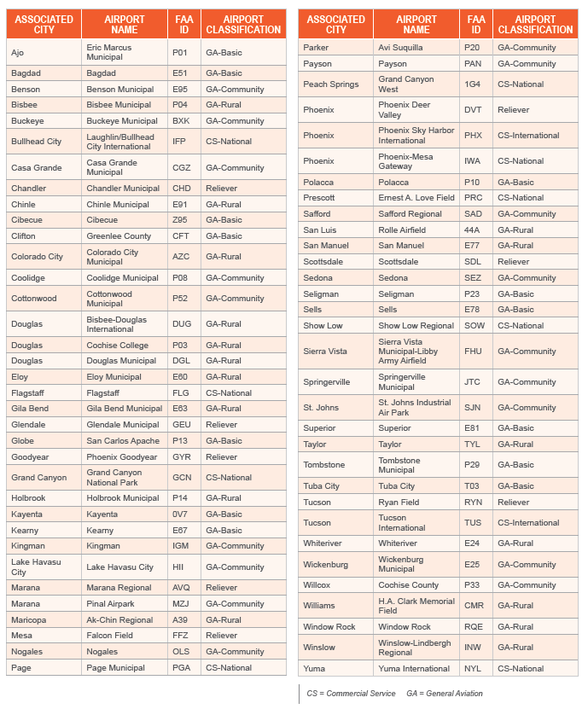

**APPENDIX C**

**Project Components &**

**Priority Value System**

**Introduction**

The following list of project component definitions are being provided to help guide airport sponsors and Aeronautics program managers in programming and reviewing State/Local airport development projects for the Arizona ACIP. For AIP projects funded through the FAA, projects must follow the FAA advisory circular for project definition.

Aeronautics has included references to the FAA definitions, eligibility requirements and design criteria for the projects. NPIAS airports, in general, must design to these standards. Non-NPIAS airports may have more flexibility to use local standards for SL projects. These references are accurate on the date of publishing. Visit the FAA website [www.faa.gov/airports](http://www.faa.gov/airports) for the most current version of references.

There may be differences in eligible items for SL only funding when compared to FAA standards. For example, ADOT does not buy rolling stock like ARFF trucks or radio equipment with a SL Grant. Aeronautics has referenced the differences and/or exceptions in each component definition.

Some of the commonly ineligible items for SL funding are:

* Spare parts beyond those needed for testing equipment purchased under a grant.
* Landscaping that is not affected by the funded project.
* Landscaping beyond what is needed for erosion control.
* Projects that could be considered “maintenance” in nature. (For example, cleaning culverts and manholes, repair of culverts and manholes, patching potholes, repairing fence, cleaning sediment/debris from ditches, refreshing existing painted markings)
* Off-airport work that is not specifically called out in the project component.
* Funding for pavement rehabilitation that has not been adequately maintained by the airport.
* Updates to any project plans, documents, or studies due to lack of progress.
* Funding for a project that is primarily for private use.
* Improvements to accommodate private development.
* Rolling stock/equipment.

NPIAS airports are required to use the FAA design and construction advisory circulars. Non-NPIAS airports should consult with Aeronautics prior to proceeding with design to confirm design criteria. Aeronautics review and approval of project definition is required prior to programming for any proposed deviation from the component definitions.

Site Development to support eligible infrastructure is an eligible item for SL funding, but the infrastructure needs to be programmed under the appropriate eligible Project Component. For example, electrical utilities may be funded in advance of a new public-use apron as a phase of constructing the apron. This includes, but is not limited to, associated site work, drainage, paving (public use roadways, taxiways, taxi lanes and aprons; and non-revenue auto parking), erosion control, lighting, airfield signage, marking, security fencing, gates (manual and powered) and main line utilities (water, electric, gas, telephone/cable/data, and sanitary sewer) needed for the development area’s operation.

Site Development to support eligible infrastructure is only eligible to support the development of public-owned, non-exclusive use areas on public use airports. (i.e. see RWY, TWY, etc.) All projects must be reviewed by Aeronautics prior to programming.

*References: FAA order 5100.38 (AIP Handbook) Sections 510 through 516, 547 and 609. Design and construction of taxiways must meet standards outlined in AC’s 150/5300-13, 150/5320-6, 150/5340-1, 150/5340-18, 150/5320-6 and others.*

For airports that are non-NPIAS and with design aircraft less than 15,000 lbs, municipal or county paving specifications may be used at general aviation facilities. The bituminous price adjustment is allowable with APMS projects.

Commonly eligible items are:

* Sponsor administrative time and materials directly for the purpose of the project not to exceed 5% of the project costs.
* Architectural, engineering, surveying, and other technical services to develop the project.
* Construction administration.
* Construction costs as described in the components.

**Alphabetical List of Project Component Titles**

|  |  |
| --- | --- |
| **Airport Buildings, Construct** | **Perimeter/Service Road, Construct** |
| **Airport Drainage, Improve** | **Perimeter/Service Road, Rehabilitate** |
| **Airport Drainage Plan** | **Perimeter/Service Road Lighting, Install** |
| **Apron, Construct (New)** | **Rotating Beacon, Install (New)** |
| **Apron, Rehabilitate** | **Rotating Beacon, Rehabilitate** |
| **Apron, Strengthen** | **Runway, Construct** |
| **Apron Lighting, Install (New)** | **Runway, Extend** |
| **Auto Parking, Construct** | **Runway**, **Rehabilitate** |
| **Auto Parking, Rehabilitate** | **Runway MIRL/HIRL, Install** |
| **Environmental Studies, Conduct** | **Runway, Strengthen** |
| **Existing Airport, Acquire** | **Runway Vertical/Visual Guidance System, Install/Upgrade** |
| **Guidance Signage, Install (New)** | **Security Fencing – Chain Link, Install (New)** |
| **Guidance Signage, Rehabilitate** | **Taxiway, Construct (New)** |
| **Heliport, Construct** | **Taxiway, Rehabilitate** |
| **Heliport, Rehabilitate** | **Taxiway, Strengthen** |
| **Heliport, Strengthen** | **Taxiway Lighting, Install (New)** |
| **Land for Development, Acquire** | **Terminal, Construct/Expand** |
| **Land for Protection (Safety Areas), Acquire** | **Weather Reporting Equipment, Install (New)** |
| **Main Airport Access/Public Circulation Road, Construct** | **Wildlife Deterrent Fencing, Install (New)** |
| **Main Airport Access/Public Circulation Road, Rehabilitate** | **Wind Cone, Install/Upgrade** |
| **Main Airport Access/Public Circulation Road, Strengthen** |  |
| **Main Airport Access/Public Circulation Road Lighting, Install** |  |
| **Master Plans** |  |
| **New Airport, Construct** |  |
| **Obstructions, Light/Mark/Remove (Safety Areas)** |  |
| **Perimeter Fencing – Barbed Wire, Install (New)** |  |

**Project Component Descriptions**

# Airport Buildings, Construct

Structures that are specifically germane to the operational needs of the airport. These types of buildings are characterized by storage/maintenance facility of airport operations equipment. This component does not include facilities for public use such as restrooms, pilot briefing areas, terminal uses, etc. These types of "terminal buildings" are covered in the component 'Terminal Construct' and follow closely the FAA Order 5100.38 (AIP Handbook). Consult with Aeronautics prior to programming.

# Airport Drainage, Improve

Removal, installation and/or alteration of an airport's drainage system, structure(s) and/or erosion control measures required to insure proper drainage to the airport’s Airfield Operations Area and other aeronautical use areas on the airport to comply with FAA, RSAT, FEMA, and local flood plain ordinances. The work includes, but is not limited to, measures to improve drainage flow, storage, erosion/flood control measures, and improvements to outfalls directly related to the airport's drainage system. *References: FAA Order 5100.38 (AIP Handbook) Sections 510, 515, 520, 547, and 584. Design and construction of marking and lighting must meet standards outlined in AC 150/5300-13, 150/5320-5 and others.*

# Airport Drainage Plan

Development of an airport-wide (airport property only) drainage management plan for a public use airport. The plan shall address existing and future development features indicated in the most recent approved airport master plan. The work includes, but is not limited to, airport aerial mapping of the airport property, limited survey services to confirm elevations of various features, drainage system inventory, hydrologic and hydraulic analysis, formation of conceptual designs to guide the future construction (drainage channel grading, erosion control measures, storm drainage systems, drainage structures, flood control and detention/retention basins), estimating to establish project costs for future drainage improvements, and time lines to coincide with the airport master plan.  *References: FAA Order 5100.38 (AIP Handbook) Sections 303, 510, 515, 520, and 584. Plan preparation: AC 150/5320-5, local flood plain ordinances and FEMA requirements.*

**Apron, Construct (New)**

New construction of a public use apron. This includes, but is not limited to, associated site work, paving, erosion control, lighting, airfield signage, marking, security fencing and any utilities needed for the apron operation. *References: FAA Order 5100.38 (AIP Handbook) Sections 406, 515, 520, 526, 531 and 590. Apron standards: AC 150/5300-13, 150/5320-5, 150/5230-6, 150/5340-1, 150/5340-18, 150/5340-30, 150/5360-13, 150/5370-10 and others.*

**Apron, Rehabilitate**

Restoration/reconstruction of the structural integrity of an existing apron by the complete or partial removal of existing pavement base and surface and replacement with an appropriate pavement base and surface to meet airport’s needs according to the airport’s master plan. The work includes, but is not limited to, associated site work, adjustment of existing edge and semi-flush edge lighting, paving, erosion control, and marking.  *References: FAA Order 5100.38 (AIP Handbook) Sections 406, 515, 520, 526, 531 and 590. Also, AC 150/5300-13, 150/5320-5, 150/5230-6, 150/5340-1, 150/5340-18, 150/5340-30, 150/5360-13, 150/5370-10 and others.*

# Apron, Strengthen

Strengthening of an existing public use apron that is in suitable structural condition by installing an additive layer of material to an existing surface. The strengthening will allow the apron to support heavier aircraft traffic to operate on the apron. The work includes, but is not limited to, associated site work, adjustment of existing edge and semi-flush edge lighting, paving, erosion control, and marking. *References: FAA Order 5100.38 (AIP Handbook) Sections 406, 515, 520, 526, 531 and 590. Apron standards: AC 150/5300-13, 150/5320-5, 150/5230-6, 150/5340-1, 150/5340-18, 150/5340-30, 150/5360-13, 150/5370-10 and others.*

# Apron Lighting, Install (New)

Installation of apron edge or area lighting equipment for a public use aircraft-parking apron. The work includes, but is not limited to, associated electrical service, controls, and electrical work for the apron operation. Spare parts beyond testing are not eligible. *References: FAA Order 5100.38 (AIP Handbook) Sections 535 and 538. Lighting standards: AC 150/5300-13, 150/5300-14, 150/5340-30, 150/5360-13, and 150/5370-10 and others.*

**Auto Parking, Construct**

New construction of non-revenue producing public parking lots associated with a passenger terminal building or hangar at a public use non-primary airport not having commercial service. Aeronautics will consider funding on a case-by-case basis construction of non-revenue producing public auto parking associated with the terminal building at commercial airports. Consult with Aeronautics prior to programming. The work includes, but is not limited to, associated site work, paving, drainage, curbs, sidewalks, marking, lighting, regulatory traffic signage, and utilities needed for the auto parking operation. *References: FAA Order 5100.38 (AIP Handbook) Sections 405, 406, 526, 606 and 620.*

**Auto Parking, Rehabilitate**

Reconstruction or restoration of the structural integrity of an existing non-revenue producing public parking lot associated with a passenger terminal building or hangar at a public use non-primary airport not having commercial service by the complete or partial removal of existing pavement surface course and replacement with an appropriate new surface course to maintain the same structural strength of the original pavement. Aeronautics will consider funding on a case-by-case basis construction of non-revenue producing public auto parking associated with the terminal building at commercial airports. Consult with Aeronautics prior to programming. This includes, but is not limited to, associated minor site work and drainage improvements adjacent to the existing pavement section, paving, and minor curb work, erosion control, and marking required to accommodate the reconstruction. *References: FAA Order 5100.38 (AIP Handbook) Sections 405, 406, 526, 606 and 620. Approved local municipal roadway standards and the Uniform Manual of Traffic Control Devices.*

**Environmental Studies, Conduct**

Development of environmental documents or updates in accordance with applicable FAA advisory circulars, orders, policies and State requirements for projects to begin within three years of approval. For State/Local funding of studies, consult with Aeronautics for process. If any FAA/NEPA requirement is necessary for any of the components, then the requested Environmental Study will carry the same points associated with the appropriate component. Note: Updates to an EA for any project due to the lack of progress on the sponsor’s part will be ineligible for state funding. *References: FAA Order 5100.38 (AIP Handbook) Section405Plan preparation: AC 150/5000-9, 150/5020-1, 150/5050-4, 150/5050-8, 150/5100-17 and other assorted FAA standards, such as FAA Order 1050 and 5050.*

**Existing Airport, Acquire**

Acquisition of an existing airport's land, buildings, and improvements to establish a public use airport. Consult with Aeronautics prior to programming. *References: FAA Order 5100.38 (AIP Handbook) Sections 512. Airport standards: AC 150/5070-6, 5300-13, 150/5370-10 and others.*

**Guidance Signage, Install (New)**

Installation of mandatory lighted or unlighted airfield runway, taxiway, and apron location, directional, and hold line signage. The work includes, but is not limited to, site preparation, signage equipment, modification or replacement of existing signs that may not meet the intent of the total signage system, supporting electrical connections from adjacent runway, taxiway, or apron edge lighting systems, new regulators or other electrical upgrades that may be necessary to support the new signage. *References: FAA Order 5100.38 (AIP Handbook) Sections 532 and 536. Guidance sign standards: AC 150/5340-18, 150/5370-10 and others.*

# Guidance Signage, Rehabilitate

Restoration of existing mandatory lighted or unlighted airfield runway, taxiway, and apron location, directional, and hold line signage that has reached the end of its useful life or to meet current standards. The work includes, but is not limited to, site preparation, signage equipment, modification or replacement of existing signs that may not meet the intent of the total signage system, supporting electrical connections from adjacent runway, taxiway, or apron edge lighting systems, new regulators or other electrical upgrades that may be necessary to support the new signage. *References: FAA Order 5100.38 (AIP Handbook) Sections 532 and 536. Guidance sign standards: AC 150/5340-18, 150/5370-10 and others.*

# Heliport, Construct

Development to accommodate helicopter operations at eligible heliports or airports. This includes, but is not limited to, associated site work, paving, erosion control, lighting, airfield signage, marking, security fencing and any utilities needed for the heliport operation. Parking facilities are not covered under this component; refer to the Apron, Construct component. *References: FAA Order 5100.38 (AIP Handbook) Sections 531 and 534. Heliport standards: AC 150/5320-5, 150/5320-6, 150/5340-1, 150/5340-18, 150/5340-30, 150/5370-10, 150/5390-2, and 150/5390-3 and others.*

**Heliport, Rehabilitate**

Restoration/reconstruction of the structural integrity of an existing heliport by the complete or partial removal of existing pavement structure and replacement with an appropriate pavement structure to meet airport’s aircraft traffic and fleet mix currently using the heliport. Parking facilities are not covered under this component; refer to the Apron, Construct component. The work includes, but is not limited to, associated site work, adjustment of existing edge and semi-flush edge lighting, paving, erosion control, and marking. *References: FAA Order 5100.38 (AIP Handbook) Sections 531 and 534. Heliport standards: AC 150/5320-5, 150/5320-6, 150/5340-1, 150/5340-18, 150/5340-30, 150/5370-10, 150/5390-2, and 150/5390-3 and others.*

# Heliport, Strengthen

Strengthening of an existing heliport by installing an additive layer of material to an existing surface that is in suitable structural condition. The strengthening will allow the heliport to support heavier aircraft traffic to operate on the heliport. The work includes, but is not limited to, associated site work, adjustment of existing edge and semi-flush edge lighting, paving, erosion control, and marking. Parking facilities are not covered under this component; refer to the Apron, Construct component. *References: FAA Order 5100.38 (AIP Handbook) Sections 531 and 534. Heliport standards: AC 150/5320-5, 150/5320-6, 150/5340-1, 150/5340-18, 150/5340-30, 150/5370-10, 150/5390-2, and 150/5390-3 and others.*

**Land for Development, Acquire**

The acquisition of necessary land or interest in land for current airport development such as runways, taxiways, associated safety areas, ramps, aprons, airport terminal and administrative buildings, hangars and other airport buildings for the operation and maintenance of the airport, tie down areas, automobile parking, and access roads and the land adjacent required by current standards. Eligible costs include appraisal, review appraisal, title, deed and legal associated with the land acquisition. For State/Local grants only, land acquisition for future development (more than 5 years after acquisition) is eligible based upon a reasonable projection of aeronautical needs as determined by Aeronautics. Grant will only be awarded for land purchased with a State-approved appraisal. Grant will only be awarded after purchase of land. Consult Aeronautics prior to programming. *References: FAA Order 5100.38 (AIP Handbook) Sections 700 through 731. Land acquisition standards: AC 150/5100-17 and FAA Orders 5100.37, 1050.1 and 5050.4 and others.*

# Land for Protection (Safety Areas), Acquire

The acquisition of necessary land or interest in land for the protection of the Airport Approach Area including the runway protection zone, runway safety area, object free area, horizontal, conical, transitional zones and navigational facilities. Eligible costs include appraisal, review appraisal, title, deed and legal associated with the land acquisition. Reimbursement is eligible upon purchase of land with a State-approved appraisal. Grant can only be issued after purchase of land. Consult Aeronautics prior to programming. *References: FAA Order 5100.38 (AIP Handbook) Sections 700 through 731. Land acquisition standards: AC 150/5100-17 and FAA Orders 5100.37, 1050.1 and 5050.4 and others.*

**Main Airport Access/Public Circulation** **Road, Construct**

The construction or extension of an airport access/public circulation road and related facilities. Must serve airport traffic. Only one connection to a public road unless surface volumes support. Access roads to a terminal, cargo facilities, hangars, and to parking lots are eligible. Access roads must be on airport right of way. Bike lanes and walkways are eligible as part of the access road. The access/public circulation road may extend only to the nearest public highway of sufficient capacity to accommodate airport traffic, must be located on the airport or within a right-of-way acquired by the airport, and must serve exclusively airport traffic. The work includes, but is not limited to, associated site work, utilities (main lines that serve the public areas of the airport and the airport operations areas), paving, drainage, curbs, sidewalks, marking, lighting, and regulatory traffic signage. Design and construction of access roads and assorted features must meet approved local (state, county, or municipal) roadway standards and the Manual of Uniform Traffic Control Devices. *References: FAA Order 5100.38 (AIP Handbook) Sections 527, 620 and 621.*

# Main Airport Access/Public Circulation Road, Rehabilitate

The reconstruction or restoration of airport access roads/public circulation roads and related facilities. Must serve airport traffic. Only one connection to a public road unless surface volumes support. Access roads to a terminal, cargo facilities, hangars, and to parking lots are eligible. Access roads must be on airport right of way. Bike lanes and walkways are eligible as part of the access road. Ineligible if reconstructed within last 20 years, rehabilitated within last 10 years, or resealed within the last 3 years. The access/circulation road may only extend to the nearest public highway of sufficient capacity to accommodate airport traffic, must be located on the airport or within a right-of-way acquired by the airport, and must serve exclusively airport traffic. Additional access roads are eligible if the airport surface traffic is of sufficient volume to require more than one road or airport entrance. The work includes, but is not limited to, associated site work, utilities (main lines that serve the public areas of the airport and the airport operation areas), paving, drainage, curbs, sidewalks, marking, lighting, and regulatory traffic signage. Design and construction of access roads and assorted features must meet approved local (state, county, or municipal) roadway standards and the Manual of Uniform Traffic Control Devices. *References: FAA Order 5100.38 (AIP Handbook) Sections 527, 620 and 621.*

# Main Airport Access/Public Circulation Road, Strengthen

Strengthen is an additive layer material to an existing surface that is in good shape. Such as thick or multiple overlays on asphalt. Item includes grinding, tack coat, surface preparation, paving, and restriping pavement markings. Item may include minor curb, utility or drainage adjustments if directly related to the work (i.e. raising manhole cover 2 inches to accommodate 2 inch overlay). Reconstruction or relocation of utilities or drainage is not eligible. Does not include sidewalks, lights, signs, landscaping, new utility installations, new utility services, additional lanes or widening, walls, rails, fencing, or any other items outside the pavement footprint. This does not provide for complete reconstruction of a pavement section to strengthen it. That will be considered in the component “Construct Main Airport Access/Public Circulation Road”. Design and construction of access roads and assorted features must meet approved local (state, county, or municipal) roadway standards and the Manual of Uniform Traffic Control Devices. *References: FAA Order 5100.38 (AIP Handbook) Sections 527, 620 and 621.*

# Main Airport Access/Public Circulation Road Lighting, Install

Installation of new roadway lighting for a public use airport's access/public circulation roads when warranted to provide increased public safety. The work includes, but is not limited to, associated site work, lighting system equipment, ducts, and utilities to support the lighting system. Design and construction of access roads and assorted features must meet approved local (state, county, or municipal) roadway standards and the Manual of Uniform Traffic Control Devices. *References: FAA Order 5100.38 (AIP Handbook) Sections 527, 620 and 621.*

# Master Plans

Development of a master plan document or periodic updates of any element of the master plan. The basic elements of a master plan include Airport Inventory, Aviation Demand and Forecast, Facility Requirements, Development Alternatives, Airport Layout Plans, and Airport Development Financial Plan. *References: FAA Order 5100.38 (AIP Handbook) Section 401, 403, 405, 406, 607. Master Plan preparation: AC 150/5070-6, 150/5300-13 and others.*

# New Airport, Construct

Initial construction of new public use airport facilities such as required by the airport's master plan per FAA standards. This includes, but is not be limited to, associated site work, paving, drainage, lighting and signage systems, erosion control, marking, security fencing and utilities needed for the new airport. Consult with Aeronautics prior to programming. *References: FAA Order 5100.38 (AIP Handbook) Section 512. Airport standards: AC 150/5070-6, 5300-13, 150/5370-10 and others.*

**Obstructions, Light/Mark/Remove (Safety Areas)**

Installation of marking and lighting or the removal, lowering or modification of an obstruction or hazard if located within navigable airspace or the runway protection zone of an airport as required under FAR Part 77 or for an approach procedure needed at the airport or has been identified as a RSAT item. *References: FAA Order 5100.38 (AIP Handbook) Sections 305, 405, 406, 537, and 701. Marking and lighting standards: AC 70/7460-1, 150/5345-43 and 5370-10 and others.*

**Perimeter Fencing – Barbed Wire, Install (New)**

Installation of a perimeter fence to secure and limit access to airport property and facilities. In addition perimeter fencing can be used for securing off-airport navigation aids, road relocation, utilities, wastewater treatment plants and other ADOT approved areas controlled by the airport sponsor. Chain link may be eligible on a case-by-case basis where pedestrian or residential areas are adjacent. Coordination with Aeronautics is required. Eligible costs include associated site work, manual swing gates and erosion control measures for fence protection and property line survey for the fence location. Design and construction of barbed wire mounted on steel posts fencing must meet standards outlined in AC 150/5370-10 and others. *References: FAA Order 5100.38 (AIP Handbook) Section 54.*

**Perimeter/Service Road, Construct**

Construction of airport airside perimeter/service roads and related facilities. Perimeter/service road can provide access for ARFF, law enforcement and operations and maintenance vehicles on the airside. The work includes, but is not limited to, associated site work, utilities, paving, drainage, marking, lighting, and regulatory traffic signage. Moving a perimeter road to improve air traffic safety is also eligible.

# Perimeter/Service Road, Rehabilitate

The reconstruction or restoration of airport airside perimeter/service roads and related facilities. Perimeter/service road can provide access for ARFF, law enforcement and operations and maintenance vehicles on the airside. The work includes, but is not limited to, associated site work, utilities, paving, drainage, marking, lighting, and regulatory traffic signage. Moving a perimeter road to improve air traffic safety is also eligible. *References: FAA Order 5100.38 (AIP Handbook) Sections 527, 532, 546 and 620. Design and construction of perimeter/service roads and assorted features must meet approved local municipal roadway standards and the Uniform Manual of Traffic Control Devices. Recommend having specs reviewed by Aeronautics prior to completing design.*

# Perimeter/Service Road Lighting, Install

Installation of new roadway lighting for perimeter/service road when warranted to provide increased operational/public safety. The work includes, but is not limited to, associated site work, utilities, lighting system equipment, ducts and utilities to support the lighting system. Lighting shall not create an obstruction under Part 77. *References: FAA Order 5100.38 (AIP Handbook) Sections 546, 620, and 621. Design and construction of perimeter/service road lighting and assorted features must meet approved local municipal roadway standards and the Uniform Manual of Traffic Control Devices. Recommend having specs reviewed by ADOT prior to completing design.*

# Rotating Beacon, Install (New)

Installation/upgrade of a rotating beacon required for visual approaches to the airfield at night. The work includes, but is not limited to, a site study to determine optimal location, site preparation or modifications to existing tower location to accommodate the beacon, rotating beacon equipment, utilities to support the beacon, and post installation testing. *References: FAA Order 5100.38 (AIP Handbook) Sections 550, 555 and 557. Beacon standards: AC 150/5340-30, 150/5370-10 and others.*

# Rotating Beacon, Rehabilitate

Restoration/rebuilding of a rotating beacon required for visual approaches to the airfield at night. The work includes, but is not limited to, a site study to determine optimal location, site preparation or modifications to existing tower location to accommodate the beacon, rotating beacon equipment, utilities to support the beacon, and post installation testing. *References: FAA Order 5100.38 (AIP Handbook) Sections 550, 555 and 557. Beacons standards: AC 150/5340-30, 150/5370-10 and others.*

**Runway, Construct**

Construction of a new public use runway or reconstruction of existing runway. This includes, but is not limited to, associated site work, earthwork, drainage, paving, erosion control, lighting, airfield signage, duct systems for electric and data, marking, security fencing, installing/updating runway guidance facilities, and any utilities needed for the runway operation. The current air traffic activity must meet projections and be included in the airport master plan to support the need for a new runway. *References: FAA Order 5100.38 (AIP Handbook) Sections 500, 511, 512, 513, 514, 521, 531, 532, 534 and 574. Runway standards: AC 150/5300-13, 150/5320-6, 150/5325-4, 150/5370-10, 150/5320-5, 150/5340-30, 150/5340-18 and others.*

# Runway, Extend

Extension of a runway includes lengthening or widening to meet FAA standard for the existing public use airport facility. This includes, but is not limited to, associated site work, earthwork, drainage, paving, erosion control, lighting, airfield signage, duct systems for electric and data, marking, security fencing, installing/updating/relocating runway guidance facilities, adjustment of existing edge and semi-flush edge lighting, any utilities needed for the runway operation. Landscaping beyond the minimum required for erosion control is not eligible. References: *FAA Order 5100.38 (AIP Handbook) Sections 500, 511, 512, 513, 514, 521, 531, 532, 534 and 574. Runway standards: AC 150/5300-13, 150/5320-6, 150/5325-4, 150/5370-10, 150/5320-5, 150/5340-30, 150/5340-18 and others.*

**Runway**, **Rehabilitate**

Rehabilitate the structural integrity of an existing runway by the complete or partial removal of existing pavement surface course and replacement with an appropriate new surface course to maintain the same structural strength of the original pavement. The work includes, but is not limited to, associated site work, adjustment of existing edge and semi-flush edge lighting, paving, erosion control, and marking. *References: FAA Order 5100.38 (AIP Handbook) Sections 500, 511, 512, 513, 514, 521, 531, 532, 534 and 574. Runway standards: AC 150/5300-13, 150/5320-6, 150/5325-4, 150/5370-10, 150/5320-5, 150/5340-30, 150/5340-18 and others.*

**Runway MIRL/HIRL, Install**

Installation of Medium Intensity Runway Lighting (MIRL)/High Intensity Runway Lighting (HIRL) airfield edge lighting equipment for a runway or helicopter landing. The work includes, but is not limited to, site work, edge lighting equipment, associated electrical service, lighting controls, airfield signage and electrical work to support the runway lighting system. Spare parts beyond testing are not eligible. *References: FAA Order 5100.38 (AIP Handbook) Sections 500, 534 and 556. Runway lighting standards: AC 150/5300-13, 150/5370-10, 150/5340-30, 150/5340-18 and others.*

# Runway, Strengthen

Strengthening of an existing runway by installing an additive layer of material to an existing surface that is in suitable structural condition. The strengthening will allow the runway to support heavier aircraft traffic. The work includes, but is not limited to, associated site work, adjustment of existing semi-flush and edge lighting, paving, erosion control, and marking. *References: FAA Order 5100.38 (AIP Handbook) Sections 500, 511, 512, 513, 514, 521, 531, 532, 534 and 574. Runway standards: AC 150/5300-13, 150/5320-6, 150/5325-4, 150/5370-10, 150/5320-5, 150/5340-30, 150/5340-18 and others.*

**Runway Vertical/Visual Guidance System, Install/Upgrade**

Installation new Vertical/Visual Guidance System such as PAPI/VASI/REIL/ALS for a public use runway per FAA Advisory Circular AC150/5340-14. The work includes, but is not limited to, site work, guidance system equipment, required accessories and calibration equipment, associated electrical service, controls, testing and certification and electrical work to support the runway guidance. Spare parts beyond testing are not eligible. Recommend coordination with FAA when installing PAPI or REIL as many airports have this equipment installed under the FAA’s Facility and Equipment Program. *References: FAA Order 5100.38 (AIP Handbook) Sections 554, 555 and 556. Guidance system standards: AC 150/5300-13, 150/5370-10, 1150/5345-28 and others.*

# Security Fencing - Chain Link, Install, (New)

Security fencing and gates must be built in accordance to FAA design standards for NPIAS Airports. Any enhancements to standards must be justified on a case-by-case basis based on demonstrated need and approved by Aeronautics. Airports under the jurisdiction of TSA must have security fencing details outlined in the Airport Security Plan to meet specific airport security requirements. The work includes, but is not limited to, associated site work, obstruction removal for fence location, manual or powered gates, electric service and controls, lighting at access control gates (if required by the airport's security plan), grounding, fence accessories, miscellaneous paving at existing road gates to stabilize gate approaches, perimeter roadways adjacent to the fence (if required by the airport's security plan), erosion control measures for fence protection, drainage crossings, and property line survey for the fence location. Aeronautics eligible fence is chain link, six foot high woven fabric topped with three-strand barbed wire. Landscaping is eligible if existing landscaping was removed or disturbed during project. *References: FAA Order 5100.38 (AIP Handbook) Sections 406, 542, 546 and 60.2 standards outlined in AC 150/5370-10 and others.*

# Taxiway, Construct (New)

New construction of a public use taxiway. This includes, but is not limited to, associated site work, drainage, paving, erosion control, lighting, airfield signage, duct systems for electric and data, marking, security fencing and any utilities needed for the taxiway operation. *References: FAA Order 5100.38 (AIP Handbook) Sections 513, 525 and 535. Taxiway standards: AC 150/5300-13, 150/5370-10, 150/5320-5, 150/5340-30, 150/5340-1, 150/5340-18, 150/5320-6 and others.*

# Taxiway, Rehabilitate

Restoration/reconstruction of the structural integrity of an existing taxiway by the complete or partial removal of existing pavement structure and replacement with an appropriate pavement structure to meet the airport’s traffic and fleet mix currently using the taxiway. The work includes, but is not limited to, associated site work, adjustment of existing edge and semi-flush edge lighting, paving, erosion control, and marking. *References: FAA Order 5100.38 (AIP Handbook) Sections 513, 525 and 535. Taxiway standards: AC 150/5300-13, 150/5370-10, 150/5320-5, 150/5340-30, 150/5340-1, 150/5340-18, 150/5320-6 and others.*

# Taxiway, Strengthen

Strengthening of an existing public use taxiway by installing an additive layer of material to an existing surface that is in suitable structural condition. The strengthening will allow the taxiway to support heavier aircraft traffic to operate on the taxiway. The work includes, but is not limited to, associated site work, adjustment of existing edge and semi-flush edge lighting, paving, erosion control, and marking.

# Taxiway Lighting, Install (New)

Installation of Medium Intensity Taxiway Lighting (MITL) airfield edge lighting equipment for a public use taxiway. The work includes, but is not limited to, site work, edge lighting equipment, associated electrical service, lighting controls, and electrical work to support the taxiway lighting system. Spare parts beyond testing are not eligible. *References: FAA Order 5100.38 (AIP Handbook) Sections 534 and 556. Taxiway standards: AC 150/5300-13, 150/5370-10, 150/5340-30, 150/5340-18 and others.*

# Terminal, Construct/Expand

Construction or expansion of non-revenue producing public-use terminal areas of an airport directly related to the movement of passengers and baggage excluding primarily revenue producing areas such as, but not limited to, restaurants, concession stands, rental car counters, and airline ticketing areas. The work includes, but is not limited to, associated site work, paving, erosion control, drainage, lighting, fencing, and utilities required for the terminal's operation, and the terminal building and approved associated features appropriate to the airport's function (baggage claim delivery areas, automated baggage handling equipment, public-use corridors to boarding areas, central waiting rooms, restrooms, holding areas, and foyers and entryways, passenger loading bridges, handicapped boarding assistance devices, pilot briefing rooms/area and public operations areas). *References: FAA Order 5100.38 (AIP Handbook) Sections 600-615. Terminal standards: AC 150/5360-9, 150/5360-13, 150/5300-13, 150/5370.10, 150/5320-5 and others.*

**Weather Reporting Equipment, Install (New)**

Installation of automated weather observation system (AWOS) equipment. The need for weather reporting equipment must be justified on a case-by-case basis based on demonstrated need and approved by Aeronautics. The work includes, but is not limited to, site study, associated site work, all standard AWOS equipment (complete with calibration accessories), obstruction lighting, communications equipment (telephone answering systems or radio transmitters), utilities to support the AWOS, and system certification testing. Spare parts beyond testing are not eligible. *References: FAA Order 5100.38 (AIP Handbook) Sections 561, 571 and 572. AWOS standards: AC 50/5220-16, 150/5370-10 and others.*

# Wildlife Deterrent Fencing, Install (New)

Specialized per airport needs. Installation of fencing required to discourage the access of large wildlife, such as deer, to the Airfield Operations Area or other areas of the airport that may cause a safety hazard to aviation. The specific location, extent, type, and height shall be designed for the purpose intended based on and in general conformance with accepted and recommendations of the Arizona Fish and Game Department or other recognized public wildlife specialists for preventing intrusion of the specific targeted animals known to inhabit the area. In general, the fence construction materials and installation shall be consistent with accepted construction practices and FAA or Aeronautics fence specifications as appropriate for the level of security required for the airport. The work includes, but is not limited to, associated site work, gates, fence accessories, erosion control measures for fence protection, and property line survey for the fence location. *References: FAA Order 5100.38 (AIP Handbook) Sections 547 Wildlife fencing standards: AC 150/5370-10 and others.*

# Wind Cone, Install/Upgrade

Installation of lighted or unlighted wind cone required for runway or helipad operations. The work includes, but is not limited to, site preparation, wind cone equipment and foundation, utilities to support the wind cone lighting if required. *References: FAA Order 5100.38 (AIP Handbook) Sections 537 and 571. Wind cone standards: AC 150/5340-30 and 150/5370-10 and others.*

**Project Component Priority Values**

|  |  |
| --- | --- |
| **Grant Category/Project Components and Associated Priority Value** | |
| **Project Component** | **Priority Value** |
| Obstructions, Light/Mark/Remove (Safety Areas) | 255 |
| Land for Protection (Safety Areas), Acquire | 245 |
| Runway, Extend | 238 |
| Airport Drainage, Improve | 237 |
| Perimeter Fencing - Barbed Wire, Install (New) | 235 |
| Runway, Rehabilitate | 230 |
| Runway, Strengthen | 228 |
| Runway MIRL/HIRL, Install | 218 |
| Runway, Construct | 215 |
| Wildlife Deterrent Fencing, Install (New) | 212 |
| Rotating Beacon, Rehabilitate | 210 |
| Heliport, Rehabilitate | 206 |
| Heliport, Strengthen | 205 |
| Wind Cone, Install/Upgrade | 202 |
| Guidance Signage, Rehabilitate | 201 |
| Heliport, Construct | 200 |
| Guidance Signage, Install (New) | 195 |
| Rotating Beacon, Install (New) | 192 |
| Weather Reporting Equipment, Install (New) | 190 |
| Runway Vertical/Visual Guidance System, Install/Upgrade | 188 |
| Security Fencing - Chain Link, Install (New) | 170 |
| Taxiway, Rehabilitate | 155 |
| Apron, Rehabilitate | 150 |
| Taxiway, Strengthen | 145 |
| Apron, Strengthen | 140 |
| Taxiway Lighting, Install (New) | 135 |
| Apron Lighting, Install (New) | 130 |
| Taxiway, Construct (New) | 125 |
| Apron, Construct (New) | 120 |
| Perimeter/Service Road, Rehabilitate | 115 |
| Perimeter/Service Road Lighting, Install | 110 |
| Perimeter/Service Road, Construct | 105 |
| Master Plans | 100 |
| Airport Drainage Plan | 95 |
| Main Airport Access/Public Circulation Road, Rehabilitate | 60 |
| Land for Development, Acquire | 55 |
| Main Airport Access/Public Circulation Road, Strengthen | 48 |
| Terminal, Construct/Expand | 44 |

|  |  |
| --- | --- |
| **Grant Category/Project Components and Associated Priority Value** | |
| **Project Component** | **Priority Value** |
| Main Airport Access/Public Circulation Road, Lighting Install | 40 |
| Main Airport Access/Public Circulation Road, Construct | 36 |
| New Airport, Construct | 33 |
| Auto Parking, Rehabilitate | 25 |
| Auto Parking, Construct | 22 |
| Airport Buildings, Construct | 19 |
| Existing Airport, Acquire | 17 |
| Environmental Studies, Conduct | Variable |

**Airport Measures**

**Registered Aircraft**

Registered aircraft means those aircraft whose ADOT state registration reflects a specific airport. Data will be generated by the aircraft registration process, obtained by ADOT MPD Aeronautics Group and provided to each airport sponsor.

**Table One**



**0 - 5 = 1**

**6 - 25 = 2**

**26 - 50 = 3**

**51 - 100 = 4**

**101 - 200 = 5**

**201 - and up = 6**

**Scheduled Air Carrier Enplaned Passengers**

Scheduled Air Carrier Enplaned Passenger means the figure reported by the sponsor of their respective official FAA passenger data from the immediately preceding calendar year prior to the sponsor’s submittal of projects to ADOT during the preparation of the Five-Year Airport Capital Improvement Program (ACIP). Sponsor should note that these groupings approximate the FAA’s Primary Hub Classification System of Non Hub, Small Hub, Medium Hub, and Large Hub. Points will be assigned according to Table Two.

**Table Two**



**0 - 2,500 = 0**

**2501 - 5,000 = 1**

**5001 - 10,000 = 2**

**10,001 - 300,000 = 3**

**300,001 - 3,000,000 = 4**

**3,000,001 - Up = 5**

**Aircraft Operations Compared to Airport Service Volume**

Aircraft Operations means either an official traffic count from airports with operating Air Traffic Control Towers or an estimate based upon FAA Advisory Circular 150/5070-6B, Master Planning Airports (or refer to Model for estimating general aviation operations at non-towered airports using towered and non-towered airport data, Statistics and Forecast Branch, Office of Aviation Policy and Plans, FAA, July 2001). Airport Service Volume (ASV) means the calculated capacity of a runway based entirely on AC150/5060-5, Airport Capacity and Delay. ASV is always a part of an airport’s master plan, and therefore, the ASV from the most current official master plan will be used.

Reported (and verified) operations will be divided by ASV to determine a percentage of runway capacity. Points will be assigned according to Table Three.

**Table Three**



**0 - 60% = 0**

**61% - 70% = 2**

**71% - 80% = 4**

**81% - 100% = 6**

APPENDIX D

Arizona Airport Development

Loan Program

**Loan Program Instructions & Application Forms Hyperlink:**

https://azdot.gov/sites/default/files/2019/05/loan_application_packet_may_2011_0.pdf