***Design Decision - Project Data and Description (Form 1)***

|  |  |  |  |  |  |  |  |
| --- | --- | --- | --- | --- | --- | --- | --- |
| **Project Name:** |  | | | | | **Project Number:** |  |
| **District Name:** |  | | | | | **Hwy/Route No.:** |  |
| **Highway/Route Name:** |  | | | | | **Highway No.:** |  |
| **County Name:** |  | **Begin MP** |  | **End MP** |  | **Classification:** |  |
| **Municipality Name:** |  | | | | | | |
| **Type of Project:** |  | | | | | | |

**PROJECT DATA**

|  |  |  |  |  |  |  |  |  |  |  |
| --- | --- | --- | --- | --- | --- | --- | --- | --- | --- | --- |
| **Functional Classification:** | | |  | | | | | | | |
| **Current AADT (Year):** | | |  | | **Design AADT (Year):** | | | |  | |
| **% Trucks and**  **Truck DHV:** |  | | **Vertical Clearance Route:** | | ☐ **Yes** ☐ **No** | | | | | |
| **Posted Speed:** |  | | **Design Speed:** | |  | **Bid Date:** | |  | | |
| **Programmed Year and Funding Source:** | | |  | | | | | | | |
| **Current Estimate:** | | |  | **Additional Cost to Meet Standard:** | | |  | | | |
| **Federal Highway Approval Required:** | | **Yes** **☐ No** **☐** | **Alt. Modal Considerations** | **Yes** **☐ No** **☐** | **NHS:**  **Non NHS:** | **☐**  **☐** | **SHS:**  **Non SHS:** | | | **☐**  **☐** |

**BASELINE PROJECT DESCRIPTION**

|  |  |
| --- | --- |
| **Primary Objective of the Project** | *Statement summarizing the desired outcomes/goals that ADOT intends to fulfill as part of the successful design and construction of the project - specifically identifying performance and/or safety objectives that are targeted to be achieved by the successful completion and construction of this project.* |
| **Baseline Need(s)** | *Identify the problem or problems that the proposed action (design and construction) is intended to address and explain, to the extent possible, the underlying cause(s) of those problems.* |
| **Safety Analysis** | **Yes** **☐ No** **☐ (If Yes, enter the title and date. If NO, enter why it was not needed.**  *Document source and results/recommendations from the “Basic” or “HSM-Based Safety Assessment” of existing conditions. Crash Analysis shall include 5-yr crash history (including collision data like type, severity, time of day, cause, MP limits). Analysis shall document patterns, contributing factors, types of crashes that could be attributed to substandard features, field observations, and conclusion based on crash history.*  *Crash/Safety Analysis shall be prepared or reviewed/concurred with by ADOT’s Traffic Safety Section.* |
| **Traffic Operational Analysis** | **Yes** **☐ No** **☐ (If Yes, enter the title and date. If NO, enter why it was not needed.)**  *Document source and results/recommendations from the Traffic Operational Analysis of existing conditions. All appropriate traffic data (and sources) should be included.* |
| **AASHTO Controlling Criteria Report** | **Yes** **☐ No** **☐ (If Yes, enter the title and date. If NO, enter why it was not needed.)**  *Required for all Rehabilitation, Reconstruction, Modernization and Expansion Projects.,* |
| **Environmental Clearance Required** | **CE ☐ EA ☐ Other ☐ ______________**  **Date: ____________________________** |

***Design Decision - Summary Of Design Features (Form 2)***

|  |  |  |  |
| --- | --- | --- | --- |
| **Project Name:** |  | **Project Number:** |  |

**The Project contains the following design features that require Design Decision:**

|  |  |  |
| --- | --- | --- |
| **Design Feature(s) Analyzed** | | |
| **FHWA-10 Controlling Criteria** | **RDG Chapter 100 – Design & Criteria** | **RDG Chapter 400 – At-Grade Intersections** |
| ☐ Design Speed | ☐ Level of Service | ☐ Use RODEL Software Model |
| ☐ Lane Width | **RDG Chapter 200 – Elements of Design** | ☐ Skewed Intersections Exceeding 20 degrees |
| ☐ Shoulder Width | ☐ Superelevation Transition Length | ☐ Access Openings on Freeways |
| ☐ Cross Slope | ☐ Ramp and Lane Taper Cross Slope | ☐ Crossovers |
| ☐ Maximum Grade | ☐ Horz. Align. Control Coincident to Axis | ☐ Private Road Connections |
| ☐ Stopping Sight Distance | ☐ Use of Spiral Curves | ☐ Intersection Stopping Sight Distance |
| ☐ Horizontal Curve Radius | ☐ Profile Grade Line Coincident to Axis | ☐ Intersection Sight Distance |
| ☐ Superelevation Rate | ☐ Minimum Highway Grade over 4000ft | ☐ Intersection Grades |
| ☐ Vertical Clearance | ☐ Maximum Grade Break w/o Vert. Curve | ☐ Free Right Turns |
| ☐ Design Loading Structural Capacity | ☐ Separate Grade Lines for Div.Highway | **RDG Chapter 500 – Traffic Interchanges** |
|  | **RDG Chapter 300 – Cross Section Elements** | ☐ Crossroad Grade at Ramp Termini |
|  | ☐ Horz. Clearance to Obstruction | ☐ Paved Gore Crossover Rates |
|  | ☐ Shoulder Wedge Steeper than 6:1 | ☐ Loop Ramp Minimum Radius |
|  | ☐ Min. Median Width w/o Barrier (Rural Highway) | ☐ Ramp Taper and Ramp Gore Crossover Rate |
|  | ☐ Median Barrier Warrants | ☐ Ramp Width |
|  | ☐ Median Curb Types (Urban Highways) | ☐ Parallel Exit Ramps in Urban Areas |
|  | ☐ Guard Rail at Embankment Curbs | ☐ No Curbed Gores |
|  | ☐ Long. Barrier End Treatment | ☐ Parallel Entrance Ramps in Urban Areas |
|  | ☐ Rural Cross Section – Section RA | ☐ No Curbed Gores |
|  | ☐ Fringe Urban Section – Median Width | ☐ Maximum Ramp/Crossroad Intersection Angle |
|  | ☐ Sidewalk Ramps Conform to ADA | ☐ Access Control Limits |
|  | ☐ Right of Way Fence | **RDG Chapter 600 Drainage** |
|  | ☐ Detour Horizontal Alignment | ☐ \*\**See Note 1 below*. |
|  | ☐ Detour Stopping Sight Distance | **RDG Chapter 700 – Earthwork Design** |
|  | ☐ Detour Sidewalks have Temp. Concrete Barrier | ☐ Ground Compaction App. To Embankment |

*Note 1: All variances to guidance and design values outlined in “Section 600 - Highway Drainage Design” of the RDG require approval by ADOT's Chief Drainage Engineer.*

**Design Features requiring Design Decision Approval have been identified at the following locations:**

|  |  |  |
| --- | --- | --- |
| **Design Feature Summary** | | |
| **Feature Number** | **Location and Direction**  **(Station and Milepost)** | **Feature Description & Existing Roadway Characteristics** |
|  |  |  |
|  |  |  |
|  |  |  |
|  |  |  |
|  |  |  |
|  |  |  |
|  |  |  |
|  |  |  |
|  |  |  |
|  |  |  |

***Design Decision Document - Analysis & Justification Form (Form 3)***

*For Each Design Feature Type identified in Form 2, complete the following table and provide the required Justification and Supporting Documentation.*

|  |  |  |  |  |  |  |
| --- | --- | --- | --- | --- | --- | --- |
| **Design Feature Type:** | | | | | | |
| **Feature Number** | **Location and Direction**  **(Station and Milepost)** | **Type**  **Guidance Source**  *(AASHTO or ADOT RDG)* | **Published Design Value** | **Existing Condition (Y/N)**  *(If Yes, provide data)* | **Provided**  *(Proposed Project Conditions)* | **Difference**  *(from Published Design Value)* |
|  |  |  |  |  |  |  |
|  |  |  |  |  |  |  |
|  |  |  |  |  |  |  |

*\*\*This is an example of a table that contains minimum required information. The Design Engineer may customize to add or adjust data types based on relevant Design Feature Elements.*

**Justification and Supporting Recommendation supported by Analysis:**

* Traffic Analysis - Existing Conditions (if feature is existing) & Proposed Conditions:

*Include operational and safety analysis of both existing and proposed conditions, including analysis and recommendations that support the change from standard.*

* Crash Analysis (Existing Conditions):

*Include 5-year crash safety analysis of existing conditions (type, severity, time of day, cause, MP limits, etc.). Include analysis that identifies patterns, contributing factors, substandard features, field observations, and conclusion(s) based on crash history.*

* Alternatives Considered and Evaluated (Operational, Performance and Safety Comparison):

*Document design alternatives considered and evaluated.*

* *Include costs, practicality, existing operational safety and performance results and predicted operation and safety performance results from alternatives evaluated and selected.*
* *The Predictive Safety Analysis for alternatives shall include no-build, full standards (with recommended design standard), and alternatives. Include discussion on anticipated safety performance - speed, severity, lane continuity, weaving, types of crashes, etc..*
* *Operational Analysis (if applicable) of alternatives evaluated.*
* Other Impacts and Considerations (Compatibility, Cost, Environmental, ROW, etc.):

*Additional considerations may include ROW or environmental constraints, impact to community, project costs, other modes of roadway use, etc.*

*If appropriate, include B/C analysis or other analyses performed (compatibility with adjacent sections of road, future planned and/or programmed improvements or reconstruction, maintenance, added cost to make/meet standard, and other risks) in support of design the alternative recommended and selected.*

* Mitigation Measures & Strategies Evaluated & Proposed (Not Included & Included):

*Include a list of all safety mitigation measures that will be implemented on this project. Include analysis of predictive safety performance results by including the mitigation measures as part of this project and quantitative analysis that supports implementation of the mitigation measure and proposed improvements. Designers should review and evaluate applicability and effectiveness of “FHWA’s “Design Decision Documentation and Mitigation Strategies for Design Exceptions” as a helpful guide and resource. If none, provide a reason why.*

* Supporting Documentation

*Include appropriate Plan Section(s), Maps, Exhibits, Cross Section(s), Alignment Sheet(s), Plan Detail(s), IHSDM Analysis, and Previously approved design documentation, including Design Standard/Criteria Change(s).*

**Conclusion and Recommendation:**

*Document the engineer’s reasons and recommendation(s) for approving the change from standard instead of using established design guidance. Include a statement that supports the recommendation based on maintaining or improving the system’s operational and safety performance if the change is approved and its alignment with the project’s documented objective and need.*

*\*\*Add additional pages for additional Design Features Analyzed (Design Feature No. 2, No. 3, etc.)*

***Design Decision - Signature Form (Form 4)***

**Signatures**

|  |  |  |  |  |  |  |  |
| --- | --- | --- | --- | --- | --- | --- | --- |
| **Prepared By:** | |  | | **Date:** | |  | |
|  | (Engineer of Record) | | |  | |  | |
|  |  | | |  | |  | |
|  | **Print Name:** | |  | **Phone:** | |  | |
|  | **Company/Agency Name:** | |  | | | | |
|  | **Company/Agency Address:** | |  | | | | |
|  | **City:** | |  | **ST:** |  | **Zip:** |  |
|  | **Email Address:** | |  | | | | |
| *(AZ PE Sign/Seal)* | | | | | | | |
| **Approved By:** |  | | | **Date:** | |  | |
| *(if required**)* | (ADOT State Roadway Engineer) | | |  | | | |
|  |  | | | | | | |
|  | (Print Name) | | |  | |  | |
|  | | | | | | | |
| **Approved By:** |  | | | **Date:** | |  | |
| *(if required**)* | (ADOT State Bridge Engineer) | | |  | |  | |
|  |  | | | | | | |
|  | (Print Name) | | |  | |  | |
| **Approved By:** |  | | | **Date:** | |  | |
| *(if required**)* | (ADOT State Traffic Engineer) | | |  | |  | |
|  |  | | | | | | |
|  | (Print Name) | | |  | |  | |

*\*\*ADOT Review and Approval only required for designs not meeting ADOT or AASHTO Design Guidelines, Standards, Values or Criteria.*

|  |  |
| --- | --- |
| **Agency Review Comments** | |
| **ADOT/FHWA Name & Department:** | **Comment(s):** |
|  |  |
|  |  |
|  |  |

***Design Decision - Alternatives Analysis Form Form 5***

|  |  |  |
| --- | --- | --- |
| **Design Feature Analysis** | | |
| **Design Feature Name:** | | **Alternative Name & Description** |
| **Alternatives Considered (circle the preferred alternative)** | **A** | *Provide a brief description of each alternative considered. Talk about key elements of the alternative that came into consideration when selecting the preferred alternative (include cost).* |
| **B** |  |
| **C** |  |
| **D** |  |
| **E** |  |
| **Preferred Alternative ____ was selected because:**  *Describe why (reasons) you selected the preferred alternative. Attach copies or provide information regarding alternatives analysis, cost comparisons, operational analysis, safety performance analysis, or similar exercises that have been completed for this project. Any mitigation measures anticipated or proposed as part of the alternatives being evaluated and selected should be included. If the prime considerations for selecting an alternative were documented in another document, you do not need to go into detail here but document where that information can be found. Instead, provide a summary, reference the document, and include it in the Design Approval.* | | |
|  | | |

***Basis of Design - Design Standards For (Form 6) (DRAFT EXAMPLE ONLY)***

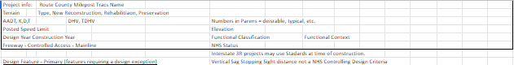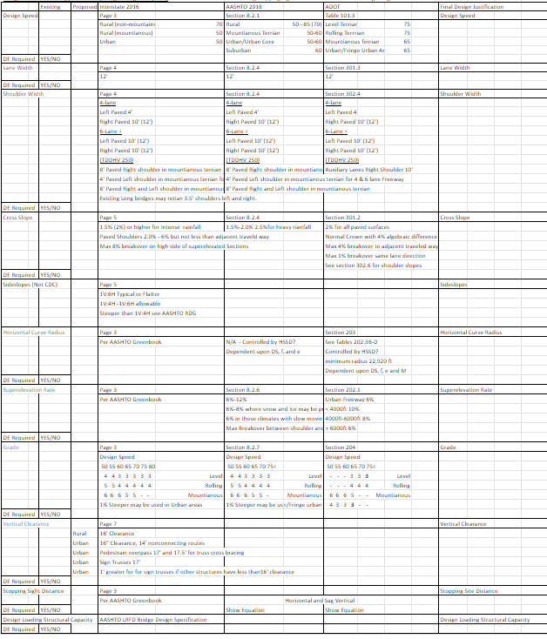

***Design Decision - Sample Cover Letter/Memorandum Form 7***

(Date)

To: (Name), ADOT State Roadway Engineer

Through: (Name), ADOT Project Manager

From: (Name), *Title & Company/Agency (Engineering of Record)*

Re: Design Decision Documentation

Project Name, Route/Location, Limits, ADOT Project Number, Federal ID No. (if applicable)

This letter, along with the accompanying Design Decision documentation, is being submitted to you in support of the above referenced project, which is a {*Provide brief project description*}.

These improvements are intended to address the project objectives of {*Provide brief description of the documented project objectives and needs*}.

The accompanying Design Decision documentation has been prepared and is being submitted for approval in support of using *(or maintaining)* the following design features within the project limits that vary from published design values: {*List Design Features that are documented in the Design Decision Documentation*}.

This letter, along with the enclosed Design Decision Document and supporting information identifies the specific design features, evaluations, and recommendations in support of this request to approve the Design Decision Documentation. Based upon the information contained in the attached Design Decision documentation, the proposed improvements and the associated design decision meets the project objectives and is anticipated to result in a net improvement in the operations without having an adverse effect on the safety performance of the system at this location. ADOT is requesting approval of these Design Decisions.

ADOT Environmental Planning approved a Categorical Exclusion (CE) (*or other appropriate type of NEPA Clearance)* on {*date*] for the Design Decision.

Please advise if further action is required on the above matter.

Attachments:  *Include Design Decision Documentation*

cc: ADOT Pre-Design Section Manager