### ADOT BIOLOGICAL EVALUATION (BE) GUIDANCE

**Revised: 8/11/2025**

**[Delete instruction pages before submitting]**

**ADOT Biological Evaluation Guidance Revision History**

|  |  |  |
| --- | --- | --- |
| **Published Date** | **Affected Sections** | **Description of Revision** |
| Aug 2025 | App. B., Sec V. | Added Monarch Section |
| Aug 2025 | App. B, Sec VII | Updated guidance and Environmental commitment |
| Aug 2025 | Section 1.4 | Example Added |
| Aug 2025 | App. B, sec. IV | Updated commitment language for Invasive Species |
| Aug 2025 | Table 1 | Updated wording, Monarch updates |
| Aug 2025 | Section 4.2 | Updated Instructions about acreage threshold |
| Aug 2025 | Page 2 | Formatting Update |
| Feb 2025 | Section 6.1 | Replace PCE with PBF throughout BE template |
| Jan 2025 | Title Page | Logo Update |
| Mar 2022 | Table 1 | Updated wording, order of species in Table 1 |
| Mar 2022 | Section 4.2 | Added template text for Water Quality/Clean Water Act |
| Sept 2021 | Instructions | Added item 10 – submit Word version of BE document once it has final approval |
| Sept 2021 | Title Page | ADOT Logo, EP street address updated |
| Sept 2021 | Exec Summary | Instructions for “Other Federal Species Analyzed” table updated |
| Sept 2021 | Definitions | Added OERT, PBFs, species status codes, etc. to the list (page iii) |
| Sept 2021 | Section 2 | Text modified to address Candidate species. Clarified that critical habitat within the action area (not just construction footprint) is identified in Table 1. |
| Sept 2021 | Table 1 | Added example text for Sonoran desert tortoise and monarch butterfly |
| Sept 2021 | Section 6 | Added Physical or Biological Features (PBFs) for Critical Habitat analyses |
| Sept 2021 | Appendix B | Added text for candidate species - Sonoran desert tortoise and monarch butterfly |
| Sept 2021 | Throughout | Updated hyperlinks and references to Appendices |
| Nov 2018 | Executive Summary | Changed “Construction Schedule and Duration of Construction” to “Project Duration and Construction Schedule.” |
| Nov 2018 | Sec. 1.1 | Removed language specifying whether ADOT or FHWA is the lead agency. Lead  agency will be defined in the transmittal letter to external agencies. |
| Nov 2018 | App. B, Sec. I | Updated commitment language for Migratory Bird Treaty Act section. |
| Nov 2018 | App. B, Sec. IV | Updated commitment language for Invasive Species |
| Nov 2018 |  | Updated web links throughout document |
| Aug 2018 |  | Updated BE Guidance posted |

### ADOT BIOLOGICAL EVALUATION (BE) GUIDANCE

**Revised: 8/11/2025**

**[Delete instruction pages before submitting]**

1. This format guidance must be used in association with the [*Consultant Biological Procedures*](https://azdot.gov/sites/default/files/2019/06/Consultant-Biological-Procedures.pdf). Please be sure to read and understand the *Consultant Biological Procedures* before preparing any ADOT biological documents. Additional technical guidance is available [here](https://azdot.gov/business/environmental-planning/biology-clean-water-act-section-404401).
2. Discuss with the ADOT biologist to confirm that a full BE is required rather than the Biological Evaluation Short Form (BESF) and which species, if any, will be evaluated in detail.
3. Formatting for this form (appearance may vary as long as content requirements are met):
   * Use Calibri font with single line spacing; body text should be 11 point font.
   * No consultant logos in the document (except attachments such as letters, plan sets, etc.)
4. Use the following terms according to the definitions below:
   * construction footprint: the area of disturbance
   * action area: all areas to be affected directly or indirectly by the action and not merely the immediate area involved in the action (50 CFR 402.02). (See Section 5 for details)
5. PLSS refers to the legal description of land using the Township, Range, Section system established by BLM. The Format of PLSS should be ‘Township 2 South, Range 3 East, Sec. 1-6’. If abbreviations are needed, define them. The use of the Gila and Salt River Meridian is assumed for projects in Arizona.
6. Wildlife Linkages should be referenced based on the 2006 map developed by the Arizona Wildlife Linkages Workgroup, which is available as a [PDF](https://azdot.gov/sites/default/files/2019/06/awlw-section-vi-figure-6-1-arizonas-wildlife-linkages.pdf) on the [ADOT Wildlife Linkages webpage](https://azdot.gov/business/environmental-planning/programs/wildlife-linkages).
7. Figure 1 showing the location of the project within the state, Figure 2 showing a more detailed view of the location, and Figure 3 showing the Action Area must be included. Figures may be combined for simple projects; for example, the state location map may be shown as an inset on the project location map if both are legible. The figure(s) may be color but should also be legible if reproduced in black & white. Include the following items:

|  |  |  |
| --- | --- | --- |
| Figure 1: State Location Map | Figure 2: Project Location Map | Figure 3: Action Area Map |
| * North arrow and scale | * North arrow and scale | * North arrow and scale |
| * County boundaries | * ADOT routes and major roads | * ADOT routes and major roads |
| * County names * Major cities/towns | * ADOT MPs for the route the project is   located on (if applicable) | * ADOT MPs for the route the   project is located on |
| * ADOT routes and route numbers for at least the   major routes | * General land ownership, e.g., USFS, BLM, NPS, tribal, state trust, private,   etc. | * Construction footprint * Critical habitat if necessary for analysis |
| * A text callout indicating the location of the project within the state | * Define construction footprint and include text callouts indicating the project beginning and ending limit, e.g., “Project Begin, MP 10.0” and   “Project End, MP 20.0” | * Ensure that terms in legend match text used in the BE * Use an aerial photograph as background |
|  | * Major landmarks in the area, such as cities/towns, rivers/streams, geological features, etc. to convey the   location of project |  |
|  | * Use an aerial photograph or topo   map as background |  |

### ADOT BIOLOGICAL EVALUATION (BE) GUIDANCE

**Revised: 8/11/2025**

**[Delete instruction pages before submitting]**

1. Photos: In most cases photos should be provided, but only enough to show a representative sample of the action area. Generally, no more than 6 photos are needed; discuss with the ADOT biologist if it appears the report would benefit from including more than 6 photos.
2. Submitting the BE:
3. Name the file with the TRACS number, BE and submittal number, and date in YYYYMMDD format (*e.g.* “H9999 BESub1 20170804” or “SH999 BESub2 20171223”).
4. Submit the BE as a single PDF file with all attachments included. Reduce the file size of images to keep the document size below 20 MB if possible. Do not include transmittal pages in the same PDF as the BE.
5. Submit by email to the ADOT Biologist and cc: the ADOT NEPA Planner. Include the following information as part of the email body or a separate file in the submittal email:
   1. Brief history of any previous coordination
   2. ADOT NEPA planner
   3. Consultant NEPA planner
   4. Consultant biologist
   5. Environmental bid ready date (typically 3 months prior to bid advertisement date)
   6. Project Manager
   7. Landowners
   8. 404 permit requirements
   9. Vegetation removal
   10. Preliminary effect determination(s)

2. Contact the ADOT biologist before transmitting a document larger than 20 MB; the ADOT biologist can send a link to an ADOT ShareFile folder for uploading larger documents.

1. **Once the BE has been approved, submit a Word version of the document to the ADOT Biologist.** If file size is a concern, photos may be removed from the Word file.
2. Using the template: Wording in black is boilerplate text or formatting that should not be altered. Wording in purple text contains instructions or examples and should be deleted before submitting the document.

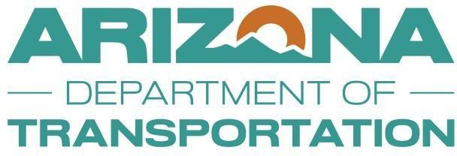

**Arizona Department of Transportation**

**Environmental Planning**

*(LPA project reports should not use the ADOT logo or name on this cover page)*

BIOLOGICAL EVALUATION

Project Name

Federal Project Number (just the number) ADOT Project Number (just the number)

|  |  |
| --- | --- |
| Prepared for: | ***ADOT Approval Signature*** |
| Arizona Department of Transportation Environmental Planning  205 South 17th Avenue, MD EM02 Phoenix, Arizona 85007  *(LPA Project Reports should list the LPA information here)* |  |

Prepared by: Name of Consulting Firm

Firm Address Line 1 Firm Address Line 2

Firm Internal Project/Report Number:

Submittal Date (date only) Submittal Number: [X]

*This report is the property of ADOT and may contain sensitive biological information.*

*ADOT approval is required prior to reproduction or distribution. (LPA project reports should not include the ADOT statement above)*

# Executive Summary – Biological Evaluation

**Project Type**: Include a short phrase describing the project, e.g. Bridge replacement, Lane addition, etc.

##### Project Duration and Anticipated Construction Schedule:

**Project Location**: Include a 1-2 sentence statement of the project location and extent.

**ESA Species and Critical Habitat Analyzed in Detail and Determinations Made** (Not Candidate species)

|  |  |  |  |
| --- | --- | --- | --- |
| **Common Name** | **Scientific Name** | **Status/Critical Habitat** | **Determination** |
|  |  |  |  |
|  |  |  |  |
|  |  |  |  |

**Tribal Special Status Species Analyzed and Determinations Made** (Include only if tribal species are analyzed)

|  |  |  |  |
| --- | --- | --- | --- |
| **Common Name** | **Scientific Name** | **Status** | **Determination** |
|  |  |  |  |
|  |  |  |  |
|  |  |  |  |

**Other Federal Species Analyzed** (Include if ESA Candidate or other federal species are analyzed in Appendix B)

|  |  |  |  |
| --- | --- | --- | --- |
| **Common Name** | **Scientific Name** | **Status** | **Potentially Affected?** |
|  |  |  |  |
|  |  |  |  |
|  |  |  |  |

Notes for filling out the summary table:

* If no detailed analyses are included in the BE, then this summary table can be replaced with a sentence stating “No threatened or endangered species will be affected by this project; see Table 1 for further information.”
* Critical Habitat for each species should have its own row and finding in the table.
* For the Tribal Special Status Species table, include the agency name (e.g. GRIC Species of Concern, etc.) in the “Status” column.
* BLM, USFS and other special status requested by federal land managing agencies should be addressed in Appendix B and summarized in the “Other Federal Species Analyzed” table in the Executive Summary.

# Table of Contents

|  |  |  |
| --- | --- | --- |
| 1. | Project Overview | 1 |
|  | *1.1 Federal Nexus* | *1* |
|  | *1.2 Project Description* | *1* |
|  | *1.3 Project Location* | *1* |
|  | *1.4 Consultation History (only if needed)* | *2* |
| 2. Federally Proposed and Listed Species and Designated Critical Habitat | | 2 |
| 3. Environmental Baseline | | 6 |
| 4. Scope of Work | | 8 |
| *4.1 Construction* | | *8* |
| *4.2 Potential Impacts on Water Quality and Clean Water Act Compliance* | | *8* |
| 5. Project Action Area | | 9 |
| 6. Species Evaluation | | 14 |
| *6.1 Species #1 Common Name* | | *14* |
| *6.2 Species #2 Common Name* | | *17* |
| 7. Environmental Commitments | | 17 |
| 8. Literature Cited | | 18 |
| 9. Signatures | | 18 |
| **LIST OF TABLES**  Table 1 – Project Species List | | 5 |
| **LIST OF FIGURES**  Figure 1 – State Location Map | | 3 |
| Figure 2 – Project Location Map | | 4 |
| Figure 3 – Project Action Area (Example 1) | | 10 |
| Figure 4 – Construction Footprint (Example 1) | | 11 |
| Figure 5 – Project Action Area (Example 2) | | 13 |
| **LIST OF APPENDICES**  Appendix A – Photos  Appendix B – Other Special Status Species Appendix C – Agency Coordination  Appendix D – Other Project Related Information  Appendix E – Attachments, including but not limited to: species handouts, SDT observation form (if needed) | |  |

### DEFINITIONS

Add or subtract from this list to reflect the definitions needed for each document.

Action area - all areas to be affected directly or indirectly by the Federal action and not merely the immediate area involved in the action (50 CFR §402.02)

AGFD – Arizona Game and Fish Department

AZPDES – Arizona Pollutant Discharge Elimination System AWLW - Arizona Wildlife Linkage Workgroup

BGEPA – Bald and Golden Eagle Protection Act BLM – US Bureau of Land Management

BMP – Best Management Practice

C – Candidate

CCAA – Candidate Conservation Agreement with Assurances

Construction footprint – the area where construction-related equipment will operate CH = Critical Habitat

EP – Environmental Planning ESA – Endangered Species Act

FHWA – Federal Highway Administration FWCA – Fish and Wildlife Coordination Act

IPaC – Information for Planning and Consultation (USFWS) LE – Listed Endangered

LPA – Local Public Agency LT – Listed Threatened

MBTA – Migratory Bird Treaty Act MP – Milepost

NAD – North American Datum

NESL – Navajo Endangered Species List NPS – National Park Service

NNDFW – Navajo Nation Department of Fish and Wildlife NPDES – National Pollutant Discharge Elimination System OERT – Online Environmental Review Tool (AGFD)

PBFs – Physical or Biological Features PLSS – Public Land Survey System PM – Project Manager

RGP 96 – Regional General Permit 96 (ADOT permit from the US Army Corps of Engineers) ROW – Right-of-Way

SWPPP – Storm Water Pollution Prevention Plan TCE – Temporary Construction Easement

USACE - US Army Corps of Engineers USGS – US Geological Survey

USFWS – US Fish and Wildlife Service USFS – US Forest Service

UTM – Universal Transverse Mercator

XN – Experimental Non-essential Population

##### Project Overview

* 1. ***Federal Nexus***

Include a statement identifying the federal nexus (for transportation projects, the federal nexus is usually due to FHWA funding; if not, it could be that a federal land managing agency is making a NEPA decision such as issuing a new easement or the Corps is issuing a permit). For example, “The project evaluated in this Biological Evaluation (BE) is funded in part by the Federal Highway Administration (FHWA) and will be constructed by the Arizona Department of Transportation (ADOT) *[or Certification Acceptance agency].*

*For projects for which the NEPA documentation is an Environmental Impact Statement, the biological document should be called a Biological Assessment. Contact the ADOT Biologist to discuss the approach.*

This BE addresses the proposed action in compliance with Section 7(c) of the Endangered Species Act (ESA) of 1973, as amended. Section 7 of the ESA requires that, through consultation (or conferencing for proposed species) with the U.S. Fish and Wildlife Service (USFWS), federal actions do not jeopardize the continued existence of any threatened, endangered, or proposed species or result in the destruction or adverse modification of critical habitat. This document evaluates the potential effects of the proposed transportation project on species that are federally listed under the ESA. Specific project design elements are identified that avoid or minimize adverse effects of the proposed project on listed species and/or critical habitat.

If there is no federal nexus for your project (e.g., the BE is being written for a maintenance project that does not require a Clean Water Act permit), then consultation cannot occur under Section 7. Use the following 3 sentences for this section rather than the suggested text above:

This document evaluates the potential effects of the proposed transportation project on species that are federally listed under the ESA. This project does not have a federal nexus. Specific project design elements are identified that avoid adverse effects of the proposed project on listed species.

For projects with no federal nexus, ADOT’s preference is to design the action with appropriate avoidance measures to reach a determination of “no effect.” If there is no federal nexus for the project and an animal take is likely, immediate coordination with the ADOT biologist is necessary, before submittal of the BE. A Habitat Conservation Plan and Section 10 consultation may be necessary in this instance. If there is no federal nexus for the project and a plant take is expected, immediate coordination with the ADOT biologist is also necessary. In this instance coordination with the Arizona Department of Agriculture is required as plants are treated differently under the ESA in this regard. Also, remember that critical habitat does not apply in the absence of a federal nexus.

* 1. ***Project Description***

Include a 1-2 sentence description of the project and anticipated construction timing and duration. EXAMPLE TEXT

This project will widen the Ganado Wash Bridge (Structure #1046) to allow for shoulders and sidewalks, accommodate a future five-lane roadway on SR 264, and improve the National Park Service (NPS) Hubbell Trading Post National Historic Site (HTP) entrance. Work will include removing existing bridge piers and constructing new piers, as well as grading and staging within the SR 264 ROW.

* 1. ***Project Location***

Provide a paragraph on the location of the proposed project that includes the following:

* + - Route number and MP limits, or other limits as applicable, e.g., “Main Street between 1st Avenue and Brown Boulevard”
    - Town/city and County, or if not within a town/city, an approximate distance and direction to nearest town/city or other landmark, e.g., “approximately 9 miles east of Payson, Arizona”
    - Project extent, e.g., “the project would occur within existing ADOT/City Name ROW/easement”, or “the project would occur within and adjacent to existing ADOT/City Name ROW/easement
    - Land ownership
    - References to state location and project location maps, “see Figures 1 and 2”
    - If the project occurs on BLM land, provide the PLSS description and the easement serial number (obtained during the scoping process)
    - If the project occurs on the Navajo Nation, provide the USGS 7.5’ Quadrangle name(s) the project occurs on, the PLSS description, and UTM NAD 1983 Zone 12 coordinates for the approximate center of the project

EXAMPLE TEXT

The project is located along State Route (SR) 264 between milepost (MP) 446.05 and MP 446.34, in the town of Ganado, Apache County, Arizona (Figures 1 and 2). The cadastral location of the project is Township 27 North, Range 26 East, in portions of Section 88. The project would occur within existing Arizona Department of Transportation (ADOT) easement through lands managed by the Navajo Nation and the National Park Service (NPS) Hubbell Trading Post National Historic Site (HTP).

* 1. ***Consultation History (only if needed)***

Include a summary of relevant project consultation history with USFWS. This may include history of the specific project and/or consultation for similar projects in the same general area. This summary should contain only documented consultation. Many projects will have no or very limited information to include in this section, while others may have an extensive amount of previous coordination. There is no need to mention the IPaC official species list here as that is discussed in the next section; if that is the only coordination with USFWS for the project, this section can be deleted. Example:

EXAMPLE TEXT

Informal consultation was conducted with USFWS for the geotech clearance for this project (Consultation Code 2024-0042253-S7-001). USFWS concurred with the findings that the proposed project may affect, but is not likely to adversely affect the endangered Yuma Ridgway’s rail (YRR) on October 30, 2024.

##### Federally Proposed and Listed Species and Designated Critical Habitat

The purpose of this section is to identify the list of species to be evaluated for potential project-related impacts. This section should contain the following (see below for example text and table):

* A statement that the USFWS IPaC system was accessed (include the date and EEA#) and that the ESA species list provided in the IPaC receipt was reviewed by a qualified biologist (include the name and firm name of the qualified biologist who reviewed the list). Include the IPaC species list in Appendix C.
  + If the project is on tribal land, a statement as to whether tribal species of concern are evaluated in the BE.
  + Do not discuss other external agency special status species, e.g., USFS, BLM, or state of Arizona Sensitive Species in the main body of the Biological Evaluation. These species should be addressed in Appendix B, Section V. Only species under the jurisdiction of the USFWS and tribal species of concern are addressed in the main body of the BE. Candidate species are included in Table 1; if analysis is needed for Candidate species, include it in Appendix B (USFWS does not review that information for Candidate species).
* A statement that USFWS IPaC system and AGFD Online Review Tool were reviewed for the presence of critical habitat within the action area (Action area is defined in Section 5). If critical habitat is included within one or both lists, include it as a row in Table 1.
* Table 1 will include the ESA species and Critical Habitat list, Candidate species, and, if the project is on tribal land, tribal species of concern that were requested for analysis.
  + Table headings should be Species, Status, Habitat Requirements, and Exclusion Justification.
  + For ESA species, list the species in the order given in the IPAC receipt.

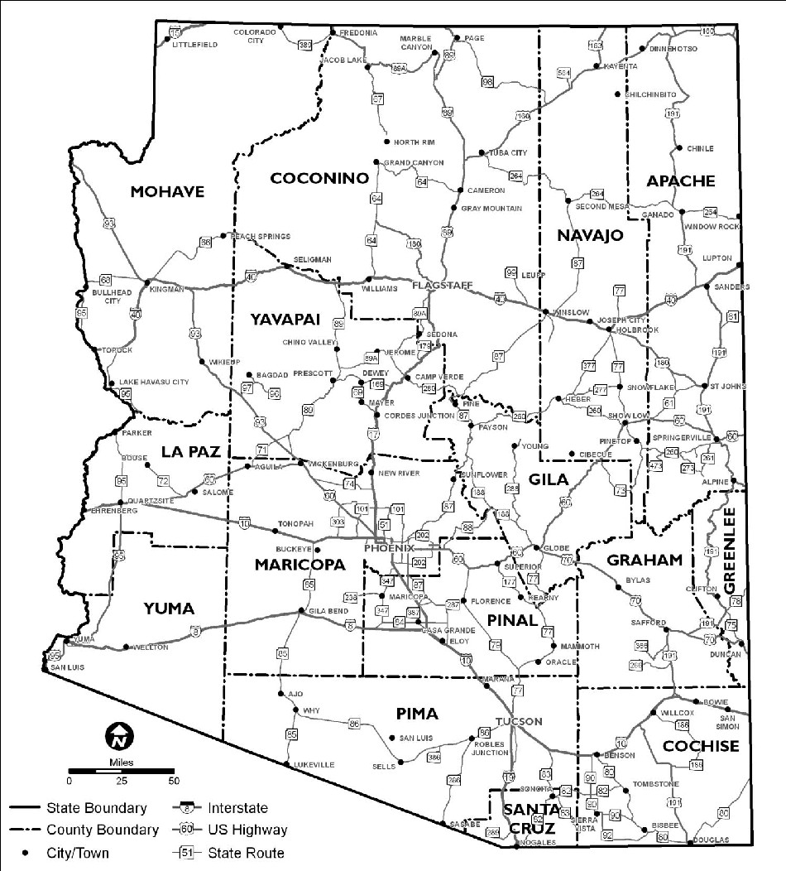

Figure 1. State Location Map

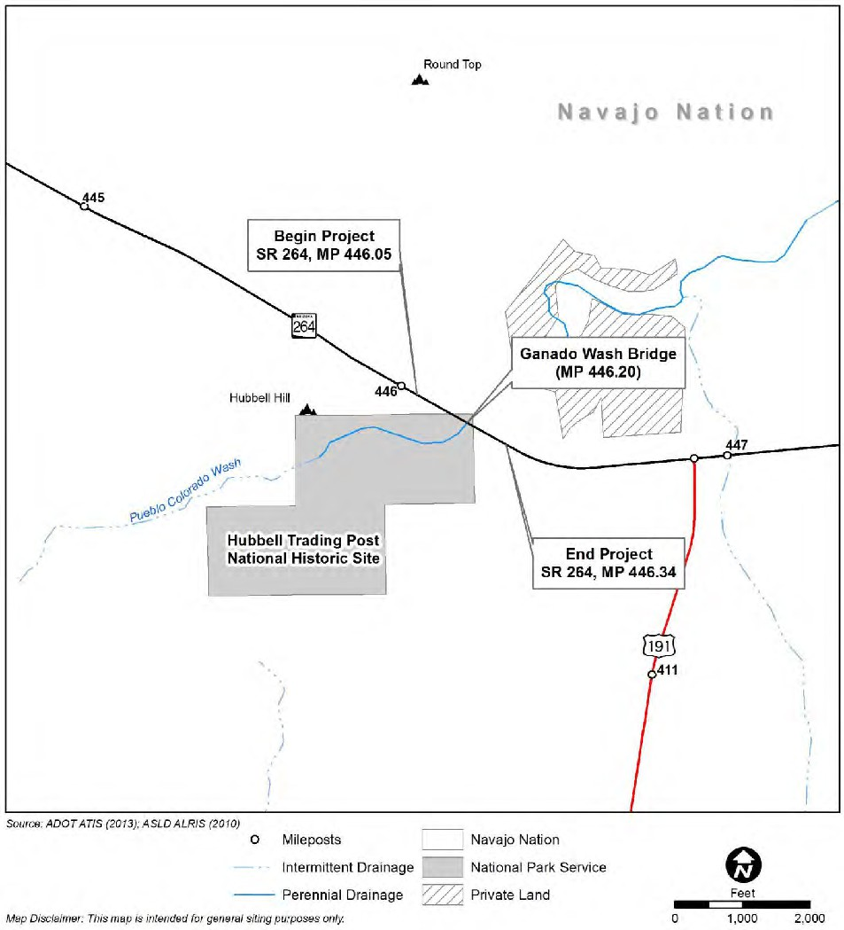

Figure 2. Project Location Map

Habitat Requirements and Exclusion Justifications should be clear and concise, only necessary details should be included. If the exclusion justification requires excessive detail, consider whether the species should be evaluated in detail. Use the standard Project Species List table posted on the [ADOT EP Biology webpage](https://azdot.gov/business/environmental-planning/biology) as a starting point. Include footnotes to define any abbreviations/acronyms, such as for status designations.

*EXAMPLE PARAGRAPH AND TABLE:*

The USFWS IPaC system was accessed on [DATE] and the AGFD Online Review Tool was accessed on [DATE]; both are included in Appendix C. The ESA species list from the IPaC receipt was reviewed by a qualified biologist (Name, Firm Name) and the species [and critical habitat] with the potential to occur within the action area are listed in Table 1 below. The AGFD Online Review Tool identified critical habitat for the

[fill in species] in the search area [ - or - Neither the IPaC search or the AGFD Online Review Tool identified critical habitat within the search area for the project.]. [If needed: Table 1 also includes Candidate species and species of concern for the project as identified by the NNDFW Navajo Natural Heritage Program.]

Only the highlighted species [and critical habitat] in Table 1 are evaluated in detail in the Species Evaluation section of this document. [If needed: Candidate species are addressed in Appendix B.] Justifications for excluding the remaining species from further evaluation are included in Table 1. The project and related erosion and sediment control measures will have no effect to species [and critical habitat] excluded from further evaluation.

**Table 1 – Project Species List**

|  |  |  |  |
| --- | --- | --- | --- |
| **Species** | **Status** | **Habitat Requirements** | **Exclusion Justification** |
| ***Birds*** | | | |
| Southwestern willow flycatcher (*Empidonax traillii extimus*) | ESA LE NESL G2 | Dense riparian woodland communities along rivers, streams, lakesides, and wetlands below 8,500 feet elevation. Prefers dense canopy cover, large volume of understory foliage, and surface water during mid-summer. | No suitable habitat, no riparian vegetation. |
| Critical Habitat for Southwestern willow flycatcher (example only) | CH | Critical habitat is located within  ½ mile of the construction footprint. | There is no suitable habitat within the action area and stream with CH is outside of the action area, over ¼ mile from the  construction footprint. |
| Yellow-Billed Cuckoo (*Coccyzus americanus*) | ESA LT | Uses large contiguous patches of multi-layered riparian habitat, such as  cottonwood-willow gallery forests along rivers and streams below 6,600 feet in elevation. | No suitable habitat, no riparian vegetation. |

**Table 1 – Project Species List, Continued**

|  |  |  |  |
| --- | --- | --- | --- |
| **Species** | **Status** | **Habitat Requirements** | **Exclusion Justification** |
| ***Reptiles*** | | | |
| Sonoran desert tortoise | CCA | Primarily rocky, steep hillsides and bajadas, or incised washes in Mohave and Sonoran desertscrub (south and east of the Colorado River) between  900 and 4,200 feet in elevation. | Options:   * No suitable habitat * No impact to suitable habitat * Addressed in App. B |
| Northern Mexican gartersnake (*Thamnophis eques megalops*) | ESA LT | Cienegas, stock tanks and rivers that are densely vegetated such as lowland river riparian woodlands, and upland stream gallery forests most frequently between 3,000 to 5,000 feet in  elevation. | No suitable habitat. No suitable water sources, riparian woodlands, or forests. |
| ***Amphibians*** | | | |
| Northern leopard frog (*Lithobates pipiens*) | NESL G2 | Wetlands usually with permanent water and aquatic vegetation (especially cattails), ranging from irrigation ditches and small streams to rivers, and small ponds and marshes to  lakes or reservoirs. | No suitable habitat. No wetlands or other suitable water sources. |
| ***Fishes*** | | | |
| Zuni bluehead sucker (*Catostomus discorbolus yarrowi*) | ESA LE | Small streams above 6,000 feet in low velocity, moderate deep pools, and pool-runs with seasonal dense algae. Young prefer quieter shallow areas  near shoreline. | No suitable habitat, no suitable water sources. |
| ***Insects*** | | | |
| Monarch butterfly (*Danaus plexippus*) | ESA PT, CCAA | Throughout Arizona where blooming nectar plants are available during the monarch migration timeframe. Lower elevations may include sources of low-flowing water (pond, streams, etc.). May overwinter in low desert washes. | Options:   * No suitable habitat, no nectar-rich plants or milkweed present. * Suitable habitat, but no impact. * Suitable habitat may be impacted, however this activity is covered under the CCAA. Addressed in Appendix B |
| Status Definitions: C = Candidate; CCA = Candidate Conservation Agreement; CCAA = Candidate Conservation Agreement with  Assurances; CH = Critical Habitat; ESA = Endangered Species Act; LE = Listed Endangered, LT = Listed Threatened, XN = Experimental Non-essential Population. NESL = Navajo Endangered Species List; G2 = Group 2 species, G3 = Group 3 species. | | | |

1. **Environmental Baseline**

The environmental baseline represents the current biological and physical conditions of the action area (defined in Section 5). This baseline describes the current conditions and reflects the following:

* Past and present impacts of all federal, state, or private activities,
* Anticipated impacts of all proposed federal projects that have already undergone Section 7 consultation, and
* Impacts of state or private actions that are contemporaneous with the consultation in process.

Focus attention on the features of the environmental baseline that have the potential to be affected by the proposed action and on the biological requirements of the species being addressed.

A clear, concise, and accurate location description is essential to determine potential impacts to species and habitat. Provide a description of the physical characteristics and setting of the action area. This includes but is not limited to:

* Dates of any site visits conducted
* General project setting (e.g., rural, urban, fringe of urban area, etc.) and development present
* Biotic/vegetative community and dominant vegetation species
* Elevation and general topography/terrain
* Geological formation and soil association information (as necessary to determine habitat suitability for certain species)
* Presence and location of any semi-perennial or perennial watercourses
* Presence and location of any riparian or wetland habitat
* Water quality (temperature, sediment/turbidity, chemical contamination)
* Habitat elements (substrate, large woody debris, refugia, nesting sites, etc.)
* Habitat access and connectivity
* Examples of general wildlife observed during any site visits and other noteworthy observations, such as prairie dog colonies, evidence of bird/bat use on structures, etc.
* Current management/land use

If access is not available to the entire action area, resources such as aerial or satellite imagery should be utilized to characterize the condition of areas not accessed. Describe whether site visit(s), imagery or a combination of methods was used. A comprehensive list of all plant or wildlife species observed during site visits is not necessary and should not normally be included in the document. If it is determined through coordination with the ADOT biologist that a comprehensive species list should be included, place it in Appendix D. Maps and figures of relevant physical features can be used to illustrate baseline environmental conditions. Plan sheets may be included in Appendix D if needed.

EXAMPLE TEXT

Site visits were conducted on March 9, 2011, August 24, 2011 and May 29, 2012. The project is located within the rural residential and agricultural town of Ganado, within the Great Basin Desertscrub Biotic Community (Turner 1994). The project occurs at an approximate elevation of 6,370 feet and the surrounding landscape is flat with mesas and low hills. The Chinle Formation is the predominant geologic feature in the area (Ludington et al 2005). Soils in the area are Mesic Arid soils of the Badland-Torriorthents-Torrifluvents Association which consists of well drained, fine textured soils on eroded uplands and floodplains weathered from sedimentary rocks (Hendricks 1985). Land use in the area primarily consists of rural residential housing, agriculture, and grazing.

The vegetative community throughout the area is dominated by rabbitbrush, scattered juniper (*Juniperus* spp.) and various grasses such as Bermuda grass (*Cynodon dactylon*), cheatgrass (*Bromus tectorum*), and foxtail barley (*Hordeum jubatum*). Pueblo Colorado Wash flows southwesterly through the construction footprint and is seasonally perennial, with heaviest flows occurring during the snowmelt and monsoon seasons. Within the project limits, the active channel measures approximately 20 feet wide and 3 feet deep. During the August 2011

site visit no surface water was present, although during the March 2011 and May 2012 site visits approximately 3 inches of flowing surface water was observed within the wash. Daily flow data is not available for the Pueblo Colorado Wash, though ADOT Bridge Group determined the 25 year event peak discharge is 4,963.1 cfs at Ganado Wash Bridge. Approximately three miles upstream of the construction footprint, a diversion dam directs water from Pueblo Colorado Wash to Ganado Lake for agricultural use. Pueblo Colorado Wash exhibits an intermittent riparian corridor of sapling and mature Fremont cottonwood trees and scattered small Russian olive and Saltcedar (*Tamarix ramosissima)* saplings. Growing along the inner banks of the wash are linear patches of bulrush, Parish’s spikerush, and alkali buttercup. Impacts from cattle, such as vegetation damage and bank erosion, are evident along the drainage. This section of the drainage is included within a 1.5 mile restoration project involving HTP, the Navajo Nation, and the Arizona Water Protection Fund. Restoration efforts are focused on reducing bank erosion and creating a natural, dynamic floodplain through exotic vegetation removal (i.e.

Saltcedar and Russian olive); native plant revegetation (*Scirpus, Populus*, and *Salix* species); cattle exclusion; and construction of in-stream erosion control structures (NPS 2000). See Appendix A for representative photographs of the construction footprint and surrounding ROW.

##### Scope of Work

* 1. ***Construction***

This section should include a **bulleted general list** of items to be removed, replaced, modified, installed, constructed, etc. As necessary, consider including and referencing a map or aerial photograph showing the construction footprint relative to biologically relevant features, such as known occurrences of special status species, washes, different vegetation types, and/or critical habitat (the same figure may also be valuable for discussion of items in Section 3, Environmental Baseline).

In the following subsections, provide a clear statement of how the project will be accomplished. Describe what will be done, how it will be done, and where it will occur. This section should include information on construction techniques, construction sequencing, site preparation, construction equipment to be used, construction access and if additional staging areas are needed, and the requirements for in-water work. A table showing the acres of temporary and permanent effects on habitat is helpful. This section should also identify:

* + - Any temporary activities (e.g. managing detours, staging plans)
    - Waste products that the action will generate (e.g., sediment-laden water, “green”

concrete-contaminated water, concrete debris, lead paint flakes). Describe containment methods if known (e.g., skirting to contain sandblasting sand and lead paint debris on bridge projects). If containment methods are not known, include a performance standard that has been agreed on for inclusion in the contract documents (e.g. turbidity measured at a point 100 feet downstream of the project will be maintained within 10% of the turbidity measured within 100 feet upstream of the project).

* + - Describe aspects of the proposed action that will add new impervious surface.
    - If there are potential noise concerns, describe the contributing activities planned, such as use of heavy equipment, a drone or other aircraft, blasting, or other loud activities that may be involved.
    - Aspects of the project that are required by regulatory mechanisms as part of the proposed action, such as U.S. Army Corps of Engineers (Corps) wetland compensation, should be included.

Add subsections as needed to capture the various aspects of construction. If specific project plan sheets are needed to support the analysis, place them in Appendix D. Include the following topics or subsections, as appropriate:

* + - Project Timeline, Construction Windows and Seasonal Considerations
    - Site Preparation
    - Construction Access and Staging
    - In-Water Work (if needed)
    - Post-Project Site Restoration
  1. ***Potential Impacts on Water Quality and Clean Water Act Compliance***

Include a paragraph summarizing Clean Water Act compliance using the following template:

The project will incorporate stormwater pollution prevention practices per Section 104.09 (Prevention of Stormwater Pollution) in ADOT’s Standard Specifications for Road and Bridge Construction. If the project will result in 1 or more acres of applicable land disturbance due to construction and associated support activities, a stored specification requiring coverage under the Arizona and/or National Pollutant Discharge Elimination System (AZPDES and/or NPDES) permit will be included in the contract.

The project (**would -** or **- would not**) involve disturbance to jurisdictional waters of the United States as regulated by the US Army Corps of Engineers; therefore, a Clean Water Act (CWA) Section 404 Permit

(**is -** or **- is not**) required. The project construction footprint (**is -** or **- is not**) within 1-mile upstream or ½-mile downstream of an impaired, not-attaining or Outstanding Arizona Water (OAW) or on a tributary to an impaired water or OAW and within 1 mile of the impaired water or OAW (modify sentence as needed if only one distance/direction applies).

##### Project Action Area

***Note: Action area should be discussed with the ADOT Biologist prior to developing the BE or the effect analysis section.***

The action area includes all areas to be affected directly or indirectly by the action and not merely the construction footprint (50 CFR §402.02). **It is more important to capture the full range of effects from the action than to distinguish between whether the effects are direct or indirect.** Note: The action area may extend beyond the right-of-way (ROW). For example, if instream work at a bridge site will add sedimentation to stream waters up to 1 mile downstream, the action area includes the bridge repair site and stream waters 1 mile downstream. It might also include waters upstream as far as the typical home range of fish species likely present at the site of the bridge. Include Figure 3 depicting both the anticipated construction footprint and the action area.

To define the project action area:

1. Identify all potential project effects (e.g., habitat destruction, noise disturbance, sedimentation, lighting, etc.). This includes all direct and indirect effects, as well as those effects associated with interrelated and interdependent activities, occurring within both aquatic and terrestrial environments. Distinguishing between direct and indirect effects is less important than capturing the full range of effects from the project.
2. Determine zones of effect for each type of project effect. Look at each type of project-related environmental effect (i.e., in-water sedimentation, aerial and terrestrial noise, clearing and grading, induced development, etc.) separately to determine its geographic extent.
3. Overlay the multiple zones to establish the geographic extent of all project impacts. These can be effectively presented using different colors to identify different elements of the action area (aquatic, noise, soil, and so on).
4. Define the action area based on the farthest geographic extent of potential project impacts.
   1. It is important to consider the existing impact from the transportation facility in most cases – i.e., when considering noise impacts, consider the existing traffic noise and whether sound generated by the activity changes or exceeds the existing typical noise from traffic.
   2. In some instances, there may be discrete areas affected by project activities that are not contiguous with the other zones of effect (i.e., an off-site mitigation area). In these cases, the

isolated area affected by project-related activities need not be physically lumped into the action area but can be considered a separate component of the action area.

EXAMPLE TEXT AND ACTION AREA FIGURE (Project 1 – Virgin River Bridge)

Several construction activities would involve work within the low-flow channel and the 100-year floodplain that could have direct effects to the Virgin River and surrounding environment. These activities are discussed in detail in the project description, along with conservation measures built into the construction of the project that would be used to minimize potential impacts. Consequently, no impacts are anticipated as a result of debris falling into the water. There will be direct impacts to the environment throughout the construction footprint of the project up to the 100-year floodplain and the ROW along the length of the project.

The construction activities and conservation measures described above may have additional effects to the Virgin River. These effects may include: (1) erosion and scouring that would increase sediment discharge into the river as a result of project activities and loss of riparian vegetation, (2) potential changes to the stream flow and associated hydrologic processes, (3) debris falling inadvertently into the river and being carried downstream, where it could damage the fish barrier, and (4) potential spills of oil, fuel, and other materials into the river. In addition, there will be effects from relocation of fish from as much as one mile upstream of the project to an area downstream of the project. Therefore, there could be impacts from fish relocation and discharges of sediments or spills from one mile upstream of the project to one mile downstream of the project along the Virgin River.

The action area for the project is defined as extending throughout the construction footprint of the project up to the 100-year floodplain and the ROW along the length of the project as well as one mile upstream and downstream of Bridge 6 along the Virgin River (Figure 3).

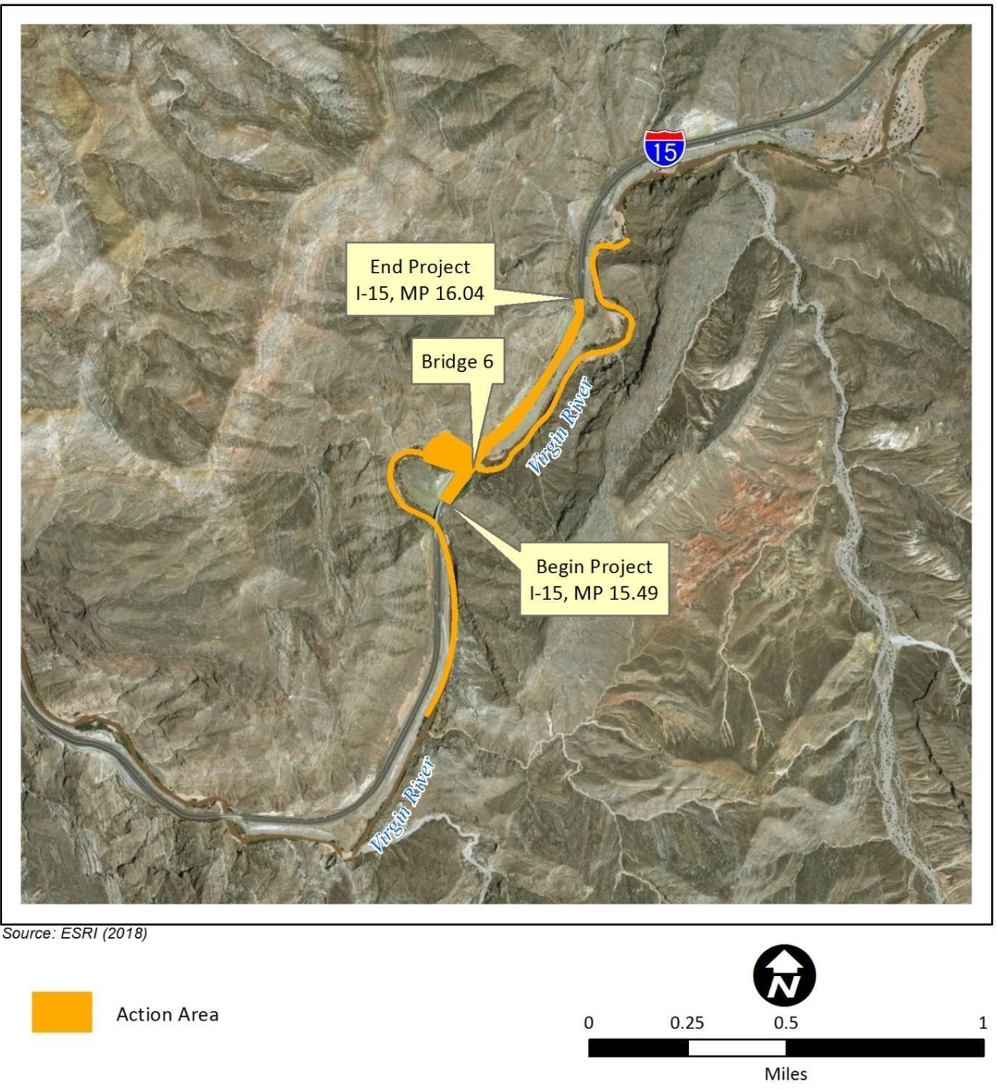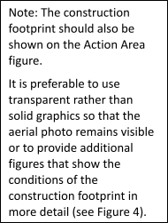

Figure 3. Action Area (Example 1)

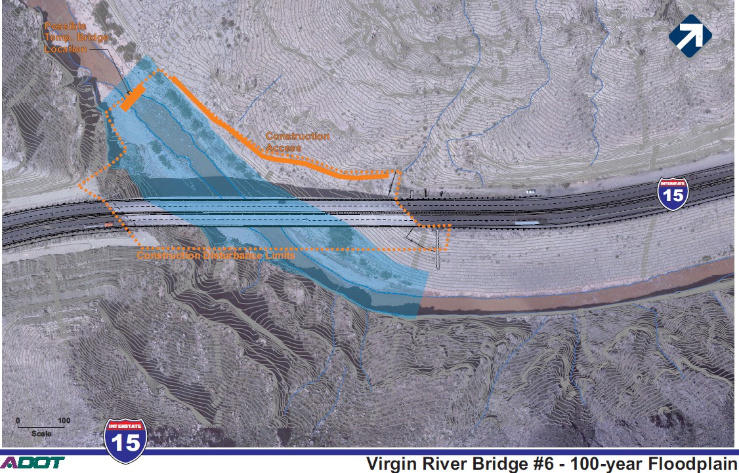

Figure 4. Construction Footprint (Example 1)

EXAMPLE TEXT AND ACTION AREA FIGURE (Project 2 – Pinto Creek Bridge)

The action area is defined as all areas to be affected directly or indirectly by the proposed action, and not merely the immediate area involved in the action (50 FR § 402.02). In delineating the action area, we evaluated the farthest reaching physical, chemical, and biotic effects of the action on the environment, focusing on, but not exclusive to, the Pinto Creek bridge.

As described in Section 4 and shown in Table X, this project is anticipated to result in 14.93 acres of temporary disturbance and 0.99 acres of permanent ground disturbance. The majority of ground disturbance would occur as a result of installing the access road. The slopes adjacent to the access road are steep with loose material that is prone to shift with any nearby disturbance. Due to the steep slopes, and loose substrate that is present along the access road, material is anticipated to shift downslope during its construction and while being used.

However, both the impact from the access road and the shifted material is encompassed within the proposed footprint depicted in Figure 5.

There could be effects to the area surrounding the disturbed footprint as a result of noise from rock removal activities, pounding micropiles to create a retaining wall, and saw-cutting to remove the existing bridge once the new bridge is complete. Culverts will need to be installed or extended to accommodate the waste sites and the realignment of US 60 and ephemeral tributary washes to Pinto Creek will be disturbed during construction, which could result in sedimentation in Pinto Creek. Night work with lights would be required to install the new bridge girders, tie-ins to the new US 60 alignment, and traffic control measures. The effects of noise, sedimentation and night lighting will be minimal and will not extend beyond the area shown in Figure 5.

The action area is defined as the 15.92-acre construction footprint plus the 48.84-acre project area —in total an area of 64.76 acres (Figure 5).

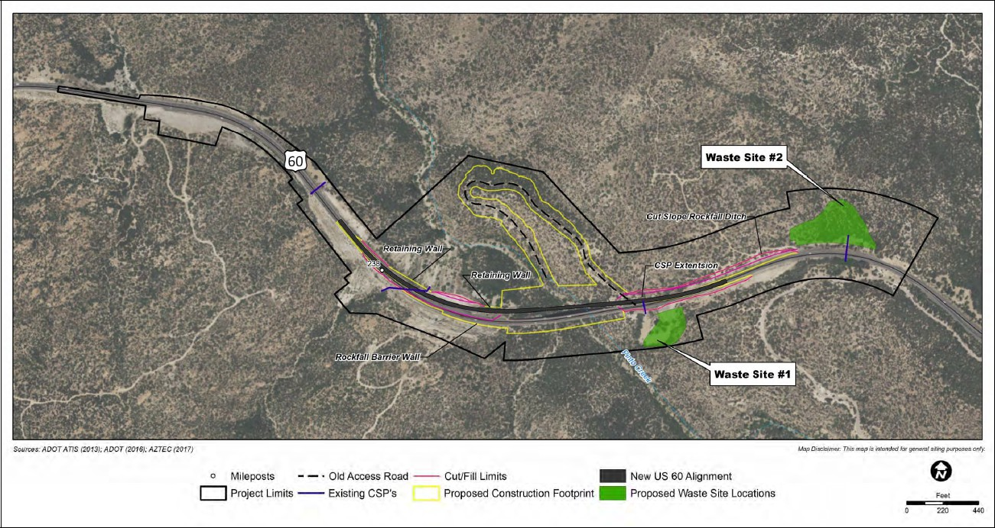

Figure 5. Action Area (Example 2)

##### Species Evaluation

Coordinate with the ADOT biologist to establish which species will be evaluated in detail before developing this section of the report. For each species evaluated in detail use the standard information available on the [ADOT EP](https://azdot.gov/business/environmental-planning/biology-clean-water-act-section-404401) [Biology webpage](https://azdot.gov/business/environmental-planning/biology-clean-water-act-section-404401) as a starting point.

* 1. ***Species #1 Common Name***

Status

Include a brief description of the species current status with citations, e.g., “Endangered (56 FR 54957; October 23, 1991) with Designated Critical Habitat (59 FR 13374; March 21, 1994).”

Species Summary Table

For each species evaluated in detail, insert the standard species information posted on the [ADOT EP Biology](https://azdot.gov/business/environmental-planning/biology-clean-water-act-section-404401) [webpage](https://azdot.gov/business/environmental-planning/biology-clean-water-act-section-404401) for the table and initial subsections below. These are being added as they are completed; if a species is not available on the webpage, contact the ADOT biologist. Following the standard table and text, provide information on surveys near the project area, habitat suitability and effects analysis.

Table for animals:

|  |  |  |  |  |  |
| --- | --- | --- | --- | --- | --- |
|  | Feeding | | Breeding | Sheltering | |
| Juvenile | Adult | Adult | Juvenile | Adult |
| Habitat |  |  |  |  |  |
| Prey |  |  |  |  |  |
| Perches |  |  |  |  |  |
| Cover |  |  |  |  |  |
| Temperature |  |  |  |  |  |
| Lighting |  |  |  |  |  |
| Moisture |  |  |  |  |  |
| Sound |  |  |  |  |  |
| Water |  |  |  |  |  |
| Dispersal |  |  |  |  |  |
| Seasonal Activity |  |  |  |  |  |

Table for plants:

|  |  |
| --- | --- |
|  | Plant Name |
| Habitat |  |
| Soil Type |  |
| Cover |  |
| Lighting |  |
| Water |  |

Table for plants, continued:

|  |  |
| --- | --- |
|  | Plant Name |
| Tolerance of  disturbed conditions |  |
| Sensitivity to  herbicides |  |
| Pollinators |  |
| Dispersal |  |
| Seasonal  Activity |  |

Life History

*Species Description and Ecology*: Provide a brief description of the species and other relevant information regarding its ecology that may not fit into the sub-sections below.

*Reproduction*: Describe aspects of the species reproduction that are relevant for evaluating impacts. For example, for birds, provide breeding season beginning and ending dates, nest substrate, and breeding chronology. For flowering plants, provide flowering and fruiting season dates. For fish, provide spawning season begin and end dates.

*Suitable Habitat*: Describe suitable habitat for the species, including known elevation range, biotic/vegetation community, any seasonal or life cycle variations in preferred habitat, and prey/food requirements. If proposed or designated critical habitat for the species is located within the action area or may otherwise be impacted, list the Physical or Biological Features (PBFs) of the critical habitat.

Threats

Include a brief paragraph describing known or suspected threats to the species based on information published in the Federal Register and/or peer-reviewed literature.

Range and Survey History

Describe the species past range (if known) and current range in relation to the project. Describe any surveys that have been conducted for the species and if any known surveys have been conducted in the action area, including survey results. Provide any other known occurrences in the vicinity of the action area and the distance to those occurrences.

Habitat Suitability Evaluation

Compare habitat within the action area to the elements of suitable habitat provided above and explicitly state whether suitable habitat is present in the action area. If suitable habitat is present in the action area but not within the construction footprint, provide the distance and direction to suitable habitat from the construction footprint.

State whether proposed or designated critical habitat is located within the action area. If the critical habitat is present in the action area but not within the construction footprint, provide the distance and direction to the critical habitat from the construction footprint. If proposed or designated critical habitat is within the action area or may otherwise be impacted, compare habitat within the action area to the critical habitat PBFs and explicitly state whether PBFs are present.

Analysis and Determination of Effects

Include all the effects sub-sections identified below and provide analyses for each effect type. For candidates or other special status species, replace the word “effects” or “affect” with “impacts” or “impact”. Describe effects or impacts to the species related to the proposed project in the beginning of this section. It is more important to capture the full range of effects from the action than to distinguish between whether the effects are direct or indirect. Focus the analysis on anticipated changes in numbers, distribution and/or reproduction of the species resulting from each effects pathway.

*Interrelated and Interdependent Actions*: Interrelated actions are those that are part of a larger action and depend on the larger action for their justification. Interdependent actions are those that have no significant independent utility apart from the action under consideration.

*Cumulative Effects (only needed for formal consultation on adverse effects to species)*: For listed species, cumulative effects are the effects of future state or private activities, not involving federal activities that are reasonably certain to occur within the action area of the federal action subject to consultation. In some cases if the cumulative effects analysis would be similar for multiple evaluated species, a single cumulative effects section generally referring to those species may be included after the Species Evaluation section instead of including a cumulative effects sub-section for each species.

*Determination*: In making your determination of effects to listed species the following language options must be used:

Threatened or Endangered Species (**use for proposed species as well**):

1. “ The project will have no effect to the [species name] or its habitat”
2. “The project may affect but is not likely to adversely affect the [species name] or its habitat”
3. “The project may affect and is likely to adversely affect the [species name] or its habitat”

Designated or Proposed Critical Habitat (projects with a Federal nexus only):

1. “The project will have no effect to [designated, proposed] critical habitat for the [species name]”
2. “The project may affect but is not likely to adversely affect [designated, proposed] critical habitat for the [species name]”
3. “The project may affect and is likely to adversely affect [designated, proposed] critical habitat for the [species name]”

Candidate and Other Special Status or Sensitive Species:

1. “The project has no impact on the [species name]”
2. “The project has a wholly beneficial impact on the [species name]”
3. “The project may impact individuals of [species name], but is not likely to result in a trend toward federal listing or loss of viability”
4. “The project is likely to result in a trend toward federal listing or loss of viability for the [species name]”

*CONSIDERATIONS FOR SPECIES ANALYSIS AND EFFECTS DETERMINATIONS:*

The Endangered Species Act requires you to consider all possible effects when determining if an action that is funded, permitted, or carried out by a federal agency may affect ESA-protected species. If there is proposed or designated critical habitat within or adjacent to the action area, please be sure to not only provide effects analysis for the species, but also for the critical habitat.

“No effect” is the appropriate determination if there is NO effect. If you believe the project will not affect a species or critical habitat, explain why. “Not known to occur” or “Not observed during a survey” does not mean the project has no effect to the species. Provide a detailed discussion as to why the project will have no effect on the species or critical habitat. In order to have a no effect finding, a project must be designed in such a way to result in no effect to the species through avoidance of impacts. Design features may be incorporated in a project that results in a finding of no effect, but mitigation cannot be used to achieve a no effect finding.

“May affect, but is not likely to adversely affect” is the appropriate determination when effects are expected to be discountable, insignificant, or completely beneficial. Beneficial effects are contemporaneous positive effects without any adverse effects. Insignificant effects relate to the size of the impact and should never reach the scale where take occurs. Discountable effects are those extremely unlikely to occur. Based on best judgment, a person would not: (1) be able to meaningfully measure, detect, or evaluate insignificant effects; or (2) expect discountable effects to occur. A “May affect, but is not likely to adversely affect” determination requires informal Section 7 consultation.

“May affect, is likely to adversely affect” is the appropriate determination when any adverse effects may occur as a direct or indirect result of the project or its interrelated or interdependent actions, and the effects are not discountable, insignificant, or beneficial. In the event the overall effect of the project is beneficial, but the project is also likely to cause some adverse effects, then "May affect, is likely to adversely affect" is the appropriate determination. If incidental take is anticipated to occur as a result of the project, a “May affect, is likely to adversely affect" determination should be made. This determination requires formal Section 7 consultation.

If you believe the project may affect a species or critical habitat, discuss with the ADOT biologist whether it is reasonable to assume that within the foreseeable future there could be take of this species as a result of this project. What part of the population will be impacted by the project? Will it affect the number, distribution and/or reproduction of the species? How much habitat will be lost, and will it be long term or short term? Are there noise impacts? If mitigation is recommended, include it here and/or the Mitigation Measures section and refer to the Mitigation Measures section here.

If more than an acre of soil will be disturbed, include an analysis of potential affects to species that may result from the installation, use and maintenance of possible Best Management Practices (BMP’s) called for in the SWPPP. For example, consider whether there are protected plants or food/shelter plants that could be impacted by the installation of BMP’s, discuss the use of BMP’s to prevent pollution of waters/aquatic ecosystems and the possible short term barrier to movement by BMP’s for small species or the potential for snakes or other species to become entangled in the netting used in BMPs, etc.

If there is no federal nexus for your project, keep in mind that it must be likely that an actual take of an animal will occur before anything other than a “no effect” determination is made. If there is no federal nexus for the project and an animal take is likely, immediate coordination with the ADOT biologist is necessary, before submittal of the BE. A Habitat Conservation Plan and Section 10 consultation may be necessary in this instance. If there is no federal nexus for the project and a plant take is expected, immediate coordination is also necessary with the ADOT biologist. In this instance coordination with the Arizona Department of Agriculture is required as plants are treated differently under the ESA in this circumstance. Also, please remember that critical habitat does not apply in the absence of a federal nexus.

* 1. ***Species #2 Common Name***

##### Environmental Commitments

Include in this section all environmental commitments from the document. If the commitments are for species discussed only in Appendix B, state so prior to listing them. Describe measures to be taken to avoid, reduce, or eliminate the potential effects to species as a result of this project. If there is suitable habitat for a species that needs to be avoided during construction it may need to be specified through avoidance mitigation, even if the project plans do not show an impact to the location. Some examples would be plants within the right-of-way, habitat within a known distance of a nest, etc. This is to ensure staging or project change orders do not impact the location. For example, this can be accomplished by specifying that no agave will be removed, no trees greater than 4 inches DBH can be removed, all construction activities will be limited to the pavement only between MP X and Y, etc.

Do not specify an exact location where staging must occur; however, it would be acceptable to stipulate that staging needs to occur within existing pullouts or that staging cannot occur at a discrete location. Coordinate all commitments with the ADOT biologist before document submittal.

**Remember, as described in the biology procedures guidance, species effect determinations and biology commitments must be discussed with the ADOT biologist as they are developed**. The consultant will e-mail the commitments to the ADOT biologist once they are developed for approval. The consultant should not send the biology commitments to FHWA, the planner, the PM or District for review without the approval of the ADOT biologist. The ADOT biologist, in coordination with the ADOT planner, will obtain PM and District review and agreement before the BE is finalized or sent to other agencies for review.

##### Literature Cited

Provide a complete reference section for information cited in the text of the BE using the format below.

[Book author.] [Year.] [Title.] [Edition.] [Place of publisher.] [Publisher (omit if same as author). Publisher (omit if same as author).] [Prepared for (if appropriate).]

[Author of agency report (typically the agency).] [Year.] [Agency report title] [Edition (Document number, if known.)] [Place (city, state of department where data may be obtained).] [Publisher (department responsible for data).] [Month and day if known.] [Prepared for, if applicable.]

[Journal article author.] [Year.] [Title of article.] [Title of journal and volume (number): page numbers.]

[Web site's author.] [Year.] [Title.] [Last revised: date posted or last revised.] [Available <[http://URL](http://URL/)>.] Accessed: [Month, day, year you accessed site.]

[Personal communications with Last name, first name.] [Job title.] [Organization or agency name, city, state.] [Date—type of communication.]

##### Signatures

A qualified general biologist or senior biologist is required as preparer. A qualified senior biologist signature is required as the reviewer. The biologist resume must be submitted to the Biology Team Lead and approved prior to submittal of a BE. The qualifications are posted on the EP Biology webpage.

|  |  |
| --- | --- |
| Prepared by: | Date: |
| Name: Title:  Firm Name: |  |
| Reviewed by: | Date: |
| Name:  Title:  Firm Name: |  |

## APPENDIX A

#### PHOTOS

Note: In most cases photos should be provided, but only enough to show a representative sample of the action area. Generally, no more than 6 photos are needed; discuss with the ADOT biologist if it appears the report would benefit from including more than 6 photos.

***GENERAL NOTES:***

## APPENDIX B

#### OTHER SPECIAL STATUS SPECIES

* ***Do not delete sections; if the section does not apply, state “Not Applicable.”***
* ***FOR PROJECTS OCCURRING ENTIRELY WITHIN TRIBAL LANDS, PARTS V, VI and VII OF THIS APPENDIX should***

***state “Not Applicable.” Analysis of species of special concern to tribes should be included in the main body of the BE report. Details on coordination with tribes should be included in Appendix C - Agency Coordination.***

* ***WHEN THE PROJECT CROSSES MULTIPLE JURISDICTIONS - follow the appropriate guidance for each portion of land. For example, if a project is on both state and tribal lands, for sections B.VI and B.VII include a disclaimer statement that the analysis for those sections is limited to state lands in the action area only.***

#### MIGRATORY BIRD TREATY ACT

The intent of this section is to document compliance with the MBTA. Provide a summary of field investigations identifying the presence or absence or migratory birds in the construction footprint and surrounding ROW and a statement as to whether the project is anticipated to impact migratory birds (e.g., bridge projects with existing nests, projects removing wetland or riparian vegetation, etc.). If there is an anticipated impact, include 1-2 photos in Appendix A to illustrate the situation. Refer to the [Migratory Bird](https://azdot.gov/sites/default/files/2019/06/mbta-guidance.pdf) [Mitigation Guidance](https://azdot.gov/sites/default/files/2019/06/mbta-guidance.pdf) on the ADOT Biology webpage to determine any necessary commitments and coordinate with the ADOT biologist regarding the appropriate commitment and date range to use.

#### BALD AND GOLDEN EAGLE PROTECTION ACT

The intent of this section is to document compliance with the BGEPA. Provide a statement as to whether the project is within the range and suitable habitat for bald and/or golden eagles and whether the project will disturb or result in take of bald or golden eagles. Include any necessary commitments. Coordinate with the ADOT biologist regarding the appropriate commitment to use. If you believe the project may disturb or result in take of eagles, coordinate with the EP biologist. If the project is within the range and suitable habitat for Bald or Golden Eagles but will not result in an incidental taking, the BE must include a statement that the project will comply with the National Bald Eagle Management Guidelines of 2007. If the project will result in the incidental taking of Bald or Golden Eagles, the BE must include an assessment of impacts as outlined in the Non-Purposeful Take Permit. Additionally, the document must reference coordination with USFWS and AZGFD if applicable.

If there is no likelihood of bald or golden eagle habitat in the construction footprint and surrounding ROW, include the following statement:

The construction footprint and surrounding ROW was evaluated by *[insert name of qualified biologist]*. It is not located in the range or suitable habitat for bald and/or golden eagles. The project will not disturb or result in take of bald or golden eagles.

#### FISH AND WILDLIFE COORDINATION ACT (FWCA)

The intent of this section is to document compliance with the FWCA. Provide a statement as to whether the project is a federal action (has a federal nexus) and if so, whether it will result in the control or modification of a natural stream or body of water. The FWCA requires federal agencies to consider the effect that

water-related projects have on fish and wildlife resources; act to prevent loss or damage to these resources; and provide for the development and improvement of these resources. Wildlife is defined broadly in [16 USC](http://uscode.house.gov/view.xhtml?req=granuleid%3AUSC-prelim-title16-chapter5A&amp%3Bsaved=%7CKHRpdGxlOjE2IHNlY3Rpb246NjYxIGVkaXRpb246cHJlbGltKSBPUiAoZ3JhbnVsZWlkOlVTQy1wcmVsaW0tdGl0bGUxNi1zZWN0aW9uNjYxKQ%3D%3D%7CdHJlZXNvcnQ%3D%7C%7C0%7Cfalse%7Cprelim&amp%3Bedition=prelim) [666(b)](http://uscode.house.gov/view.xhtml?req=granuleid%3AUSC-prelim-title16-chapter5A&amp%3Bsaved=%7CKHRpdGxlOjE2IHNlY3Rpb246NjYxIGVkaXRpb246cHJlbGltKSBPUiAoZ3JhbnVsZWlkOlVTQy1wcmVsaW0tdGl0bGUxNi1zZWN0aW9uNjYxKQ%3D%3D%7CdHJlZXNvcnQ%3D%7C%7C0%7Cfalse%7Cprelim&amp%3Bedition=prelim) of the Act to include fish, wildlife, and the habitat on which they depend. The applicability of the act is also very broad, as it applies to “any stream or other body of water” that is “impounded, diverted, the

channel deepened, or otherwise controlled or modified for any purpose.” Under the act, federal agencies must consult with resource agencies, “with a view to the conservation of fish and wildlife resources in connection with that project,” which includes the Arizona Game and Fish Department (AZGFD) and the USFWS, if applicable. This law provides a mechanism for federal agencies to consider measures to avoid impacts to wildlife and any mitigation measures in coordination with resource agencies, but does not require the federal agency to accept conservation recommendations.

Choose one of the following statements:

* 1. This project is not a federal action; the FWCA does not apply.
  2. This project is a federal action but it will not impound, divert, deepen the channel or otherwise control or modify any stream or other body of water; the FWCA does not apply.
  3. This project is a federal action and will impound, divert, deepen the channel or otherwise control or modify a stream or other body of water. Coordination with the Arizona Game and Fish Department (AZGFD) and the USFWS has been undertaken to consider the effects of the project on fish and wildlife resources, including water-related aspects. This coordination fulfills the requirements of the FWCA.

Summarize the result of the coordination with AZGFD and USFWS regarding the FWCA. For most projects, this coordination occurs as a result of the scoping process. Projects requiring an Individual Permit under Section 404 of the Clean Water Act may have additional coordination related to consideration of alternatives. If recommendations were received from USFWS and/or AZGFD, explain whether they will be implemented. Include copies of any related correspondence in Appendix C.

#### NOXIOUS AND INVASIVE PLANT SPECIES

The intent of this section is to document compliance with Arizona State Law and federal regulations regarding noxious and invasive plants.

Choose one sentence from each of A, B, and C below to compose a paragraph. Next, include section D for all ADOT/LPA projects in which construction is administered by ADOT. If commitments are needed, include section E or contact the ADOT biologist if needed.

1. The construction footprint and surrounding ROW were surveyed for the presence of noxious and invasive plants on (insert date and include a description of the method used, e.g. windshield survey, foot survey). -or- The ADOT District responded to a request for information on the presence of noxious and invasive plants in the construction footprint and surrounding ROW on (insert date).
2. No noxious and/or invasive plants were reported within the construction footprint and surrounding ROW. -or- The following noxious and/or invasive plants were reported within the construction footprint and surrounding ROW: .
3. Although noxious and/or invasive plants were found within the construction footprint and surrounding ROW, no treatment measures will be required for this project because (a pavement preservation project that will stay on pavement, weeds are outside area of impact, short-term project such as sign installation, etc.) -or- A Noxious Species Control Plan will be required for the project.
4. In order to prevent the introduction and spread of noxious and invasive plant species, the project will incorporate noxious and invasive plant species prevention practices per Section 104.16 (General Vegetation Protection Program) in ADOT’s Standard Specifications for Road and Bridge Construction. Prior to entering and before leaving the construction site all construction equipment will be inspected and cleaned to remove attached debris including plant parts, soil, and mud.
5. If treatment and control plan commitments are needed, include the following language for ADOT/LPA projects in which construction is administered by ADOT or contact the ADOT biologist.

Roadside Development Section Responsibility

* + The Arizona Department of Transportation Roadside Development Section will provide special provisions for the control of noxious and invasive plant species during construction that may require treatment and control within the project limits.

Contractor Responsibilities

* + The contractor shall develop a Noxious and Invasive Plant Species Treatment and Control Plan in accordance with the requirements in the contract documents.
    - Plants to be controlled shall include those listed in the state and federal noxious weed and the state invasive species lists in accordance with state and federal laws and executive orders.
    - The plan and associated treatments shall include all areas within the project right-of-way and easements as shown on the project plans.
    - The treatment and control plan shall be submitted to the Engineer for the Arizona Department of Transportation Construction Professional Landscape Architect for review and approval prior to implementation by the contractor.
    - Control of noxious and invasive species in the project area shall be performed prior to the start of ground-disturbing activities, throughout the duration of construction, and any landscape establishment period.

#### OTHER FEDERAL SENSITIVE SPECIES

If candidate species appear on the IPaC or AGFD OERT list for the project, they should be included in the Project Species Table (Table 1 in the main body of the BE); if candidate species (including those addressed in Candidate Conservation Agreements) may be affected by the project, they should be discussed in this section. If the action area includes easement from another federal agency such as BLM or USFS and an agency biologist has requested analysis of particular Sensitive Species that information also goes in this section. Include documentation of the coordination in Appendix C - Agency Coordination. If species are also listed under the Endangered Species Act, do not include them again in this section. For any species addressed in this section:

1. Include the species in Table B-1 (below). If a species may be potentially affected by the project, coordinate with the ADOT Biologist for next steps. If there are no federal sensitive species to address, state “Not Applicable.”
2. If there are additional forms for other species analyses such as Management Indicator Species Analysis or USFS MBTA analysis, include those at the end of this section.

##### Table B-1. Other Federal Sensitive Species

|  |  |  |  |  |  |  |
| --- | --- | --- | --- | --- | --- | --- |
| **Common Name** | **Scientific Name** | **Status** | **Occupied**  **Habitat Present?** | **Suitable**  **Habitat Present?** | **Suitable**  **Habitat Affected?** | **Species**  **Potentially Affected?** |
| ***Mammals*** | | | | | | |
| **Common Name** | **Scientific Name** | **Status** | **Occupied Habitat**  **Present?** | **Suitable Habitat**  **Present?** | **Suitable Habitat**  **Affected?** | **Species Potentially**  **Affected?** |
| Western red bat | *Lasiurus blossevilii* | FS S | No | Foraging,  roosting | No | No |
| ***Birds*** | | | | | | |
| American peregrine falcon | *Falco peregrinus anatum* | FS S | Yes | Nesting and foraging | No | No |
| ***Reptiles and Amphibians*** | | | | | | |
| Sonoran desert tortoise | *Gopherus morafkai* | CCA, BLM S |  |  |  |  |
| Lowland leopard frog | *Lithobates yavapaiensis* | FS S | No | No | No | No |
| ***Fish*** | | | | | | |
| Sonoran sucker | *Catostomus insignis* | FS S | No | Yes | No | No |
| ***Invertebrates*** | | | | | | |
| Monarch butterfly | *Danaus plexippus* | PT, CCAA |  |  |  |  |
| Caddisfly | *Lepidostoma knulli* | FS S | Yes | Yes | Yes | Yes |
| ***Plants*** | | | | | | |
| Eastwood alum root | *Heuchera eastwoodiae* | FS S | No | Yes | No | No |

1. Sonoran desert tortoise: If Sonoran desert tortoises may be present in the construction footprint and surrounding ROW and were not addressed in the sections above, include an analysis here.
   1. State the following:

The Sonoran desert tortoise is designated a Candidate species under the Endangered Species Act. ADOT is a signatory to the *Candidate Conservation Agreement for the Sonoran Desert Tortoises (Gopherus morafkai) in Arizona* (USFWS and AIDTT 2015) and makes accommodations for protection of tortoises on construction projects where tortoises may be present.

* 1. Include analysis of SDT here; use species information from the ADOT biology webpage and appropriate commitments. Coordinate with the ADOT Biologist if commitments beyond those listed below are needed.
  2. A determination of effect is not required; finish with a statement as to whether the project may impact Sonoran desert tortoises.

Include the following commitments for all projects in SDT habitat Contractor Responsibilities*:*

* If any Sonoran Desert tortoises are encountered during construction, the contractor shall adhere to the attached Arizona Game and Fish Department “Guidelines for Handling Sonoran Desert Tortoises Encountered on Development Projects”. If any tortoise is encountered during construction the contractor shall notify the Engineer to report the encounter.
* The contractor shall report encounters with any Sonoran Desert tortoise tortoises (live, injured, or dead) during construction to the Engineer using the attached Arizona Department of Transportation Sonoran Desert Tortoise Observation Form. The final form shall be sent to Arizona Department of Transportation Environmental Planning (email: [bioteam@azdot.gov](mailto:bioteam@azdot.gov)) within 24 hours of the encounter. Photographs should be taken of tortoises encountered and included in the report if possible.
* Prior to construction activity the contractor’s field personnel including the Project Manager, Assistant Project Manager, General Superintendent, and Project Superintendent shall review the attached Arizona Department of Transportation Environmental Planning “Sonoran Desert Tortoise Awareness Program Handout” flier, become familiar with the identification and avoidance of the Sonoran Desert tortoise, and follow the notification request, as applicable.

*\*Coordinate with the ADOT Biologist if commitments beyond those listed above may be needed.*

1. Monarch butterfly: If habitat for monarch butterflies is present in the construction footprint and may be impacted as part of the project, use the language below (Option 1 only). Monarch habitat has specific characteristics but for the purposes of this evaluation, habitat is considered areas of natural vegetation potentially containing nectar resources for monarch butterflies. This section is not needed if a Detailed Species Analysis is completed.
   1. State the following:
      1. Include for all applicable ADOT Projects or LPA Projects within a portion of ADOT ROW ADOT is enrolled in the Nationwide Candidate Conservation Agreement (CCAA) for Monarch Butterfly on Energy and Transportation Lands and has been issued a Certificate of Inclusion in

the CCAA which confers exemption from take prohibitions for this activity. ADOT has committed to adoption of conservation areas (‘adopted acres’) and conservation measures under the CCAA which are anticipated to result in a net conservation benefit to the species.

* + 1. Include in applicable Biological Evaluation Short-Forms (BESF) if brief additional evaluation summary is required

As of December 12, 2024, a ruling was published on the Federal Register (89 FR 100662) proposing the monarch butterfly (*Danaus plexippus*) to be listed as a threatened species under the Endangered Species Act. ADOT is enrolled in the Nationwide Candidate Conservation Agreement with Assurances (CCAA) for Monarch Butterfly on Energy and Transportation Lands and has been issued a Certificate of Inclusion in the CCAA which confers exemption from take prohibitions for certain activities performed in ADOT ROW. ADOT has committed to adoption of conservation areas ('adopted acres') and conservation measures under the CCAA which are anticipated to result in a net conservation benefit to the species. Include: This project occurs outside of the ADOT ROW, therefore, coverage under the CCAA is not applicable or This project is covered under the CCAA.

Monarch butterflies migrate to Arizona in the spring from overwintering sites in California and Mexico. They follow the blooming of nectar plants to the north and from low to higher elevations and back between spring and fall. While the majority of monarchs return to overwintering sites in the fall, some monarchs remain in sheltered low elevation riparian areas in central and southern Arizona during the winter months. Suitable breeding habitat for monarch butterflies includes open fields and meadows with both nectar plants and the milkweed host

plants required by larvae. Include: Suitable habitat is present, but it will not be impacted by the project activities or This project will impact suitable habitat.

*\*Coordinate with the ADOT Biologist to determine any necessary commitments.*

Summarize the findings for this section in the “Other Federal Species Analyzed” table in the Executive Summary.

#### STATE SENSITIVE SPECIES

If the project is completely on tribal land, then state “Not Applicable.” Otherwise, choose the appropriate paragraph:

1. State the following:

The Arizona Game and Fish Department (AGFD) on-line environmental review tool was accessed on [DATE] (Receipt Number: XXXXX) to determine whether special status species have been reported to occur in the area surrounding the project. As part of the environmental review process a letter describing the project was sent to the AGFD to inform them of the project and to solicit comments. The letter requested any specific concerns, suggestions or recommendations the agency may have related to the project. (If the on-line tool was not used, state that the species list was requested in the scoping letter. The on-line tool should be used for all projects that can be accurately delineated).

1. Then choose the appropriate paragraph from below:
   1. *If there are no concerns and no mitigation, but species were listed*:

(The AGFD on-line environmental review tool included a list of special status species known to occur within the area surrounding the project, and AGFD returned a response letter) -or- (The AGFD sent a response letter and included a list of special status species known to occur within the area surrounding the project). The agency did not include any species specific concerns related to this project. The potential for state sensitive species to be impacted by the project is unlikely because

(include reason - suitable habitat is not available, species are not likely present, limited scope of work etc.). Based upon the lack of specific concerns from the AGFD and (above reason) no protection of state sensitive species is necessary.

-or-

* 1. *If AGFD has no concerns, but species were listed and there is mitigation\**:

(The AGFD on-line environmental review tool included a list of special status species known to occur within the area surrounding the project, and AGFD returned a response letter) -or- (The AGFD sent a response letter and included a list of special status species known to occur within the area surrounding the project). The agency did not include any specific concerns related to this project.

However, ADOT will make the following accommodations for species: (follow into mitigation section, as a separate paragraph).

-or-

* 1. *If AGFD has concerns, with or without mitigation*:

[The AGFD on-line environmental review tool included a list of special status species known to occur within the area surrounding the project, and AGFD returned a response letter] -or- [The AGFD sent a response letter and included a list of special status species known to occur within the area surrounding the project.] The agency also included specific concerns related to the project,

(include a summary of their concerns). (Forward the letter and/or response to the ADOT Biologist to coordinate a response letter as well as the text for this section. In this section discuss what the result was. For example, the biologist coordinated with such and such from the AGFD, the regional biologist agreed with the recommendations, etc. Follow this by a separate mitigation paragraph as necessary).

-or-

* 1. *No concerns, no mitigation, no species listed and possibly no AGFD response*

[The AGFD on-line environmental review tool did not identify any special status species occurring in the area surrounding the project.] - or – [The AGFD did not send a response letter.] No accommodations are necessary for sensitive species.

***NOTES:***

* + - ***If conditions do not fit a category above please coordinate with the ADOT biologist. Wording changes should be made as necessary to fit the given situation***
    - ***Coordinate with the ADOT biologist for non-standard responses received from AGFD and Federal agencies. Responses may be addressed here, through an additional letter, or during project development.***

***\* Species that ADOT routinely provides accommodations for include: general migratory birds, raptors, burrowing owls, bats, Sonoran desert tortoise, and Gila monster. Projects should be reviewed for the presence of these species during early stages of project development. ADOT is a signatory to the Sonoran desert tortoise Candidate Conservation Agreement; therefore, if tortoises may be present in the action area, appropriate commitments for tortoise protection will be included.***

#### PROTECTED NATIVE PLANTS

The intent of this section is to document compliance with the Arizona Native Plant Law. If the project is completely on federal or tribal land, then state “Not Applicable.” Otherwise, choose the appropriate paragraph from section A:

1. The construction footprint and surrounding ROW was surveyed for the presence of protected native plants on (insert date and include a description of the method used). No protected plants were found.

-or-

The construction footprint and surrounding ROW was surveyed for the presence of protected native plants on (insert date and include a description of the method used). The following protected plants were found: . Although protected plants were found none will be impacted by this project because (a pavement preservation project that will stay on pavement, outside area of impact, etc. Also include any necessary avoidance commitments).

-or-

The construction footprint and surrounding ROW was surveyed for the presence of protected native plants on (insert date and include a description of the method used). The following protected plants were found: . Since protected native plants will be impacted by this project, the Arizona Department of Transportation Roadside Development Section [or Local Public Agency] will determine if notification to the Arizona Department of Agriculture is necessary under the Arizona Native Plant Law (A.R.S. Section 3-904).

1. Include the following paragraph for ADOT/LPA projects in which construction is administered by ADOT when impacts to protected native plants will occur: This project will incorporate Arizona Native Plant Law protection practices per Section 107.11 (Protection and Restoration of Property and Landscape) in ADOT’s Standard Specifications for Road and Bridge Construction*.* The contractor shall not deface, injure, destroy trees, shrubs, or cacti except as required to complete the proposed construction. The attention of the contractor is called to the requirements of the Arizona Native Plant Law (A.R.S. Section 3-901, et seq.)
2. *For LPA projects in which construction is administered by the LPA sponsor, include the following commitment when impacts to protected native plants will occur:*

Local Public Agency Responsibility

* + Protected native plants within the project limits will be impacted by this project; therefore, the Local Public Agency will determine if the Arizona Department of Agriculture notification is needed. If notification is needed, the Local Public Agency will send the notification at least 60 (sixty) calendar days prior to the start of construction.

*Coordinate with ADOT Biologist if any additional commitments may be necessary

#### WILDLIFE CONNECTIVITY

1. State the following:

ADOT, the AGFD, the Federal Highway Administration and representatives from other agencies have completed a Wildlife Linkages Assessment to address important wildlife movement corridors in Arizona. The AGFD on-line environmental review tool included a standard response regarding local or regional needs of wildlife movement, connectivity, access to habitat needs and design of various roadway features such as culverts and bridges.

1. Then choose the appropriate paragraph(s) from below:
   1. If the project is not located in a linkage zone:

The project is not located within the Potential Linkage Zones identified in the *Arizona Wildlife Linkages Assessment* (Arizona Wildlife Linkage Workgroup [AWLW] 2006).

* 1. If AGFD (or another agency) provided additional comments on connectivity:

The AGFD also provided an email/letter with recommendations for (summarize the recommendations and include the letter in Appendix C).

* 1. If the project is located in a linkage zone:

The project occurs within Potential Linkage Zone (enter the zone number) as identified in the *Arizona Wildlife Linkages Assessment* (AWLW 2006).

* 1. If the project is in a linkage zone but will not affect connectivity:

Because of the limited scope of work, this project will not affect connectivity in the linkage zone.

* 1. If the project is in a linkage zone and could affect connectivity:

Some of the target species that are identified for this linkage zone include

(species names from the AWLW document). The

(aspect of project that would impact connectivity) affords an opportunity to improve habitat connectivity; additional analysis is recommended. Contact the project manager or design team. (Describe commitments made to address connectivity).

## APPENDIX C

#### AGENCY COORDINATION

Provide a summary of the biology-related coordination with other agencies including the items below. Attach all biology-related correspondence with external agencies, including the [AGFD Online Review](https://ert.azgfd.gov/) summary and the [IPaC](http://ecos.fws.gov/ipac/) [summary](http://ecos.fws.gov/ipac/).

* A statement that the USFWS IPaC system and AGFD on-line environmental review tools were utilized to identify special status species potentially occurring in the area surrounding the project and that the results are included in this Appendix.
* A statement that as part of the environmental review process, a letter describing the project was sent to applicable agencies to inform them of the project and to solicit comments, followed by a list of the individuals contacted with each agency.
* A statement whether the agencies responded and if so, what their concerns were and whether they preferred to review the document or receive a copy for their files. *Note: The AGFD response is typically discussed in Appendix B, Section VI – that section can be referenced here.*
* A list of any other individuals that were contacted regarding the project.
* If coordination under the FWCA was conducted, refer to the summary in Appendix B and include the correspondence here.

*EXAMPLE COORDINATION SUMMARY*:

The USFWS IPaC system and AGFD on-line environmental review tool were utilized to identify special status species potentially occurring in the area surrounding the project. The IPaC and AGFD review tool results are included in this Appendix. As part of the environmental review process, a letter describing the project was also sent to the agencies below to inform them of the project and to solicit comments.

Arizona Game and Fish Department (AGFD) Name #1, Title, Office

Name #2, Title, Office

US Bureau of Land Management (BLM) Name #1, Title, Office

Name #2, Title, Office

National Park Service (NPS) Name #1, Title, Office Name #2, Title, Office

The AGFD responded with a letter, summarized in Appendix B, Section VI. The BLM responded via e-mail with a request that certain BLM sensitive species be evaluated and that the BLM receive a copy of the biological document for their files. The requested BLM sensitive species are evaluated in Appendix B, Section V of this BE and the document will be sent to the BLM for their files. All correspondence with these agencies is attached.

## APPENDIX D

#### OTHER PROJECT-RELATED INFORMATION

Note: Plan sheets or site plans should only be included when necessary to the analysis; discuss with the ADOT Biologist before including them in the appendix.

## APPENDIX E

#### ATTACHMENTS

[Include items to be attached to the environmental clearance for inclusion in the construction contract. These may include items such as species handouts, Sonoran desert tortoise observation form, etc.]