

Low Impact Development Plan:
Erosion and Sediment Control

Project Name:
ADOT Project No:
ADOT District:
Project Location:

Prepared by:
[Insert company/organization.]
[Insert street address.]
[Insert city, state zip code.]

Table of Contents
- Introduction…………………………………………………………………………3
- Erosion and Pollution Control Contact ……………………………………….3
- Project Description………………………………………………………………..4
- Site Plan……………………………………………………………………………..5
- Spill Prevention…………………………………………………………………….6
Spill Contacts…………………………………………………………………..6
Emergency Contacts………………………………………………………….6
Hazardous Materials…………………………………………………………..7
Spill Procedures……………………………………………………………………...8
6. ADOT Engineer Certification …………………………………………………….9

Introduction
In accordance with Section 104.09 of the Standard Specs which states:
'At least 15 days prior to the start of ground disturbing activities, the contractor shall submit, for the Engineer's approval, a plan for prevention of erosion and pollution which includes all the Control Measures which the contractor proposes to implement during the construction of the project'

This template serves to provide clarity and consistency on what is required in a Low Impact Development plan for ADOT construction projects. The Low Impact Development plan is in lieu of a full Stormwater Pollution Prevention plan required when a construction general permit is needed. This template is for use ONLY on ADOT construction projects that have been determined to be less than an acre of ground disturbance as legally defined and is therefore subject to only ADOT stormwater policies and procedures.

Erosion and Pollution Control Contact
Name:
Company:
Title:
Phone Number:
Email Address:

Project Description

Estimated Start/End Dates:
[Select start date.] to [Select end date.] Project start and finish dates
Estimated Ground Disturbance (sq ft):

Summary of Construction Activities & Project’s purpose:

Summary of Erosion/Pollution Control Measures Utilized:

Site Plan

Shall include locations of:

- Equipment Staging, Fueling, & Chemical Storage locations (if not onsite brief description of offsite location)
- Stockpile areas
- Type of control measures
- Construction boundaries
- Disturbed areas.
- Discharge points/outfalls from construction site
- Arrows that indicate flow of water
- AND Legend/ Compass indicating North.

EXAMPLE SITE PLAN

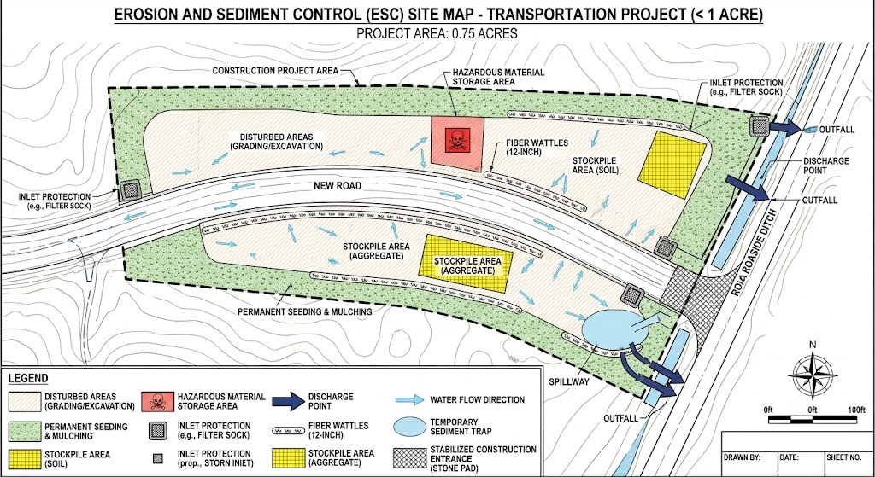

Spill Prevention
(Note: An existing company spill plan may substitute provided it includes the information requested below or submit a completed ADOT Spill Prevention & Response Plan Template < https://azdot.gov/business/environmental-planning/water-resources/construction-swppp-forms>. Follow link above and click heading > attachment templates. Please attach either with this document.)

Spill Contacts
Name:
Company:
Title:
Phone number:
Email Address:

ADOT Representative
Name:
Title:
Phone number:
Email Address:

Emergency Contact Information:
Local Fire Department: (insert phone # here)
(602) 257-1563: ADOT Traffic Operations Center, or
(800) 379-3701: Arizona Department of Public Safety's Hazardous Materials Response Unit (HMRU)
Other relevant outside agency numbers include:
(602) 771-2330 or toll free at (800) 234-5677. ADEQ Emergency Response Duty Office
(800) 424-8802 National Response Center (NRC)
IMPORTANT: The decision to contact any non-emergency outside agency shall be made by the Spill Response contacts or an ADOT official ONLY.

Hazardous Materials

Table 1: Hazardous Materials Stored On-Site
Material Type | Type of Storage and Volume | Total Volume | Control Measure | Dimension Calculations and/or Capacity
[Insert type of material being stored on-site.] | [Insert type of storage used (ex. secondary containment, etc.) and the volume each storage vessel contains.] | [Insert the total amount of this material stored on site.] | [Insert the control measure used for this material.] | [Insert the dimension calculations and/or capacity.]

Description of Onsite spill kit locations:

Description of Spill Response Procedures:

ADOT Approval and Certification of the Low Impact Development Plan

“I certify under penalty of law that this document and all attachments were prepared under my direction or supervision in accordance with a system designed to assure that qualified personnel properly gathered and evaluated the information submitted. Based on my inquiry of the person or persons who manage the system, or those persons directly responsible for gathering information, the information submitted is, to the best of my knowledge and belief, true, accurate, and complete. I am aware that there are significant penalties for submitting false information, including the possibility of fine and imprisonment for knowing violations.”

ADOT Project's Engineer Name:

___________________________________________

Phone Number:

___________________________________________

Email Address:

___________________________________________

ADOT Engineer's signature: ______________________________________

Date Approved: ___________________________

