

**Certification Acceptance Training MODULE 1**

**PLANNING/PROGRAMMING/PROJECT INITIATION**

**10/15/2020**

**Module 1 begins with an introduction from staff representing our Infrastructure Delivery and Operations Division (IDO). Attendees then become familiar with the CA Delegation of Authority and communications distributed by ADOTs Local Public Agency (LPA) Section. The discussion continues with attendees learning best practices from ADOT on proactive project management. A Multimodal Planning Division (MPD) representative will discuss their role with planning and programming projects. LPA section staff will discuss successfully initiating projects and the Joint Project Agreement (JPA) section reviews the development of agreements with our transportation partners.**

**AGENDA**

WELCOME AND INTRODUCTION 8:00 am-8:15 am (15 minutes)

Steve Boschen, Infrastructure Delivery and Operations Director, ADOT

Lisa Pounds, Local Public Agency Manager, ADOT

Jennifer Catapano, Local Public Agency Liaison, ADOT

UNDERSTANDING THE CA DELEGATION OF AUTHORITY & 8:15 am-8:40 am (25 minutes)

COMMUNICATIONS AND NOTIFICATIONS FROM LPA SECTION

Rolanda Smedley, Local Public Agency Process Manager, ADOT

* The Matrix of Delegated Authority can be viewed at <https://azdot.gov/node/14030>.
* Forwarding and implementing notifications from ADOT LPA.

HOW TO MEASURE PROJECT DELIVERY 8:40 am-9:10 am (30 minutes)

Lisa Pounds, Local Public Agency Manager, ADOT

* Proactively measuring project delivery.
* Understanding the notion of 20/30/30/20 – The ADOT targeted distribution of projects to be advertised in a fiscal year.

PLANNING AND PROGRAMMING PROJECTS 9:10 am-9:55 am (45 minutes)

Bret Anderson, Statewide Programming Manager, ADOT

* Proactively managing the Transportation Improvement Program (TIP).
* Important state and federal dates.
* <https://www.azmag.gov/Programs/Transportation/Transportation-Improvement-Program-TIP>
* https://pagregion.com/mobility/transportation-improvement-program/

BREAK 9:55 am-10:10 am (15 minutes)

**AGENDA CONTINUED….**

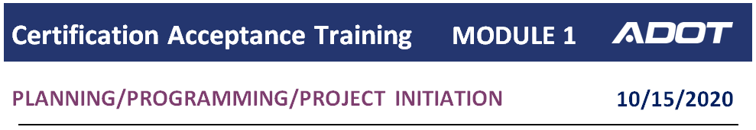

**AGENDA**

PROJECT INITIATION OF CA PROJECTS 10:10 am-11:10 am (60 minutes)

Mark Henige, Local Public Agency Program Manager, ADOT

Jennifer Henderson, Local Public Agency Project Coordinator, ADOT

* The role of LPA Section related to project initiation.
* Forms and documents to be completed by the CA.

JOINT PROJECT AGREEMENTS (JPA) 11:10 am-11:55 pm (45 minutes)

Korina Lopez, Joint Project Agreements Manager, ADOT

* When and why an Intergovernmental Agreement (IGA) is required between a CA Agency and ADOT.
* How long does the IGA process take and what are the deadlines that need to be met?

CLOSING REMINDERS AND SURVEY 11:55 am-12:00 pm (5 minutes)

Jennifer Catapano, Local Public Agency Liaison, ADOT

* Training survey - https://www.surveymonkey.com/r/CMCFFX6