

**Certification Acceptance Training MODULE 2**

**FEDERAL AUTHORIZATION AND WORKING WITH ADOT**

**11/4/2020**

**Module 2 offers a discussion from ADOT Financial Management Services (FMS) as they explain federal authorization steps and requirements. Attendees will then hear from Federal Highway Administration (FHWA) and understand their role in authorization. Project Management Group (PMG) staff will discuss the best ways to communicate and work with your ADOT project manager.**

**AGENDA**

WELCOME AND INTRODUCTION 8:00 am-8:15 am (15 minutes)

Karla Petty, Division Administrator, FHWA

Rolanda Smedley, Process Manager, ADOT

Jennifer Catapano, Local Public Agency Liaison, ADOT

FEDERAL AUTHORIZATION 8:15 am-9:15 am (60 minutes)

Elise Maza, Program/Project Funding Administrator, ADOT

Alison Hill, Resource Administration Manager, ADOT

Maria Coronado, Accountant III, ADOT

Patrycja Kozaczka, Accounting Manager, ADOT

* Understanding Federal Aid
* Certification Acceptance (CA) Packet Overview
* 01D vs. 03D
* Project End Dates
* Inactive Projects

BREAK 9:15 am-9:25 am (10 minutes)

FHWA AND THEIR ROLE IN AUTHORIZATION 9:25 am-10:25 am (60 minutes)

Tom Deitering, Project Delivery Team Leader, FHWA

Roman Moreno, Finance Manager, FHWA

Susan Webber, Area Engineer, FHWA

* Project Funds Management
* Project Authorization Package
* Commonly Non-Participating Items/Change Orders

BREAK 10:25 am-10:35 am (10 minutes)

**Agenda continued…**

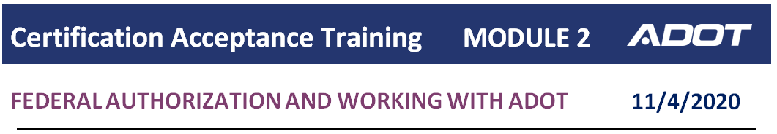

**AGENDA**

WORKING WITH YOUR ADOT PROJECT MANAGER 10:35 am-11:35 am (60 minutes)

Jennifer Acuna, Senior Project Manager, ADOT

Eric Prosnier, Project Manager, ADOT

* The Role of the ADOT Project Manager
* Scheduling and Reporting
* Design Phase, Advertisement and Closeout

CLOSING REMARKS AND SURVEY 11:35 pm-11:50 am (15 minutes)

Rolanda Smedley, Process Manager, ADOT

Jennifer Catapano, Local Public Agency Liaison, ADOT

* Training survey
* Next meeting date
  + December 3, 2020 at 8 am
  + Module 3 - Clearances